Report of FOSM Project to Process Hazard Trees at Coyote Trailhead, in Pine Flat Picnic Area, and at Cedro Reservation Campground, Wednesday, May 27, 2026

Sam Beard
On Wednesday, May 27, ten FOSM volunteers processed hazard trees at Coyote Trailhead, in Pine Flat Picnic Area, and in Cedro Reservation Campground. Two dead trees were felled and bucked at Coyote Trailhead. Two trees at the south end of Pine Flat Picnic area were felled and bucked. At Cedro Reservation Campground, two dead pinyons were fell and partially bucked. The bucked wood was left where the trees were felled and will be available for collection by residents who obtain Sandia Ranger District wood hauling permits.
Volunteers working on this project were Cliff Giles, Sam Beard, Sim Cook, Lorna Morrow, Kent Towler, Steve Roholt, Jerry Carroll, Michael Arndt, Dan Benton, and Chuck Logan.
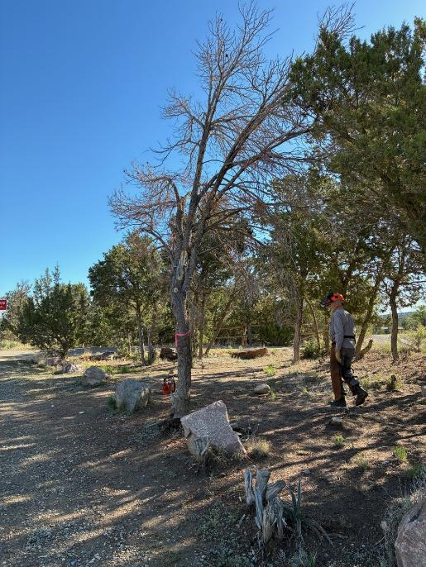
Dan Benton analyzing dead hazard tree at Coyote Trailhead on Forest Road 462.
All photos by Cliff Giles unless noted otherwise.

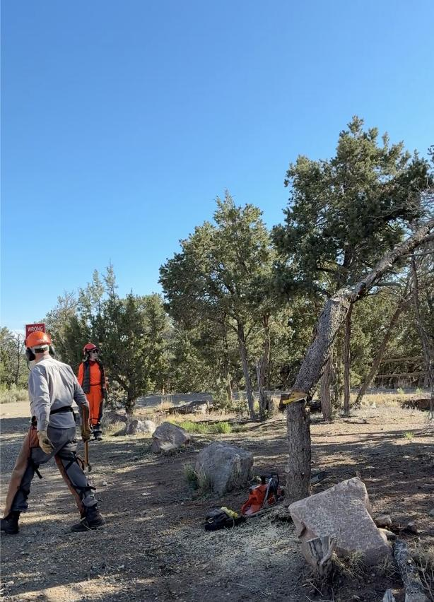
Dan running away from falling tree. Lorna Morrow is observing Dan’s work.
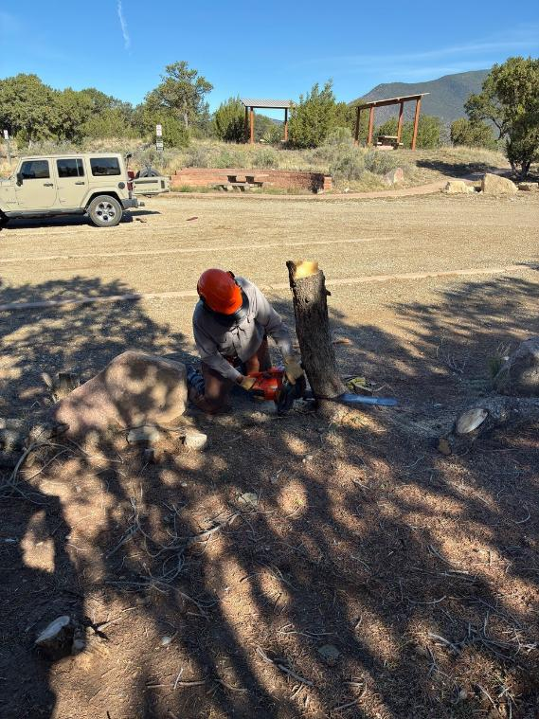
Dan low stumping tree he has felled.
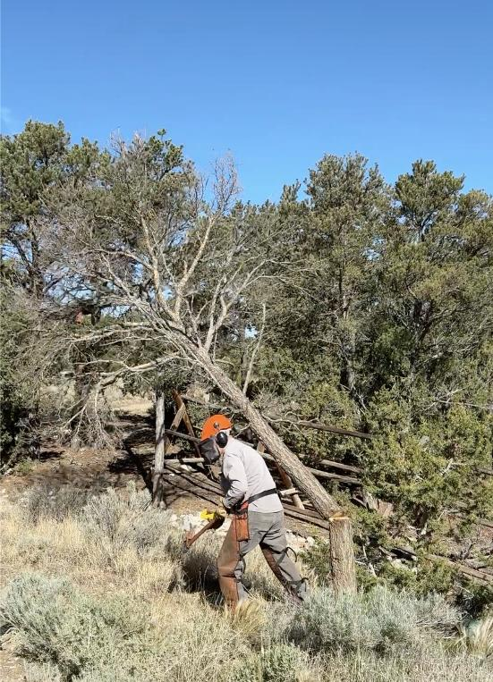
Dan running away from second dead tree he has felled at Coyote Trailhead.

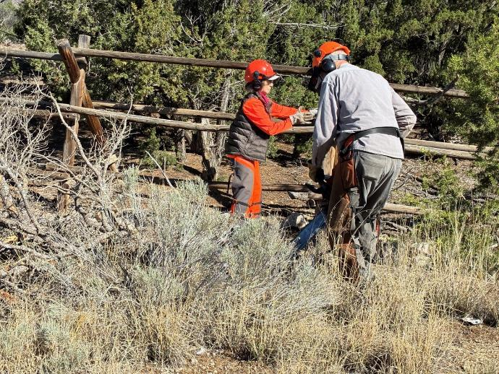
Dan bucking tree he has felled, and Lorna is swamping.

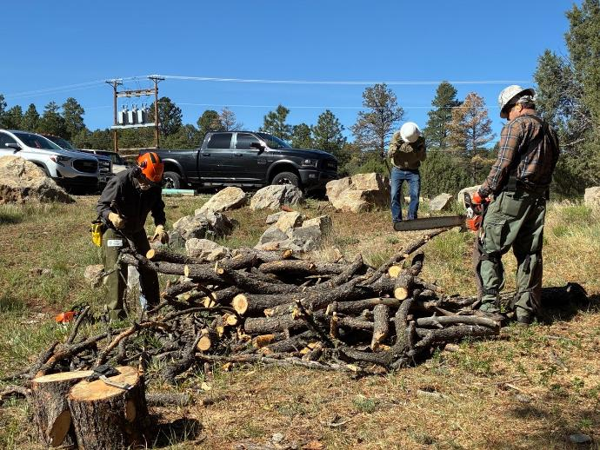
Jerry Carroll and Michael Arndt are preparing to buck this pile of small rounds
In the south part of Pine Flat Picnic Area near NM-337 south of the ranger station.

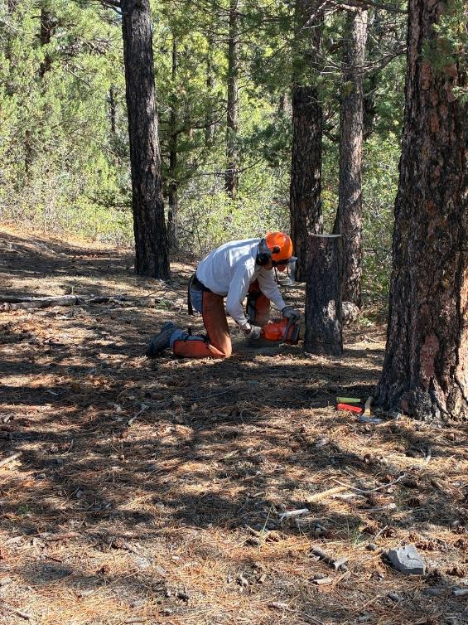
Sim Cook is low stumping the small dead tree he has just felled.
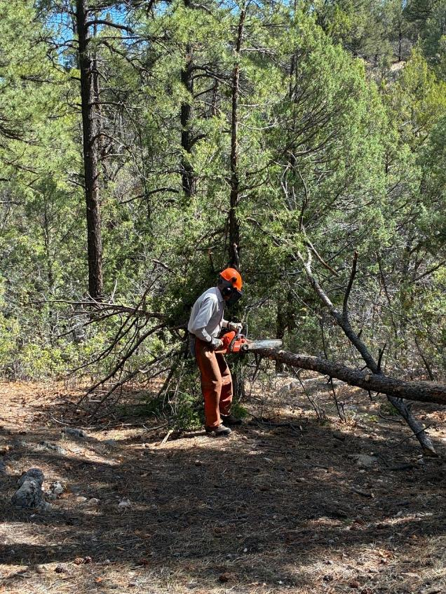
Sim is beginning to buck the tree he felled.

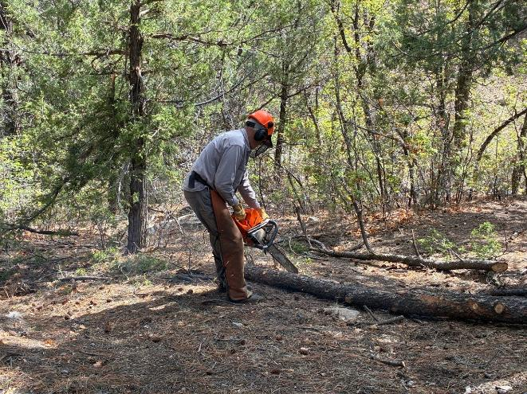
Dan bucking the tree Sim felled.

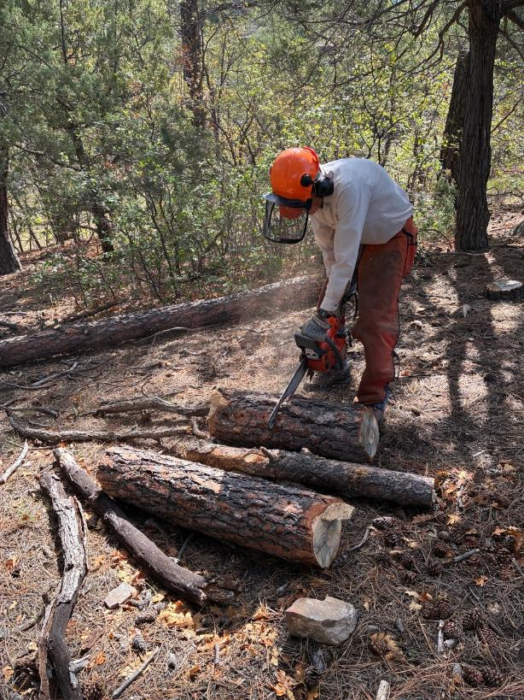
Sim bucking the large end of the tree he felled.

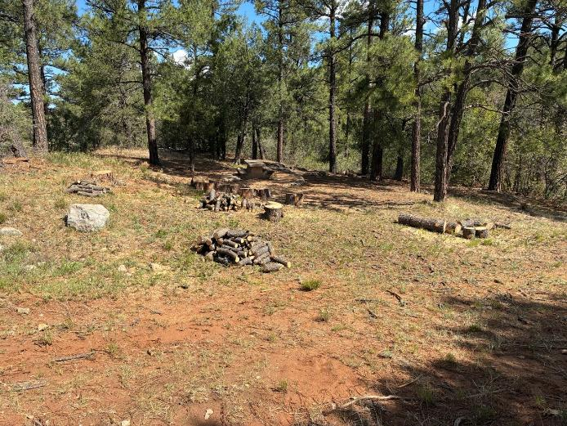
Felled, limbed, and bucked hazard trees in the south part of Pine Flat Picnic Area. The largest rounds
are in the center of the picture just beyond the second pile of small rounds.

