Thursday 05/28/26- Pokerchip: Back to Pokerchip for 12 volunteers and Chris (SRD). We had a good size crew so we made more progress this week even though the oak stumps tried to keep us in check. The weather was warm but the cloud cover kept the temps reasonable. There was even some moisture in the soil left over from the rains earlier in the week. We packed out the tools since we will take a break from Pokerchip while we have Talking Talons youth with us for the next 3 weeks. We don’t want to grind them down right off the bat!

Volunteers: Kerry Jones, Jim Houle, Bruce Hansche, Eric Russell, Luis Cuadros,
Byron Garner, Don Fisher, Jay Wulf, Cleve Sharp, Claudia Bergsohn, Bill Perkins,
and Laura Leon

Pictures: Laura Leon Map info: Luis Cuadros and his bad elf

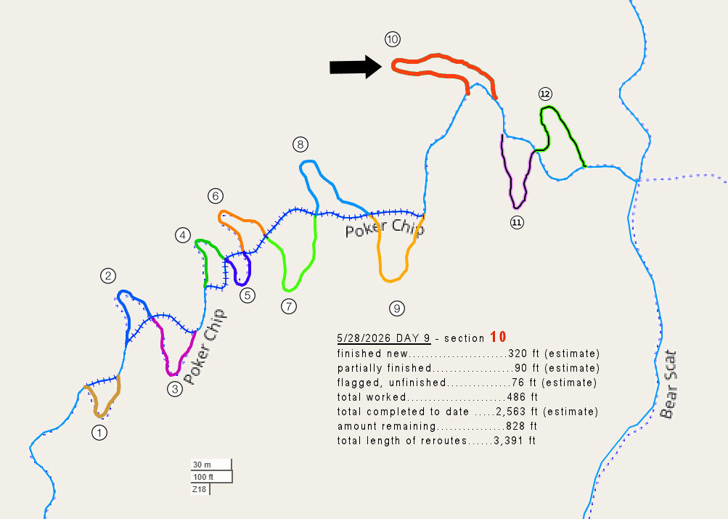
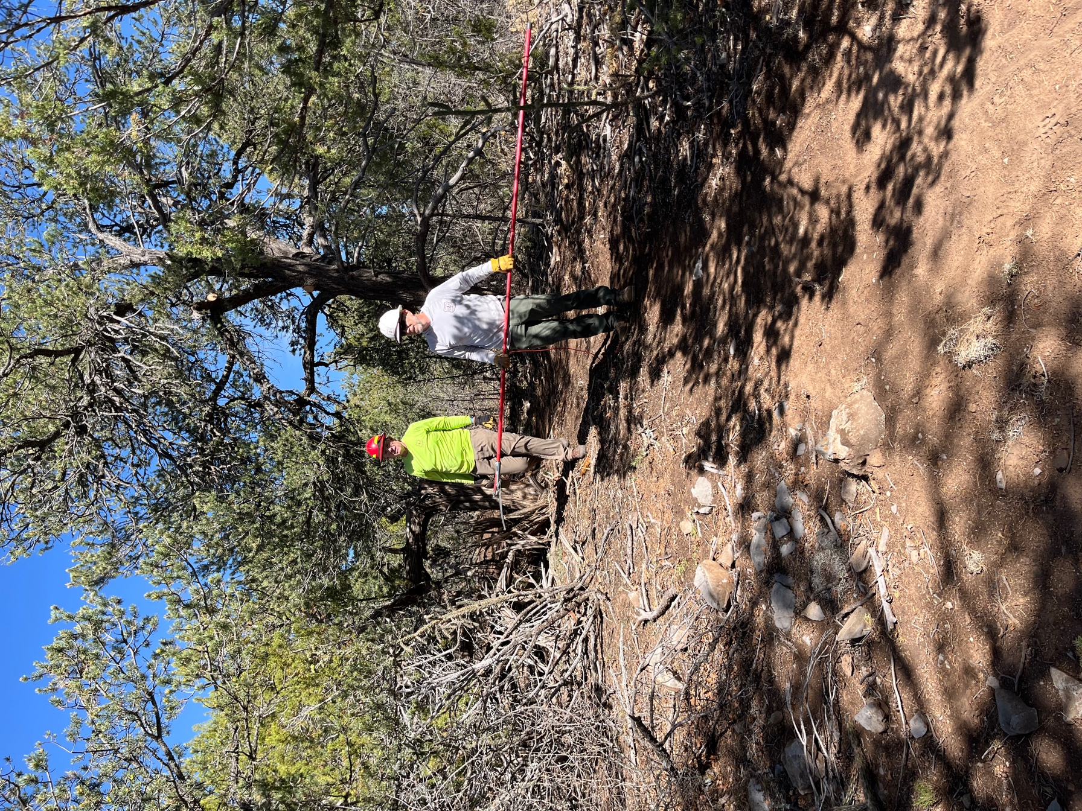

Kerry and Chis went back through the earlier work to do some saw work and Claudia went back and packed down the trail in spots -moist soil!!
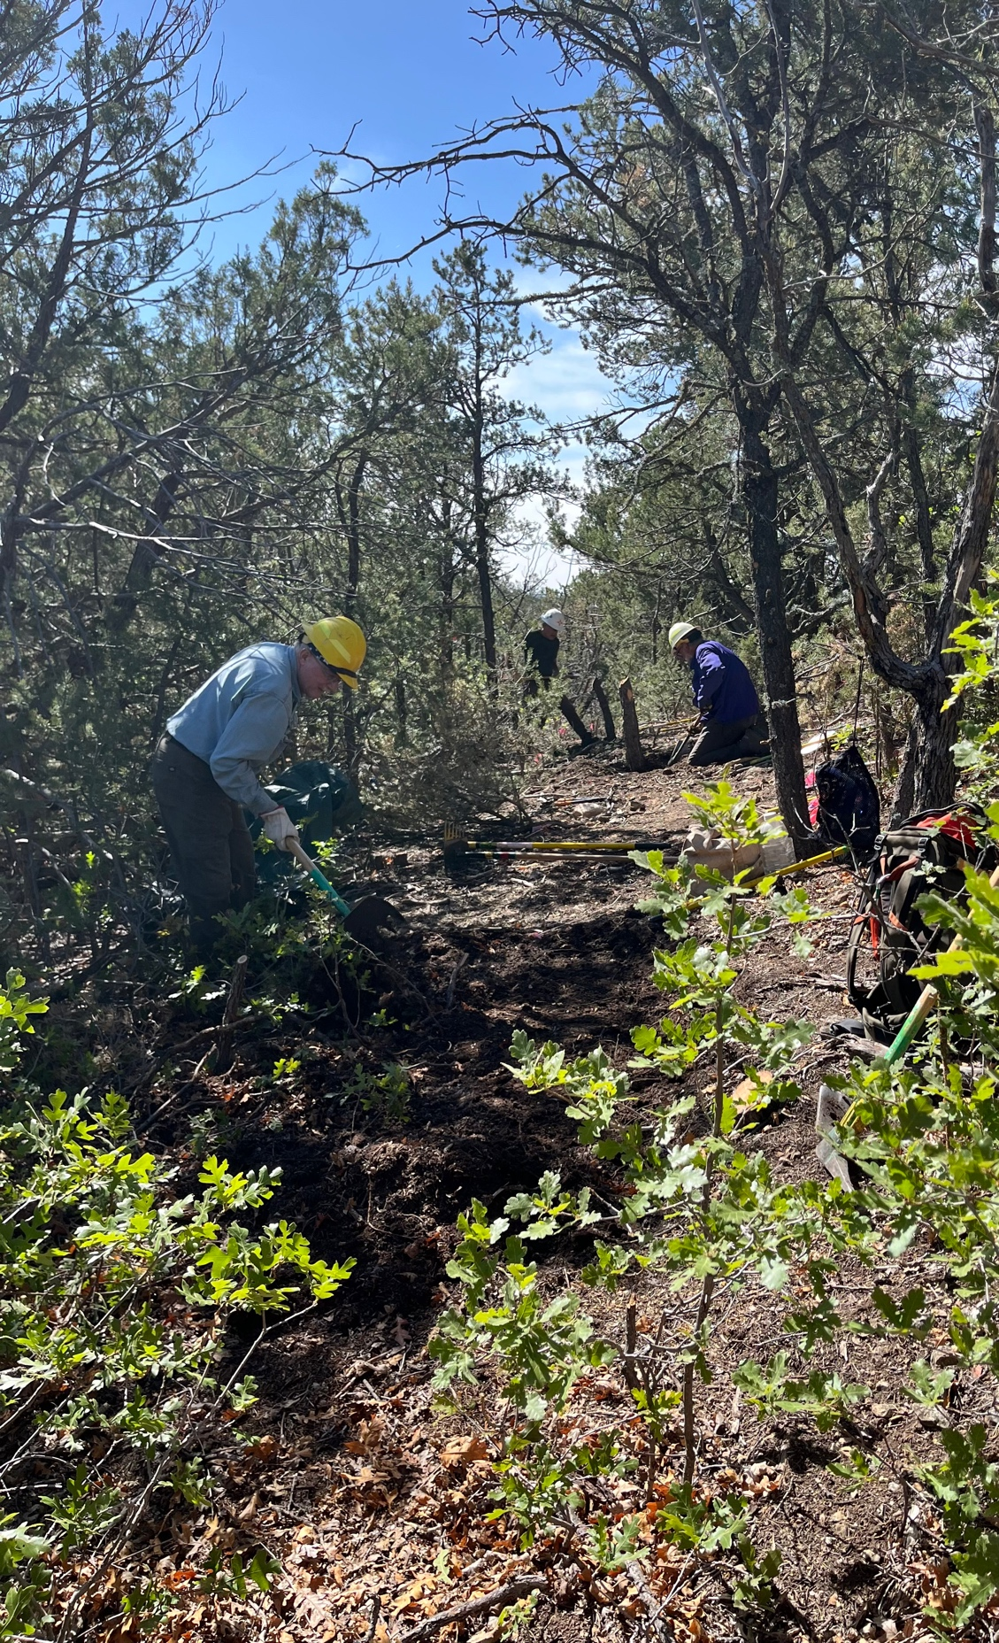

Eric, Jim and Luis start in on stumps.
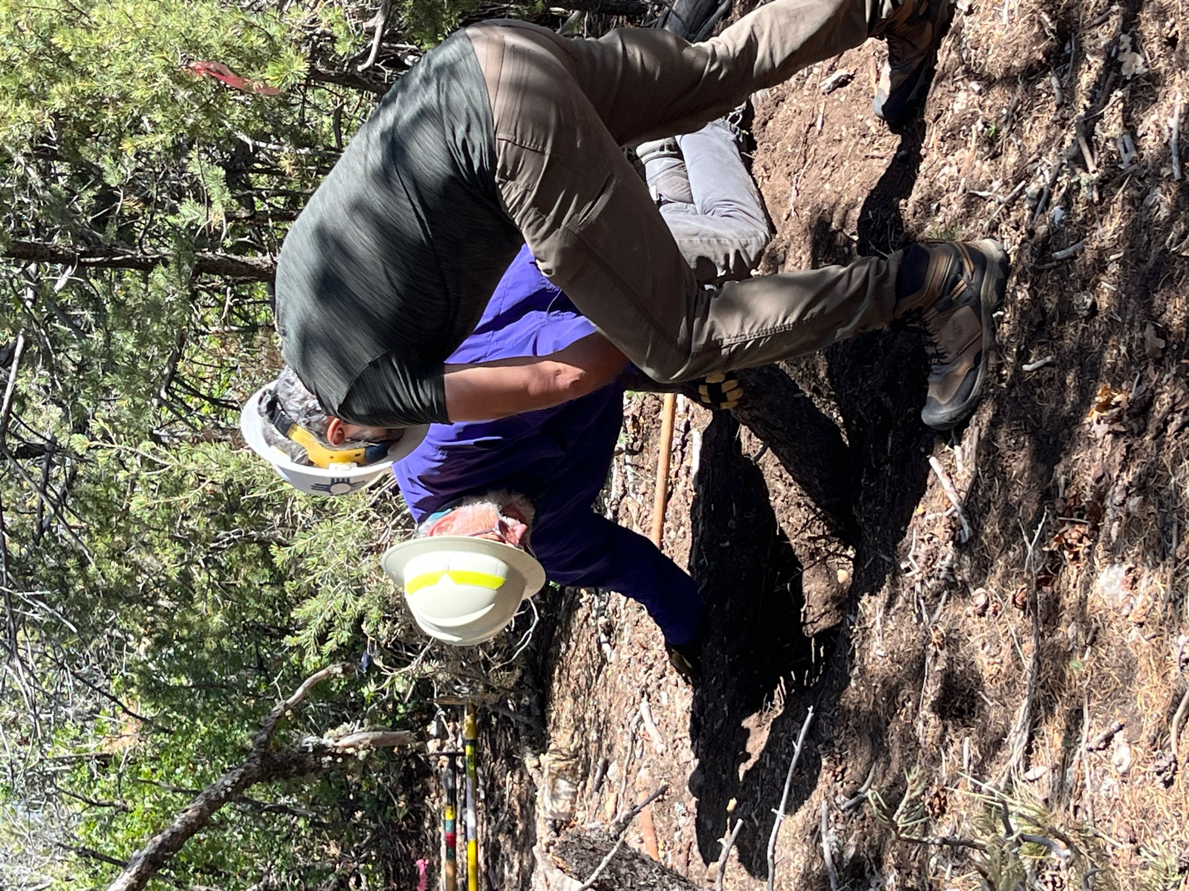

Stumps-sigh.

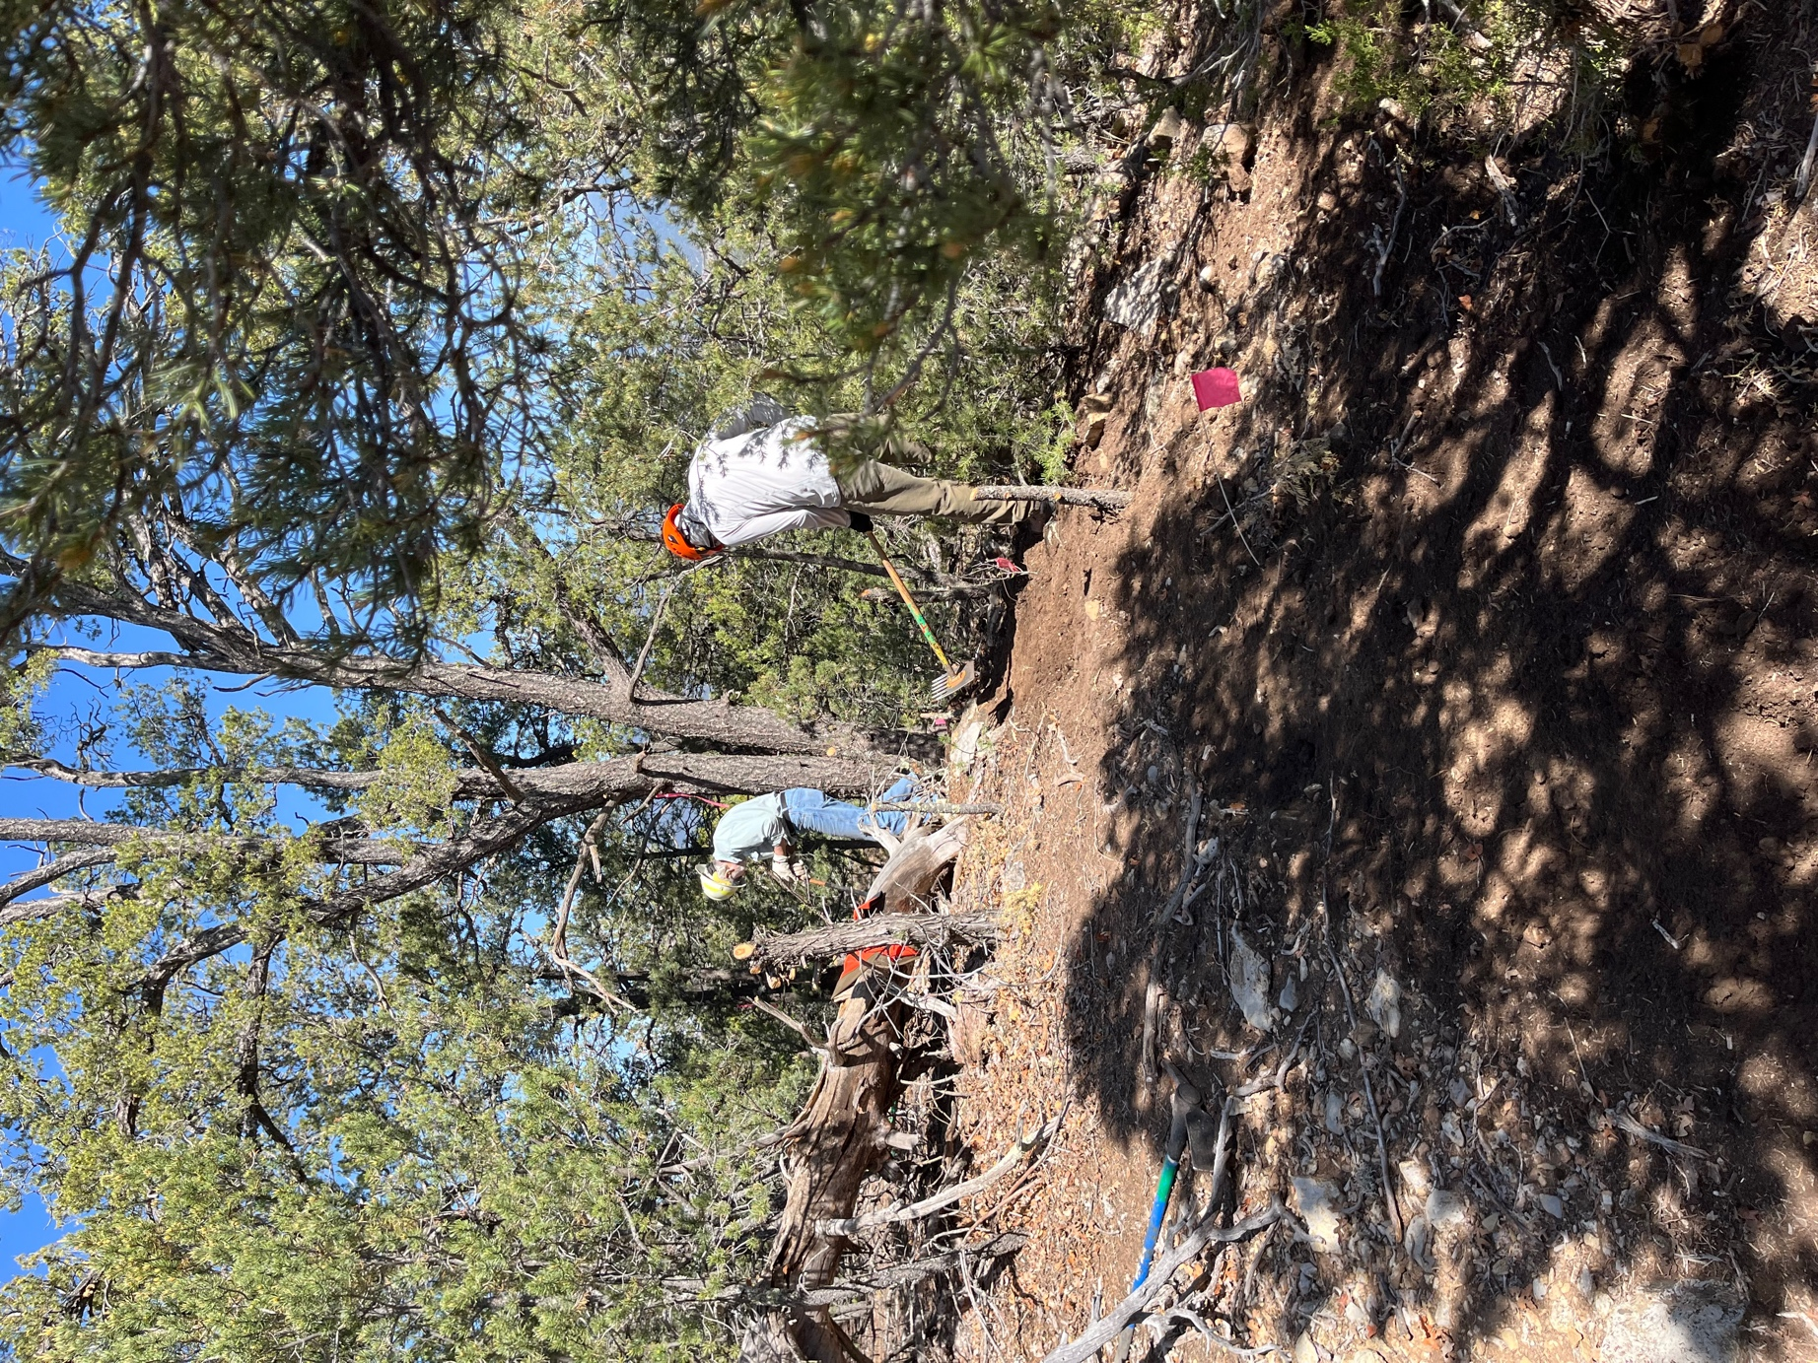

Byron and Don work out some tread.
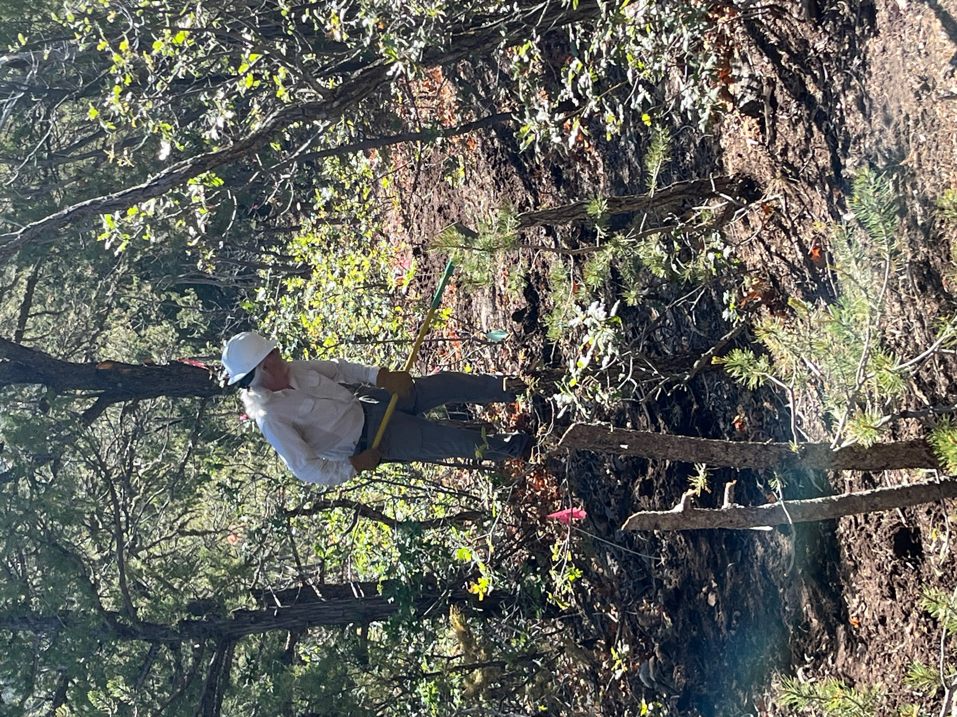

Bill starts tread while the stumps await his attention.
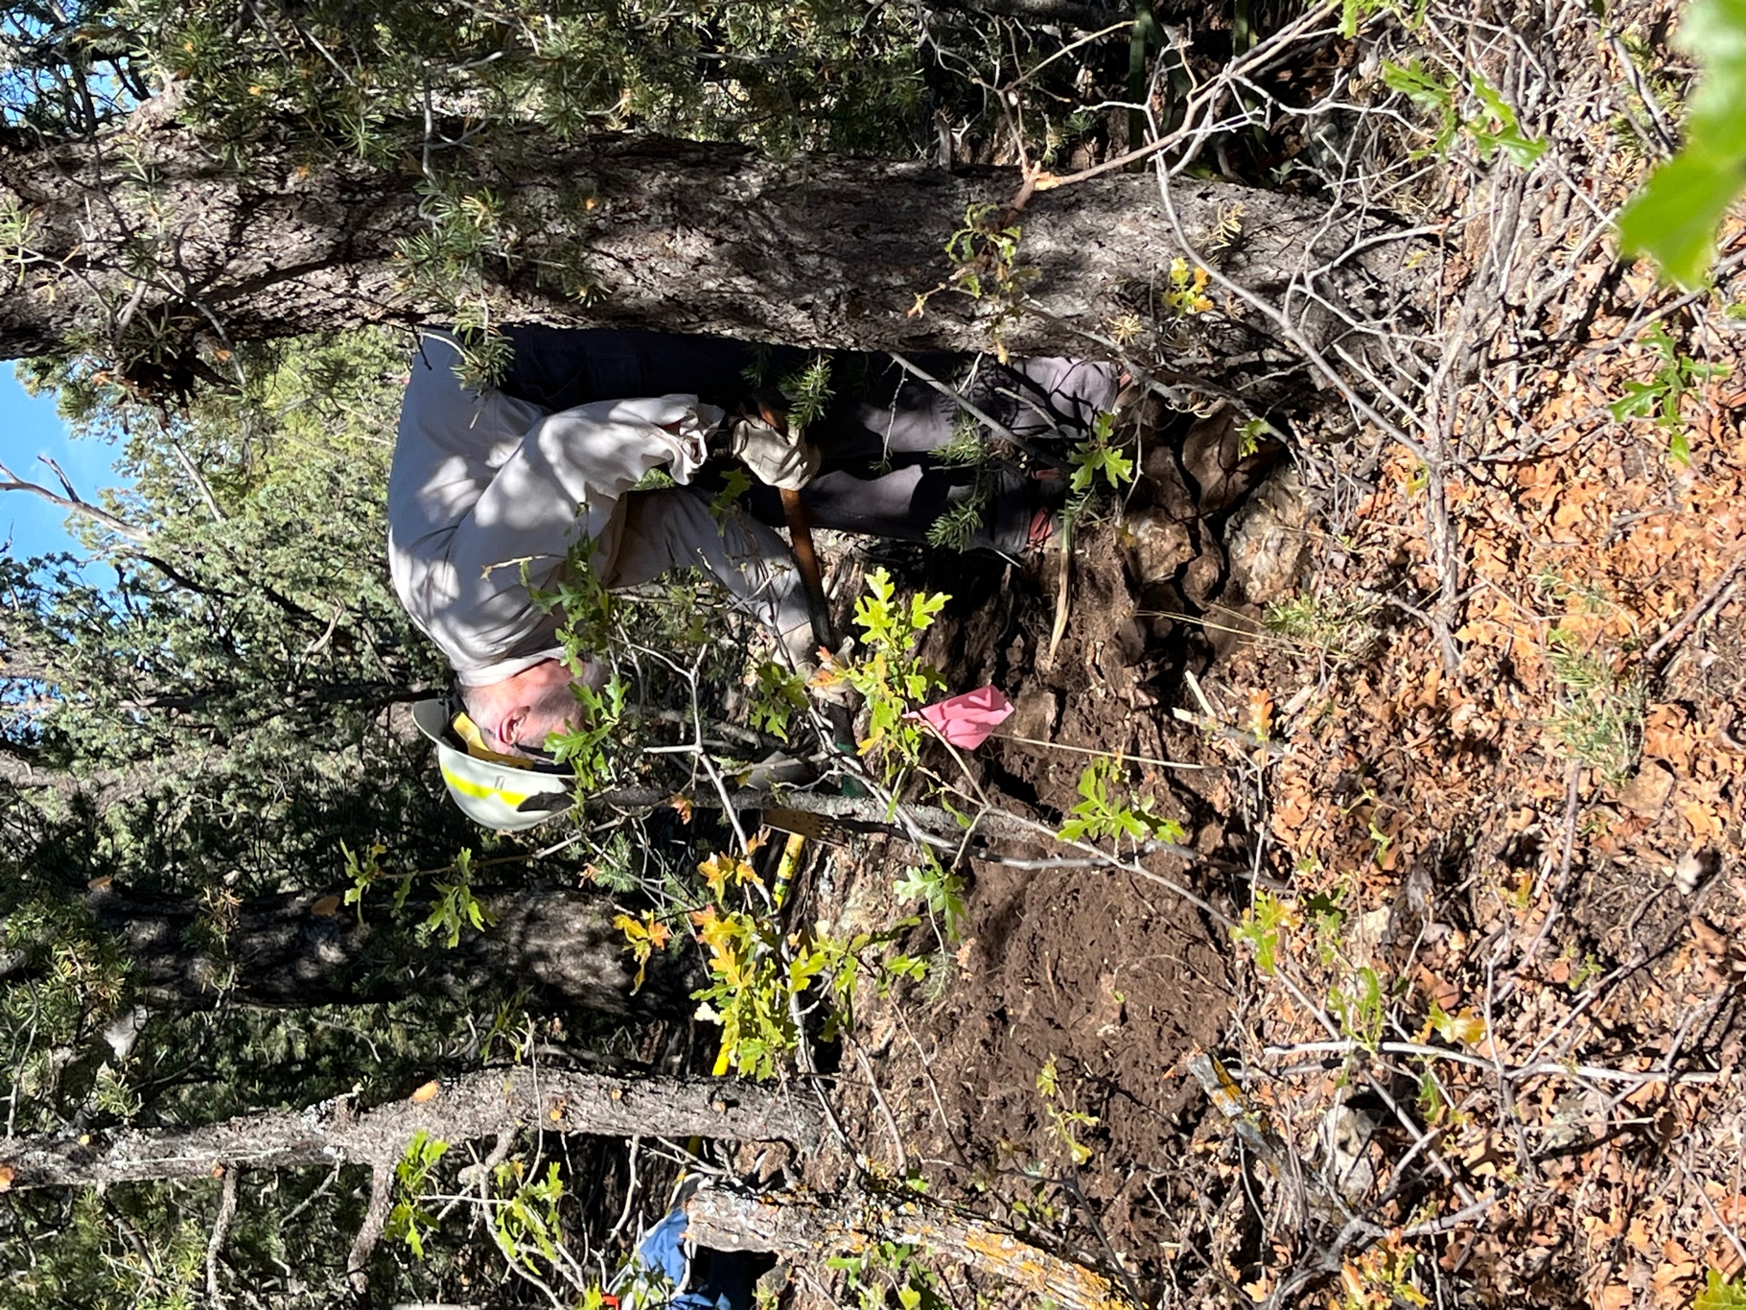

Cleve and stumps.
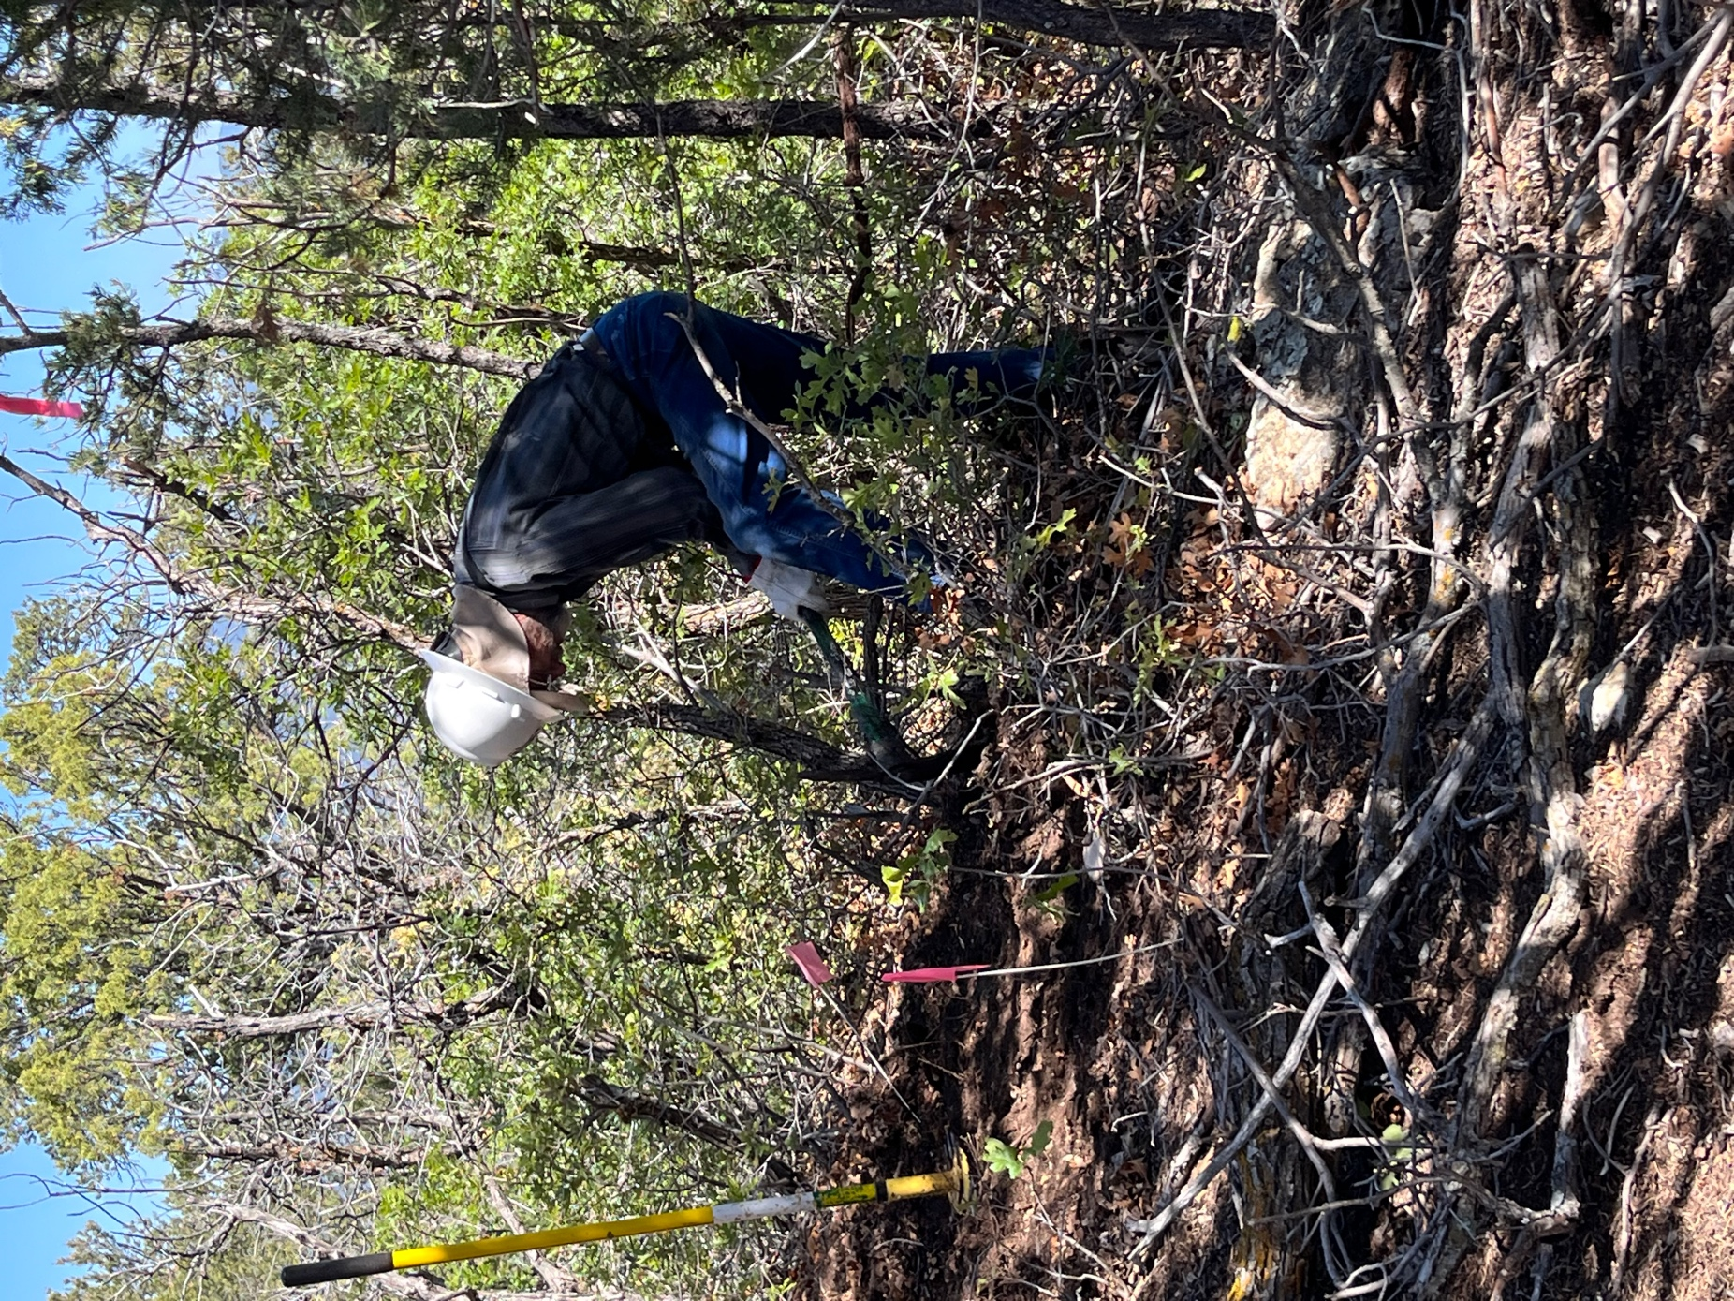

Bruce and stumps.
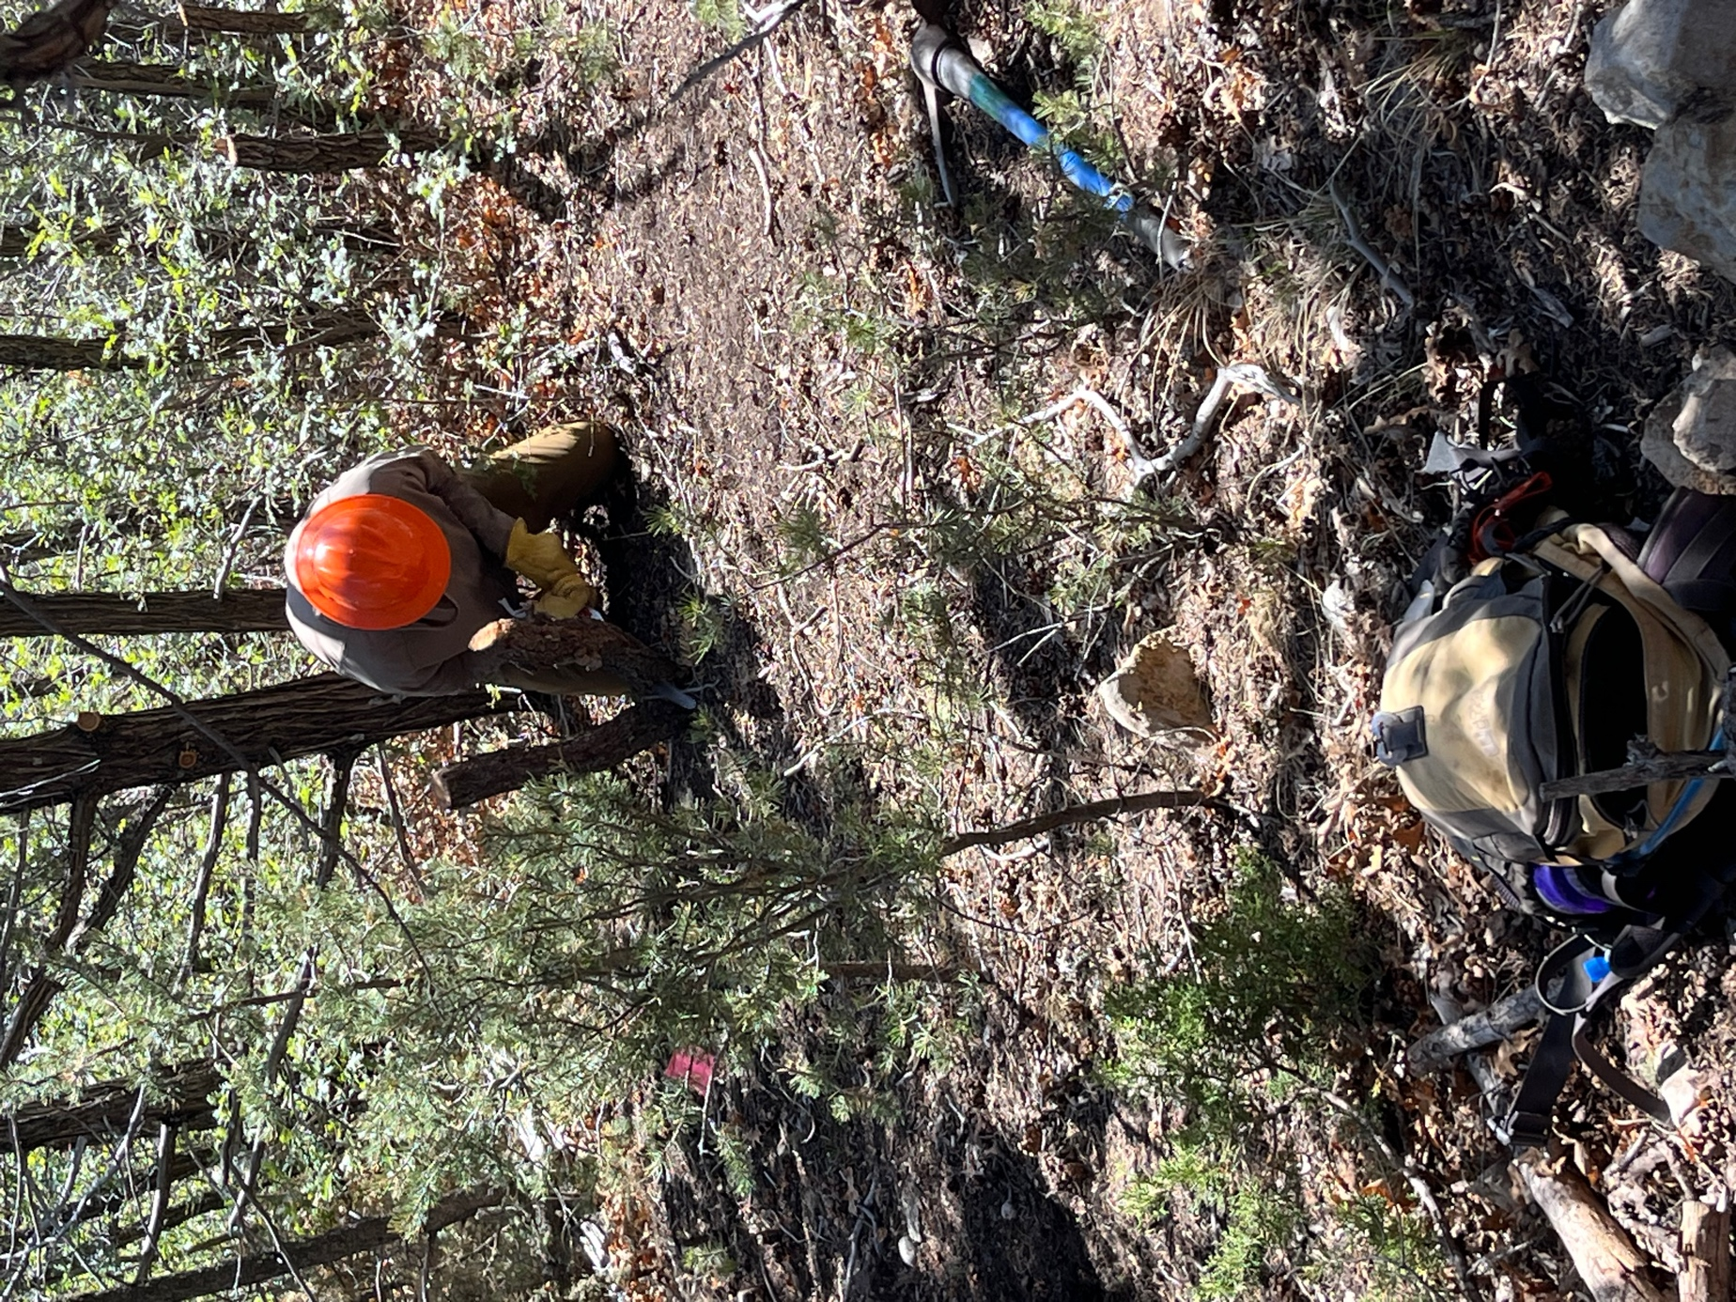

Jay and stumps.
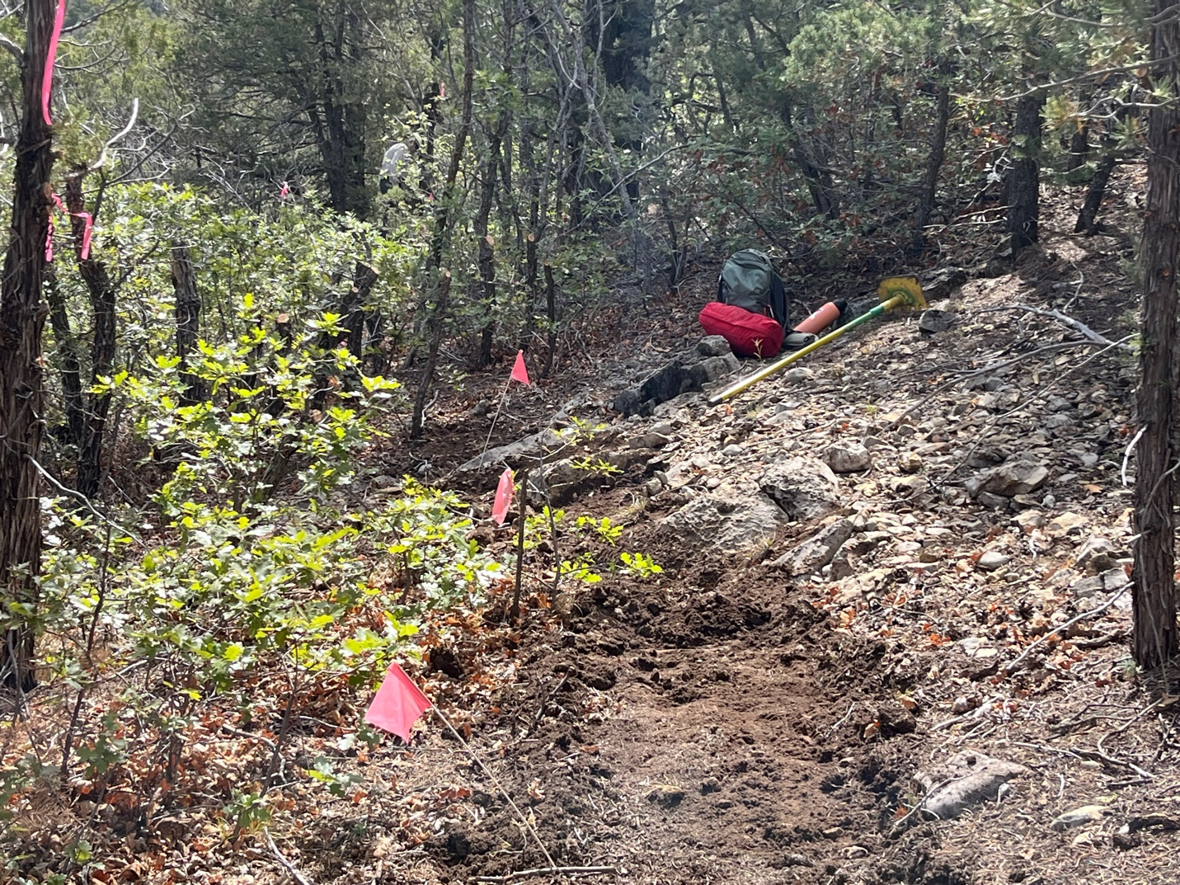

And there are rocks too!

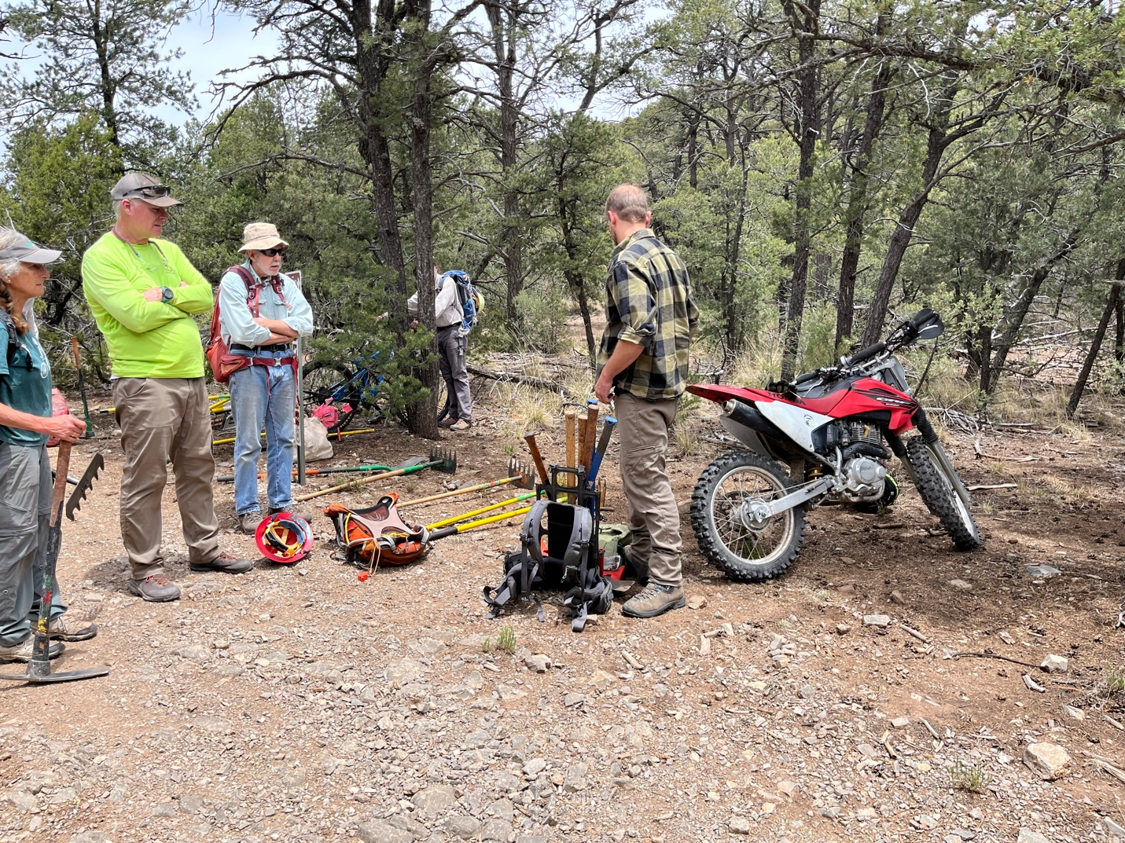

We had special help moving all the tools out. Canyon came with a motor bike and an ever-expanding pack to take out a bunch or pics.

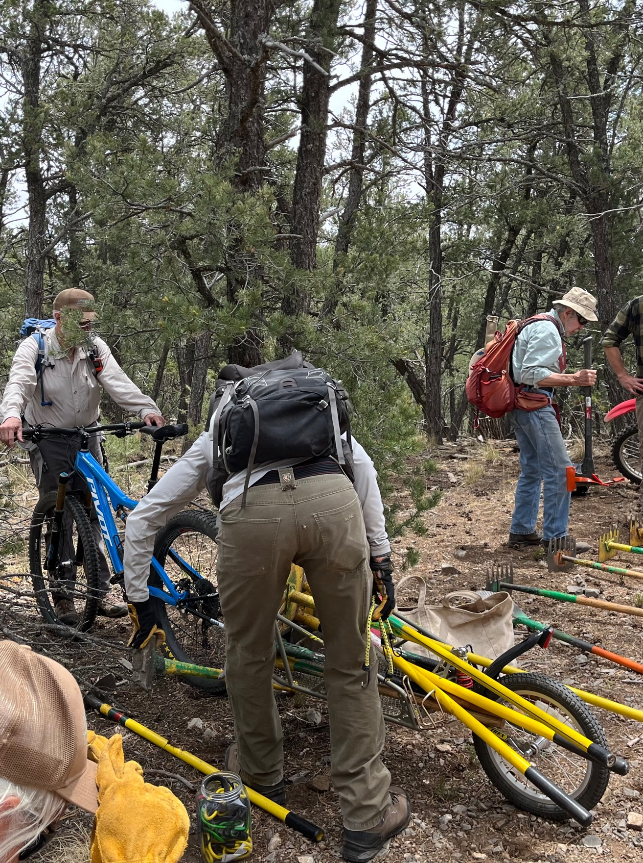

Don rode his bike and brought a trailer that was able to take out a bunch of McLeods. I broke the first rule of picture taking- no butt shots. Sorry Don!

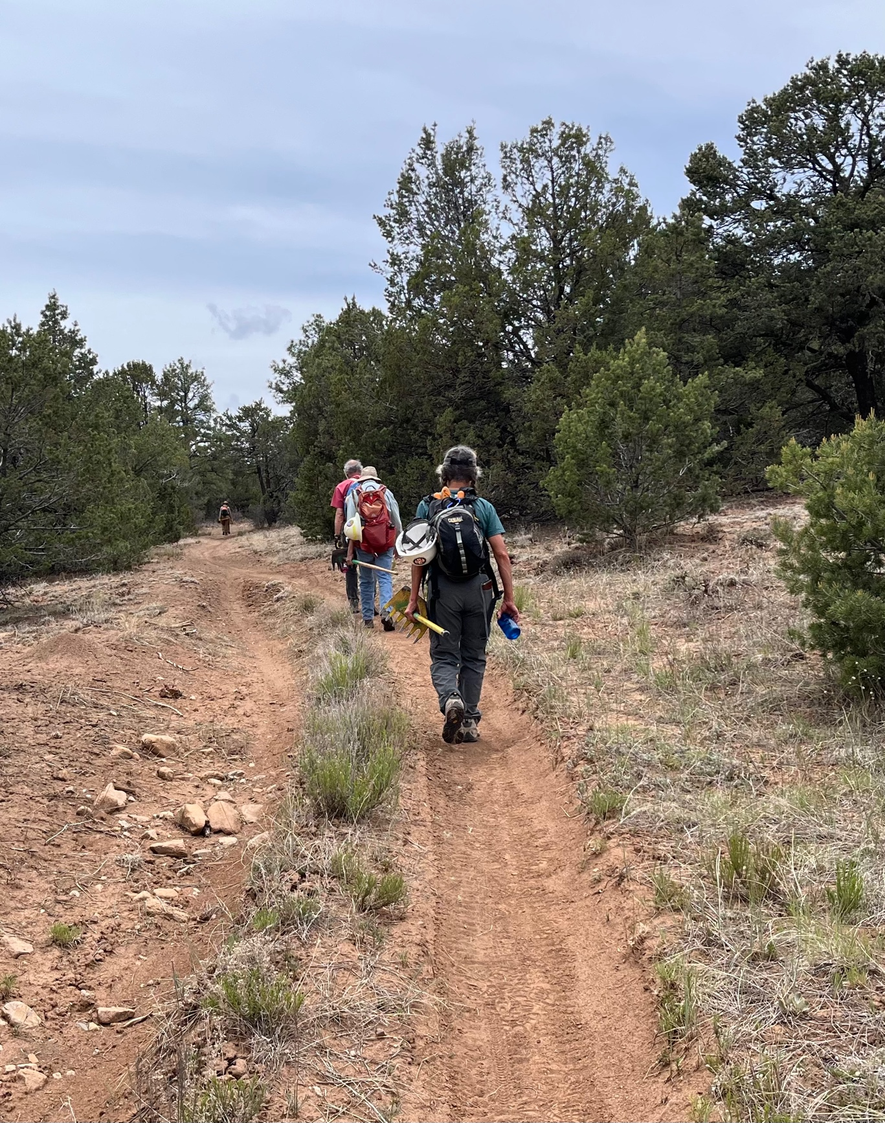

There were still plenty of tools for everyone to carry as well. Goodbye to Pokerchip for now.

