Trail Maintenance Project: Monday, June 01, 2026
Byron Garner
Last Monday our trail crew hiked 10K-N beginning at the trailhead with a lite breeze and a partly cloudy sky, to remove two reported trees located in the northern half of the trail before the Osha Loop junction. The first tree encountered was a twelve inch fir across the trail. With Cleve as lead sawyer, binds and trail clearances were assessed and with two cuts, the trail was clear. Moving on, we encountered the second tree, a fifteen inch rather knobby and elevated aspen across the trail, which proved to be the more interesting project. Jamey was our lead sawyer on this one and with an assessment of binds, escape routes and debris clearing, the sawing began. Luckily, with two cuts and a lot effort with the cant hook, the trail was clear.
By now, lunch time was approaching and we hiked on to the Ellis junction and had a good rest on a beautiful day. The more energetic of the crew elected to do a short "add on" to check on an unfinished project on Survey just passed the junction with that trail. The thirty inch tree they expected to find had been cleared and Survey and 10K-N up to Survey junction are now clear.
As a bonus, roadside iris were seen blooming. The crew included Phil Cromer, John Cooper, Rene Archer, Rich Federson, Cleve Sharp, Dave McCreery, Dana Price, Jamey Browning and Byron Garner. Photo credit: Rene Archer

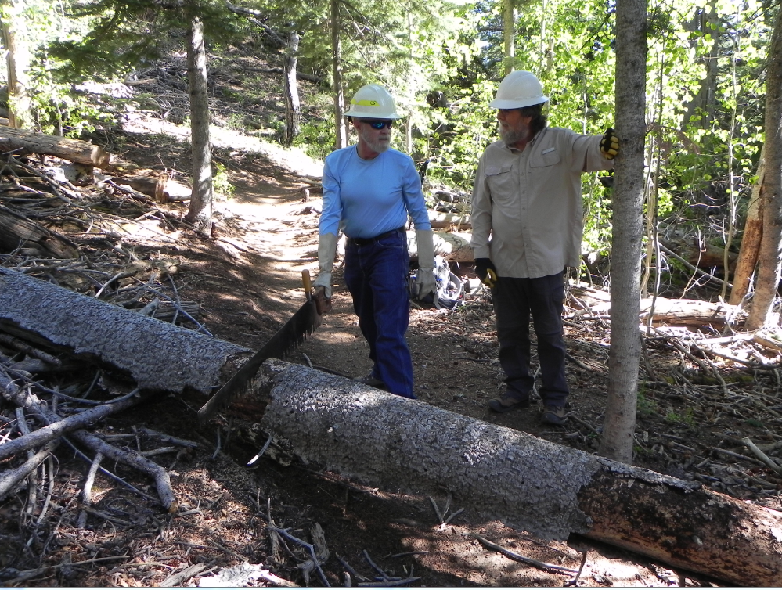
Cleve and Phil work on strategy

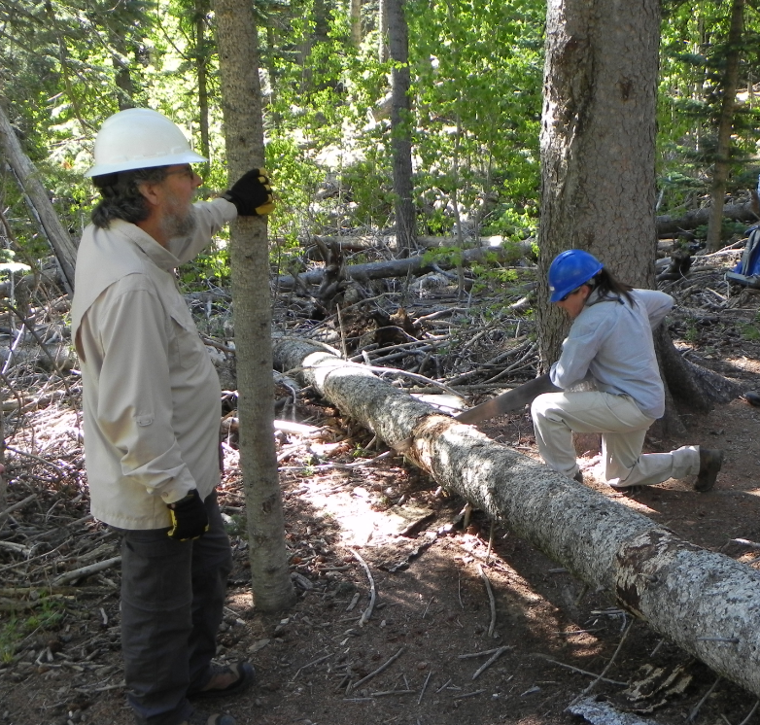
Dana gets a good start

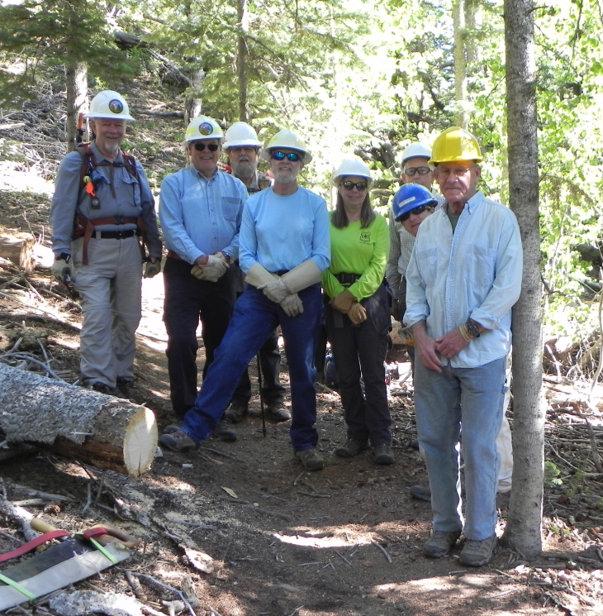
Clear to go
Jamey, Dave, Phil, Cleve, Rene, John, Dane and Rich

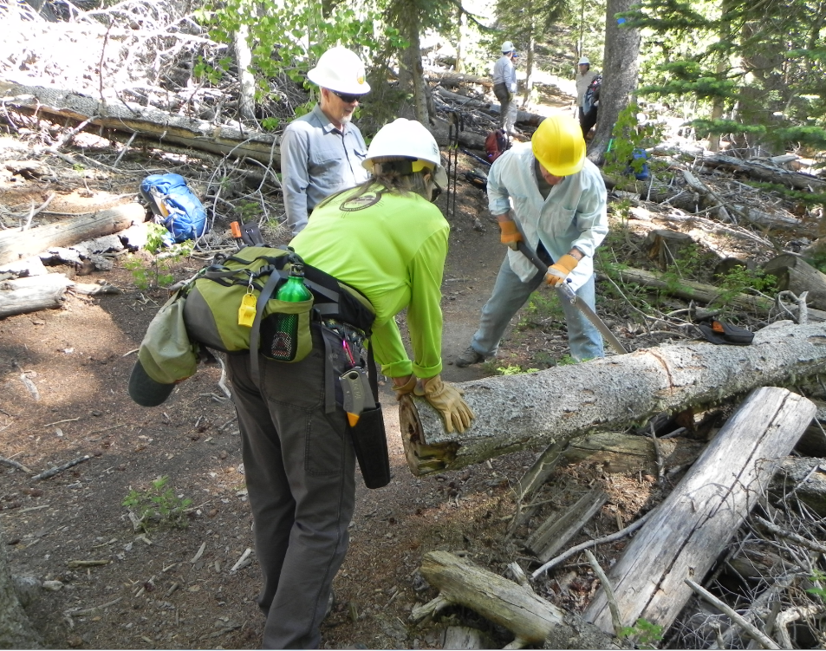
Rich works on a pesky intrusion

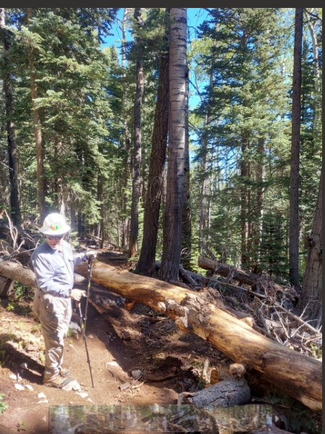Archer
Jamey takes measure of this fifteen incher

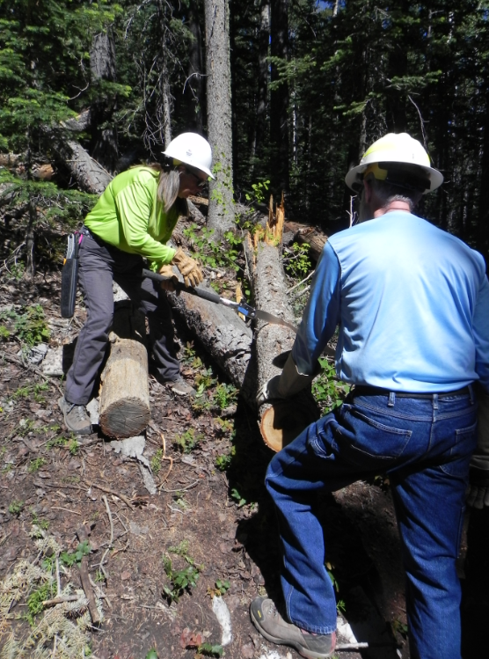
Rene clears for the escape route

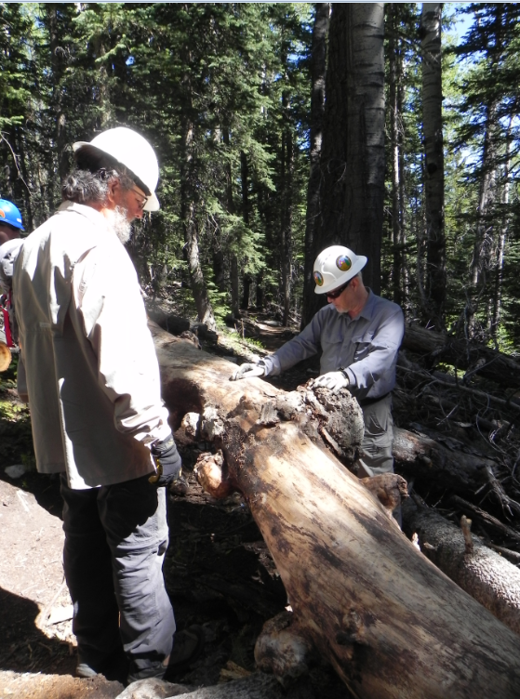
Phil and Jamey consider the "what-ifs"

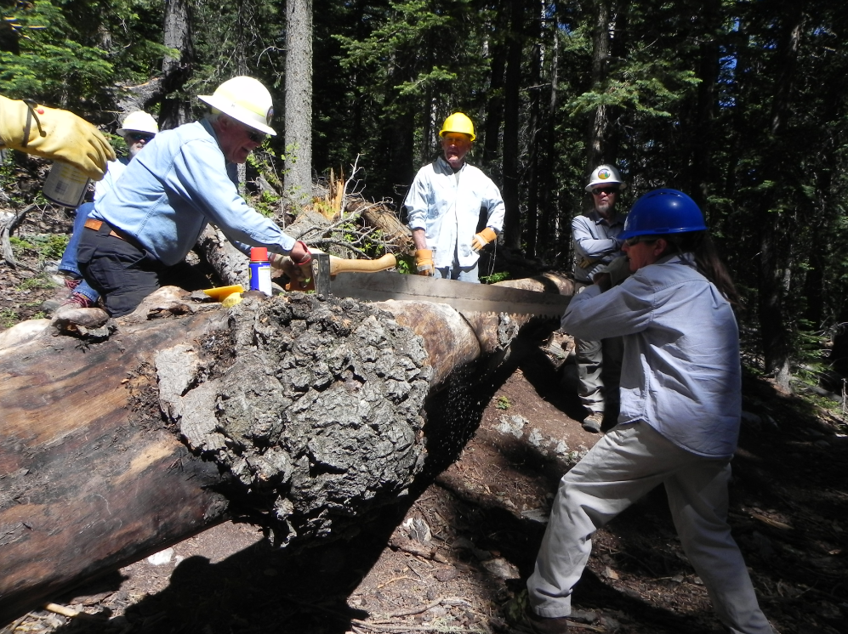
Dave and Dana give it their best

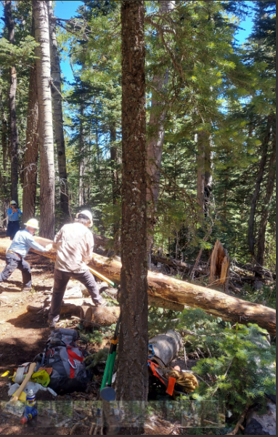Archer
Dave and Phil give the final push

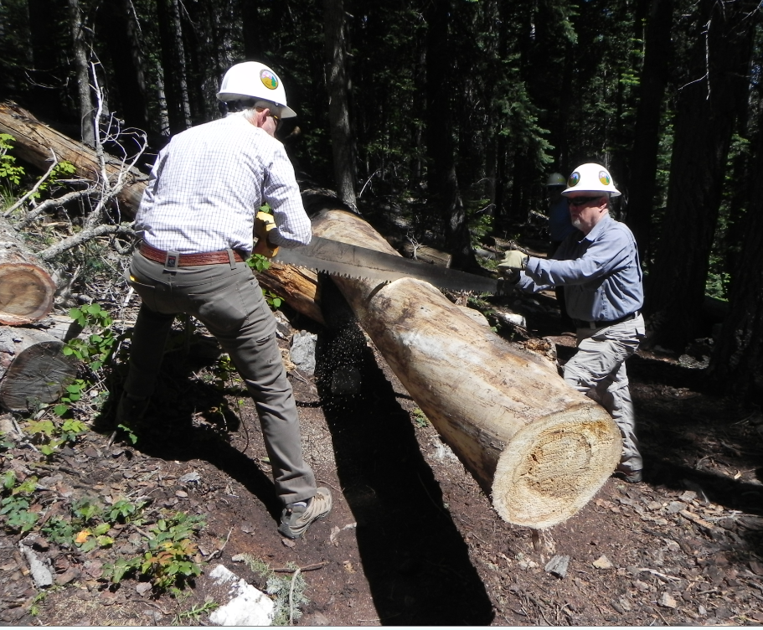
John and Jamey finish the final cut

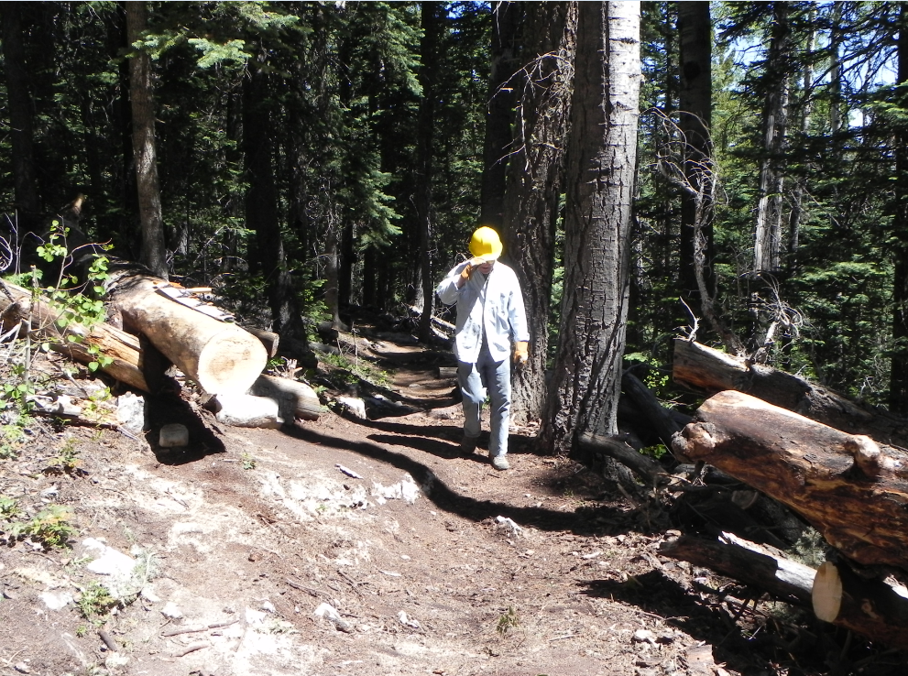

Rich gives the final check

