Thursday 06/04/26- 10K: The plan had been to work on the Bill Springs/Faulty interchange but a bear scuttled that and we worked on a couple of 10K reroutes. Five FOSM volunteers, 6 Talking Talons and Chris and Jen (SRD) all met up at the 10K parking are for some trail work. We hiked in about 1.5 miles to the first reroute and the Talking Talons and Jen went on another half mile to the second reroute. The groups set to work on moist and duffy soil. There were plenty of rocks to remove and by the end of the day the work was completed. It was a beautiful day and FOSM volunteers really enjoyed the green, cool change from Pokerchip.

Volunteers: John McNett, Bill Perkins, Byron Garner, Eric Russell and Laura Leon

Pictures: Laura Leon

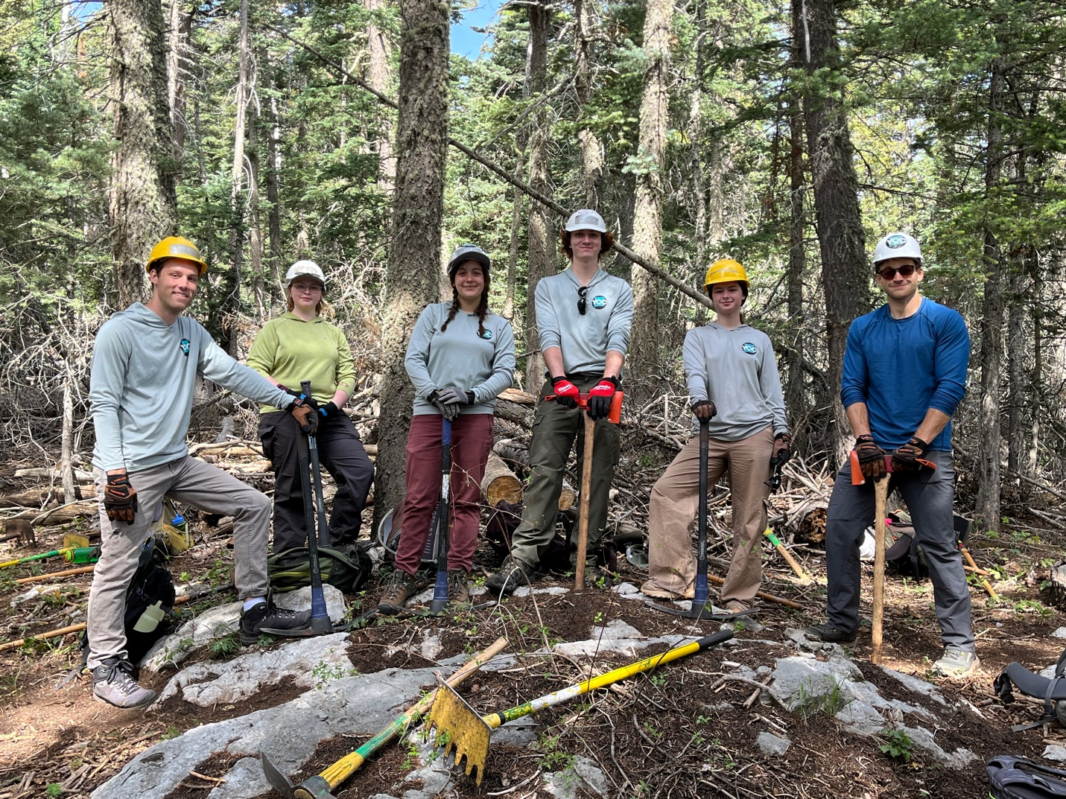

Talking Talons (L to R): Aiden, Zoe, Lila, Kyle, Beth and Beck
Heading off with Jen to work on one of the reroutes.

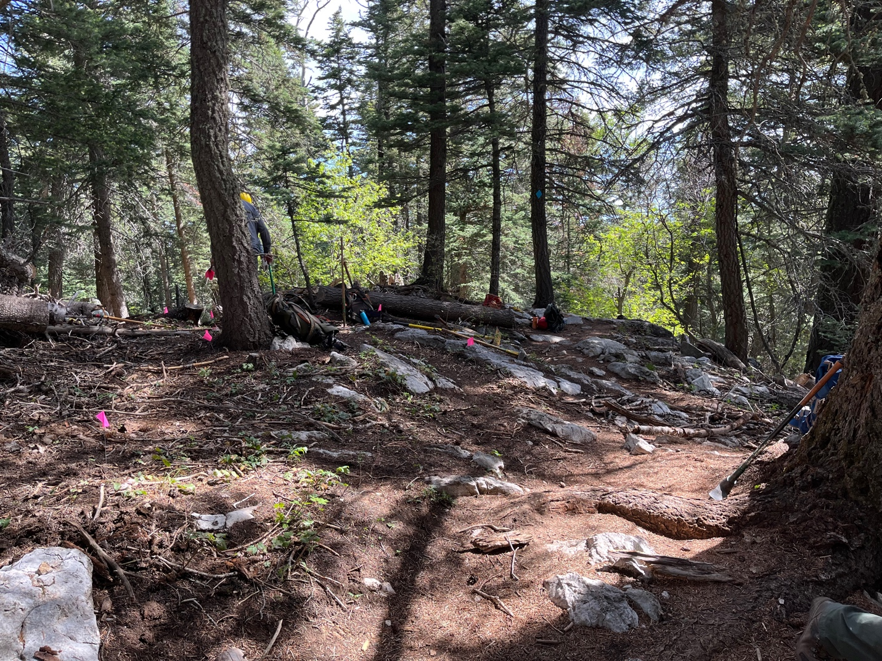

Old trail to the right and new trail marked on the right.
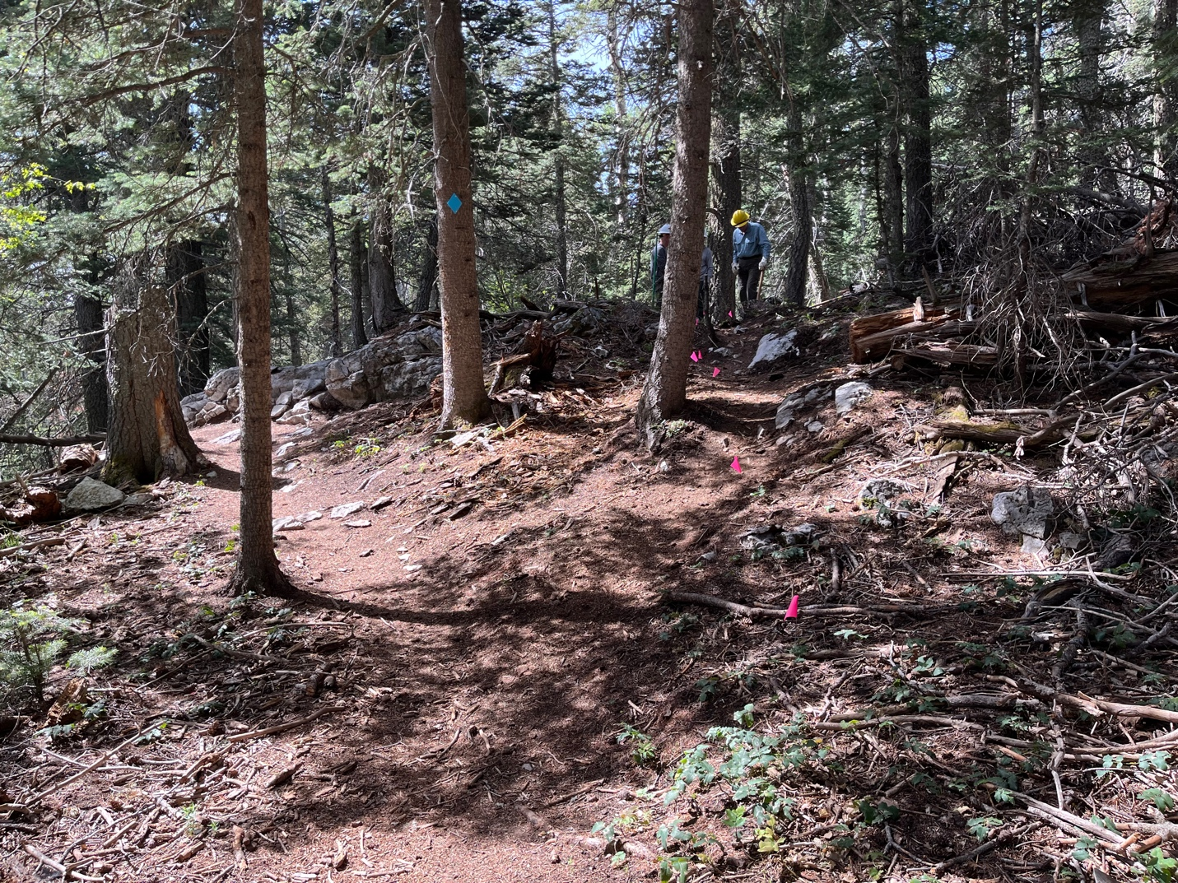

From the other direction- old trail on the left (you can see the large rock outcrop on the edge of the slope that users have been trying to navigate) and new trail on the right.

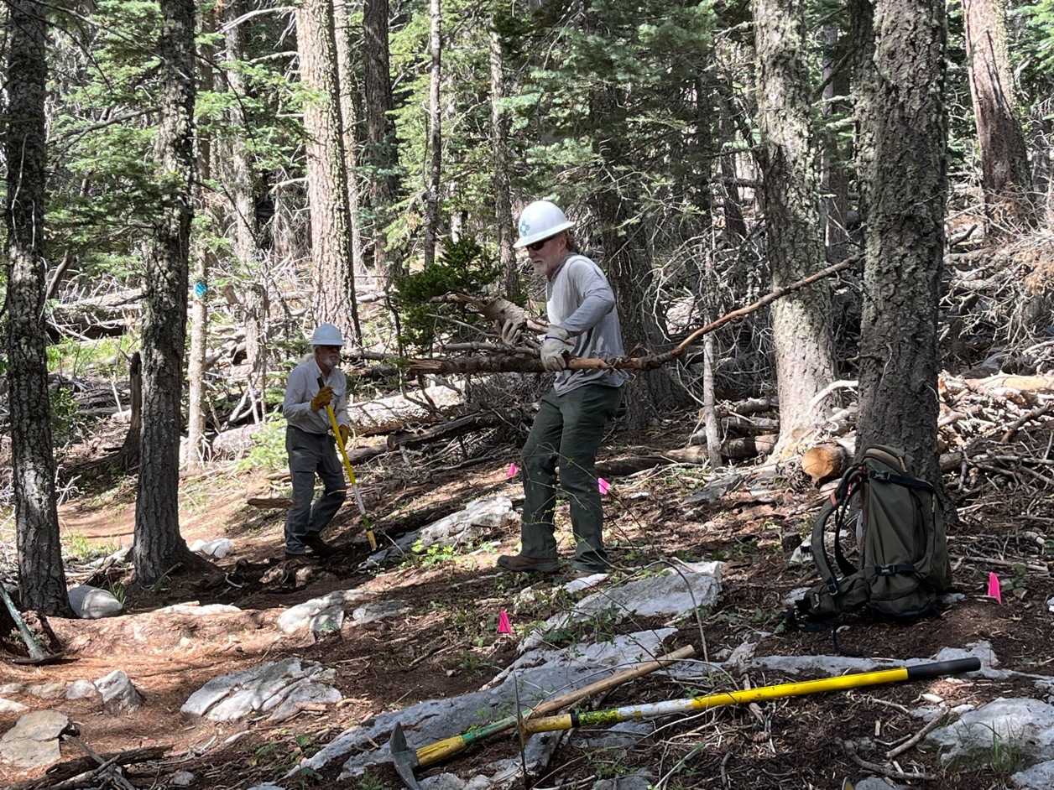

Lots of debris to move- Bill and John (above ), Byron and Eric (below)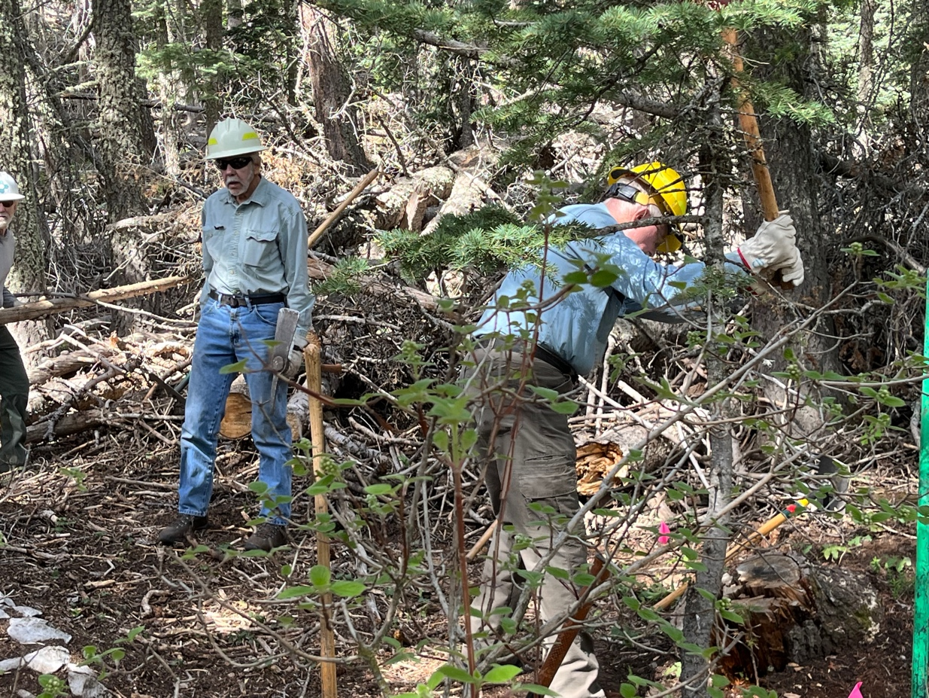
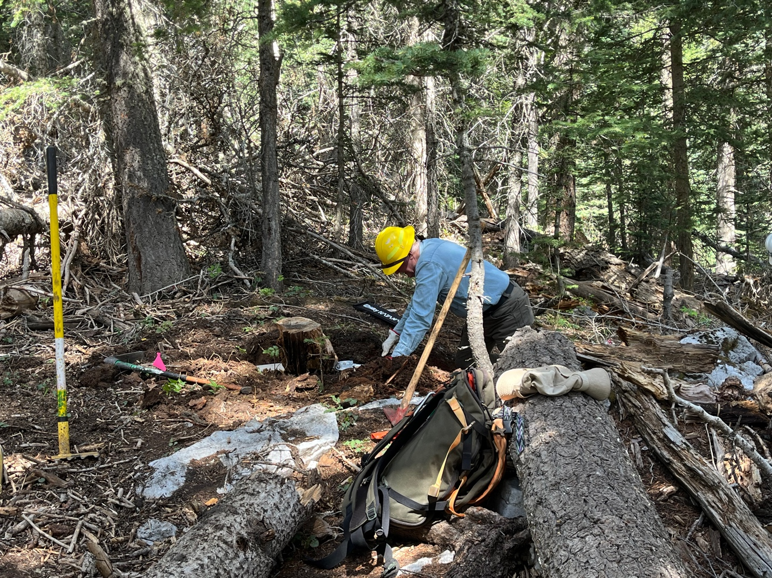

Eric dug out this large stump which was partially decayed but had a stout core.

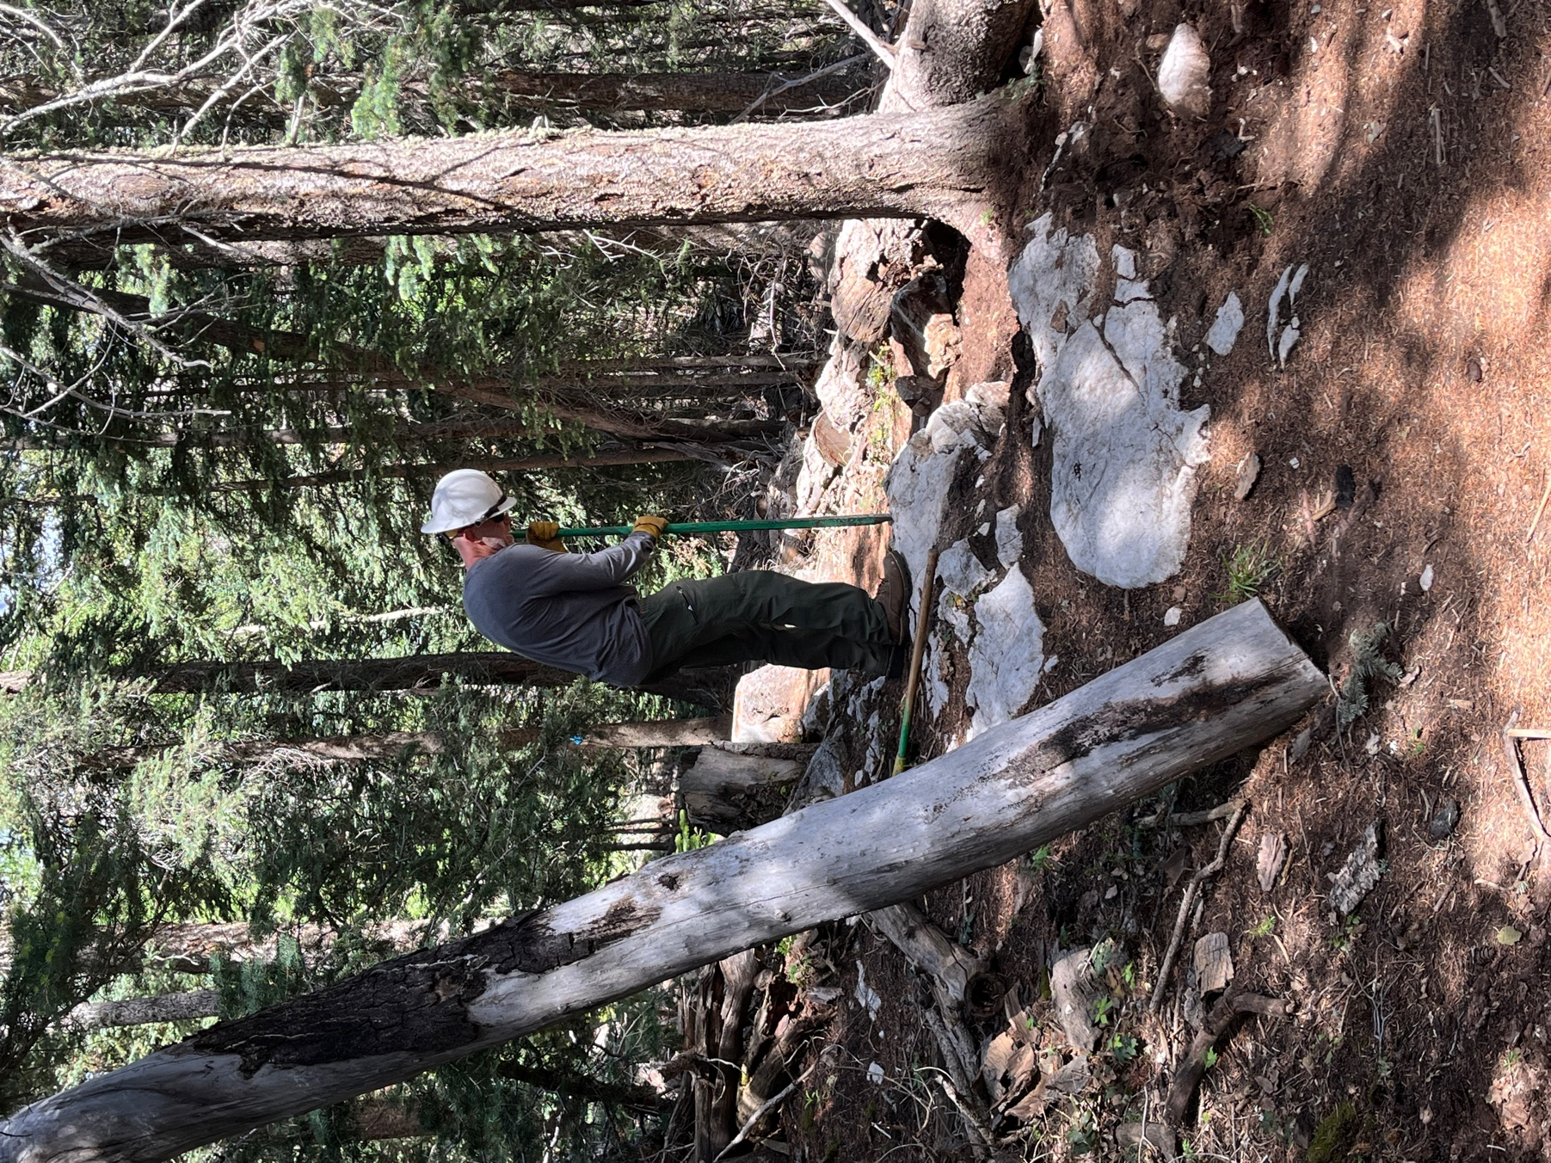

Chris works on breaking down rock. The large dead tree in front of Chris is part of a problem-
There are 2 dead trees hung up in a real mess. But not work for today’s crew.
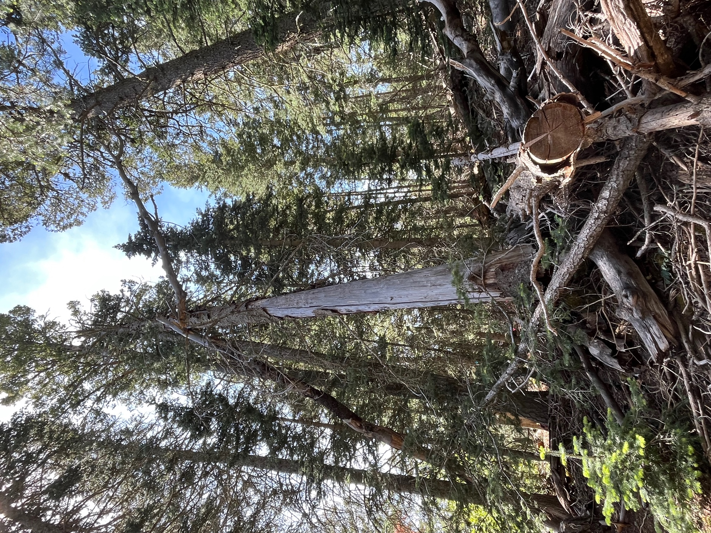
So many pretty flowers and green shoots coming out!

