New FOSM Adopt-A-Trail Sign for Tecolote Trail
Made by Jamey Browning, Sunday, June 7, 2026

Sam Beard
Jamey Browning has made a new Adopt-A-Trail sign for Tecolote Trail, one of the trails adopted by FOSM. It will replace a sign that was installed on Tecolote Trail many years ago. Jamey made the sign with oak wood and deeply routed the text with his automated equipment. Sam Beard applied one coat of Cabot Australian Timber Oil Natural color. Jamey thought that a coated sign would probably be better that an uncoated sign in the Sandia Mountain weather. Photos of the oak sign without and with the oil finish are presented below.

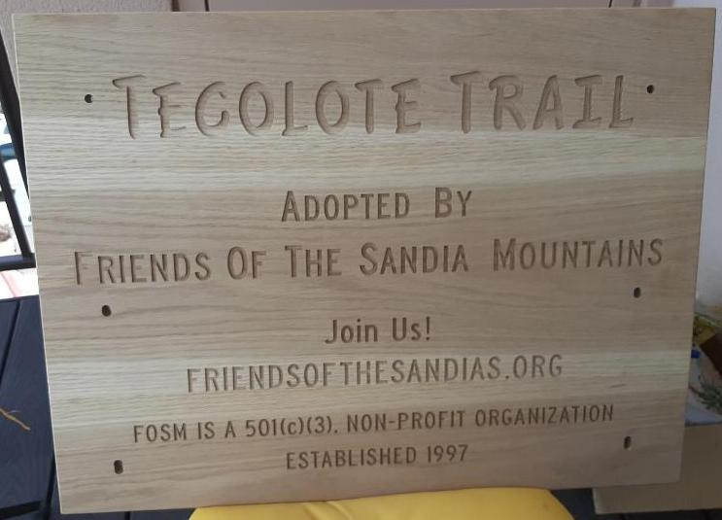
Adopt-A-Trail sign made by Jamey Browning to go on Tecolote Trail that was adopted by FOSM. All photos by Sam Beard
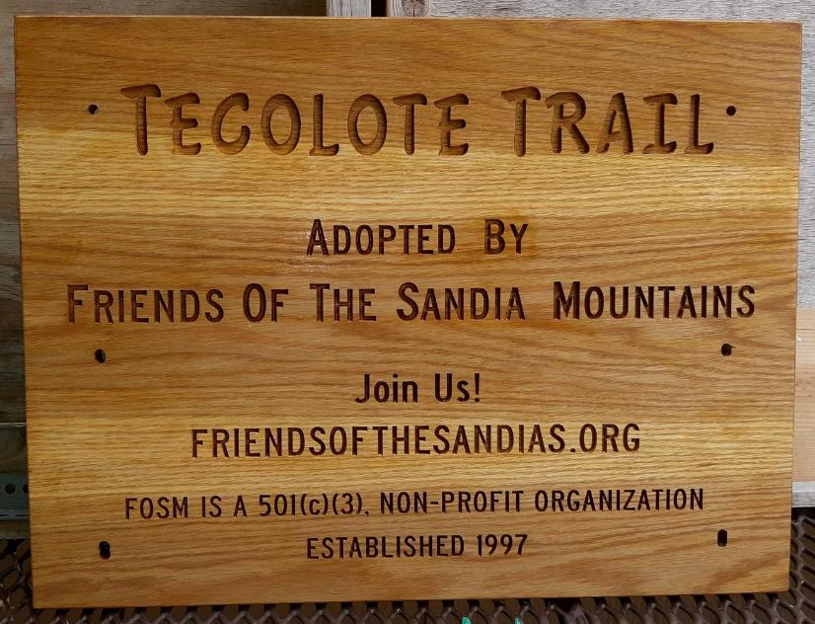
Jamey’s Adopt-A-Trail sign after Sam put one coat of Cabot Australian Timber Oil Natural color on it.

