Trail Maintenance Report: Monday, June 8, 2026
Byron Garner

On Monday the trail crew headed up Agua Sarca trail to begin work clearing several trees reported by Canyon Young USFS. The first, a little more than one mile from the trail head, was a complex cluster of two entangled moderately angled leaners suspended over the trail which included a bifurcated fir with an estimated thirty inch base and a much smaller fir. The crowns of both trees were entangled by cross trail supporting trees and stable. The primary issue was with the lower eleven and one half inch diameter segment of the bifurcated tree which was obstructing the trail. After limbing and escape route preparation, careful consideration was given to our strategy and potential complications for the two required cuts. Once done, there was adequate clearance under the remaining tree cluster which remained stable.
A very short distance up the trail were two more low angled leaning firs - fourteen and one half and sixteen and one half inches in diameter respectively. With these trees as close as they were to our lower work site, simultaneous work was done on these which required extensive limbing. Potentially complex binds and uncertain movement again required more collaborative discussion before cranking up the saws. The final effort required a total of two cuts each.
With a few more trees known to be a short and very steep hike further up the trail as you exit the canyon, Cleve and Dave elected to go for a look as our other work continued. As expected, two more trees were found and well documented though time did not allow for the work to be finished that day. Agua Sarca is definitely not a hot weather trail, though conditions turned out to be reasonably comfortable in the denser forest but not in the more exposed scrub. The crew included Cleve Sharp, John Cooper, Dave McCreery, Dana Price, Steve Roholt and Byron Garner. Photo credit: John Cooper and Steve Roholt

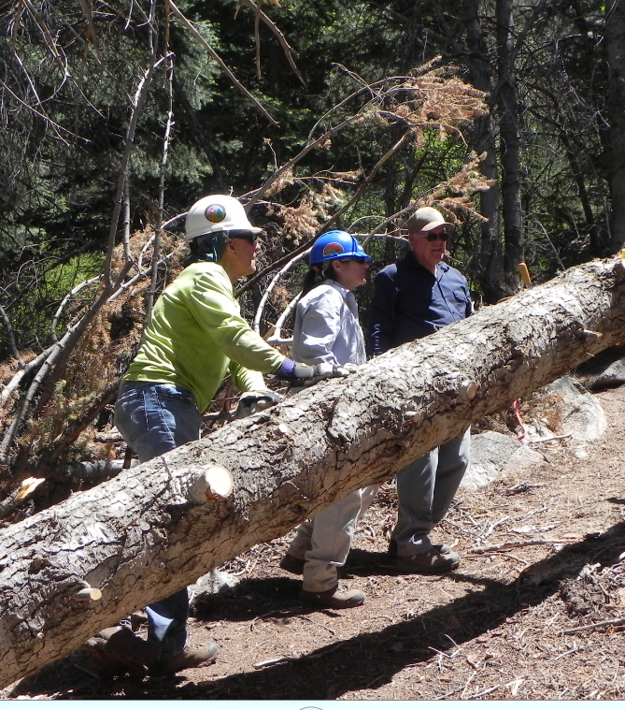
Steve, Dana and Dave discuss how best to continue on the first tree

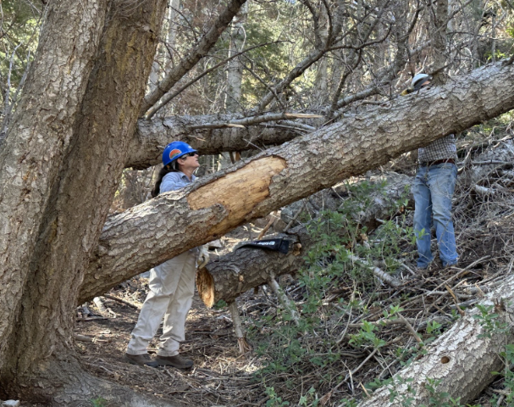Roholt
Dana and John limbing our next two trees

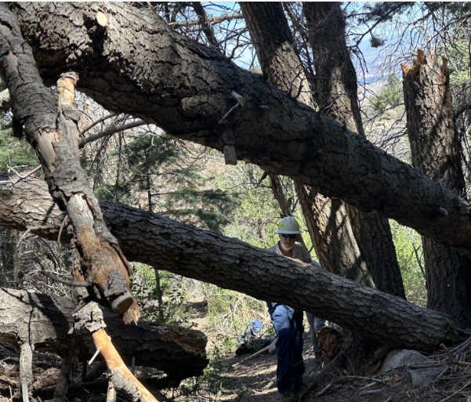Roholt Cleve continues the effort

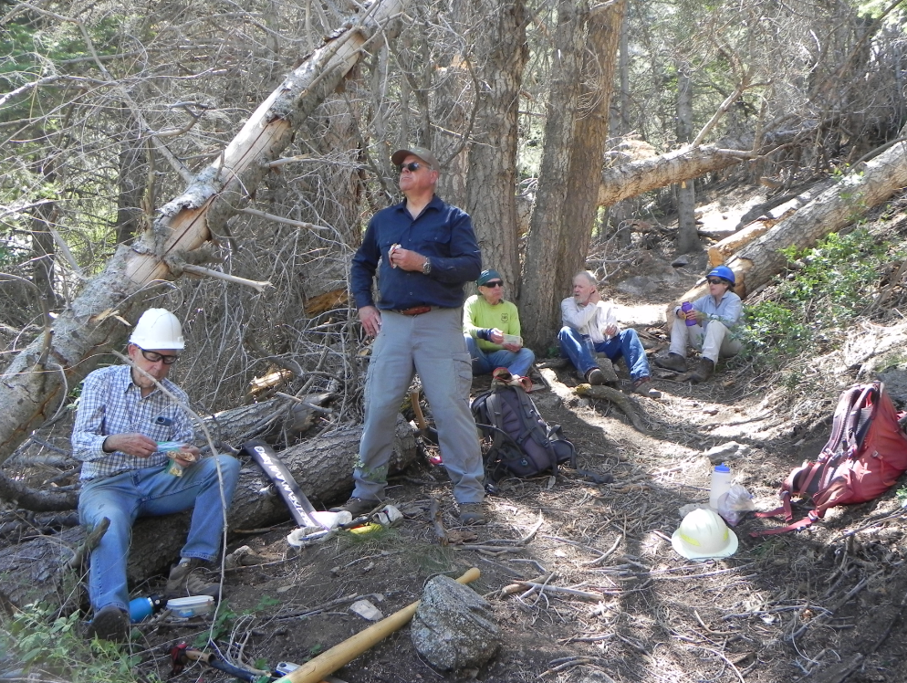
A shady lunch we were all grateful for

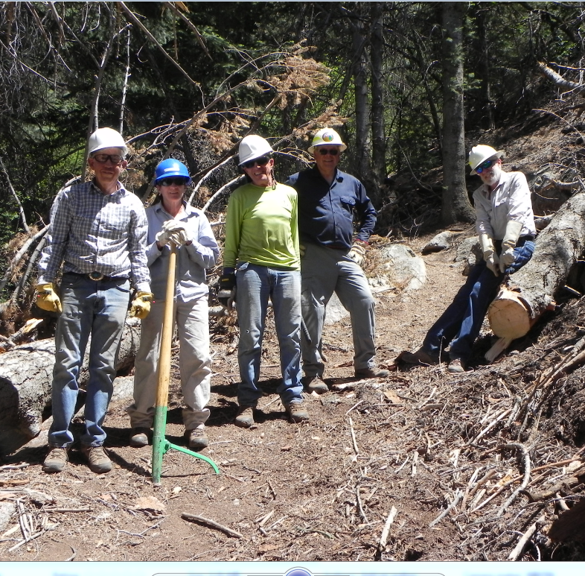
John, Dana, Steve, Dave and Cleve

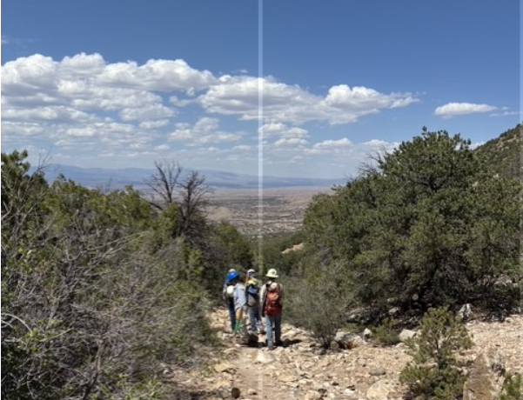Cooper
Homeward bound

