Thursday, 06/11/26-Bill Springs/Faulty junction: This week we had 7 Talking Talons, Jen and Chris (SRD) and 6 FOSM volunteers meet at the Doc Long parking area to do rock work on the creek along Bill Springs and start work on the repairing and fixing of sections of Faulty, starting at the junction. The work of the day was hot, although it didn’t start out too bad. Even with all the trees, the sun was relentless and seemed to find the spots we were working on. The rock work was completed by Jen and the Talking Talons and the other workers got a good start on Faulty work which will continue next week.

Volunteers: Kent Towler, Kerry Jones, Eric Russell, Luis Cuadros, Bruce Hansche and Laura Leon

Talking Talons: Beth, Aiden, Zoe, Lila, Kyle, Beck and Kiara

Pictures: Laura Leon

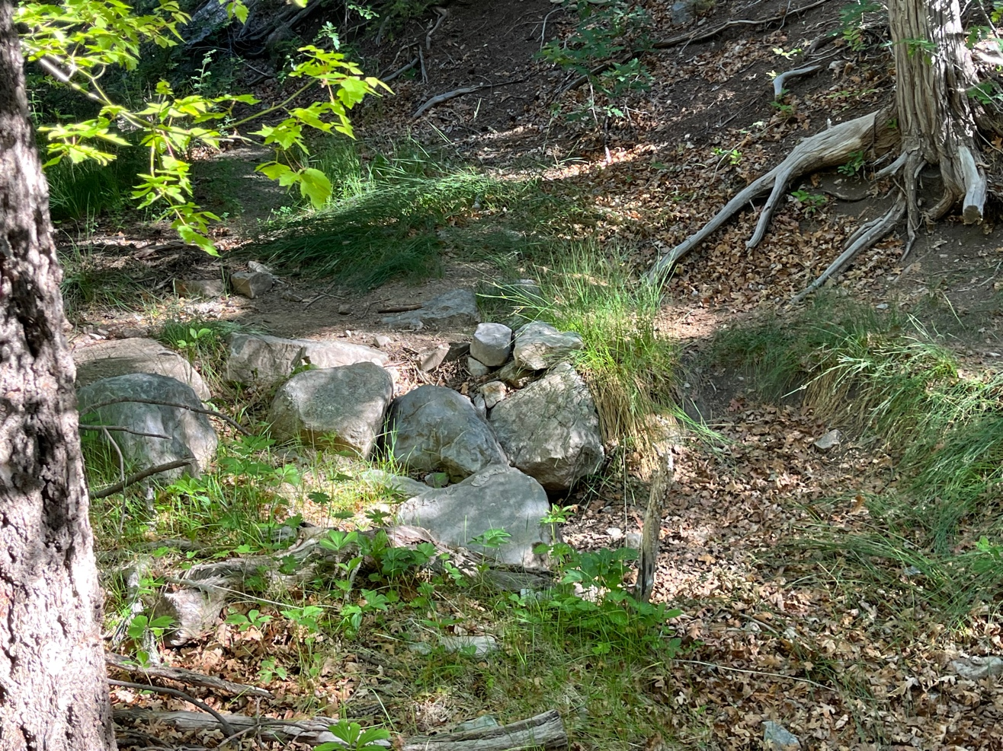

Rock work needed in this section of the creek.

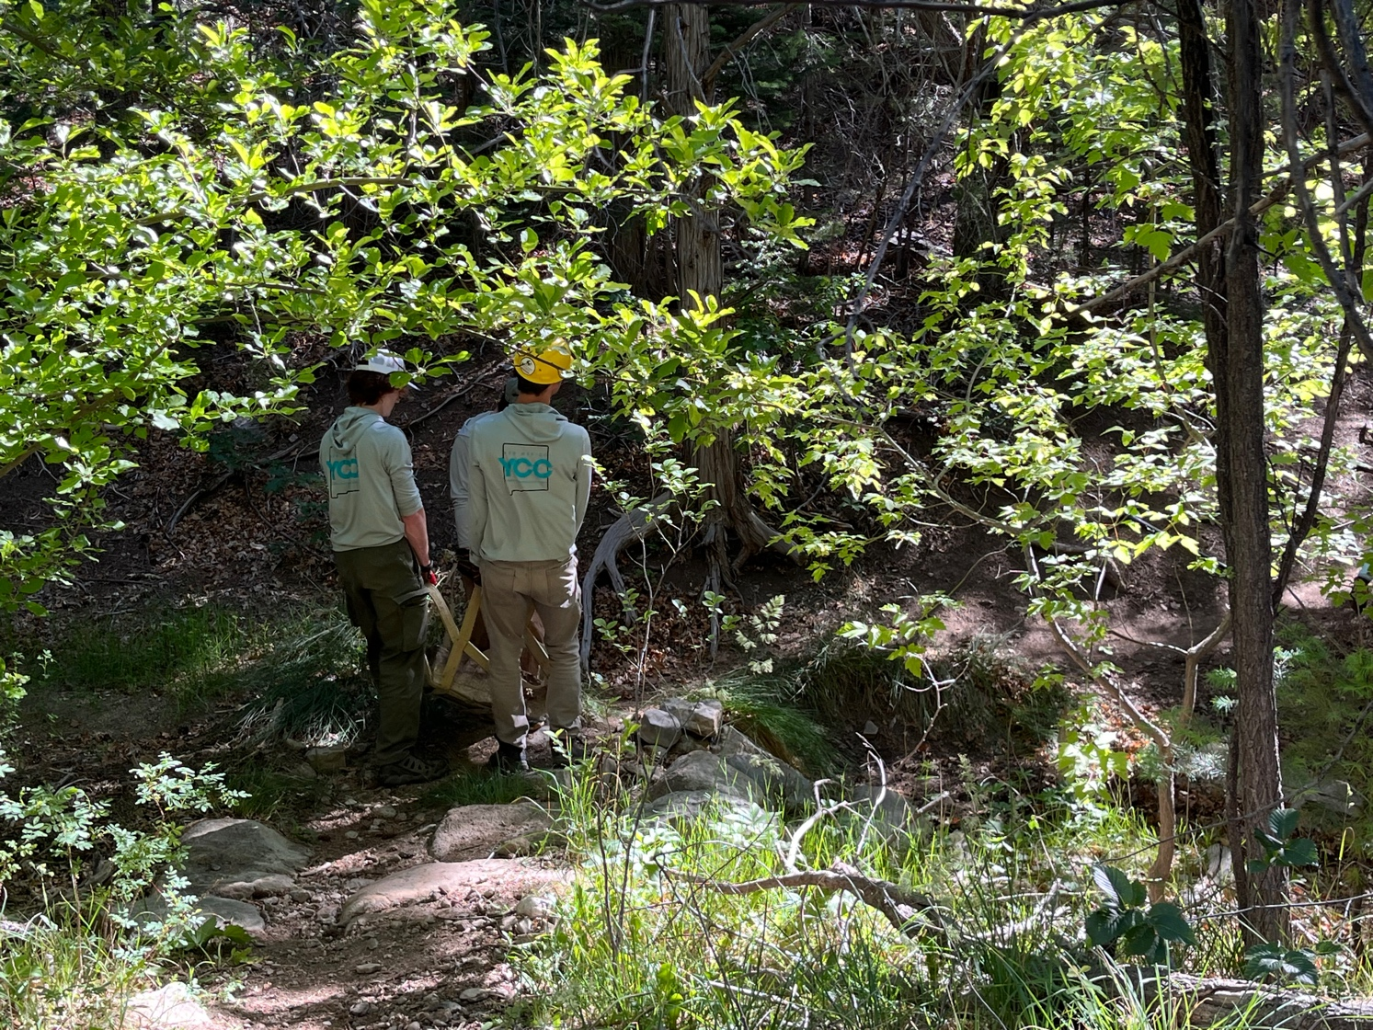

Aiden and Kyle get started on lugging big rocks. You can see where the banks of the creek have been dug out to accommodate more rocks for stabilization. Always with the more and bigger rocks…….
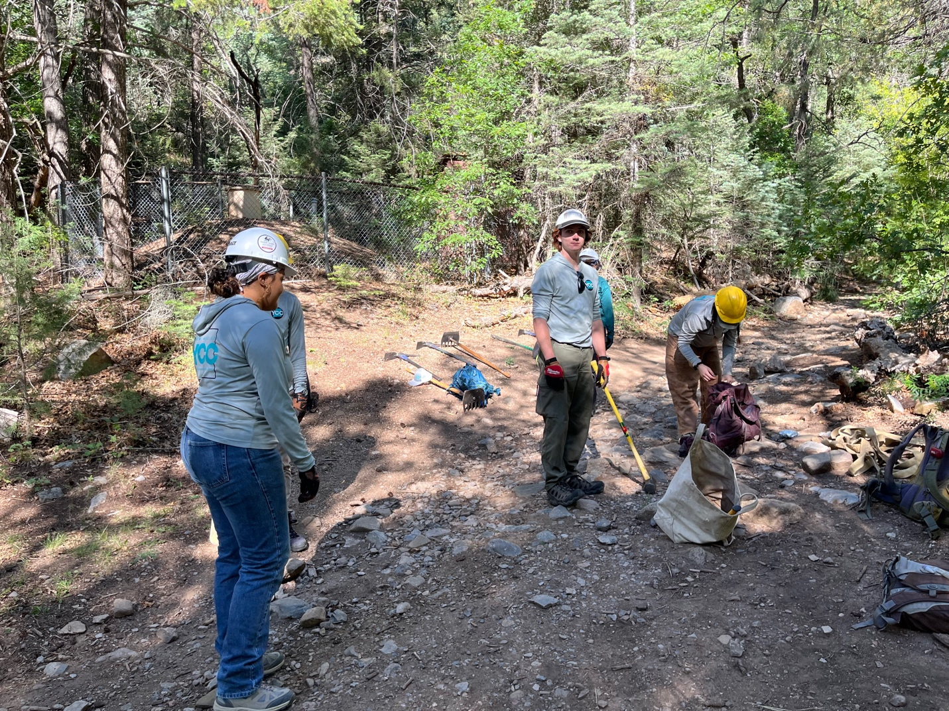

Kiara, Kyle and others get materials ready.

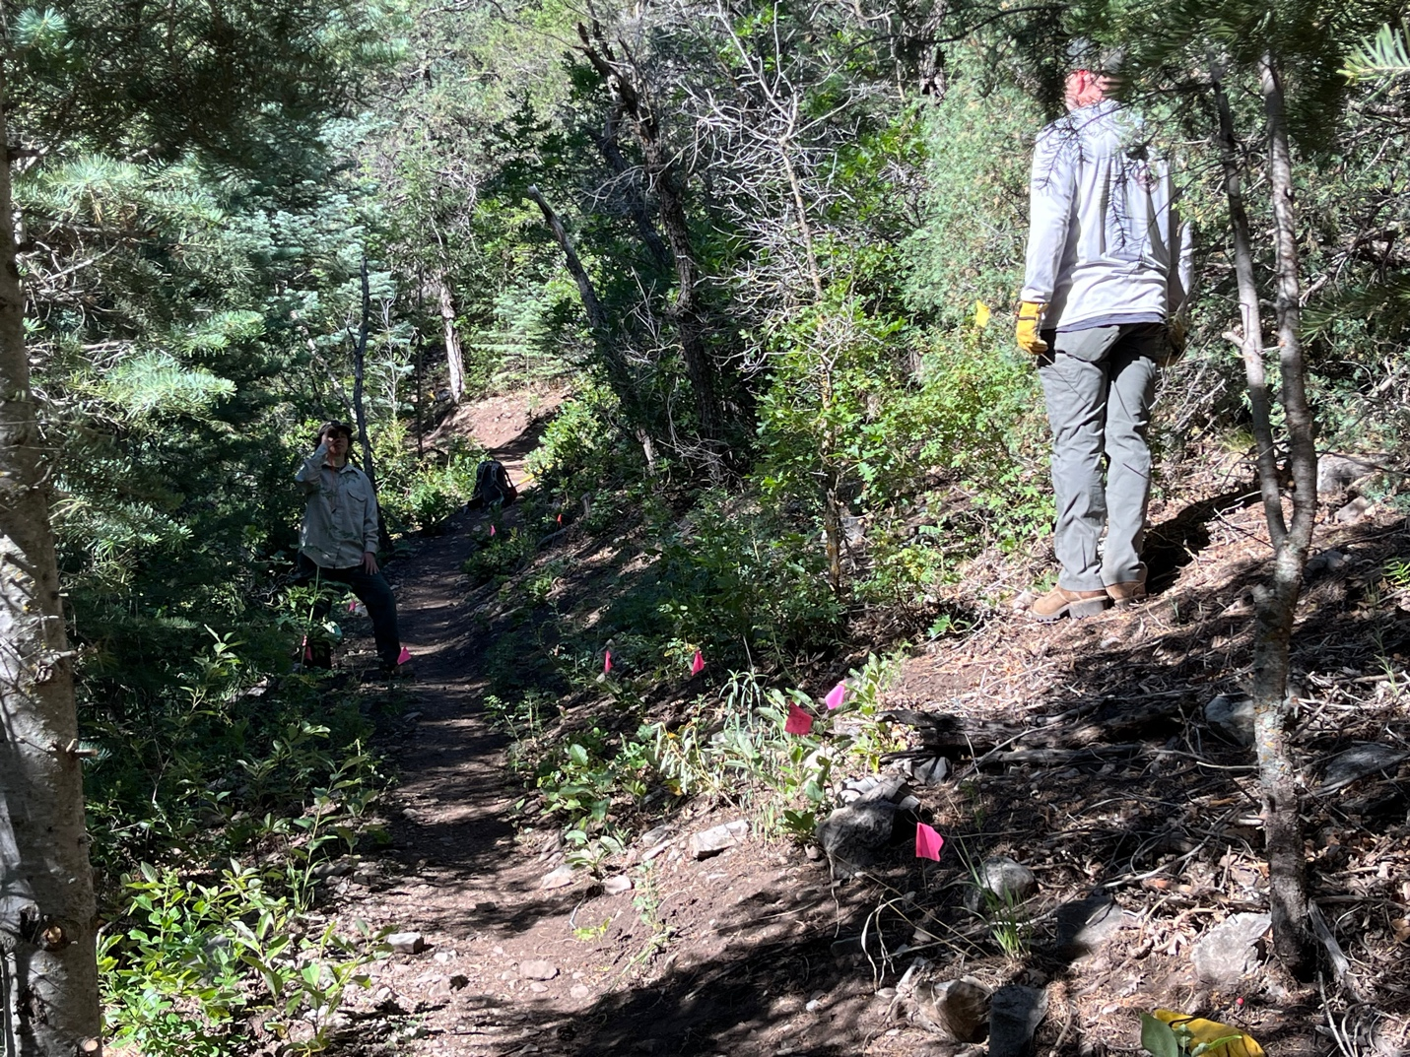

Jen and Chris use the clinometer to mark a grade reversal on a long downhill slope.

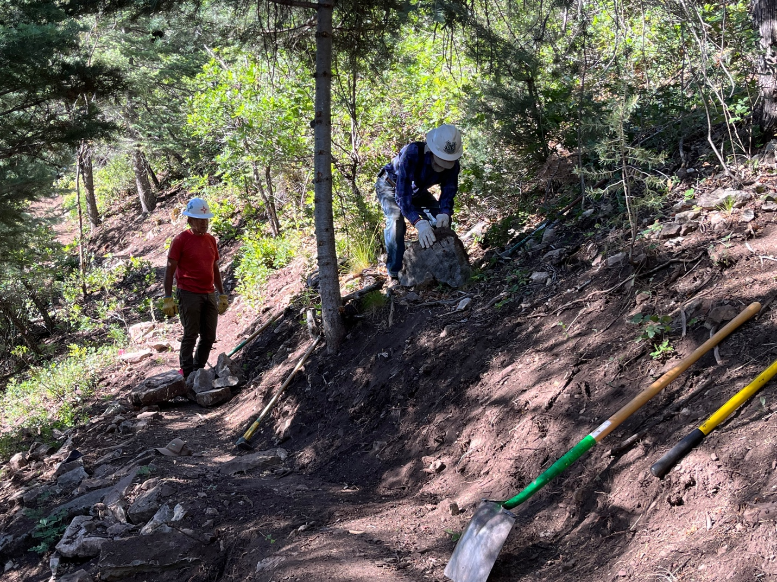

Luis and Bruce get more, bigger rocks to stabilize the trail edge.

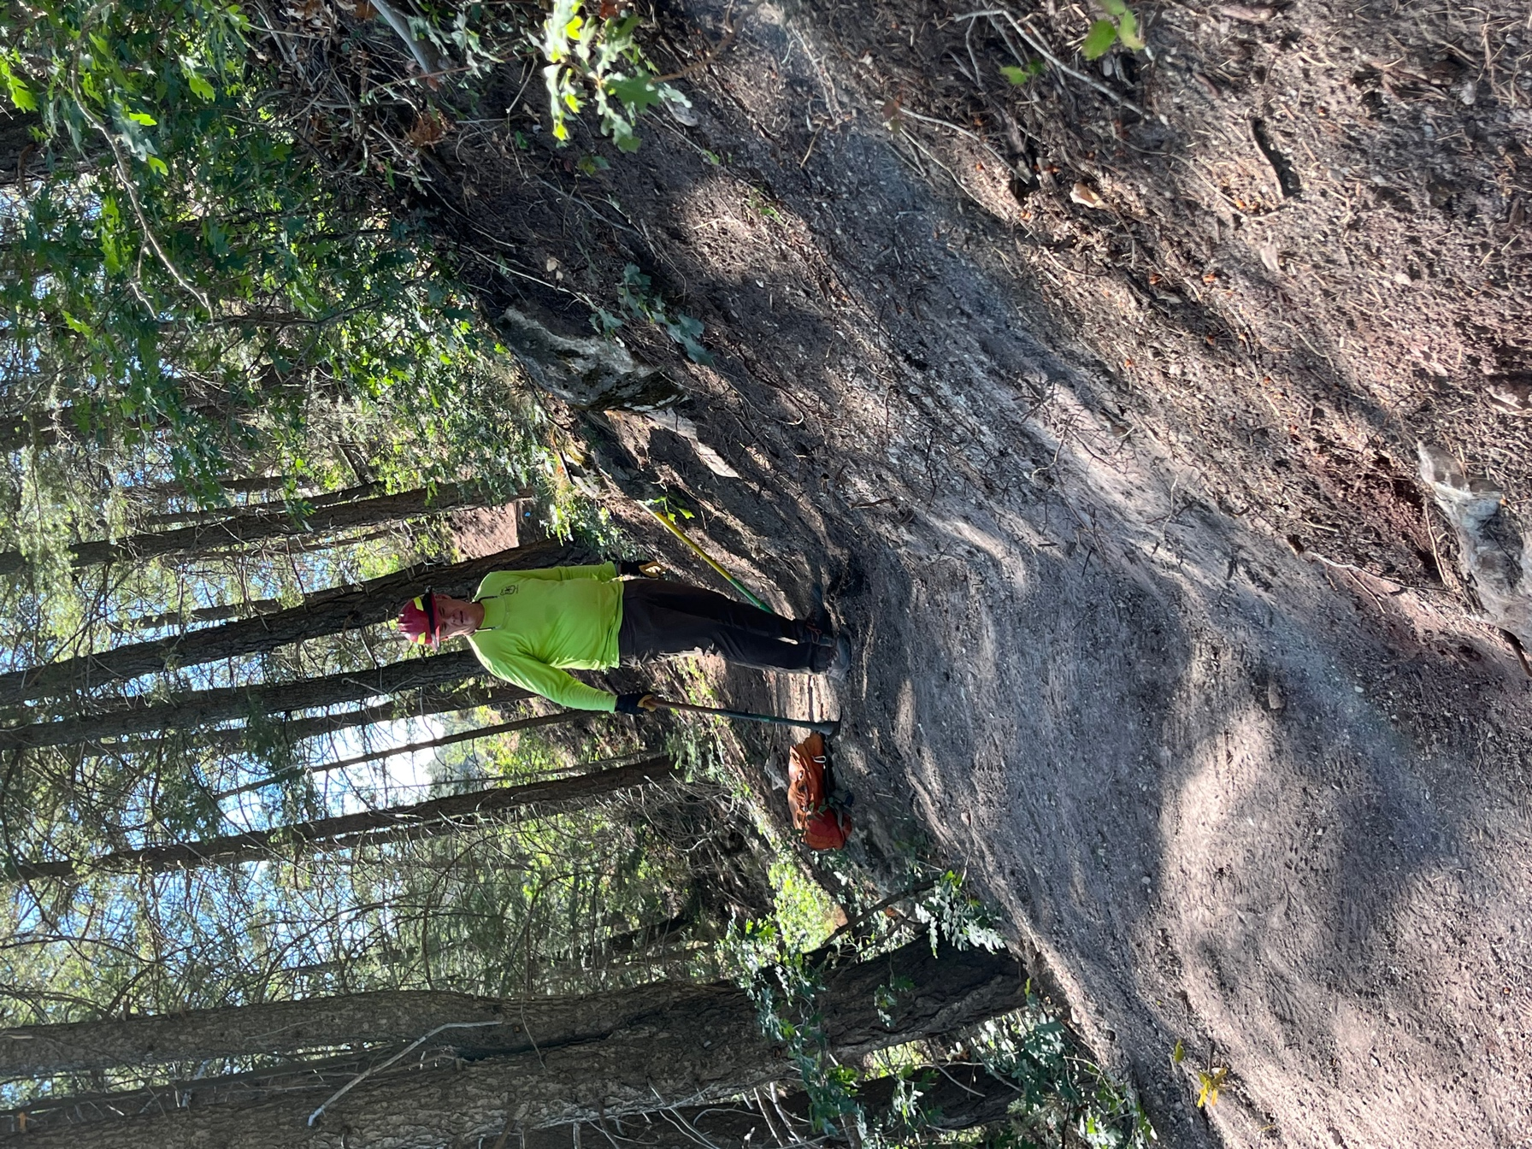

Kerry widens a section of trail.

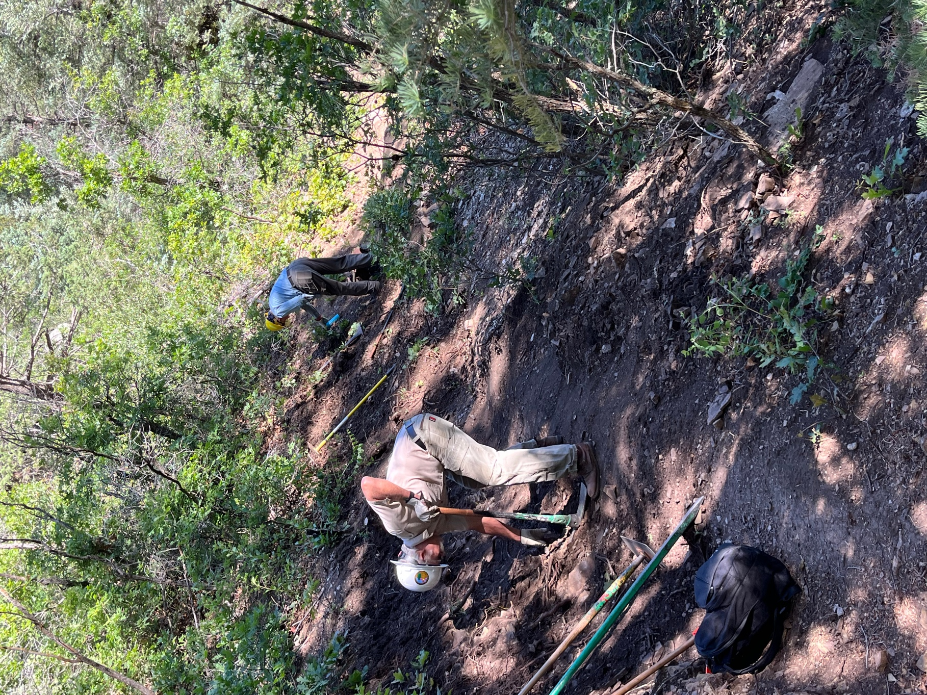

Kent and Eric widen another section.

