Report of FOSM Project to Install a Steel Roof on Yucca Picnic Shelter in Oak Flat Reservation Picnic Area
on Monday, Tuesday, and Wednesday, June 8 – 10, 2026

Joelle Hertel and Sam Beard
On Monday through Wednesday, June 8-10, the crew installed a steel roof on the Yucca picnic shelter in the Oak Flat Reservation Picnic Area. The removal of the old roof was completed on Monday by Manny Chavez, SRD Maintenance Supervisor. Two TTYL/YCC crew members went to the dump in Moriarty with Manny who says that this dump is the only local one that accepts construction materials. The remaining crew members pounded in nails on the roof left from tear-off and picked up small bits of roof debris on the ground. On Tuesday, roofing felt was rolled on the 2x8 wooden sheathing and nailed down by the TTYL/YCC crew. This work was finished early, and the crew returned to the FOSM Guard Station where Sam Beard demonstrated chain saw maintenance for the crew.
On Wednesday, the crew installed 18 3-foot-wide R-panels of steel roofing. This roof was 28 feet long, and the R-panels were 3 feet wide and 10.5 feet long. The panels were ordered cut to the length of the roof slope. On each side of the roof, the crew installed 9 panels and covered the final 1 foot of the roof by placing two sections of the final panel over the adjacent two sections of the neighboring panel. Therefore, it was not necessary to make a long cut to make a 1-foot-wide piece of steel. The steel trim on the gable ends and the ridge cap were custom fitted at the project site. The crew worked well together and safely completed (always tied off with harnesses) this roof in three days.
The TTYL/YCC crew members were Aidan Stewart (crew leader), Kiara Laweka, Zoey Lund, Beck Wilson-Scott, Lila Eaton, Kyle Mullen, and Beth Powers. The FOSM volunteers were Joelle Hertel and Sam Beard.

Project photos are presented below.

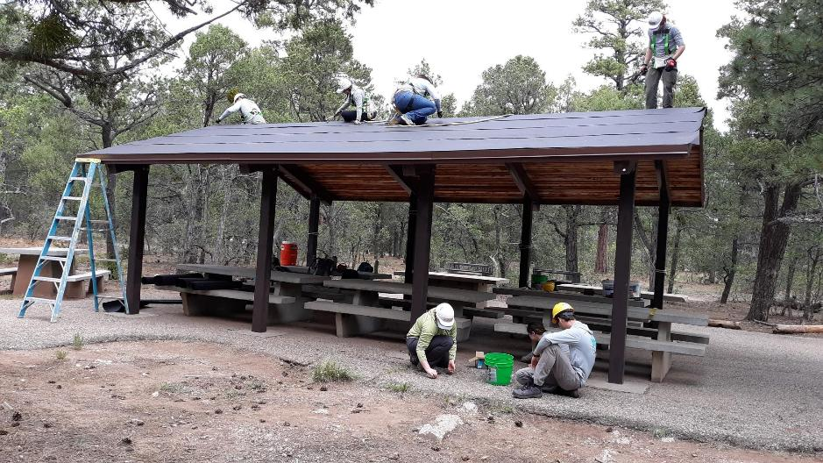
The crew has completed nailing the felt on this side of the Yucca shelter. The crew members on the ground
are picking up nails, screws, and small pieces of old felt from the tear-off of the old roof. All photos by Sam Beard

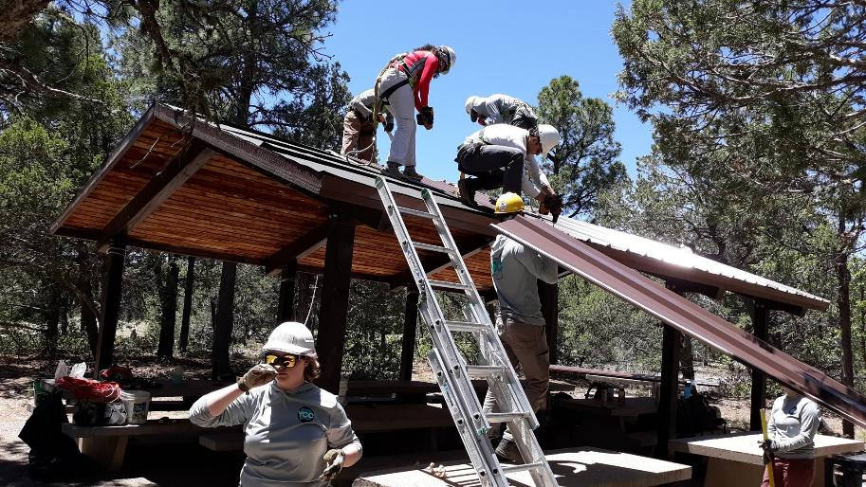
The crew has almost completed installing the R-panels on this side of the shelter. The panels are attached to the 2x8 T&G wooden sheath
with 1.5-inch screws in the area between the ridges. Overlapping ridges of two panels are secured with ¾-inch self-tapping screws.
Both screws have a small washer under the heads to prevent water leaks.

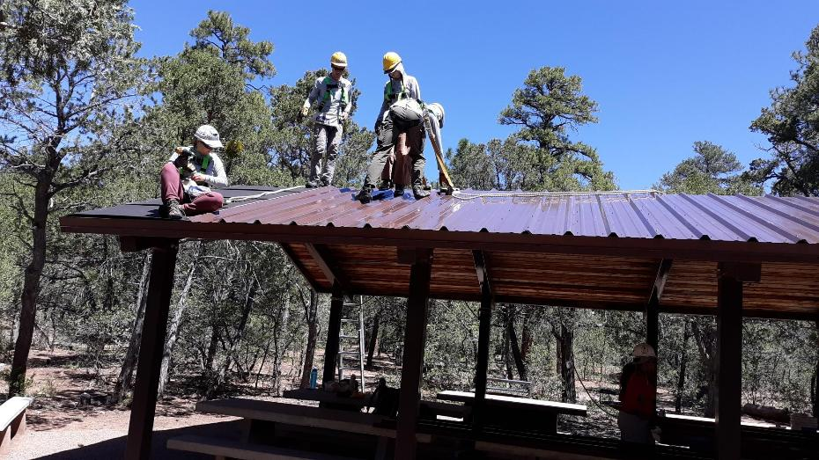
One more 3-foot-wide steel panel will almost completely cover this side of the roof. The final foot of the roof was covered
by placing the right two sections of the final panel over the adjacent installed panel. The left section of the final panel then
covered the felt, and the left edge of the final panel was at the left end of the roof. It was not necessary to make a long cut
in the final panel to obtain a 1-foof wide piece of sheet steel.

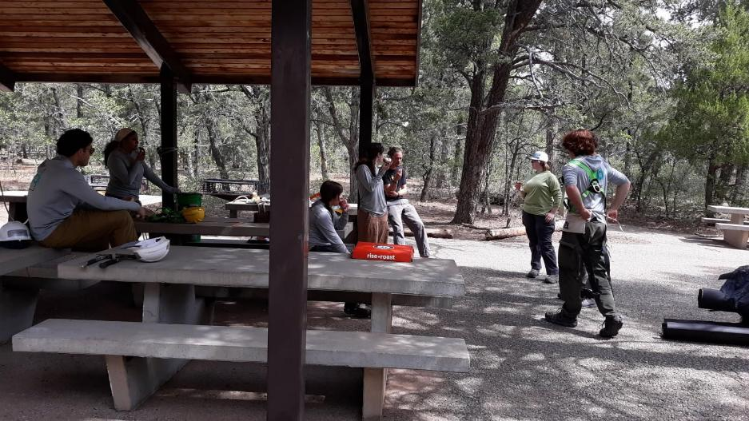
The crew is taking a rest break and enjoying donuts brought by Jared.

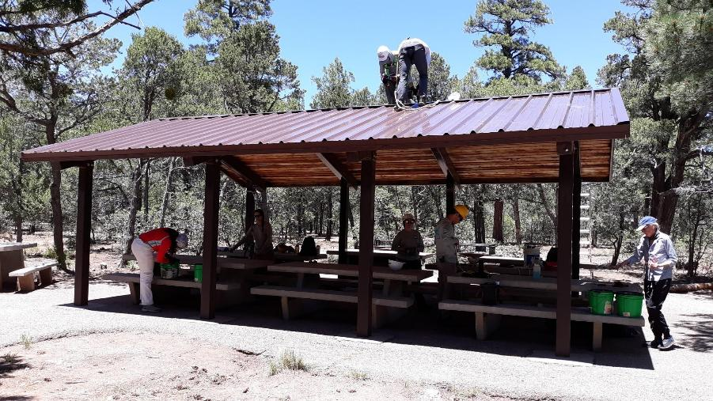
The steel roof on the Yucca picnic shelter has been completed.

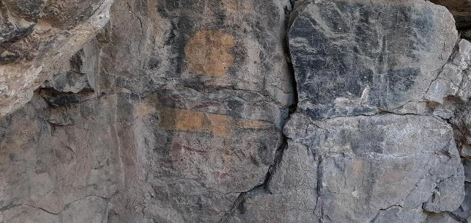
On the return trip to the Ranger Station, Joelle led the group on a short hike from the Otero Canyon Trailhead
to see a prehistoric orange mountain lion pictograph with a round orange “sun” over it. The head of the lion is on the left
end of the horizontal body. The large tail of the lion is on the right end of the body.

