Trail Maintenance Report: June 15, 2026
Byron Garner

On June 26, the Monday trail crew, with the help of USFS, headed up to Cole Spring to begin the steep hike up Bart's trail to clear a possible twenty trees reported to be blocking the trail. About a mile up, we found our first tree - a fourteen inch pinon. At this point it was decided to divide into two groups and leapfrog our way up. Group one got to work on the pinon. After a couple crosscuts the whole thing, root ball and all were off the trail and down slope. Within the next half mile+, fourteen more trees, ranging between fourteen and four inches, were found and cleared - all effective trail blockers bur none complicated. After lunch, Jen hiked to the crest and reported no more trees. Bart's is now clear to the top but a bit of brushing and other work is still needed which will be a future project. Team 1 included Jenny Blackmore and Byron Garner; team 2 included Jen Medina-Gray USFS and Chris Secor USFS. Photo credit: Jenny Blackmore and Jen Medina-Gray

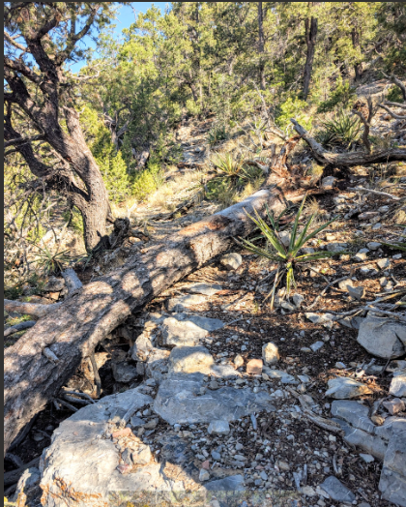
Blackmore
A very dry and saw resistant 14" pinon

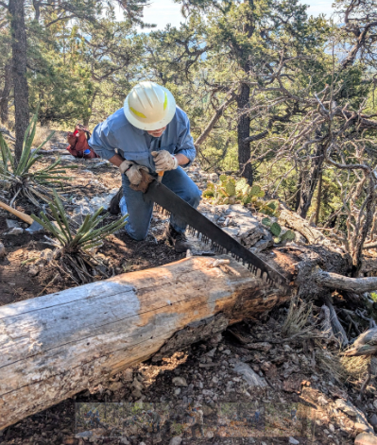
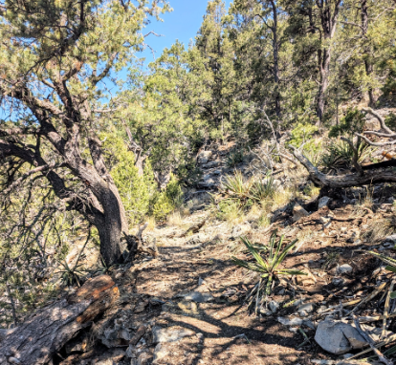
Blackmore

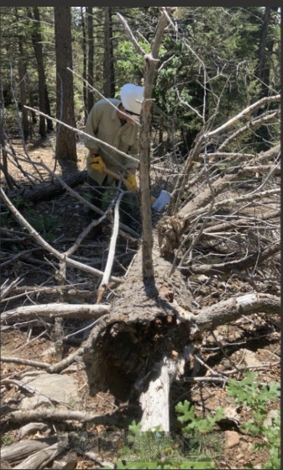
Medina-Gray
Chris gets a good start on this one which is completely in the trail

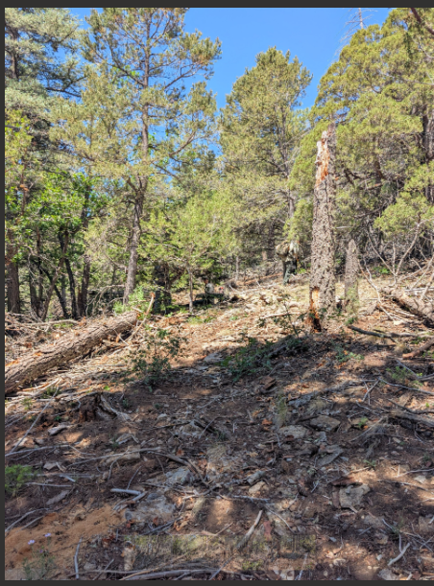
Blackmore
A long covered up trail now revealed

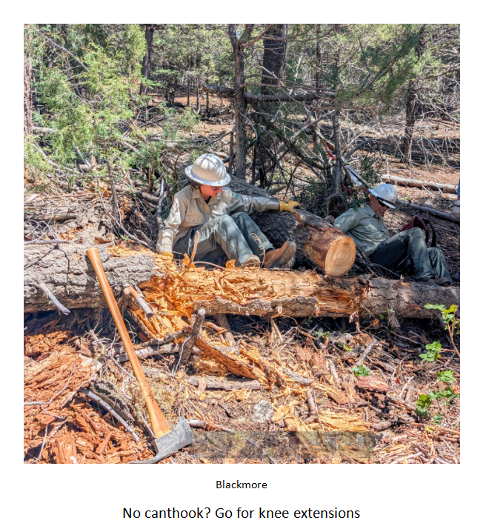

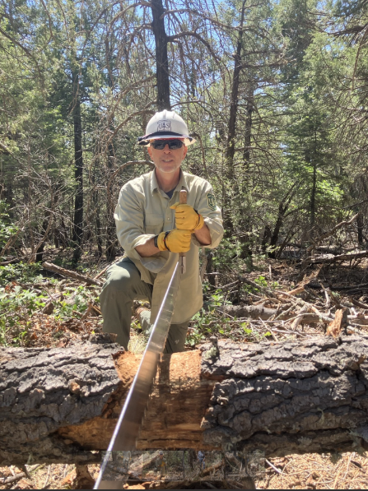
Medina-Gray
Chris was mighty glad to have the big saw on this one

