Thursday, 06/18/26- Old Faulty: A large group of 13 volunteers met up at the Doc Long parking area with the plan that the work day would be very open ended because of the heat. The importance of leaving when workers started getting hot was stressed and thankfully everyone was good about taking care of themselves and each other. That said, Chris (SRD) called as we were arriving at Doc Long to tell us he had hit his head while working with Manny on a cleanup project and would have to get stiches, so needless to say we did not expect to see him. FOSM volunteers started at 7:30 AM and began work on the Old Faulty fixes that were flagged- mostly widening the trail. At 8 AM, six of the Talking Talons met up with us and set to work while Steve started brushing Old Faulty headed towards the highway. We worked from the Bill Springs junction and made it to the Mystery Trail junction when volunteers started to leave due to the heat. Chris surprised us by stopped by with a stylish bandage and staples to see how things were going. At that point, Zoe, one of the Talking Talons stepped into the loose duff below the trail and twisted her knee. She was unable to put weight on it so we called SAR and then rigged up a shade cover for her, popped out the ice packs and waited for help. Zoe was a bit peaky at first but Luis was really good at talking her into a calm state and using a SAM splint to stabilize her leg. By the time SAR came, she was chatting and eating her lunch. SAR had a nifty stretcher with a giant wheel on it and they moved Zoe down off the trail. The parking lot was full of emergency vehicles, like everyone wanted to have a chance to get in on the action. We worked out logistics for the rest of the Talking Talons and everyone headed out. It was a good chance to work on a medical situation without the trauma of blood or organ failure, and Zoe looked to be in good spirits when she left.

Volunteers: John McNett, Jim Houle, Claudia Bergsohn, Kerry Jones, Eric Russell,
Luis Cuadros, Bruce Hansche, Byron Garner, Larry Larrichio, Steve Roholt,
Sim Cook, Kent Towler and Laura Leon

Talking Talons: Aiden, Kiara, Zoe, Lila, Kyle and Beck Beth was out today

Photos: Luis We were very spread out and it turned out to be a really weird day so there wasn’t any picture taking….

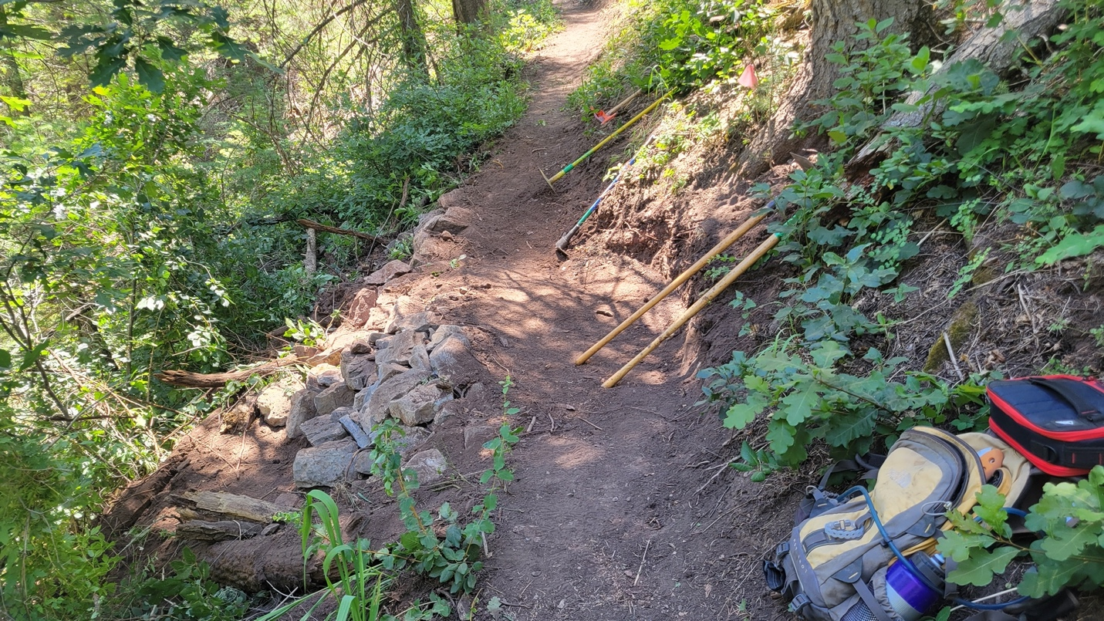

Some of the trail work.
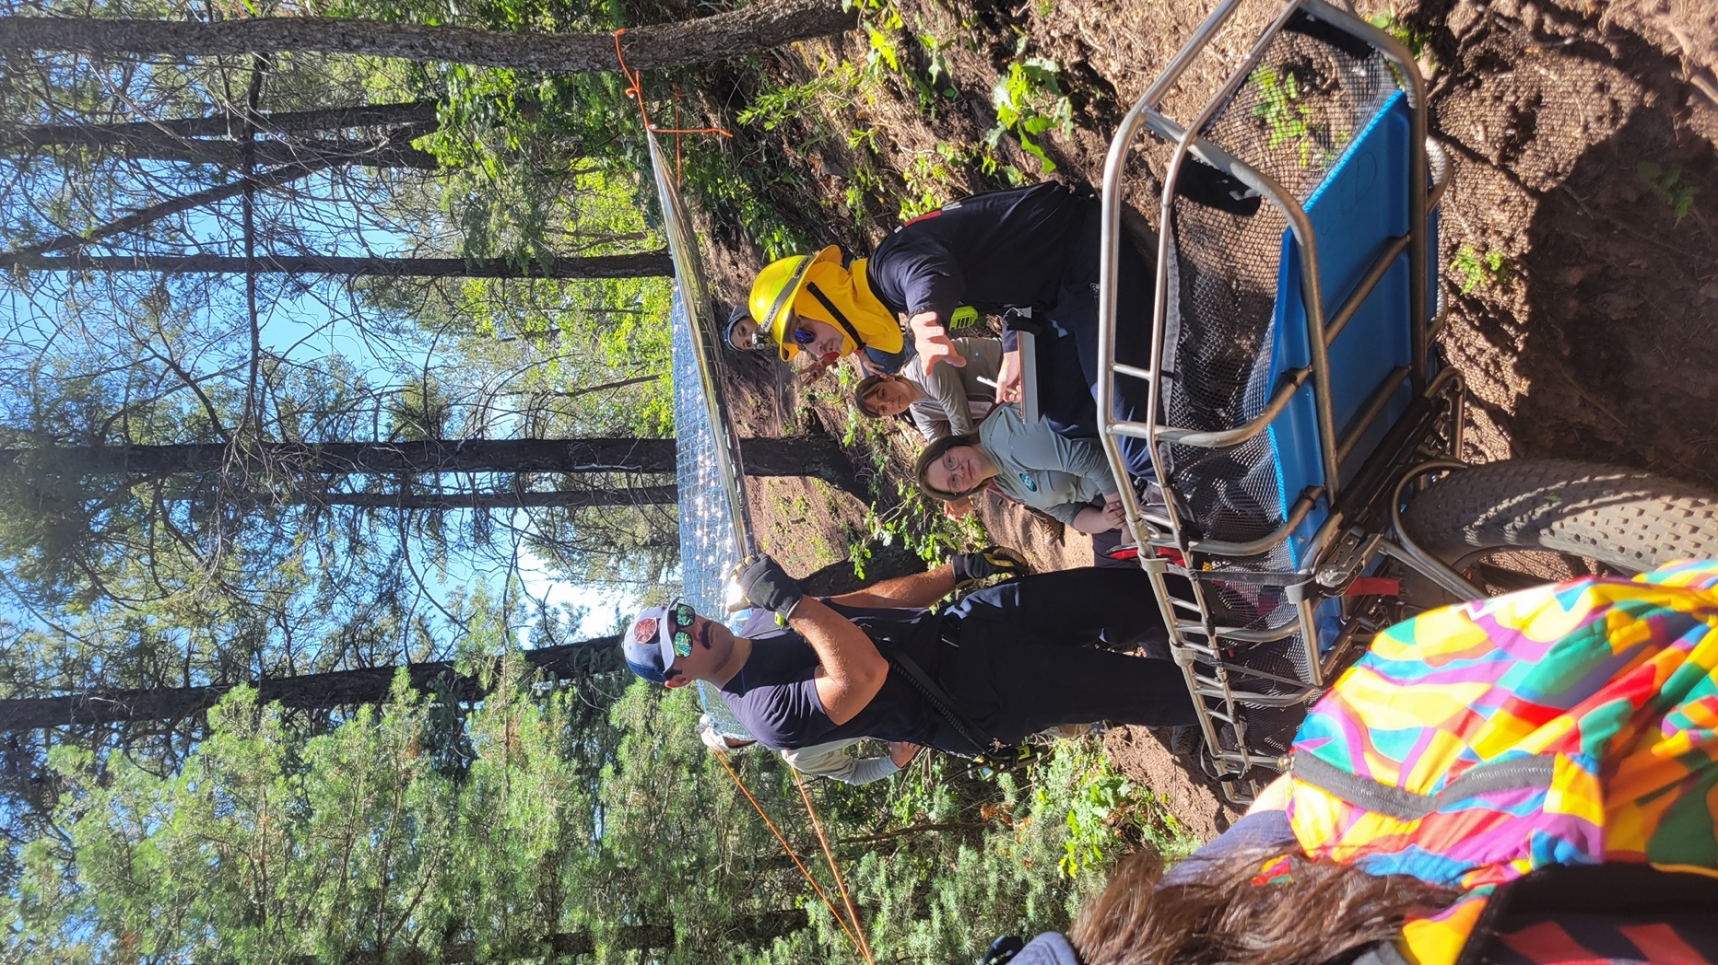

Zoe and SAR getting ready to exit the work site.

