Report of FOSM Project to Paint Parking Stripes at Tree Spring Trailhead,
Balsam Glade Picnic Area, Capulin Spring Picnic Area, and
Capulin Snow Play Area Parking Lots, Tuesday, June 16, 2026

Sam Beard
On Tuesday, June 16, four members of the FOSM paint crew painted stripes in the following parking lots: Tree Spring Trailhead, Balsam Glade upper and lower, Capulin Spring Picnic Area, and parts of Capulin Snowplay Area upper and lower. The crew uses Aervoe spray marking paint which consistently makes better lines than another brand. Lines marking several parking places can be obtained from each can. Usually, two layers are required to make well defined solid color lines. The crew can no longer purchase Aervoe paints in Albuquerque; therefore, cases of a dozen cans are purchased from Amazon. The paint is ordered as needed, because old cans do not spray well. SRD also purchases cases of cans for the FOSM crew to use. Old lines are swept with a broom to remove gravel and dirt before new paint is applied. Power blowers can also be used to clean the lines.
The striping crew member were Pauline Ho, Rick Buss, Sam Beard, and Karen Greif.

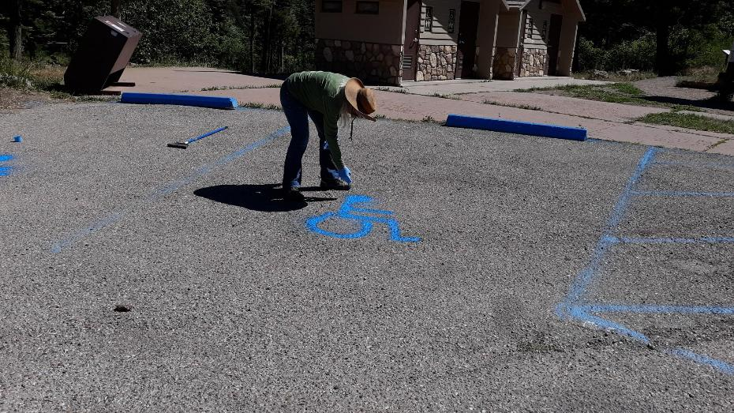
Karen Greif painting a wheelchair figure free-hand in a handicapped space in the upper Balsam Glade Picnic Area parking lot.
All photos by Sam Beard

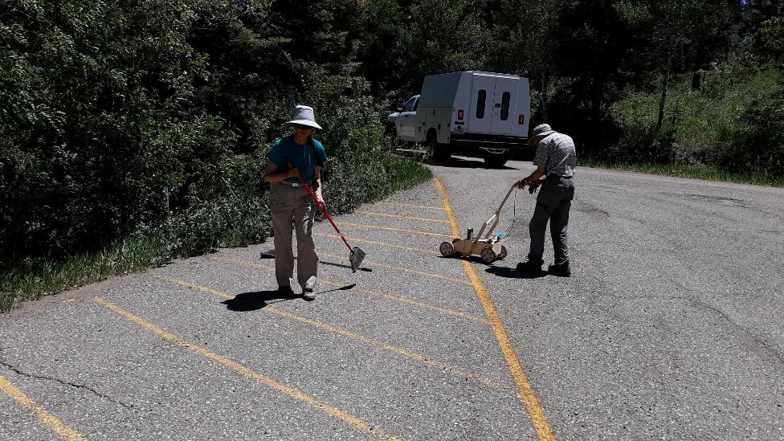
Pauline Ho and Rick Buss painting yellow stripes in a no-parking area in the lower part of the Capulin Snowplay Area.
The pickup is part of a three-vehicle group of wildland fire fighters stationed for a few hours at the Snowplay Area.

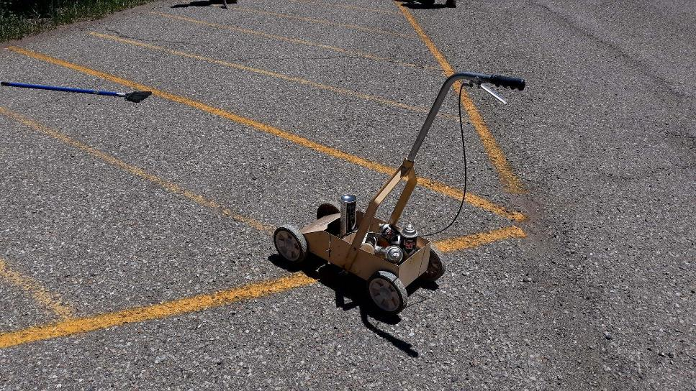
The dolly used by FOSM volunteers to paint stripes on SRD parking lots. A spray can of Aervoe marking paint is shaken vigorously until the ball bearing moves freely, and the can is then inverted and placed in the dolly in the correct orientation to spray a 4-inch-wide line.

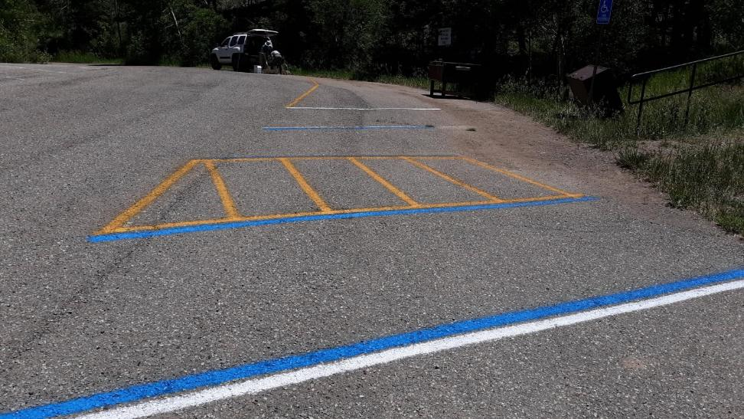
Stripes in the upper level of the Snowplay Area lot at the lower end of the trail to the old sledding hill.
The following parking areas are marked: white – general parking, yellow – no parking, and blue – handicapped parking.

