Thursday, 06/25/26- Old Faulty: Ten volunteers met up at the Sulphur Canyon parking area in the rain on Thursday to continue making fixes to last year’s work on Old Faulty. By the time we got afield the rain was backing off. Jen, Chris and Steve (SRD) met up with us as we spread out across the trail, working on widening and fixing the slope on various areas of the trail. By lunch time the sun was out and the temps were heading up. The fixing seems to be completed and the plan is to work on Old Faulty between Bill Spring and the Crest Highway next week.

Volunteers: Jim Houle, Cleve Sharp, Claudia Bergsohn, Courtnee Bennett,
Kerry Jones, Eric Russell, Byron Garner, Luis Cuadros, Mike Madden and
Laura Leon
Pictures: Laura Leon

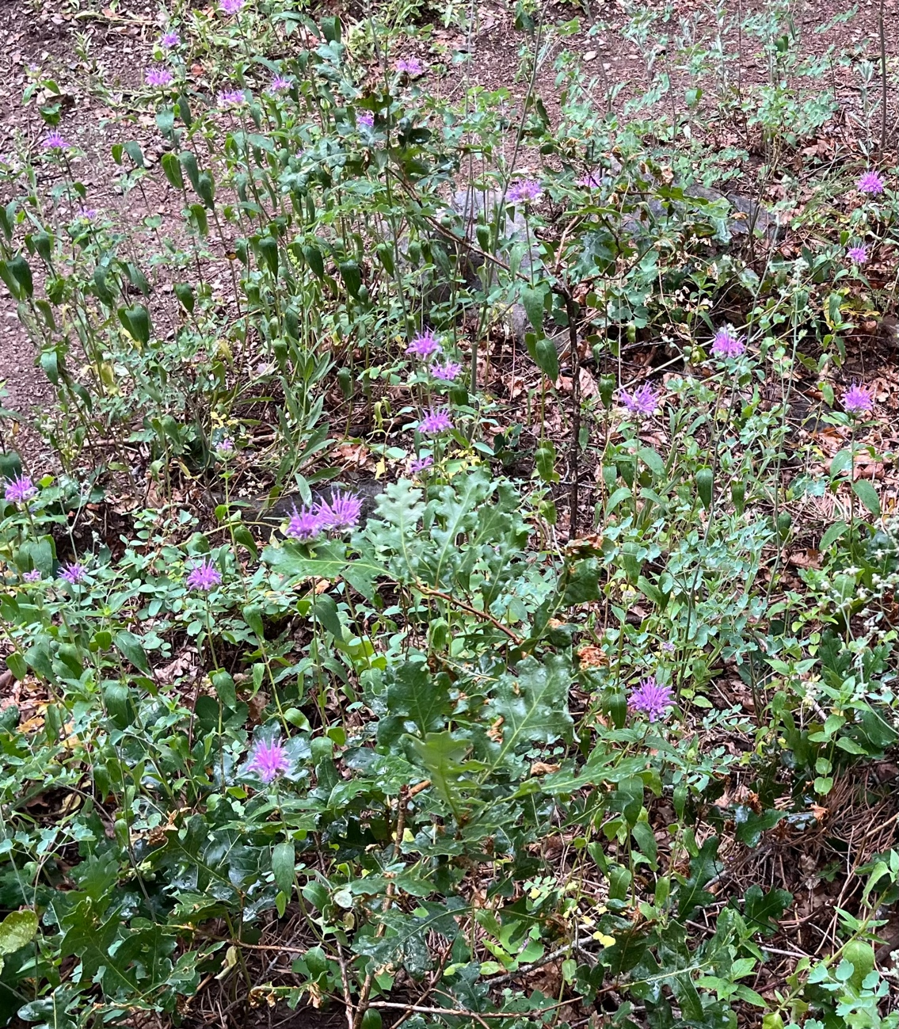
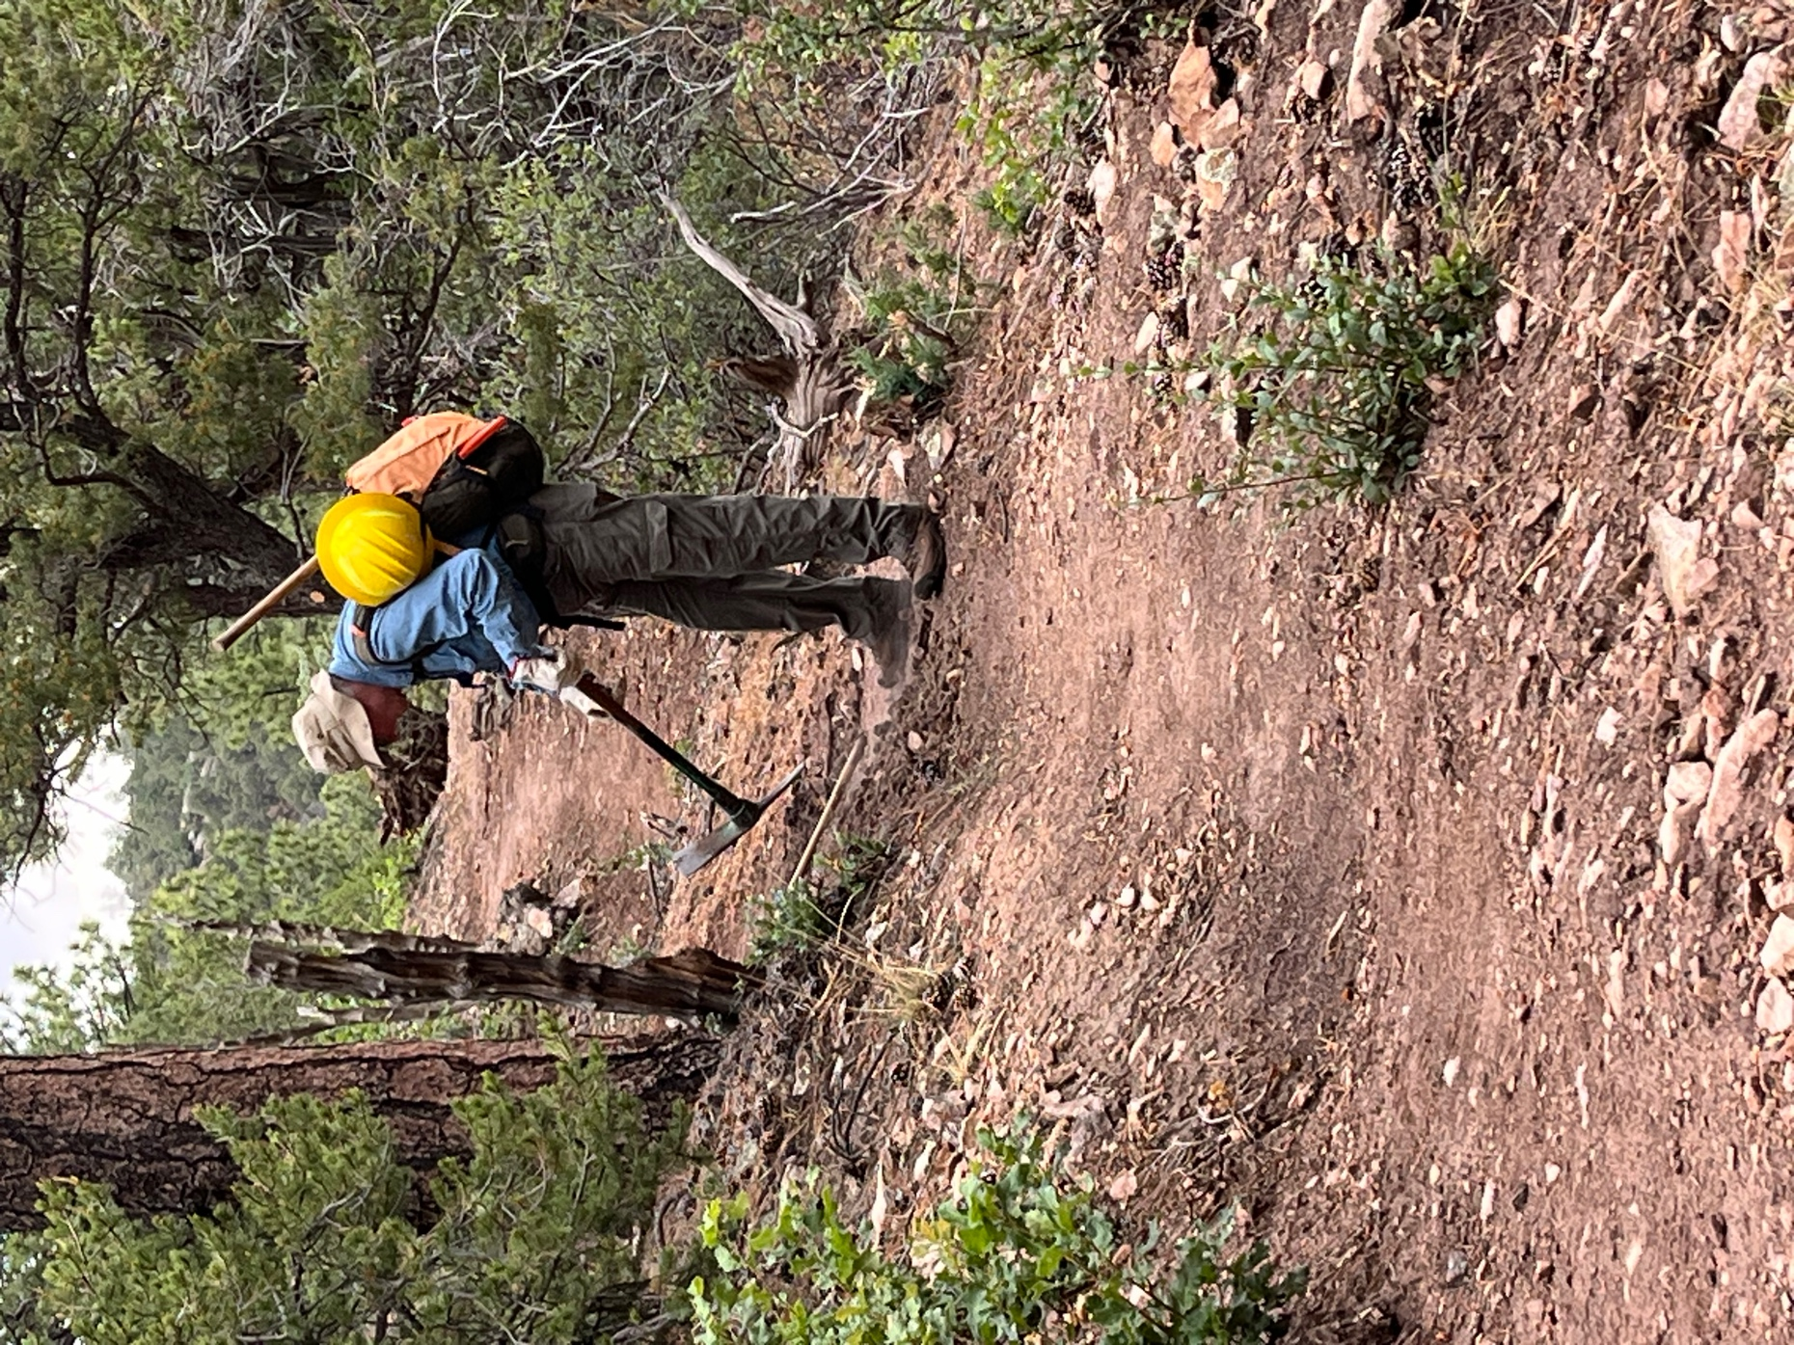

Eric stops to work on an area of trail under a cloudy morning sky.
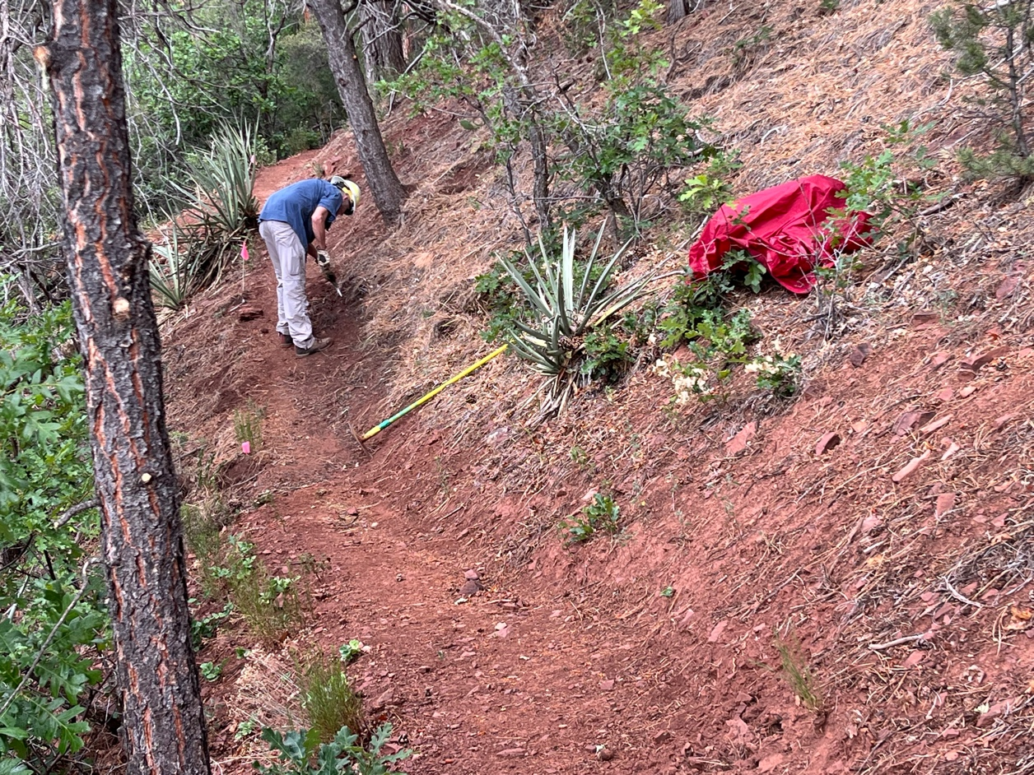

Cleve is hard at work while Courtnee and Jen discuss problem areas

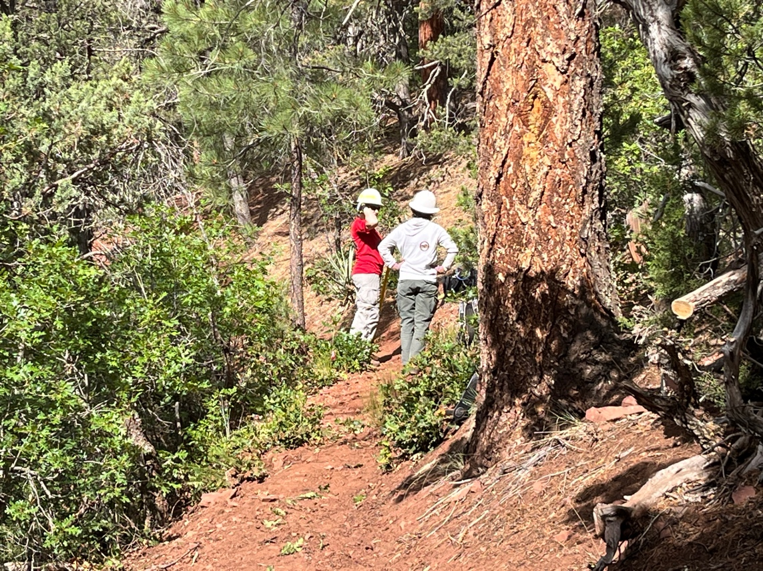
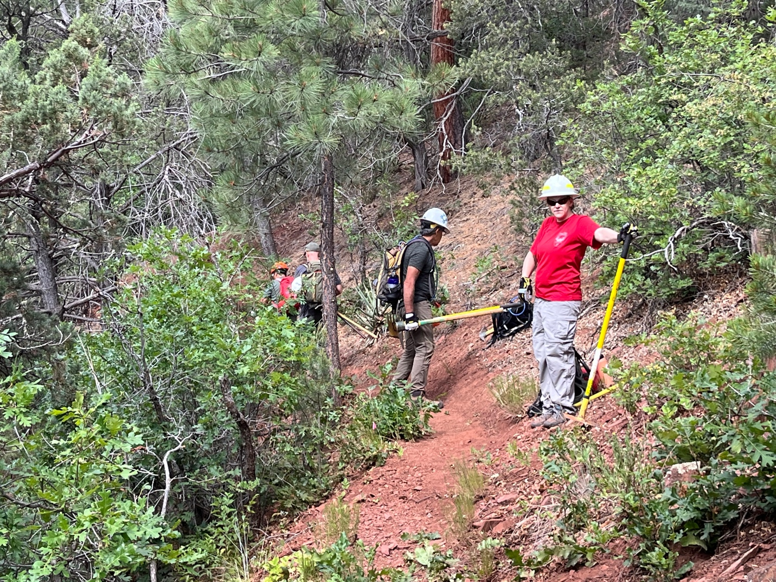

Courtnee and Luis look over an area while Chris and Steve bump up ahead.

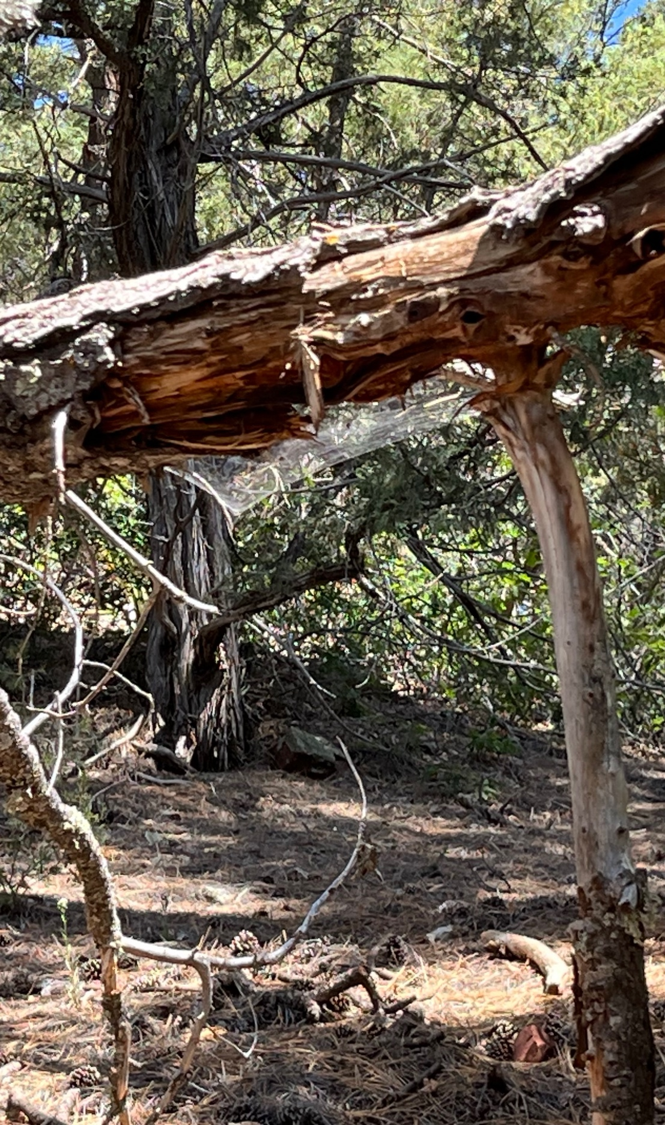

The sun came out and the light caught this lovely web.
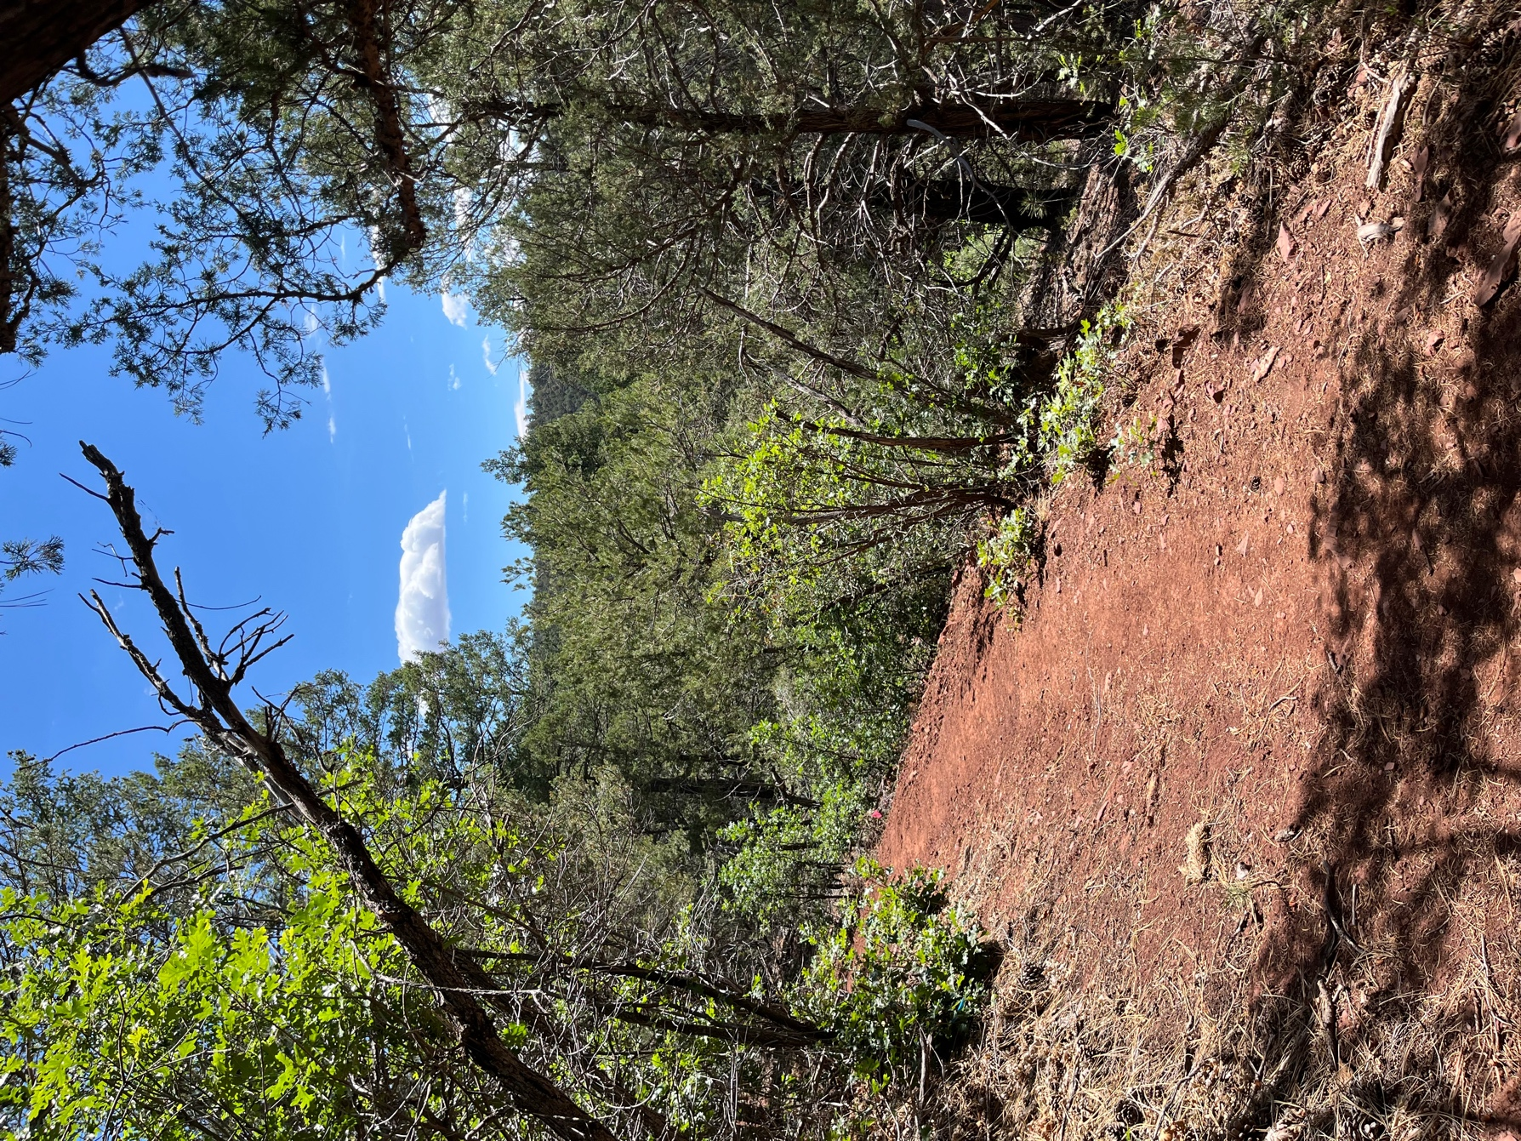

By lunchtime the sun was out in full force. I was lucky to get a good rain at my house last night- filled the water barrels! Hope you were lucky as well.

