Report of the Completion of the Talking Talons Youth Leadership Project
to Install a Steel Roof on the Tunnel Spring Restroom on June 15
and the TTYL/YCC Crew Activities on June 16 and 17, 2026.

Sam Beard and Joelle Hertel
Monday, June 15 -- The TTYL/YCC (Talking Talons Youth Leadership/Youth Conservation Corps) crew completed the installation of the steel roof on the Tunnel Spring Trailhead restroom. The crew installed the gable trim on each end of the restroom and the roof cap along the top of the roof. The following components of the ventilation structure were installed: drip edge along the eaves, 3 steel roof panels, gable trim, and roof cap. This installation completed the project to put metal roofs on eight wooden restrooms on the Sandia Ranger District.
Tuesday, June 16 -- The crew worked with Dorothy of the Forest Service on brushing some trail. This was Canyon's project delegated to Dorothy.
Wednesday, June 17 – We did the exercise with the crew of measuring and estimating quantity of materials and then the total cost of a project for a large picnic shelter at the Cedro Reservation Campground. The cost of materials was based on unit costs for materials from the recently completed picnic shelter at Oak Flat. Following that exercise, we met the Forest Service staff for the pizza lunch. FOSM treated the crew and FS personnel to pizza. Employees described their professional activities, and Lou Romero, FOSM member, described his USFS career history in a motivational presentation.
It was a pleasure to work with the TTYL/YCC crew. All members of the crew were willing participants on activities whether tearing off old roofing, hauling materials, constant trips up and down ladders. and loading and unloading equipment every day. And the weather was hot! It was great to see how the crew started as individuals but ended after three weeks as a blended efficient team. Both FOSM and the Forest Service appreciate the effort to complete two picnic shelter roofs at Oak Flat Reservation Picnic Area. The group is a credit to the TTYL organization.

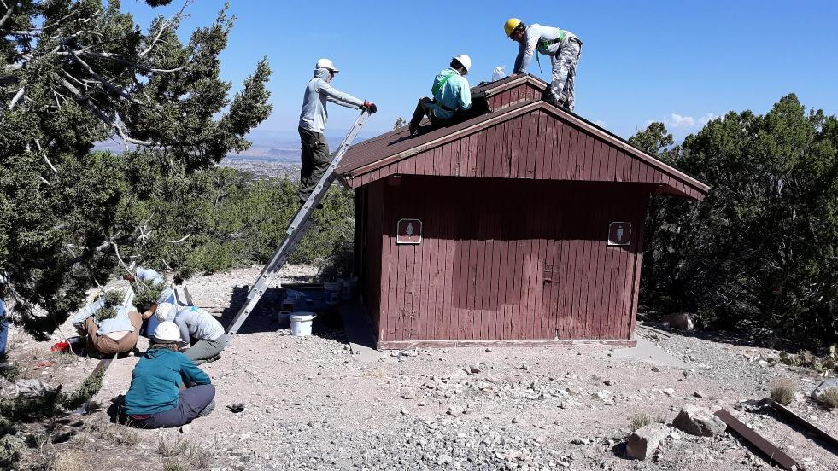
Putting a metal roof on the ventilation structure on the Tunnel Spring Trailhead restroom.

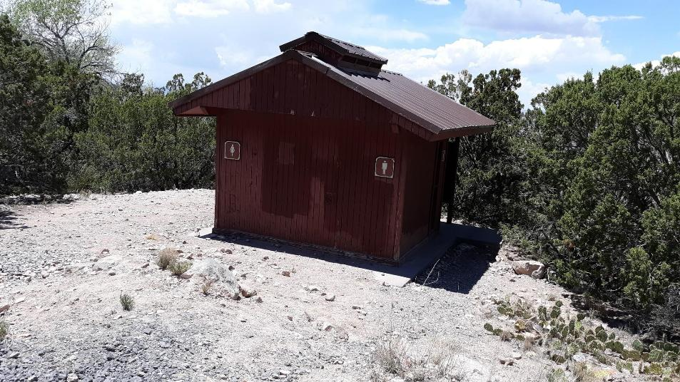
The metal roofs on the restroom and ventilation structure are complete.

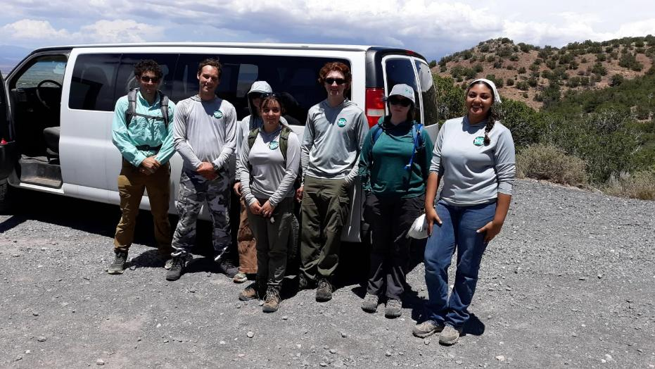
The TTYL/YCC crew in June 2026. L to R: Beck Wilson-Scott, Aidan Stewart (crew leader), Beth Powers, Lila Eaton, Kyle Mullen,
Zoey Lund, and Kiara Laweka.

