Report of the FOSM Project to Remove Graffiti Tags and Cleanup at the CCC Juan Tabo Picnic Shelter
for a Congressional Visit, Tuesday, June 23

Sam Beard
On Tuesday, June 23, at the request of Julie Padilla, SRD Recreation Staff Officer, FOSM volunteers and SRD personnel removed graffiti tags and cleaned up at the CCC Juan Tabo Picnic Shelter in preparation for a congressional visit to the west side of Sandia Mountain.

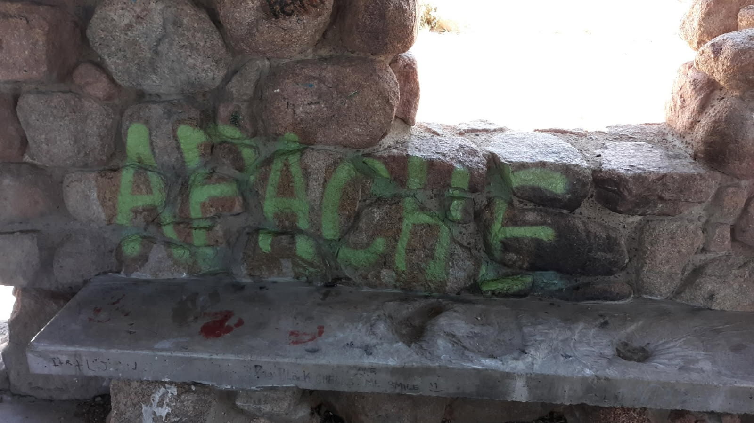
This graffiti tag spelling APACHE in green paint on the interior wall of the CCC Juan Tabo Picnic Shelter was treated with four coats of the World’s Best Graffiti Removal System chemical for stone and brick.

