Report of FOSM Project to Fell Hazard Trees in Doc Long
and Sulphur Canyon Picnic Areas on Wednesday, June 24, 2026

Sam Beard
On Wednesday, June 24, FOSM sawyers felled two dead hazard trees in the upper part of Doc Long Picnic Area and two dead hazard trees in Sulphur Canyon Picnic Area. One live oak was felled to make a safe lie for the two hazard trees. All the trees were limbed, bucked and left where they fell. In Doc Long PA, a Rocky Mountain juniper found on the ground was also bucked and left where we found it.
The volunteers working on this project were Dan Benton, Eric Russell, Michael Arndt, Lorna Morrow, Jerry Carroll, Sam Beard, Sim Cook, Cliff Giles, and Kent Towler.

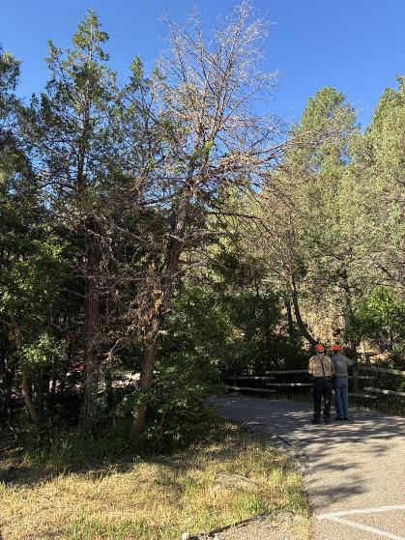
Sam Beard and Jerry Carroll looking for hazard trees at the upper Doc Long PA loop.
The tree leaning to right in the photo center is a hazard tree. All photos by ooo
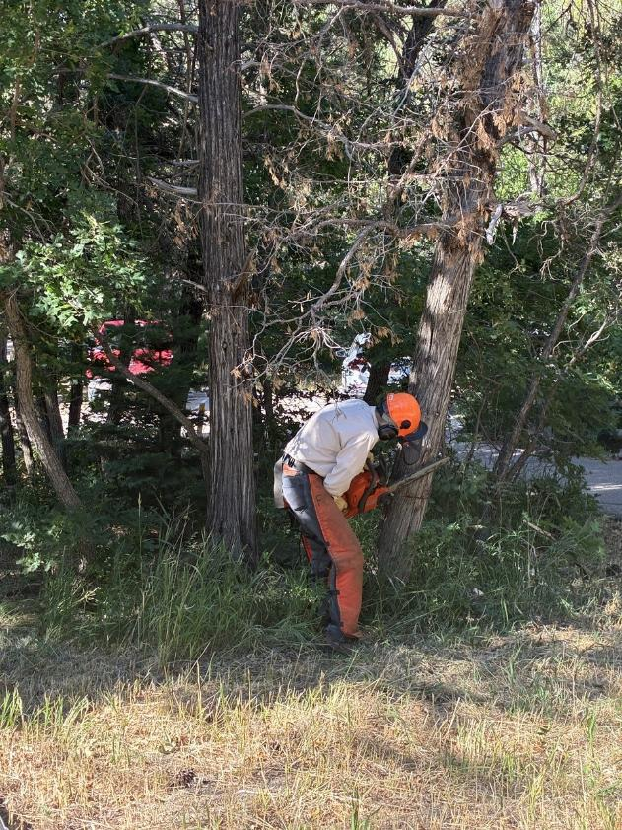
Sim Cook making the face cut in the dead Rocky Mountain juniper in Doc Long Picnic Area.
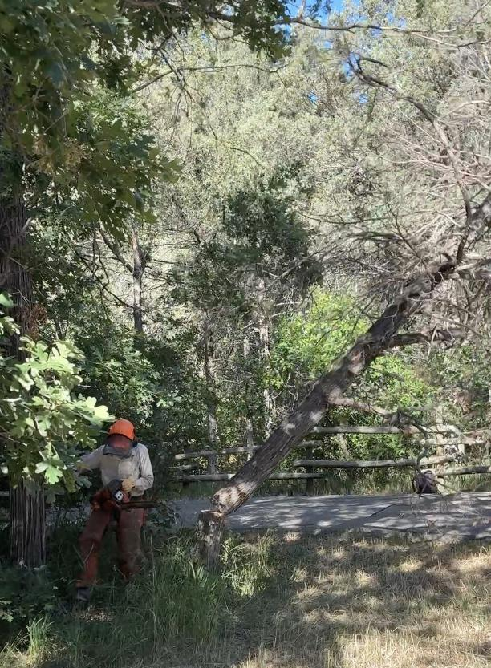
Tree falling and Sim running away. The top of the felled tree was near the opening
in the fence on the other side of the road.
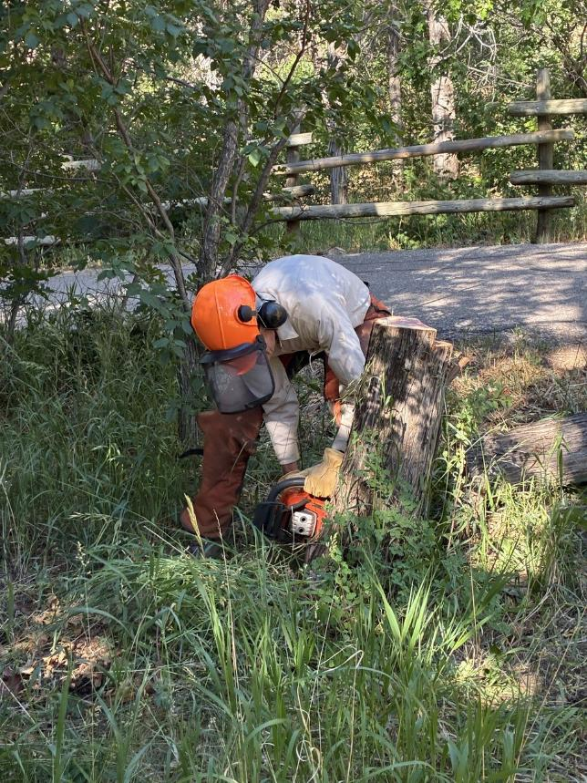
Sim low stumping the tree he just felled.
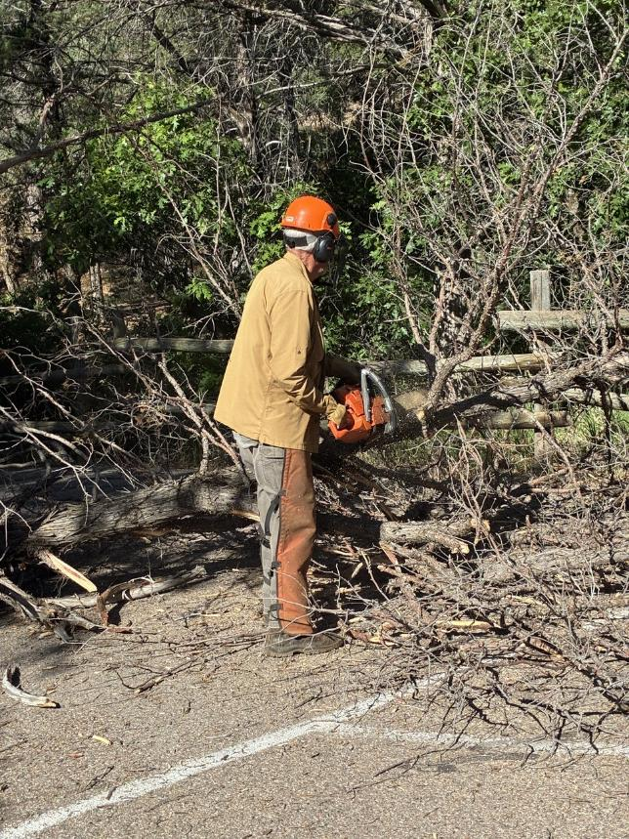
Dan Benton limbing the tree that Sim felled.

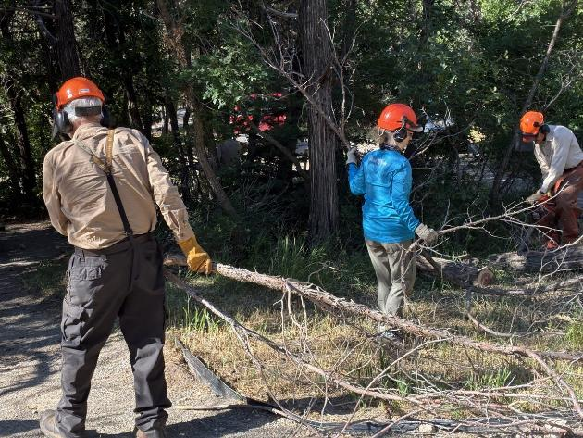
L to R: Sam Beard and Lorna Morrow swamping and Sim bucking log.

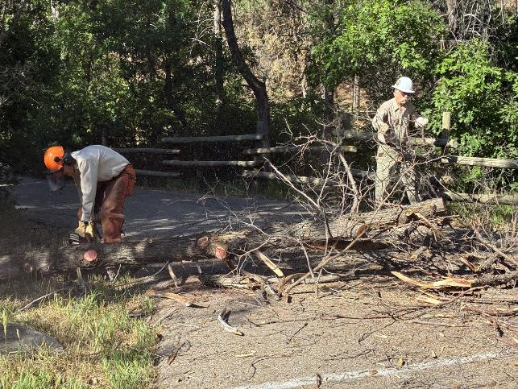
Sim bucking the trunk of the felled tree and Kent Towler swamping.

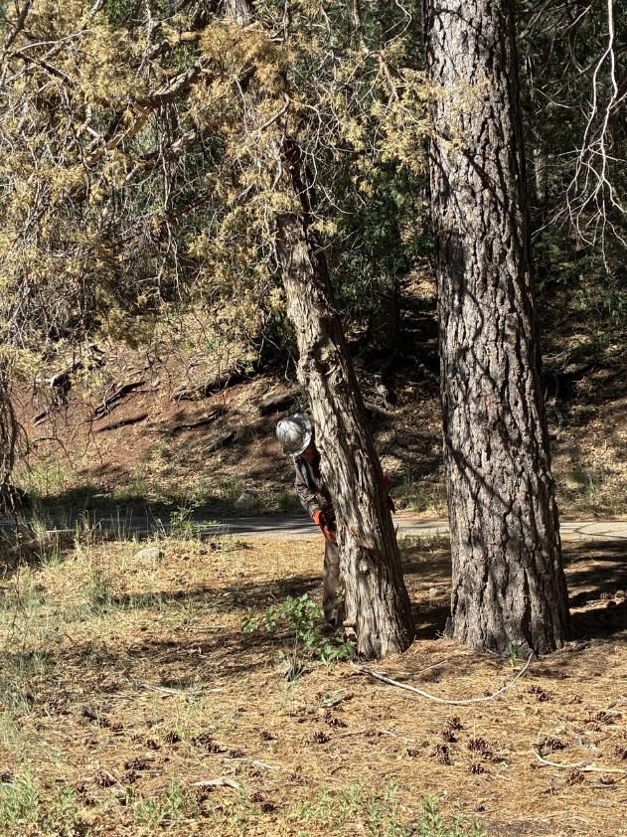
Michael Arndt making a face cut in another dead Rocky Mountain juniper
near Bill Spring Trailhead.

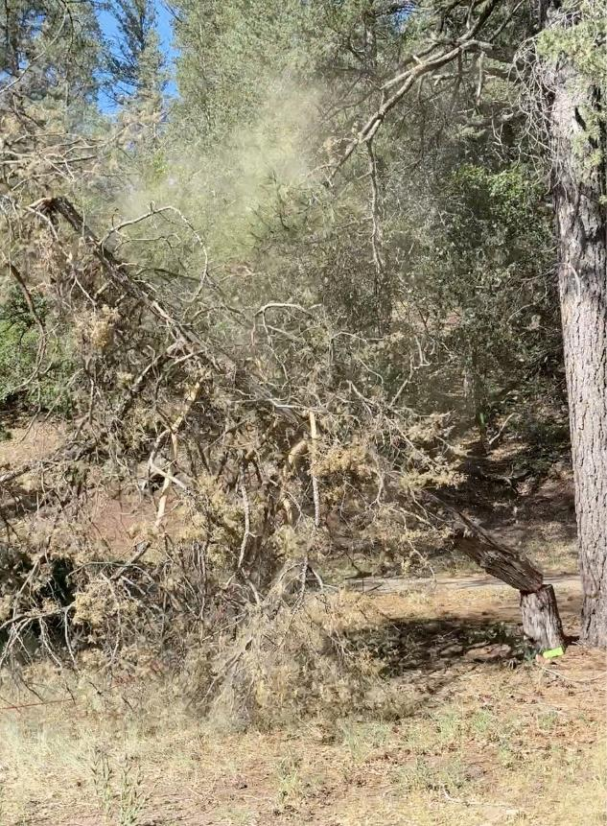
Micheal’s tree falling.
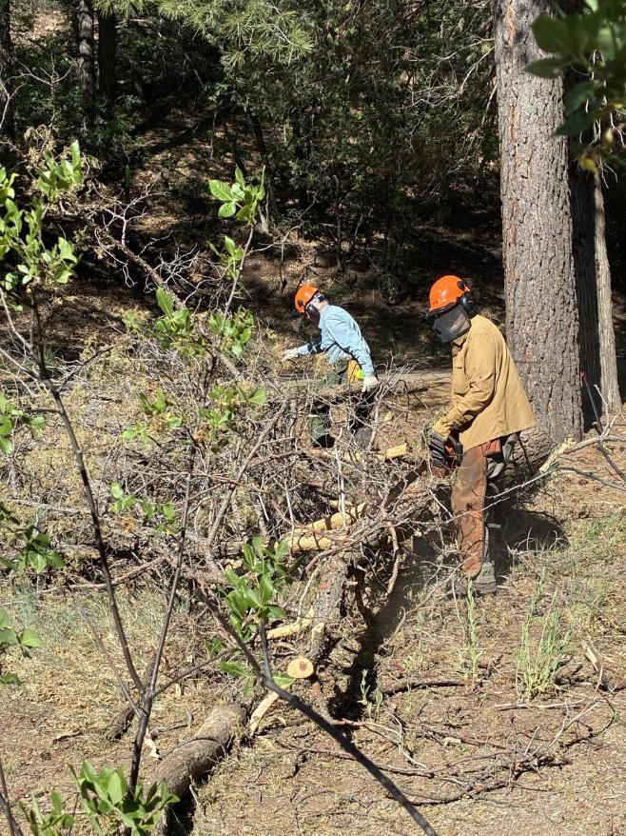
Eric Russell and Dan Benton limbing the tree felled by Michael Arndt.
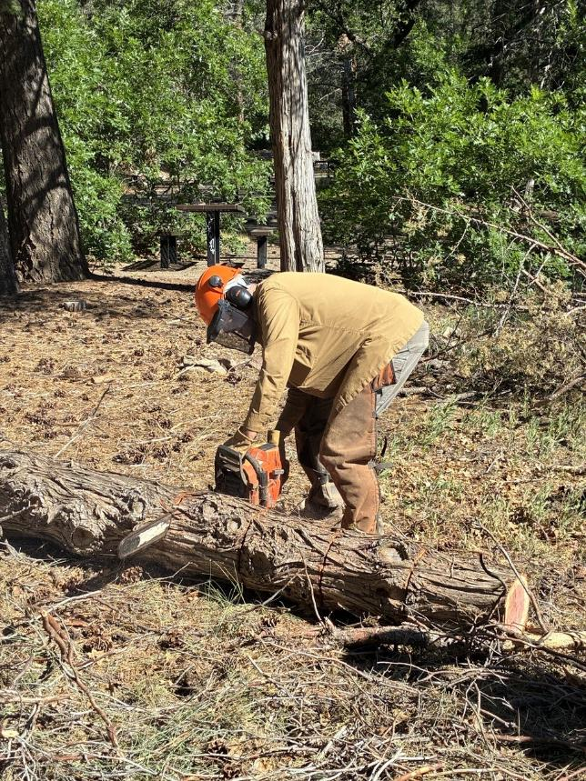
Dan bucking a Rocky Mountain juniper trunk that was lying on the ground.
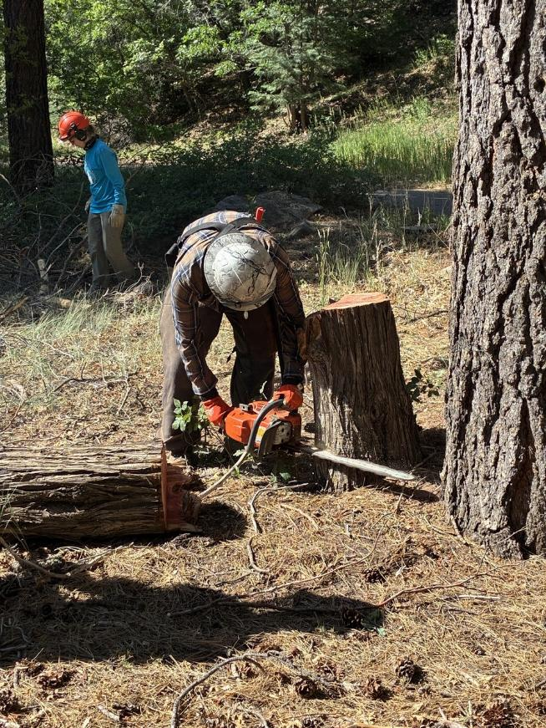
Michael low stumping the tree that he felled. Lorna swamping in the background.
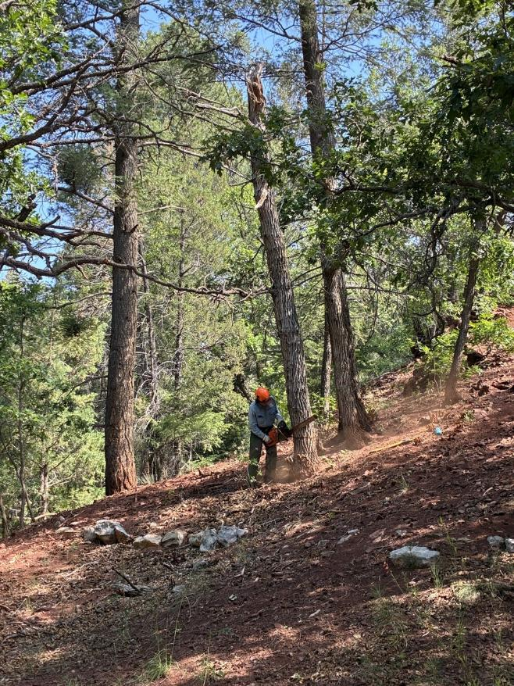
Eric Russell felling a large dead oak snag in Sulphur Canyon Picnic Area.
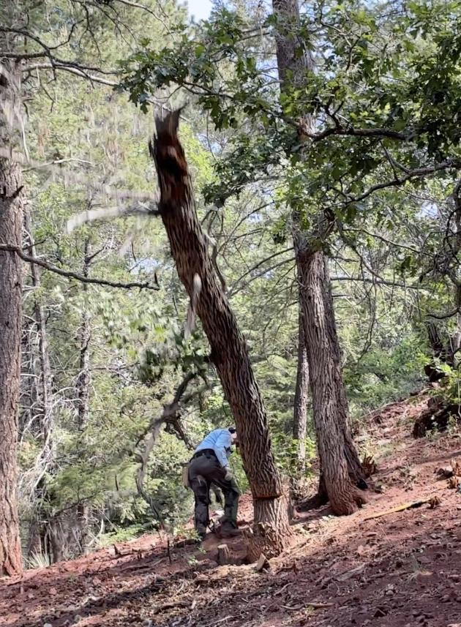
Eric running away from the falling oak snag.

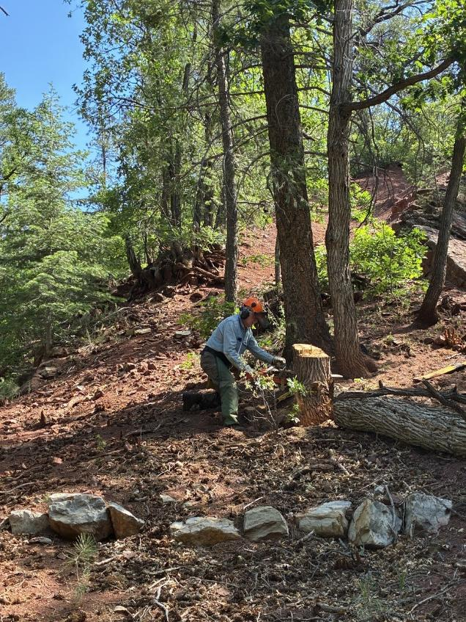
Eric low stumping the tree he just felled.
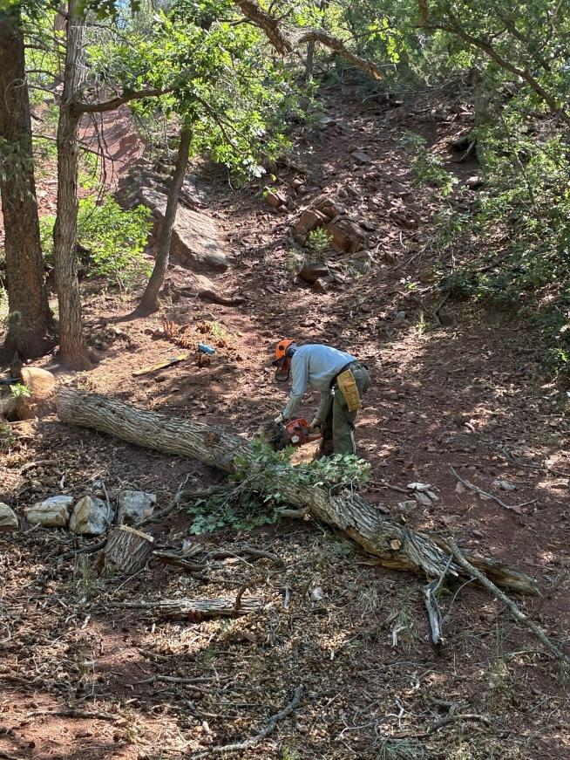
Eric bucking the oak that he felled.
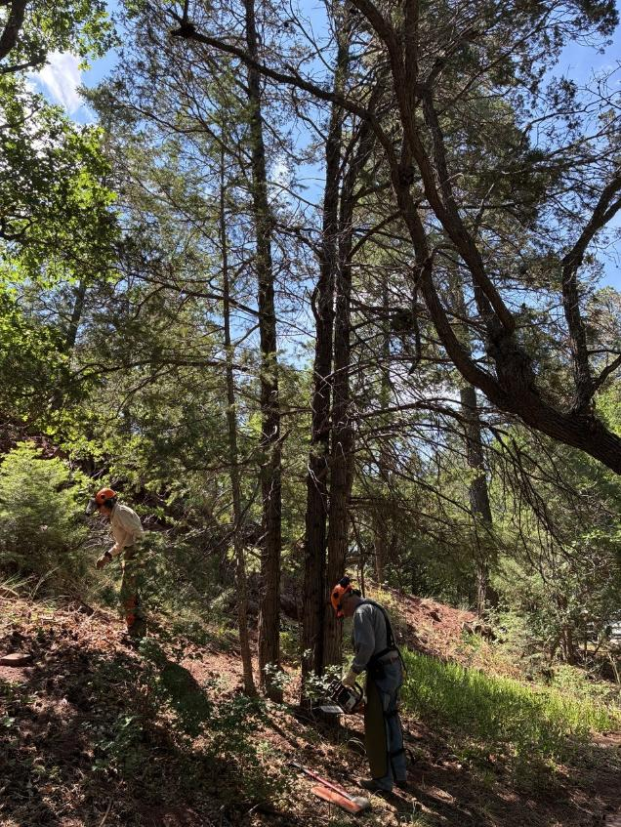
Jerry Carroll preparing to fell a couple of dead oaks near the sidewalk in Sulphur Canyon
Picnic Area. Sim Cook is helping clear the area around the trees.

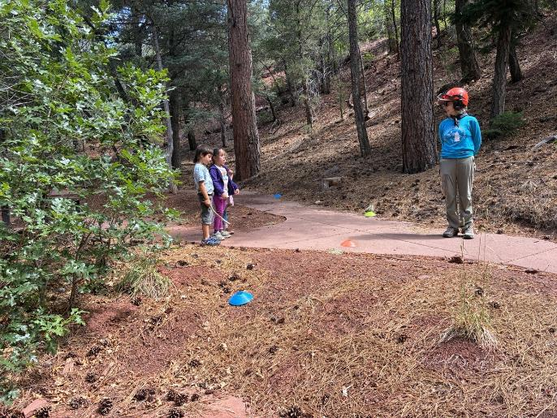
Sawyer Lorna Morrow talking with three children at a neighbor picnic table site.

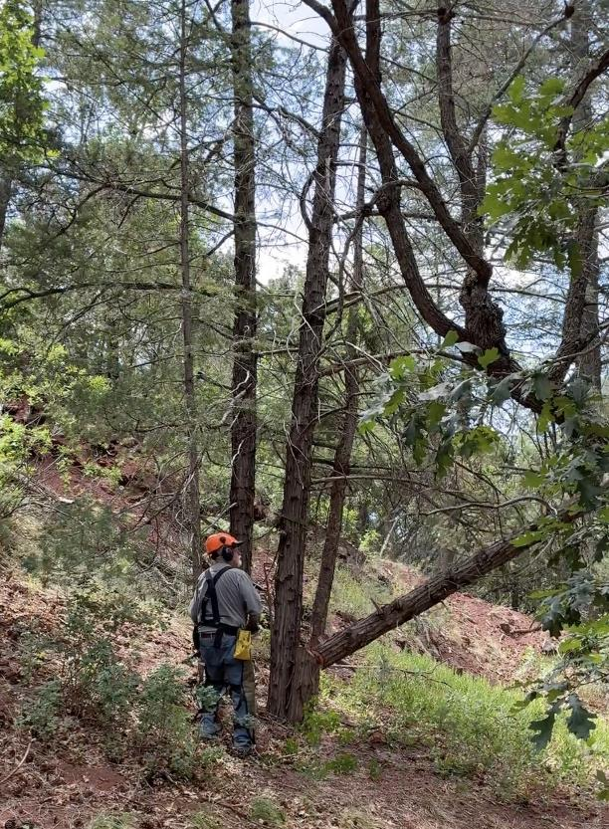
The first Rocky Mountain juniper is falling so that the adjacent dead juniper can be felled.
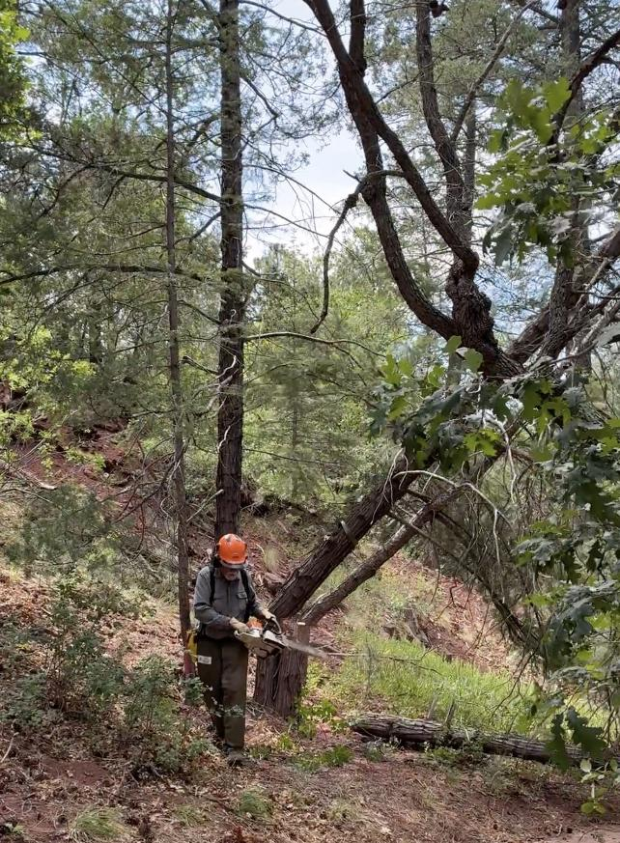
Two dead junipers falling across the adjacent sidewalk.
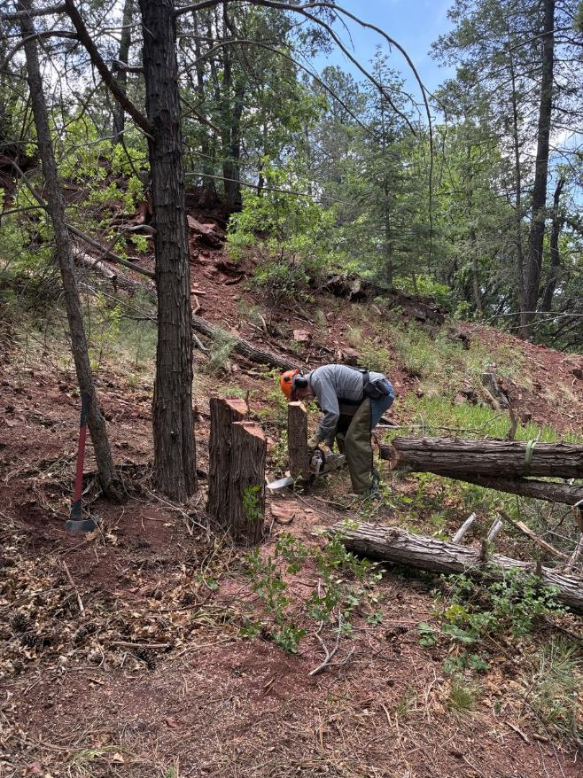
Jerry low stumping the trees he just felled.

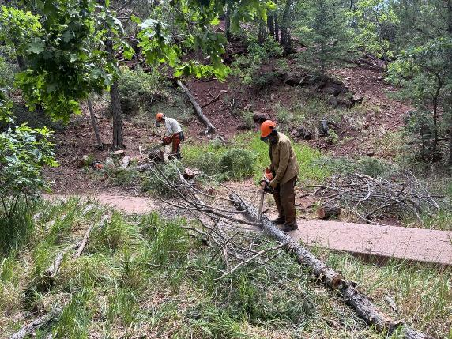
Sim Cook and Dan Benton limbing and bucking the junipers that Jerry felled.

