Report of FOSM Project to Paint Parking Stripes at Capulin Snow Play Area
and in the East End of the 10K North Parking Lot, Tuesday, June 30, 2026

Sam Beard
On Tuesday, June 30, Pauline Ho, Rick Buss, and Sam Beard painted stripes in the lower and upper parking lots at the Capulin Snow Play Area and in the east end of the 10K North parking lot. A handicapped parking space was painted in both the upper and lower lots at the Snow Play Area. The Snow Play Area is open to provide more parking and recreation opportunities while the Crest area is closed due to the thinning project and renovation of the Crest area. After completing the Snow Play Area parking stripes, the crew went to the 10K North parking lot where they painted blue stripes and wheelchairs in two parking spaces near the restroom.
Project photos are presented below. A photo of the road block on the Crest Highway and a few “No Parking” signs in the 10K South parking lot that is part of the turn-around loop.

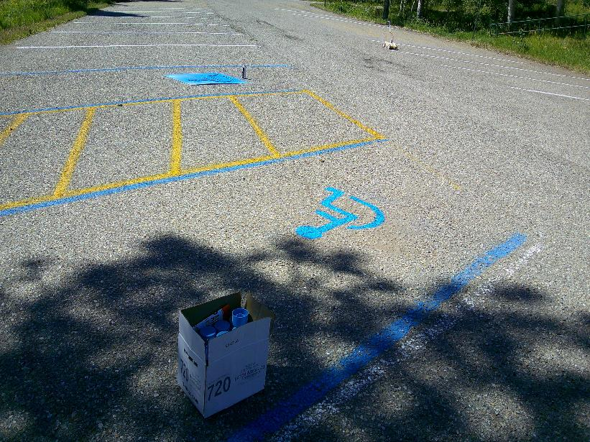
Handicapped parking, no parking, and general parking areas in lower parking lot at Capulin Snow Play Area.
All photos by Sam Beard
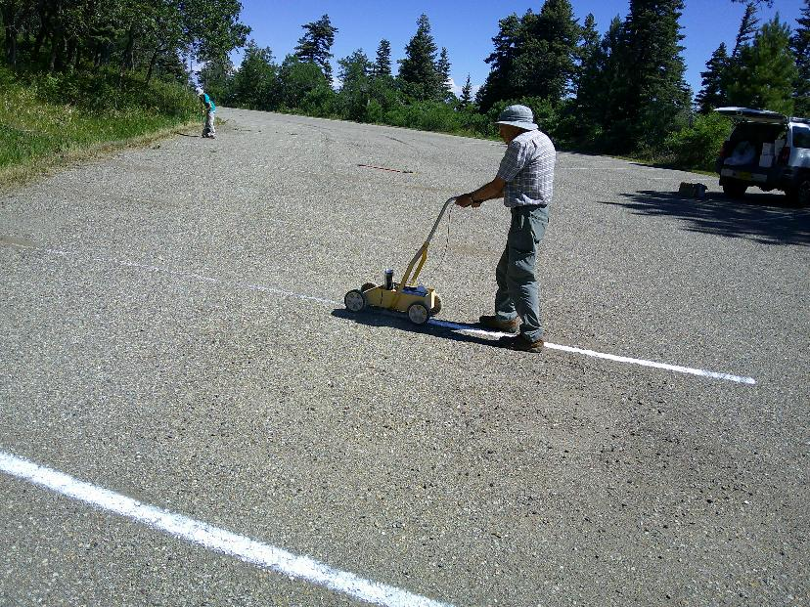
Rick Buss painting white stripes and Pauline Ho sweeping dirt off lines in the upper Capulin Snow Play Area parking lot.
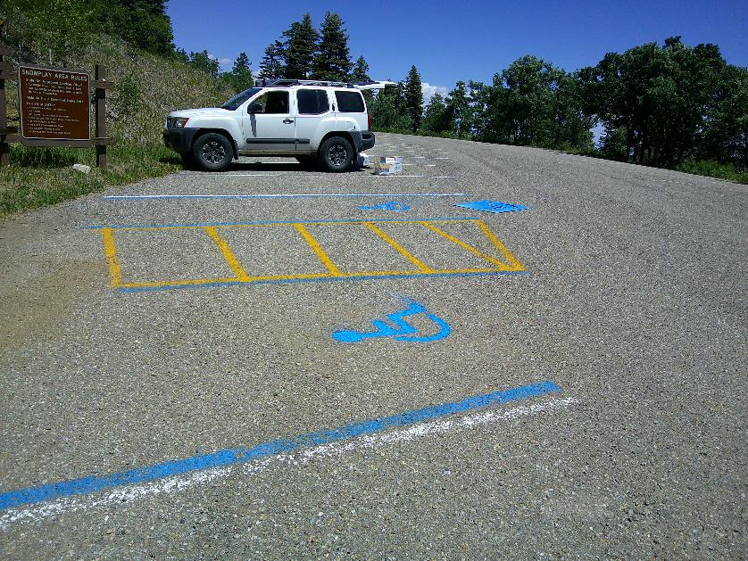
Handicapped parking, no parking, and general parking areas in upper parking lot at Capulin Snow Play Area.
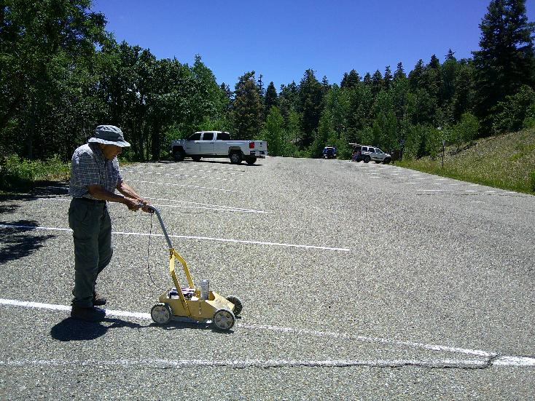
Rick Buss painting white stripes in upper Capulin Snow Play Area.

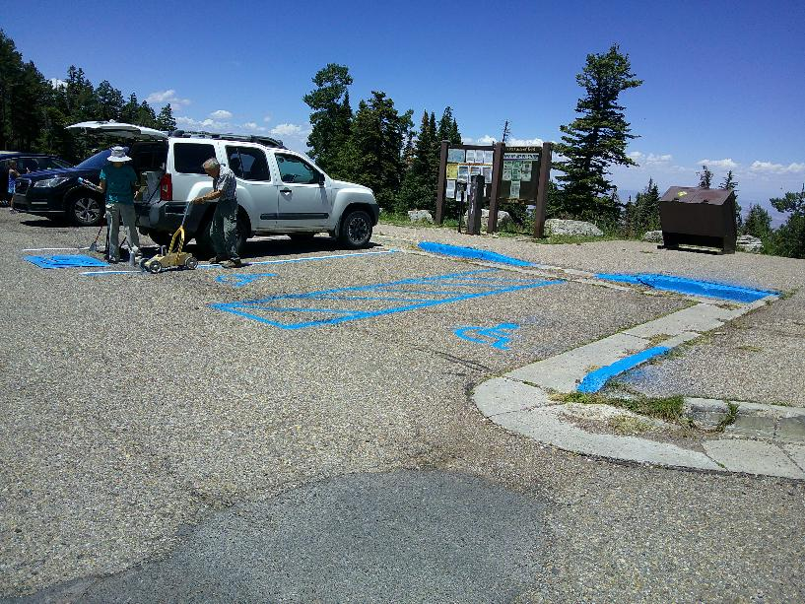
Two handicapped parking spaces were painted in 10K North parking lot.
Vehicles were parked in all the general parking spaces; therefore, we did not paint any white lines.
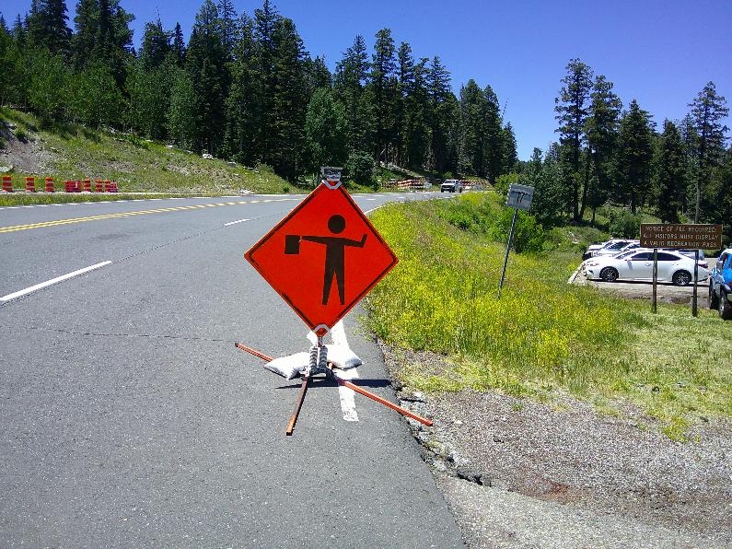
Road block at the 10K North parking lot related to the thinning project in the forest between 10K Trailhead and the
Crest. No parking is permitted in the 10K South parking lot, because that lot is part of the
turn around loop for vehicles going back down the highway.

