Report of FOSM Project to Fell Hazard Trees at the SRD Shop, in Sulphur Canyon Picnic Area, and in Doc Long Picnic Area, Wednesday, July 1, 2026
Sam Beard
On Wednesday, July 1, eight FOSM volunteers felled dead hazard trees at the following locations:
- Sandia Ranger District Shop – A dead 24-inch diameter Rocky Mountain juniper was felled, limbed, and partially bucked. The large pieces of the trunk and branches were hauled to the hazmat building in Jerry Carroll’s pick up where they will be bucked and split. The Mountain Christian Church will donate this wood to needy families in the East Mountain area who heat their homes with wood.
- Sulphur Canyon Picnic Area – Three dead Rocky Mountain junipers were felled, limbed and bucked by Dan Benton’s crew of Eric Russell, Sim Cook, and Jerry Carroll. This wood will be collected by a member of the public with a wood hauling permit.
- Doc Long Picnic Area – A 10-inch dead Rocky Mountain juniper was felled, limbed, and bucked. This wood will be collected by a member of the public with a wood hauling permit.
Project photos are presented below.

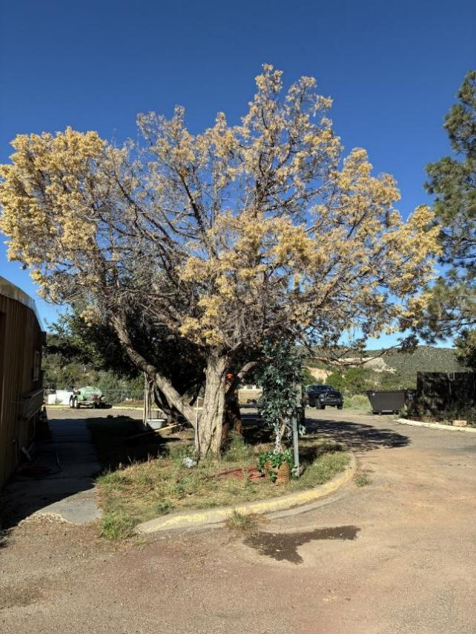
Dead Rocky Mountain juniper at north end of SRD shop.
All photos by Cliff Giles unless noted otherwise
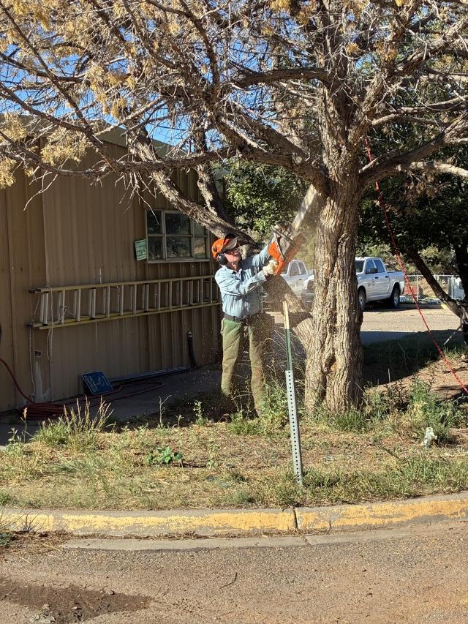
Eric Russell cutting off a large branch.

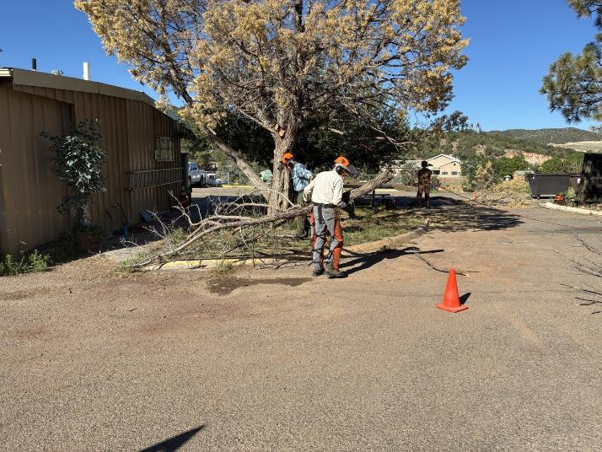
Sim Cook moving large branch away from tree.

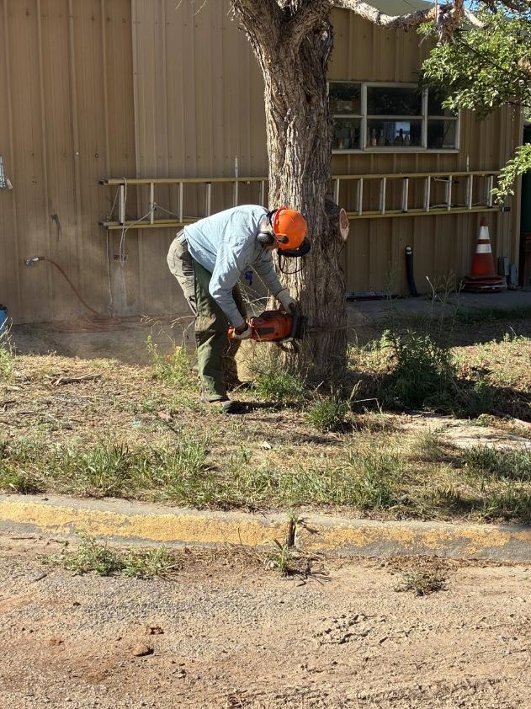
Eric making face cut.
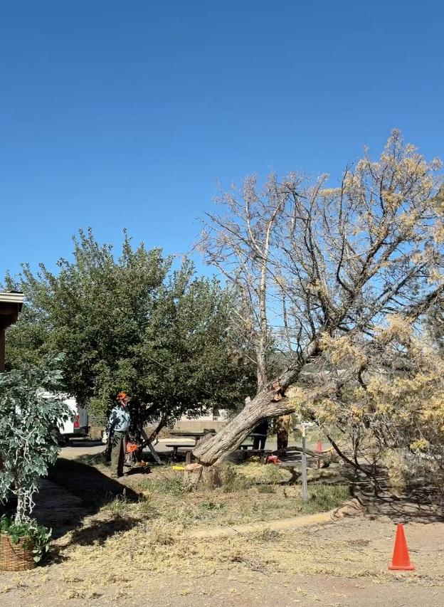
Tree falling.
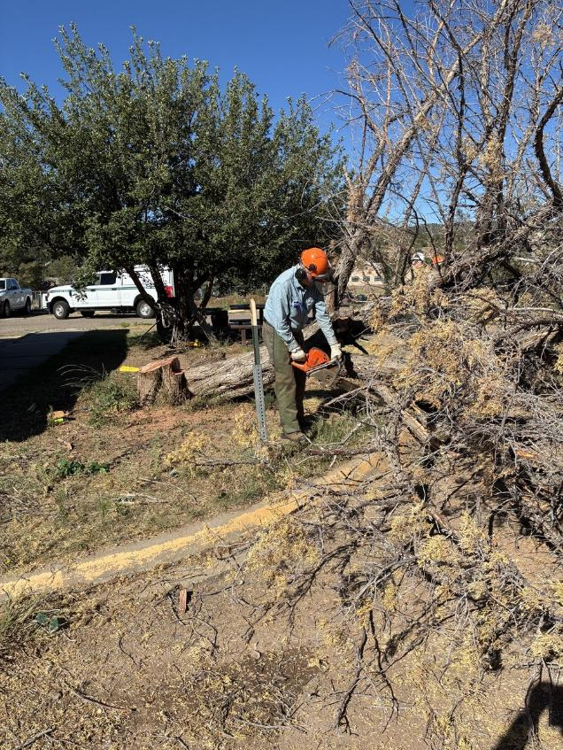
Eric limbing the felled tree.

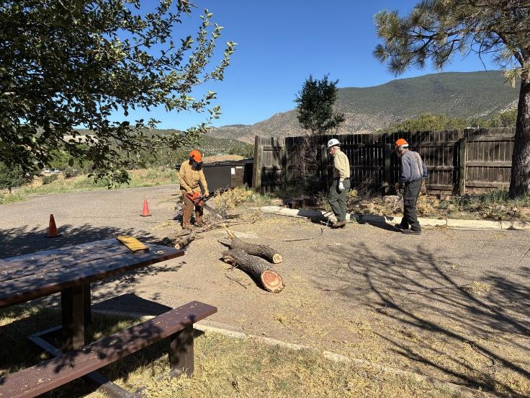
Dan Benton bucking log with Kent Towler and Sam Beard swamping.

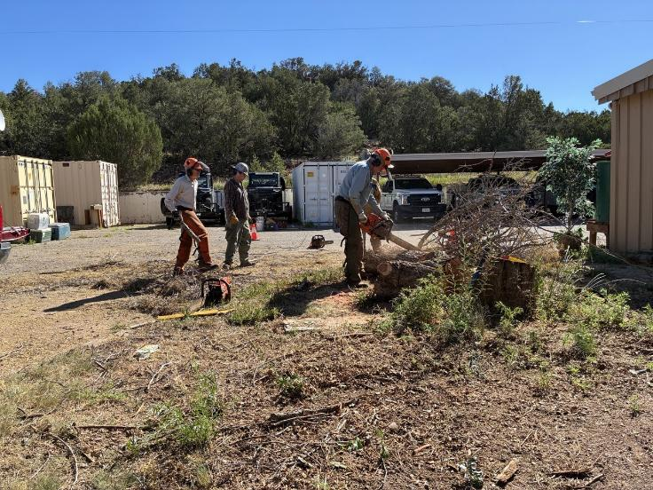
Eric bucking trunk with Sim Cook and Michael Arndt observing.

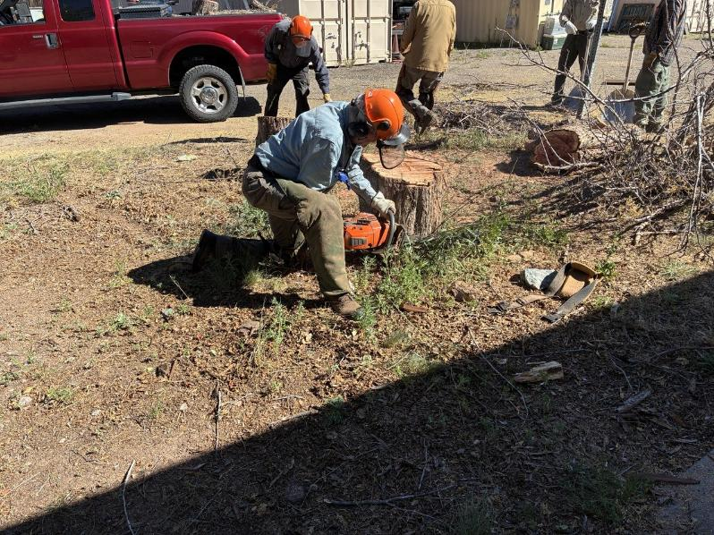
Eric low stumping the tree.
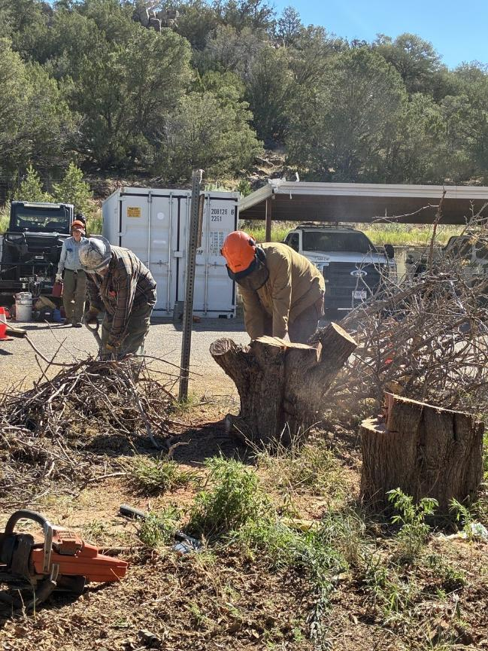
Dan cutting a piece of the trunk vertically.

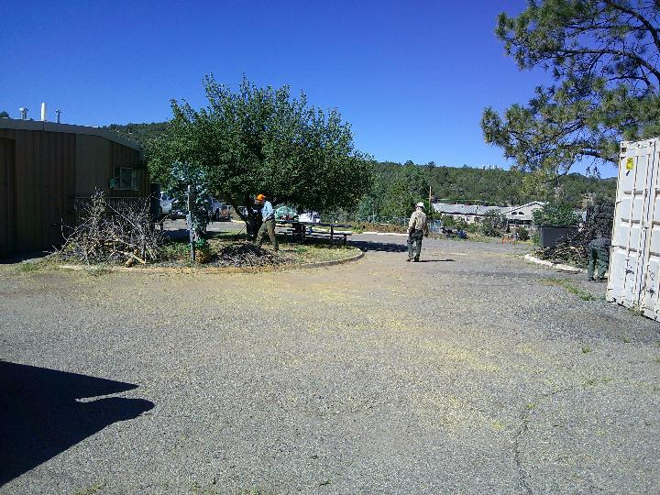
Branches and pieces of the trunk have been removed from the parking lot. The bucked trunk and large branches were hauled to the hazmat building in Jerry Carroll’s pickup. We would like to chip the smaller branches. Photo by Sam Beard

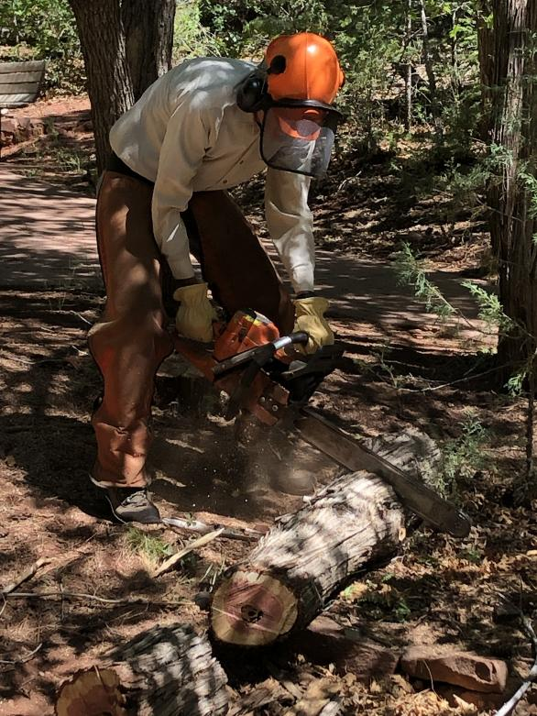
Sim Cook bucking piece of a dead Rocky Mountain juniper in Sulphur Canyon Picnic Area.
Photo by Dan Benton
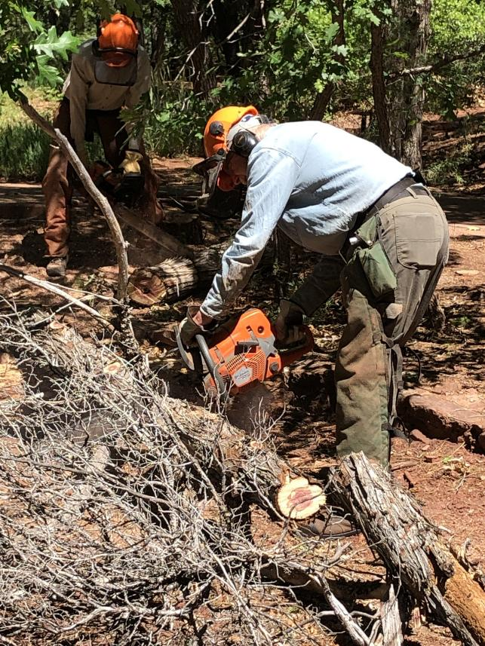
Eric bucking a Rocky Mountain juniper trunk in Sulphur Canyon Picnic Area. Photo by Dan Benton
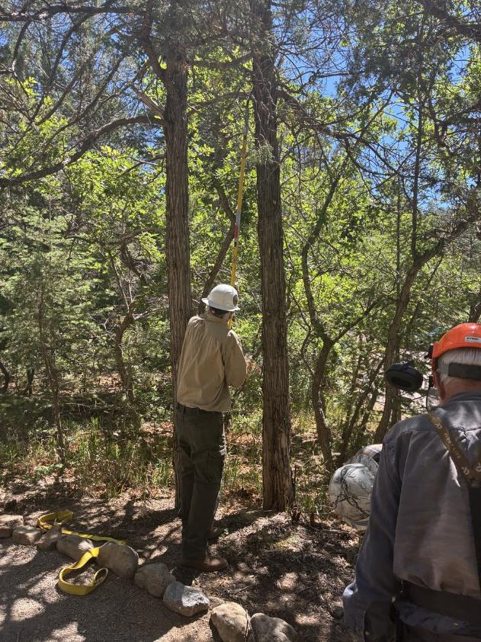
Kent Towler using a pole saw to remove a small limb.
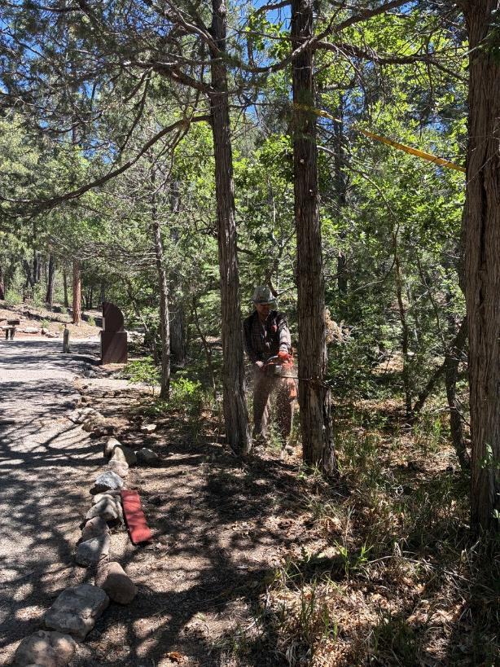
Michael Arndt making a back cut in a 10-inch dead Rocky Mountain juniper at Doc Long picnic area.
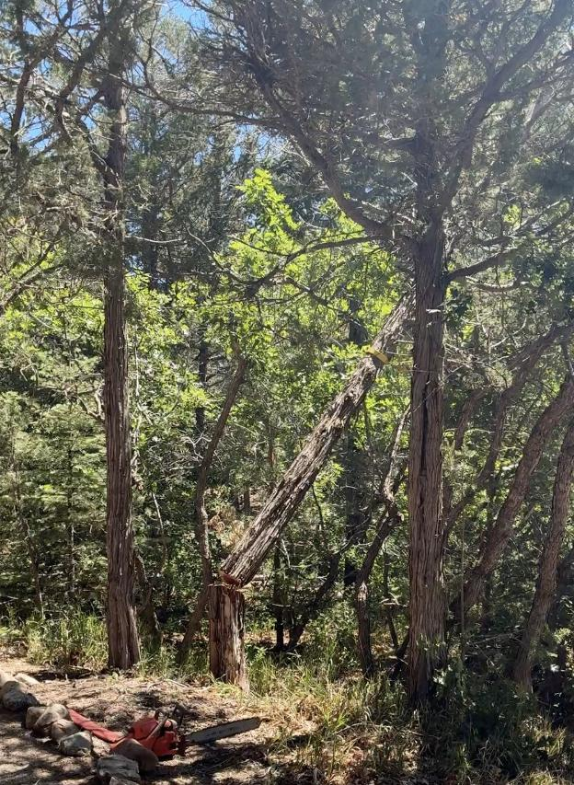
Dead Rocky Mountain juniper falling.

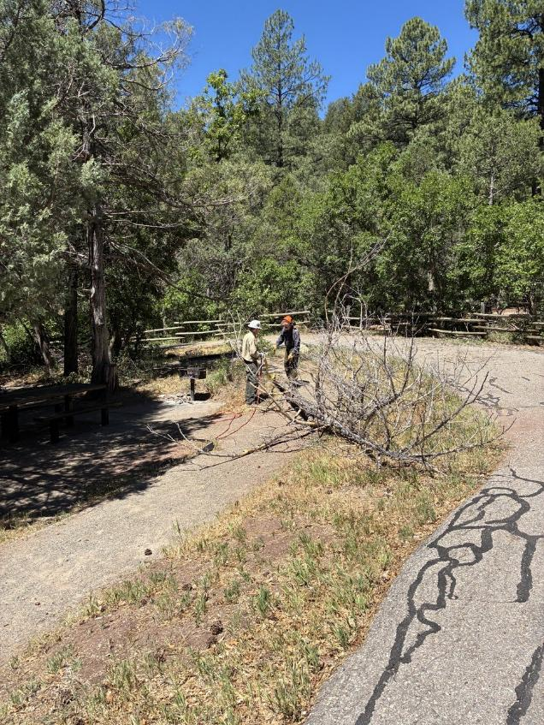
Kent Towler and Sam Beard discussing the felled tree.

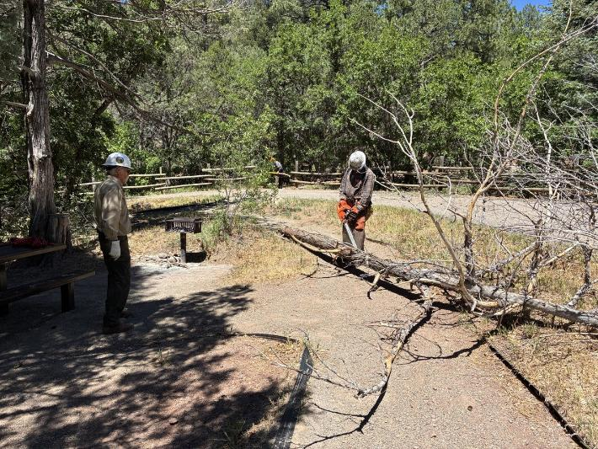
Michael limbing the juniper while Kent waits to move the bucked wood.

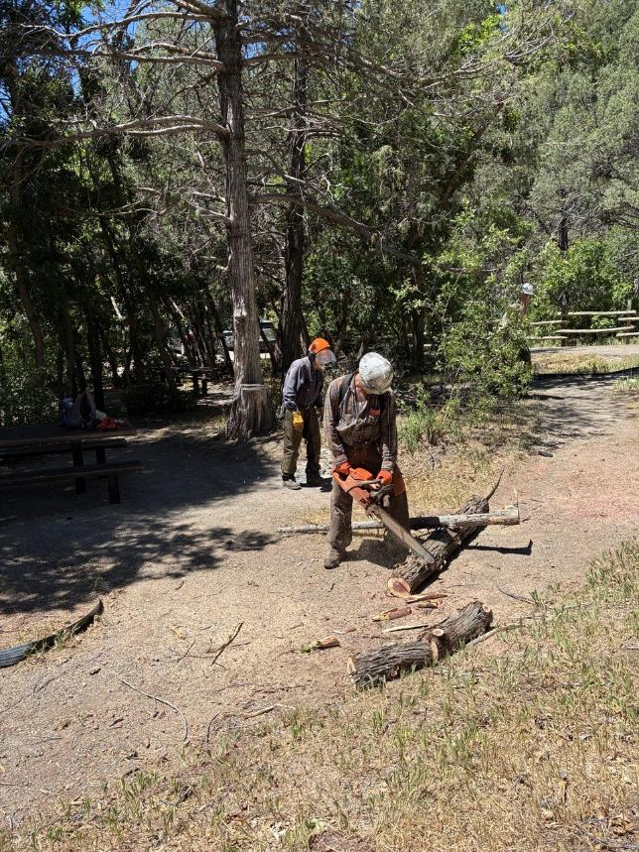
Michael bucking the last part of the juniper trunk.

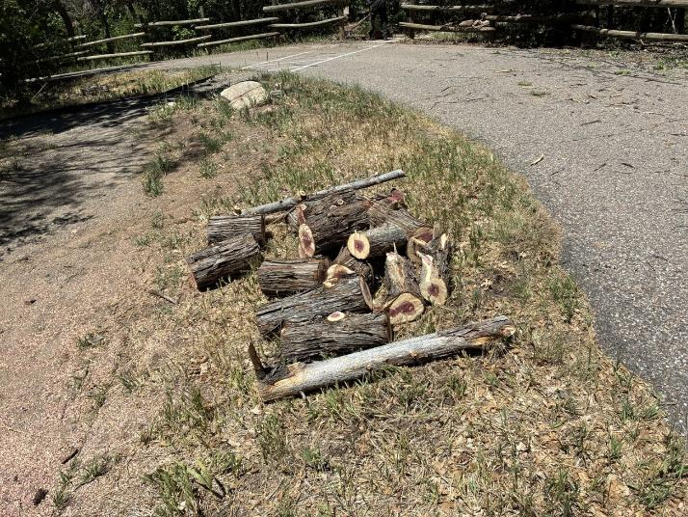
Pile of bucked juniper waiting to be collected by a member of the public with a wood hauling permit.

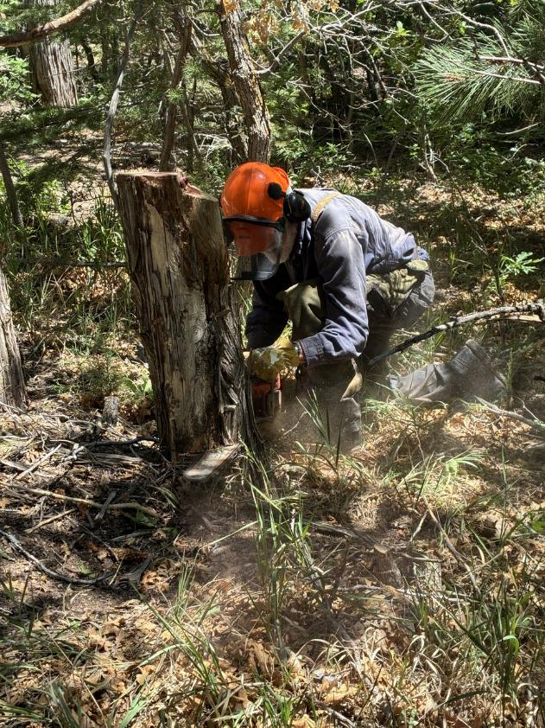
Sam Beard low stumping Michael’s tree.

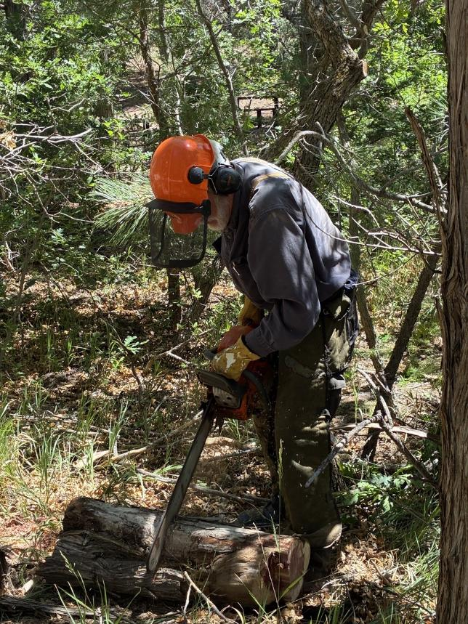
Sam bucking the stump.

