Report of Installation of New FOSM Adopt-A-Trail Sign on Tecolote Trail, Saturday, July 4, 2026
Sam Beard
On Saturday, July 4, Chuck Logan, Michael Arndt, and Sam Beard installed the new FOSM Adopt-a-Trail sign on Tecolote Trail. The sign was made by Jamey Browning, and Sam Beard applied a coat of Cabot Australian Timber Oil. The color was Natural which is a very light beige. The original New Mexico Friends of the Forest sign was vey weathered and was taken to the FOSM Guard Station. Tim Brown, former FOSM treasurer, completed the N. M. State forms for the NMFOF to be doing business as (dba) Friends of the Sandia Mountains (FOSM) so that the public would know what we do.
Photos of the installation of the new sign are presented below.

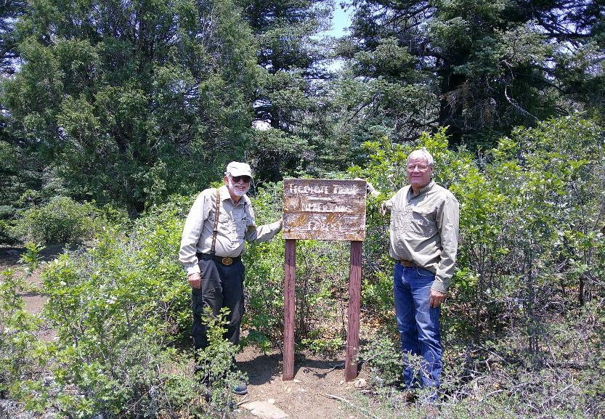
Sam Beard and Chuck Logan at the old NMFOF (New Mexico Friends of the Forest) Adopt-A-Trail sign on Tecolote Trail.
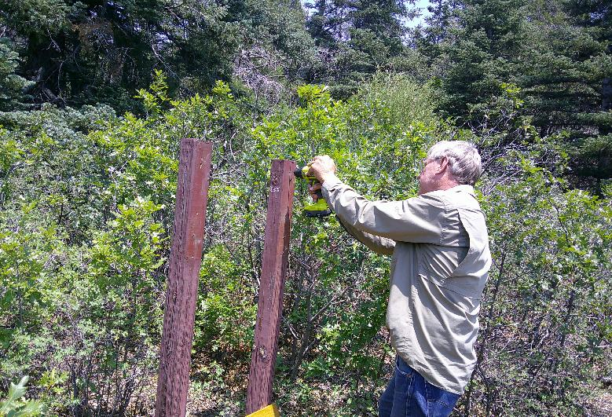
Chuck drilling pilot holes for the screws that will attach the new sign to the posts.
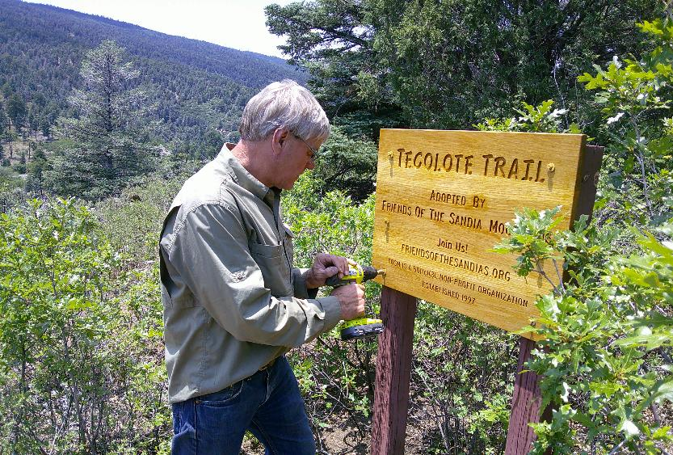
Chuck tightening the last lag screw securing the sign to the posts

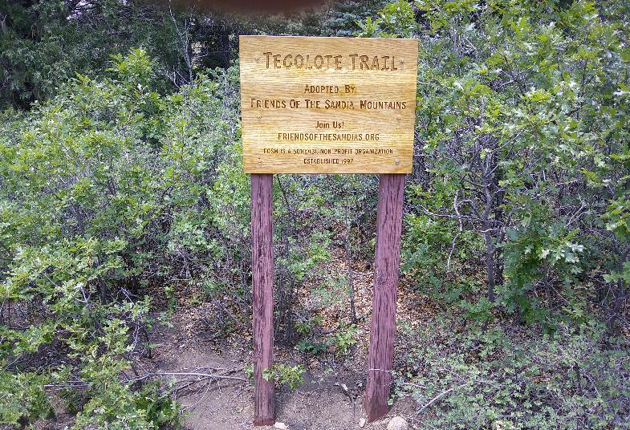
Jamey Browning’s new FOSM Adopt-A-Trail sign on Tecolote Trail.

