Thursday, 07/09/26- Rocky Point and Challenge: It was a warm one, even up on top of the mountain! Thirteen volunteers and Jen and Chris (SRD) met at Doc Long and carpooled up to the Ellis parking area. Last week was quiet but this week we could hear machinery working and there were plenty of trucks runing up and down the road.

Byron and Cleve took off to take care of a down tree that Canyon had reported:
As an addendum to the continued work in the crest closure area, Cleve and Byron hiked, from the tram, about a mile down the South Crest trail to remove a sixteen-inch tree reported by Canyon. Fortunately, this "lunker" of a fir with a large root ball was cleared with one cut and leveraged off the trail.

The rest of the group hiked back out Rocky Point where we looked for additional work beyond the tape where we had stopped last week. The machinery has not been in this area yet and it really felt dark and close compared to the worked area.
No work there yet so we split into two groups with one group staying to build a retaining wall on a section of the trail that has been very eroded by the machinery. The rest of the folks headed back towards the parking area, stopping to make fixes and disperse material along the way and then started working on the Challenge trail fixes.

Work is coming along nicely but all the fixing ends up being in the sunny spots!

Volunteers: Cleve Sharp, Jim Houle, Courtnee Bennett, Kerry Jones, Eric Russell, Sim Cook, Bruce Hansche, Byron Garner, Claudia Bergsohn, Bill Perkins,
Erin Gaddis, Dallas Duckworth and Laura Leon

Photos: Kerry Jones, Cleve Sharp and Laura Leon

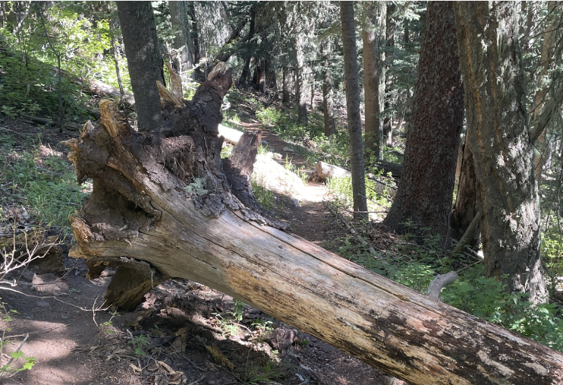

This is the tree Byron and Cleve worked on removing. One cut!

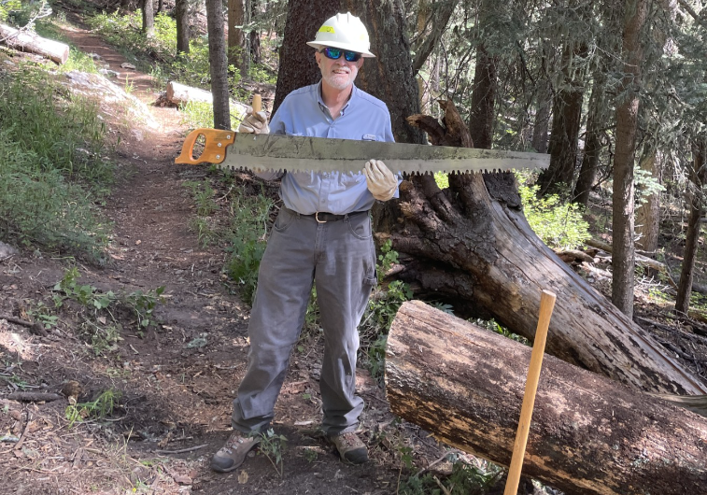
Meanwhile back on Rocky Point, work started on the retaining wall.

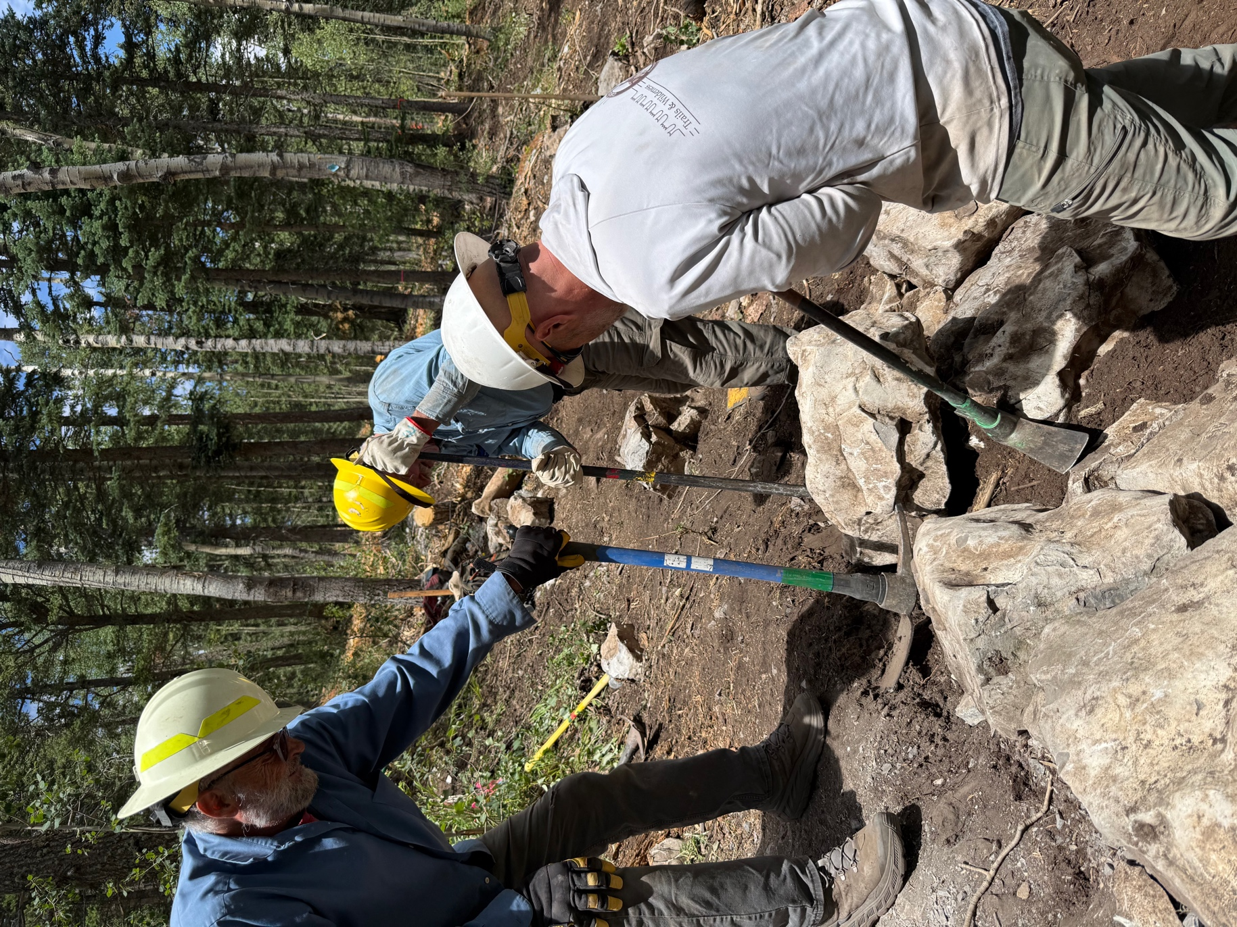
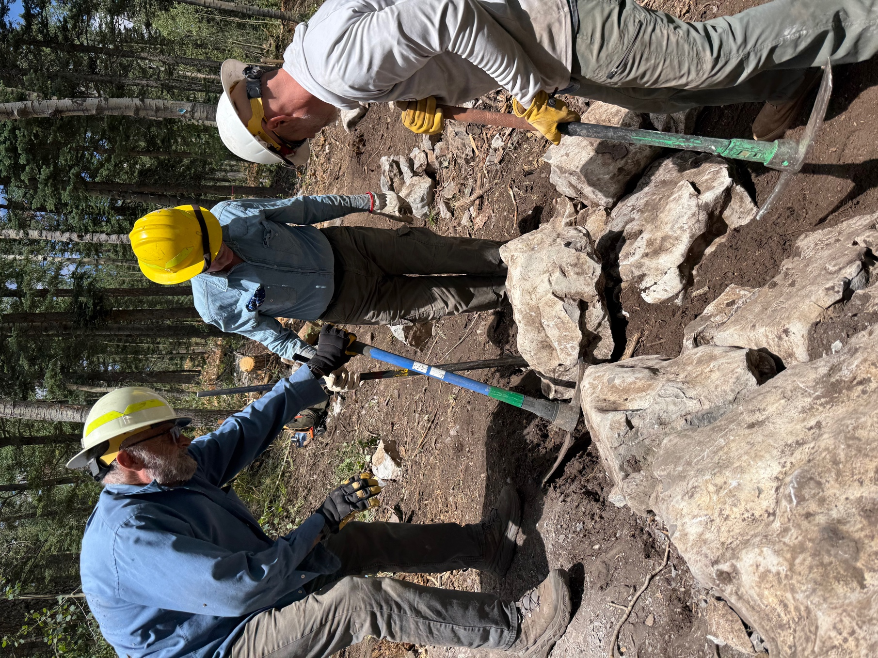

Bill, Eric and Chris work rocks into place. It was a challenge to find loose rocks big enough to use- lots of hunting.
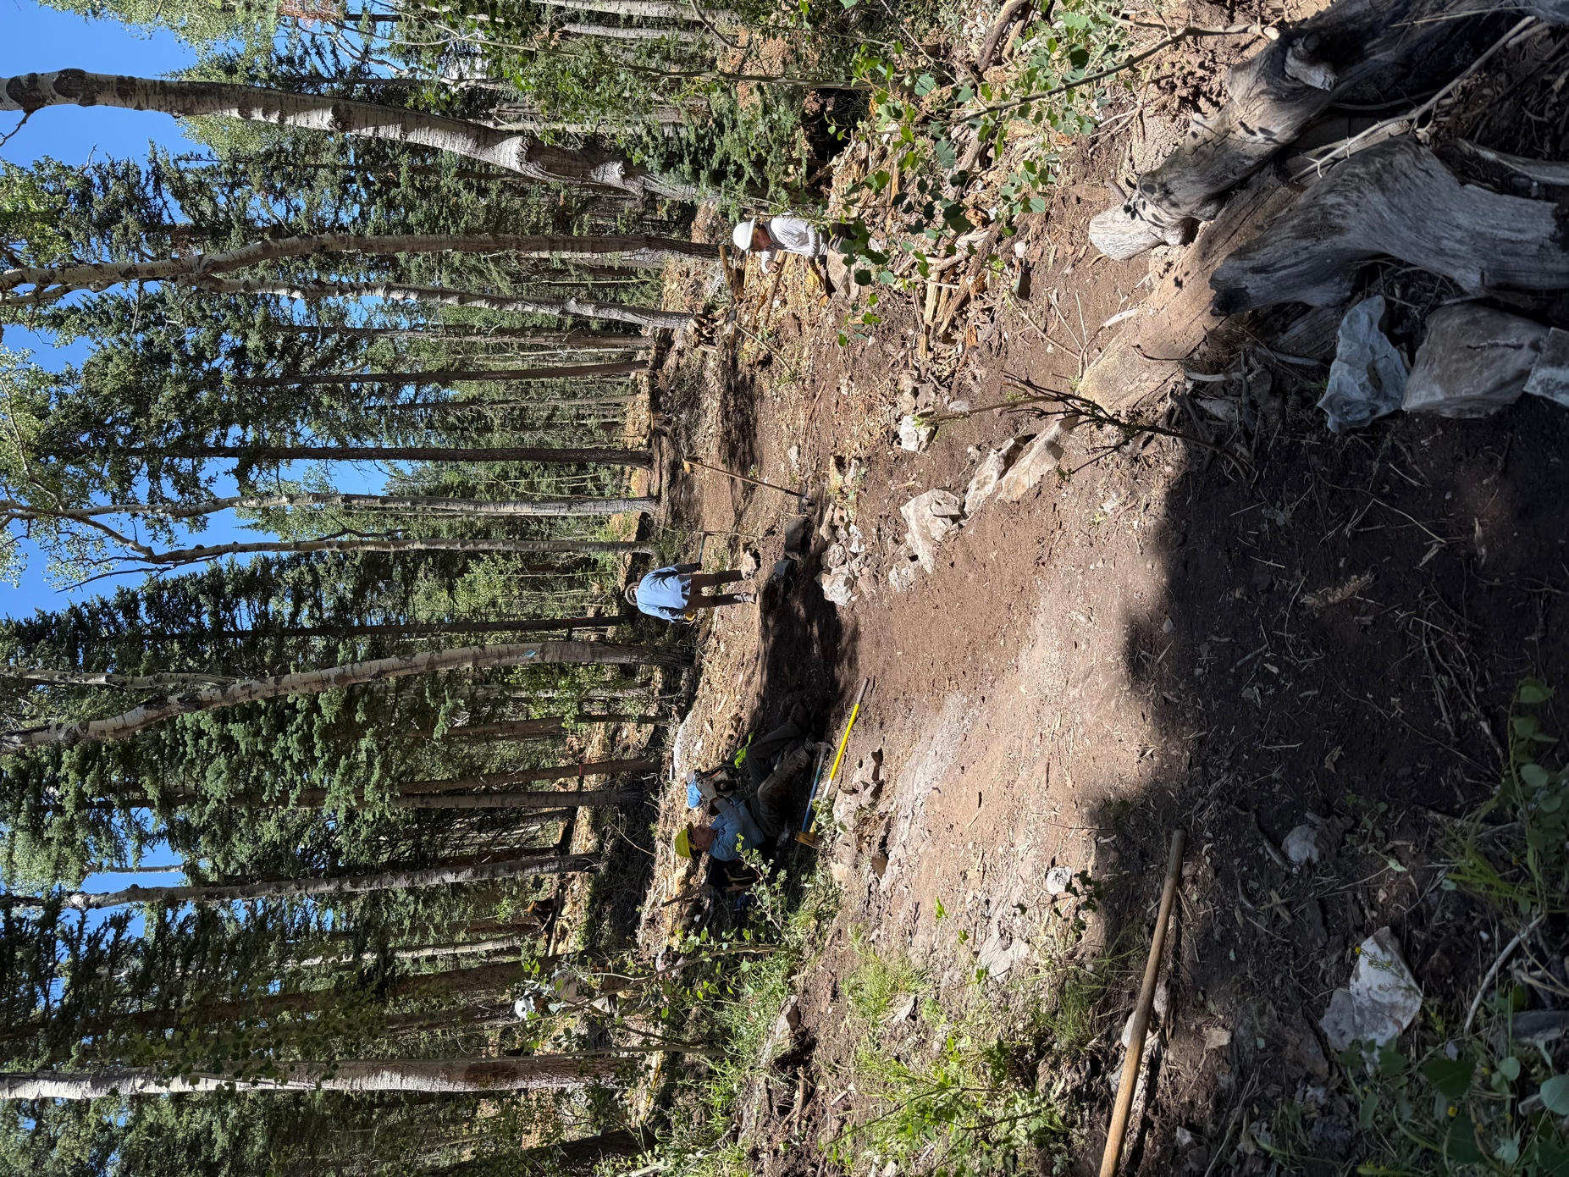

Rest time- almost finished!
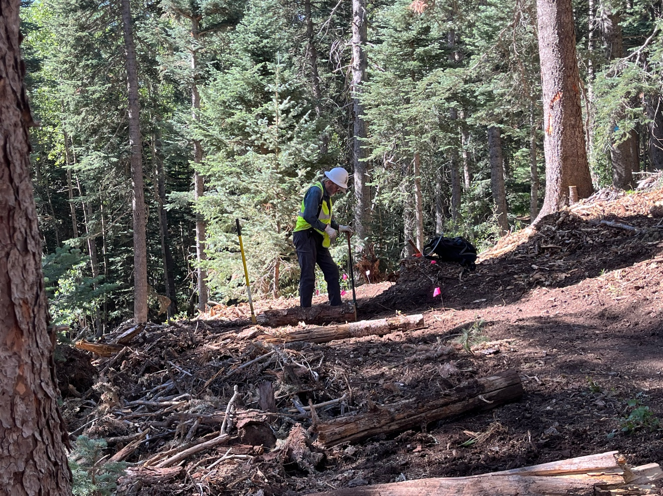

Meanwhile Bruce and Claudia did some trail fixes.
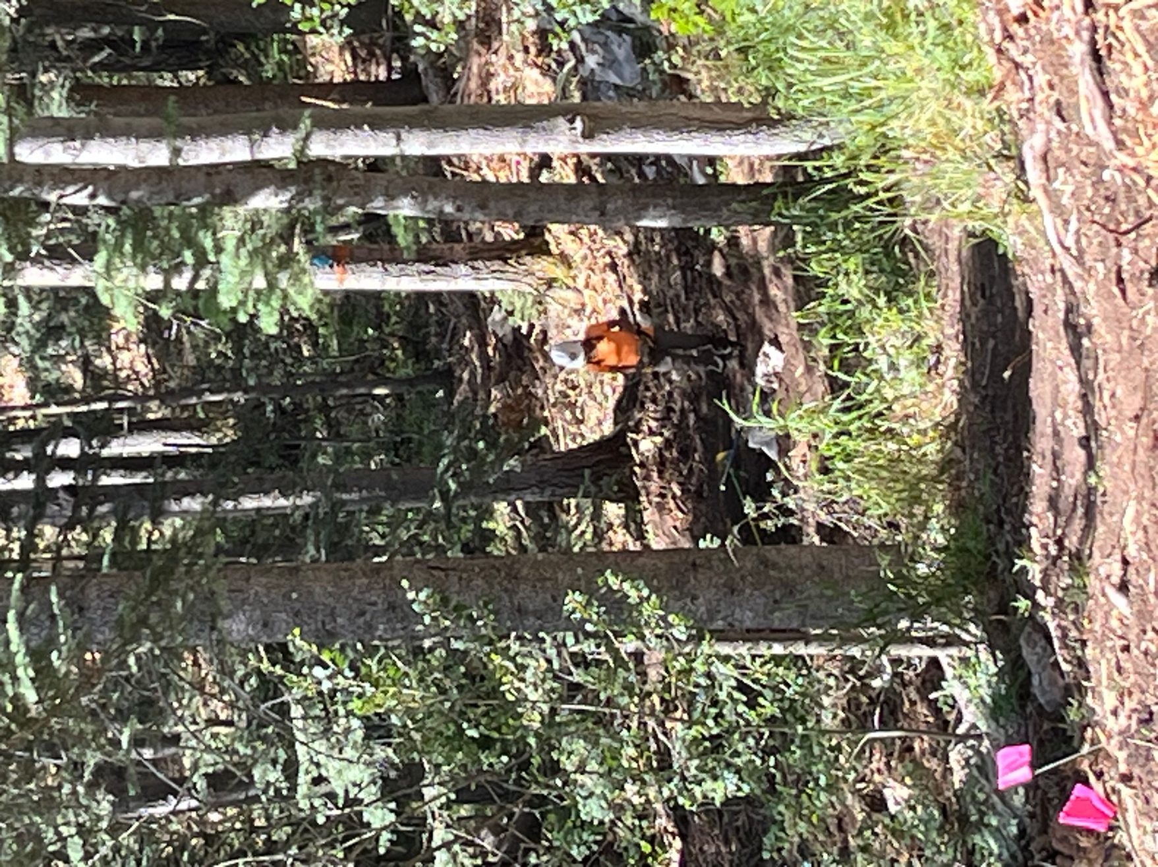

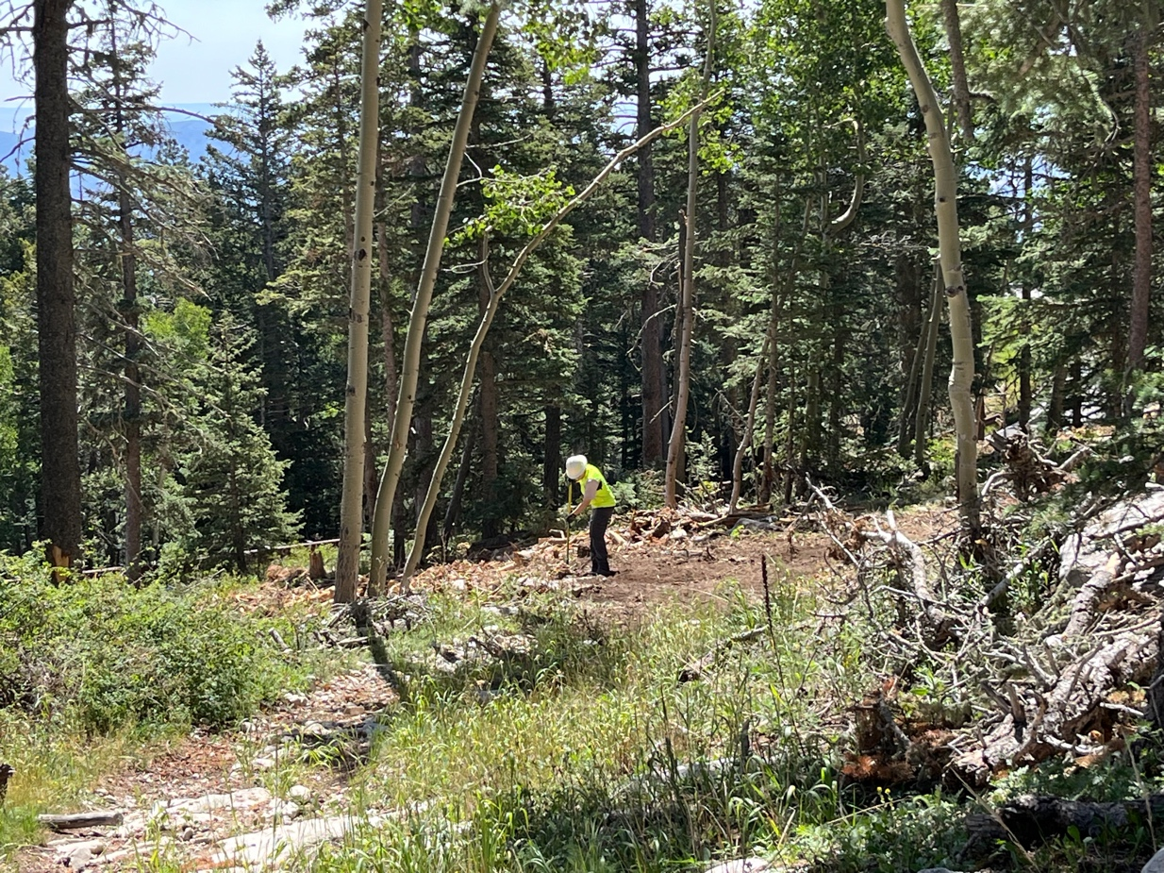

Courtnee, Erin and Sim start repairs on Challenge.

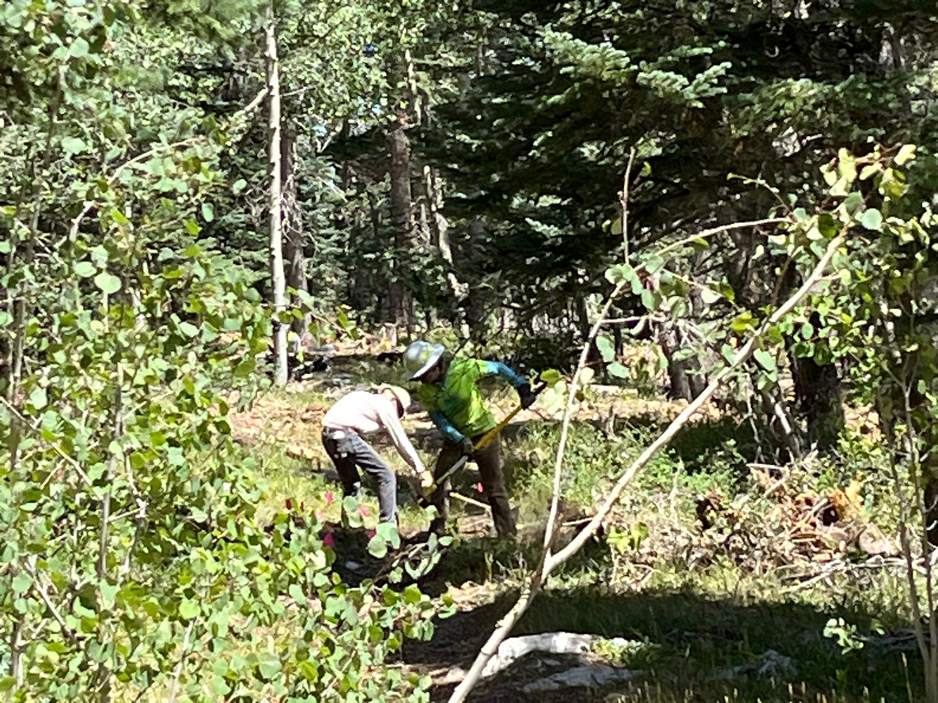
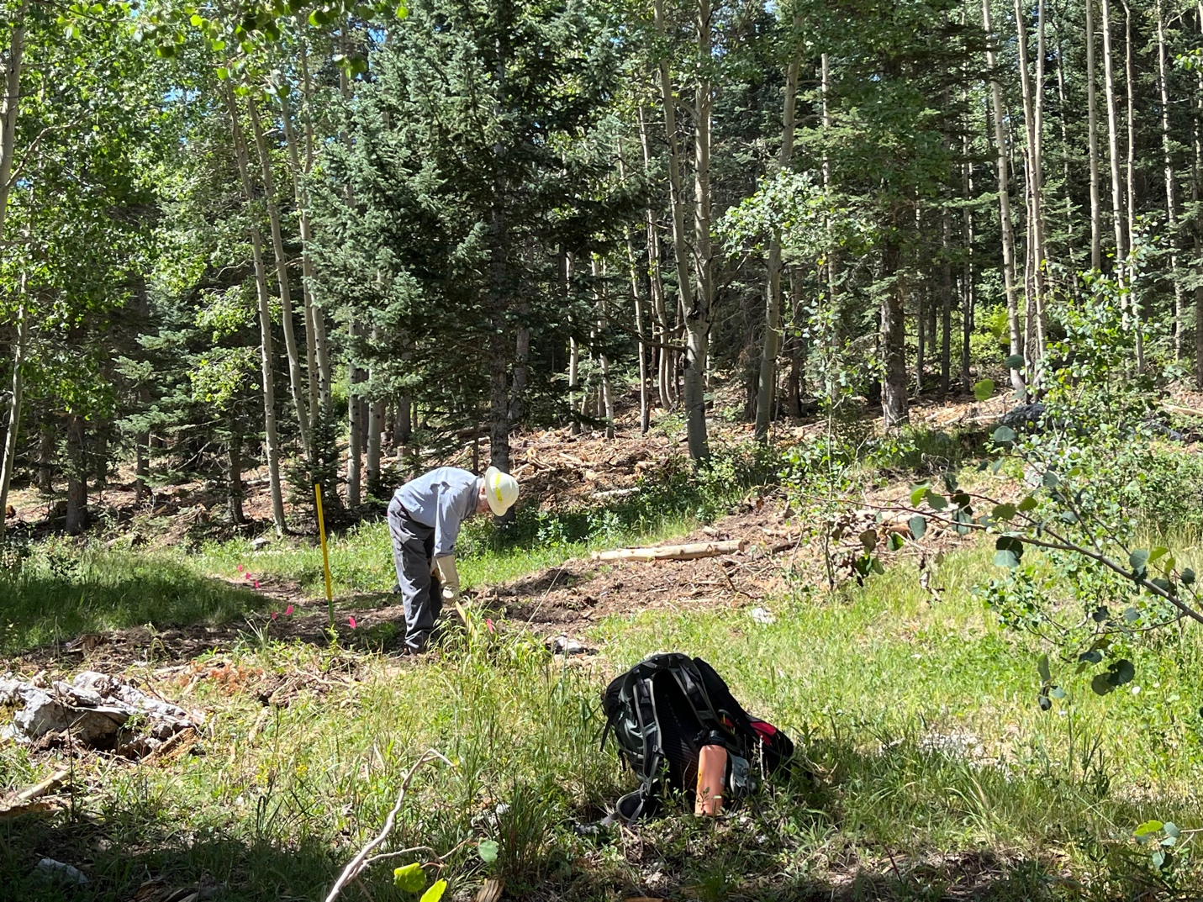

Cleve caught up with us after working on the tree removal.

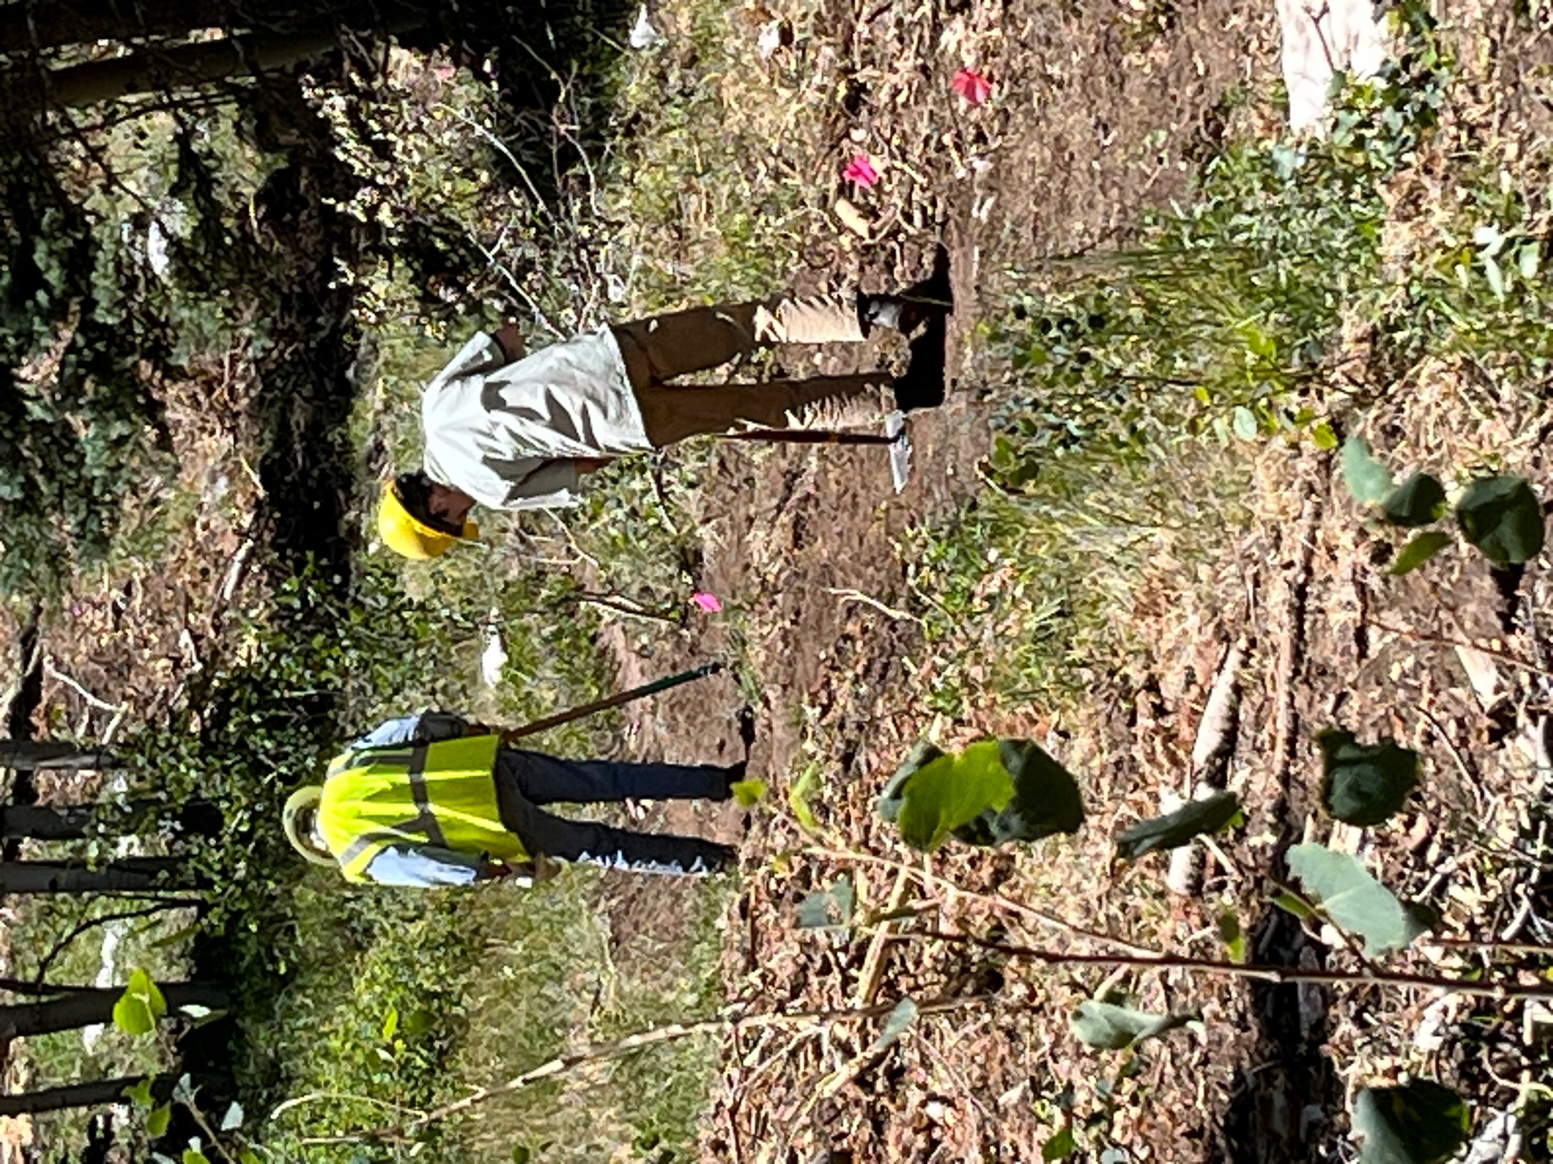

Byron and Dallas work on a stretch of trail.
Now that you are all cloud experts, can you name these??

