Report of FOSM Volunteers Felling Hazard Trees at Tree Spring Trailhead and in Balsam Glade Picnic Area, Wednesday, July 8, 2026
Sam Beard and Dan Benton
On Wednesday, July 8, FOSM volunteers felled hazard trees at Tree Spring Trailhead and in Balsam Glade Picnic Area.
- Tree Spring Trailhead -- Our Tree Spring crew felled, limbed, and bucked seven trees. I believe all were white fir. Sim and Eric felled, limbed and bucked two dead trees below the sidewalk to the rest rooms. I felled a dead tree next to the trail just above the rest rooms. Lorna bucked it. I felled a dead snag next to the trail a little farther up, and Sim bucked it. Jerry felled a larger dead tree between the trail and parking lot and Lorna bucked it. Eric felled another larger dead tree nearby and bucked it. Jerry felled a dead top tree with three witches' brooms at the crown that was inside the first bend of the trail above the rest rooms. Jerry and Eric bucked it. Tree diameters ranged from 5 inches to 12 inches. Other smaller trees were cut to clear lays or escape routes. (Dan Benton)
- Balsam Glade Picnic Area – Michael Arndt felled, limbed, and bucked two dead trees with diameters of 10 to 12 inches below the restrooms in Balsam Glade Picnic Area. Then the crew moved to the end of the nature trail where Michael limbed a 22-inch ponderosa pine that had been felled earlier. All three trees were bucked into 8-foot pieces. After moving to a 33-foot-long pine log on top of the ridge that the nature trail goes around, Michael’s chain saw would not start; therefore, this 20-inch diameter log was not bucked. (Sam Beard)
Volunteers working on this project were Eric Russell, Sam Beard, Sim Cook, Kent Towler, Cliff Giles, Chuck Logan, Dan Benton, Michael Arndt, Jerry Carroll, and Lorna Morrow.
Project photographs are presented below.

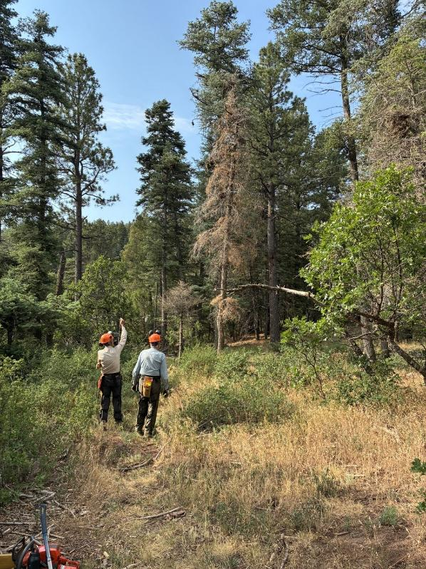
Sim Cook checking lean on a dead tree with Eric Russell. All photos by Cliff Giles unless noted otherwise.
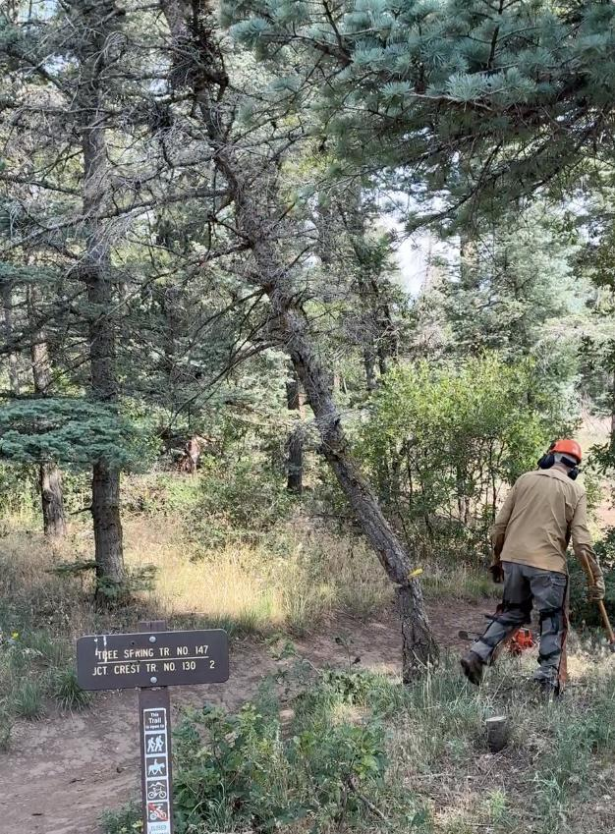
Dan Benton running away from a dead tree he has just felled near the Tree Spring restroom.
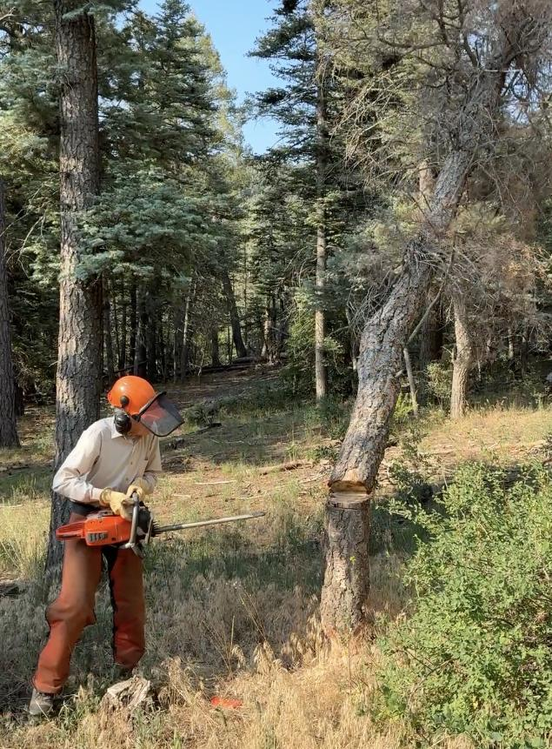
Sim has just felled this dead tree.
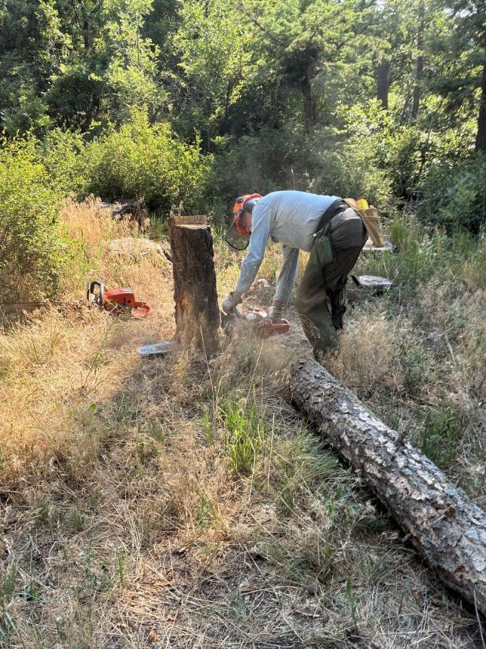
Eric low stumping Sim’s tree.
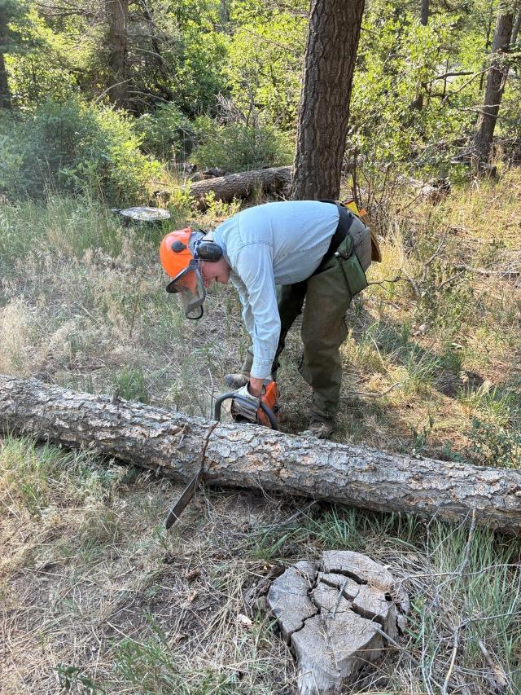
Eric bucking Sim’s tree into 4-foot pieces.
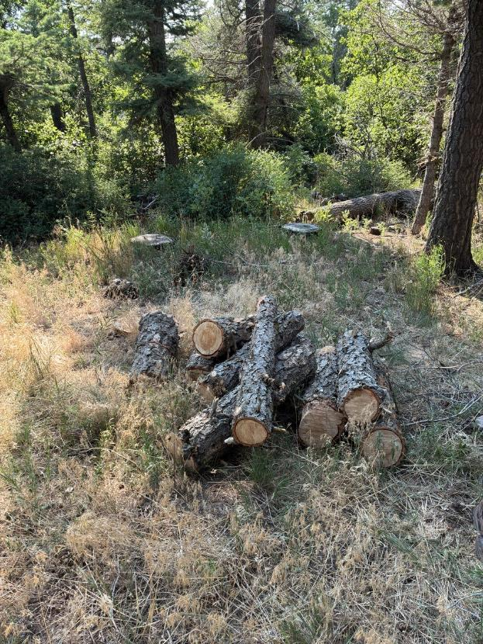
4-foot pieces of the tree ready to be collected by a fuelwood collector with a permit.
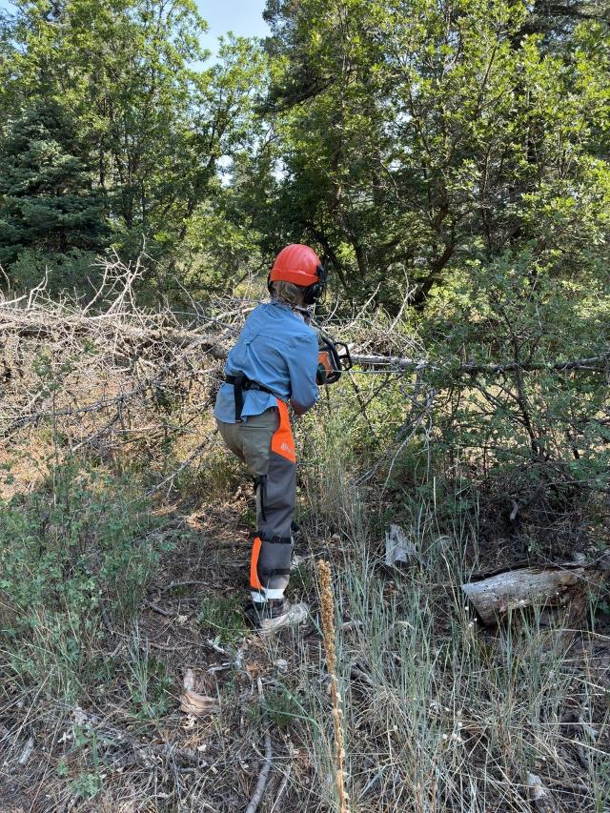
Lorna Morrow limbing a tree felled by Jerry Carroll.
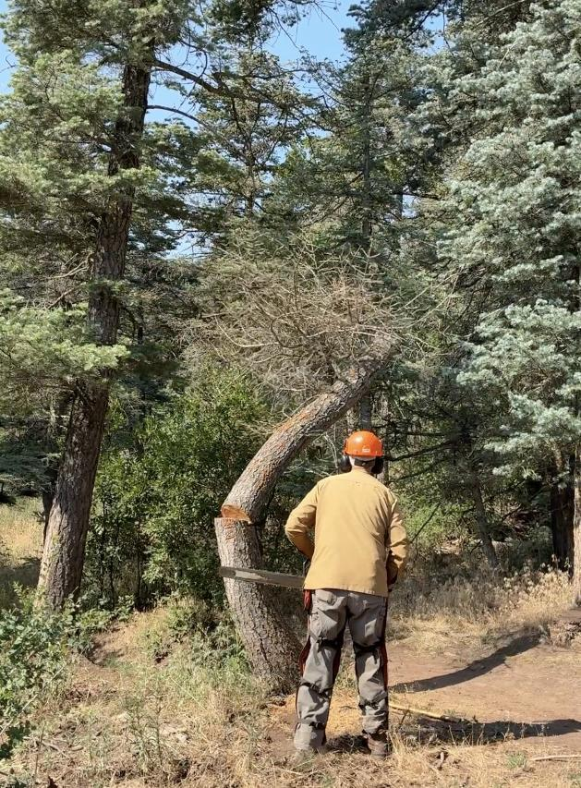
Dan Benton felling a curved tree beside Tree Spring Trail.
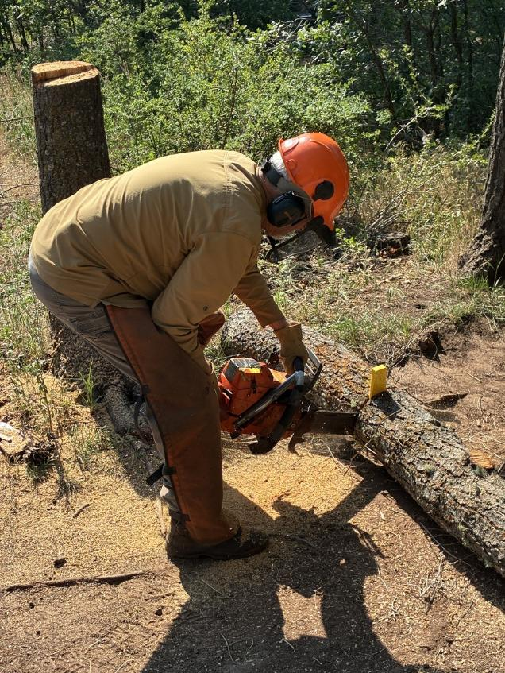
Dan bucking his tree. Trees bucked to 4 feet are less likely to be stolen than trees bucked shorter.
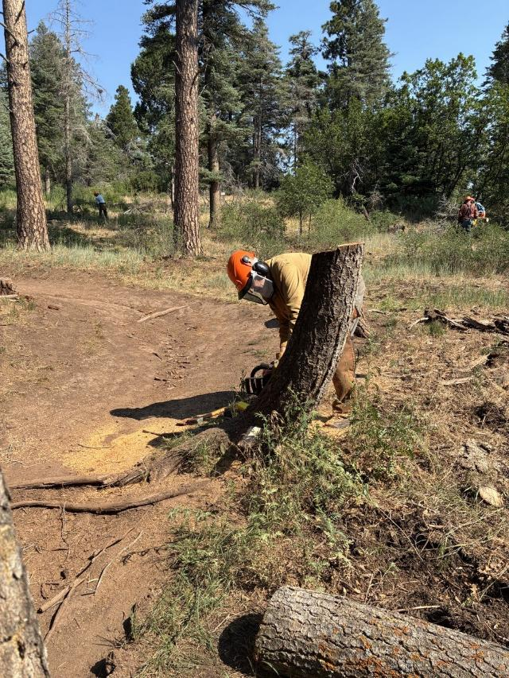
Dan low stumping his tree at a curve in the trail.
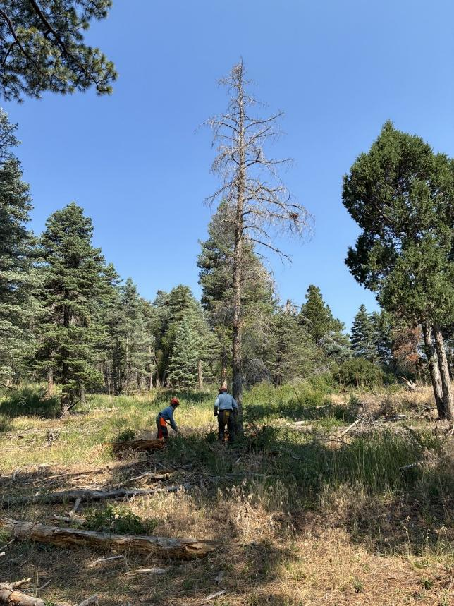
Lorna clearing debris from around the tree that Eric will fell.
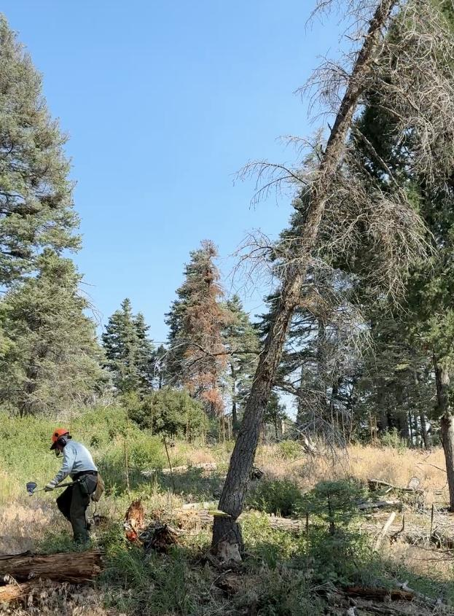
Eric running away from his falling tree. Note the face cut and back cut at the stump.

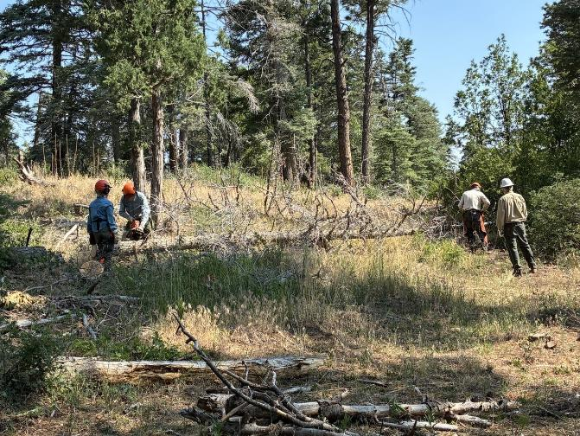
Lorna Morrow and Kent Towler are swamping, and Eric and Sim are bucking the tree.

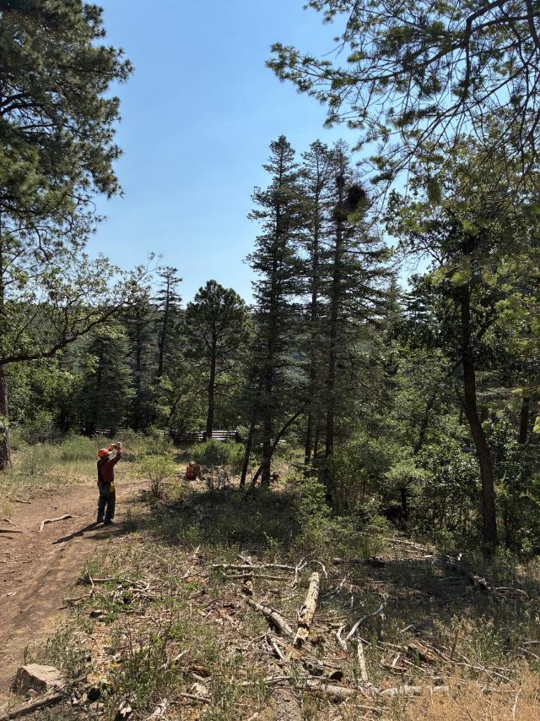
Jerry checking the lean of a tree he will fell.
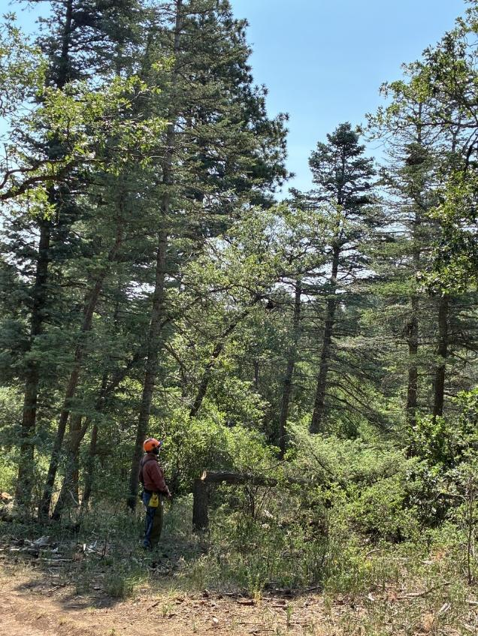
Jerry standing by the dead tree he felled.

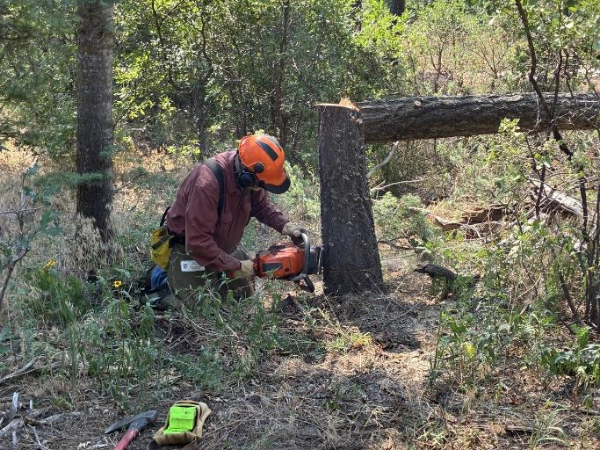
Jerry low stumping his tree.

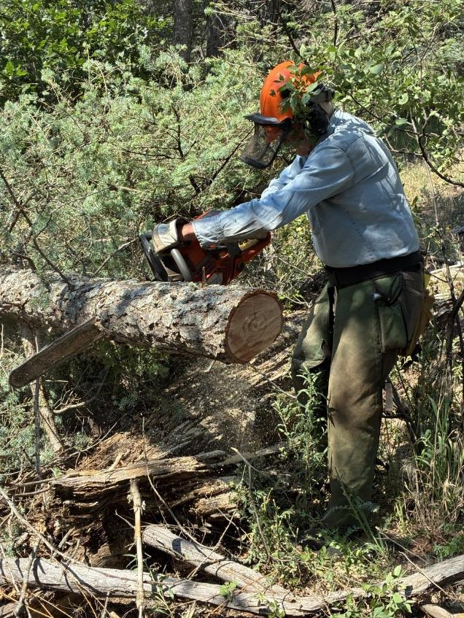
Eric bucking Jerry’s tree.

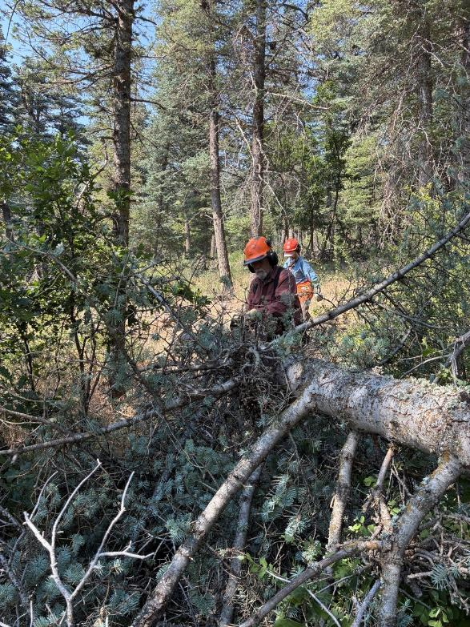
Jerry limbing his tree with Lorna swamping.

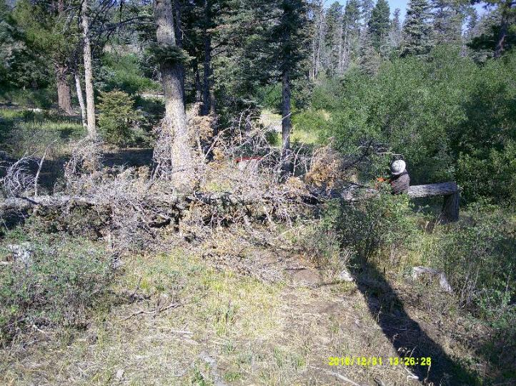
Michael Arndt limbing a dead hazard tree he felled in Balsam Glade Picnic Area.
Photos by Sam Beard

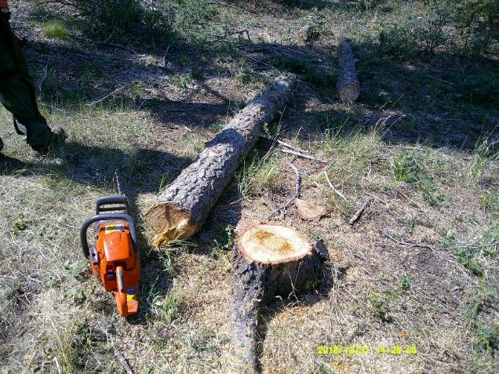
The lower part Michael’s tree was rotten in the center.

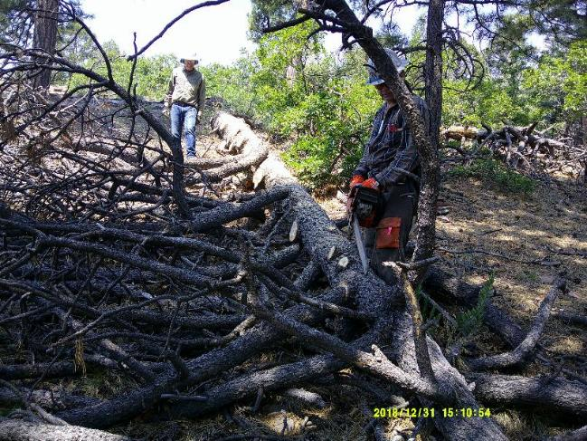
Michael limbing a large tree felled earlier while Chuck Logan swamps.

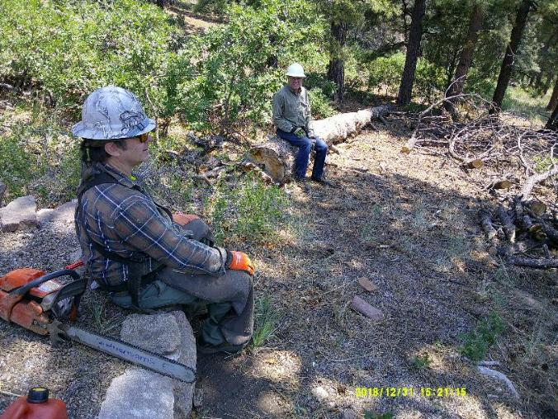
Michael resting while Chuck Logan sits on the 22-inch log Michael limbed and buck into 8-foot pieces.

