Report of FOSM Project to Replace Fence Rails and a Post in Doc Long, Sulphur Canyon,
and Cienega Canyon Picnic Areas, and at Tree Spring Trailhead, Wednesday, July 15, 2026

Sam Beard
On Wednesday, July 15, ten FOSM volunteers completed the following tasks:
- Loading Wood in Trailer at Hazmat Building – Split wood stacked at the hazmat building was loaded in Mike Oliver’s trailer and some unbucked juniper branches were loaded on his pickup.
- Replacing Fence Rail in Doc Long Picnic Area – In Doc Long PA, the volunteers replaced a broken fence rail at the entrance.
- Replacing Fence Rail in Sulphur Canyon PA – In Sulphur Canyon PA, a broken fence pole at the second parking lot was replaced.
- Replacing Fence Rail and post in Cienega Canyon PA – A broken fence post at the group area parking lot was replaced.
- Replacing fence rail at Tree Spring Trailhead – At Tree Spring Trailhead, a top fence rail broken by a falling tree was replaced.
The volunteers working on this project were Eric Russell, Dan Benton, Sim Cook, Jerry Carroll, Chuck Logan, Lorna Morrow, Lou Romero, Kent Towler, Cliff Giles, and Sam Beard.
Project photos are presented below.

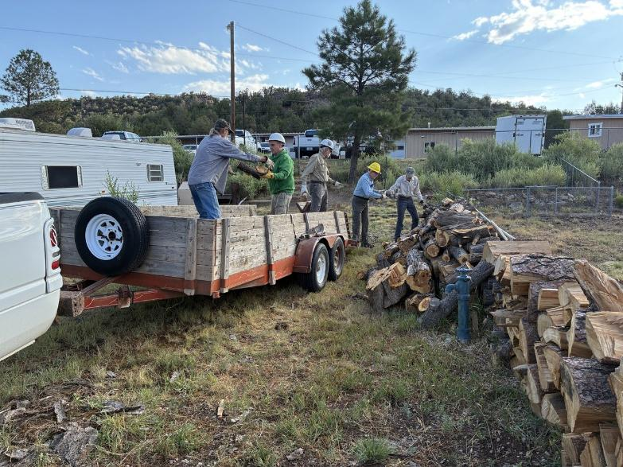
Loading wood on Mike Oliver’s trailer at the hazmat building that FOSM volunteers felled,
bucked to 12-inches, and split. All photos by Cliff Giles unless noted otherwise.
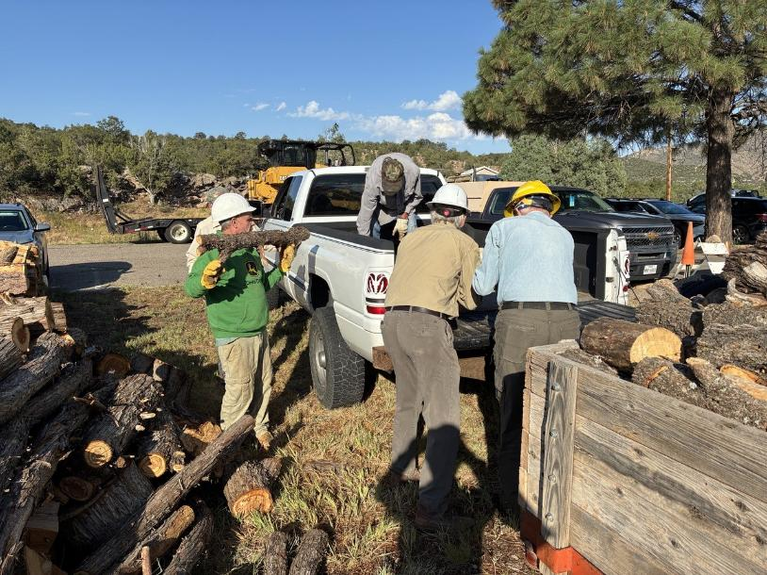
Loading Rocky Mountain juniper wood in Jerry’s pickup. This wood came from a large RM Juniper that died
at the north end of the SRD shop.
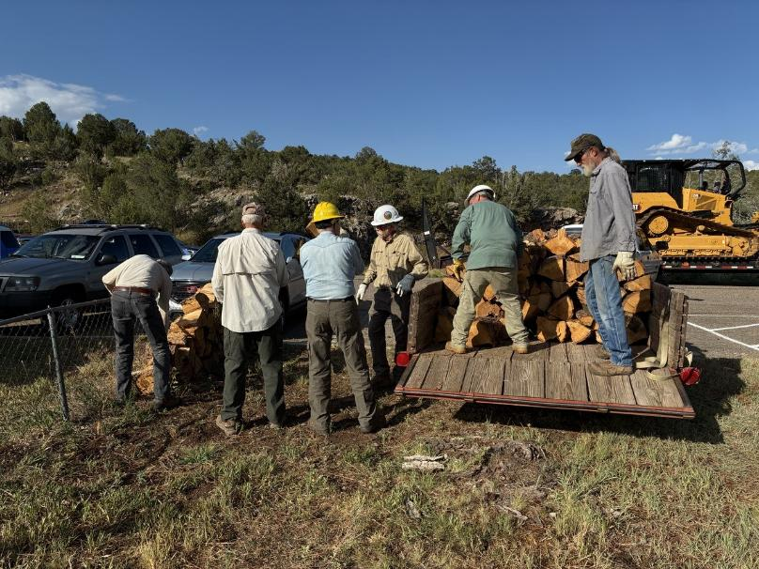
Continuing to load split wood in Mike’s trailer. Note the very large bull dozer in the background that is used
to fight wildfires.
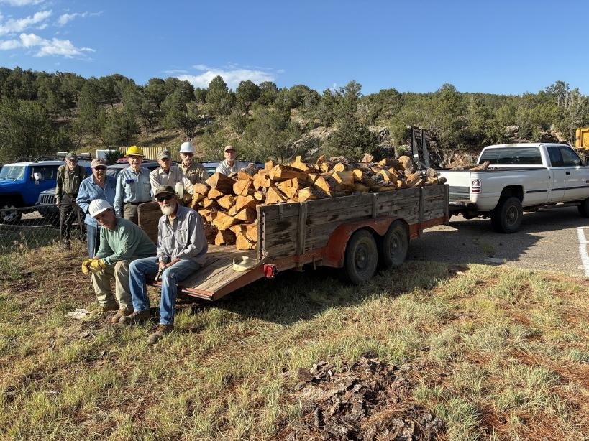
All the wood has been loaded. Mike will store this wood in his woodlot, and Wood Ministry members
at the Mountain Christian Church will donate it to East Mountain families who heat their homes with wood.
L to R: Sam Beard, Lou Romero, Mike Oliver and his friend, Eric Russell, Sim Cook, Kent Towler, and Dan Benton.

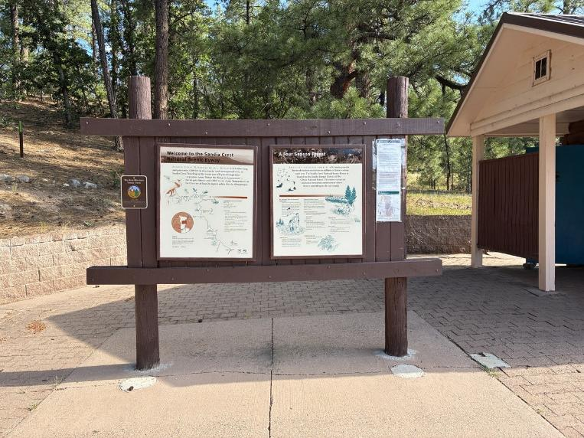
The small sign on the left post on this Doc Long Picnic Area kiosk is one of Jamey Browning’s new signs
about FOSM.
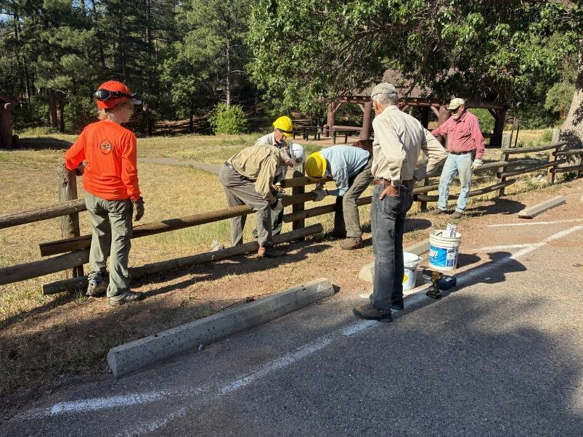
Replacing a broken rail on the fence at the entrance to Doc Long Picnic Area.
L to R: Lorna Morrow, Kent Towler, Dan Benton, Eric Russell, Sim Cook, and Jerry Carroll.
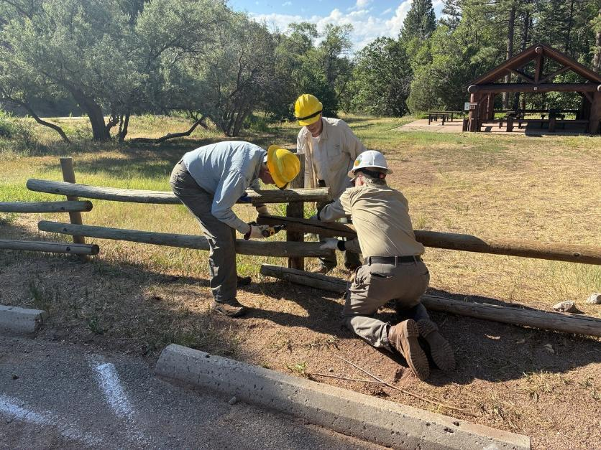
Drilling a hole for a threaded rod in the new rail. L to R: Eric, Dan, and Kent.
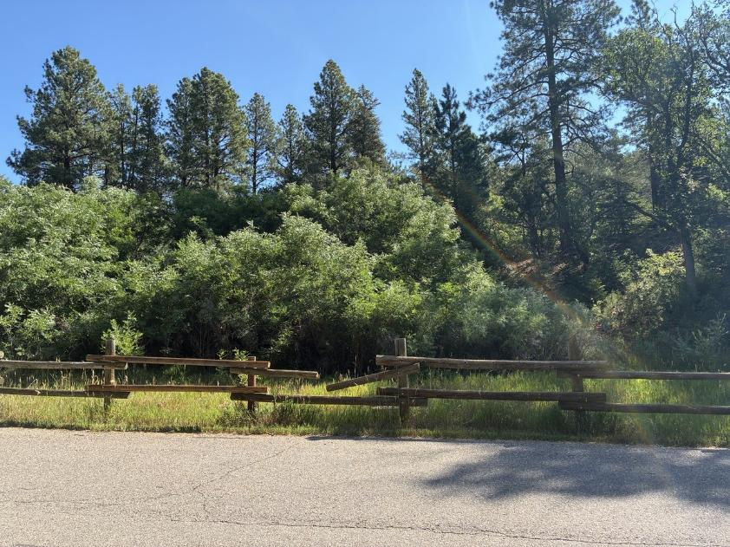
The broken rail in Sulphur Canyon Picnic Area.
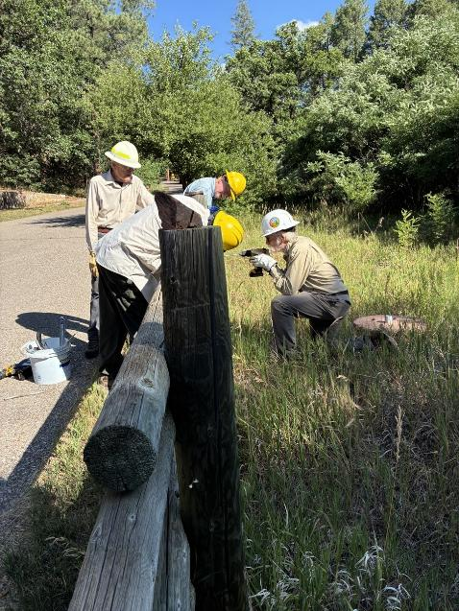
Kent drilling a hole through the post into the new rail.

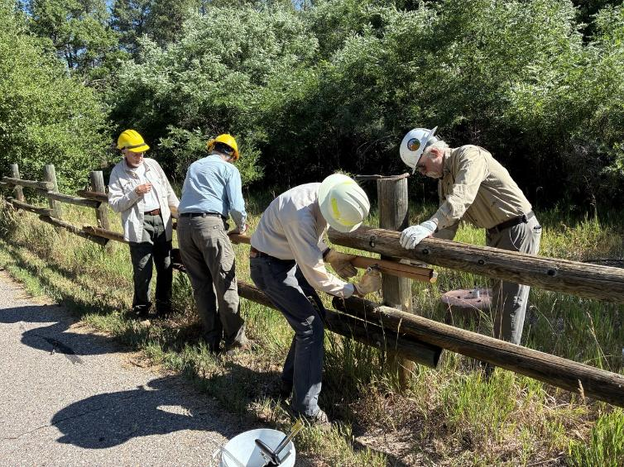
Attaching the new rail to the post on the right.
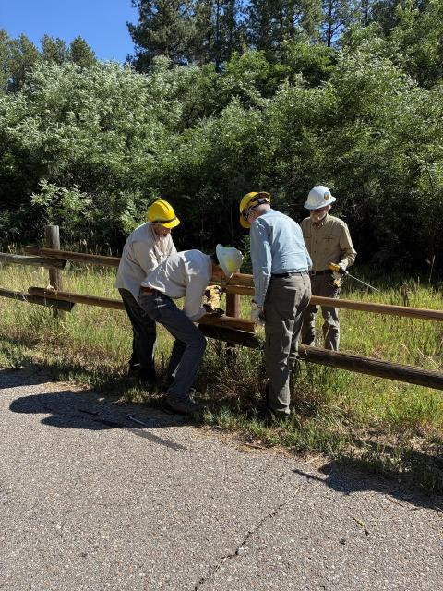
Putting the last threaded rod in the new rail.
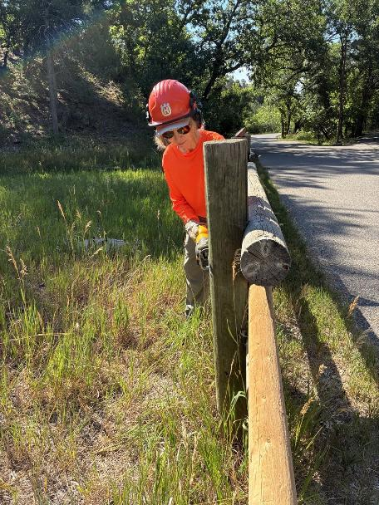
Lorna using the battery-powered reciprocating saw to cut off the excess threaded rod.
This saw is difficult to hold because of the strong vibrations
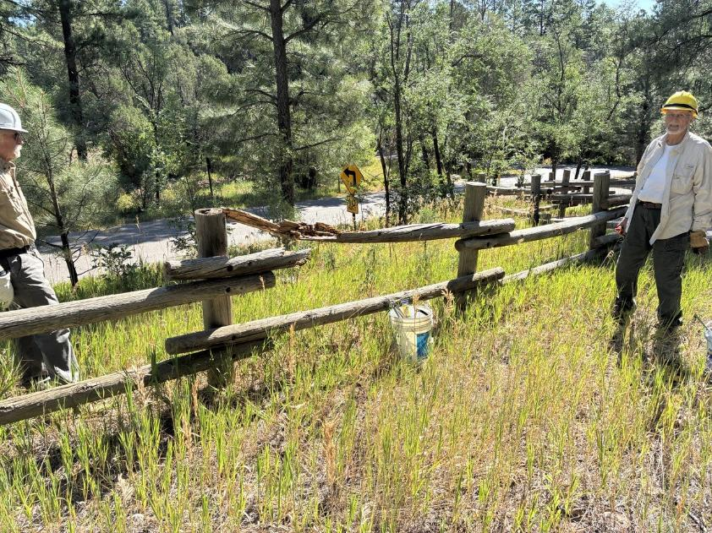
The rotten broken rail in Cienega Canyon Picnic Area near the lower restroom.
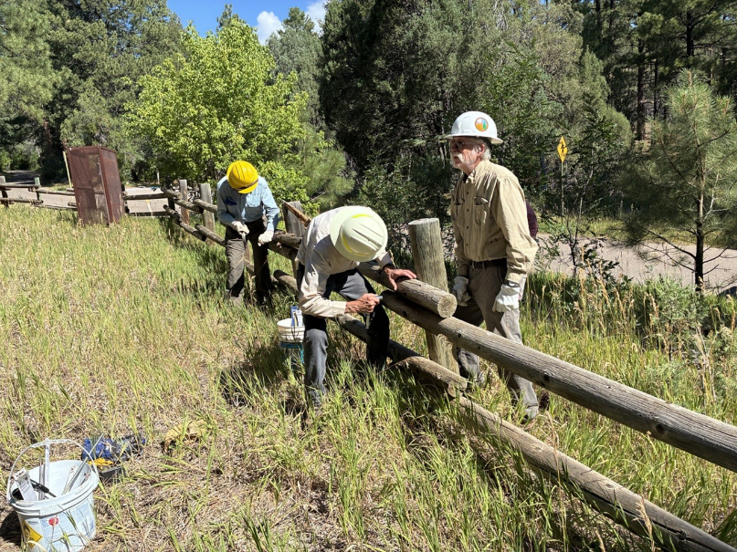
Removing the broken rail.
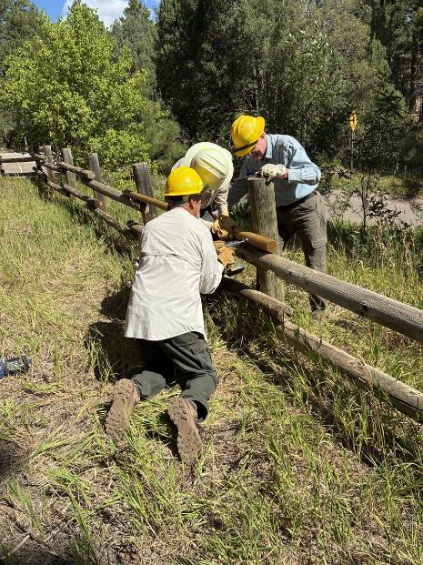
Dan, Sim, and Eric installing the new rail.
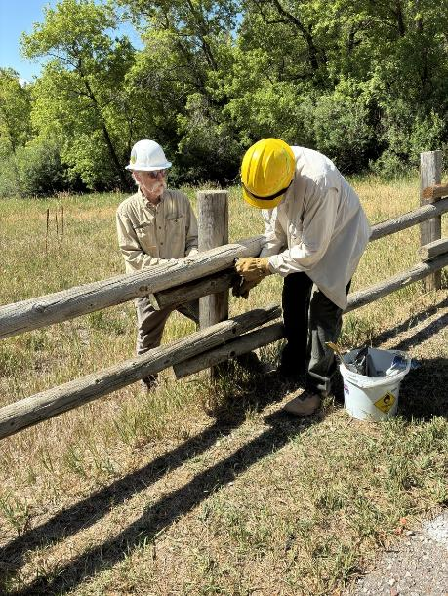
Removing a rail from the broken post in the fence at the parking
lot for the group area in Cienga Picnic Area.
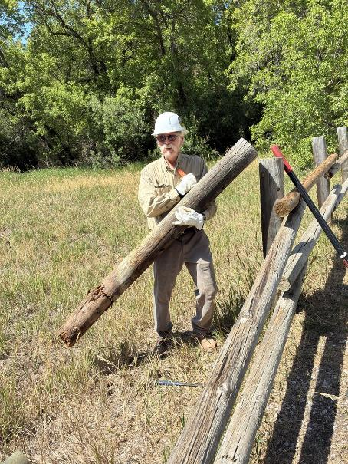
Kent pulled out the entire broken post so that it was not necessary to dig out the broken
part in the bottom of the hole.
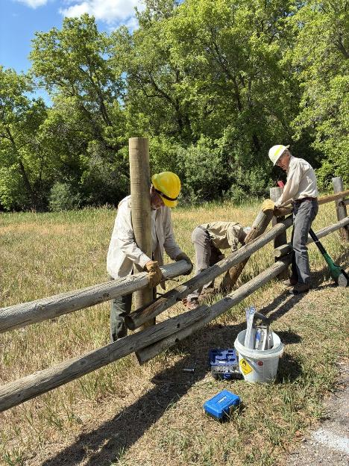
Preparing to attach rails to the new post that has been set in the old hole.
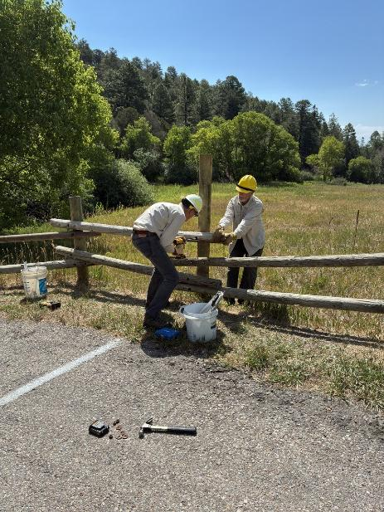
Sim is drilling a hole in the post while Dan holds the rail in place.
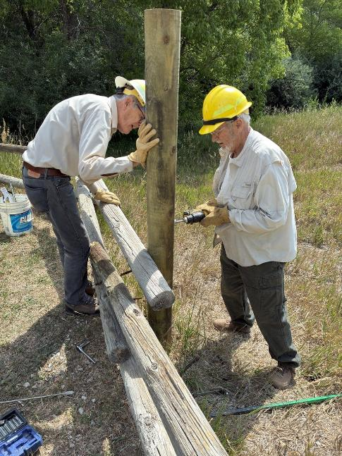
Dan using Forstner bit to drill countersink hole in new post.
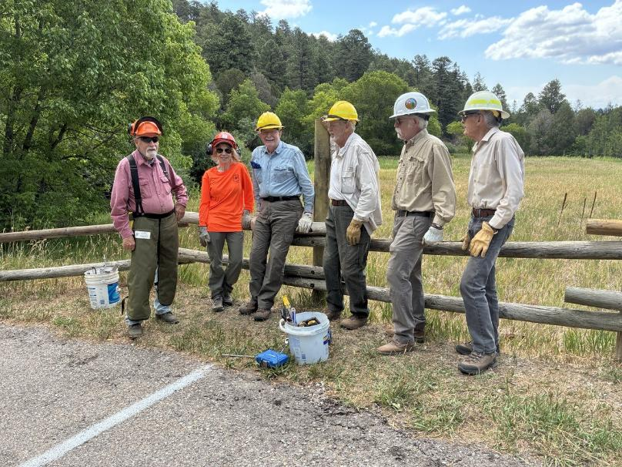
The FOSM fence repair crew. L to R: Jerry Carroll, Lorna Morrow, Eric Russell, Dan Benton, Kent Towler, and Sim Cook.

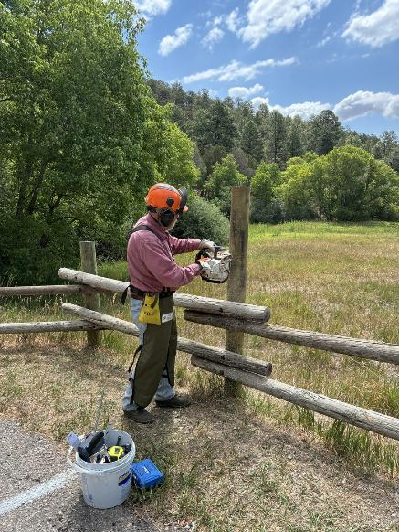
Jerry using a chain saw to cut off the post.

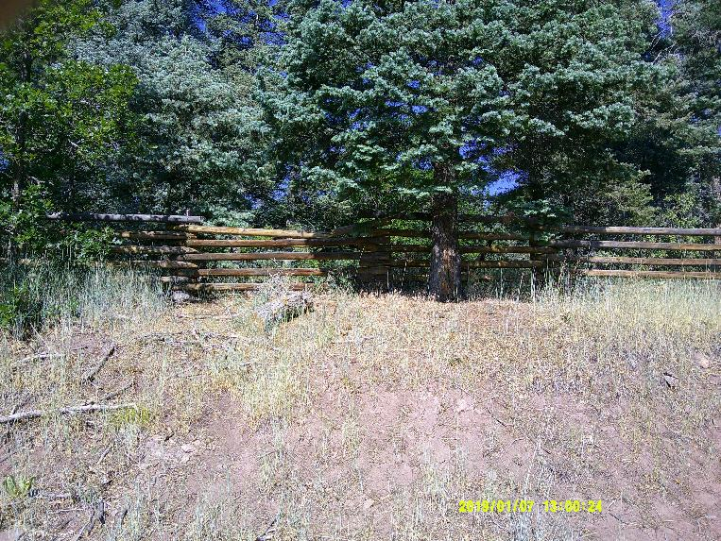
The broken top rail in the fence at Tree Spring Trailhead parking lot. FOSM volunteers built this
fence several years ago to discourage hikers who had been going directly from the parking lot to a
switchback in the trail instead of hiking from the trailhead at the lower end of the parking lot.
Photos by Sam Beard
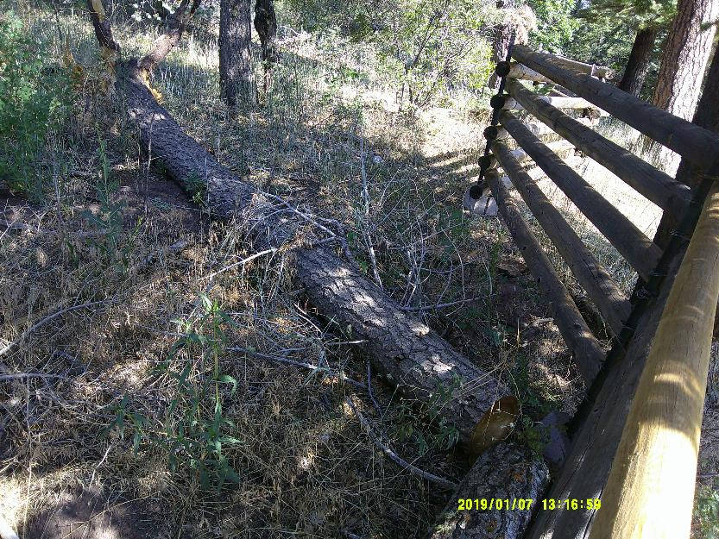
The fallen tree that broke the top rail. Someone had cut the tree while it was lying on the top rail.
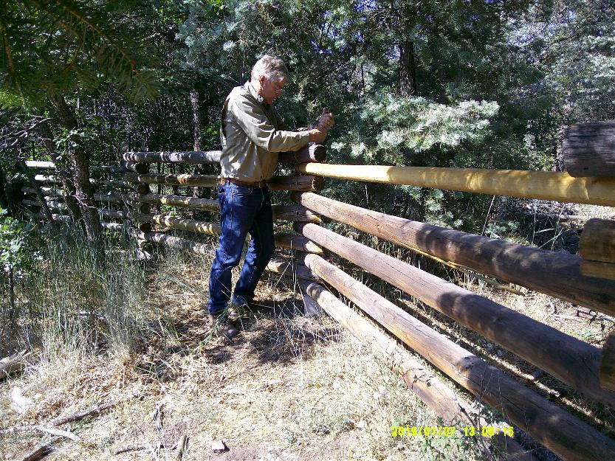
Chuck Logan tightening the wire that secures the top rail to a T-post that supports the ends of the rails.
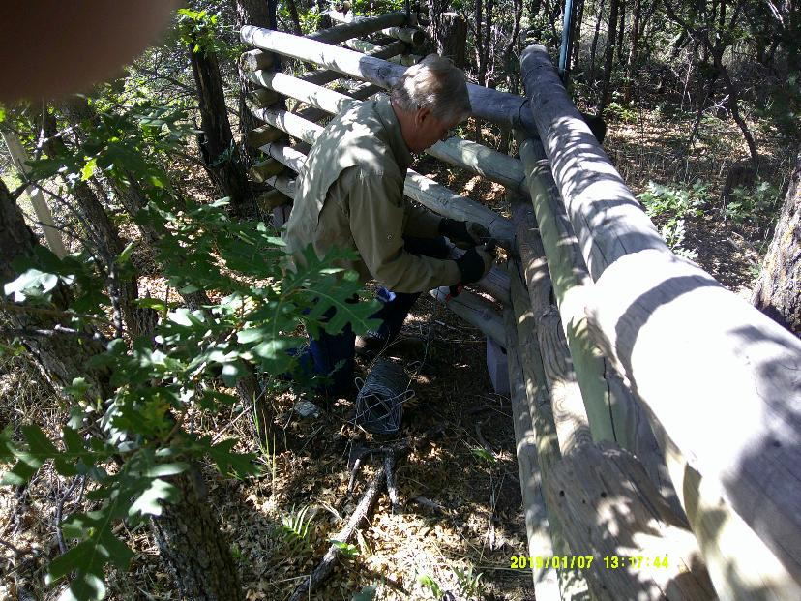
Chuck securing the end of a neighboring rail that had not been secured when the fence was built.
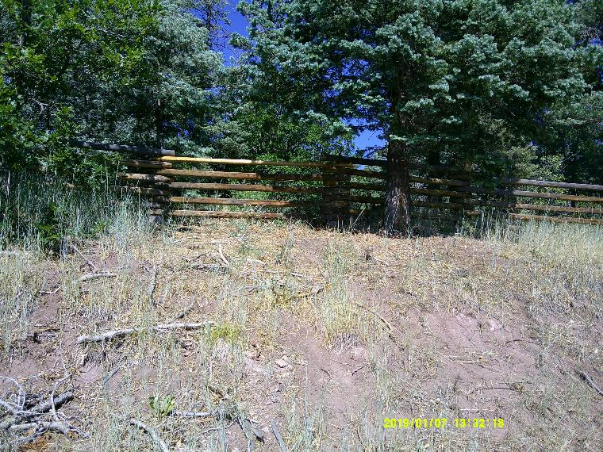
The broken top rail has been replaced.

