Report of FOSM Project to Paint 10K Trailhead Restroom and Picnic Table,
Remove about a Dozen Small Graffiti Tags on Boulders at the North End of the Parking Lot, and Complete Painting Parking Stripes on Tuesday, July 14, 2026

Sam Beard
On Tuesday, July 14, four members of the FOSM paint crew completed the following tasks at the 10K Trailhead parking lot:
- Restroom – Brown USFS paint was applied to external areas needing paint, and white paint was used to cover graffiti tags on an interior wall. A faded pink color was used to paint exterior trim such as the short supports on the west side of the restroom.
- Picnic Table – System 3 epoxy paste was applied to about a half-dozen patches on the table top to fill deep carvings in the wood. After the epoxy cured in about 90 minutes, the table and benches were painted with USFS brown paint.
- Graffiti Tags – About a dozen small red graffiti tags on boulders were removed with three coats of World’s Best Graffiti Removal System chemical for stone. The chemical and paint residue was rinsed from the boulders with water.
- Parking Lot Stripes – Most of the stripes on the parking lot were painted last week, but some lines near parked vehicles were not painted. A small cloud of white spray paint follows the paint dolly as it is pushed along over a line. As vehicles were moved by returning hikers, the crew painted most of the remaining unpainted stripes.
The paint crew members were Pauline Ho, Rick Buss, Sam Beard, and Ted Anaya (new volunteer).
Project photographs are presented below.

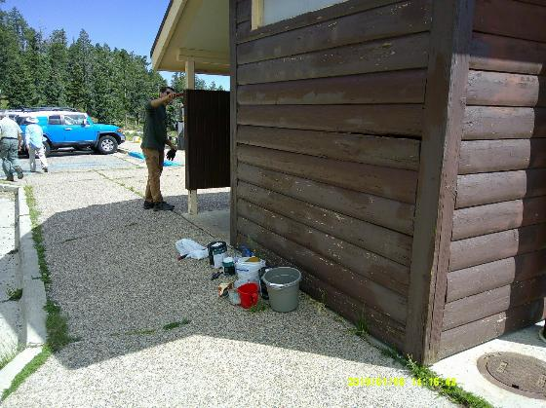
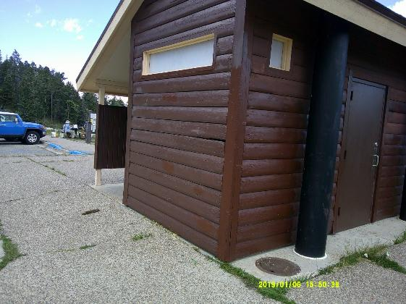
Top – South side of 10K Trailhead restroom with paint missing on the lower part of the wall.
Bottom – South wall has been painted with USFS brown paint.
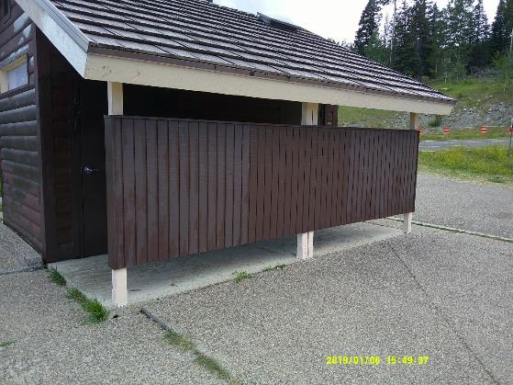
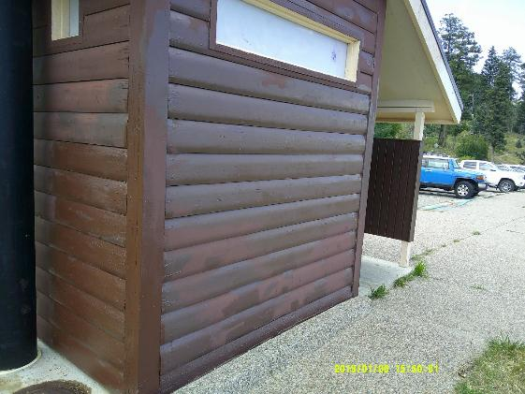
Top – West side of restroom has been painted with faded pink color paint on the lower supports.
Bottom – North side of restroom has been painted.

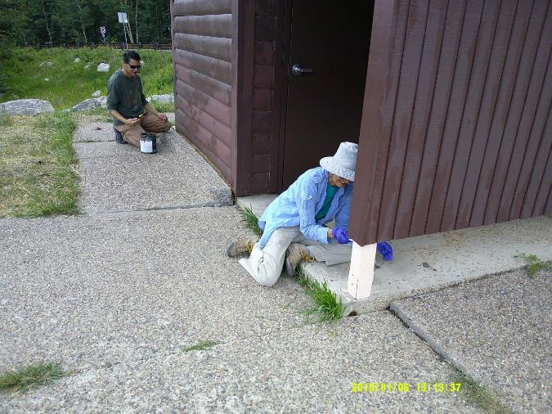
L to R – Ted Anaya painting north side of restroom. Pauline Ho painting lower supports with the
USFS faded pink color paint used on certain trim parts of the wooden restroom.

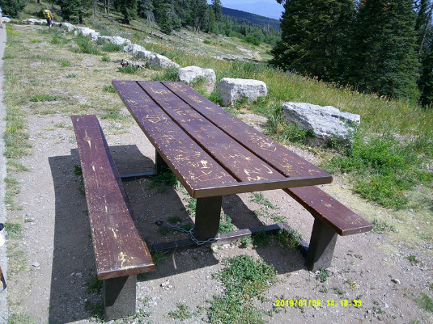
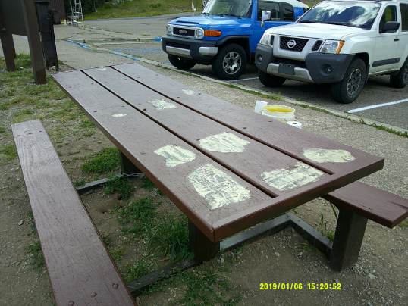
Top – Damaged surface of picnic table coated last year with Cabot Australian Timber Oil
brown color. Bottom – Most of the table has been painted with USFS brown paint.
System 3 epoxy paste on the light-colored patches was applied to fill deep gouges.
The epoxy cured in about 90 minutes, and these patches were painted with the brown paint.

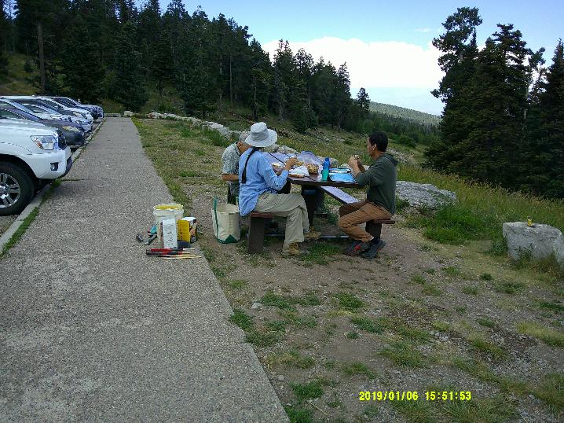
By noon the brown paint had dried enough for the crew to eat lunch at the table.
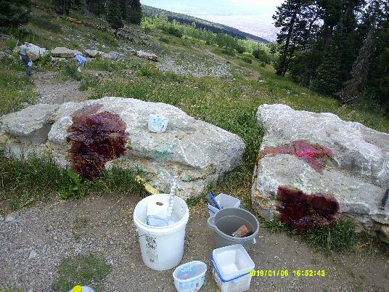
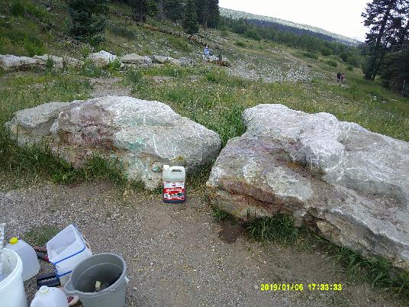
Top – Red graffiti on parking lot boulders has been painted with one coat of WBGRS chemical
for removing paint from stone. Bottom – Three coats of the chemical were applied, and
the areas were rinsed with water. Most of the paint was removed.
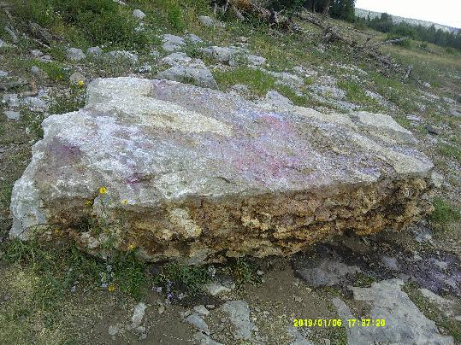
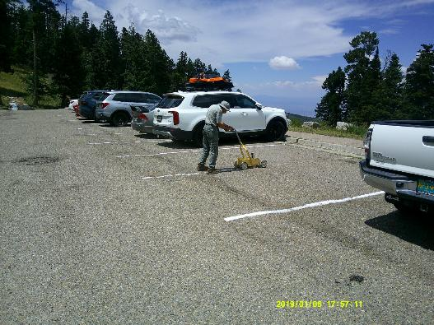
Top – Most of the red paint has been removed from this large boulder located about
100 feet from the parking lot. Bottom – Cars in this area were moved after lunch, and Rick Buss
is applying two coats of white striping paint. A small cloud of white spray paint follows the
dolly; therefore, we cannot paint too close to parked vehicles.

