Thursday, 07/16/25- Challenge: Nine volunteers continued work on the Challenge Trail, making fixes where fire mitigation work has damaged the trail. It was a beautiful morning, nice and cool and sunny. While the crew worked on sections of trail, Jen and Chris (SRD) hiked around the mitigation zone to make sure we had done all the accessible trails. As we finished up the work and headed to the picnic area for lunch, the clouds rolled in and then rain started as we packed up for the day. Hooray for the monsoons!!

Volunteers: Erin Gaddis, John McNett, Eric Russell Sim Cook, Bruce Hansche, Byron Garner, Claudia Bergsohn, Bill Perkins and Laura Leon

Pictures Laura Leon

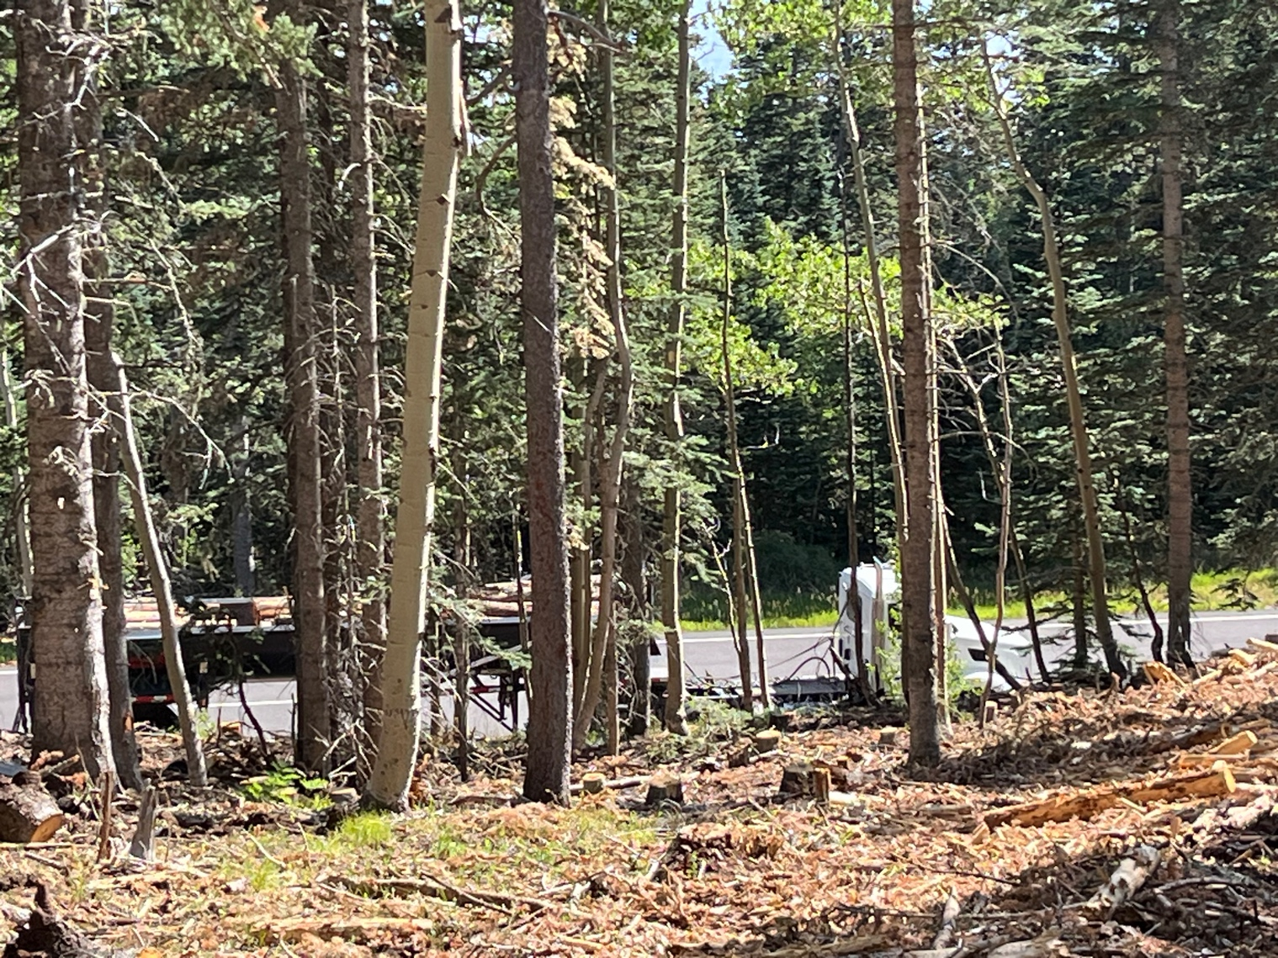

One of the full trucks heading down hill. The first few logs dropped into the truck bed make a big noise!
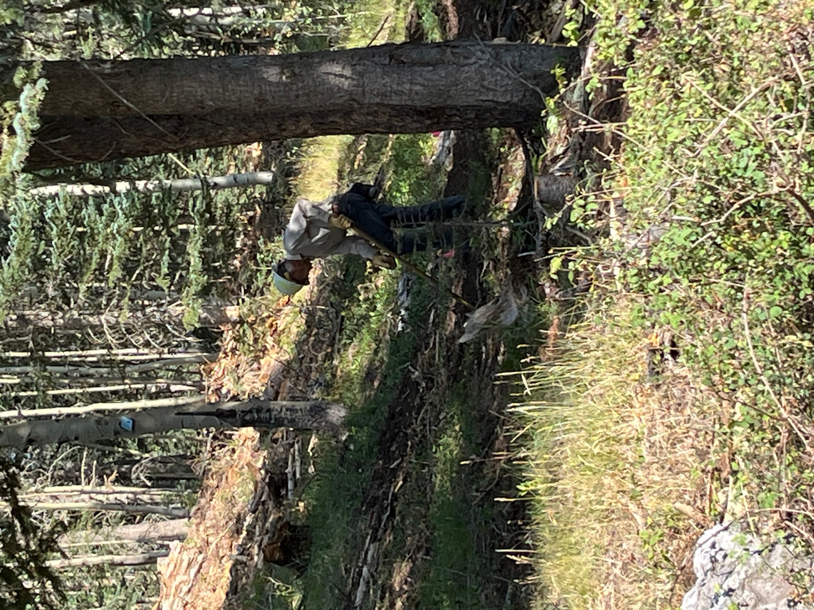

Sim works at knocking down berm and creating good drainage.

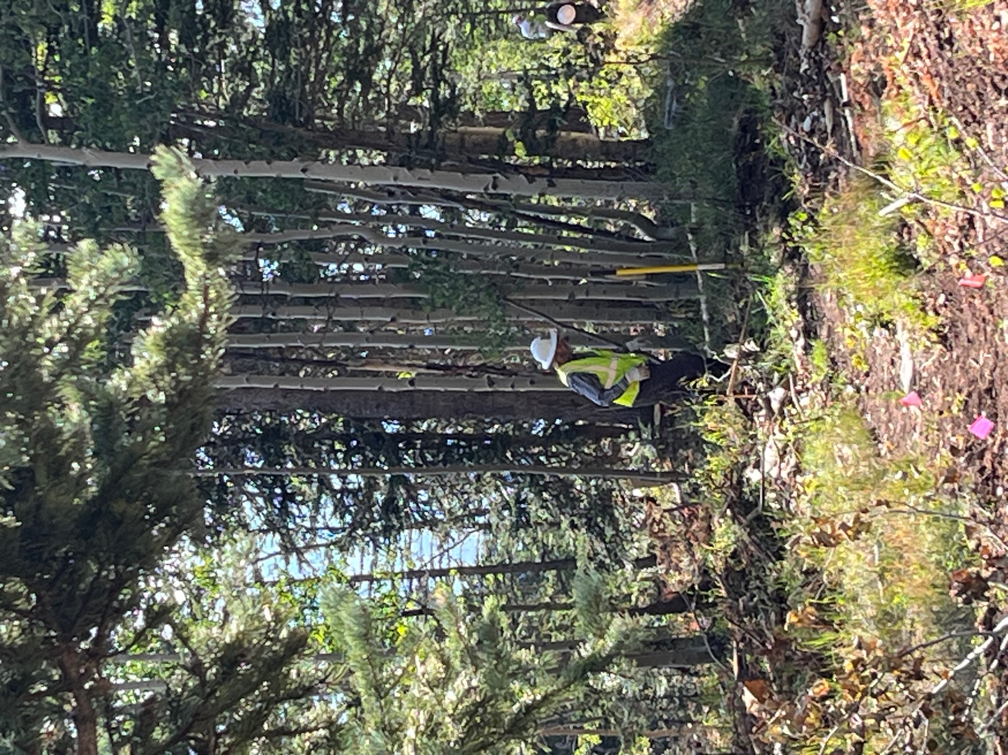

Bruce in knee deep in slash.

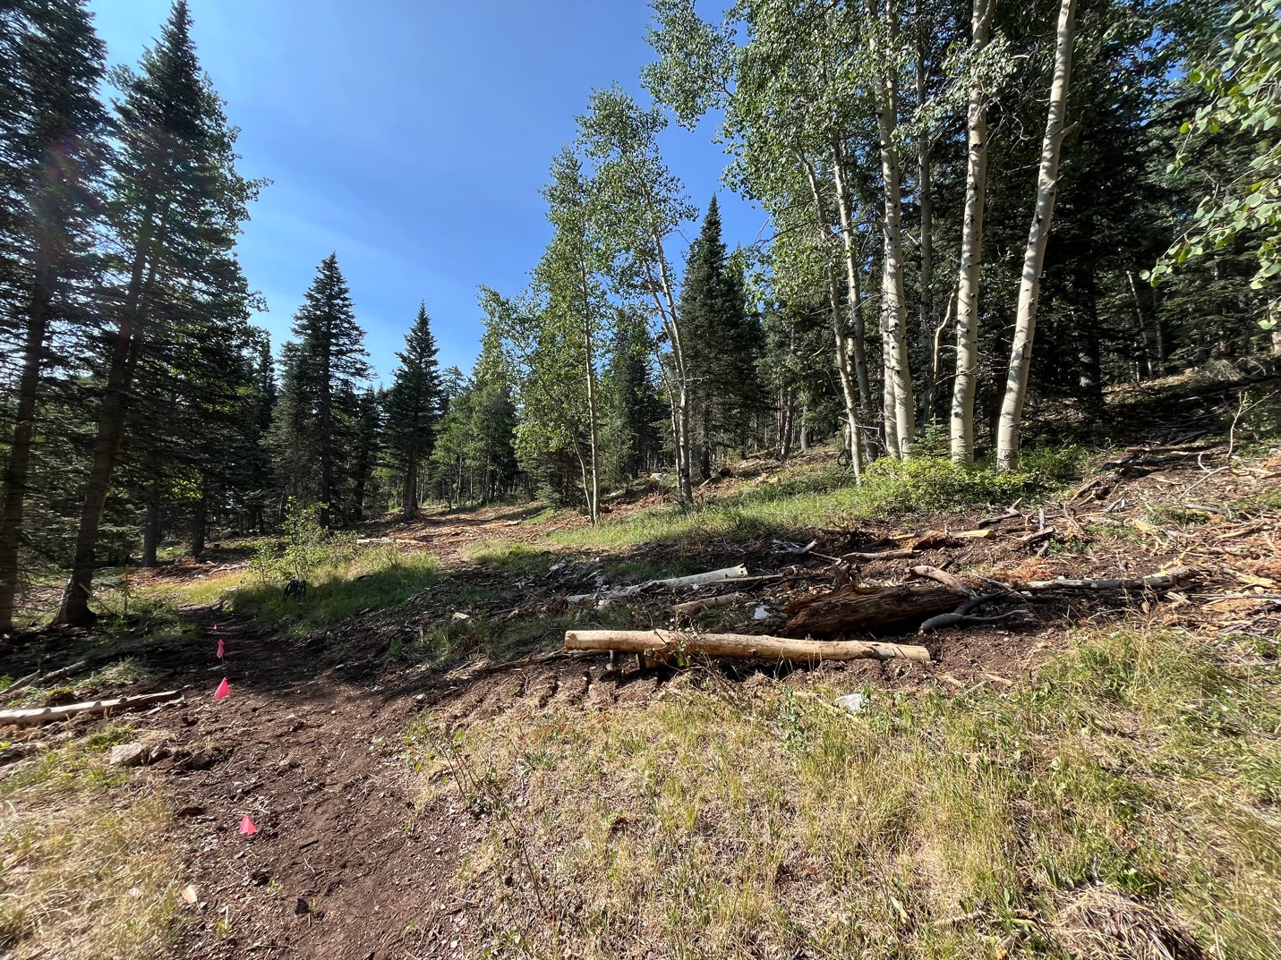

You can see the striped pattern of untouched and churned sections.

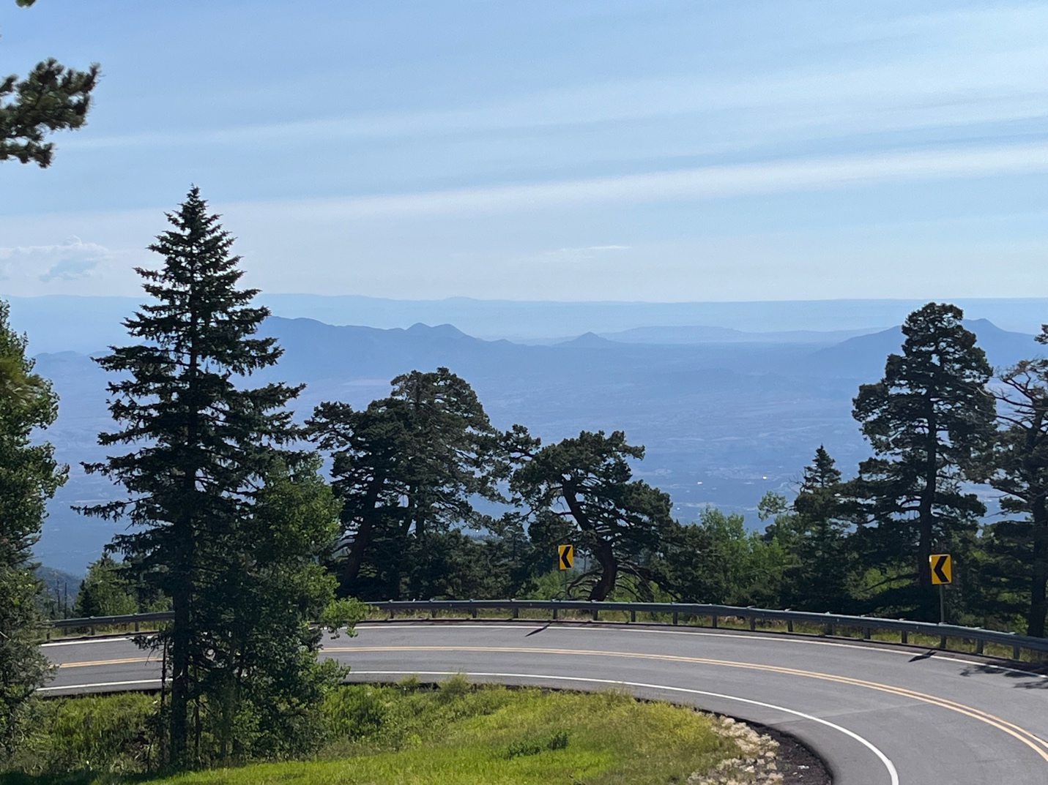

Smoke?

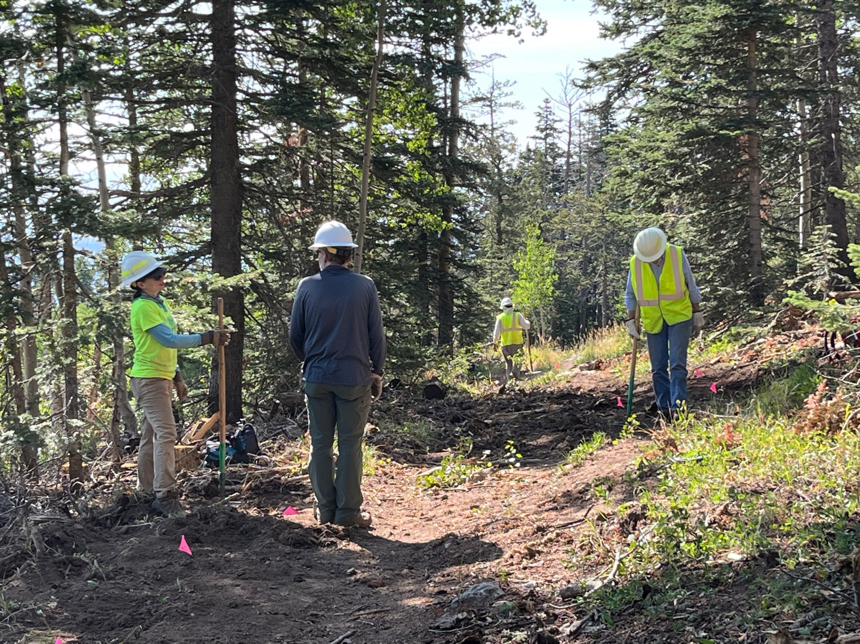

Erin, John, Bill and Byron work on flagged sections.

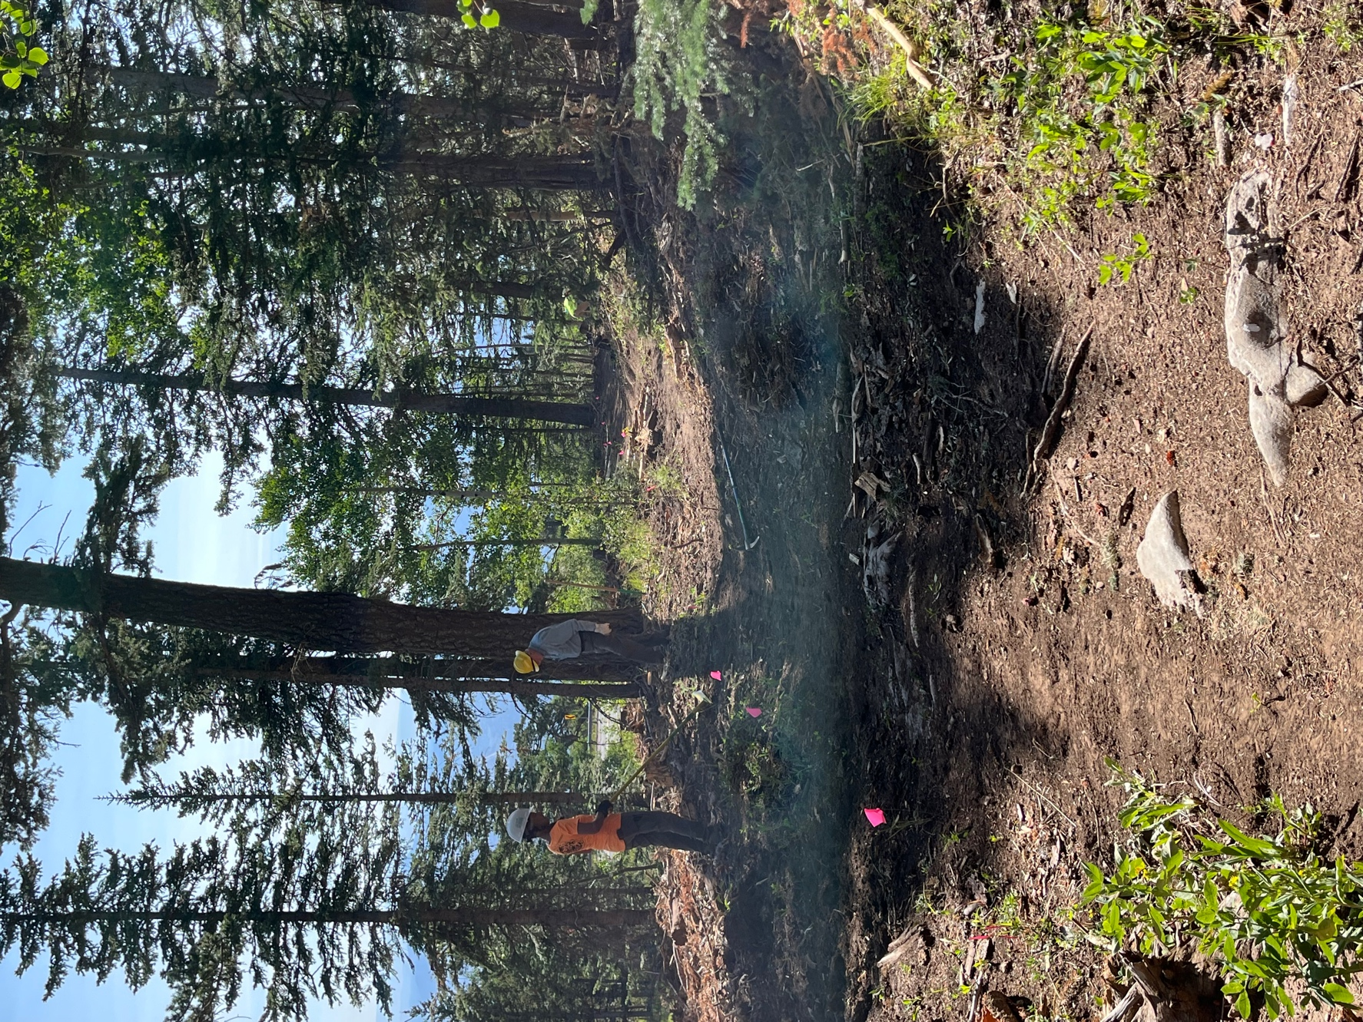

Claudia and Eric at work- it looks mystic but that’s just the light.. No magic except for the exceptional trail work.
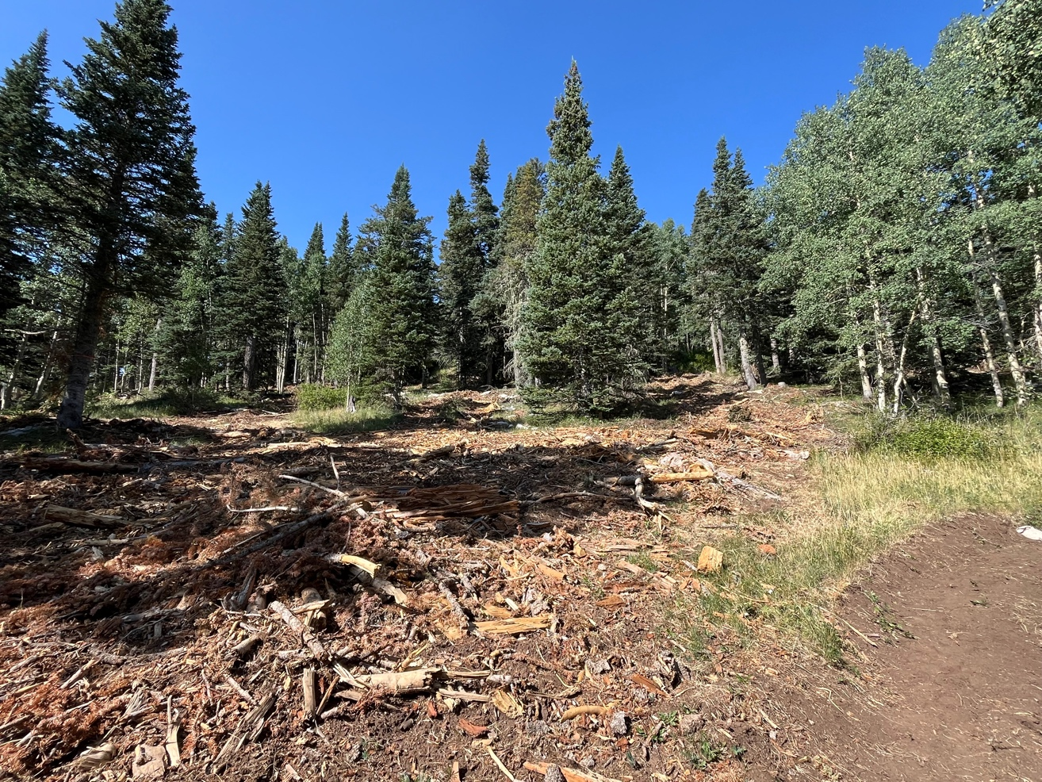

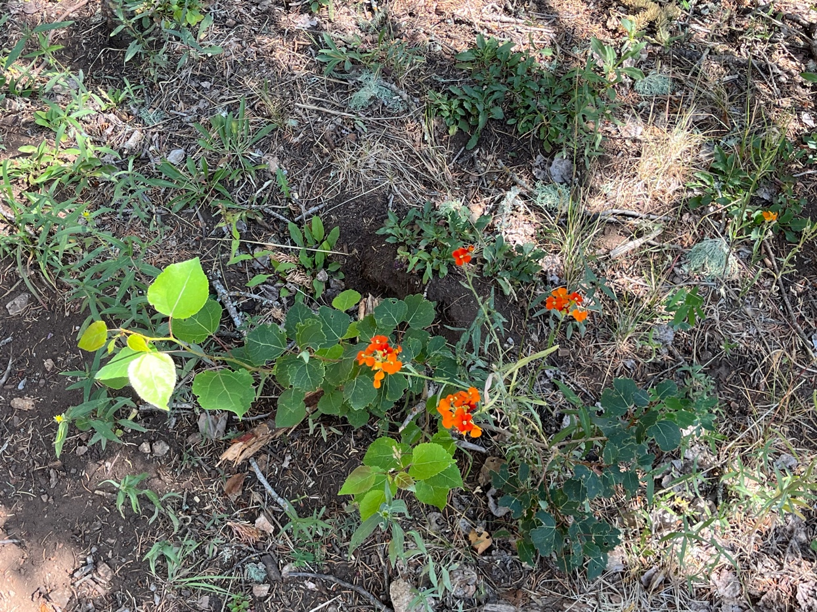
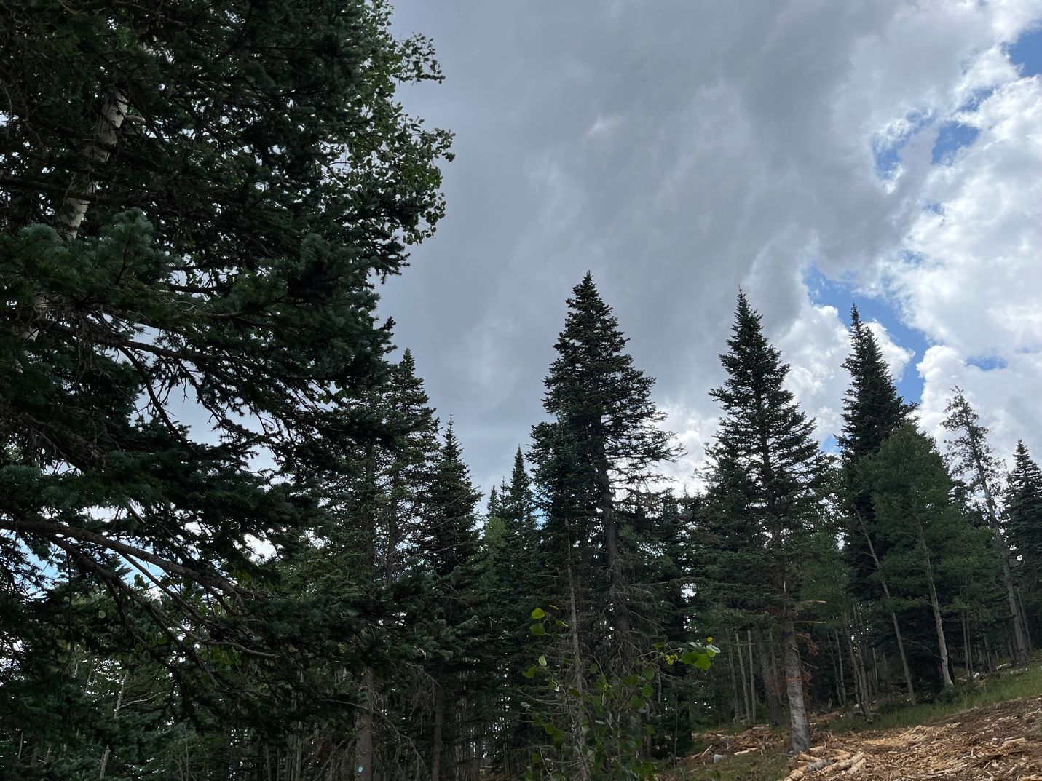

Lunch time clouds building.

