Report of Graffiti Tag Removal by FOSM Volunteers at Juan Tabo CCC Picnic Shelter,
Saturday, July 18, 2026
Sam Beard

On Saturday, July 18, four FOSM volunteers removed four graffiti tags in and near the Juan Tabo CCC Picnic Shelter. The two largest tags were unusual in that they were on the interior wall above two windows; therefore, we used ladders to reach these tags. Two tags were on steel objects, and we were able to paint over them with USFS brown paint.
The volunteers were Fred Hagstrom, Pauline Ho, Rick Buss, and Sam Beard.
Project photos are presented below.

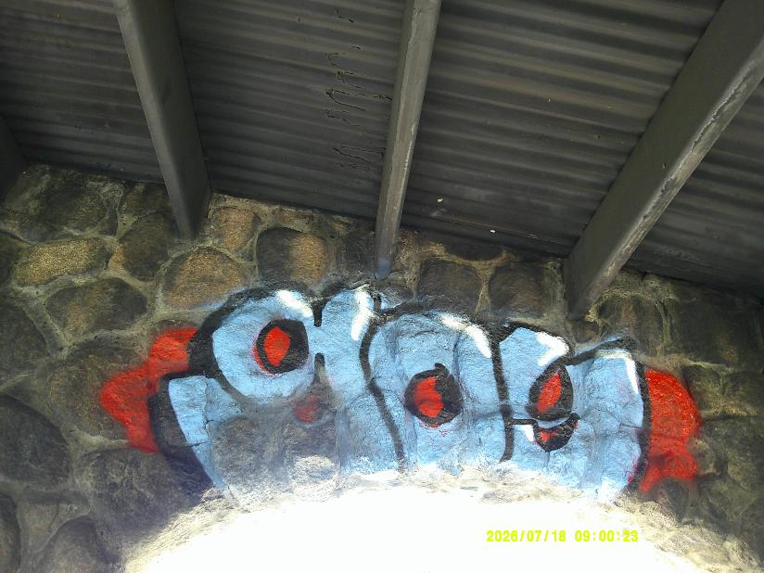
This large (6 feet by 2 feet) blue, black, and red tag was on the wall above one of the large east windows.
All photos by Sam Beard
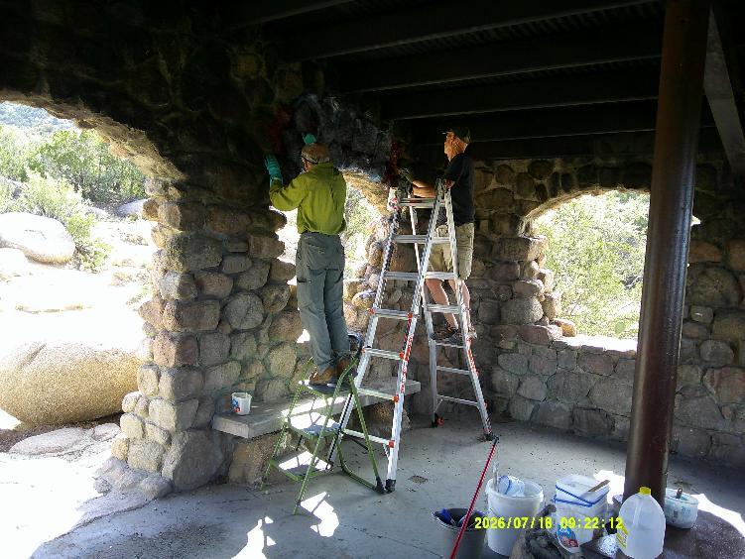
L to R—Rick Buss and Fred Hagstrom are on ladders in order to reach this large tag. Today is the first time that we removed
tags over windows.
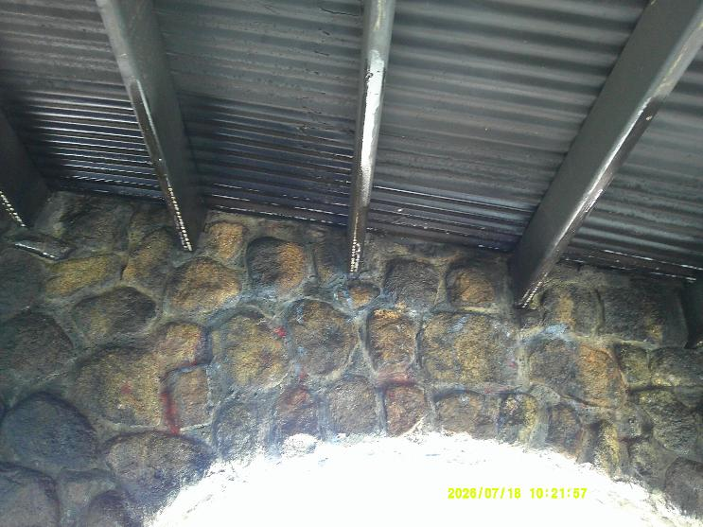
Most of the paint on the large tag over the east window was removed.
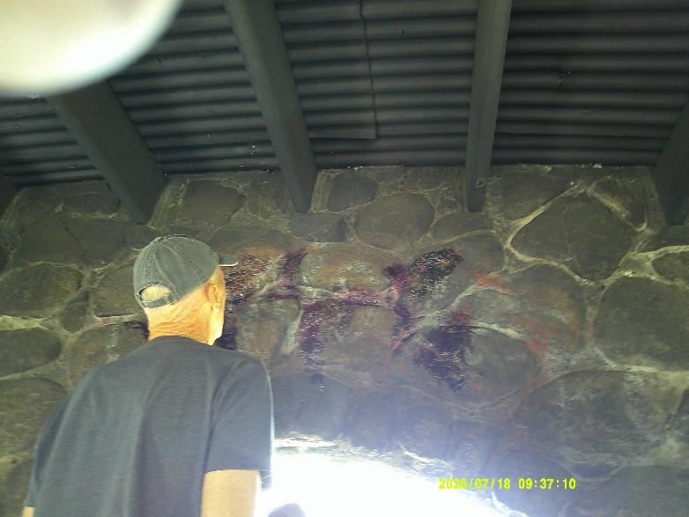
Fred has put one coat of World’s Best Graffiti Removal System chemical on red tags over a west window.
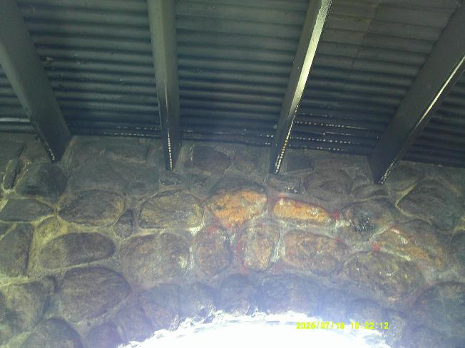
Most of the red tags were removed.
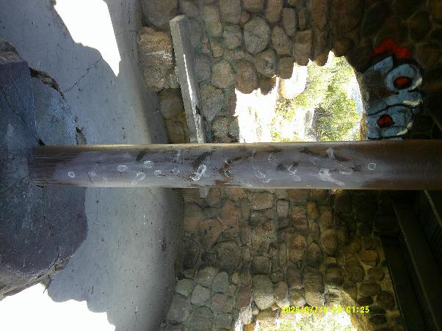
These white tags on a steel post were painted over with brown paint.
The large blue, black, and red tag is visible in the upper left corner of this photo.
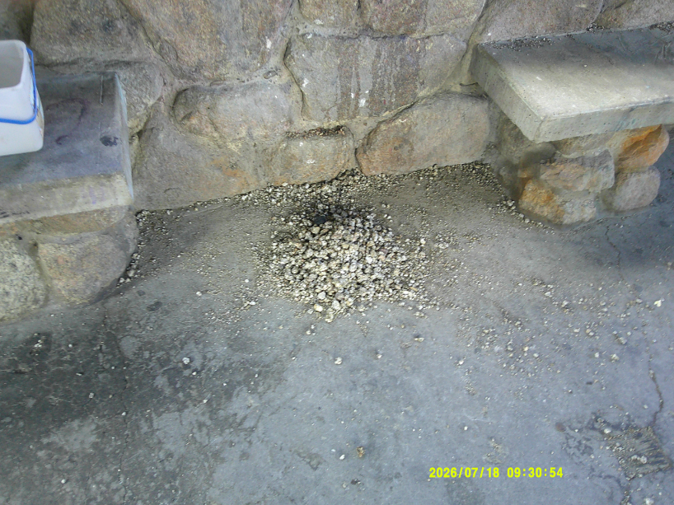
Another first for this shelter – We removed about two quarts of granite gravel.
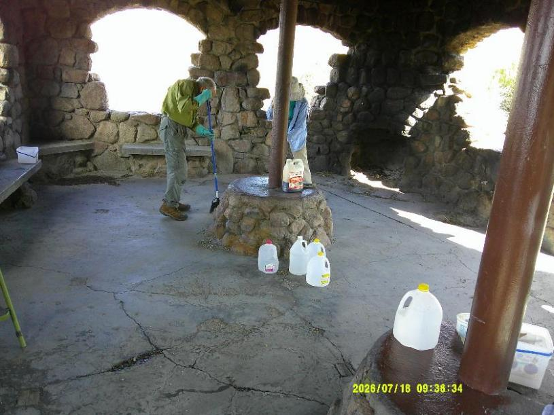
Rick Buss and Pauline Ho sweeping the floor to remove the gravel and other debris.
The painted brown post is on the right side of this photo.
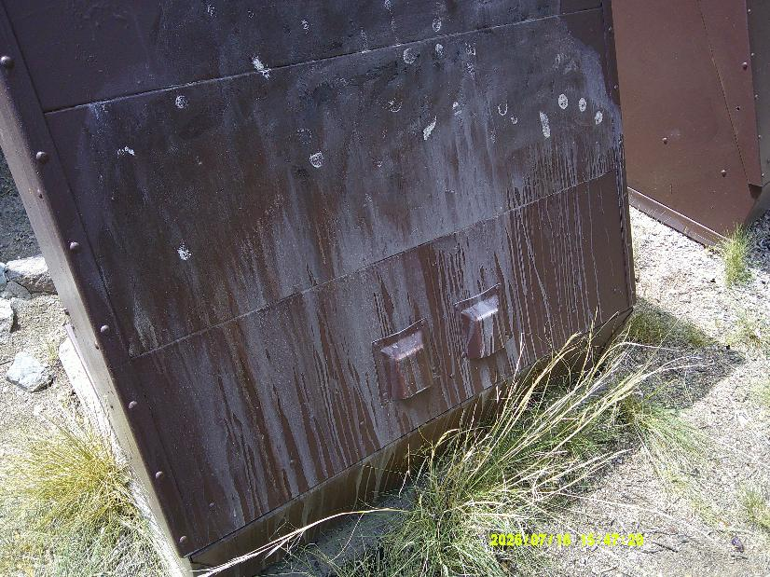
This partially removed white tag was painted over with brown paint.
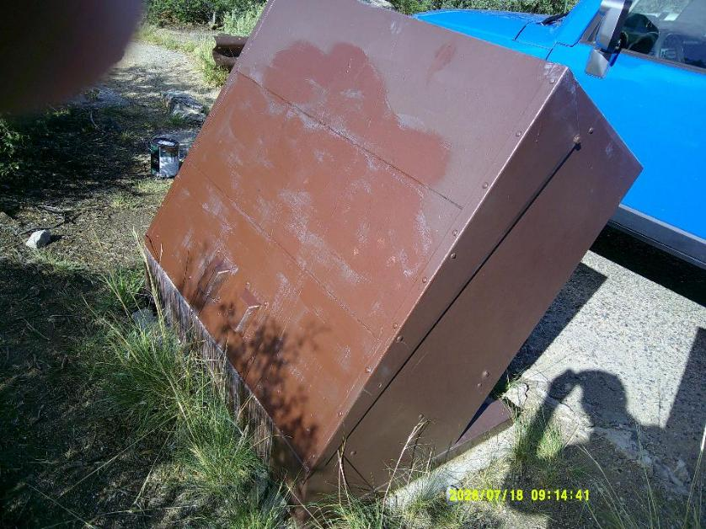
New brown paint on this trash receptacle covers the white graffiti tag.

