Report of the Felling of Hazard Trees by FOSM Volunteers at the Group Area and at the Upper Parking Lot
in Cienega Canyon Picnic Area, Wednesday, July 22, 2026

Sam Beard

On Wednesday, July 22, six FOSM volunteers felled, limbed, and bucked five hazard trees at two sites in Cienega Canyon Picnic Area. In the group area, they felled one dead 13-inch diameter Gambel oak near the restroom. At the corner of the upper parking lot near the restroom, two 8-inch diameter dead boxelder trees were felled. South of the parking lot across the creek near the upper end of Acequia Trail, 19-inch and 16-inch dead Rocky Mountain junipers were felled. All these trees were limbed and bucked to lengths of 4 to 8 feet. These trees will be collected by homeowners with USFS fuel wood hauling permits
The volunteers working on this project were Dan Benton, Chuck Logan, Michael Arndt, Sim Cook, Jerry Carroll, and Sam Beard.
Project photographs are presented below.

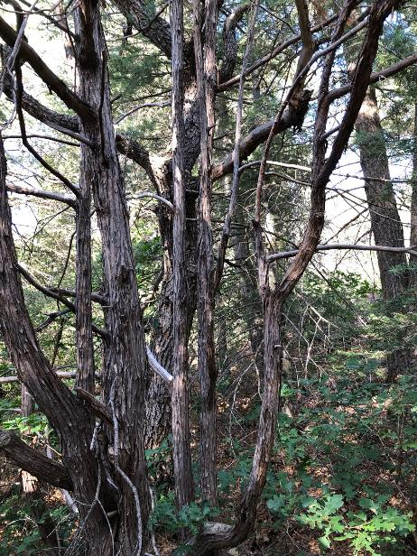
The dead Gambel oak tree in the center of the picture is the larger trunk in the group
of smaller Rocky Mountain juniper trunks. Photo by Dan Benton
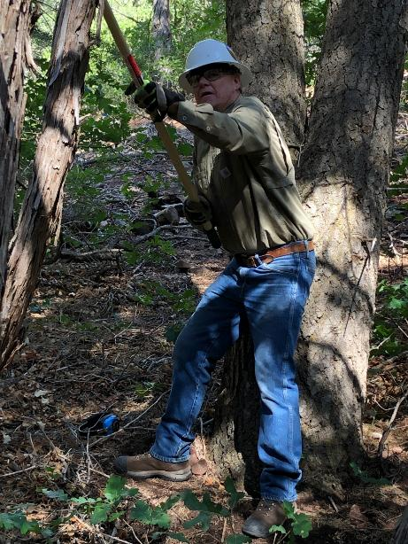
Chuck Logan is using a pole saw to cut off a side oak branch that would have hit
a juniper trunk when the oak was felled. Photo by Dan Benton
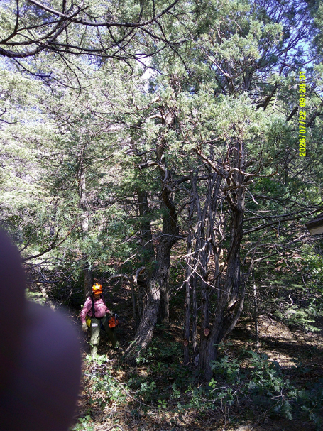
Jerry Carroll walks by the Gambel oak after several small junipers in front of the oak have been removed.
Photo by Sam Beard
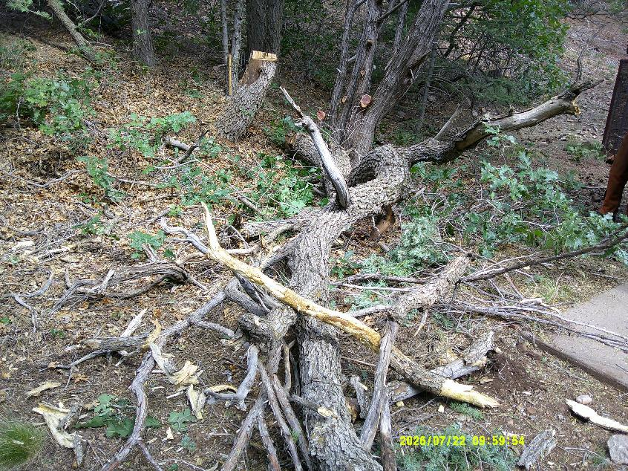
The lower part of the Gambel oak trunk. Photo by Sam Beard
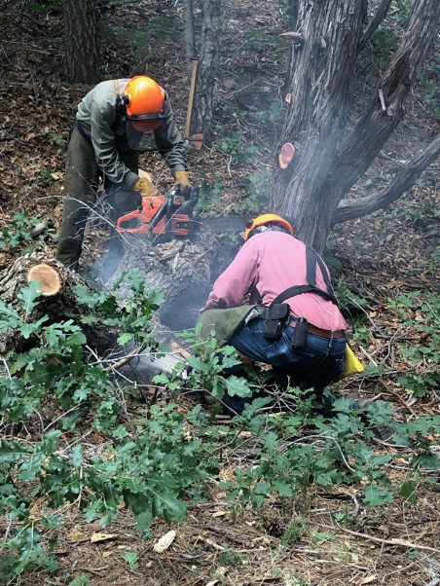
Jerry Carroll bucking the trunk, and Sam Beard preparing to buck another piece of the tree,
Photo by Dan Benton

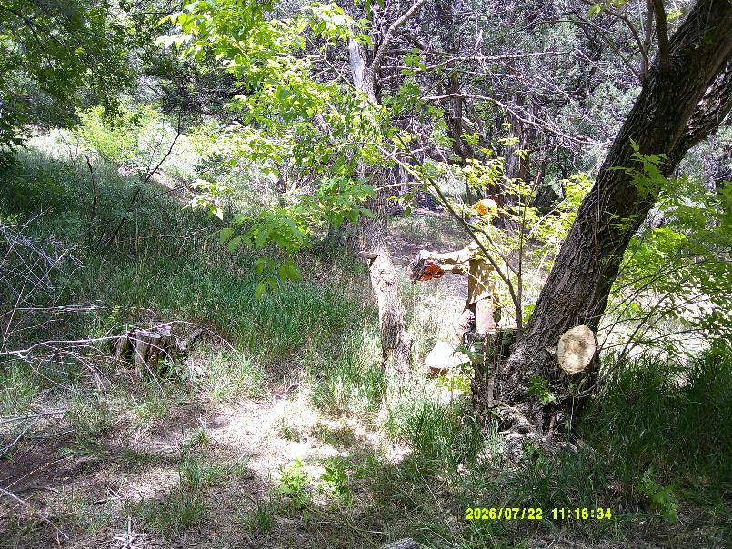
Dan Benton bucking a piece of the trunk of this boxelder tree he has just felled.
This and the following photos by Sam Bead
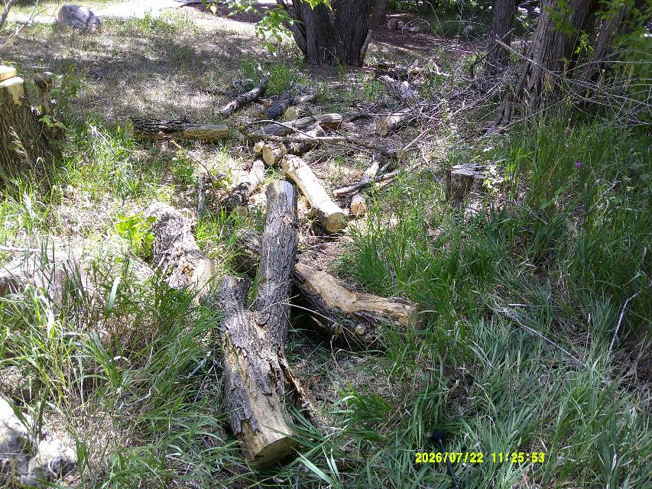
Bucked pieces of the boxelder trunk.
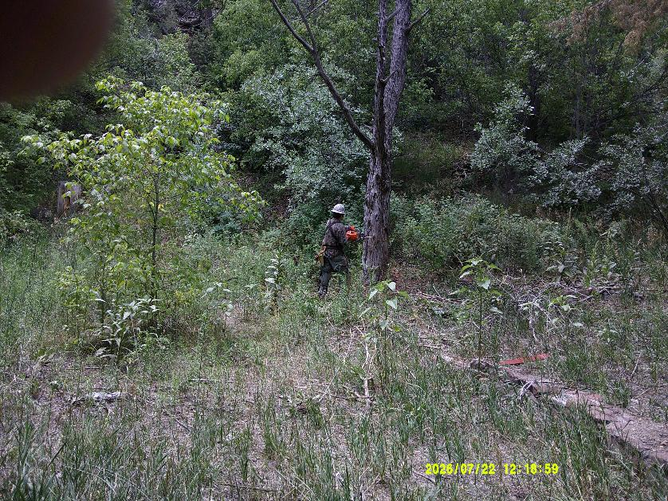
Michael Arndt felling this 19-inch dead Rocky Mountain juniper near the Acequia Trail.
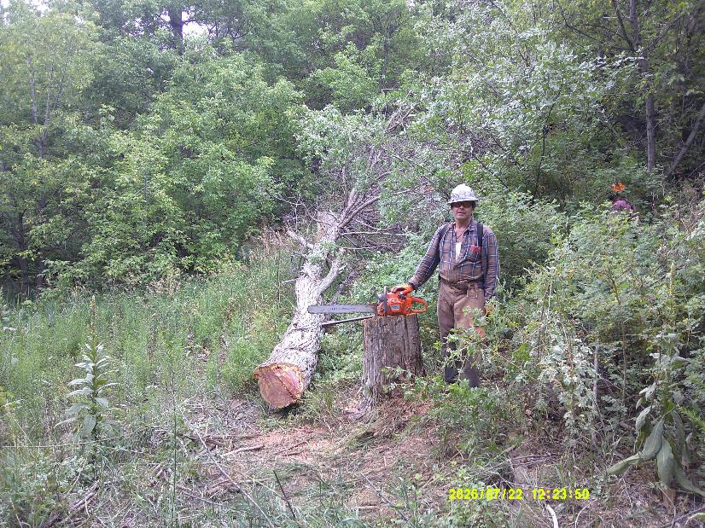
Michael Arndt, his saw, and the felled juniper.
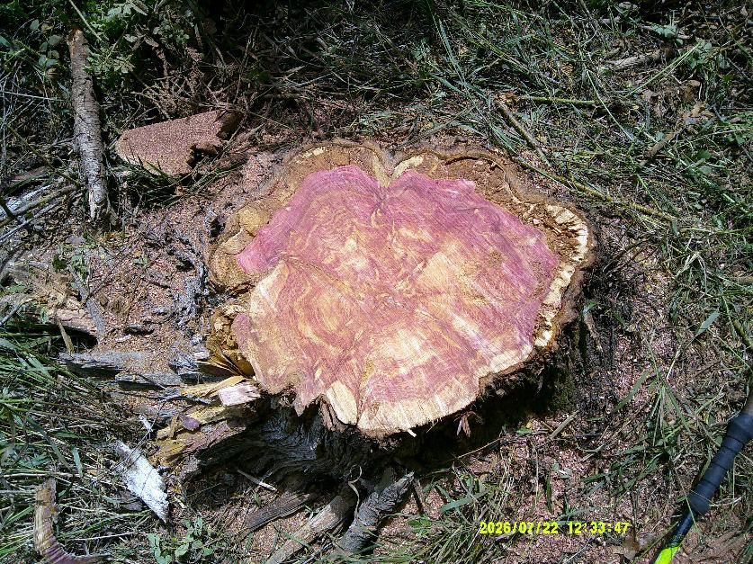
Beautiful pink and white pattern in a juniper stump.
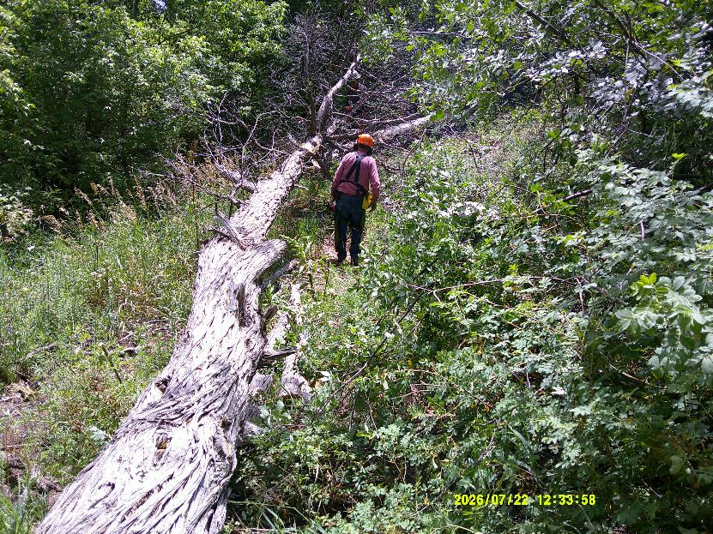
Jerry Carroll preparing to limb the juniper.
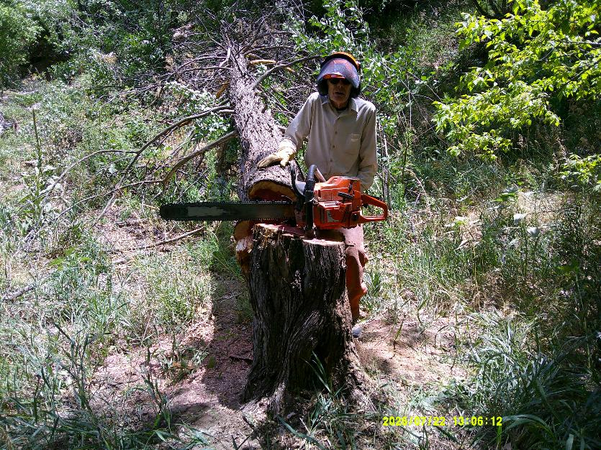
Sim Cook standing beside the 16-inch Rocky Mountain juniper he just felled.
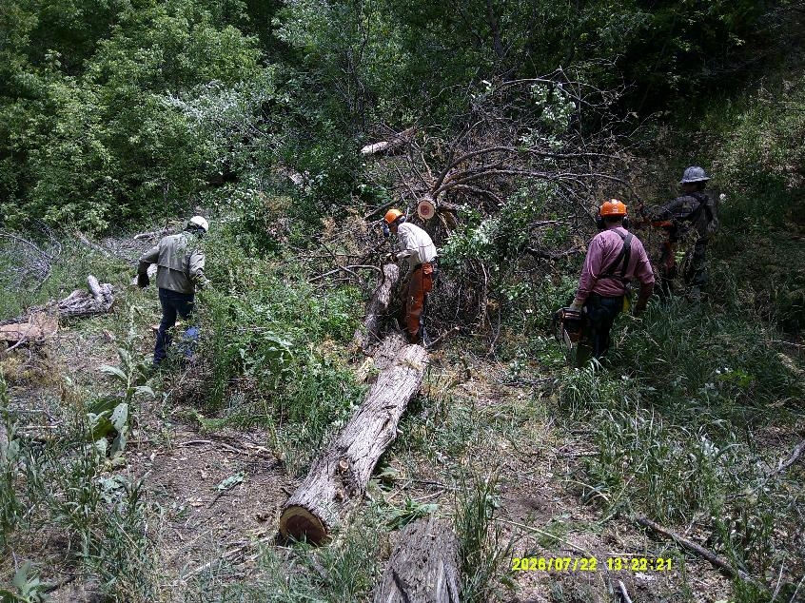
L to R: Chuck Logan, Sim Cook, Jerry Carroll, and Michael Arndt limbing and bucking the 16-inch juniper.

