Thursday, 07/23/26- Switchback: Eleven volunteers and Chris (SRD) carpooled up the crest to start working on the Switchback Trail. It was nice and cool up there and we hiked a short distance, got our tools and gear all ready and it started to thunder. We trooped back to the vehicles and waited until the thunder passed. The rest of the morning was cool, breezy and we even had a short shower. Excellent digging weather! There was lots of debris to remove- more than we have encountered on the trails off of the Ellis parking area. The trail was more churned up and obliterated than near Ellis so work is slow but proceeding. The sun came out at lunch time and the temps rose- but not as bad as down in Albuquerque! We’re happy to be working at a high altitude.

Volunteers: Claudia Bergsohn Bill Perkins, John McNett, Kerry Jones, Jim Houle, Luis Cuadros, Bruce Hansche, Byron Garner, Rich Feddersen, Kent Towler, and Laura Leon

Pictures: Laura Leon

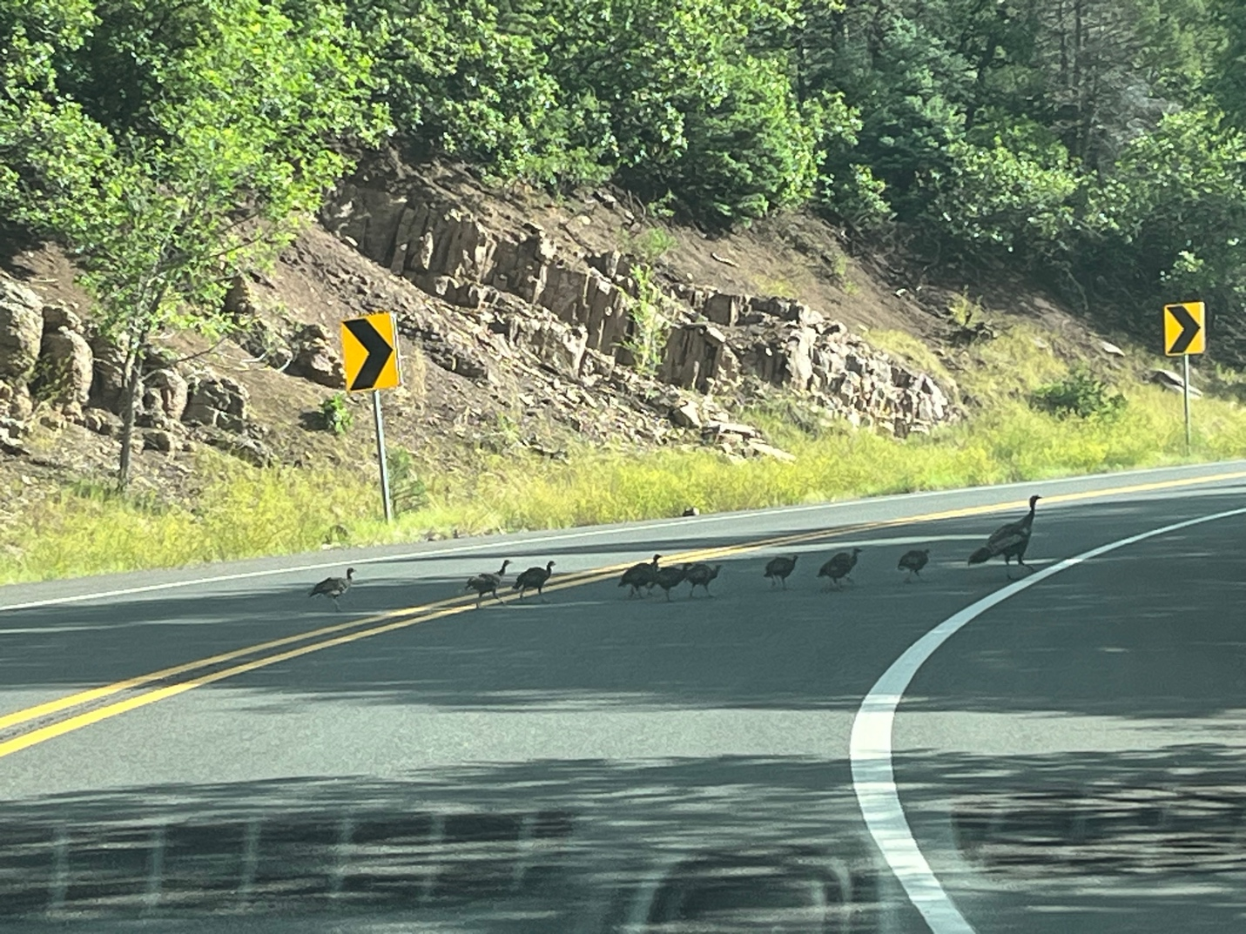
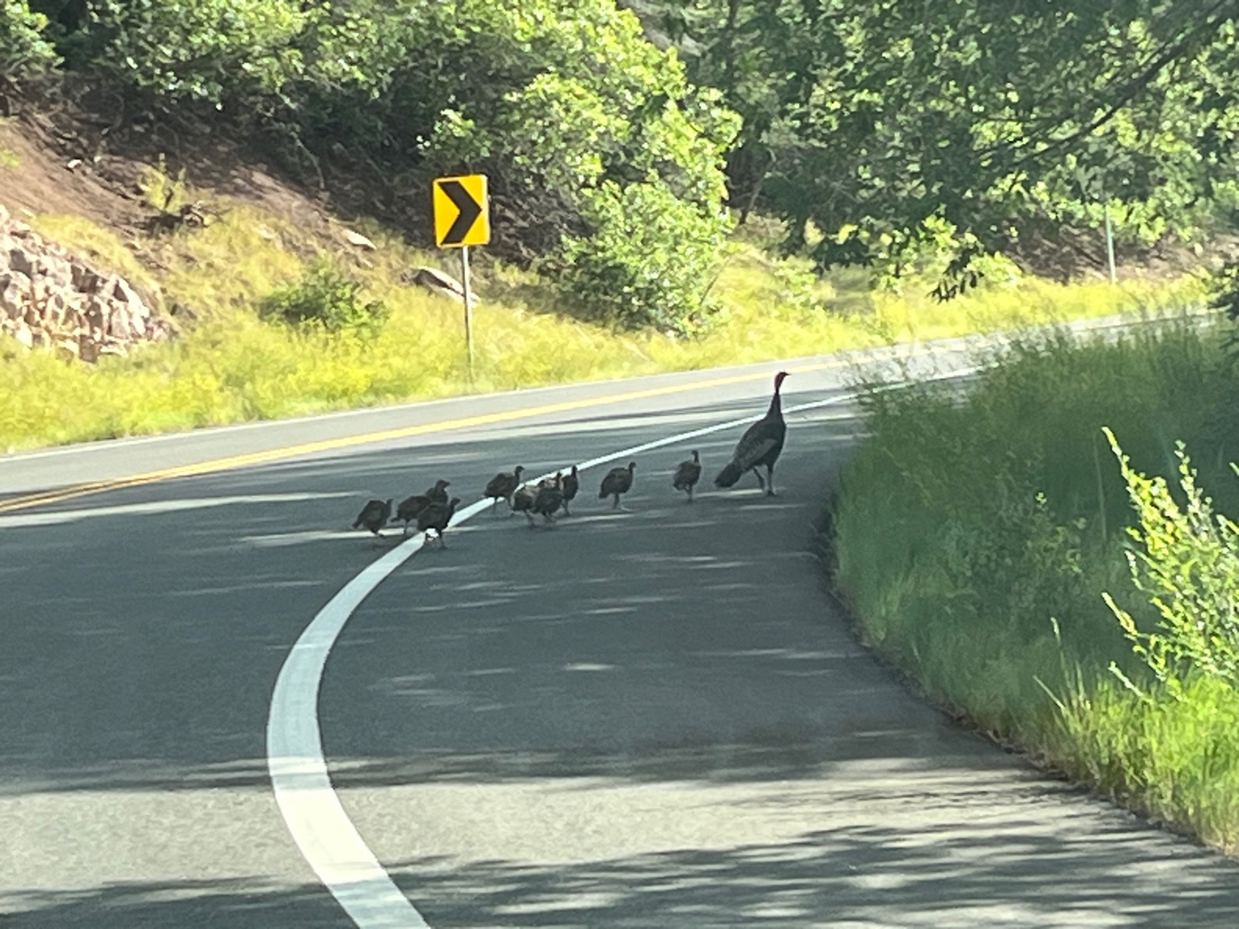

Moms are always at work.

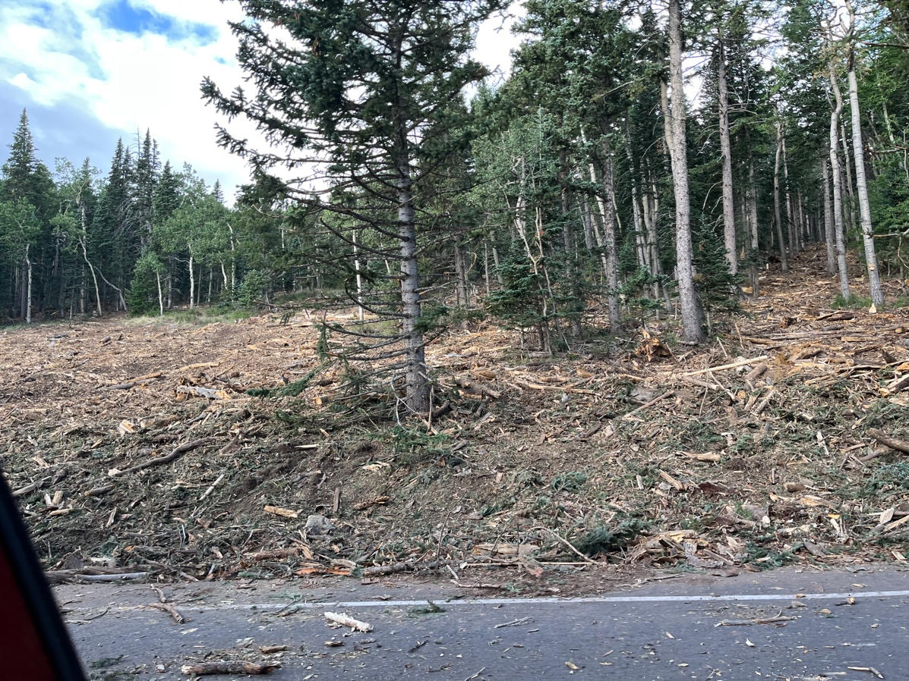

View as we approached the crest. Lower crest parking area.

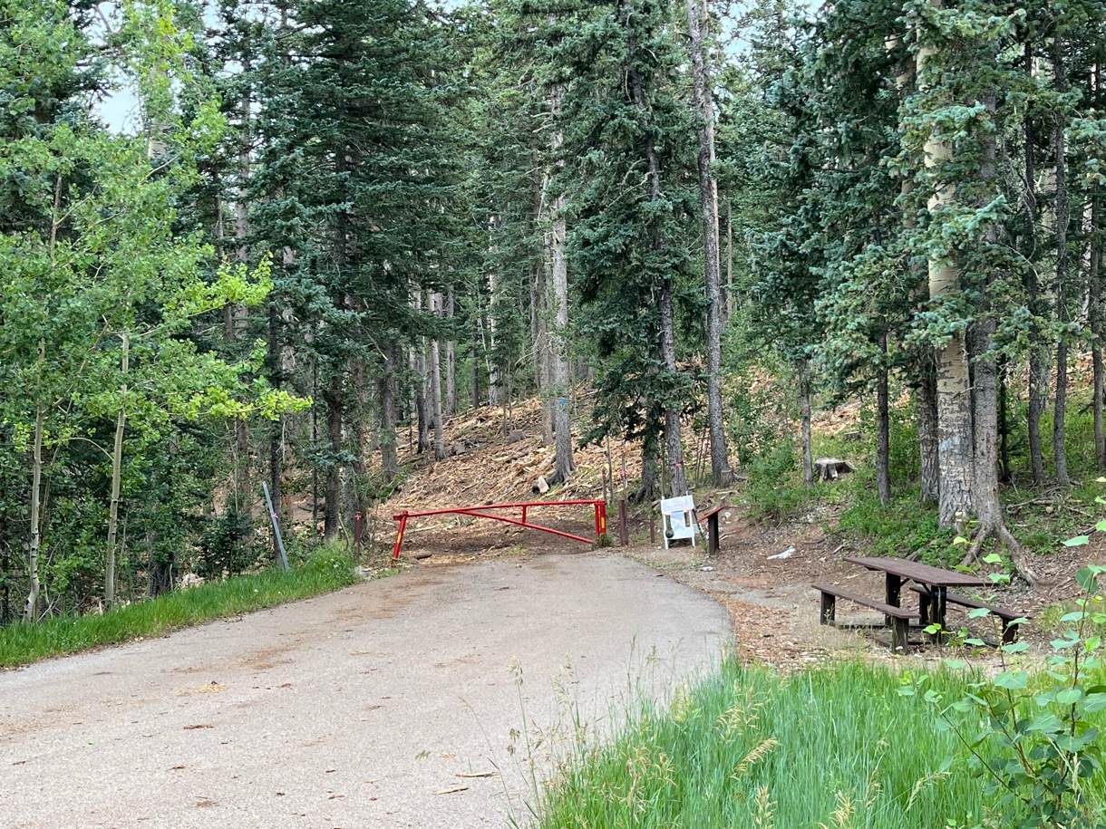
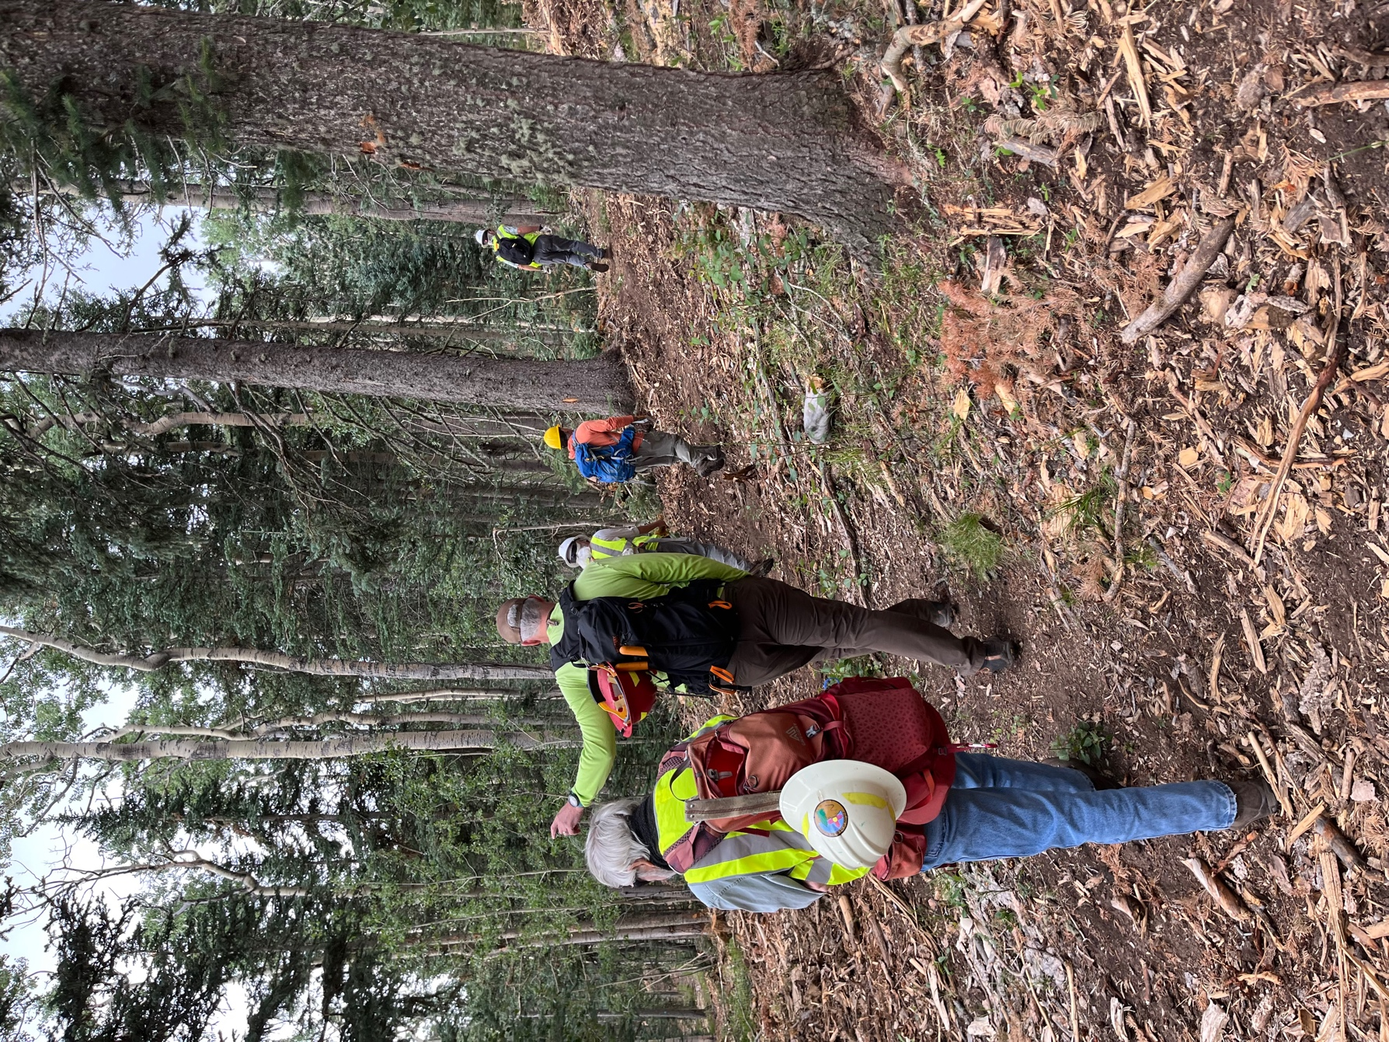

Thunder sent us back to the vehicles.

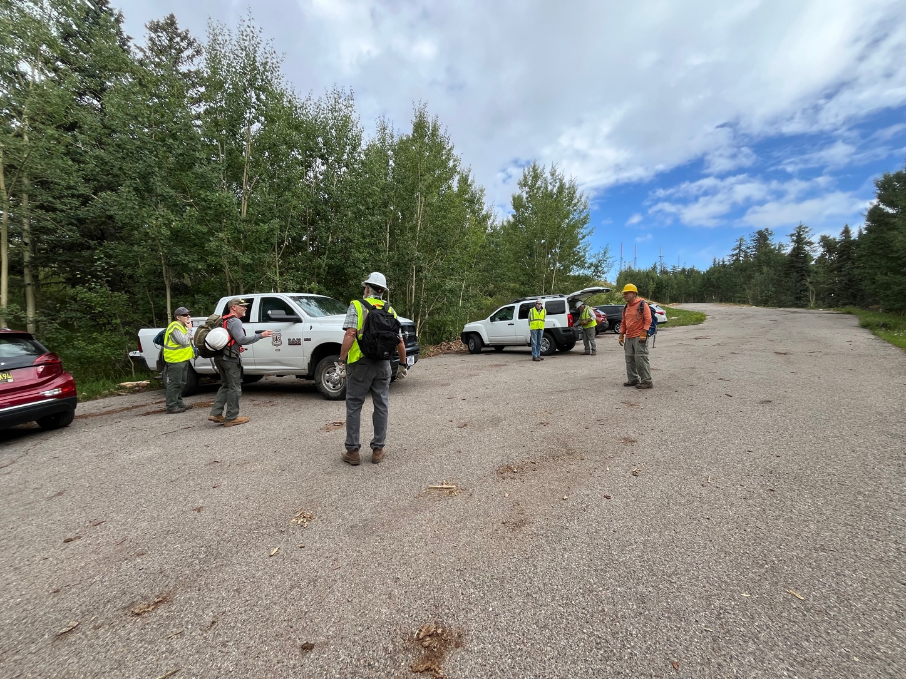

All clear but we continued to have clouds and some rain. Back to work!

Below are all the worker bees doing their excellent work!

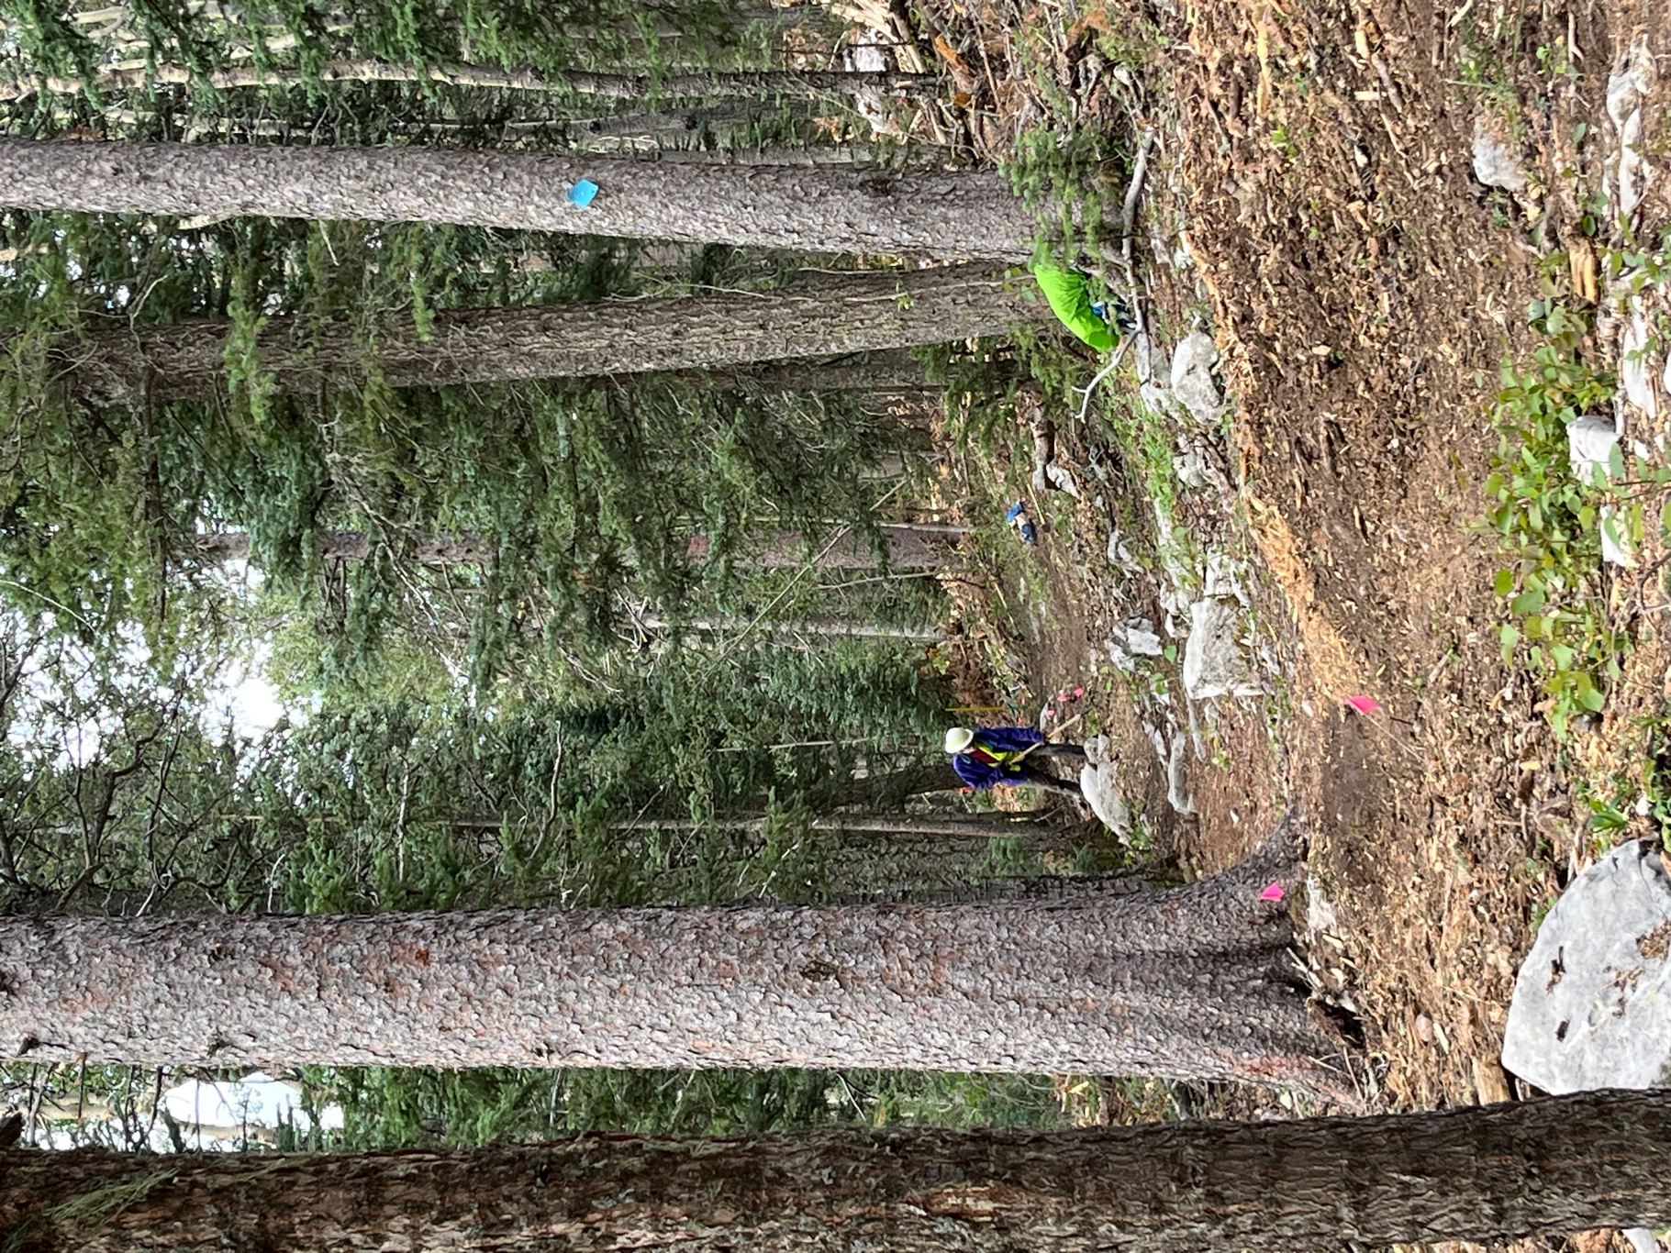

Bruce
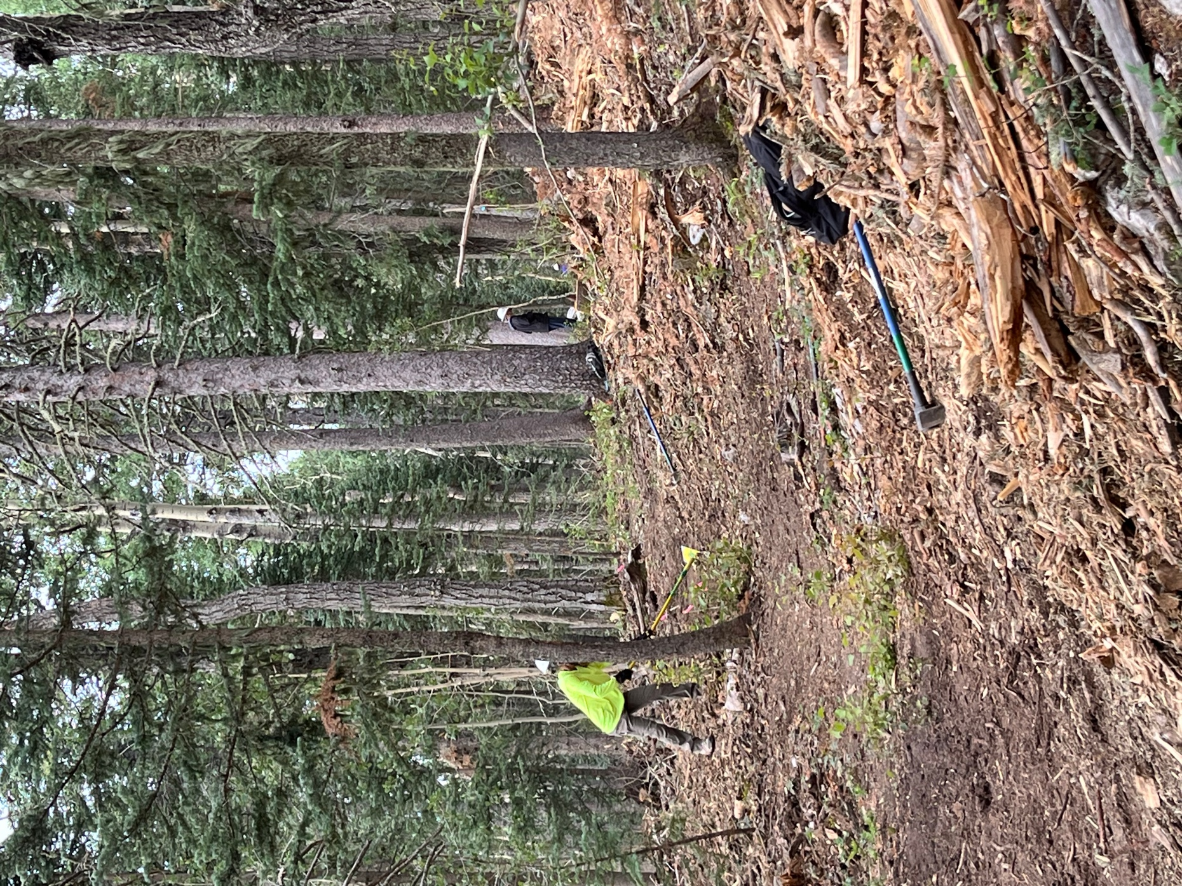

Claudia and Bruce
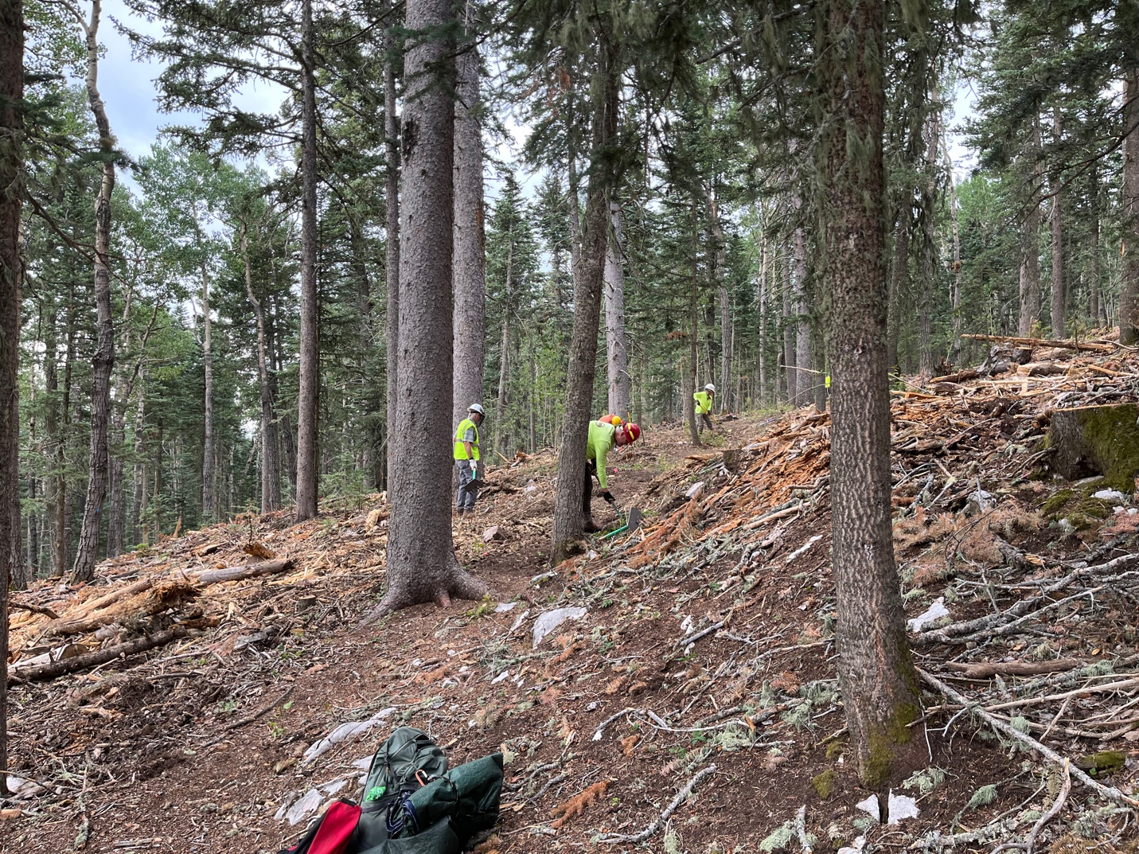

Kerry, Kent and Claudia

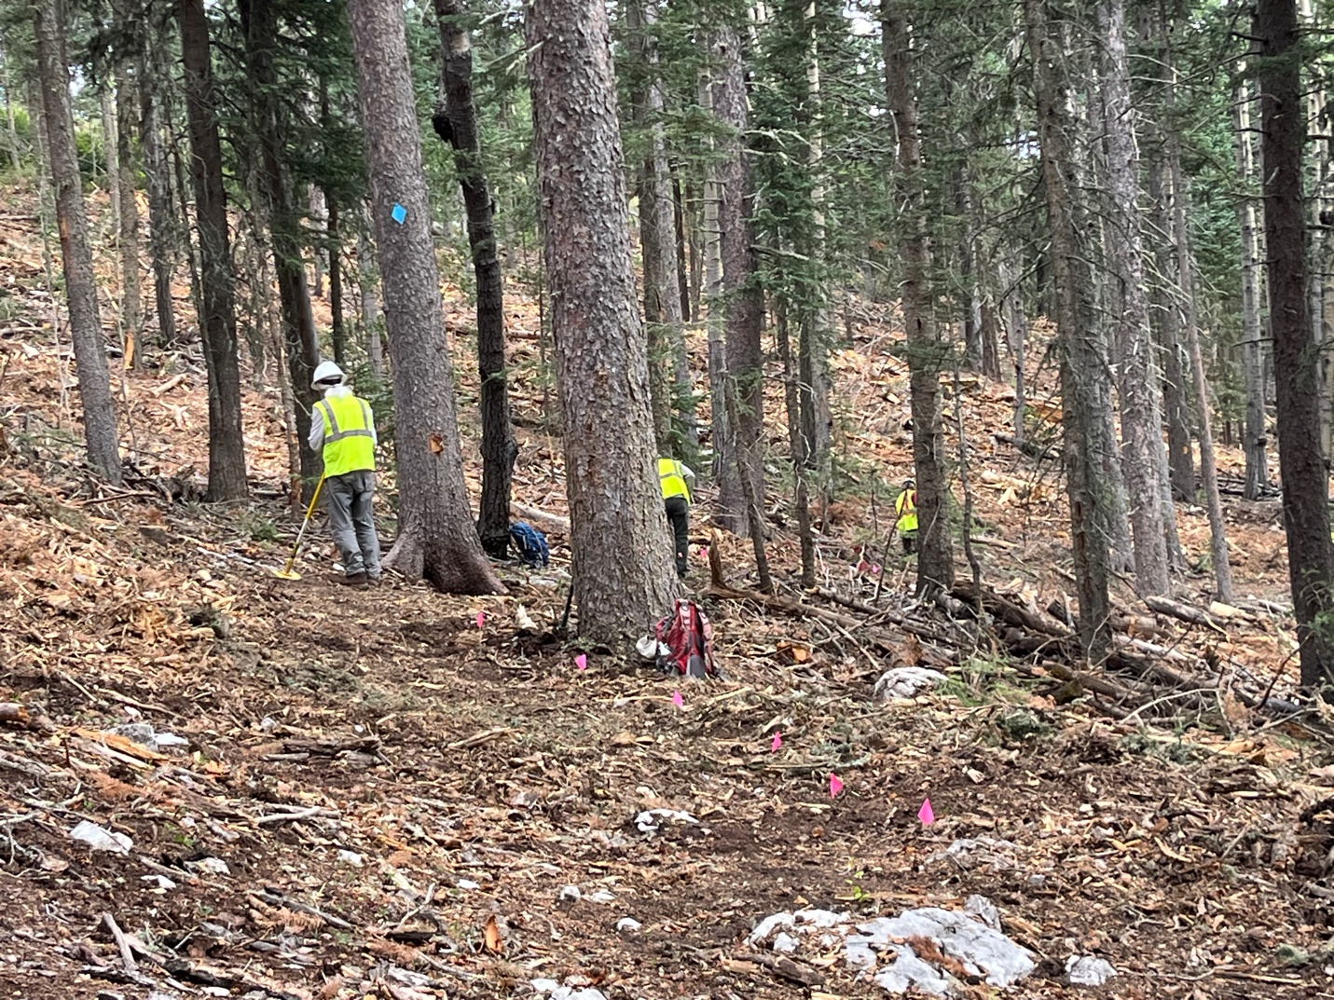

Bill, John and Luis

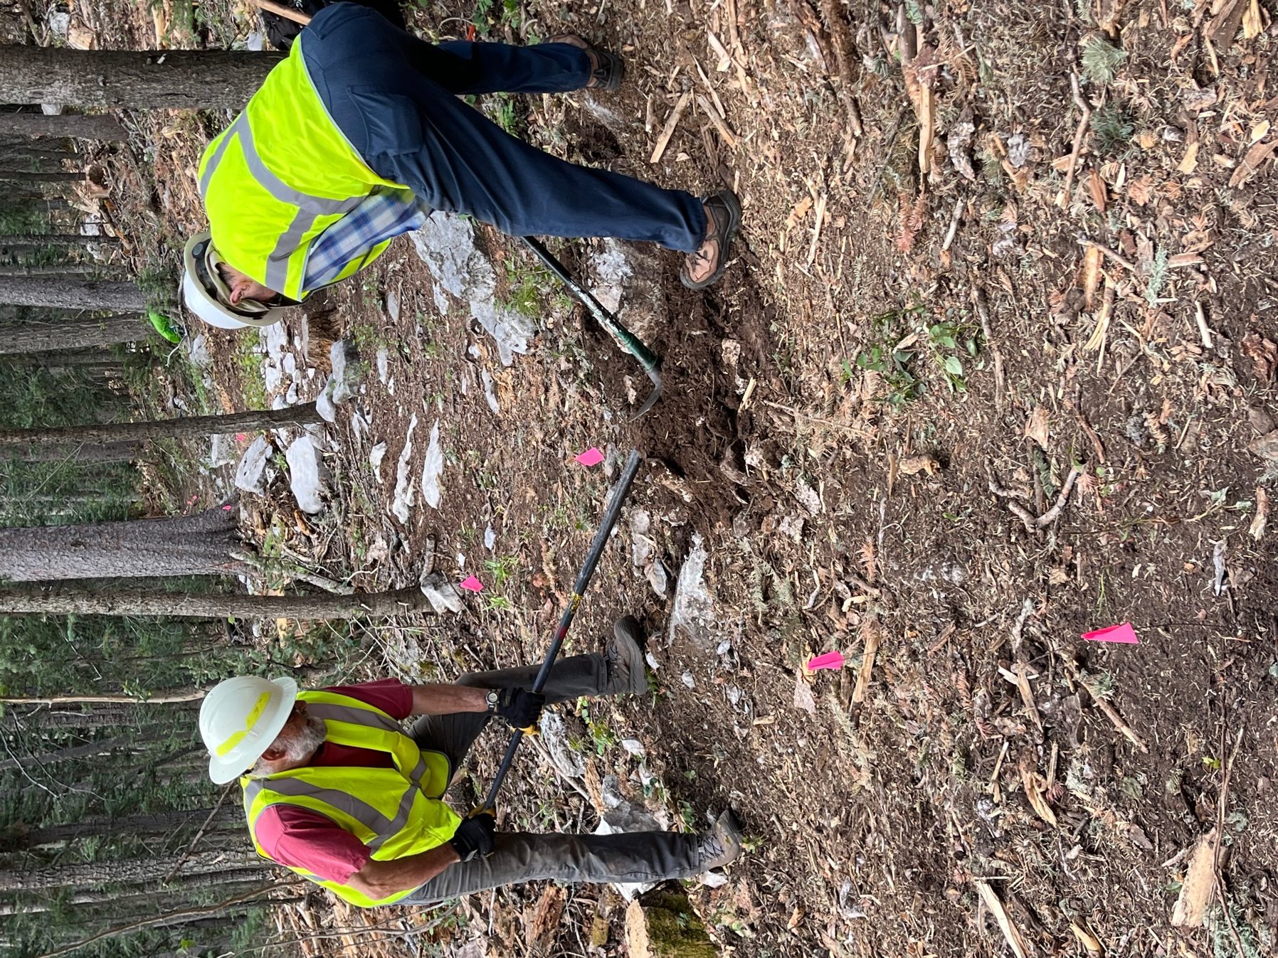

Jim and Bruce wrangle a rock.

