1972 Ford Galaxie Wreck Found below Crest Highway
near MM-5, Tuesday, July 28, 2026

Sam Beard and Chuck Logan
On Tuesday, July 28, Sam Beard and Chuck Logan found the 1972 Fork Galaxie below the Crest Highway near MM-5. The location on the guard rail above the wreck is about 100 feet up the highway from where the old highway joins the Crest Highway.
Sam and Chuck bush whacked down the bottom of Tejano Canyon from the location where a very large culvert is under the highway. Sam had hiked directly down the highway fill slope decades earlier to the wreck. He remembered that it was near where the old highway joins the present highway. Sam and Chuck hiked up the very steep highway fill slope from the wreck to the guard rail about 1/8 mile below MM-5. The location is marked with two pink flags on the steel rail posts behind the rail. Chuck put small stones on top of the two posts where we got to the railing. The wreck is about 100 feet down the very steep highway fill slope.
Sam, Chuck, and Michael Arndt will look for the SUV below where we park between MM-4 and MM-5 to clean the highway after the leaves are off the deciduous bushes in the fall. Two vehicles are off the highway below the first switchback below 10K Trailhead.
Photos of the wreck are presented below.

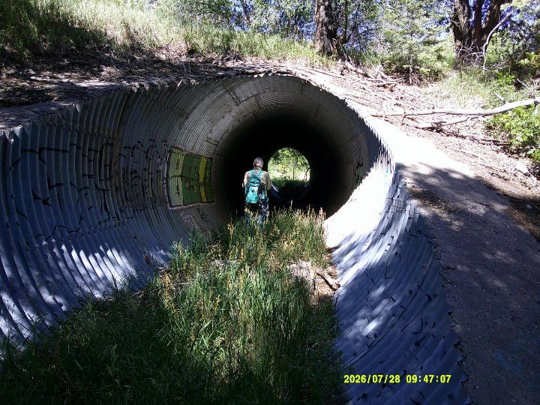
The 15-foot diameter culvert under the Crest Highway where we parked the pickup and where we
started bush whacking down Tejano Canyon. Photo by Sam Beard
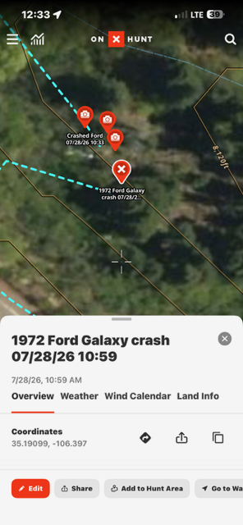
Location coordinates for 1972 Ford Galaxie wreck below Crest Highway near MM-5 are given above.
The edge of the Crest Highway is in the lower left corner of the satellite photo. All photos by Chuck Logan
unless noted otherwise.
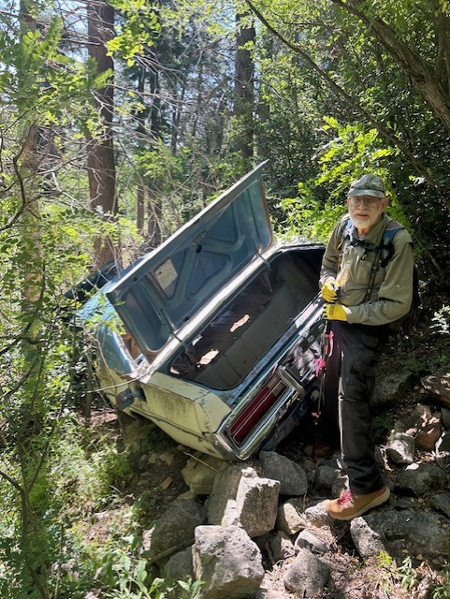
Sam Beard at open trunk of the Ford.
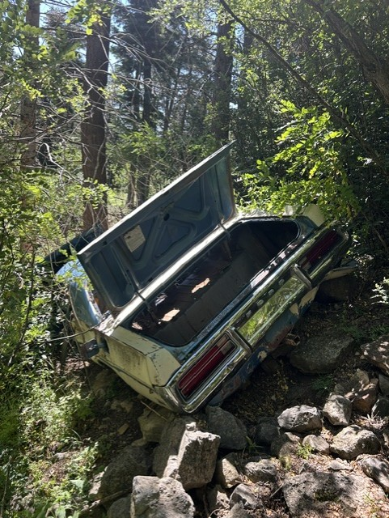
The car is across the slope of the steep mountain side.

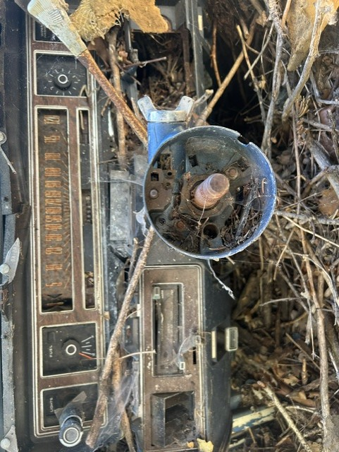
Instrument panel of the Ford. Note that the steering wheel is missing.

\

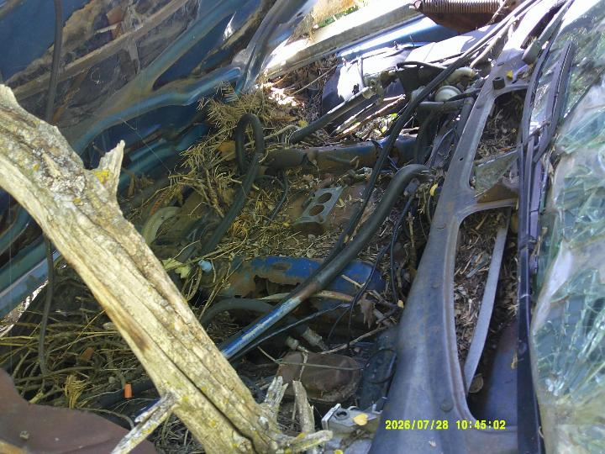
The V8 engine compartment with the air filter and carburetor missing.
Photo by Sam Beard
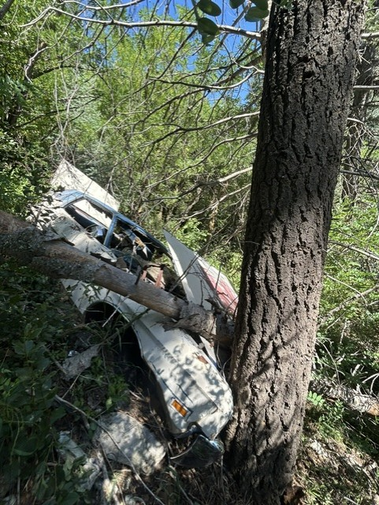
The car is across the mountain with the right side up. Apparently, the large tree
stopped the vehicle as it slid down the mountain side.
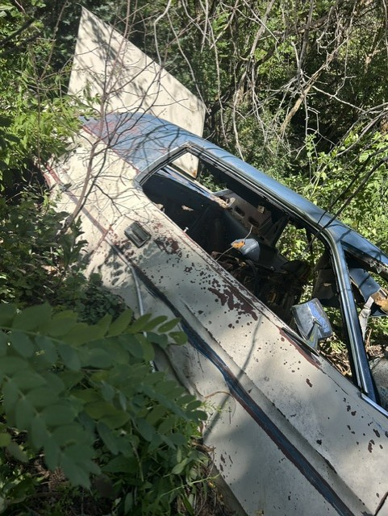
The right side of the blue and white car with all the windows missing.
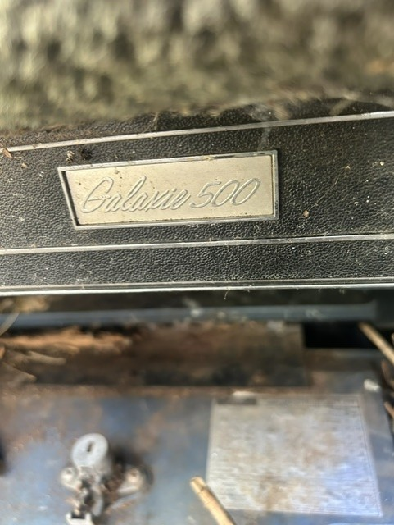
It was a Galaxie 500 model 1972 Ford with two doors.
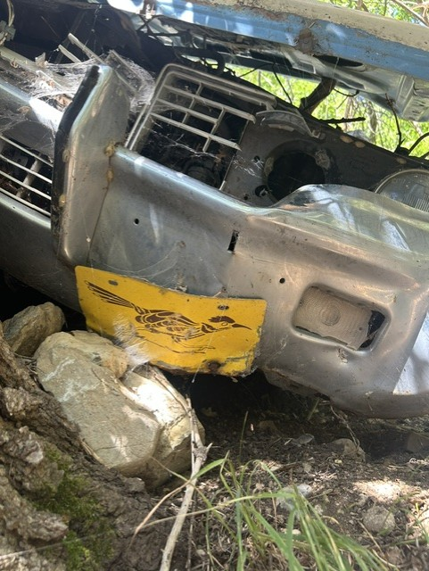
A roadrunner license plate is on the front bumper.

