Thursday, 07/30/26- Switchback: While everyone in town was sweltering, seven volunteers and Jen and Chris (SRD) were up on the crest enjoying the reasonable weather! Our goal was to put the trail signage back up around the crest and continue clearing Switchback trail. The highway is open, not barricaded any more. The NM DOT permit has run out and so the barriers are down. The parking areas are all barricaded off in hopes of keeping hikers off the trails until they are restored. There is a lot of debris and unstable footing up on Switchback although Challenge and Rocky Point were both less damaged and are now clear, at least in the sections we were able to work. The electronic sign at the Doc Long area says that the trails are still closed but we’ll see if people pay any attention. The mitigation crew is ahead of schedule and is currently doing work at an active fire site but they will return and they plan to finish work on the crest in the time allotted by their contract. There is no word yet on whether they will close the road again. The motorcycles were back running up and down the road and there were quite a few cars that came up the road to the crest but they seemed to all turn around and head back down. So far so good.

Volunteers: Claudia Bergsohn, Kent Towler, John McNett, Jim Houle, Luis Cuadros,
Byron Garner and Laura Leon

Pictures: Laura Leon

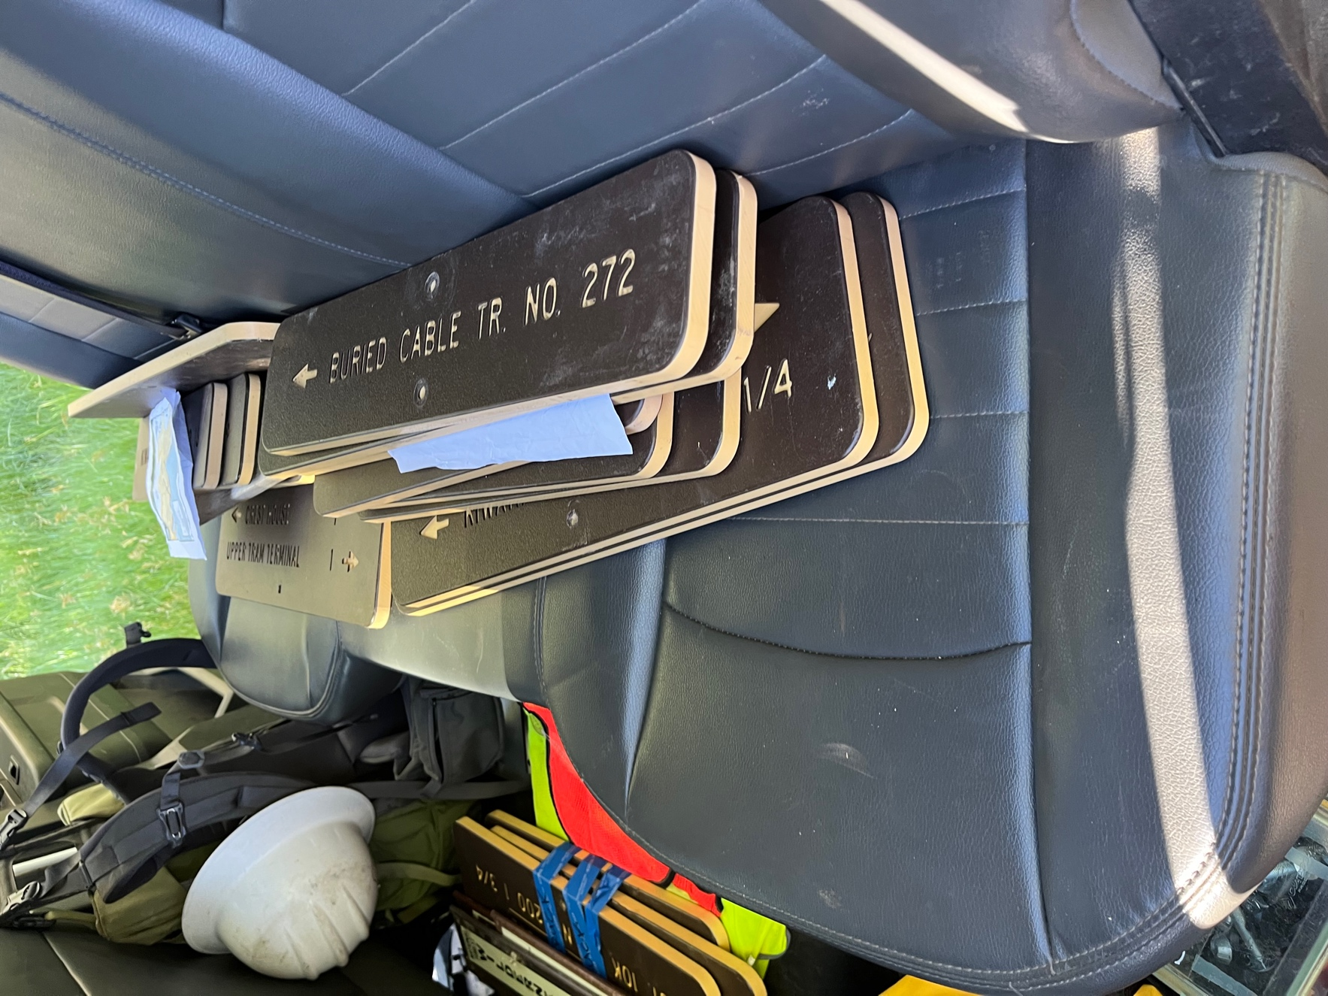

Lots of signs to put back up. We were going to go out in small groups but it worked out better to have one crew work on signs (Jen, Chris, Kent and John) and the rest of the crew continue work on the trail.

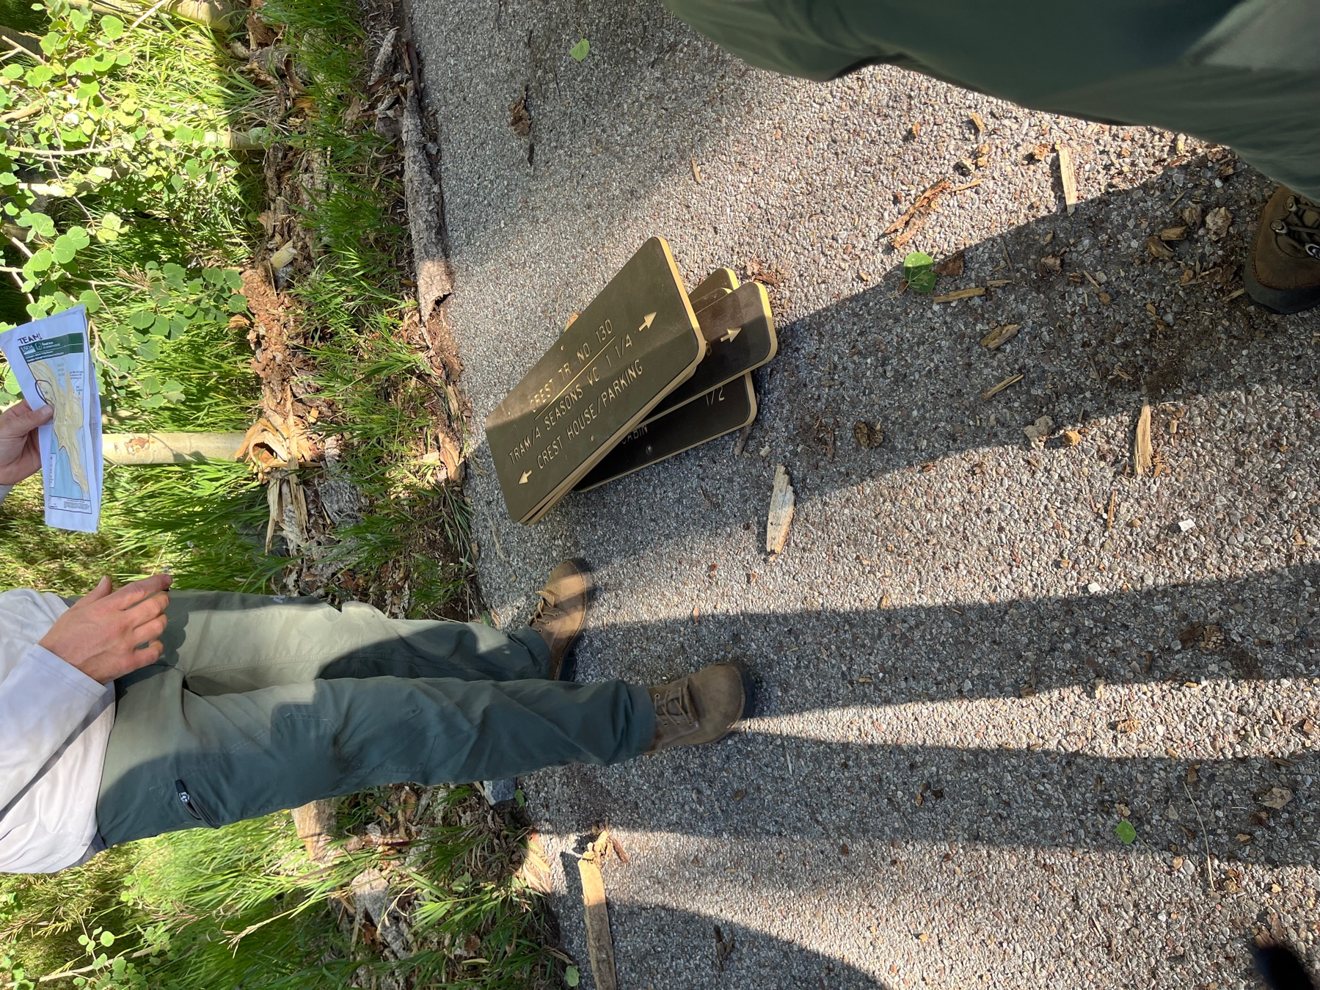

Chris talks strategy!
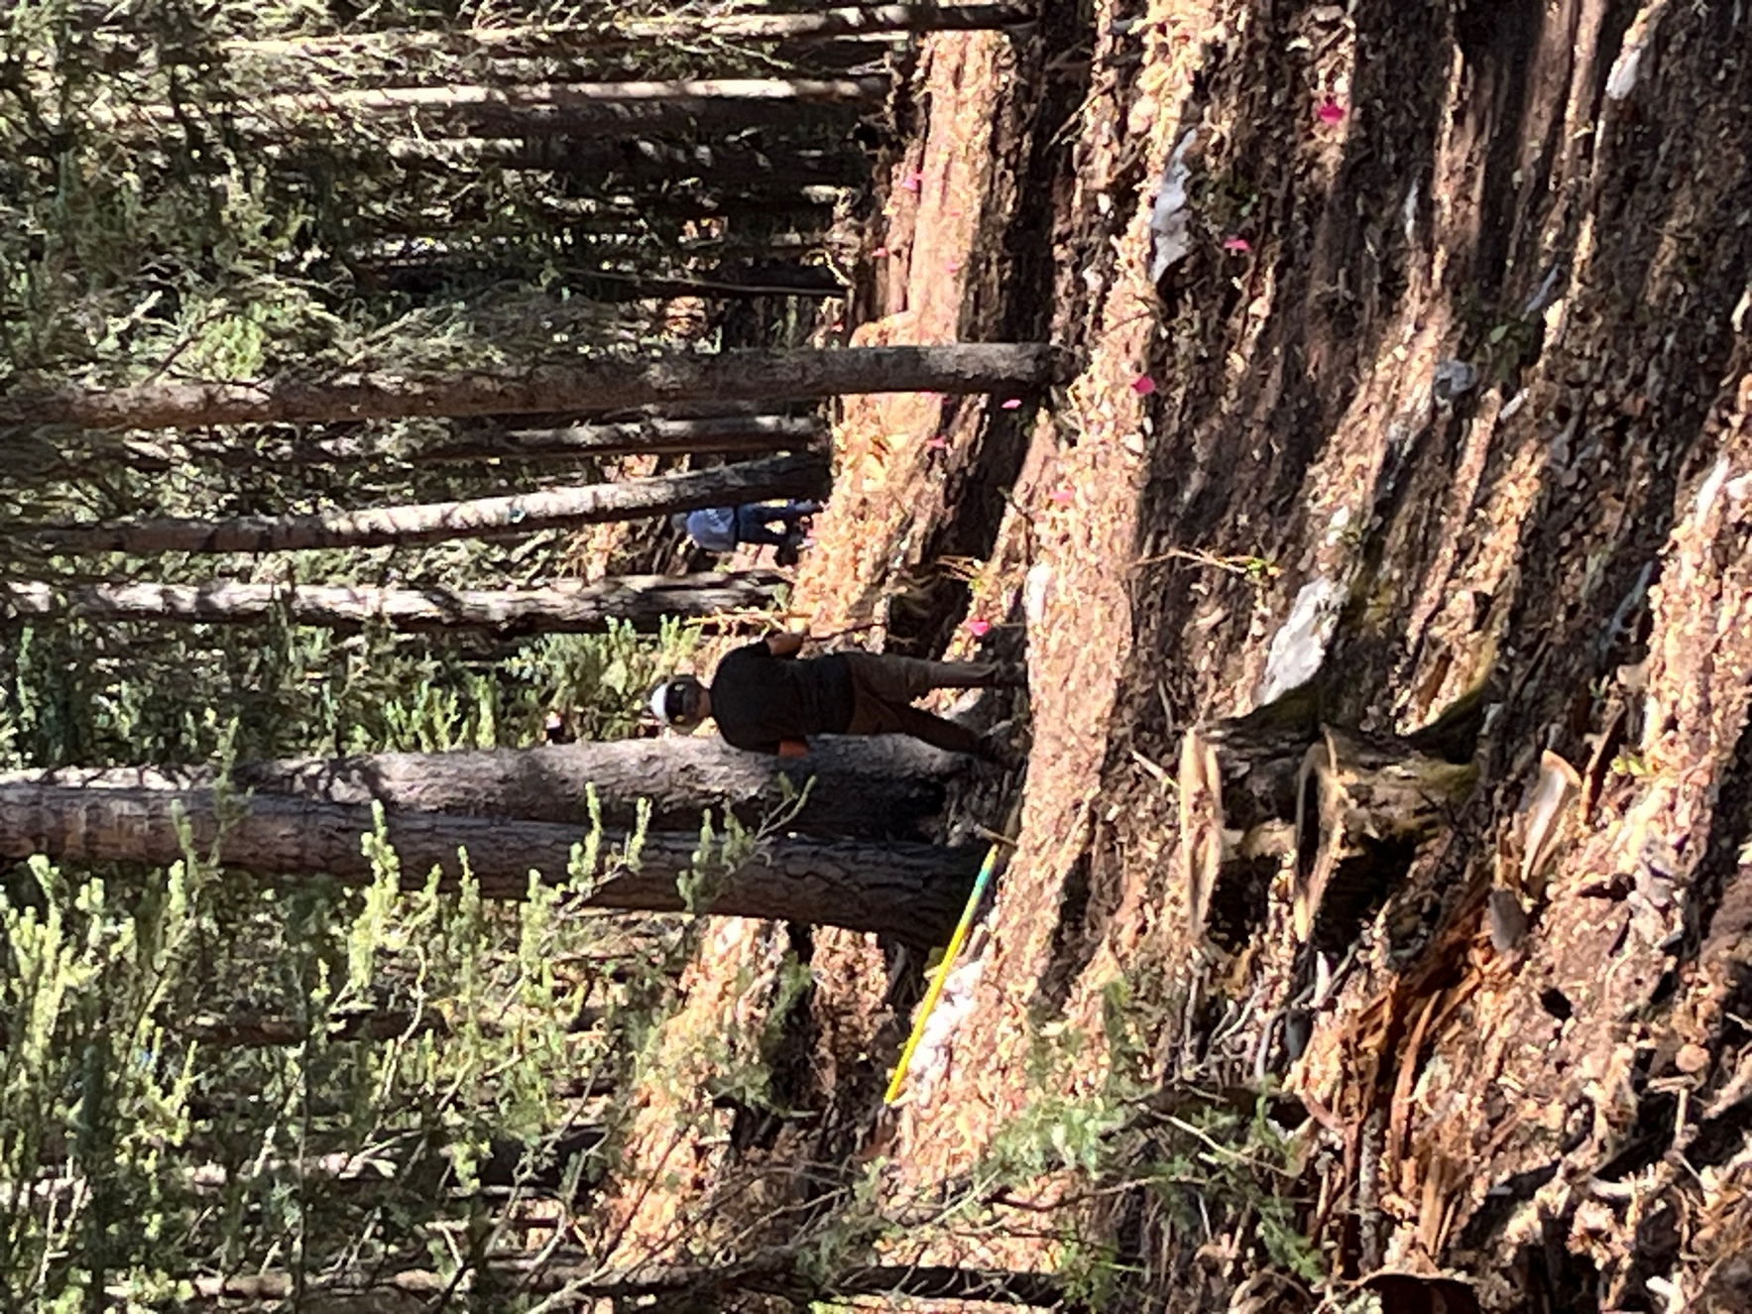

Luis and Byron spread out to rework some trail areas. Luis, Byron, Jim Claudia and Laura were all spread out fixing trail. In some areas we are just clearing it and in others we’re trying to make trail more sustainable.

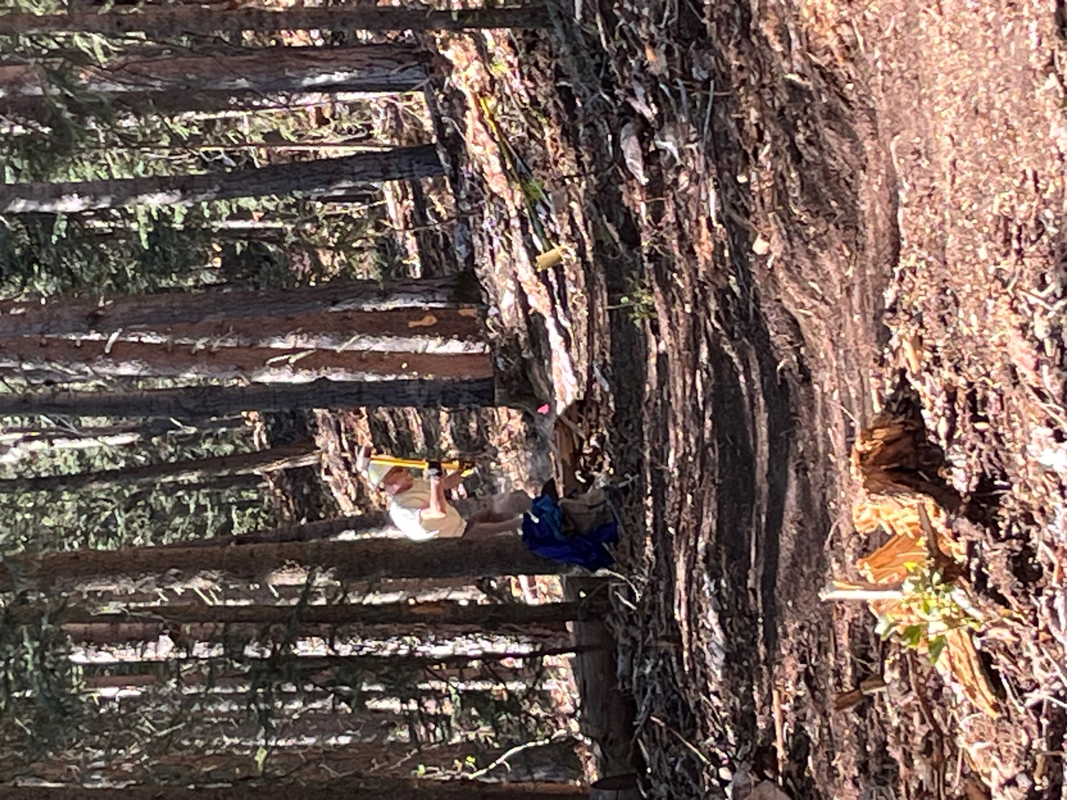

Jim with his sledge hammer- knocking down a rock.

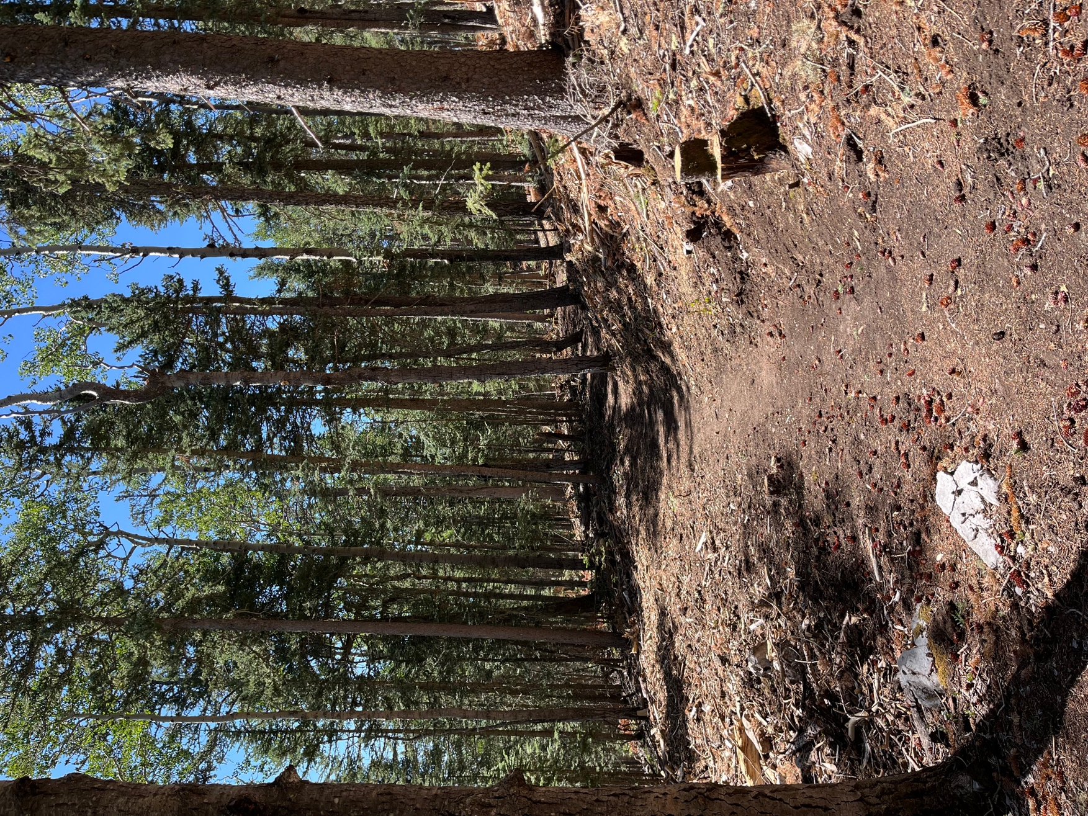

Cleared trail. The forest looks great, open and healthy, and we were able to watch a hawk hunt while we had lunch.
