Report of FOSM Project to Fell Hazard Trees in Cienega Canyon Picnic Area
on Wednesday, July 29, 2026

Sam Beard
On Wednesday, July 29, eight FOSM volunteers felled eleven dead hazard trees in the following parts of Cienega Canyon Picnic Area: upper parking lot, lower host site near Tee intersection, road between the lower restrooms, near middle restroom, Nature Trail, and group area.
The volunteers were Sim Cook, Michael Arndt, Dan Benton, Cliff Giles, Jerry Carroll, Chuck Logan, Steve Roholt, and Sam Beard.
Project photographs are presented below.

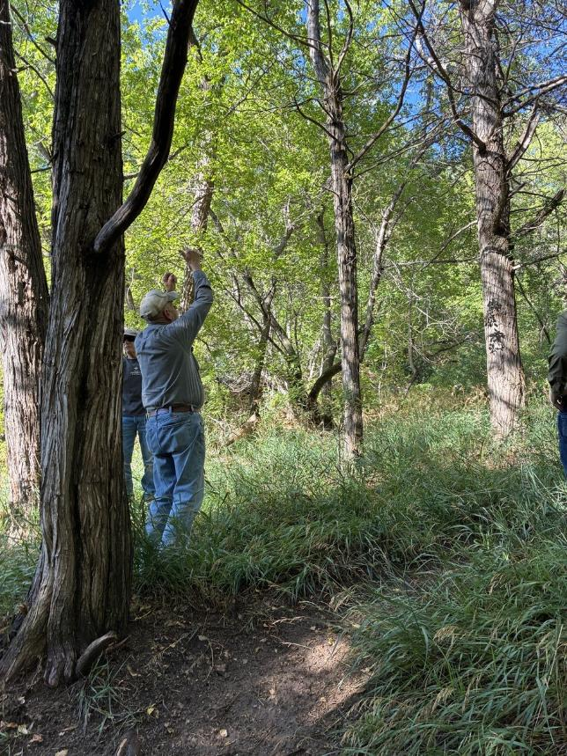
Jerry checking the lean of a dead Rocky Mountain juniper near the upper parking
lot in Cienega Canyon Picnic Area. All photos by Cliff Giles unless noted otherwise
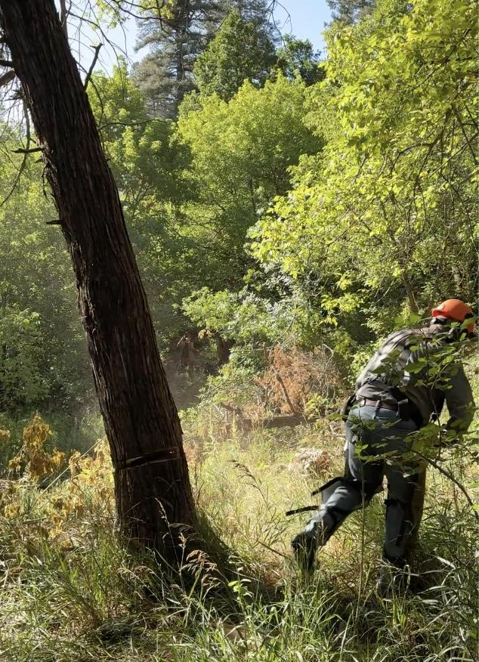
Jerry running away from the tree he has just felled.
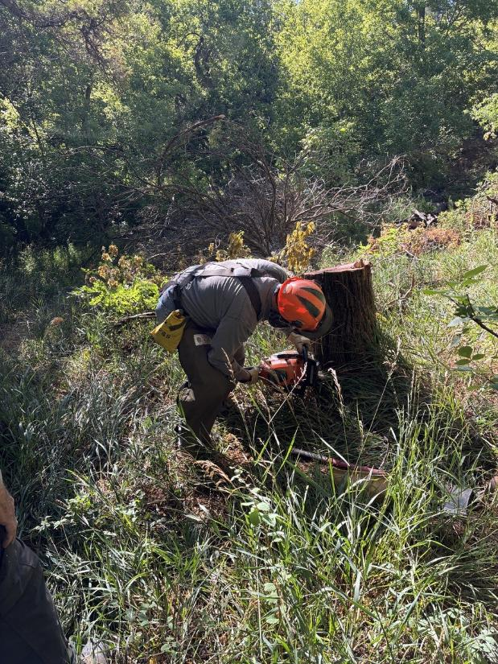
Jerry low stumping the tree he felled.

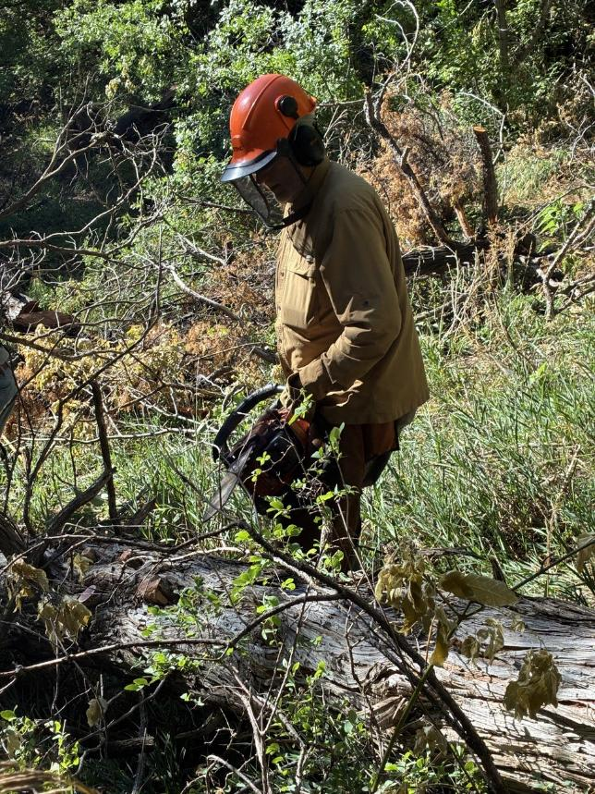
Dan Benton limbing and bucking the tree Jerry felled.

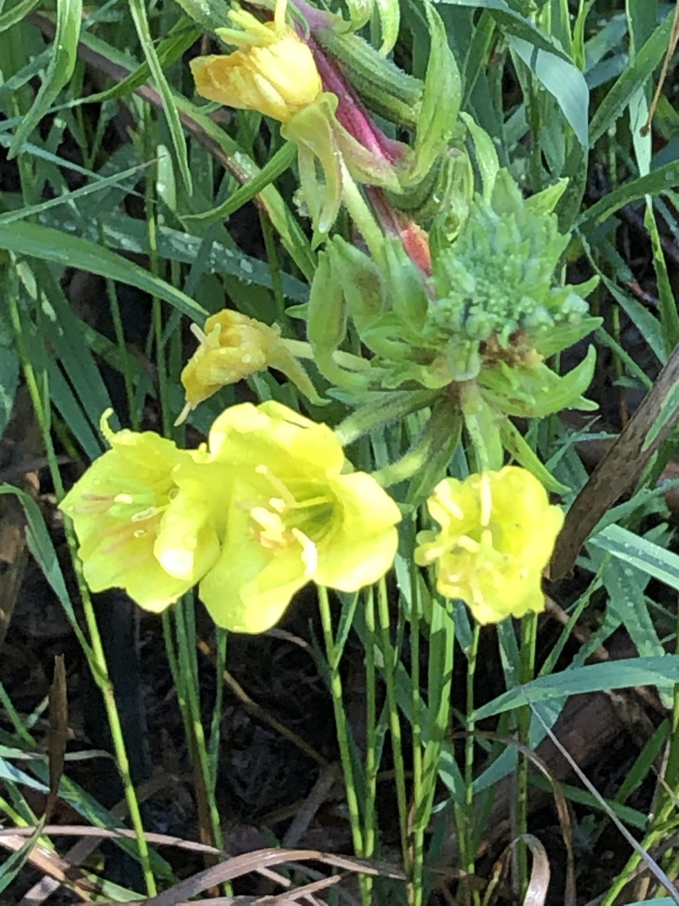
Dan Benton emailed me this photograph of a Hooker’s primrose
in upper Cienega Canyon Picnic Area.

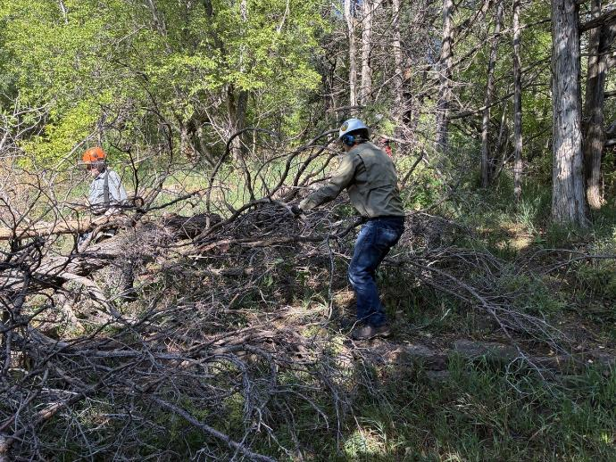
Chuck Logan swamping while Jerry limbs the felled tree.

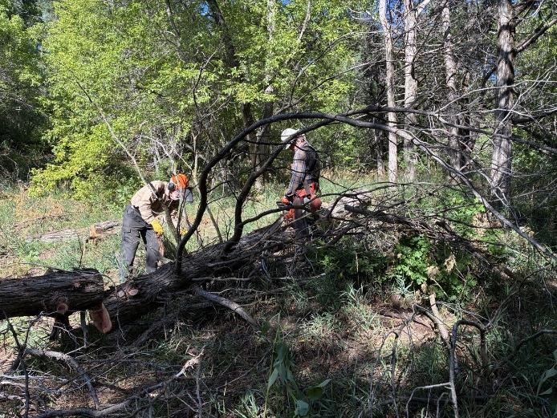
Sam Beard swamping while Michael Arndt limbs this tree.

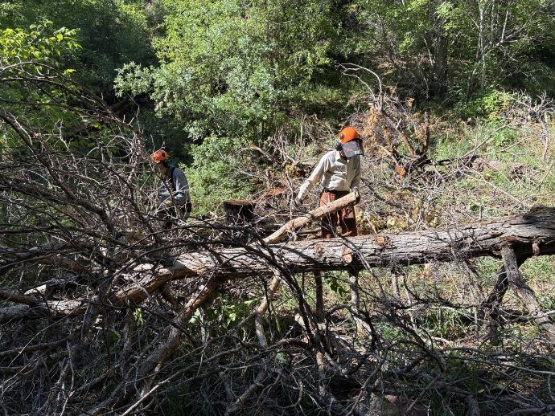
Sim Cook swamping while Jerry limbs.

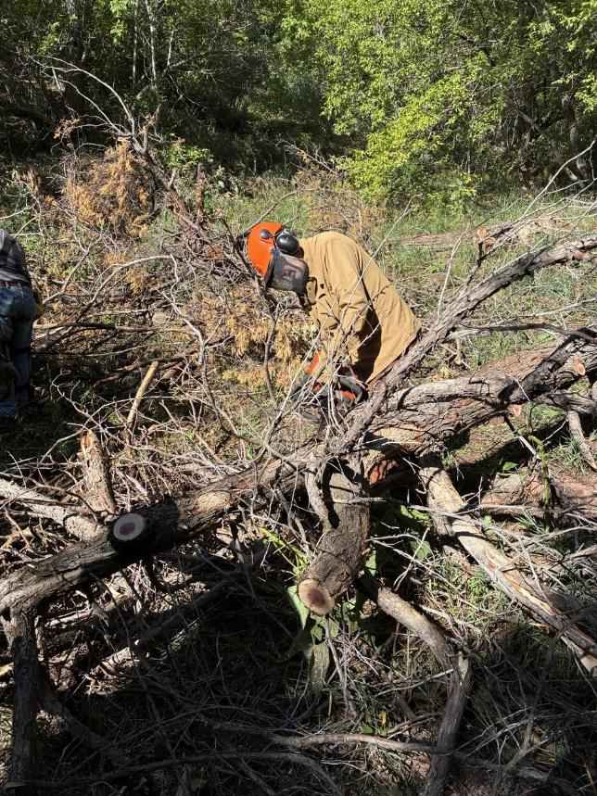
Dan Benton limbing and bucking Jerry’s tree.
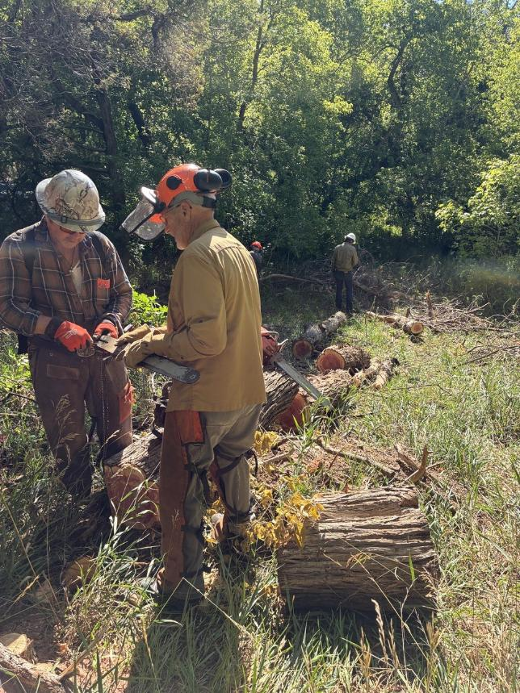
Michael and Dan putting a sharp chain on Michael’s saw.
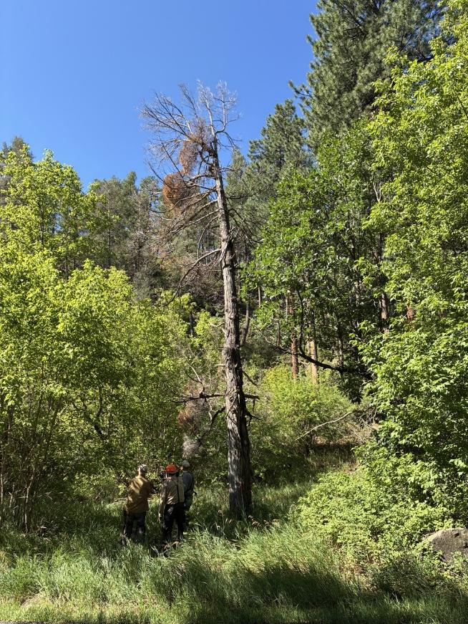
Crew members analyzing a dead Rocky Mountain juniper beside Cienega PA Road.
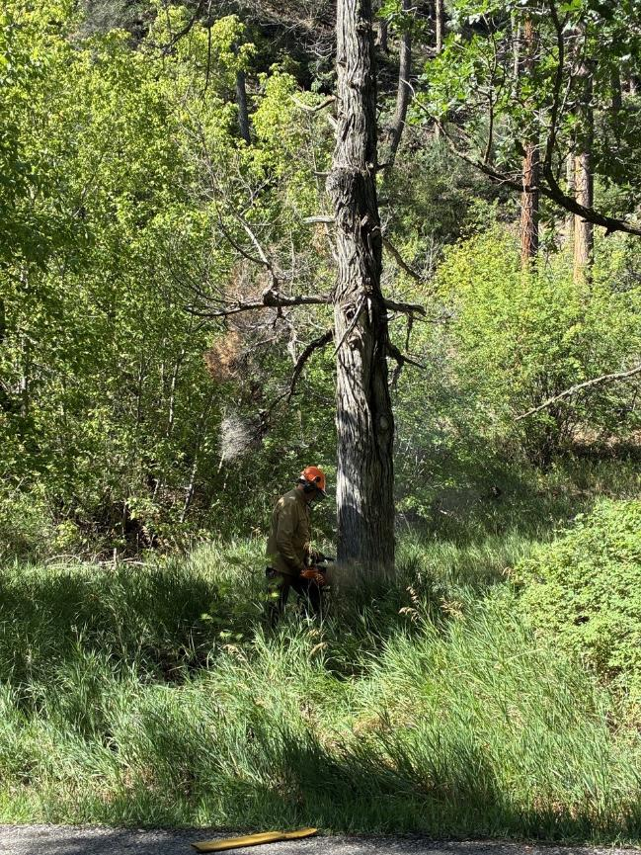
Dan making the face cut on this large juniper tree.

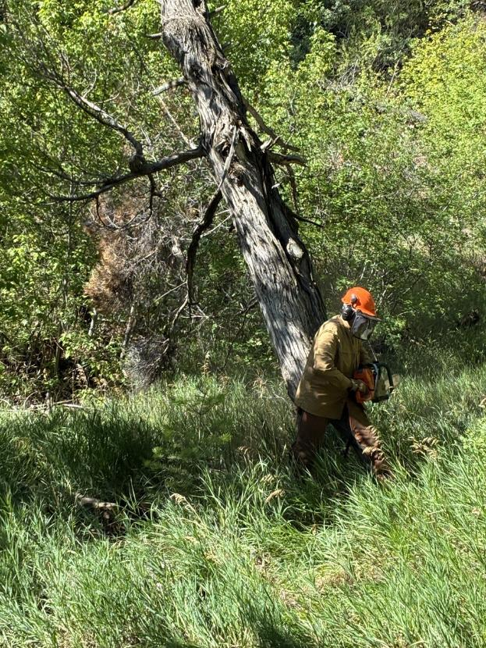
Dan running away from the falling tree.
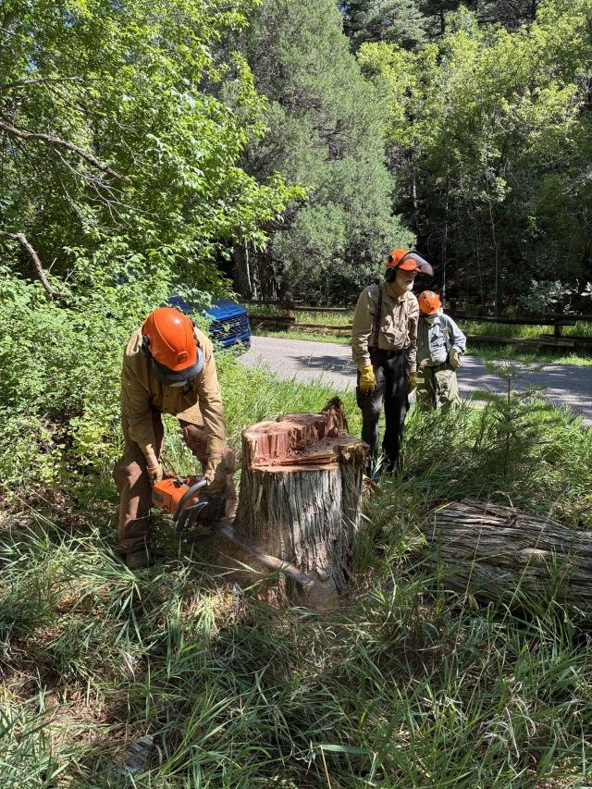
Dan low stumping the tree he felled.

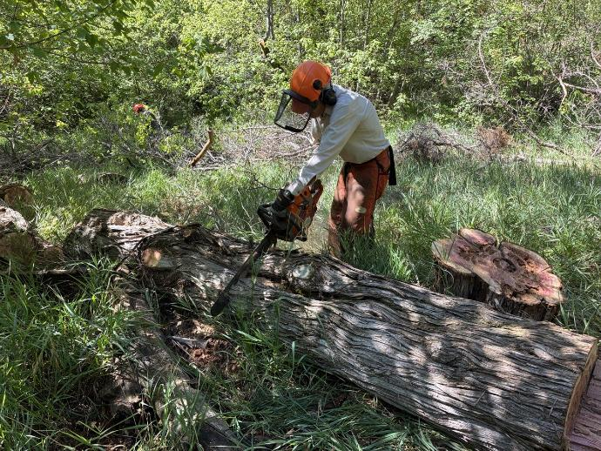
Sim Cook bucking Dan’s tree.

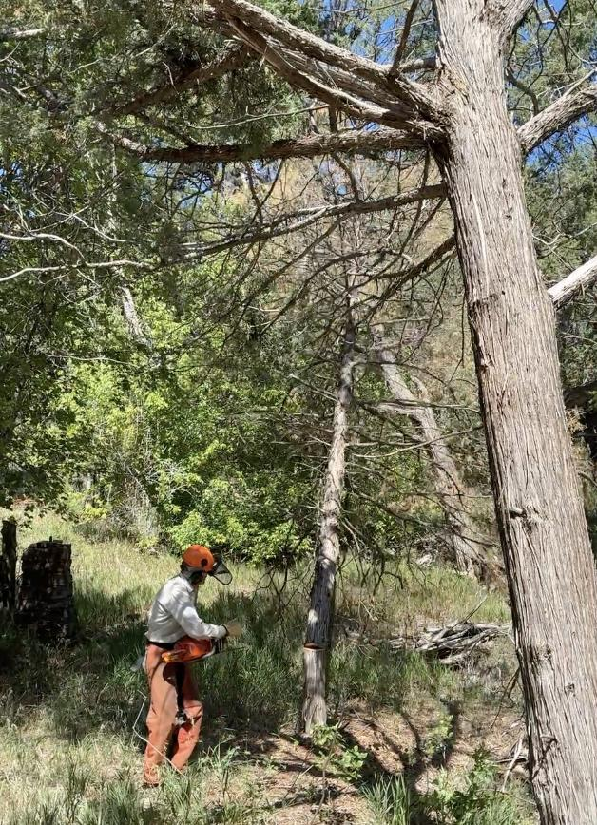
Sim felling a small dead Rocky Mountain juniper near the host site in Cienega PA.
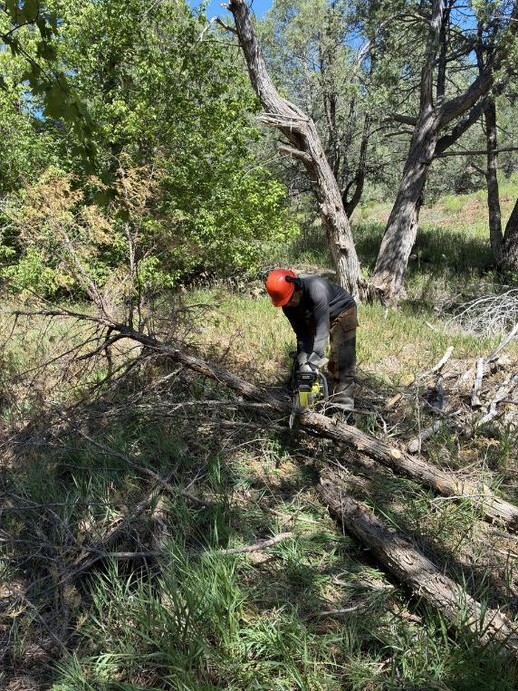
Jerry bucking Sim’s tree.

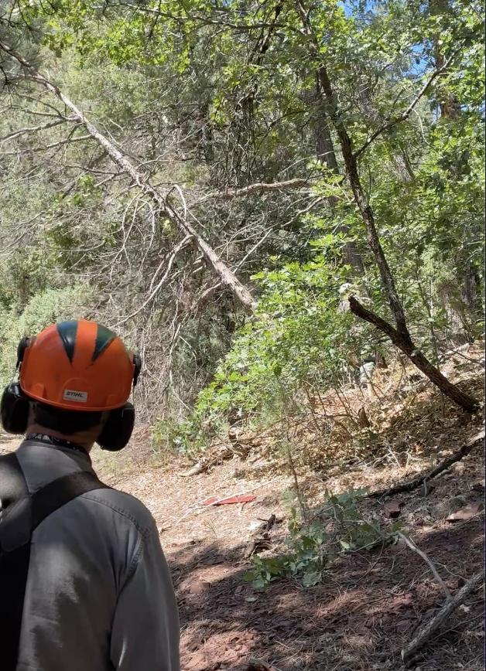
Jerry observing a falling dead tree felled by another crew member.
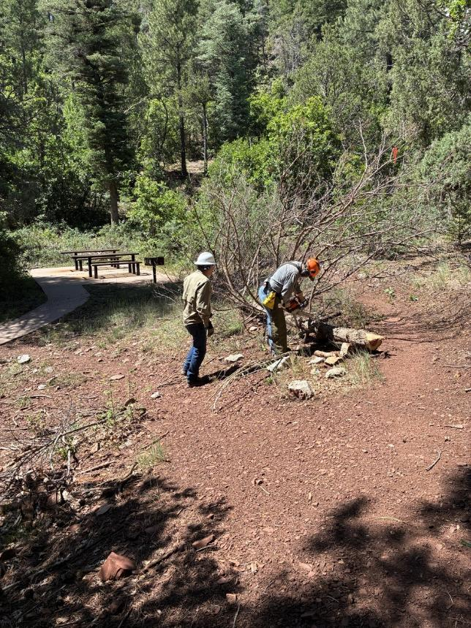
Chuck Logan observing Jerry limb a dead juniper beside Acequia Trail near the middle restroom.

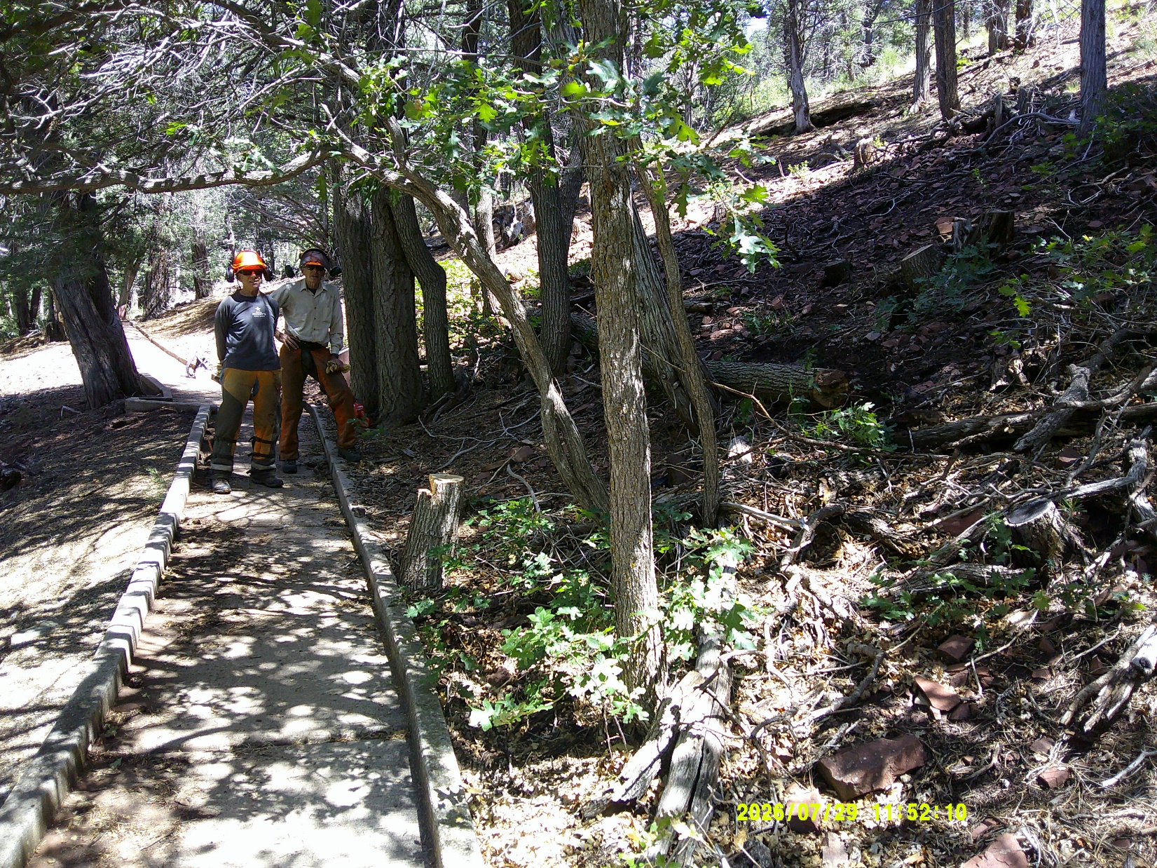
Steve Roholt and Sim Cook on the Cienega PA Nature Trail
where Sim felled two dead hazard trees.

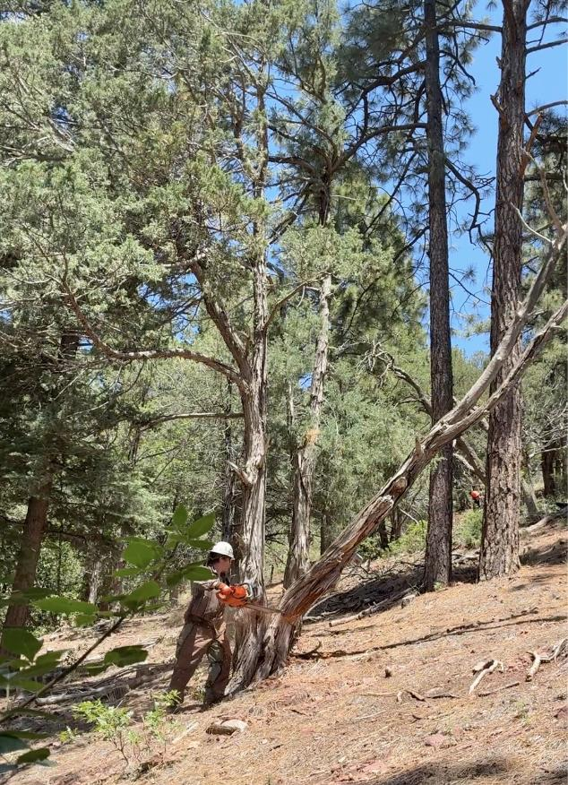
Michael felling a dead juniper trunk in the Cienega PA Group Area.
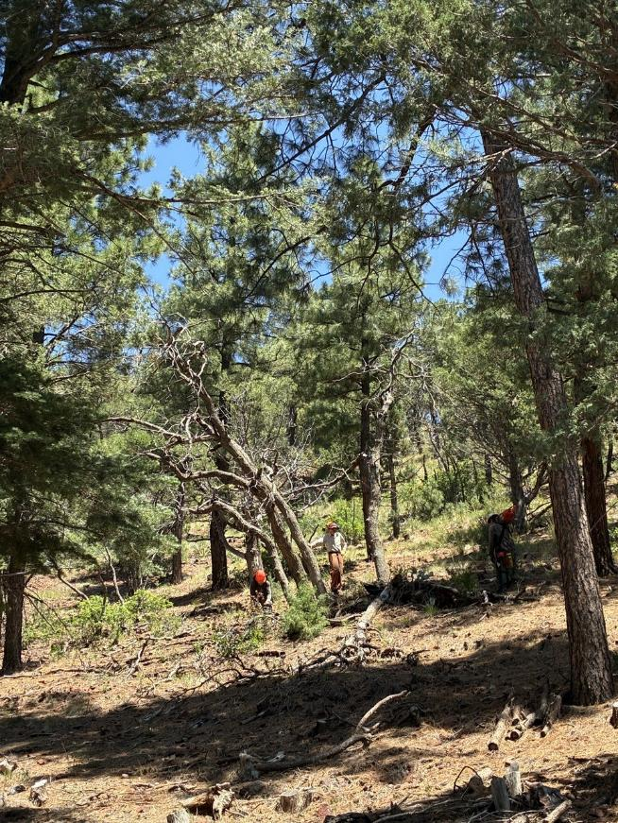
Crew members felling dead Gambel oaks in the Group Area.

