Photographs of Graffiti Tags in Juan Tabo CCC Picnic Shelter, Sunday, August 2, 2026

Sam Beard
On Saturday, August 1, Julie Padilla, SRD Recreation Staff Officer, requested that FOSM remove the graffiti tags in the Juan Tabo CCC Picnic Shelter. On Sunday, August 2, I took the following photographs of the graffiti in this picnic shelter.

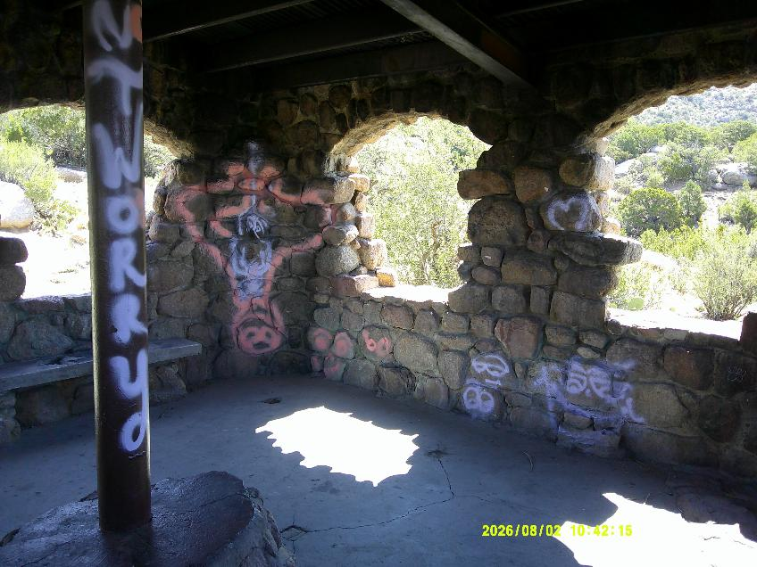
Graffiti tags on south wall in Juan Tabo CCC Picnic Shelter on Sunday, August 2. All photos by Sam Beard
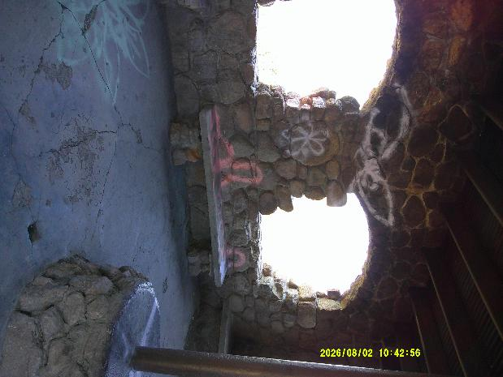
Graffiti tags on west wall of picnic shelter.
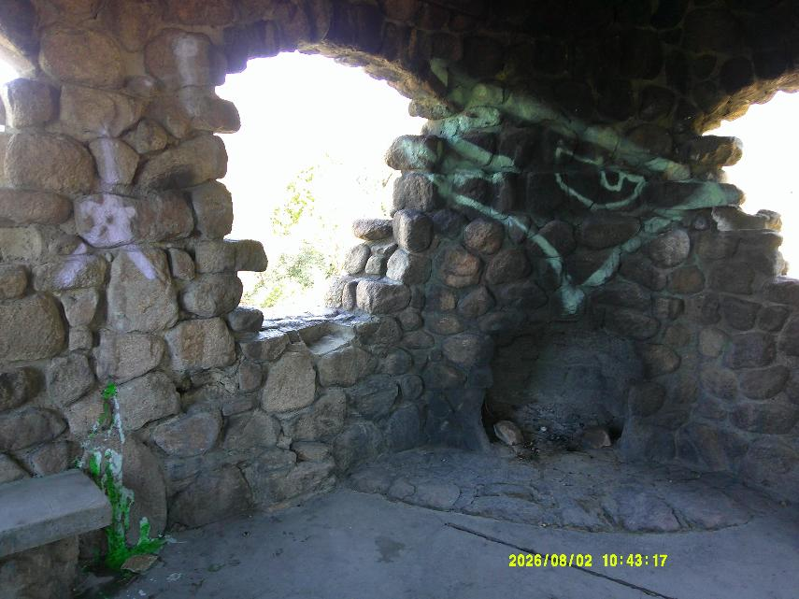
Graffiti tags in northeast corner of picnic shelter.
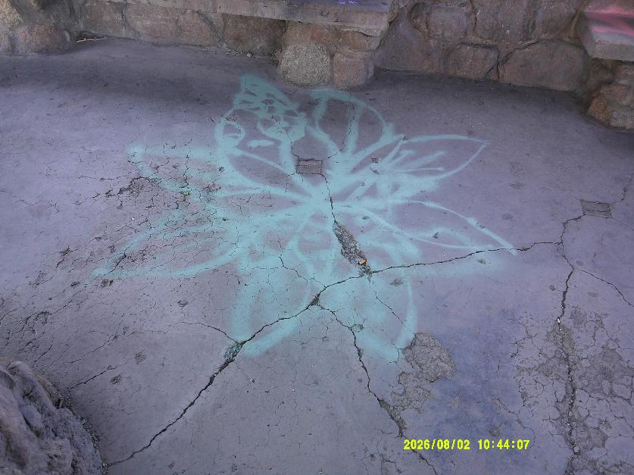
Graffiti tag on floor of picnic shelter.

