Photographs of Mother Bear and Two Cubs in Capulin Spring Picnic Area, Wednesday, August 5, 2026
Sam Beard and Michael Arndt
On Wednesday, August 5, Sam Beard and Michael Arndt had been looking for dead trees to fell next Wednesday in Capulin Snow Play Area and were driving back to Capulin Spring Picnic Area. They stopped to look at dead tree beside the road and saw an adult black bear in the road near the picnic shelter. Soon two small cubs joined their mother in the road. The bears went up into the forest near the trash containers at the shelter. Soon the mother came running from the forest and crossed the road, and the cubs were running behind her. We eventually drove into the picnic area but did not see the bears again. When we were looking at the bears, they appeared to be larger then than in the photos later.
Fortunately, each of us had time to take a couple of pictures while the bears were standing in the road. In the pages that follow, the top photograph is the picture as taken. The bottom picture is the result of cropping much of the original photograph, and enlarging the part of photograph showing the bears.
It is interesting that on Tuesday evening the program for the August FOSM meeting was presented by two game wardens from the N. M. Wildlife Department. Part of the program focused on black bears and mountain lions and their lives in the forest.

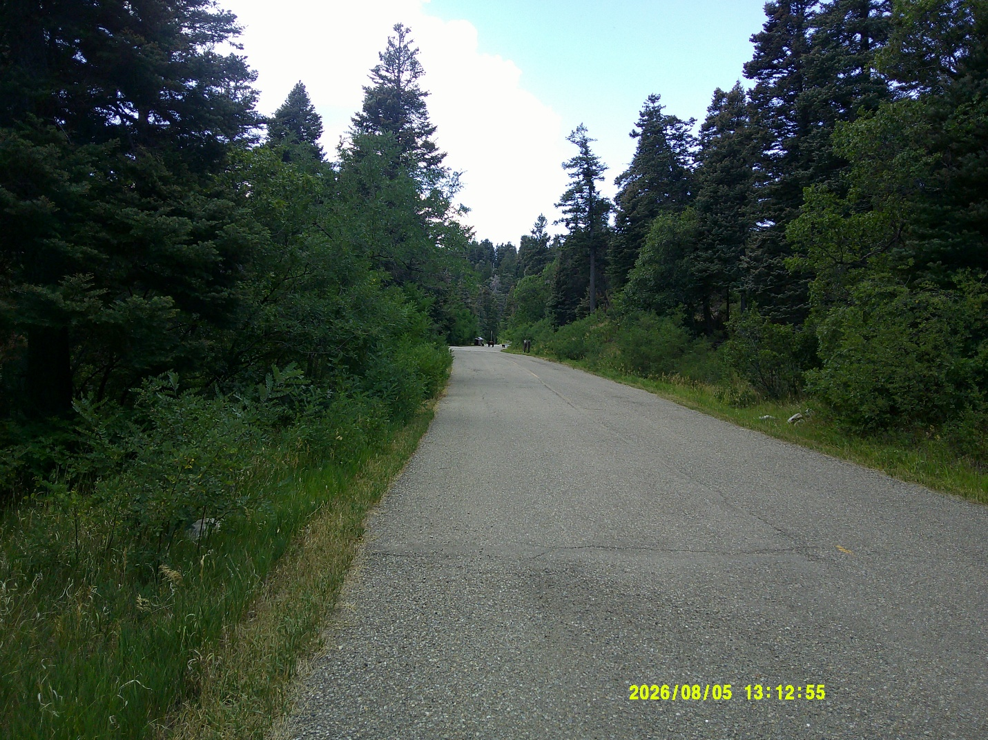
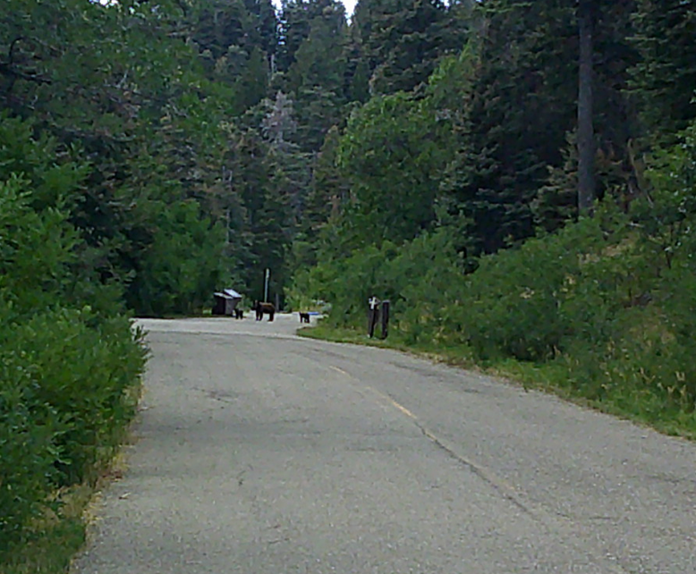
Bear photo by Sam Beard
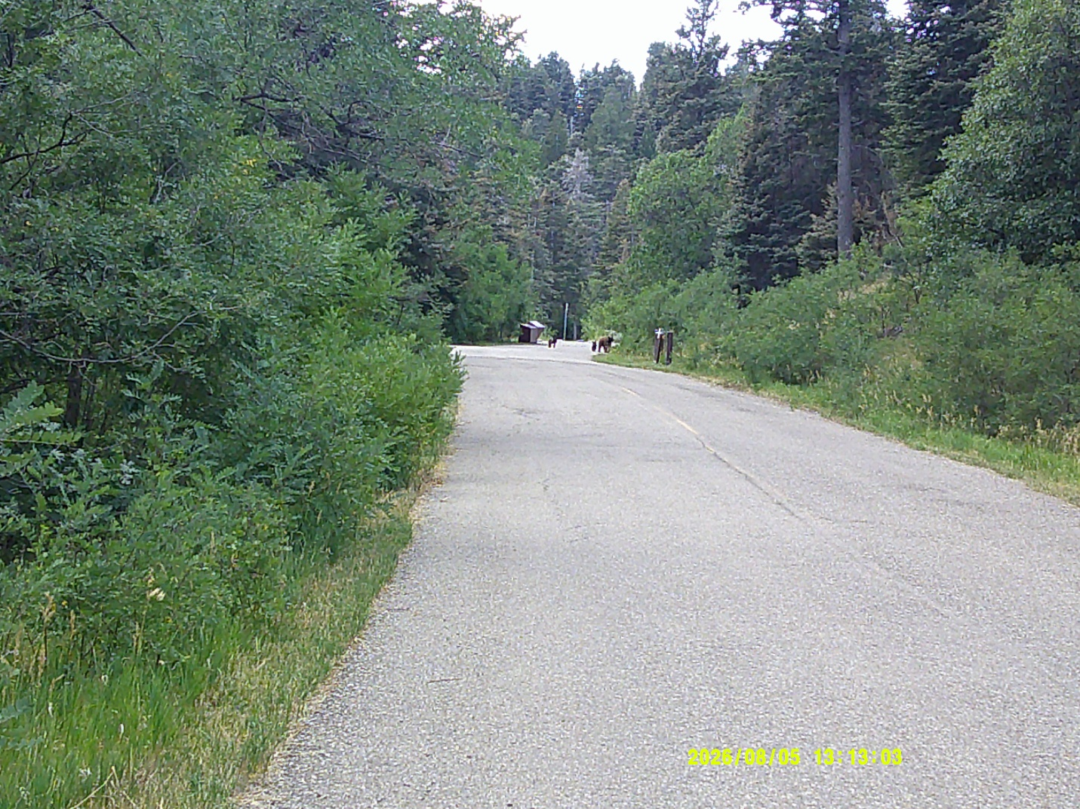
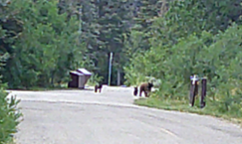
Bear photo by Sam Beard

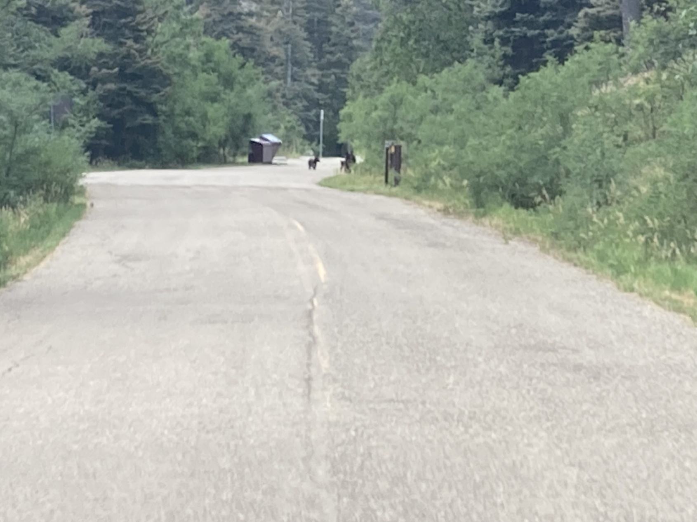
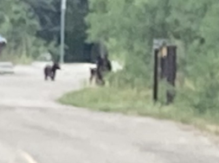
Bear photo by Michael Andt
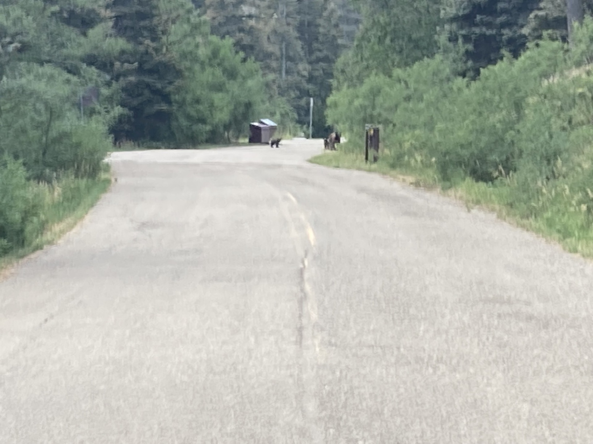
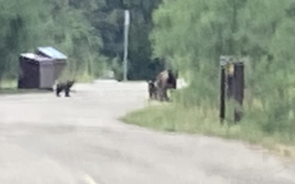
Bear photo by Michael Arndt

