Report of Felling of Five Hazard Trees in the Lower Part of Cienega Canyon Picnic Area,
Wednesday, August 5, 2026

Sam Beard
On Wednesday, August 5, seven FOSM volunteers felled, limbed, and bucked five dead hazard trees in the lower part of Cienega Canyon Picnic Area. Across the road from the lowest restroom, a 16-in diameter Rocky Mountain juniper trunk growing from a 29-inch stump was felled. The larger stump with several smaller branches was also felled. West of Tee intersection near the host site, three 12-inch diameter dead boxelders were felled. These trunks were surrounded by a large number of smaller boxelders. Just east of the intersection, an 11-inch diameter boxelder was felled. It had also been surrounded by several smaller boxelders. The trunks of these trees were bucked to lengths of approximately 4 feet and left to be collected by homeowners with fuelwood collection permits.
The volunteers working on this project were Sim Cook, Dan Benton, Eric Russell, Jerry Carroll, Michael Arndt, Chuck Logan, and Sam Beard.
Project photographs are presented below.

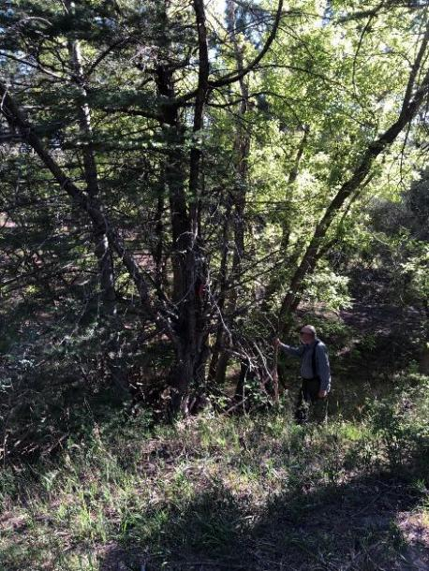
Jerry Carroll analyzing the dead Rocky Mountain juniper trees he will fell across
the road from the lowest restroom in Cienega Canyon Picnic Area. Photo by Sim Cook
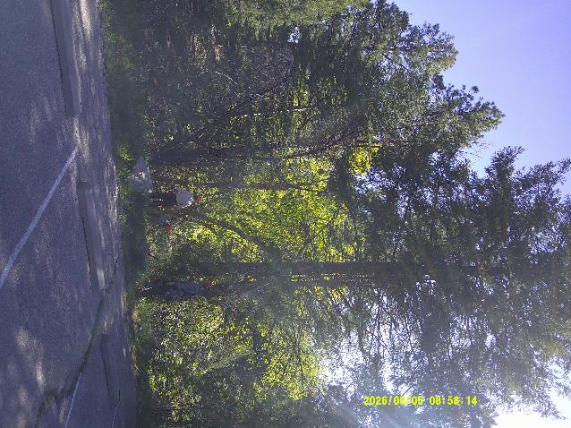
The Rocky Mountain juniper with multiple trunks is in the center of the photograph. Photos by Sam Beard
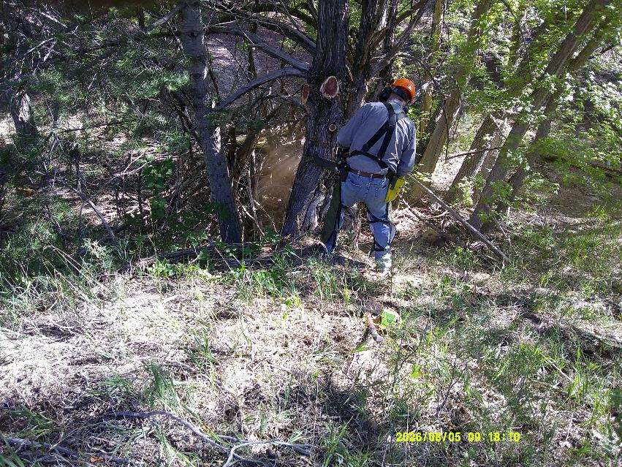
Jerry is felling the largest trunk on which two limbs have been removed.
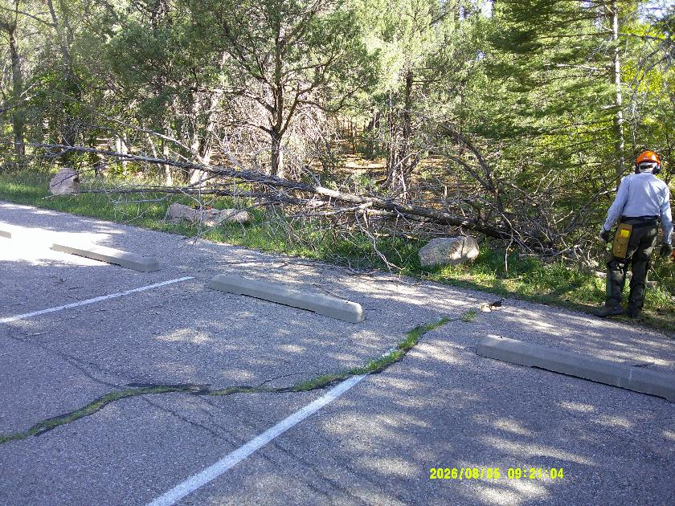
Eric Russell standing beside the top of the felled juniper.
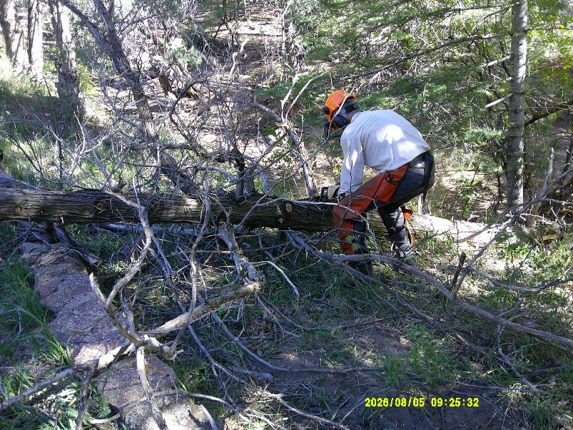
Sim Cook limbing and bucking the juniper.
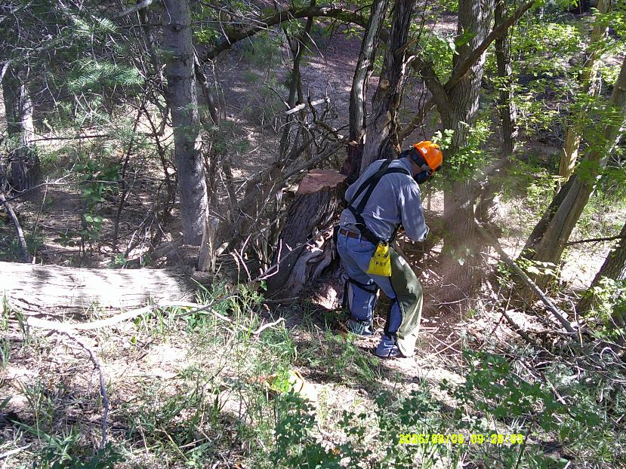
Jerry cutting branches on the larger part of the trunk.
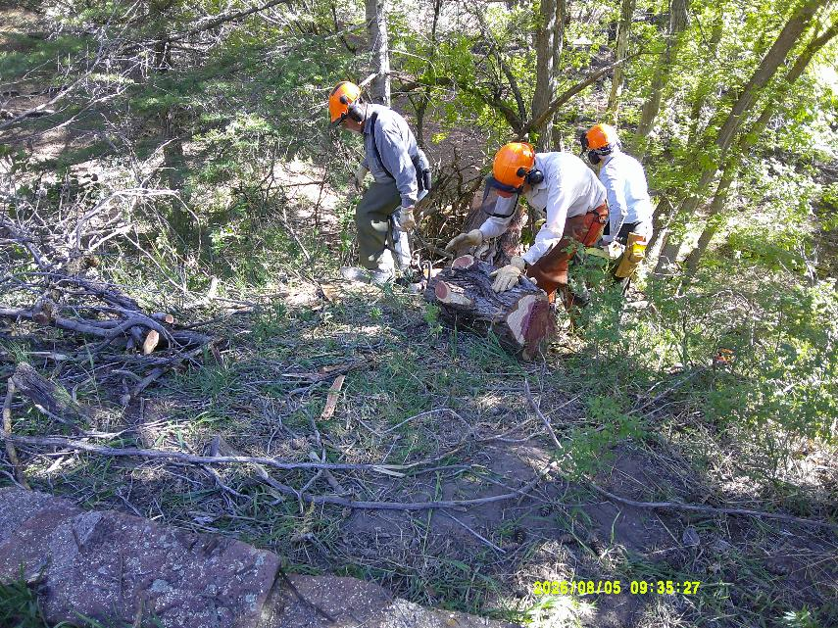
Eric rolling the large part of the felled juniper trunk up to the parking lot.
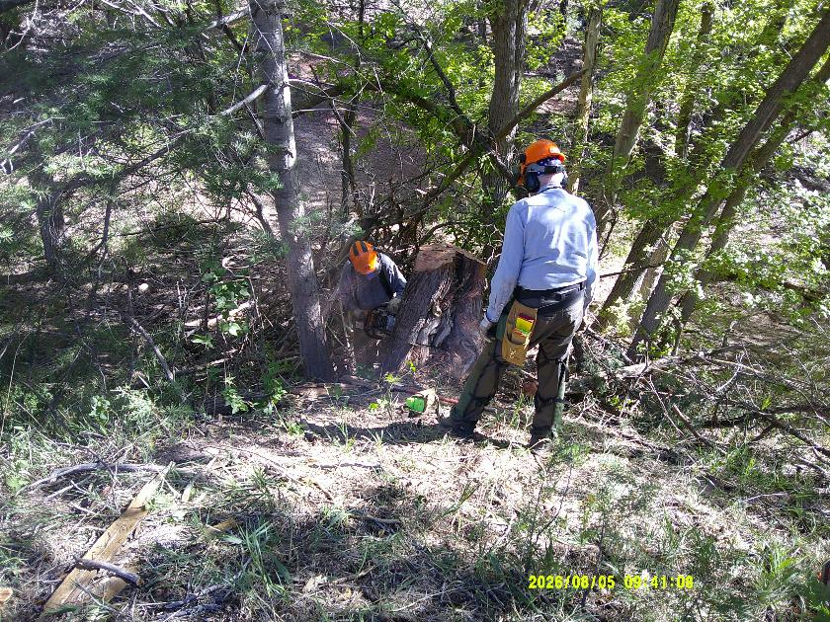
Jerry is low cutting the stump. The stump rolled into the dry Cienega Creek bed.
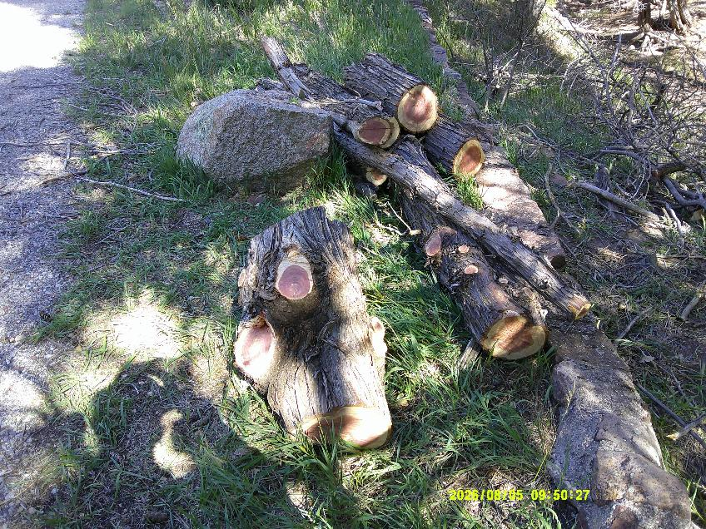
The pile of Rocky Mountain juniper wood at the parking lot.
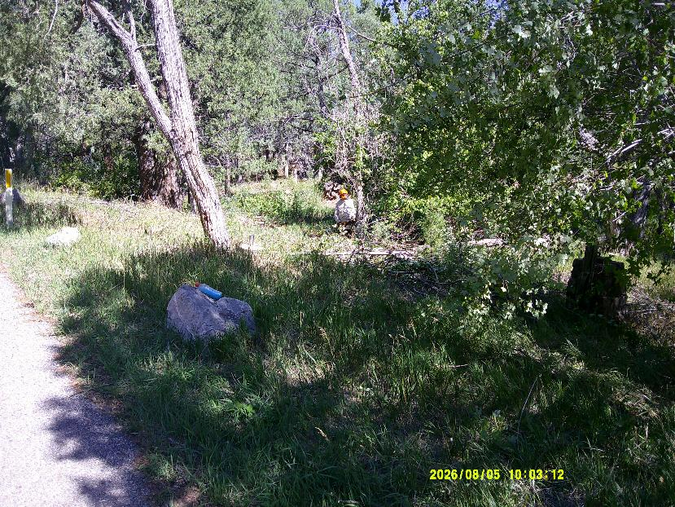
Dan Benton felling a boxelder tree west of the Tee intersection near the host site in Cienega Picnic Area.
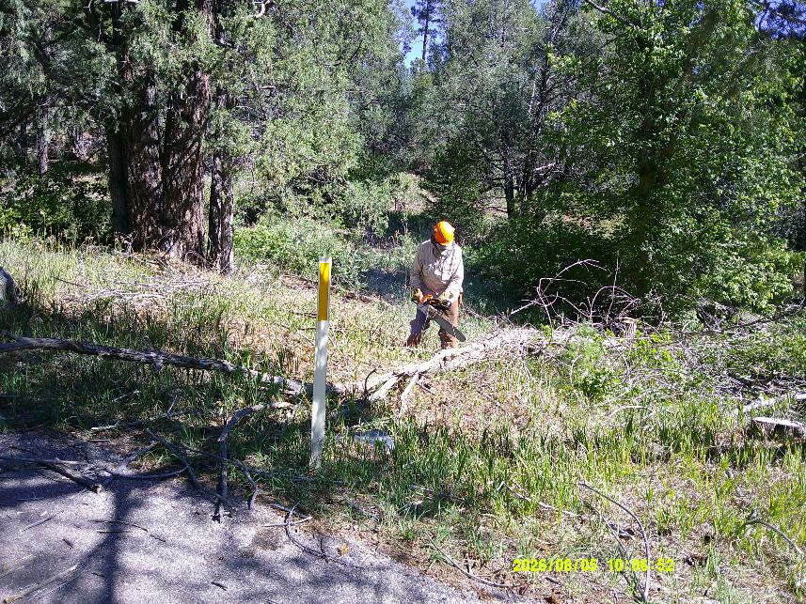
Dan bucking the boxelder tree he felled.
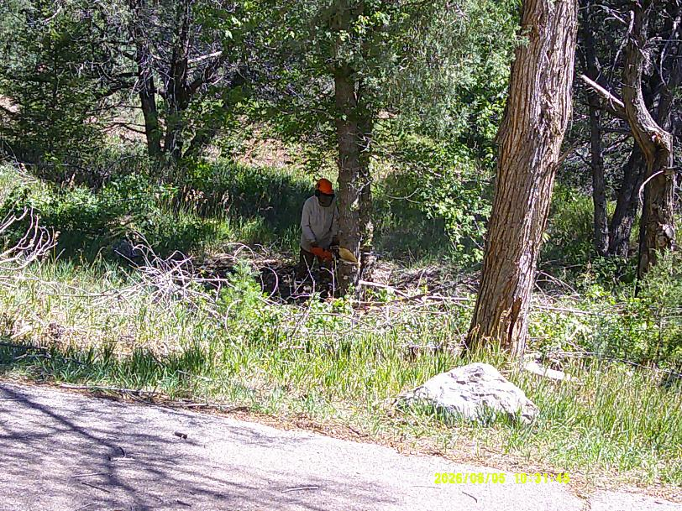
Dan felling a dead 12-inch boxelder.
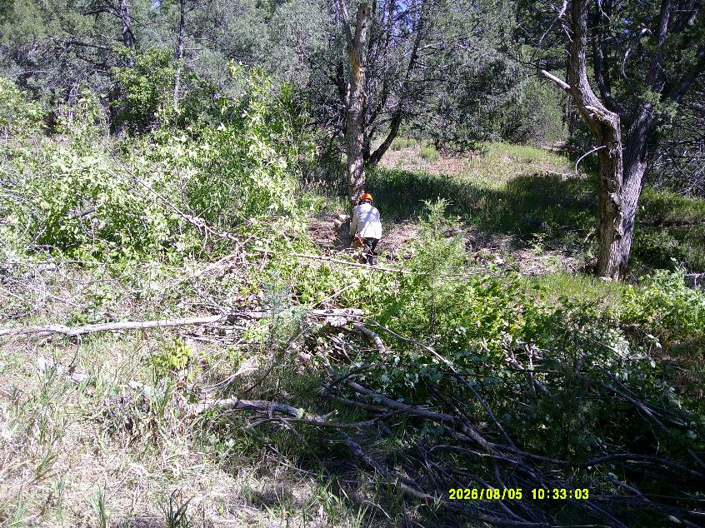
Dan preparing to fell another 12-inch boxelder.
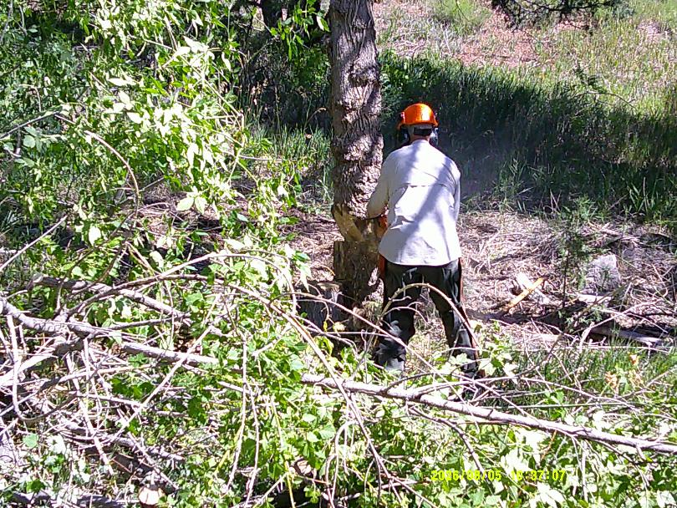
Dan making the back cut on this dead boxelder.
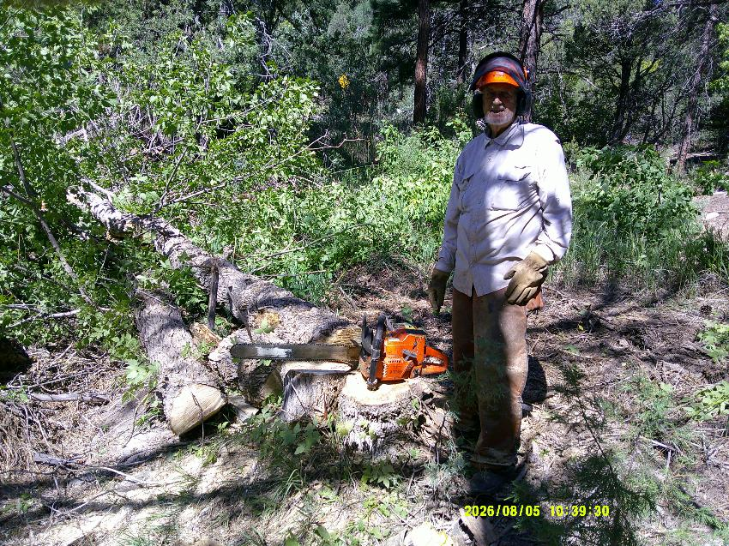
Dan standing beside the chain saw on the stump with two felled tree trunks in the dry Cienega Creek bed.
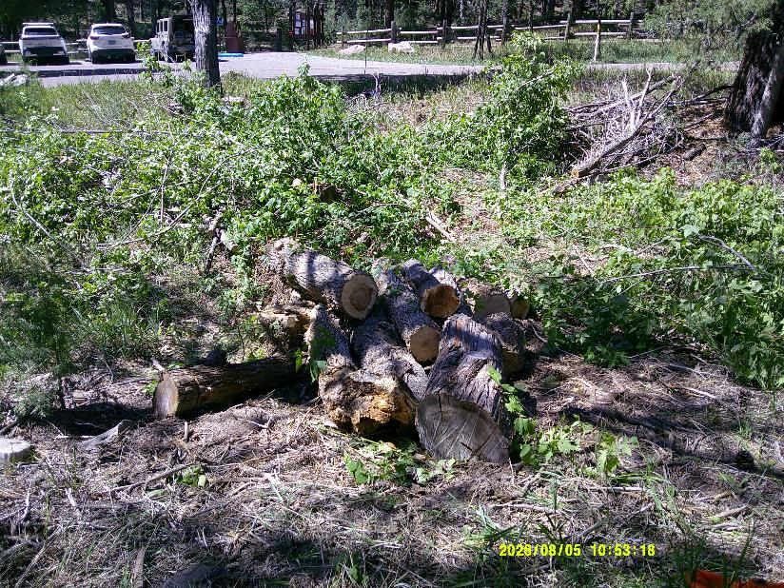
The pile of boxelder trunks that Dan felled west of the Tee intersection.
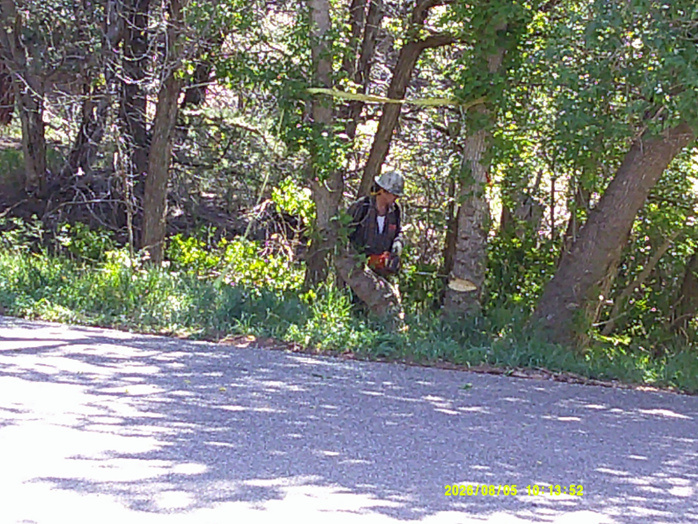
Michael Arndt felling an 11-inch dead boxelder on the east side of the Tee intersection.
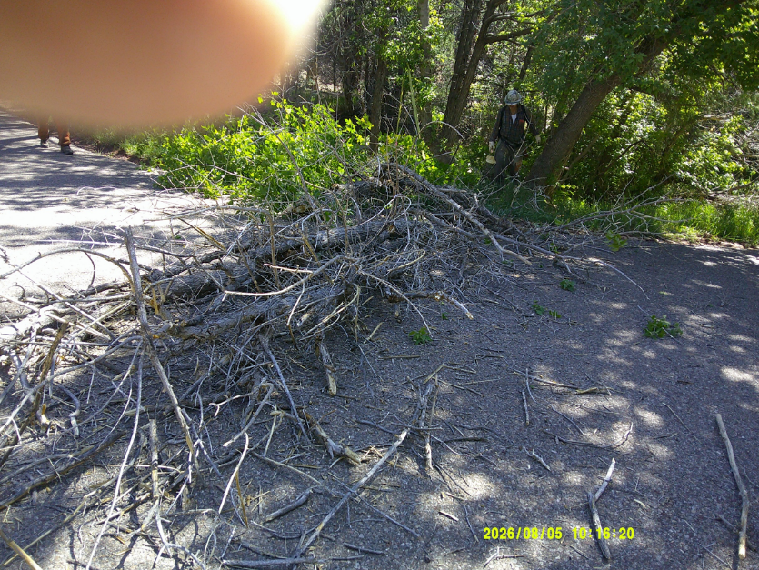
The boxelder trunks on the pavement.

