Thursday, 08/06/26- Switchback: Great to be up top of the mountain and out of the heat! Nine FOSM volunteers, Sue H. from NMVFO, Dallas from the BLM and 3 SRD folks joined forces on Thursday to continue work on the Switchback trail.
Chris and John took off to finish bolting the trail signs on and later they joined everyone else at digging. It’s great to be working out of the heat even though there is an awful lot of work to do and progress feels slow. We just keep plugging along!

Volunteers: Claudia Bergsohn, Bill Perkins, John McNett, Bruce Hansche,
Jim Houle, Luis Cuadros, Eric Russell, Silke Bletzer and Laura Leon
Sue Harrelson from NMVFO and Dallas Duckworth from BLM

Pictures: Luis Cuadros and Laura Leon

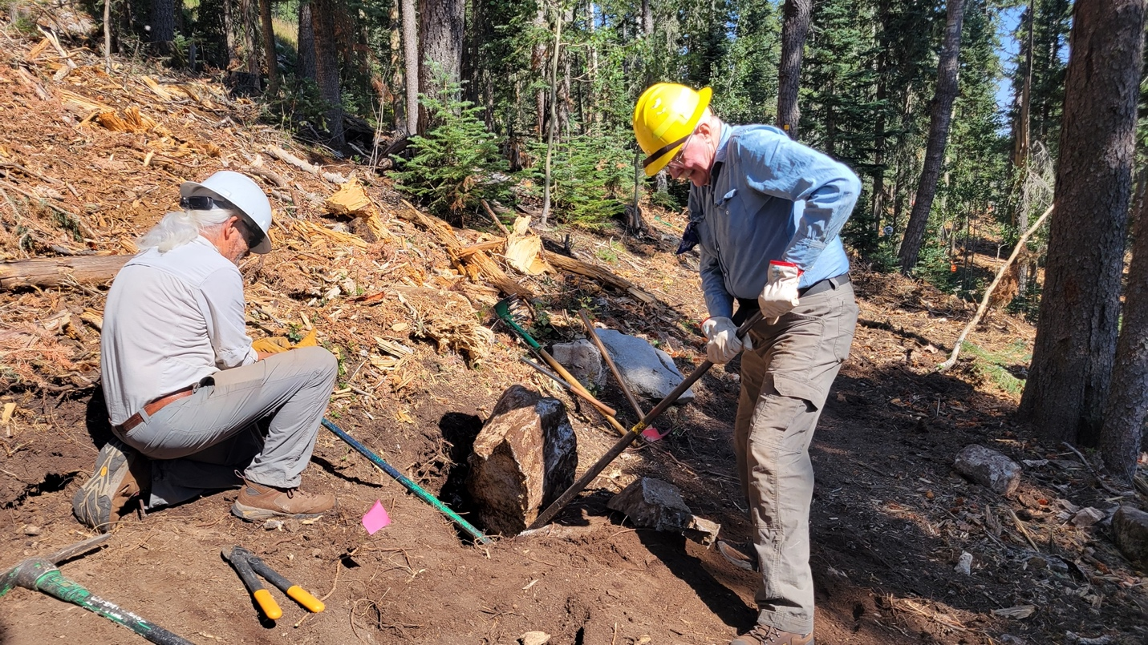

Eric and Bill wrangle a tripper.

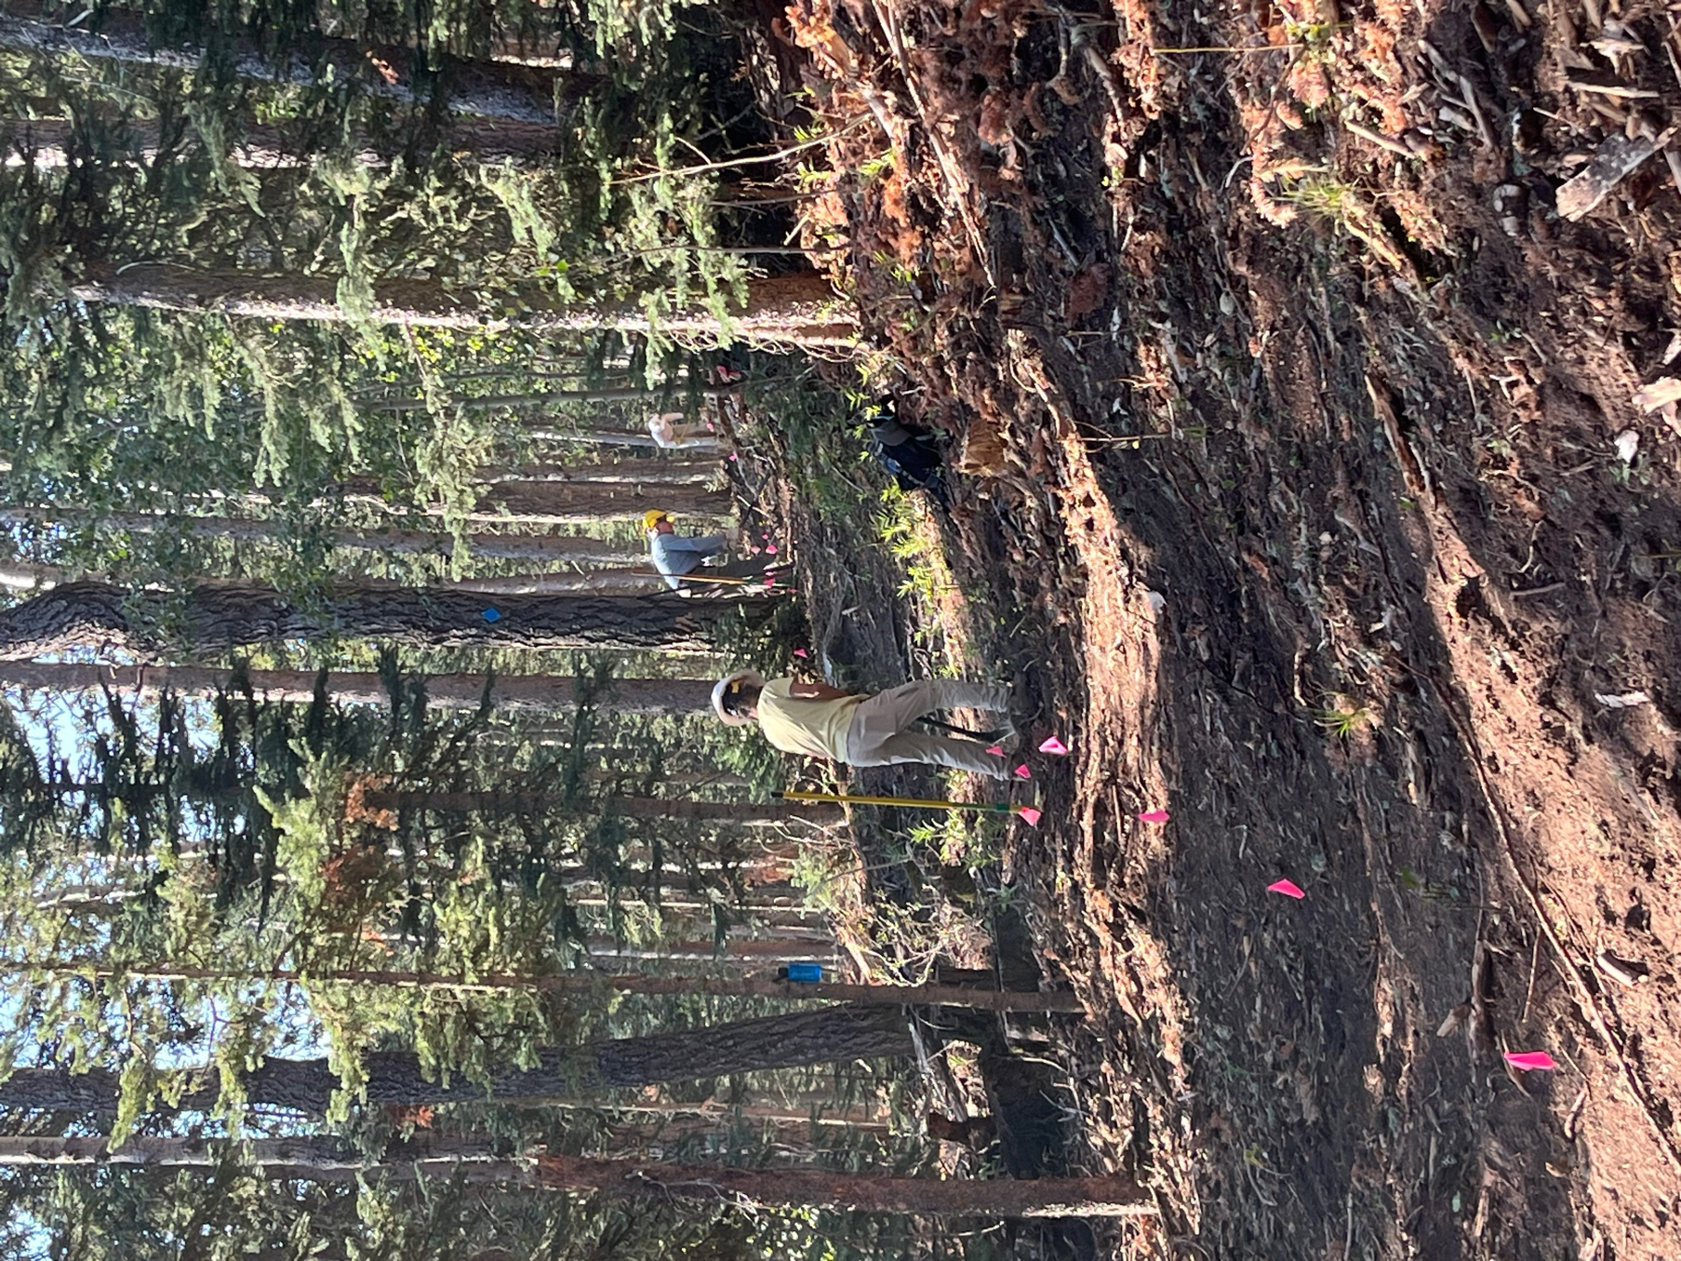

Claudia and Eric dig and dig.

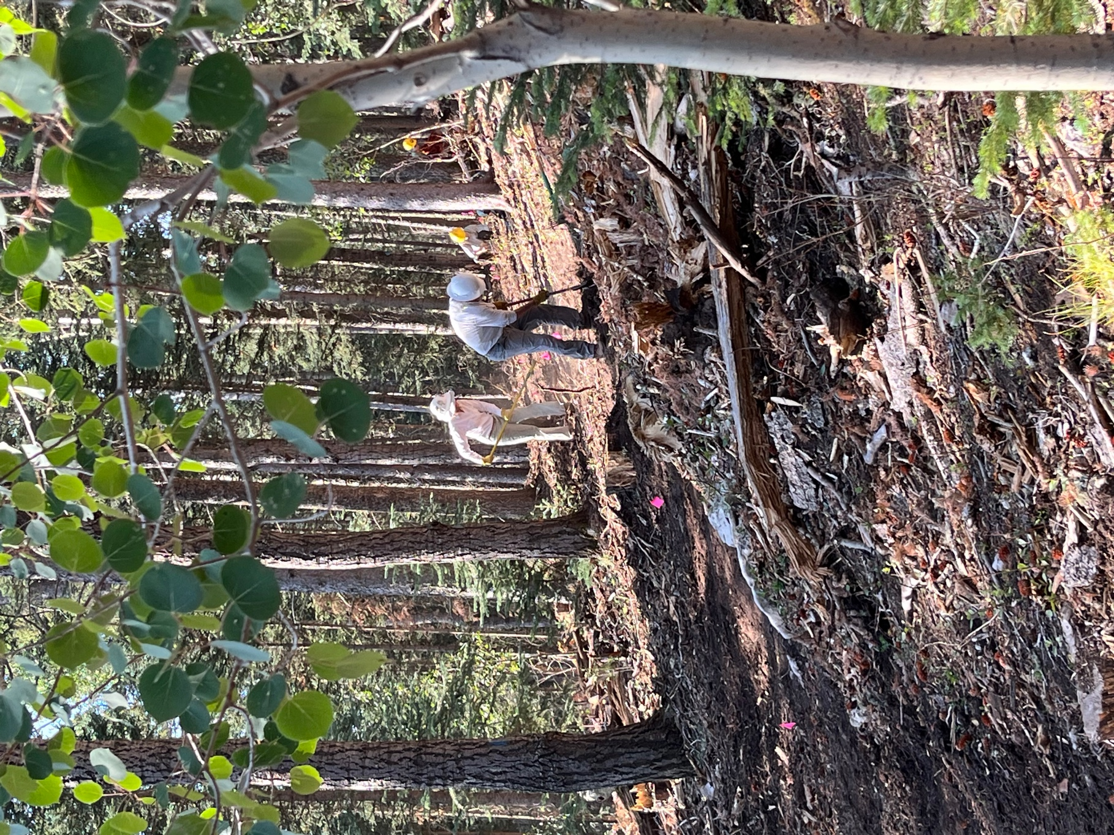

Bill and Sue hard at work.

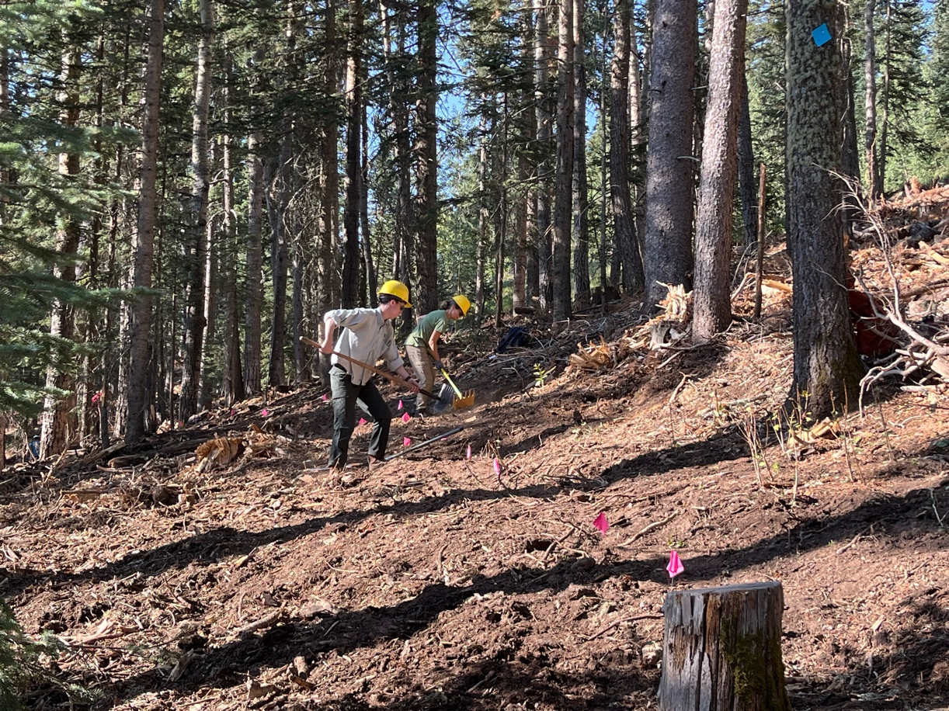

Dallas and Silke get after some roots. Ditto Bruce and Jim.

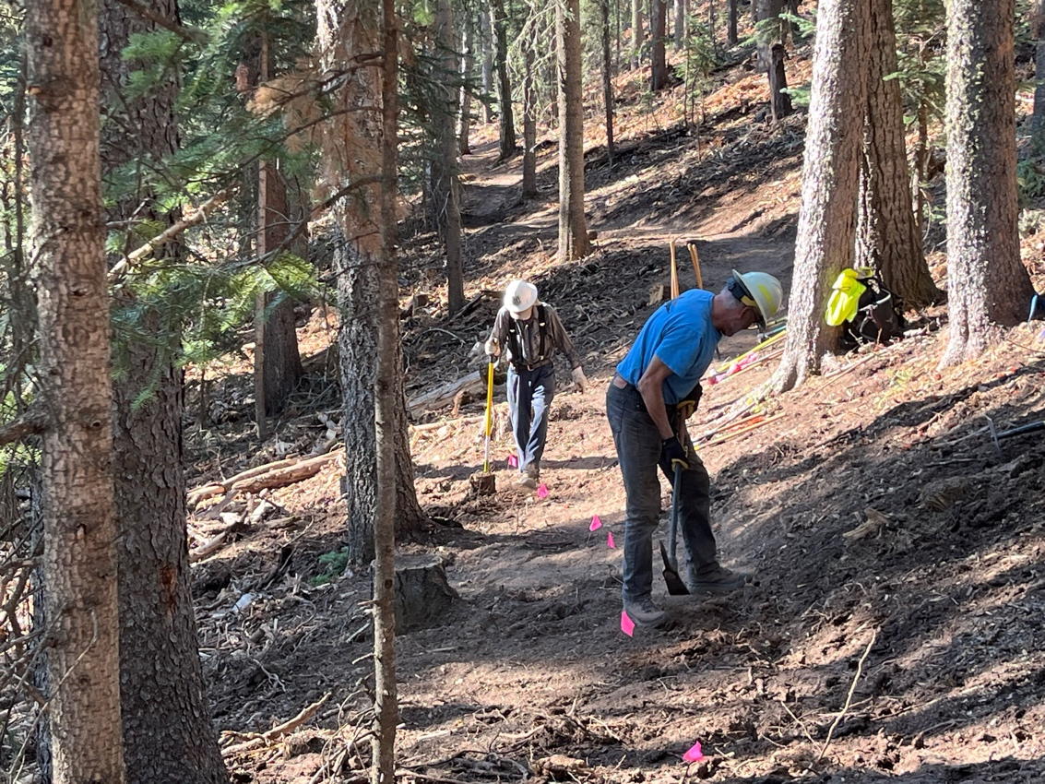
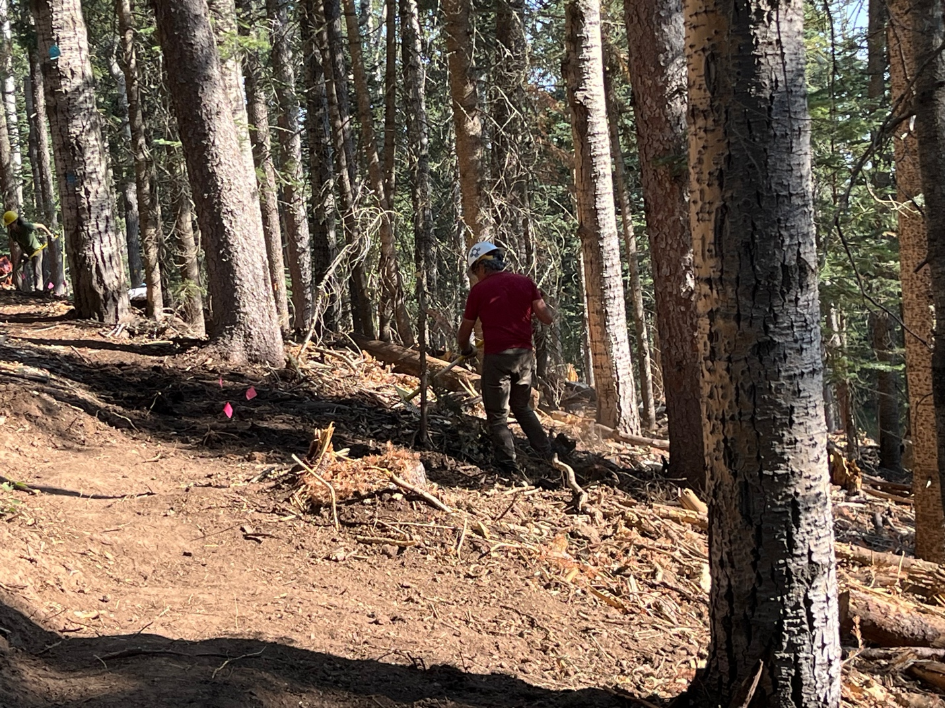

Luis deals with the piles and piles of debris.

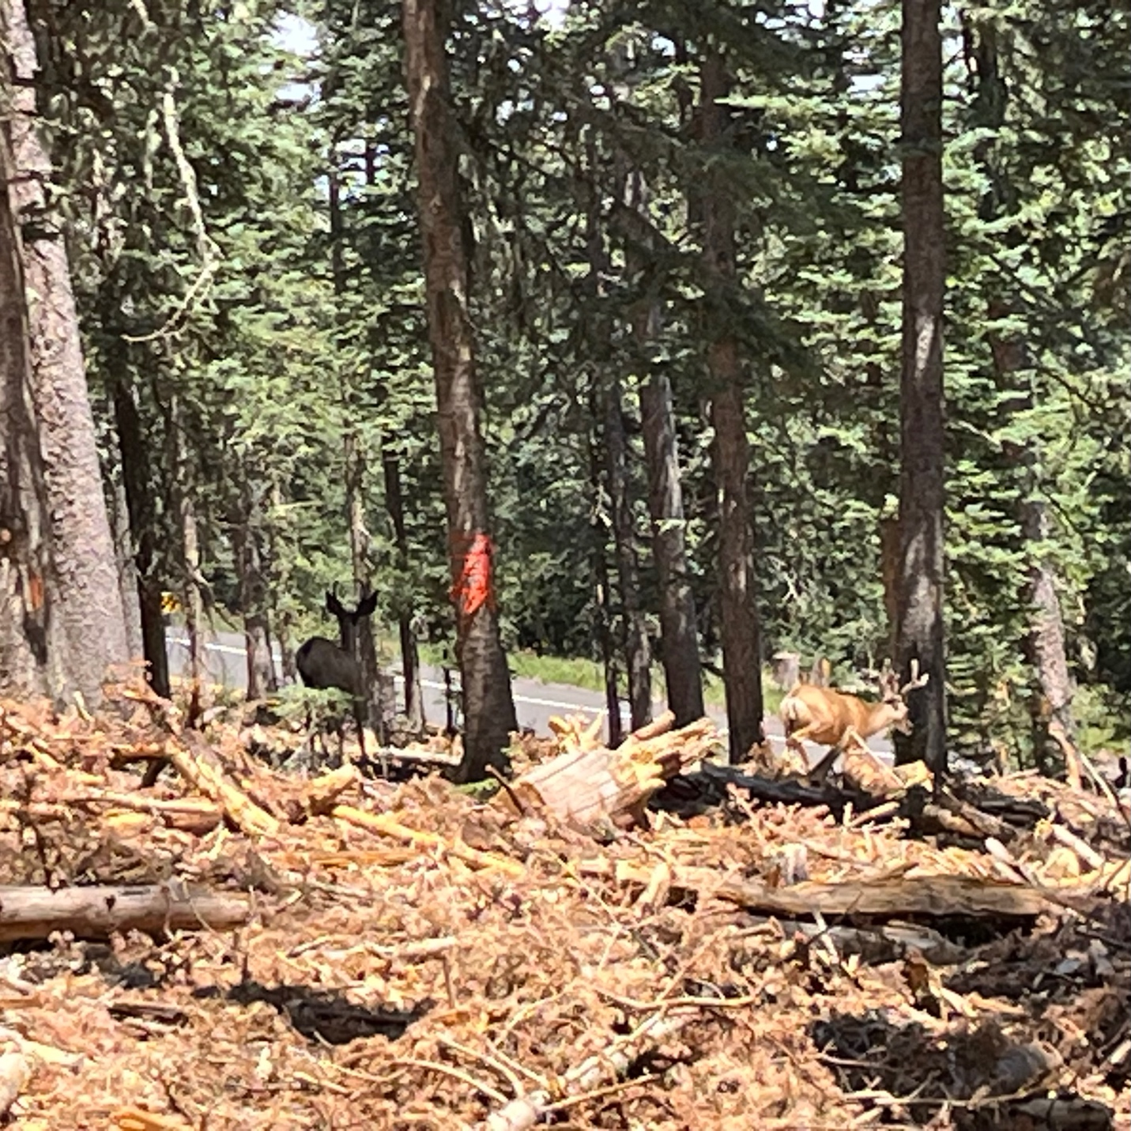

Not a great picture but we had 4 deer show up at lunch time. They seemed very curious about what we were doing. I’m not sure how they manage to walk through all of the debris! There is certainly nothing to nibble on yet.

