Report of FOSM Project to Fell Hazard Trees in Capulin Picnic Area,
Wednesday, August 12, 2026

Sam Beard
On Wednesday, August 12, eight FOSM volunteers felled seven dead white fir trees in Capulin Picnic Area. The tree diameters were 8, 10, 13, 14, 15, 19, and 23 inches, and they were bucked to lengths of 4 feet to approximately 8 feet.
The volunteers were Michael Arndt, Jerry Carroll, Eric Russell, Ciff Giles, Dan Benton, Sim Cook, Lorna Morrow, and Sam Beard.
Project photographs are presented below.

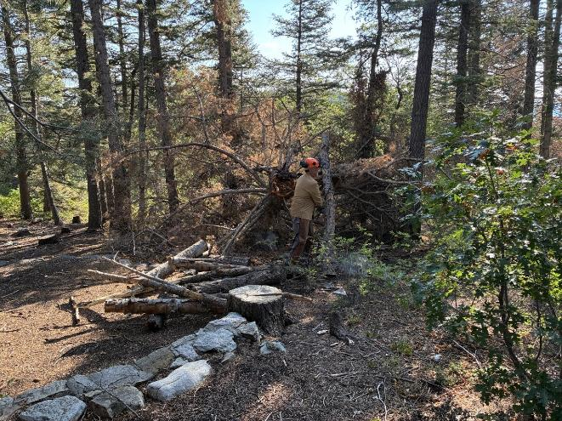
Dan Benton removing the “teepee” of logs that had been placed against the top of a white fir
that had broken off sometime in the past. All photos by Cliff Giles

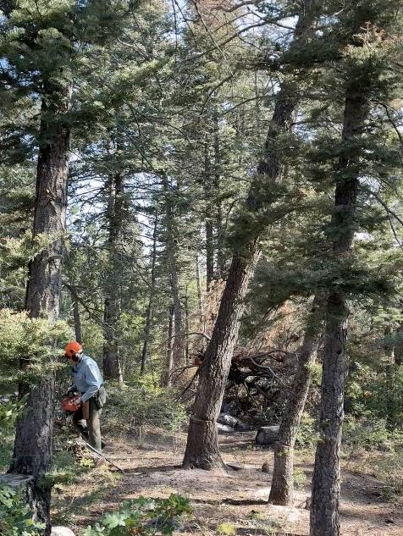
Eric Russell running away from the white fir he has just felled.
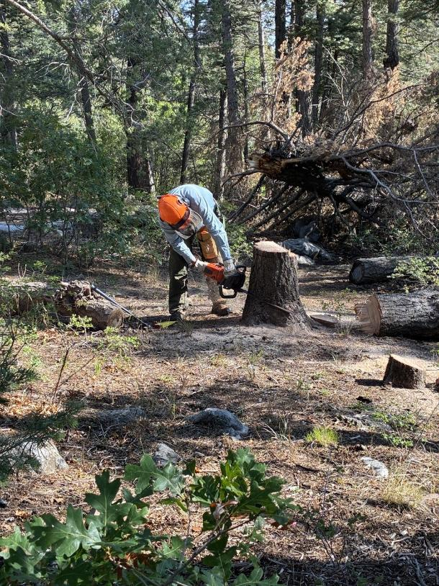
Eric low stumping the tree he just felled.

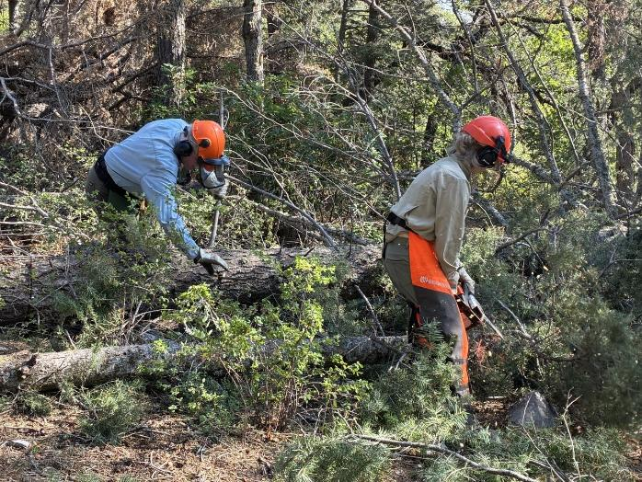
Eric Russell and Lorna Morrow limbing the felled white fir.

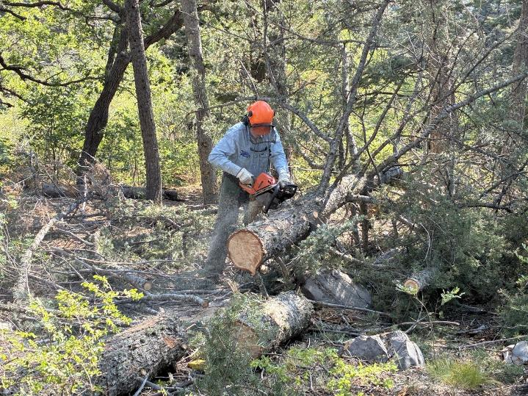
Eric bucking the tree he felled.

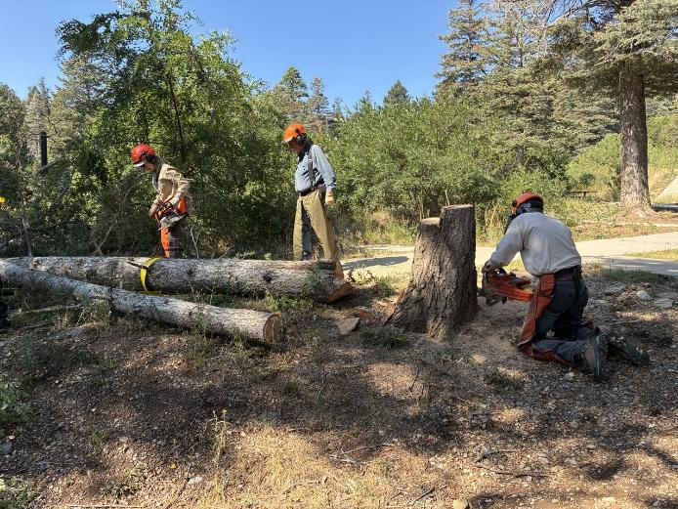
Sim Cook low stumping the tree he felled.

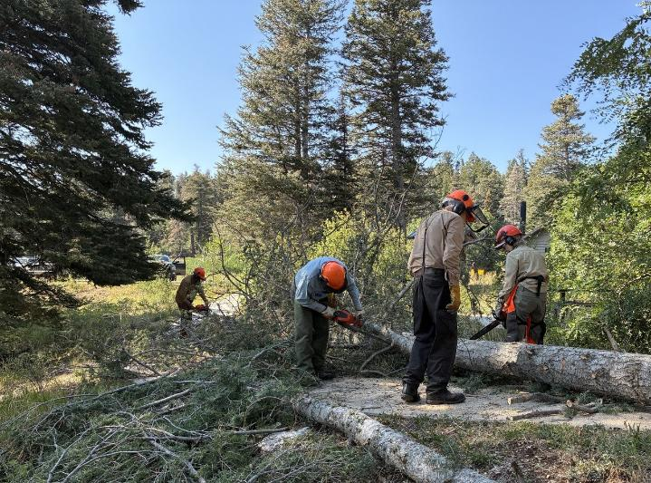
Dan Benton, Eric Russell, and Lorna Morrow limbing the tree Sim Cook felled with Sam Beard observing.

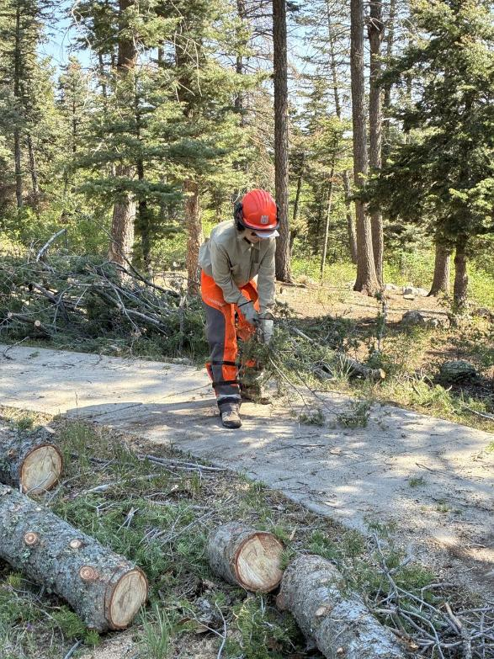
Lorna sweeping the sidewalk with a branch.

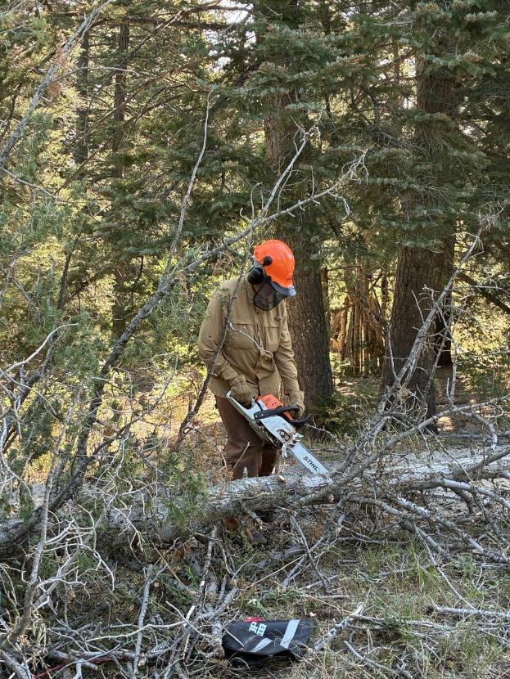
Dan limbing Sim’s tree.
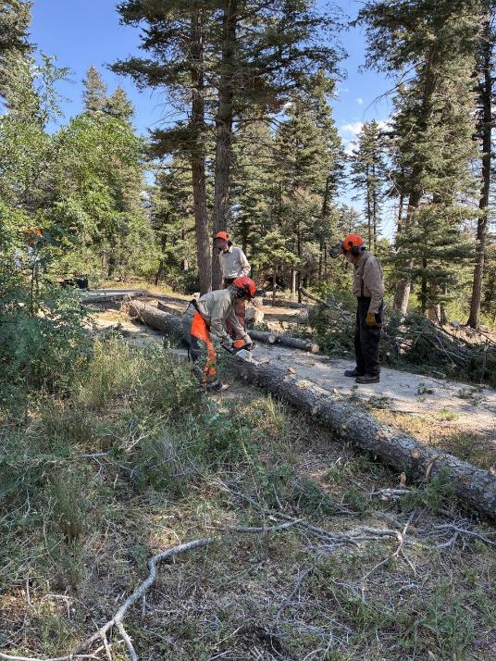
Lorna bucking Sim’s tree with Sam observing.

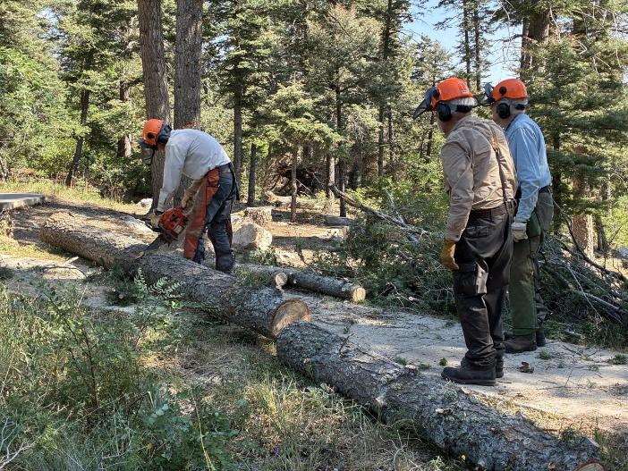
Sim bucking his tree with Sam and Eric observing.

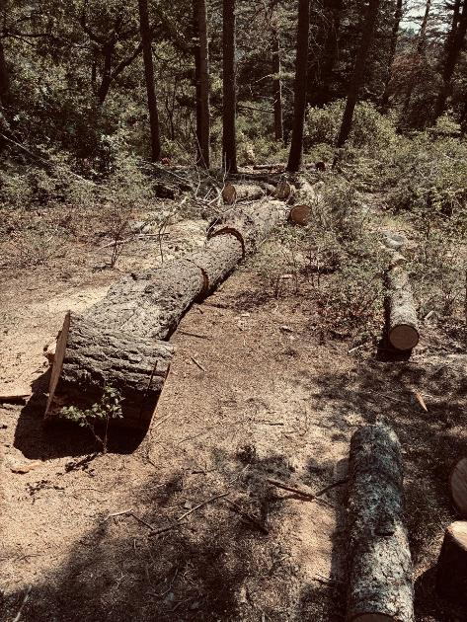
Eric’s tree was bucked into several pieces.

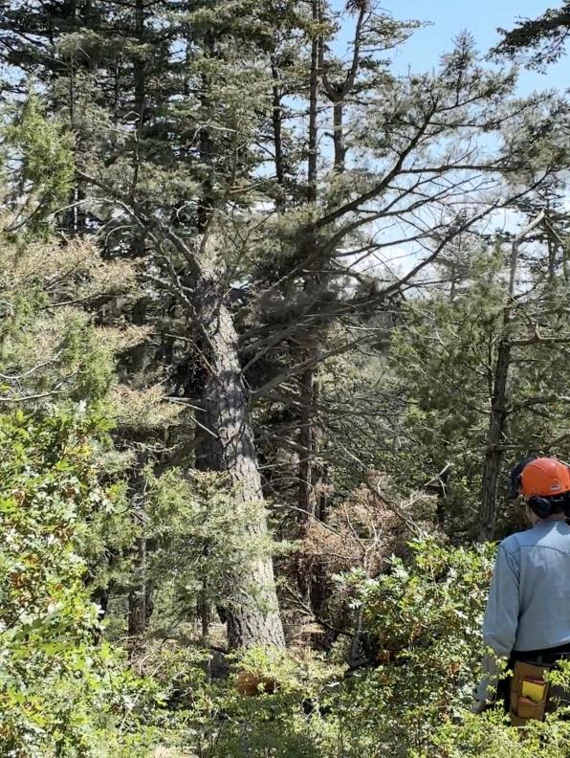
Eric observing a falling cigar butt tree felled by Michael Arndt.
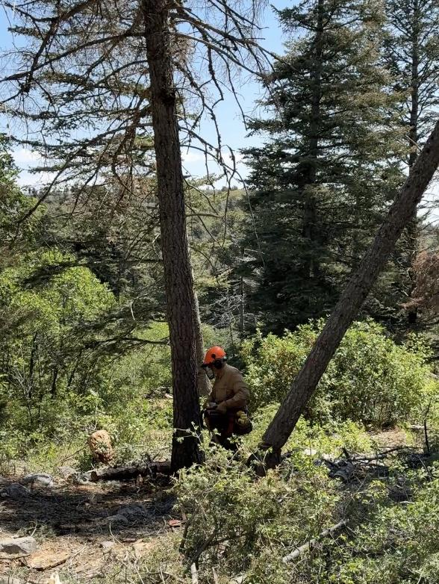
Dan moving away from his falling tree.

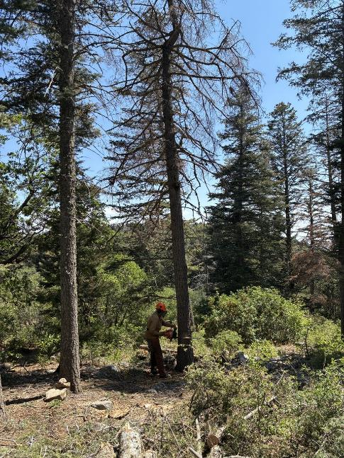
Dan making the back cut in a fir tree he was felling.

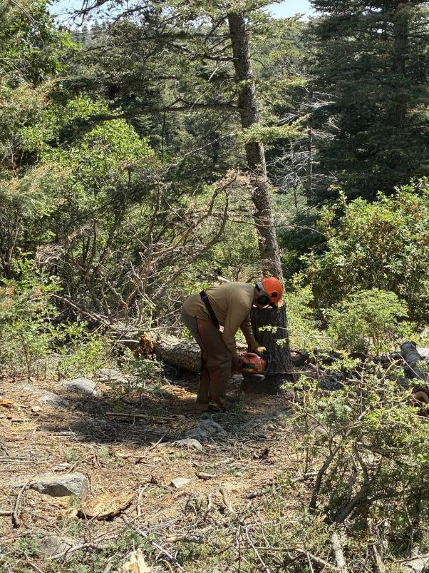
Dan low stumping his tree.

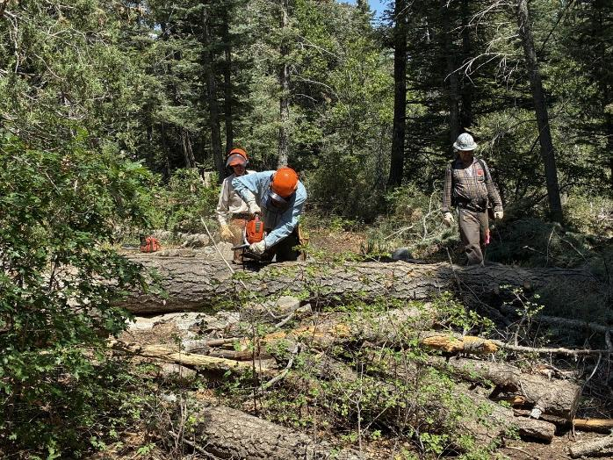
Eric bucking the tree felled by Michael Arndt.

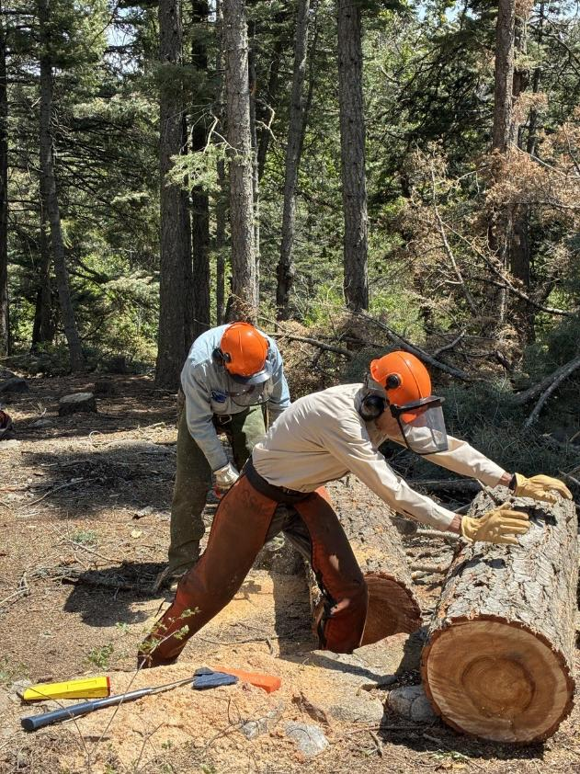
Sim moving a bucked log away from where Eric is bucking another piece.

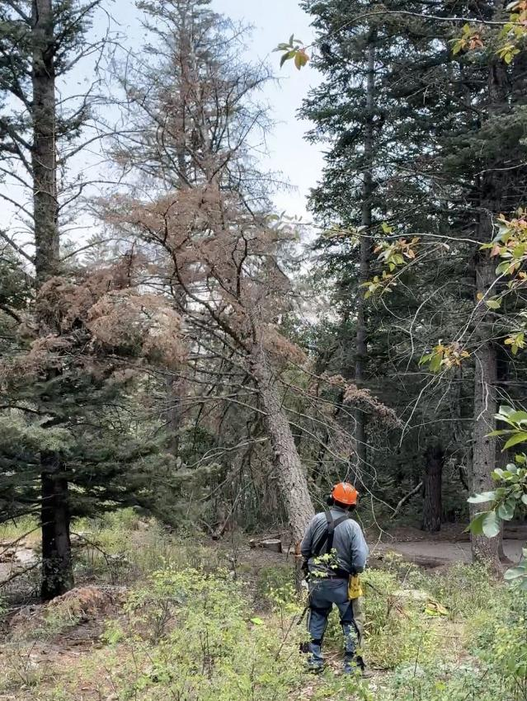
Jerry Carroll observing a fir falling across the road to the lower part of Capulin Picnic Area.
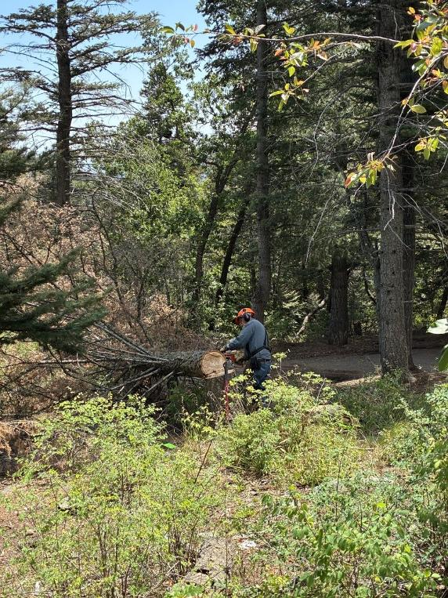
Jerry limbing his felled tree.
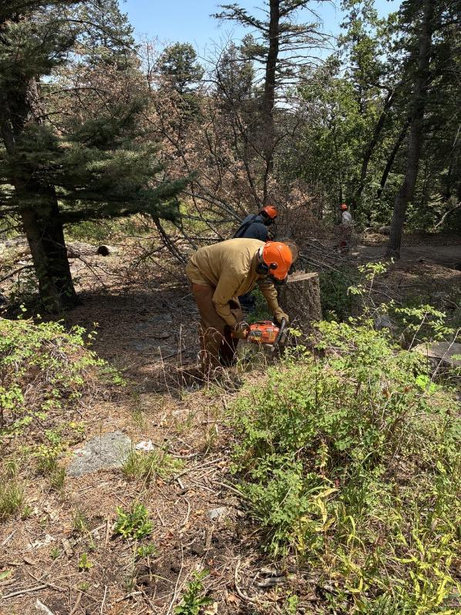
Dan low stumping the tree felled by Jerry while Jerry continues to limb his tree.

