Thursday, 008/13/26- Switchback: We had 8 volunteers meet up with Chris and Dorothy (SRD) to brave the cold and continue work on Switchback this week. OK, that’s an exaggeration but it was cool and cloudy until the afternoon when it became cool, sunny and breezy- so all in all an excellent working day! We still need rain badly. In the pictures you’ll notice everyone in long sleeves and jackets. Tons of duff and roots along with the debris make the work slow but the trail is looking fabulous and as we left, we were talking about how much bikers are going to love it, as well as hikers and skiers. There’s talk of getting some machinery to help move some of the debris so we’ll see how that works out. Until then we just keep digging along!

Volunteers: Bill Perkins, Rifka Stern, Bruce Hansche, Jim Houle, Luis Cuadros,
Eric Russell, Eric (The Younger) Messerschmidt and Laura Leon

Pictures: Laura Leon

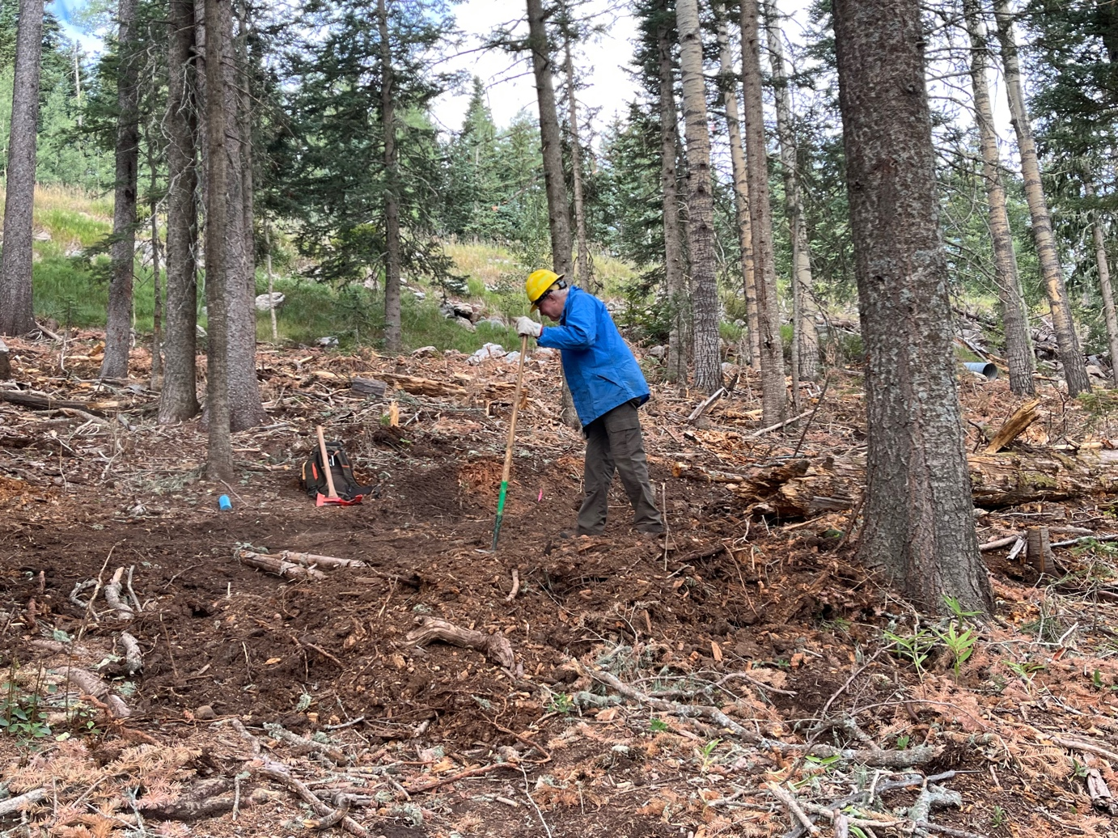
Eric R. works along a curve- it’s had several adjustments over the last couple of weeks.
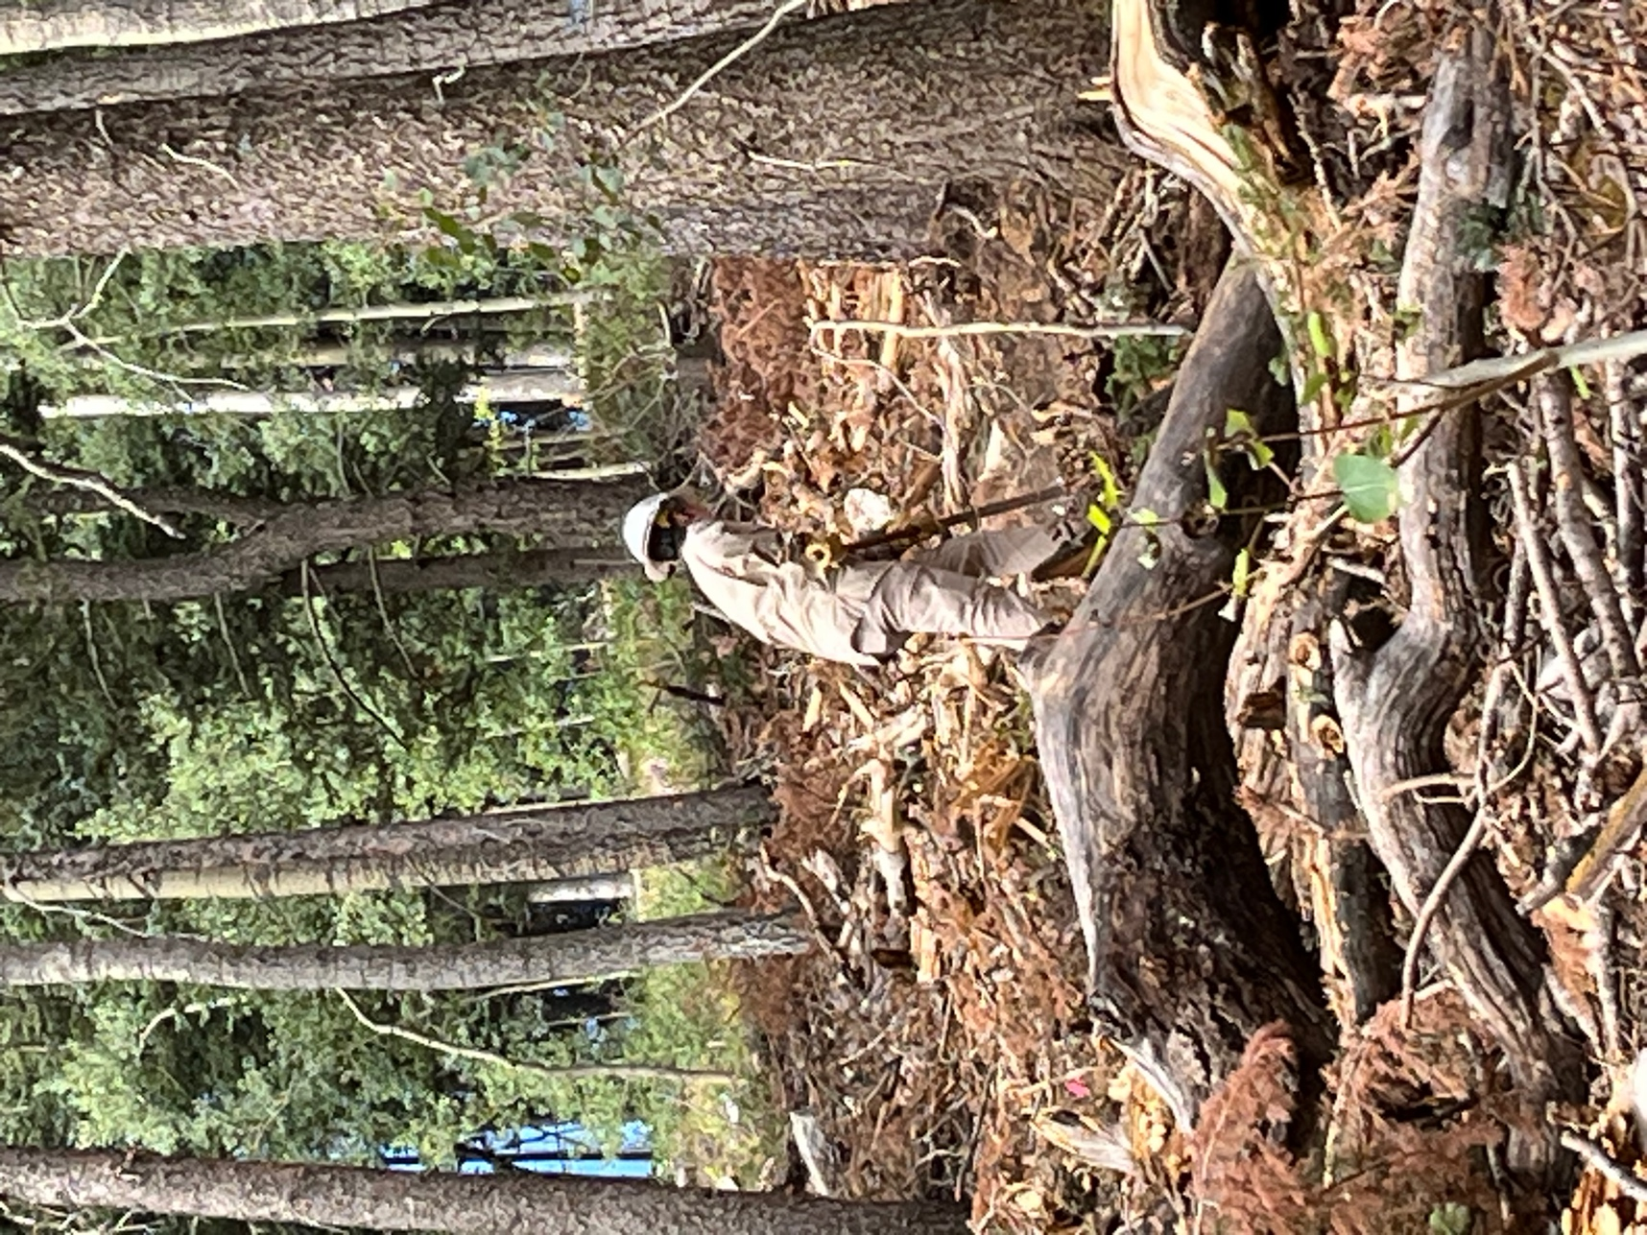

Dorothy worked hard on their last day of the SRD assignment. Good Luck Dorothy!
May your tools never need sharpening!
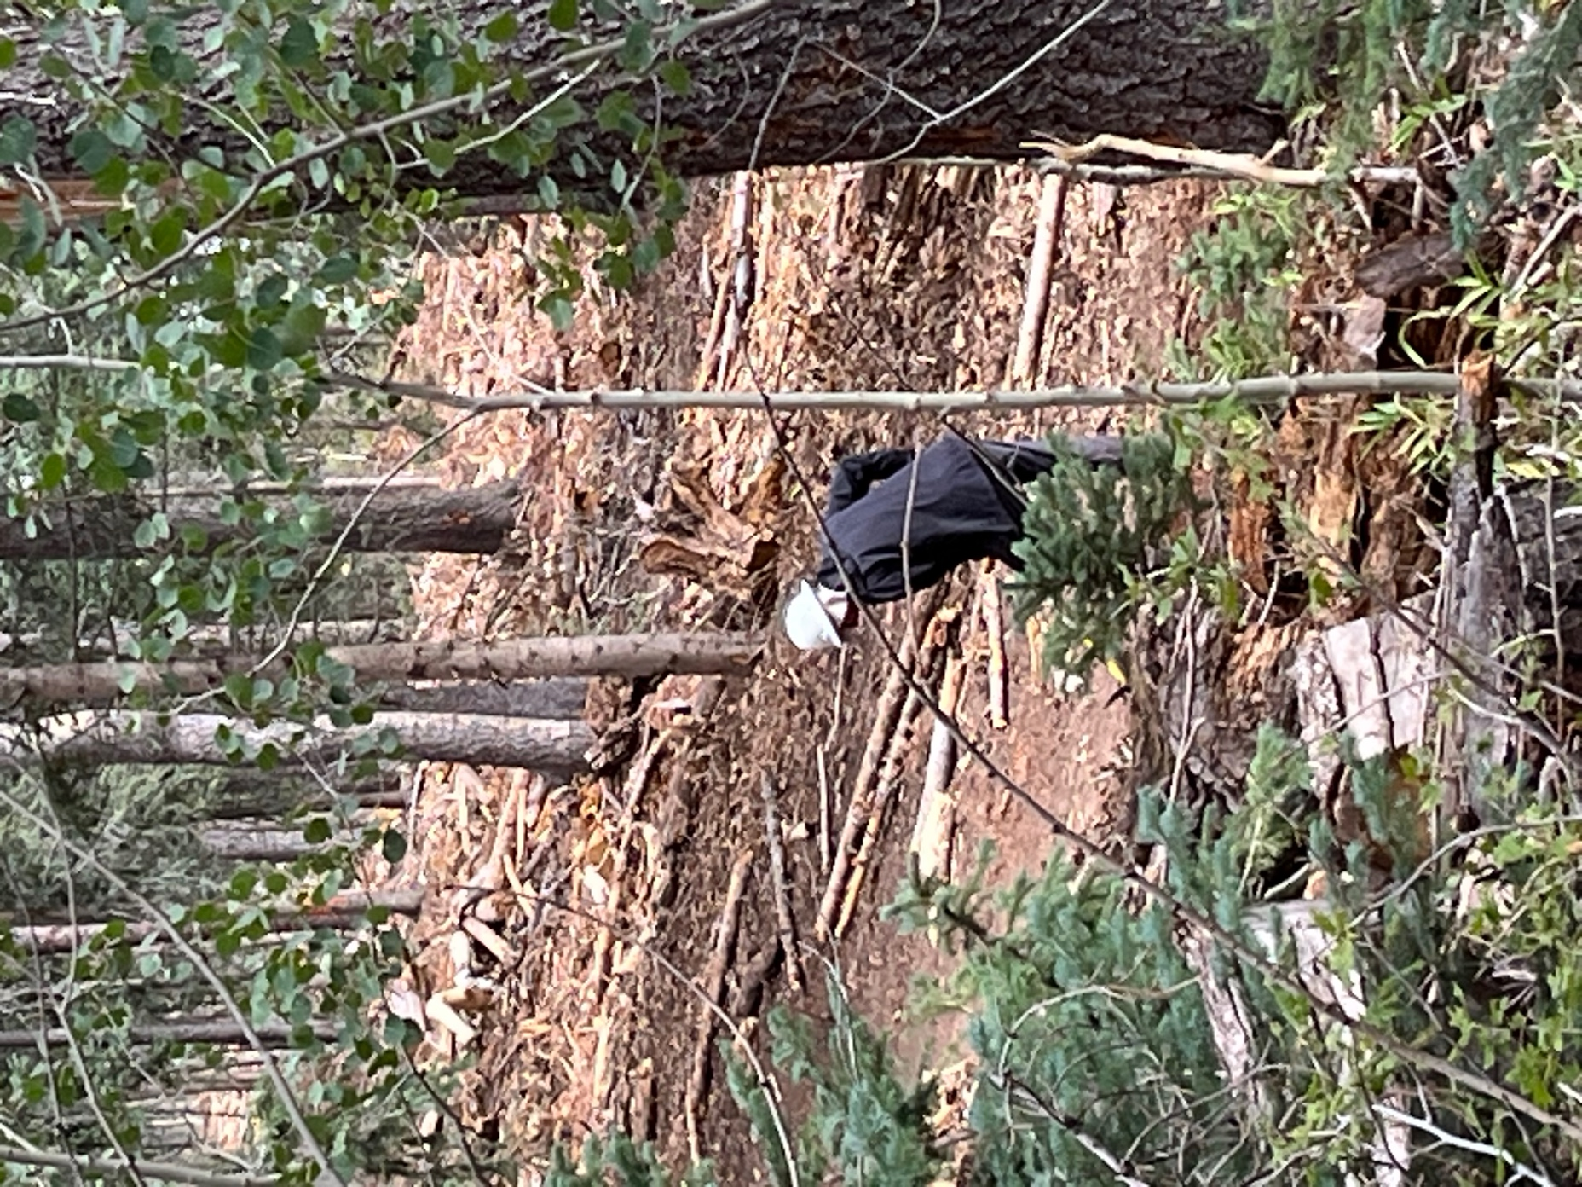

Bruce worked on a dip and tree area.
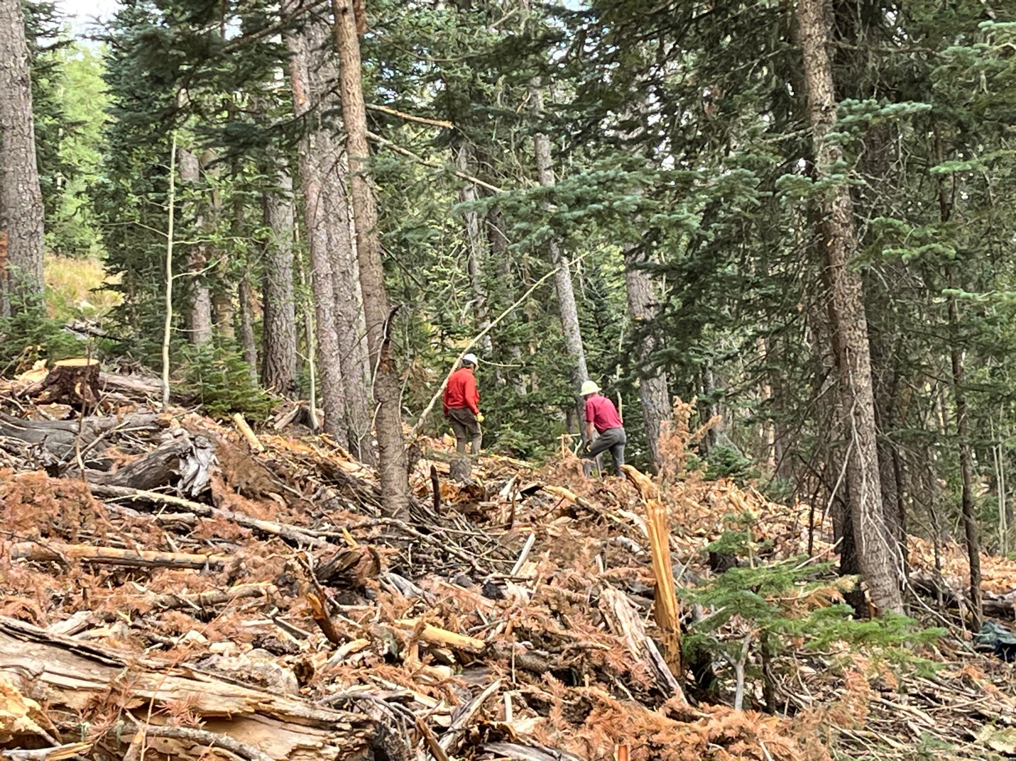

Luis and Jim did a little cribbing along a trail ‘cause that’s what they do…

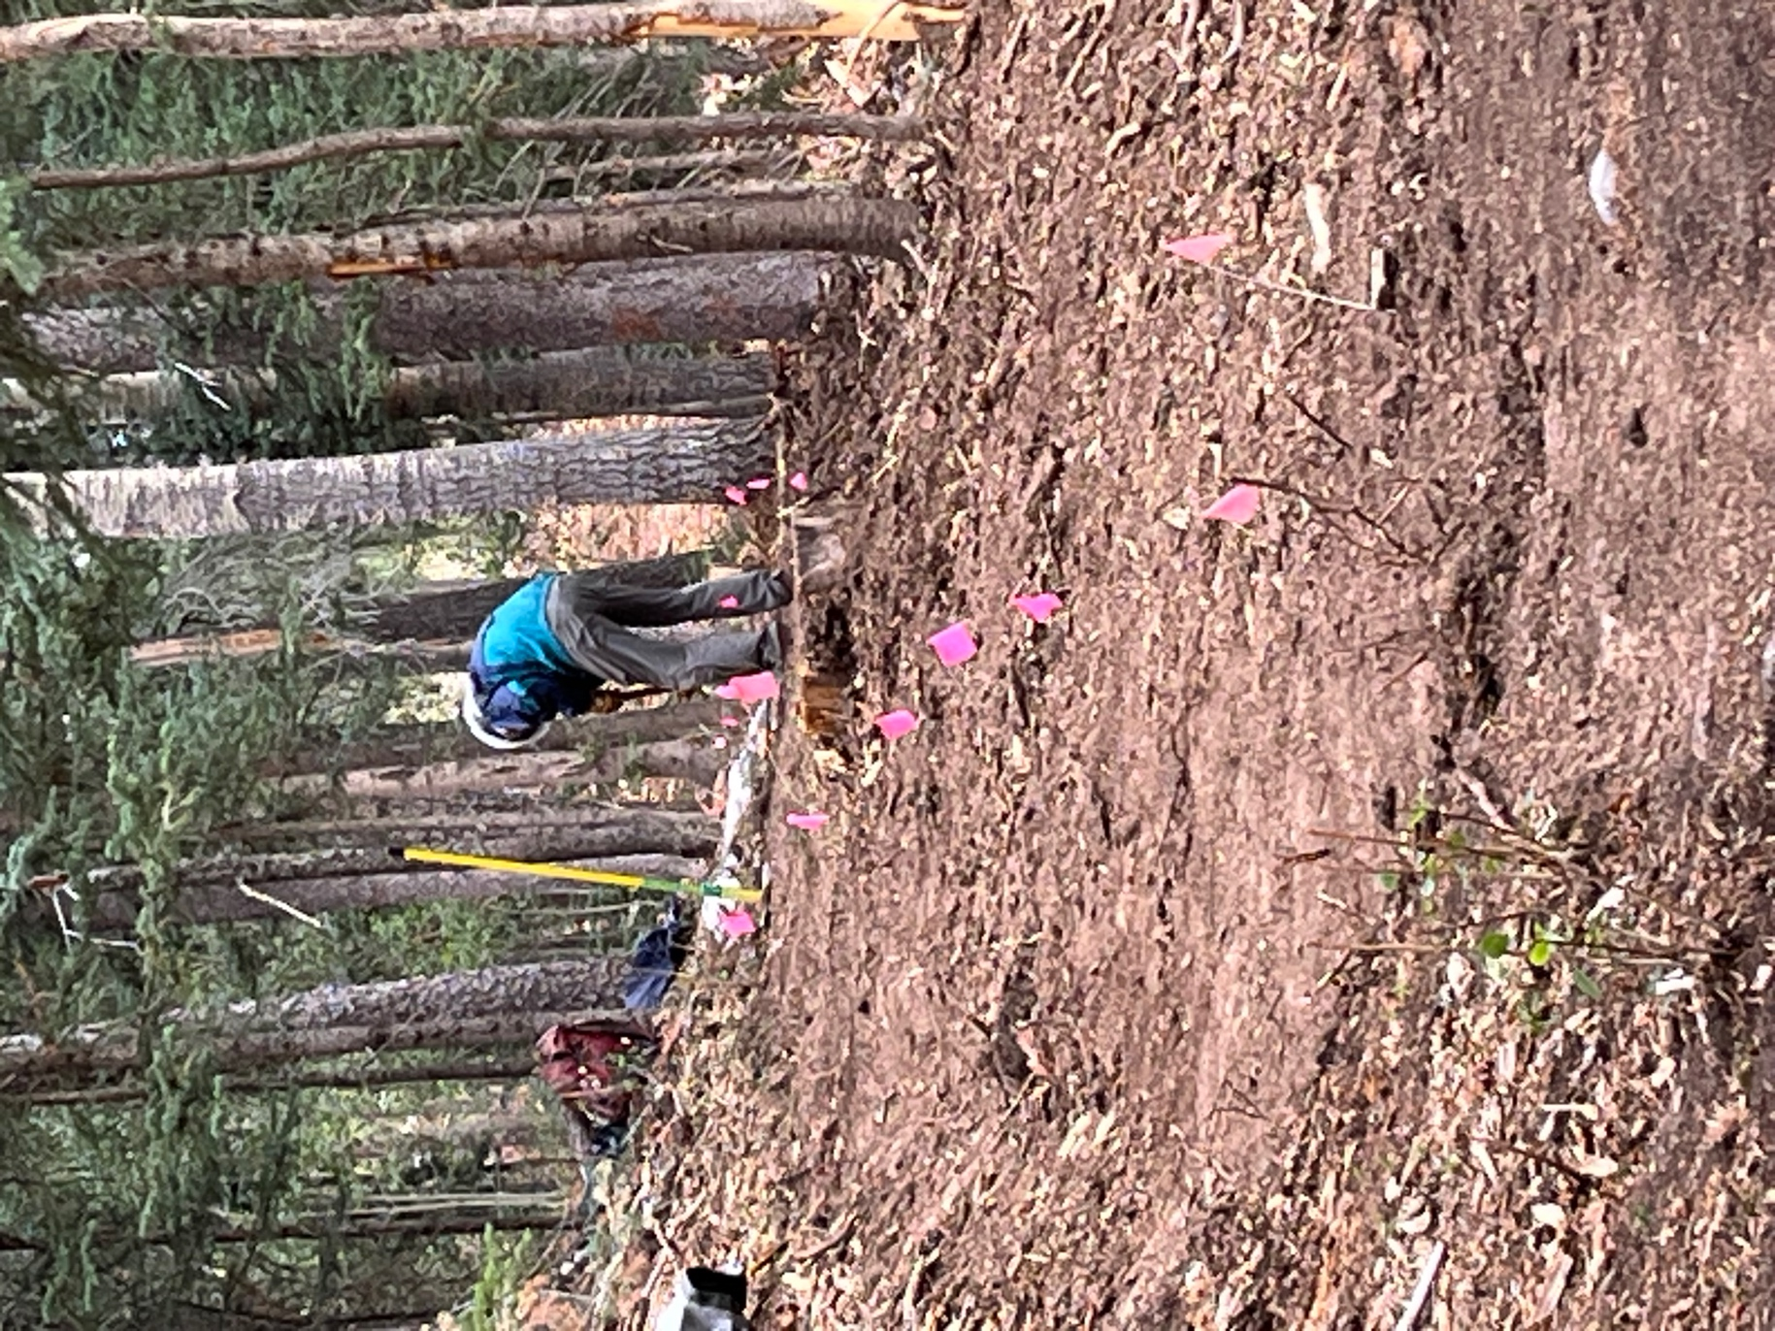

Bill digs along a section- sorry for the partial butt shot Bill.
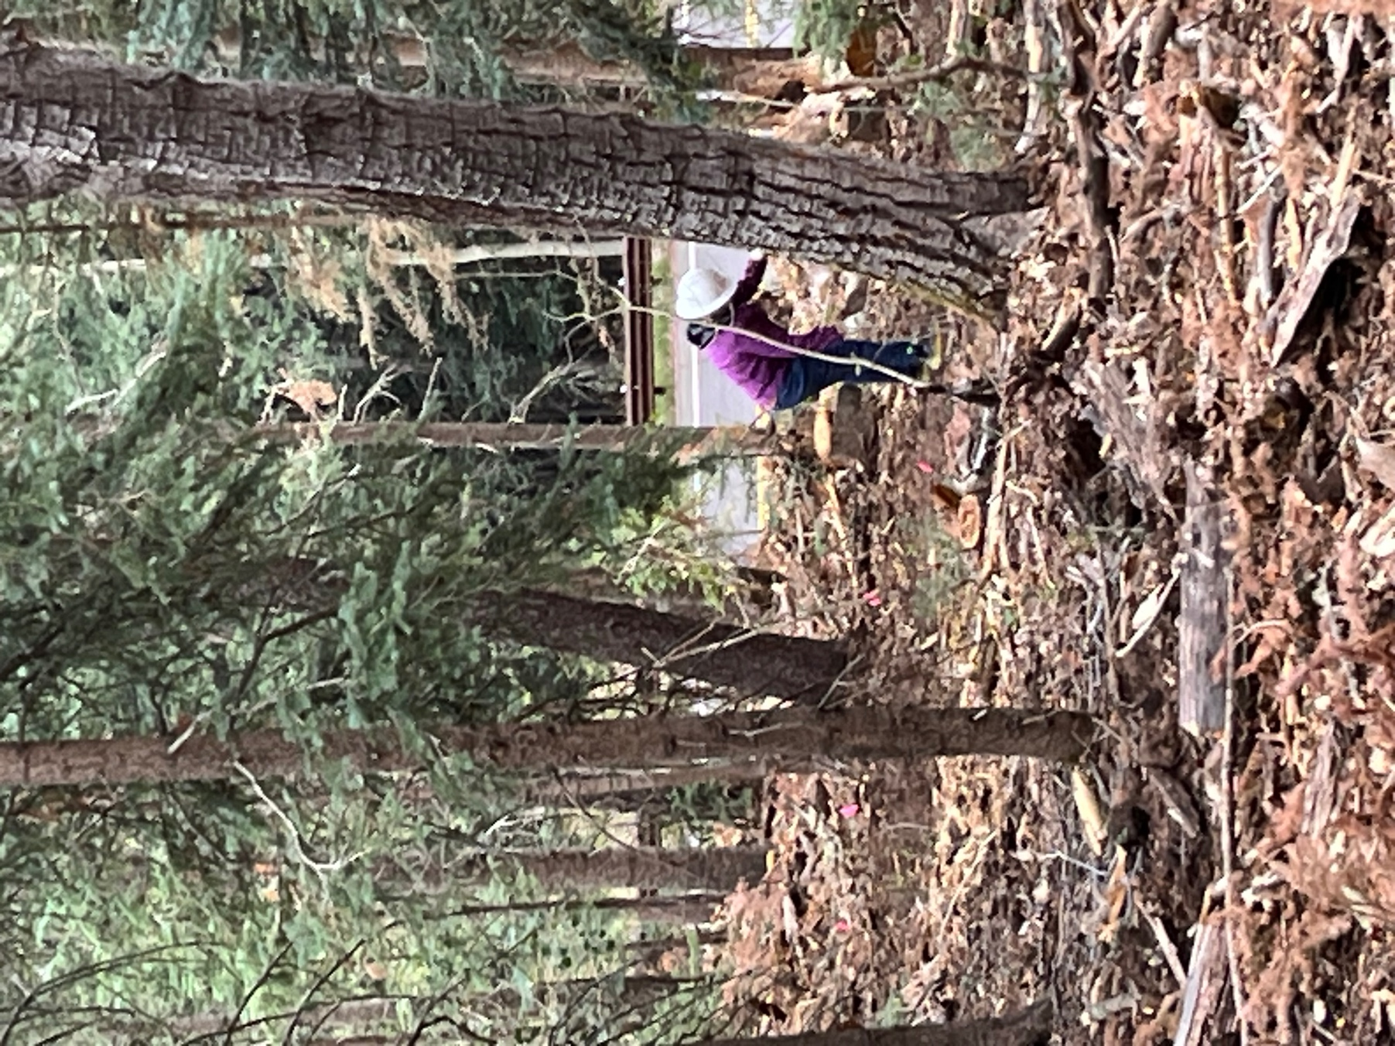

Rifka pulls debris down form the trail- SO MUCH DUFF! She was surprised to actually see the road from the trail and not just hear it.
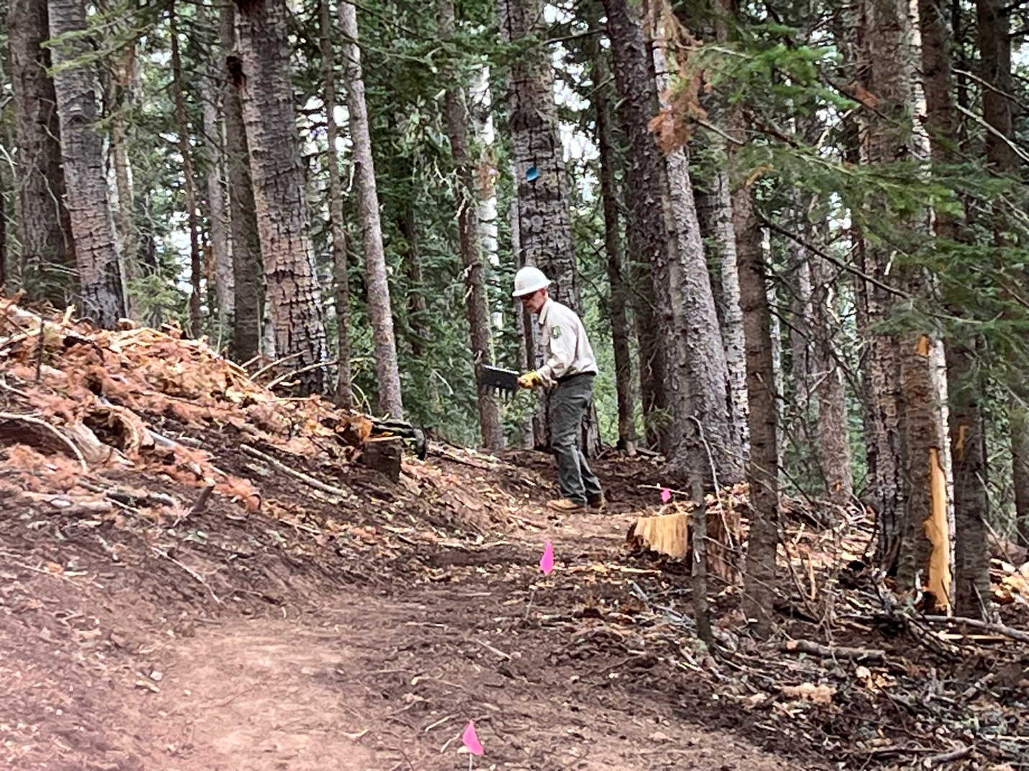

Chris adds the finishing touches to a rough area.

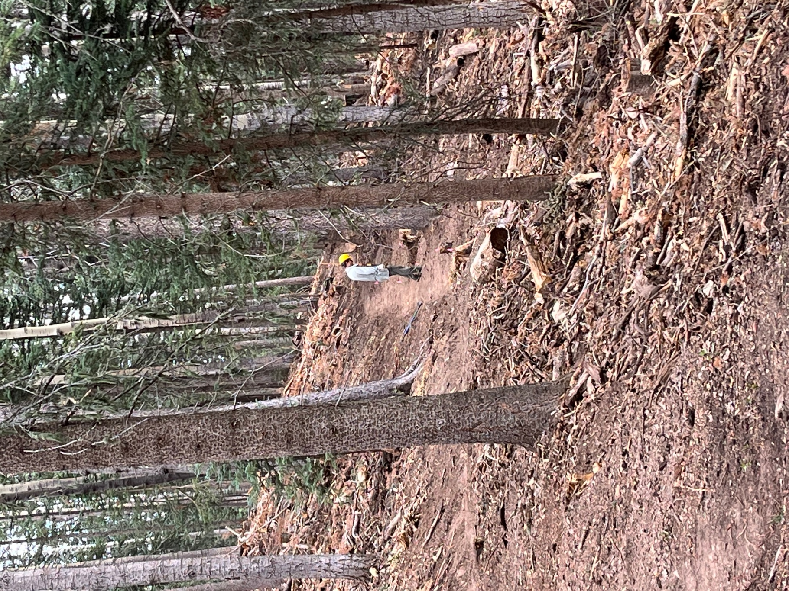

Eric M. check his work before bumping ahead to another spot.

