Thursday, 08/20/26- Switchback: Another week (actually week 5) at Switchback and the word is slogging. Seven volunteers, Sue from NMVFO and Chris, Jen and Isaiah (SRD) slogged on with our Switchback work. The weather is great up top and while there has been a fair bit of traffic on the road, we have not seen anybody trying to hike or bike. We saw a beautiful buck on the way up to the parking area.

Volunteers: John McNett, Bruce Hansche, Claudia Bergsohn, Luis Cuadros,
Eric Russell, Kerry Jones, Sue Harrelson (NMVFO) and Laura Leon

Pictures: Laura Leon and Kerry Jones

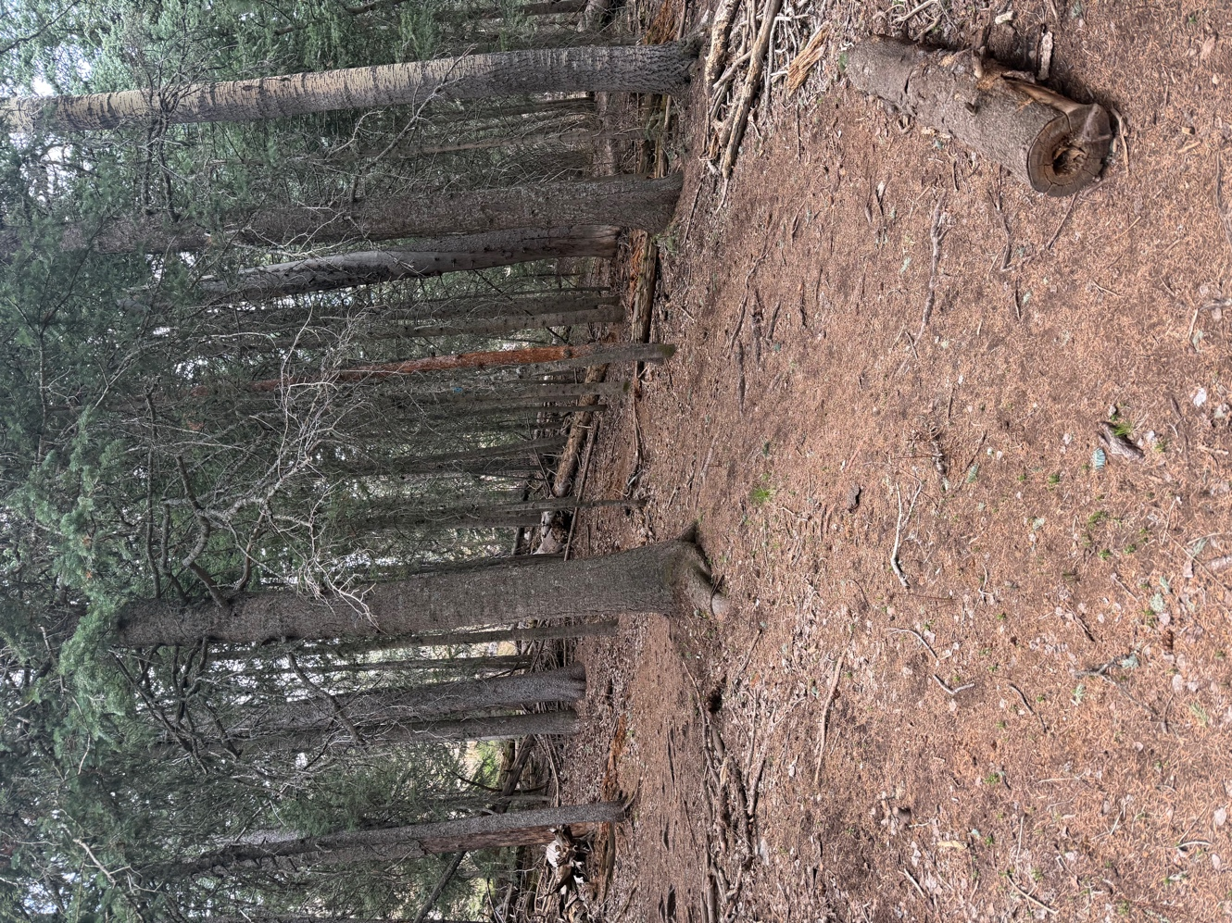
This is the first curve on Switchback- above is the before and this is the after.

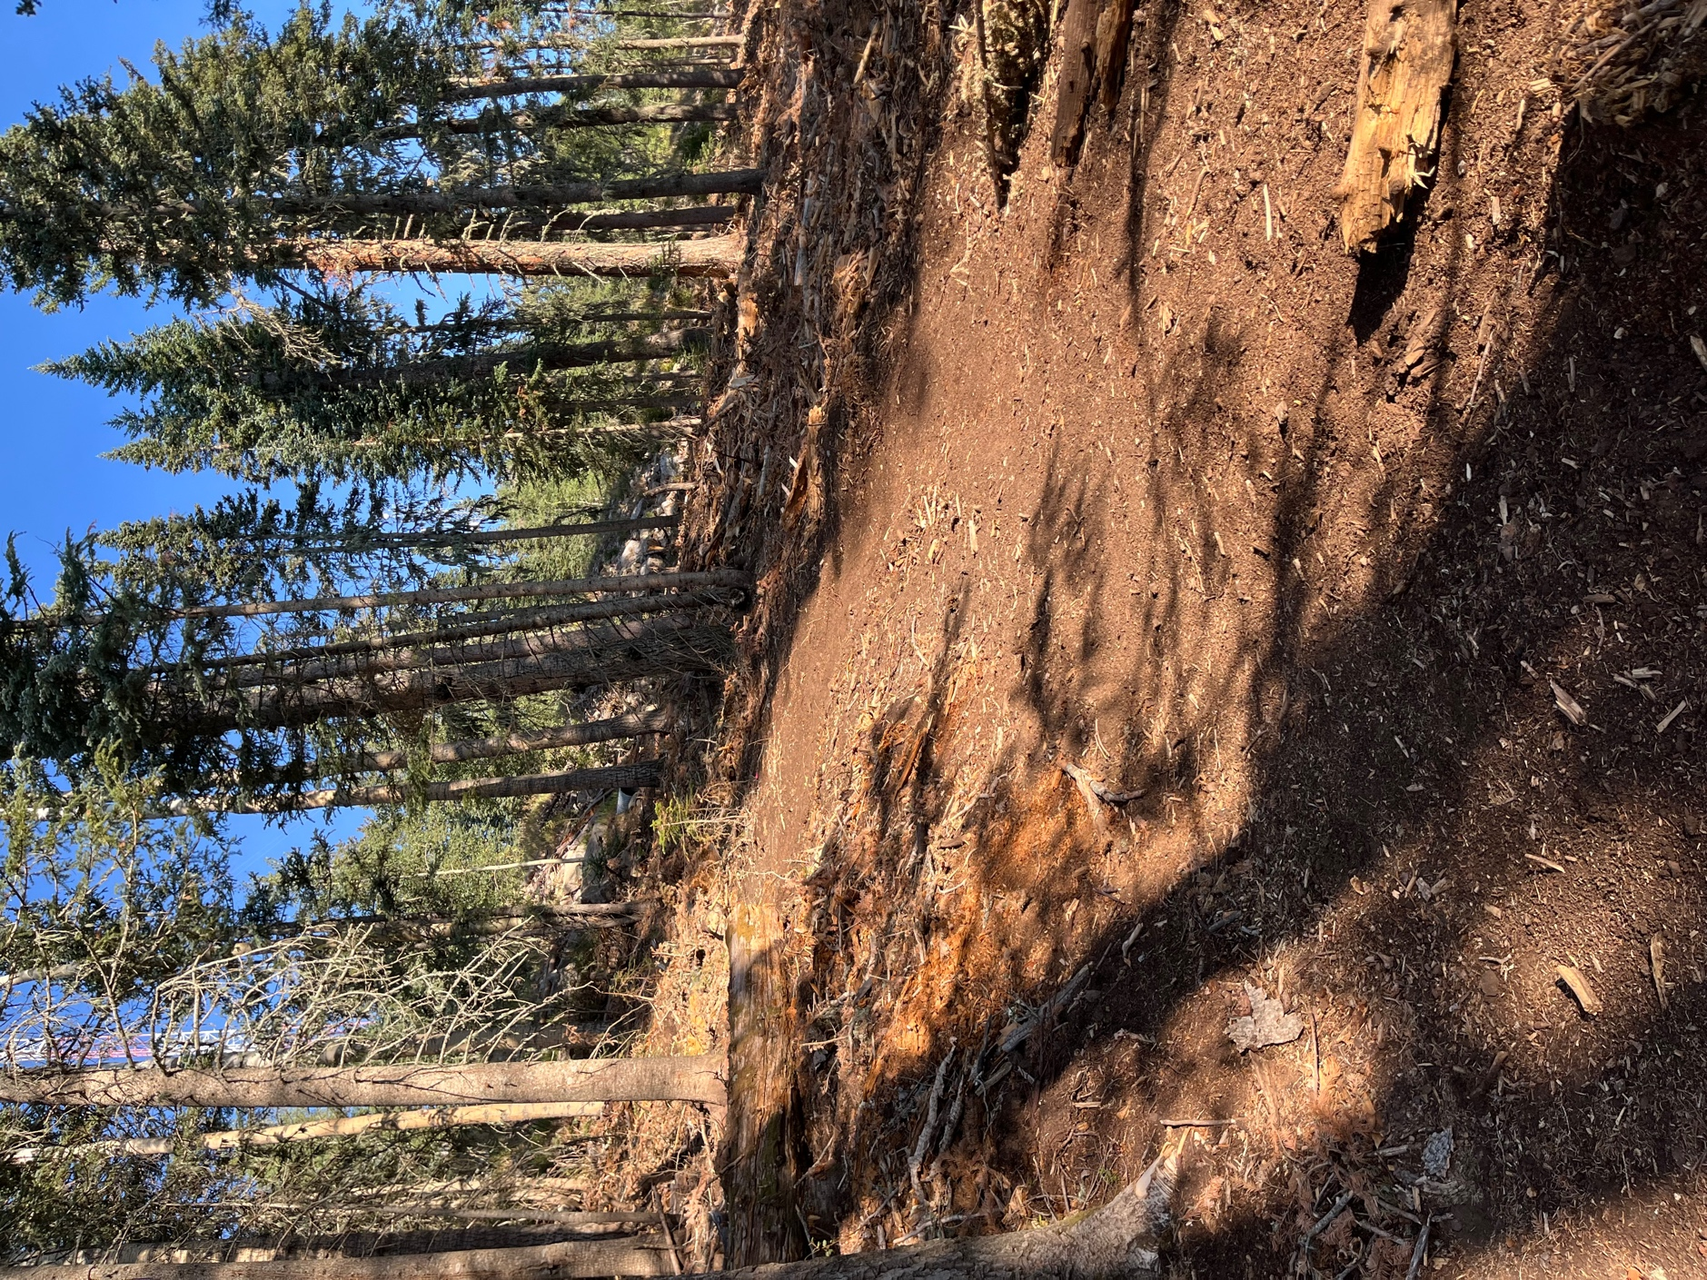

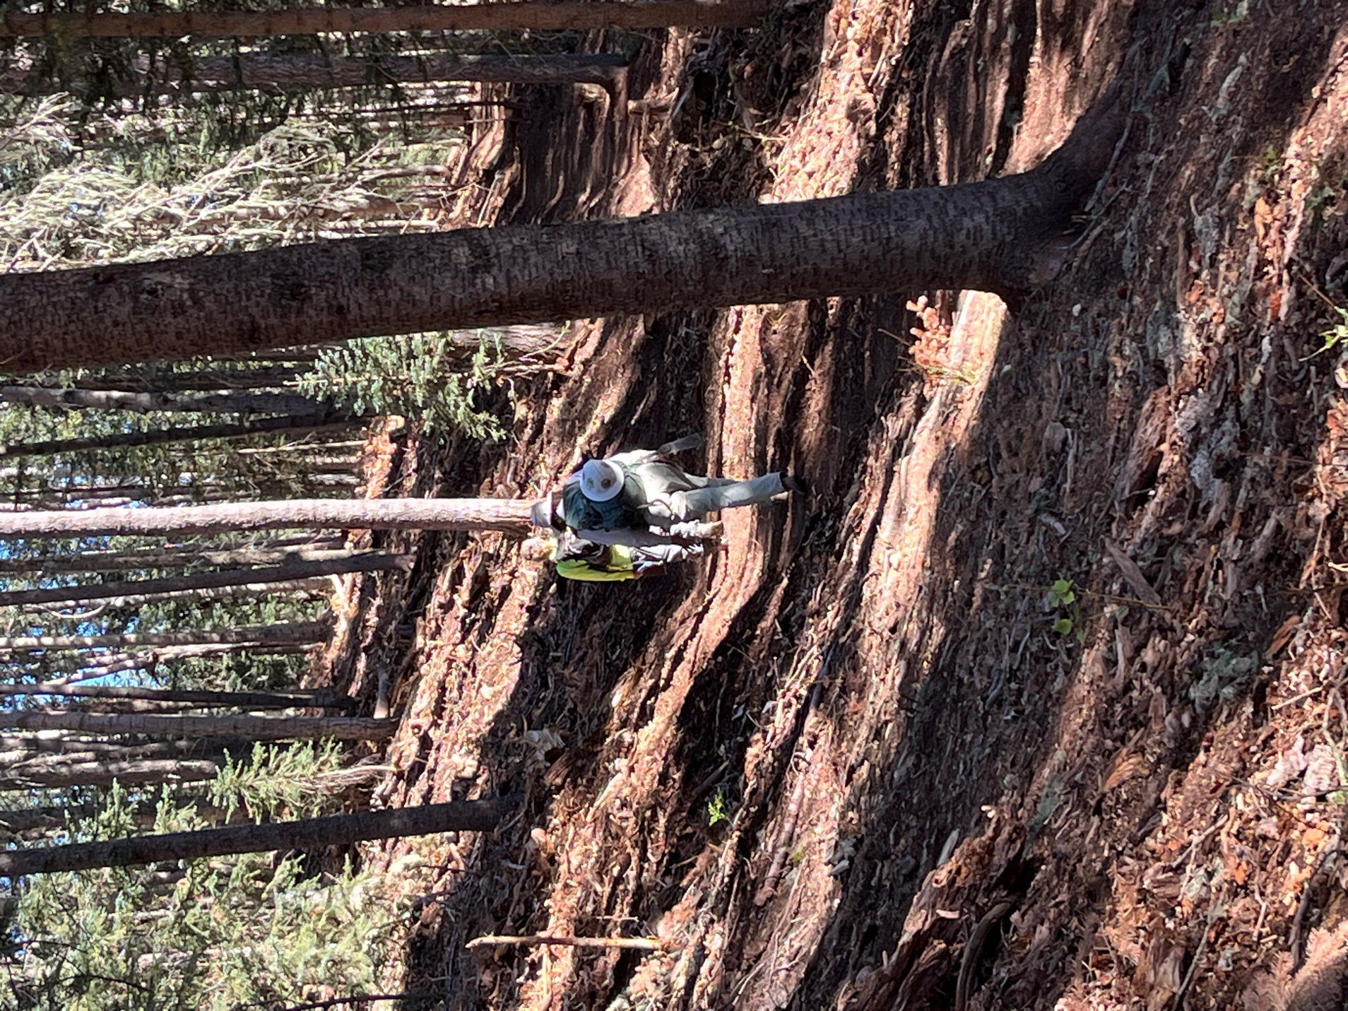

A nice walk in to the work site- the mornings have been very cool and comfortable.

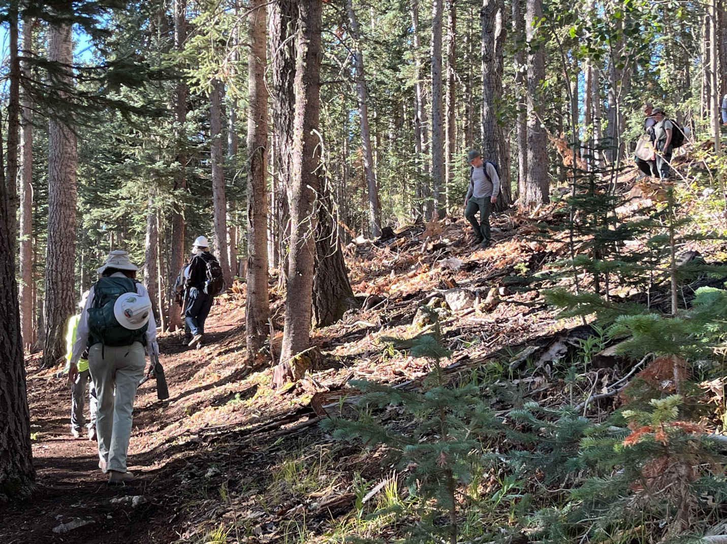

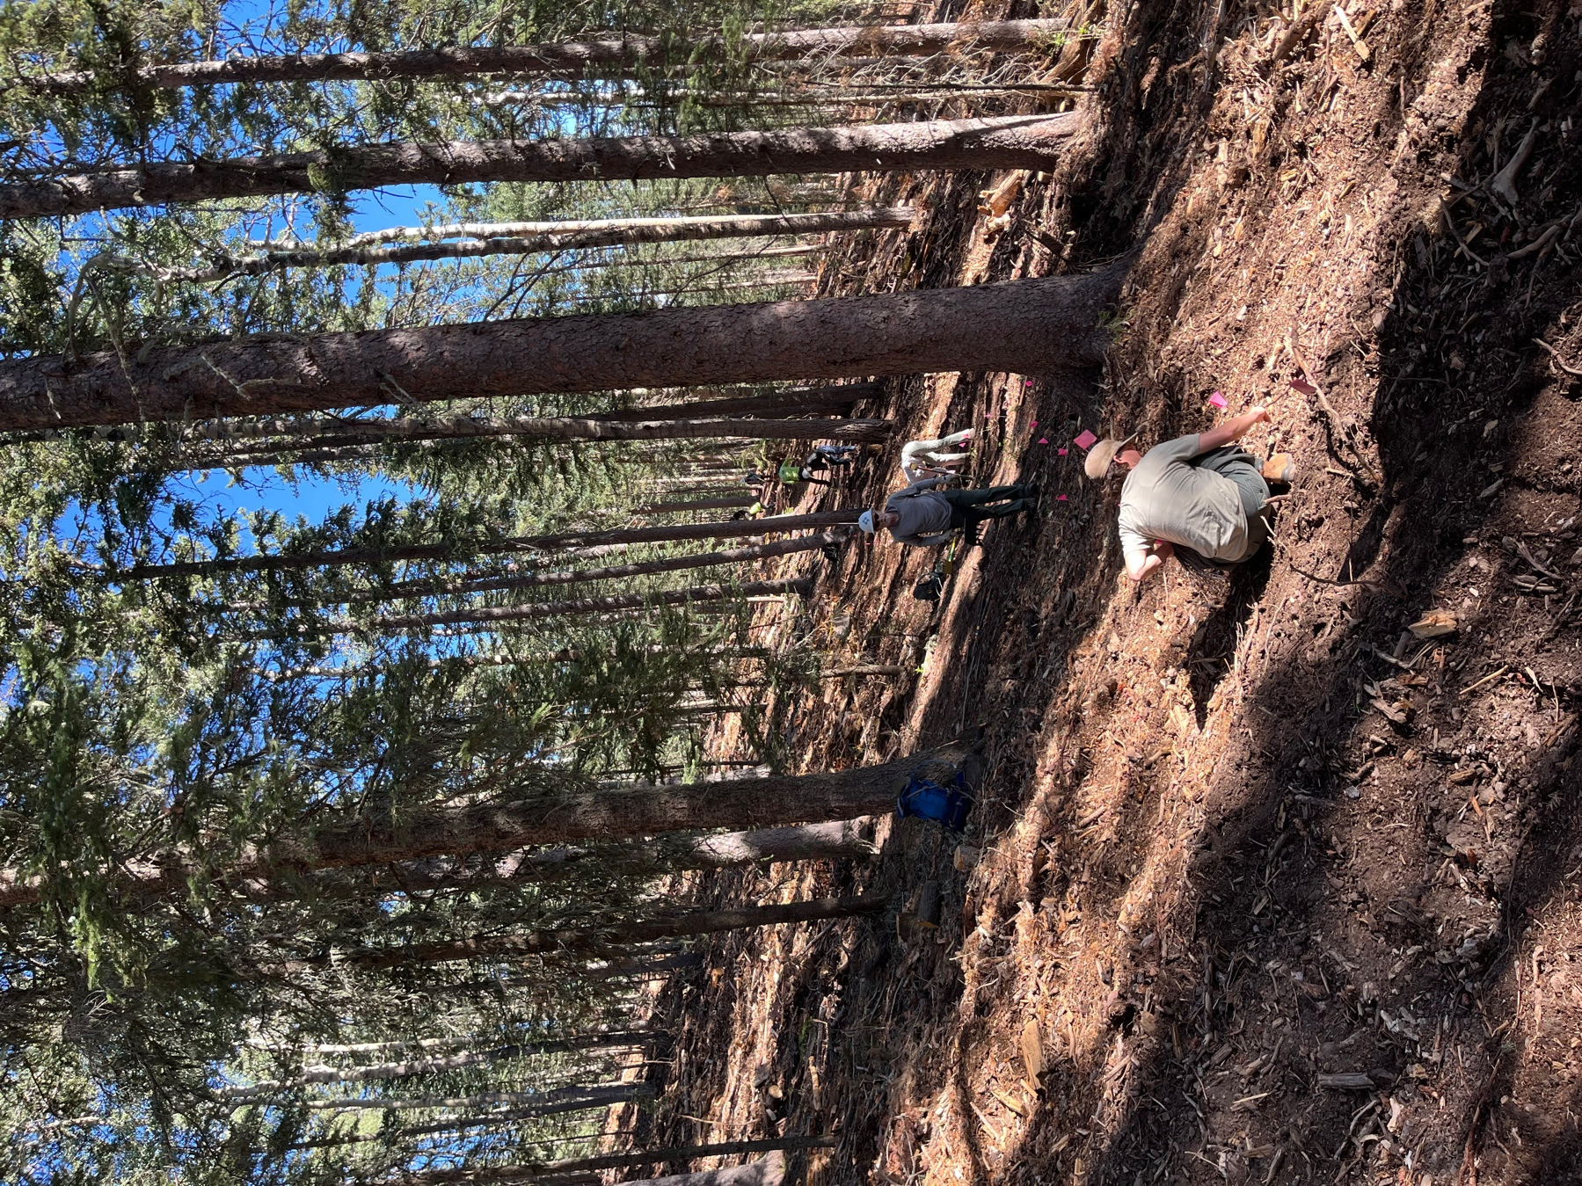

Jen flags while everyone gets tools and spreads out.
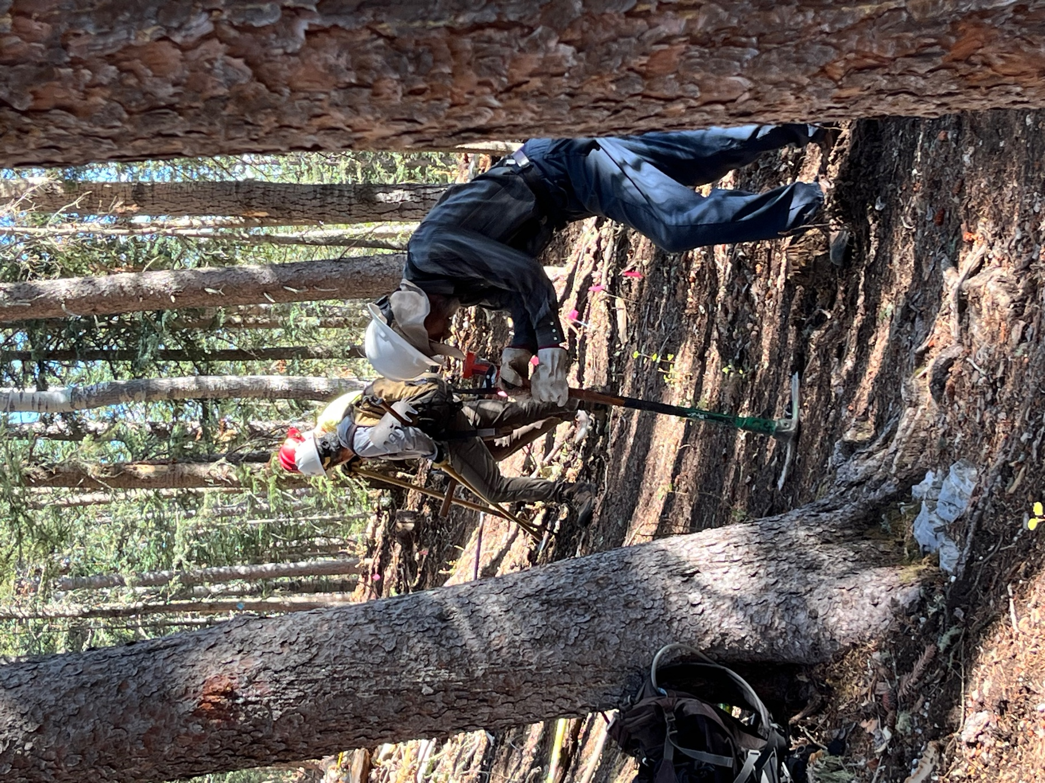

All our ducks in a row.
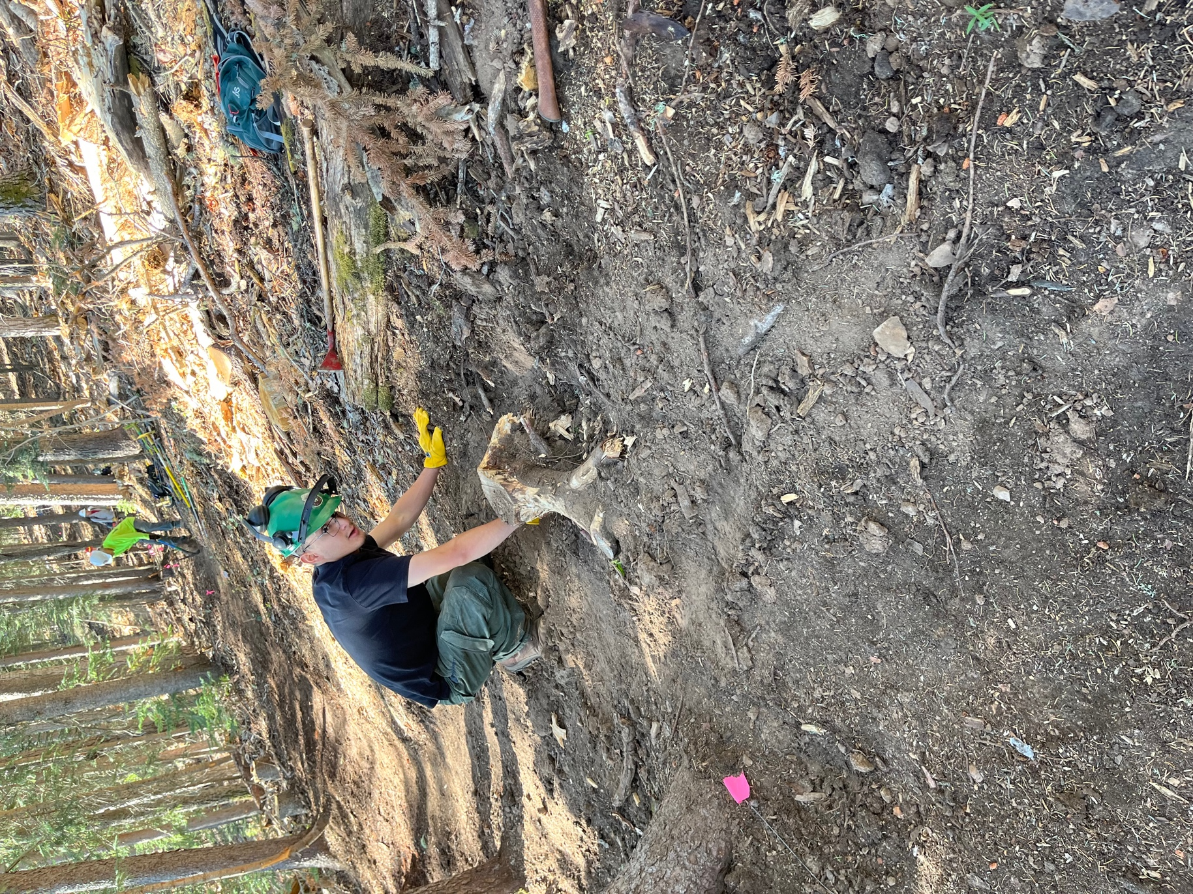

Isaiah works on a stump- he got after 2 or 3actually! Oh, to be young.

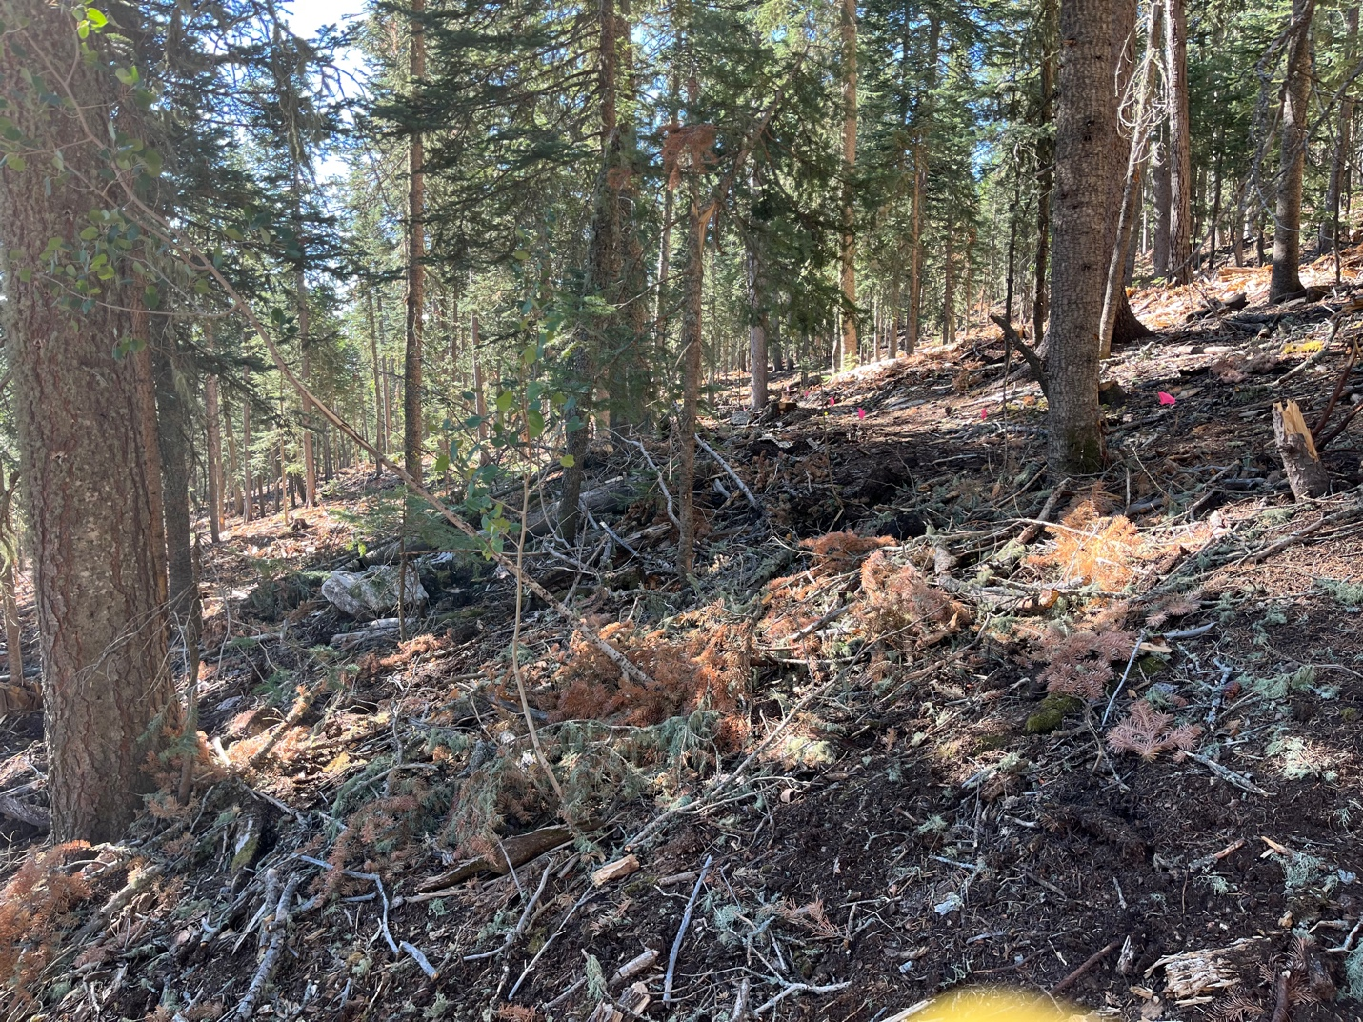

This is what a new area of work looks like when we move in. All the debris has to moved down hill before any digging starts or a berm builds up. The dirt has been very duffy in places and it takes a while to get down to real dirt.

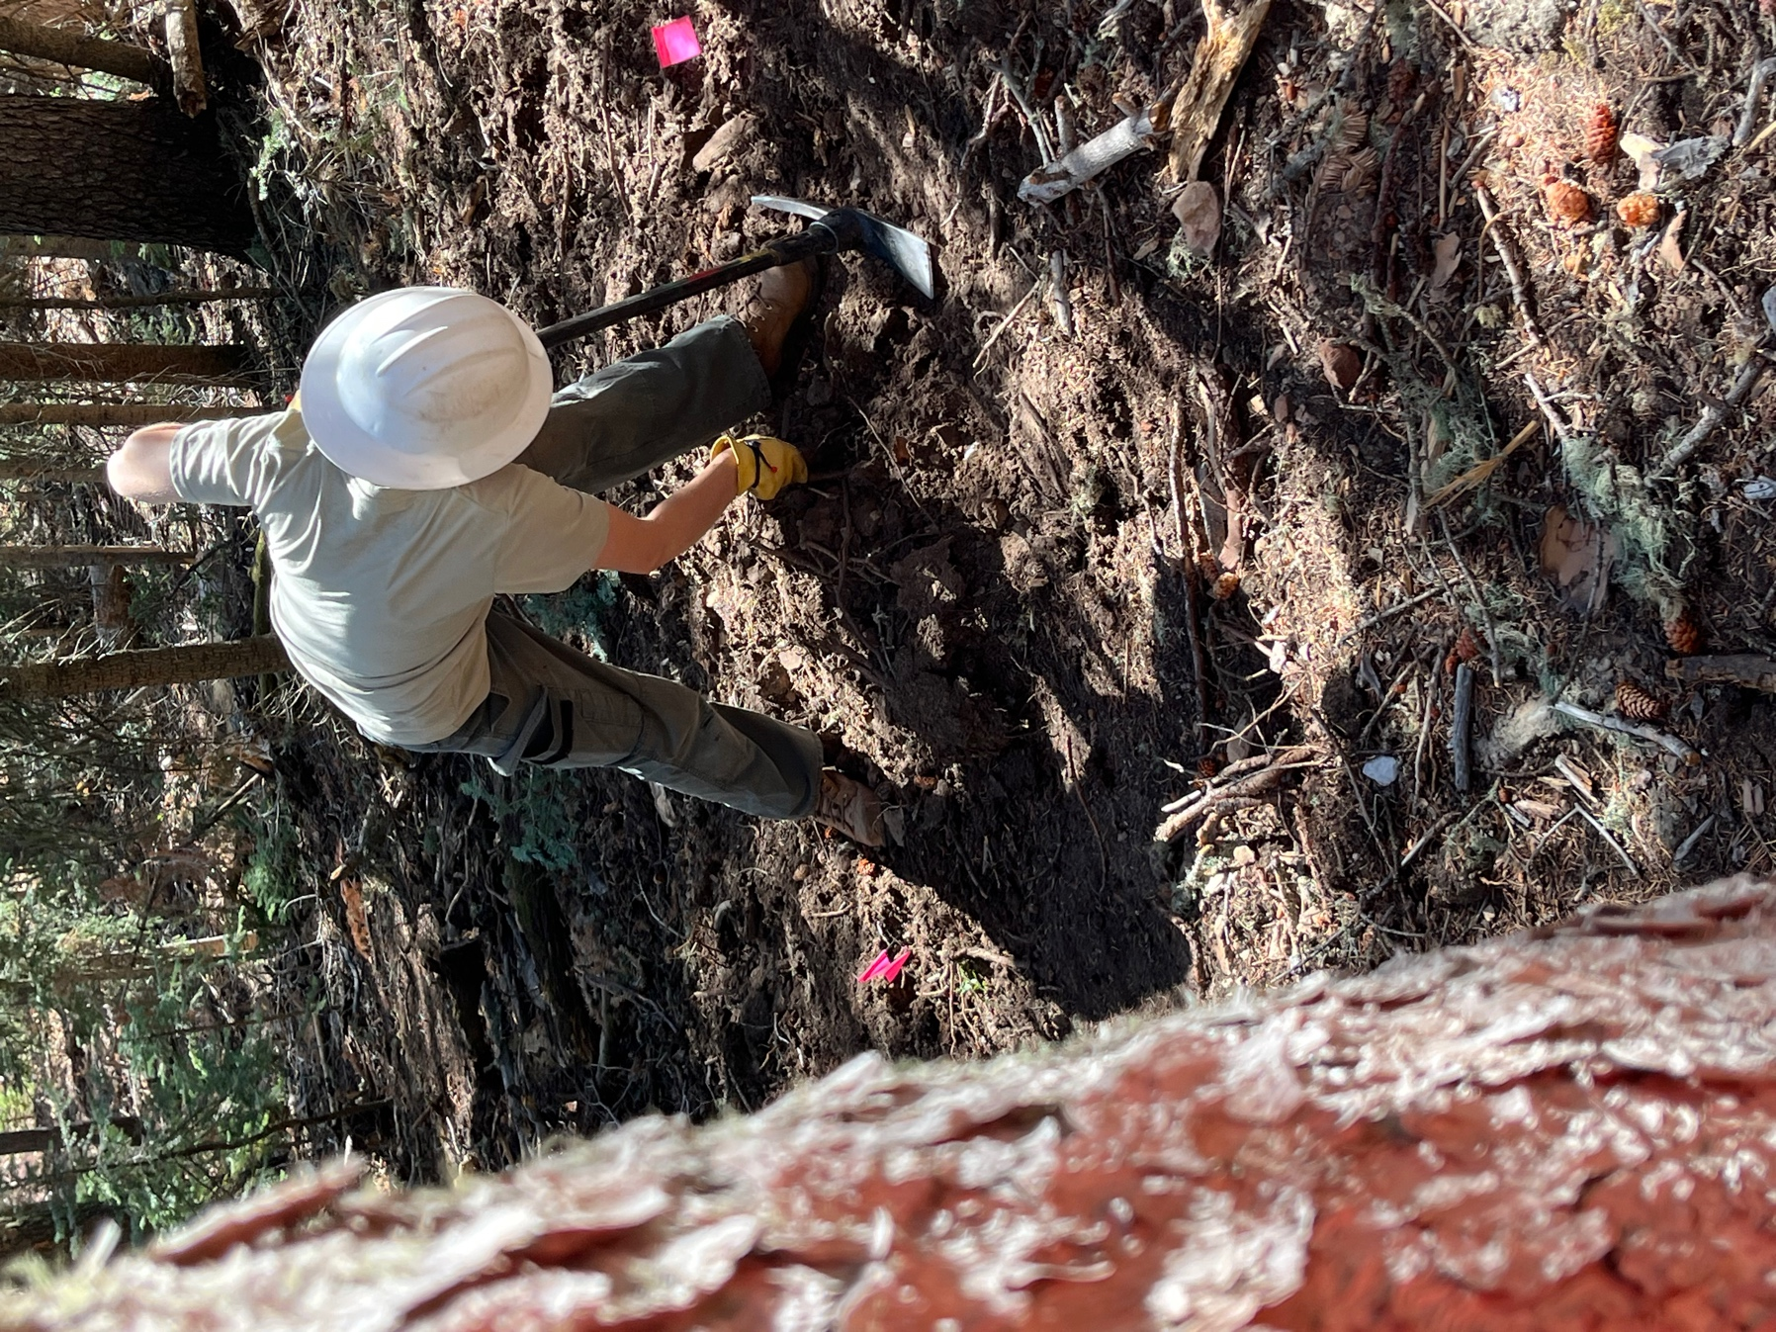

Jen digs away.

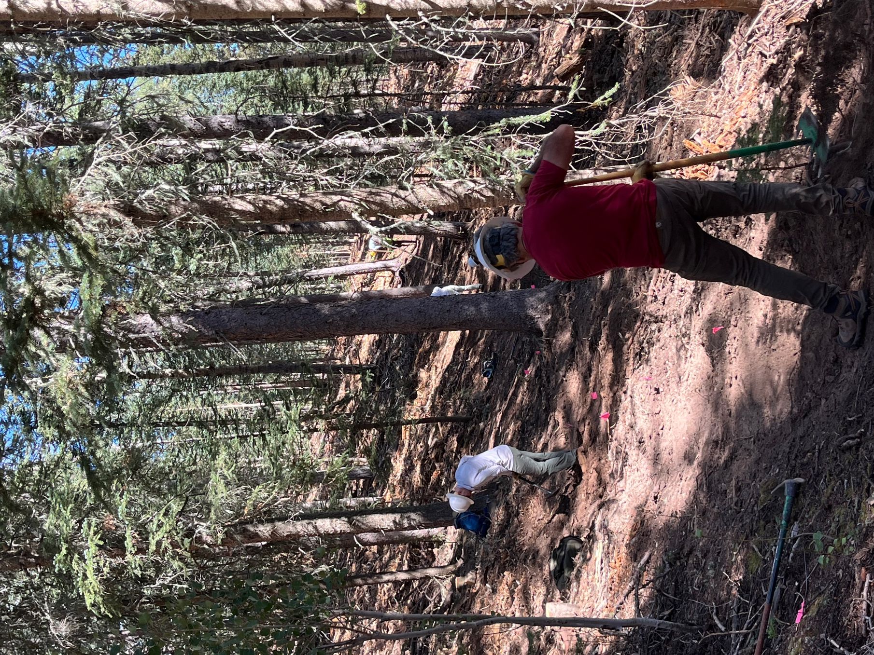

We have these lines of people working along… Feel free to come and join us!

