Report of the FOSM Project to Fell Hazard Trees in Capulin Picnic Area on Wednesday, August 19, 2026
Sam Beard
On Wednesday, August 19, ten FOSM volunteers felled five dead white fir hazard trees at Capulin Picnic Area. One hazard tree was felled near the entrance to the upper part of the picnic area, and four hazard trees were felled in the lower part of the picnic area near the Bird Log. The diameter of the largest tree was 27 inches. The volunteers were happy to see homeowners with a USFS permit bucking trees felled last week and this week and loading the wood onto a pickup.
The volunteers were Steve Roholt, Cliff Giles, Sim Cook, Michael Arndt, Jerry Carroll, Eric Russell, Chuck Logan, Dan Benton, Lorna Morrow, and Sam Beard.
Project photographs are presented below.

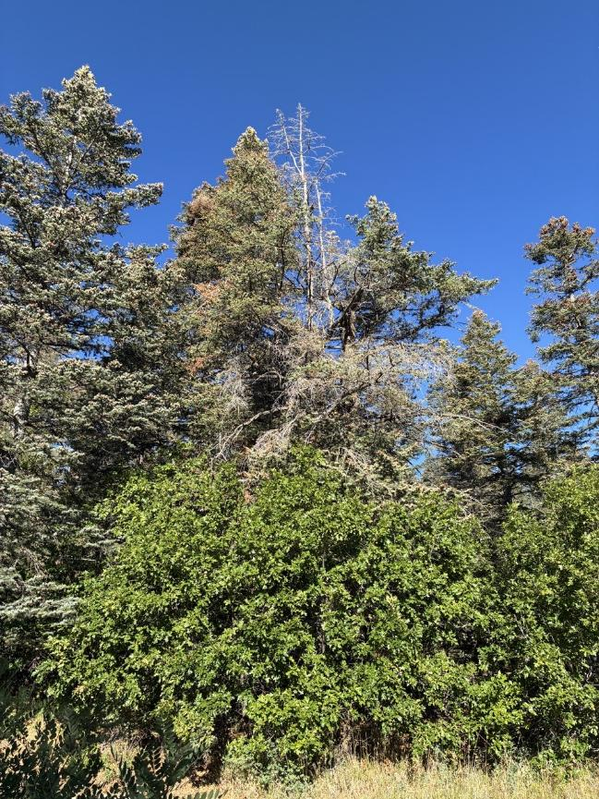
The lower part of a dead tree near Capulin Picnic Area entrance was obscured by small oak trees.
All photos by Cliff Giles unless noted otherwise.
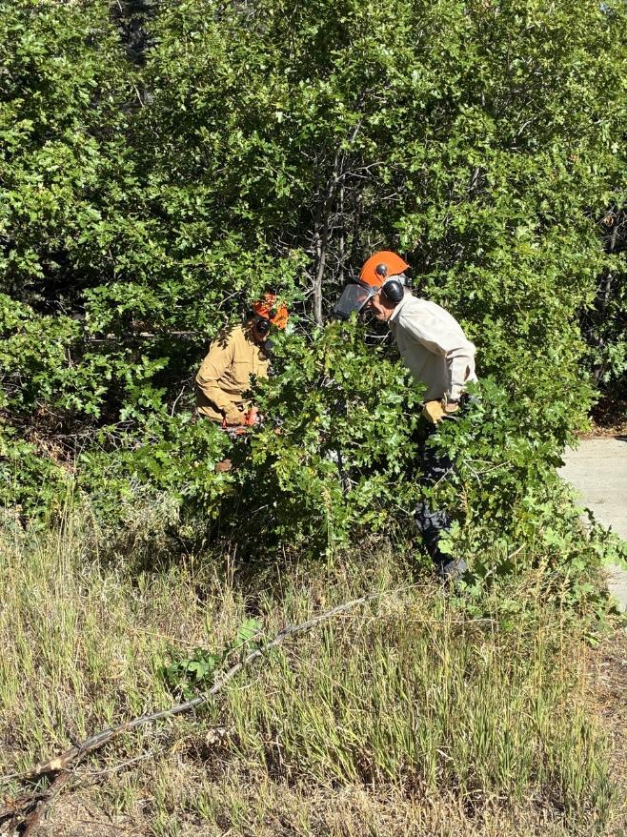
Dan Benton and Sim Cook removing the small oak trees where the felled trees would fall.

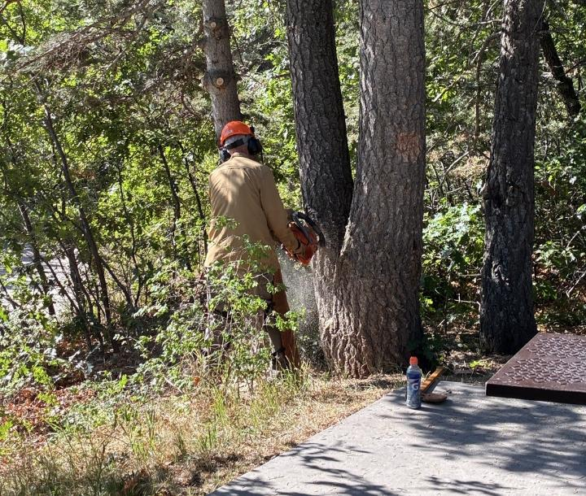
Dan making the face cut in the larger tree.

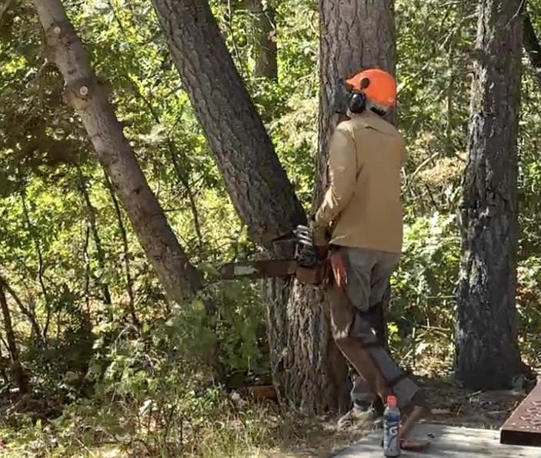
The two trees are falling.

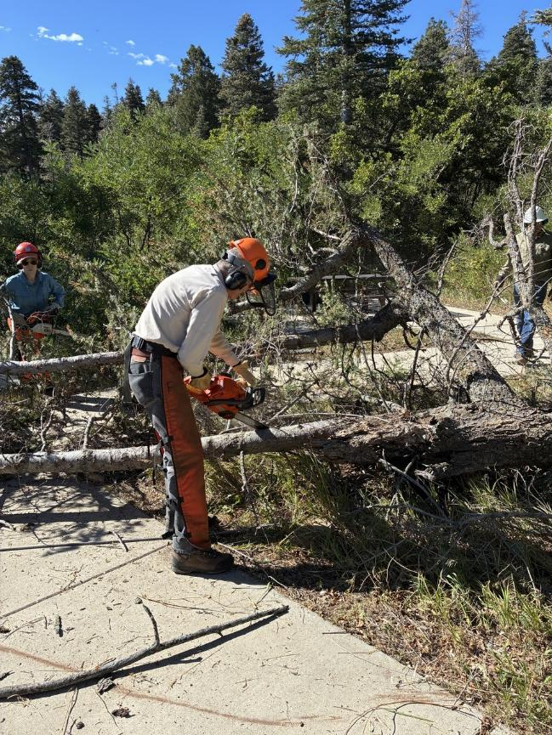
Sim Cook limbing a felled tree. The trees were limbed and bucked and left for homeowners with
permits to collect as fire wood.

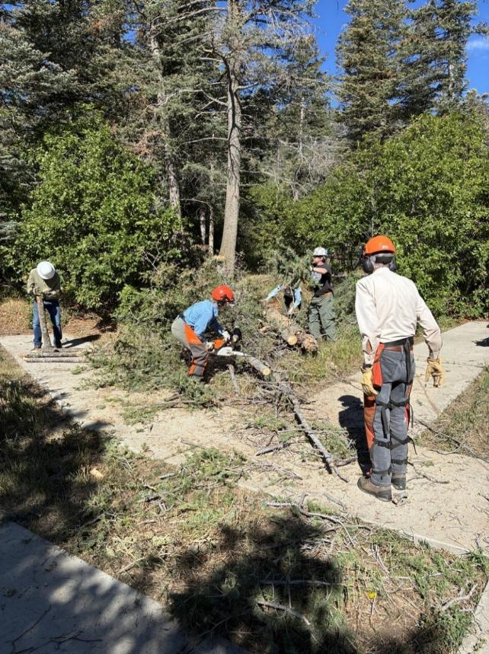
Chuck Logan, Lorna Morrow, Michael Arndt, and Sim Cook processing the tree felled by Dan Benton.
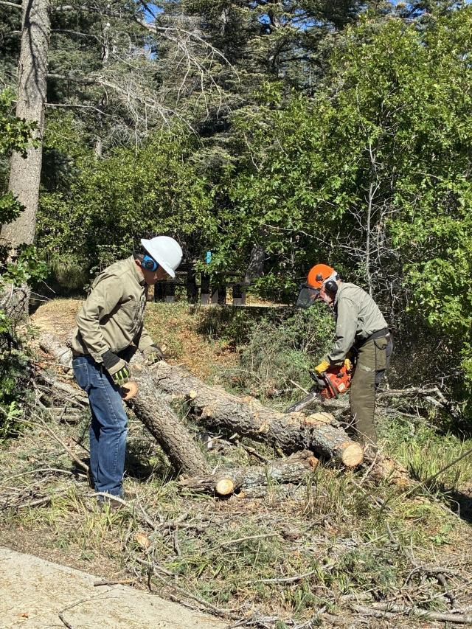
Chuck Logan moving a log and Sam Beard bucking a log.

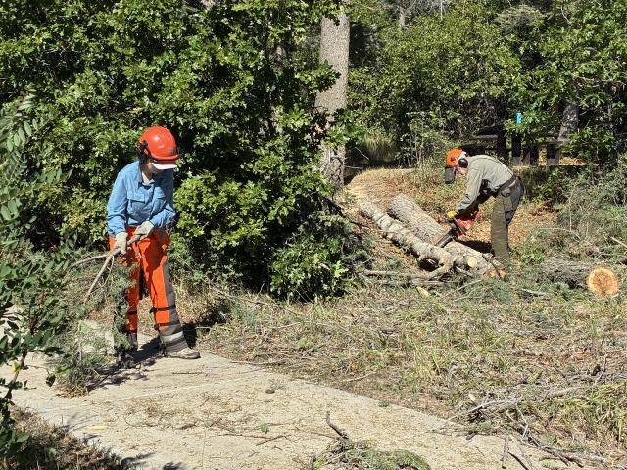
Lorna Morrow sweeping the sidewalk with a branch and Sam Beard bucking a tree.

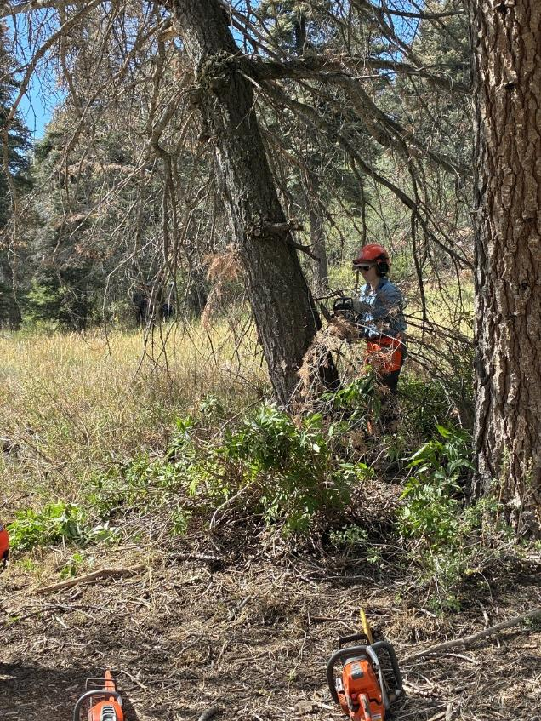
Lorna limbing Sim Cook’s tree in the low part of Capulin Picnic Area near the Bird Log.

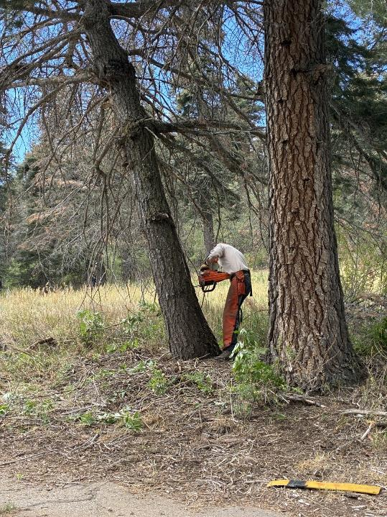
Sim making the face cut on this leaning tree.

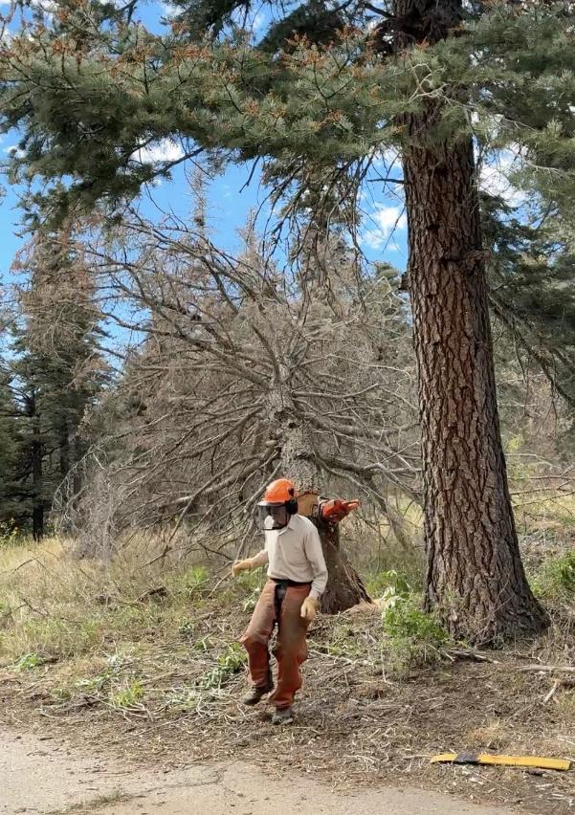
Sim running away from the falling tree.

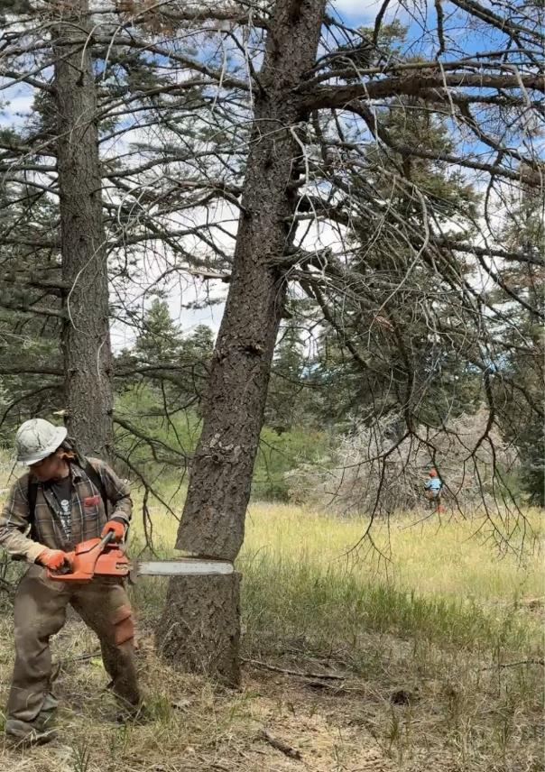
Michael Arndt running away from the falling tree.

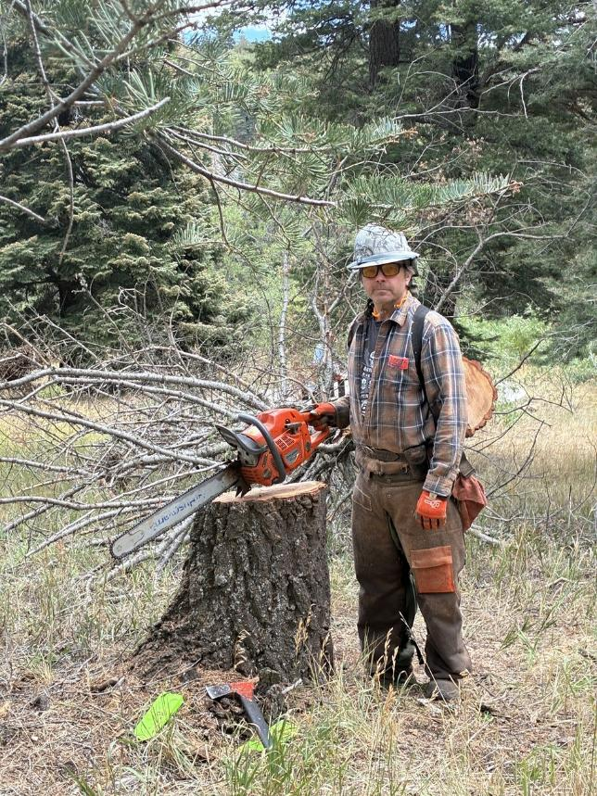
Michael at the stump of the tree he felled.
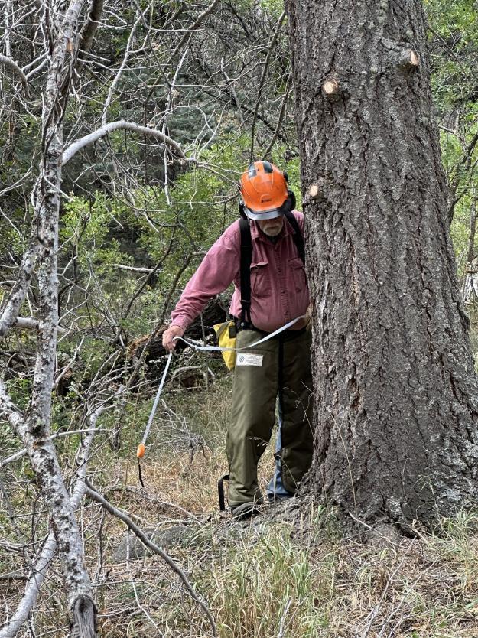
Jerry Carrolll using his diameter tape to measure the diameter of this 27-inch dead white fir.
Photo by Steve Roholt

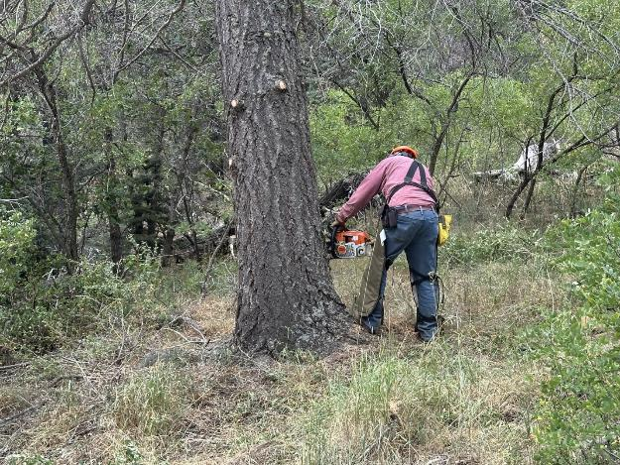
Jerry making a slabbing cut on the side of this large tree.
Photo by Steve Roholt

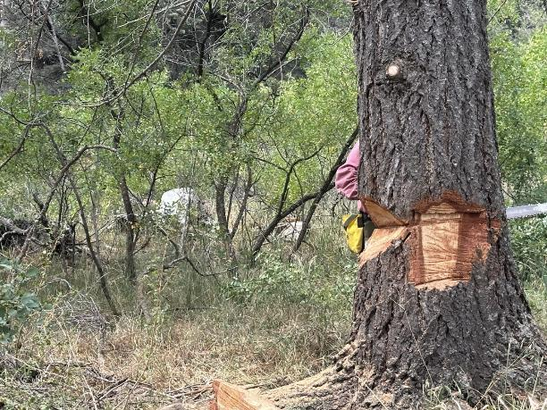
Jerry making the back cut on this dead tree. The cut on the left side of the tree is the facing
cut. Jerry also made two slab cuts on the sides of the tree to effectively reduce the
thickness of the wood to be cut. Photo by Steve Roholt

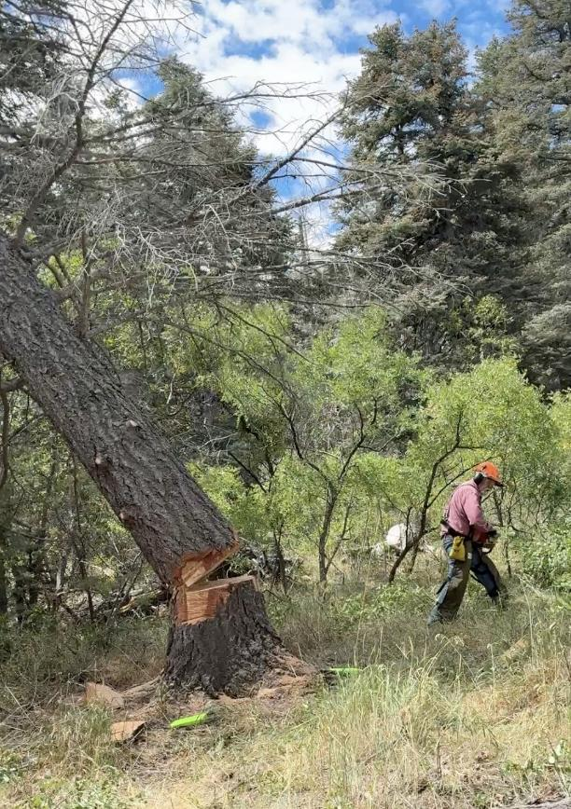
Jerry running away from the falling tree.
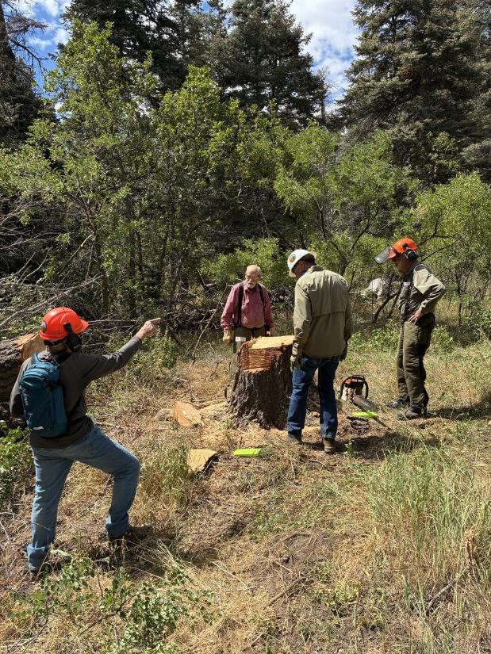
L to R: Steve Roholt, Jerry Carroll, Chuck Logan and Sam Beard looking at the stump
of the large tree Jerry felled.

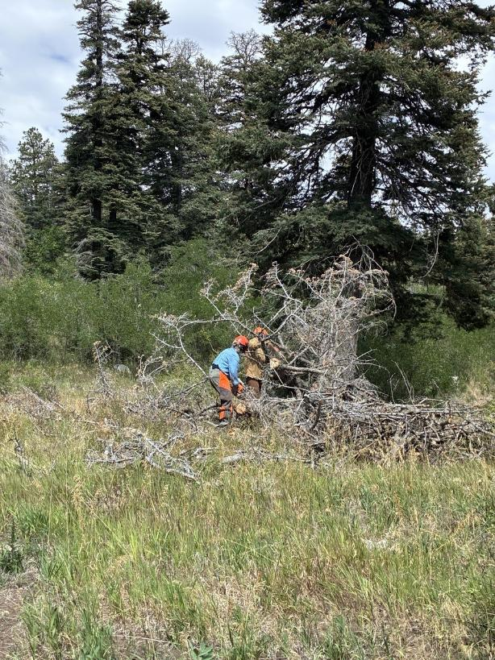
Lorna Morrow and Dan Benton limbing the tree felled by Sim Cook.

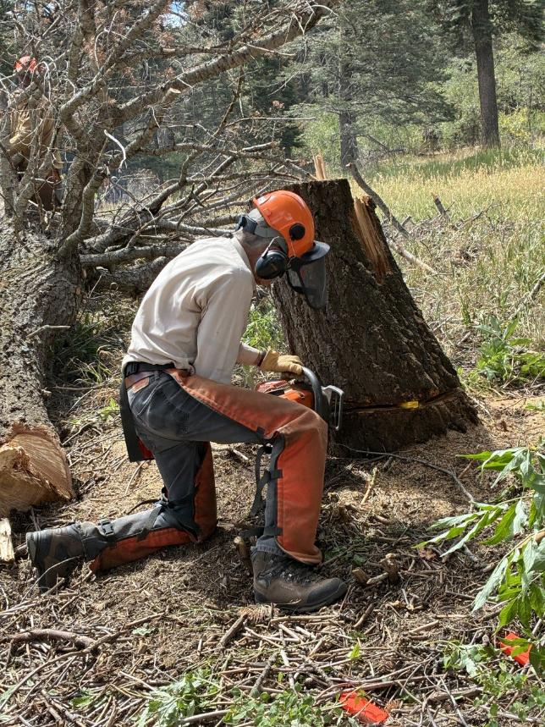
Sim low stumping the tree he felled.
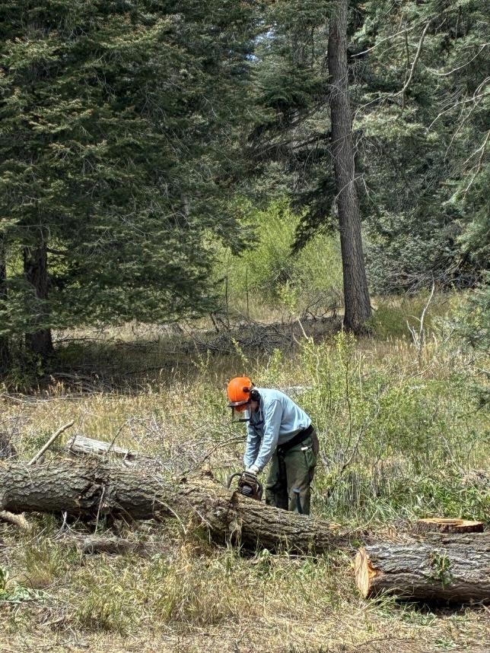
Eric Russell bucking the tree Sim felled.

