Report of Removal of Graffiti Tags in the Crest, Ellis Trailhead, and
10K North Trailhead Areas by FOSM Volunteers on Saturday, August 22, 2026

Sam Beard
On Thursday, August 20, Julie Padilla, SRD Recreation Staff Officer, requested that FOSM volunteers remove graffiti tags that had been reported to her in the Crest area.
On Saturday, August 22, Cliff Giles, Sim Cook, and Sam Beard removed several tags in the Crest area. They also removed one tag at Ellis Trailhead and one at 10K North Trailhead. On their way down the mountain, they checked other picnic areas but did not find any other graffiti tags.
Project photographs are presented below.

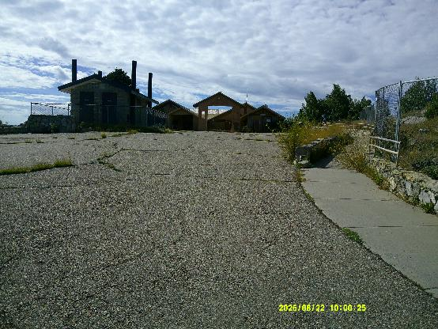
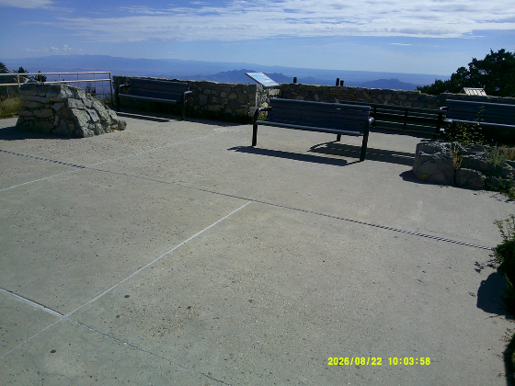
No graffiti tags were found at the Crest Plaza or at the Crest Overlook.
Photos by Sam Beard

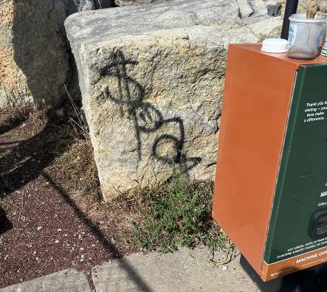
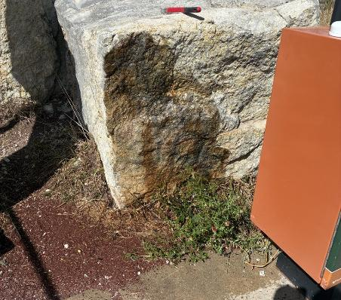
Graffiti removed from a boulder at the pay box near the upper Crest parking lot.
All photos by Cliff Giles unless noted otherwise
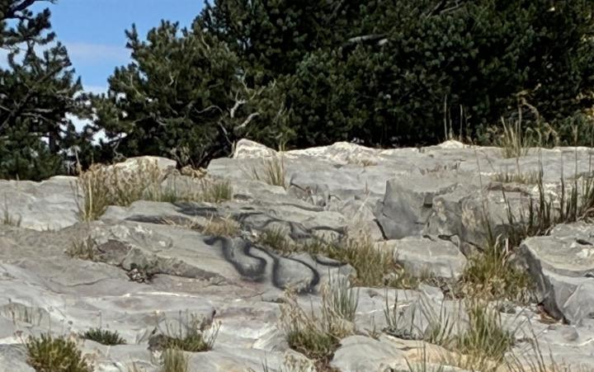
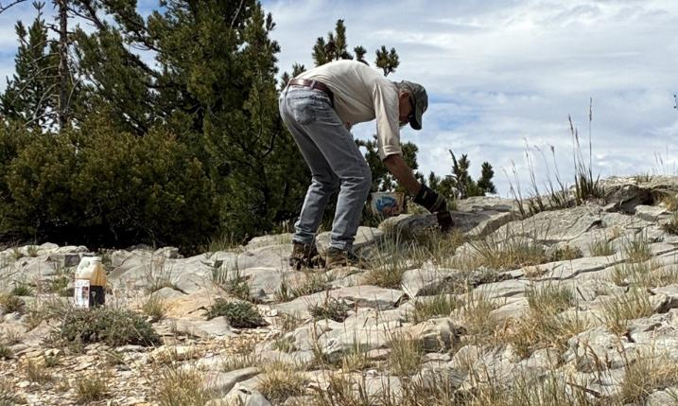
Sim Cook painting graffiti removal chemical on a tag on a rock near the lower restroom.
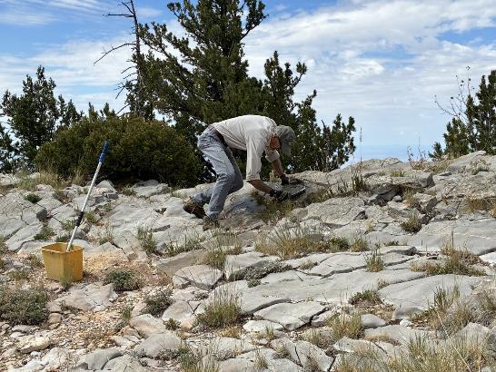
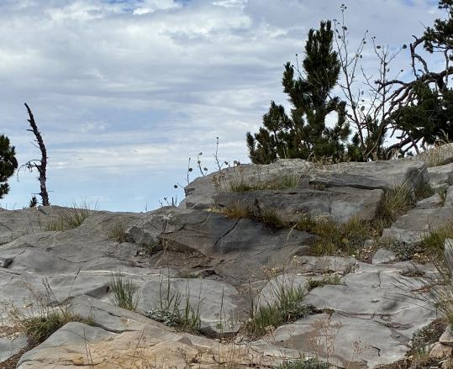
Top – Sim using a brush to remove the tag on the rock. Bottom – Tag has been removed.
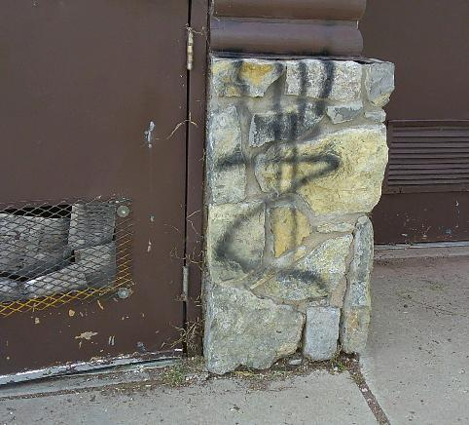
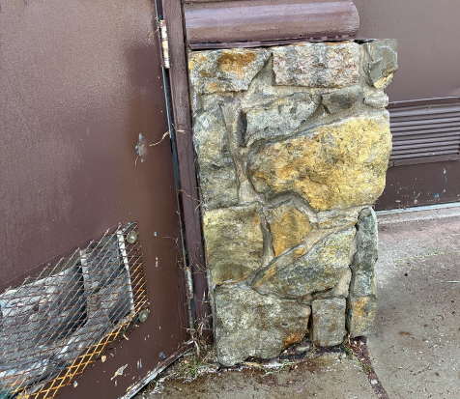
Graffiti on one of the lower restrooms was removed.
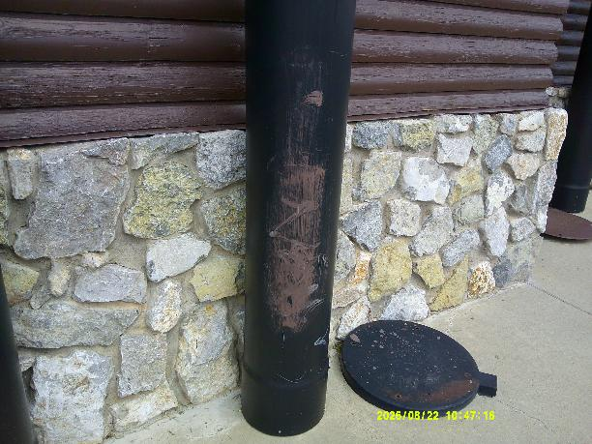
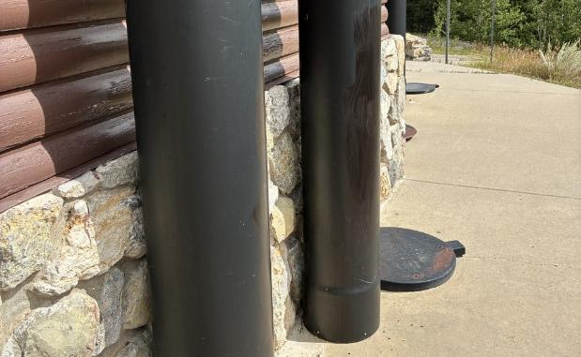
Graffiti tag on a ventilation pipe at the lower restroom was painted over with black paint.

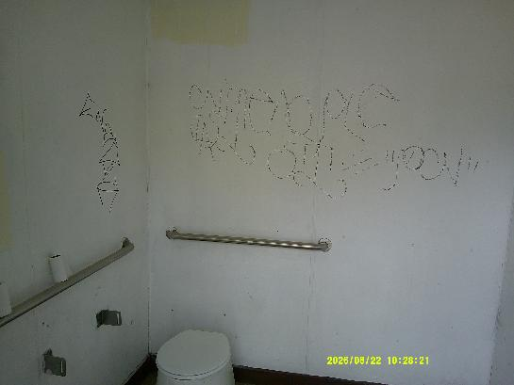
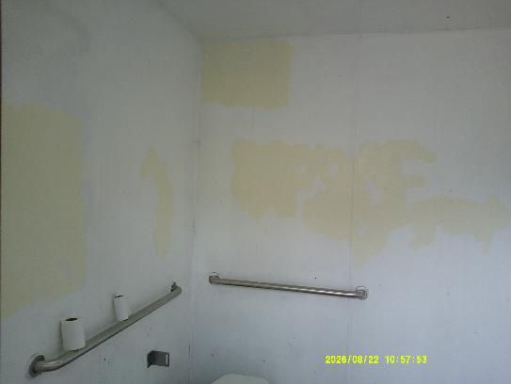
Large black tag on an interior wall of a lower restroom was painted over
with Linen White paint. Photos by Sam Beard
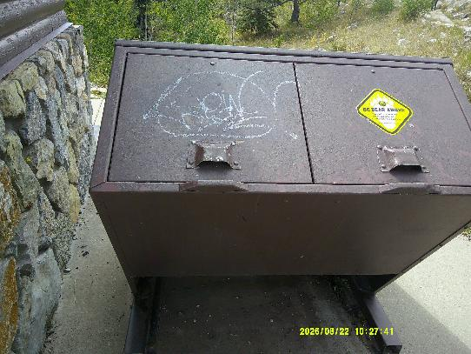
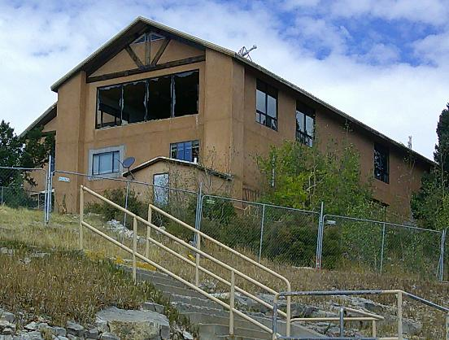
Top – Tag on trash container was painted over with brown paint.
Bottom – Large windows on east side of the Crest House have been broken.
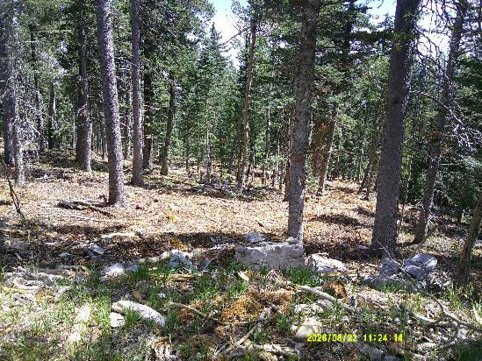
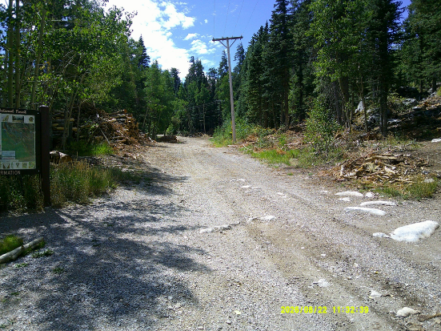
Top – Thinning and mastication of mountain side below the Crest exit road. Bottom – Log pile
and thinned forest along Service Road at Ellis Trailhead. Photos by Sam Beard

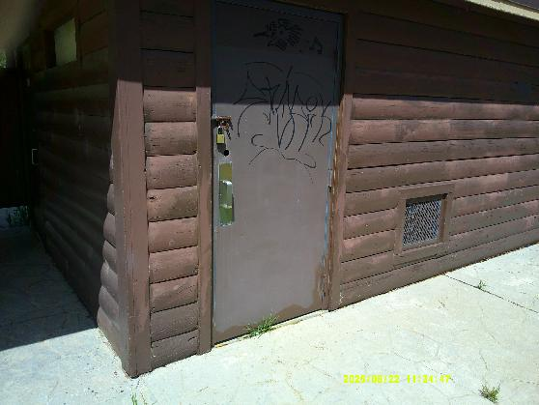
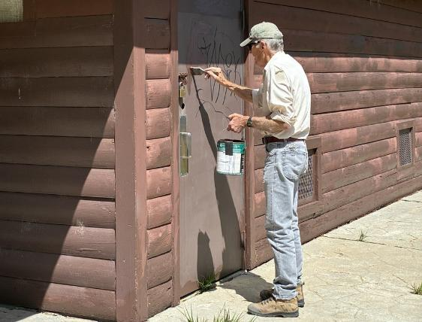
Sim painting over tag on Ellis Trailhead restroom door.

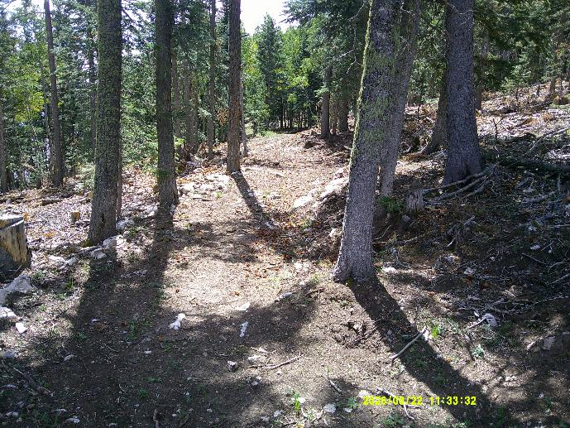
Sandia Nordic Ski Club trail with thinned and masticated forest of both sides.
Photo by Sam Beard

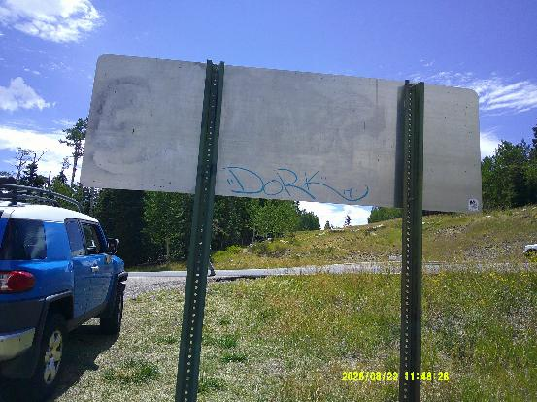
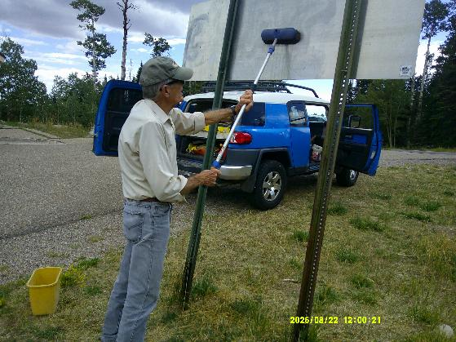
Sim rinsing off graffiti and chemical residue from back of sign at
10K North Trailhead. Photo by Sam Beard

