Thursday, 08/27/26- Switchback: Ten volunteers met Jen and Chris (SRD) for week 6 of Switchback cleanup. The weather has been great for working. We listened to the demolition of the Crest House while we worked. There continues to be traffic on the road but no hikers. The word for this week was rocks. All sorts of rocks to move, smash and generally get out of way. We made some good progress this week.

Volunteers: Bill Perkins, Byron Garner, Kent Towler, John McNett, Bruce Hansche, Claudia Bergsohn, Luis Cuadros, Eric Russell, Jim Houle and Laura Leon

Pictures: Jen Medina-Gray and Laura Leon
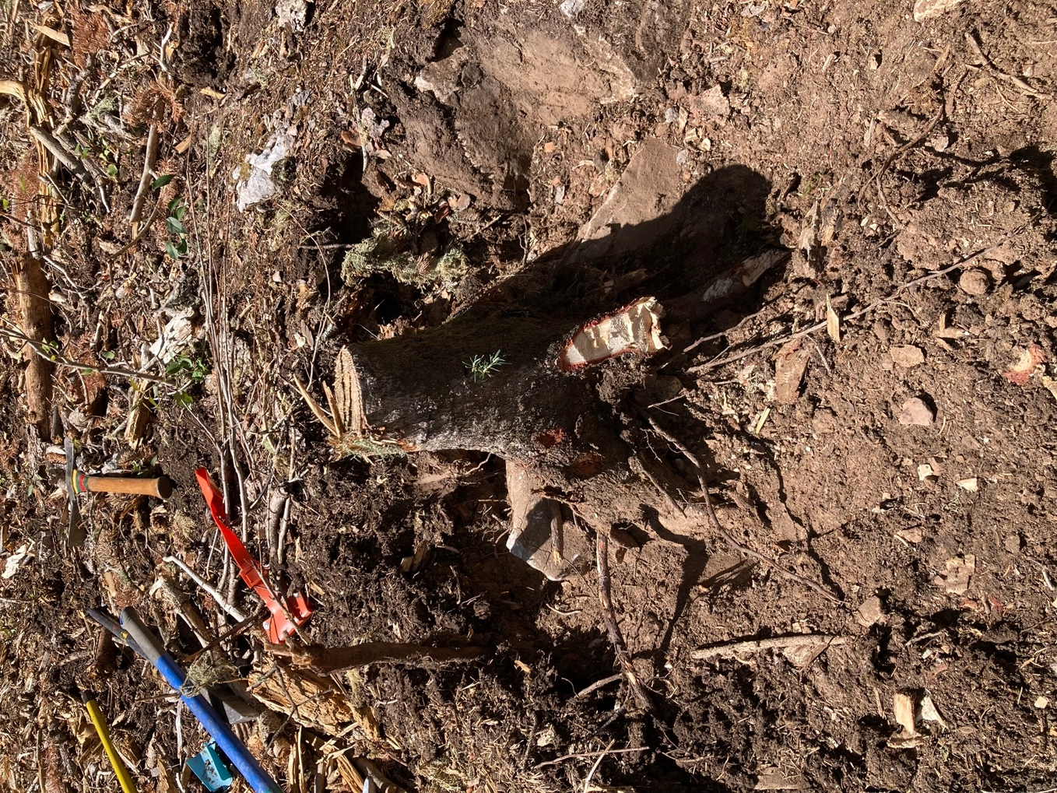

This is a rock/root/stump that Jen worked on Tuesday. The root wound around the rock making it very challenging to remove. They used every tool in attendance.

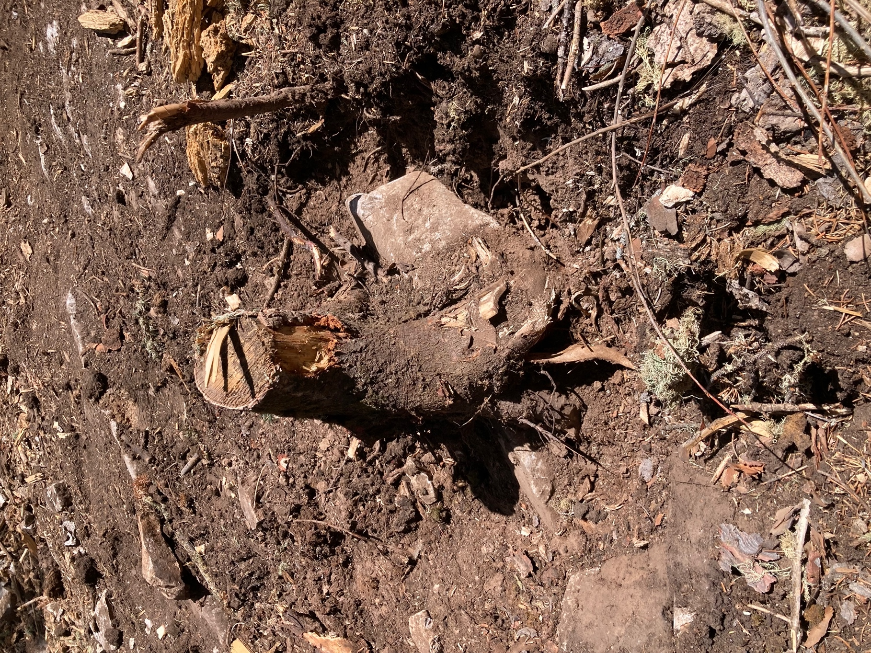

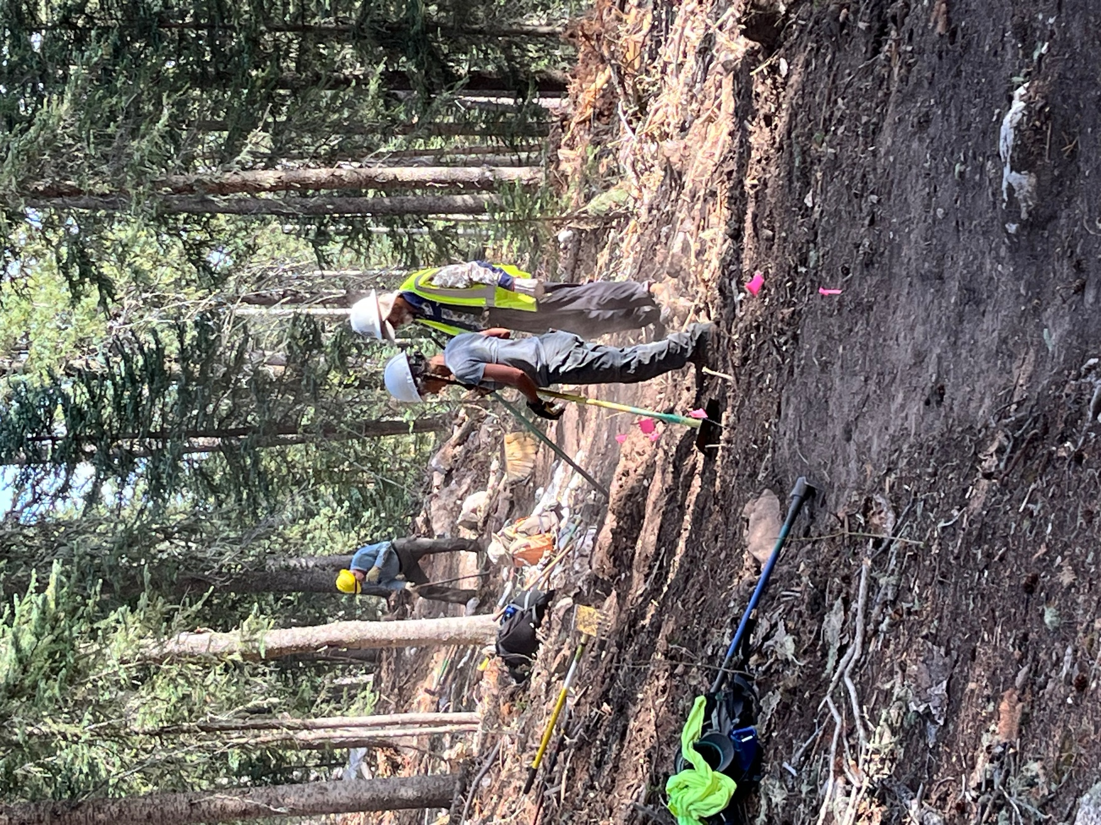

Bruce and Claudia work in the spot where Jen’s stump was removed while Eric works on a rocky area. Quite the hole to fill in.

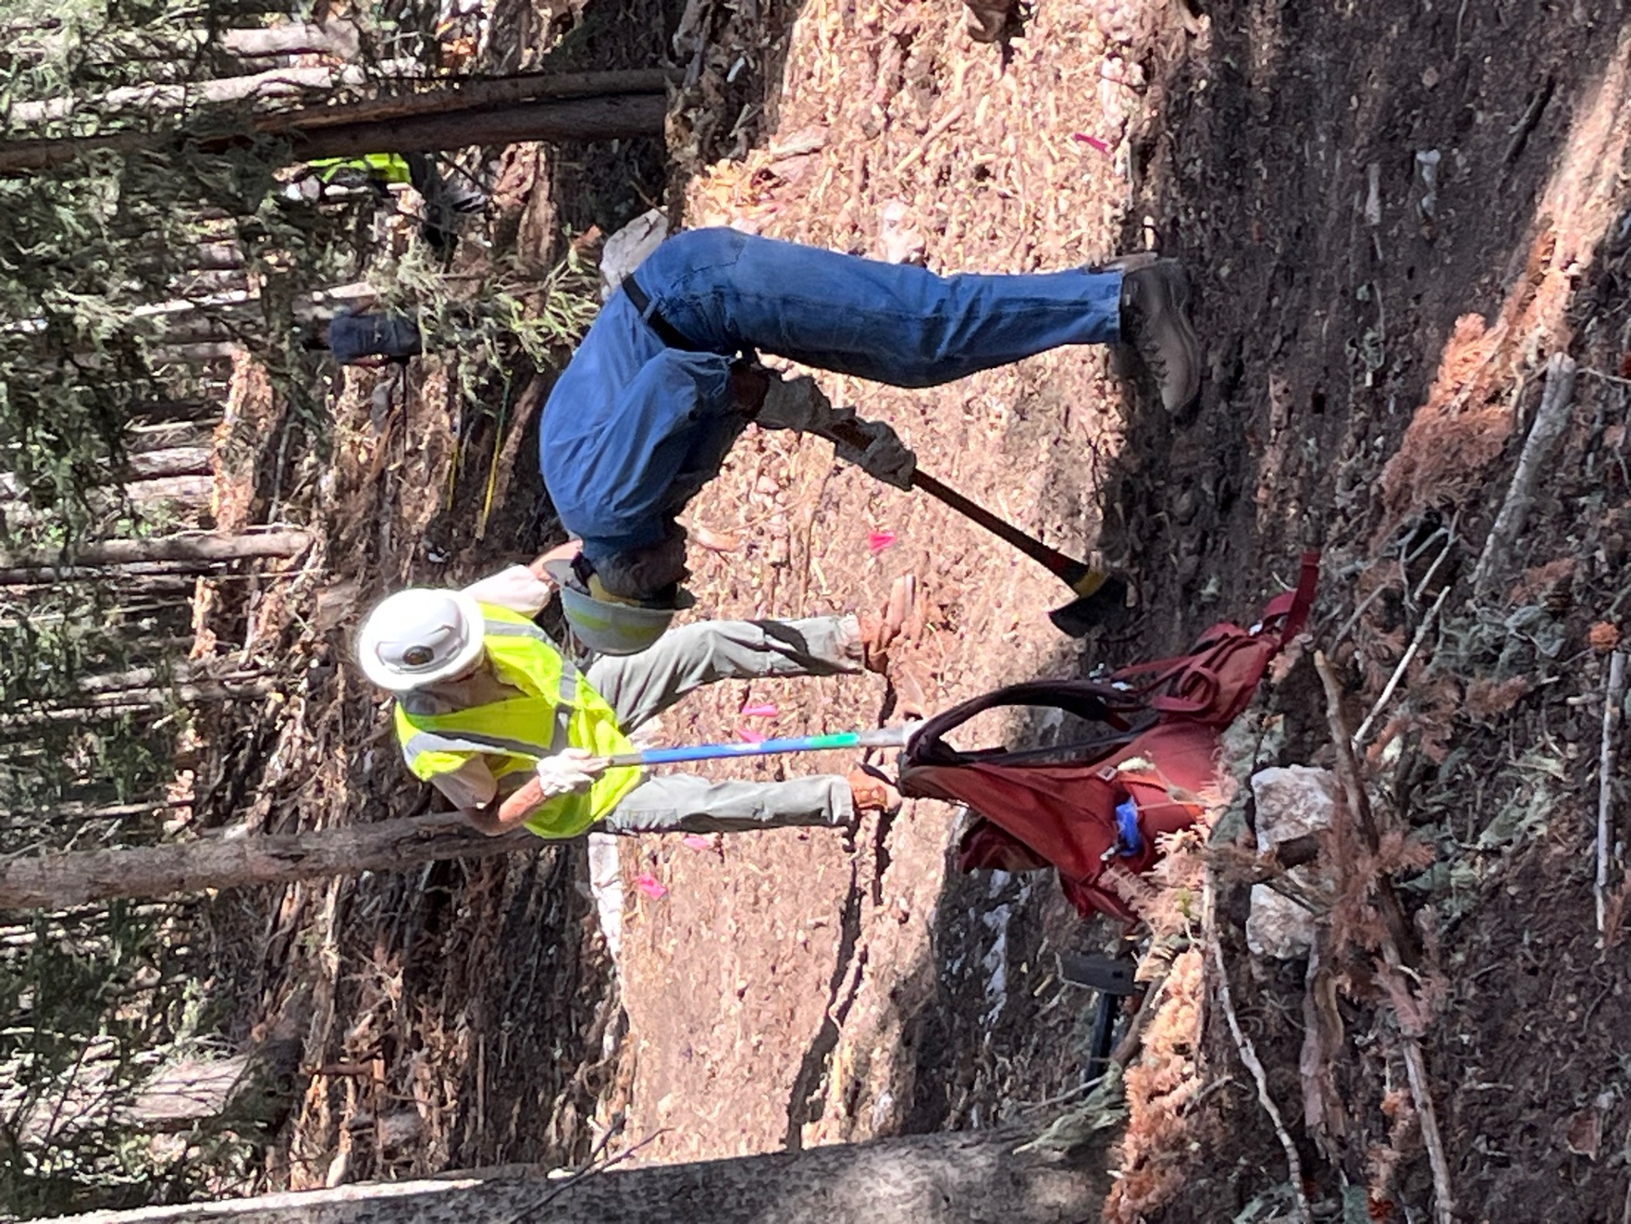

Byron and Kent try to dig out the duff and roots in an area.
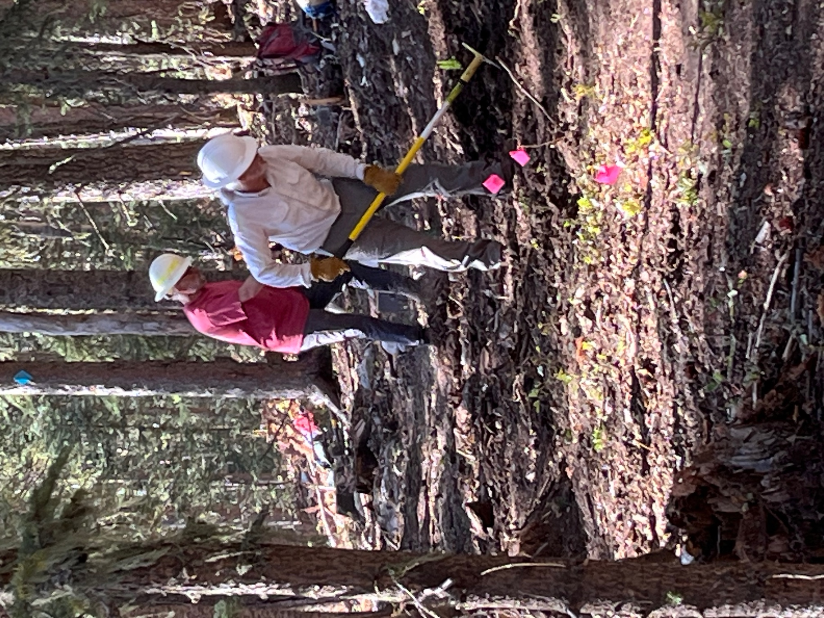

Bill and Jim clear an area.
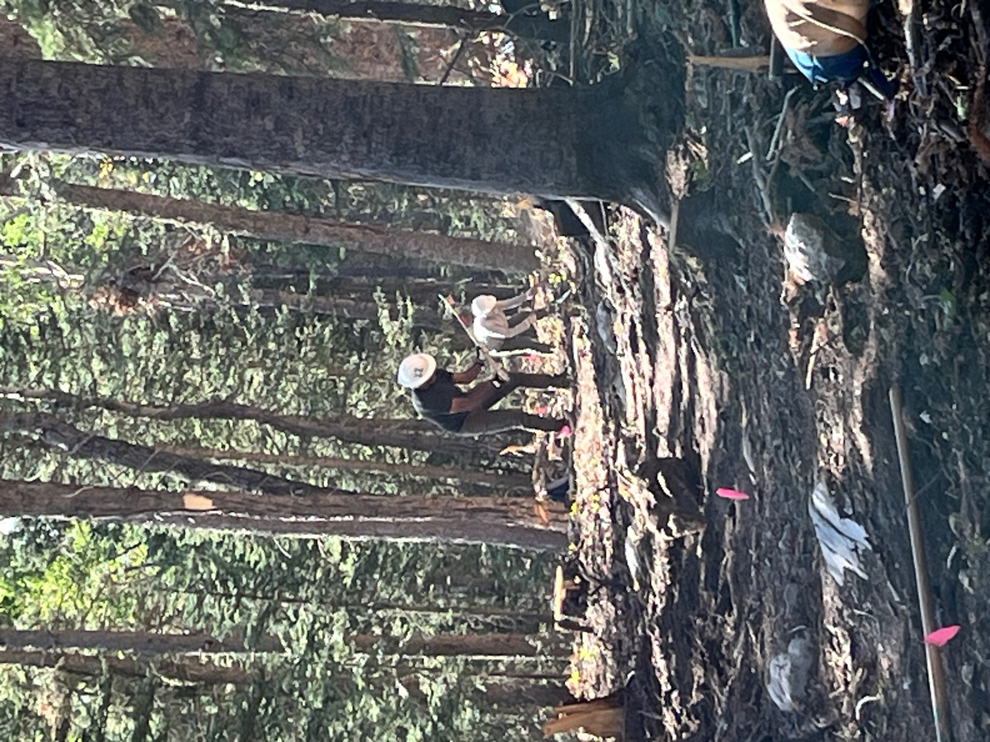

Luis and John work down the line.
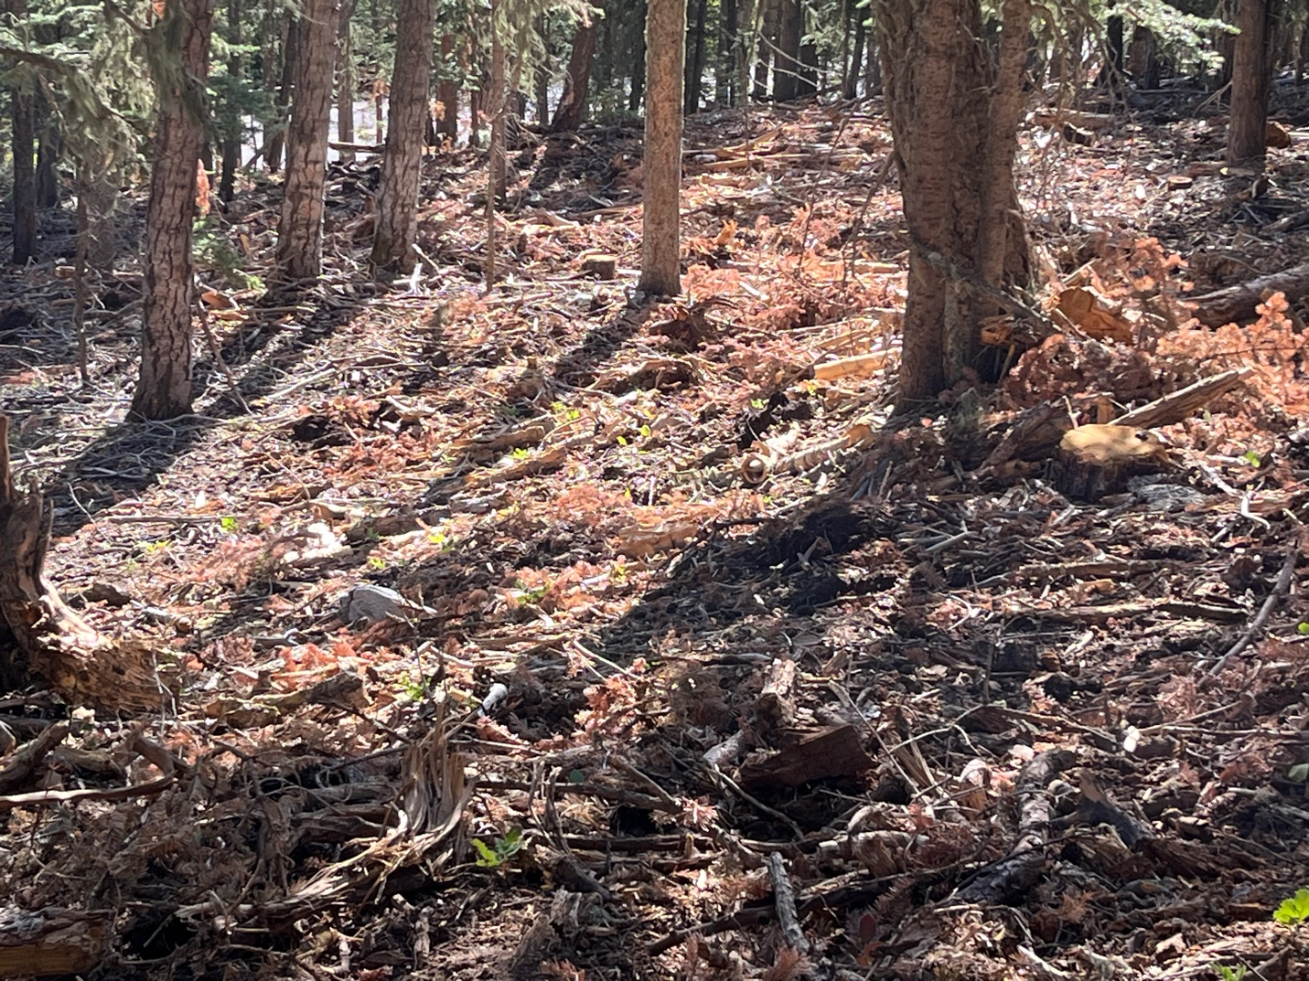

In the sunlight you can see all the green sprouts coming up.

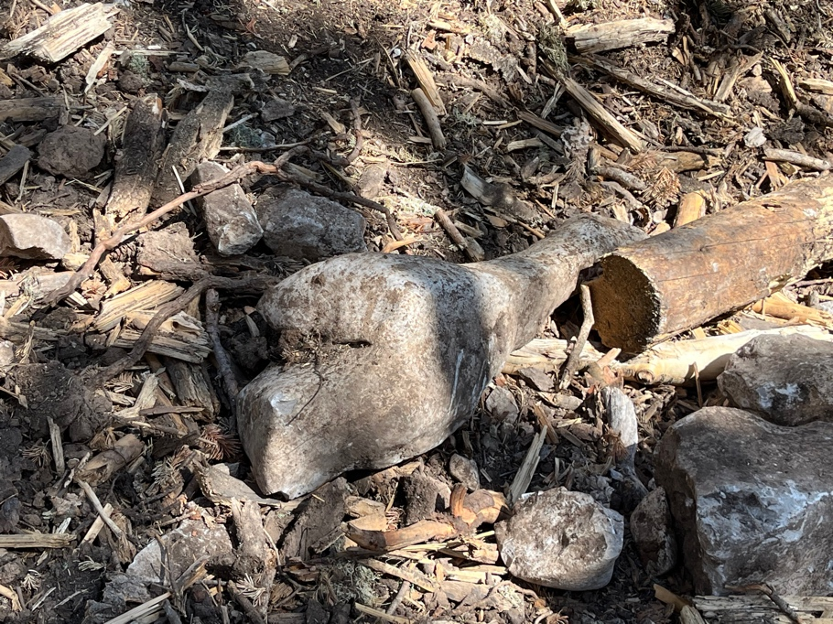 A large dinosaur bone looking rock. Or maybe a ham…
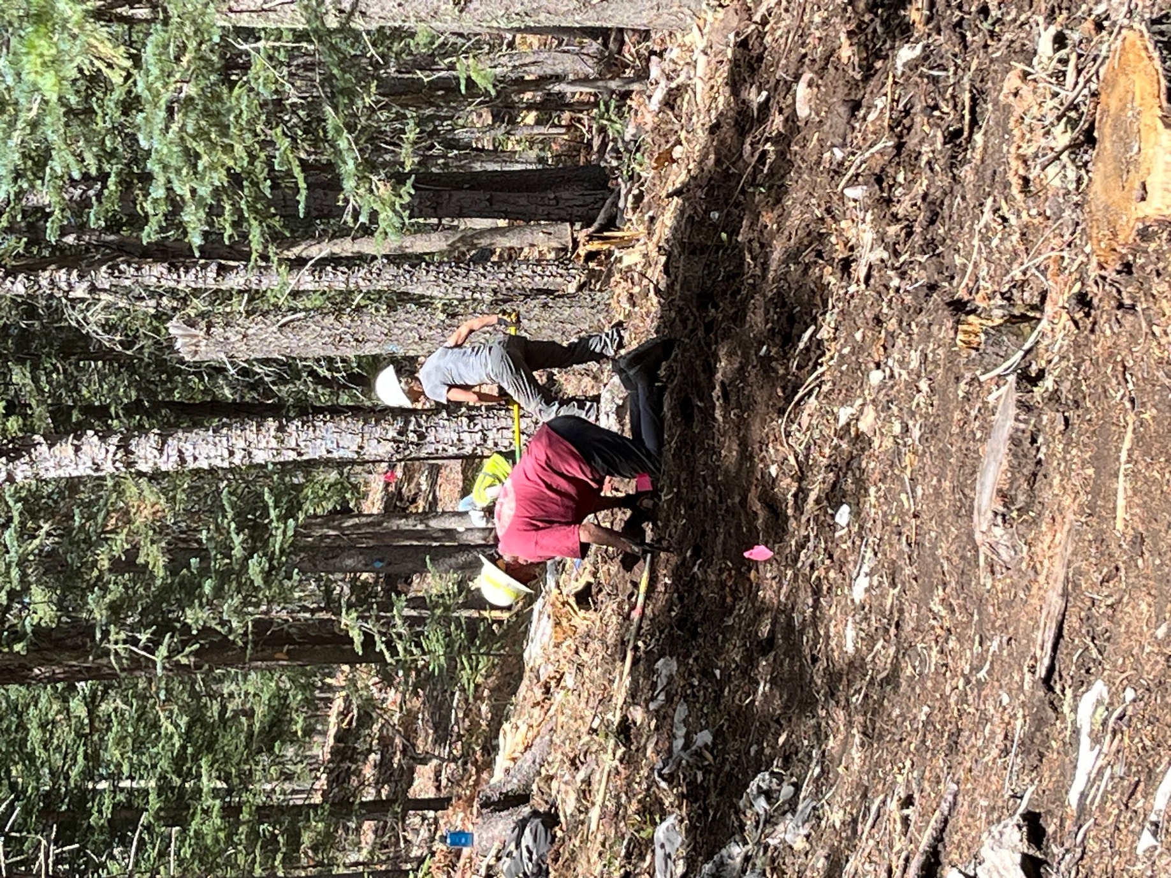

Claudia found another rocky area to work on with Jim.

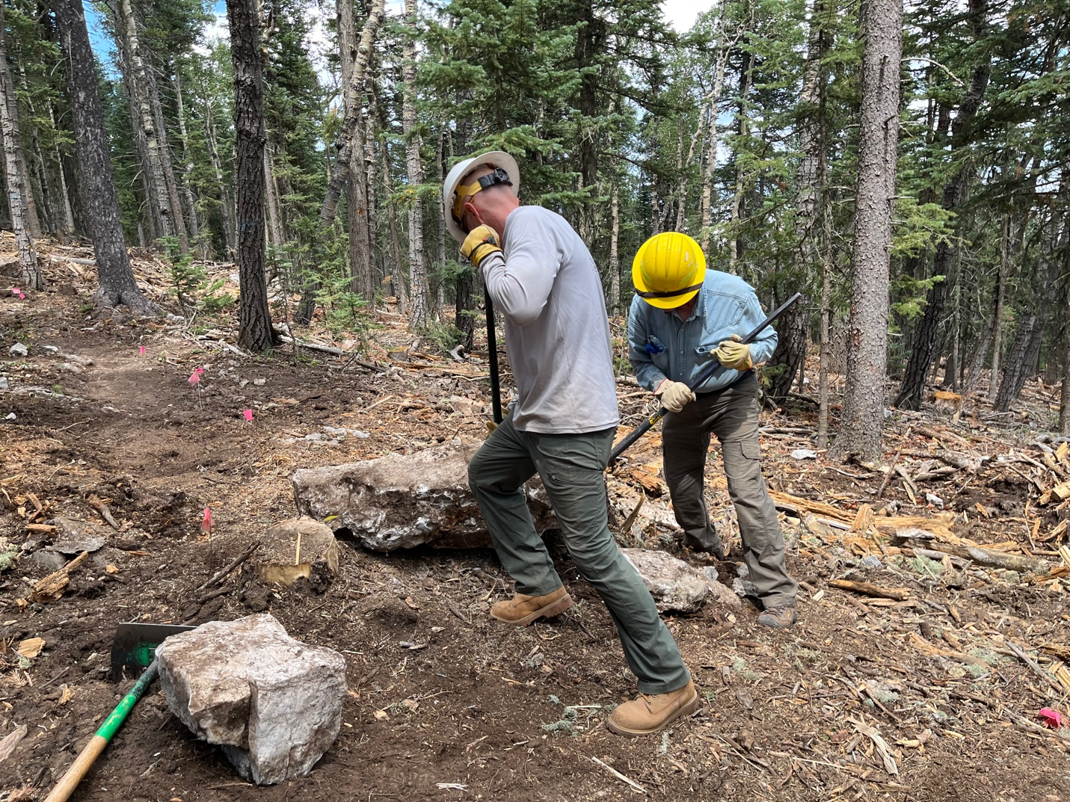

And the Rocky Horror show continues with Eric and Chris hoisting this bad boy out.
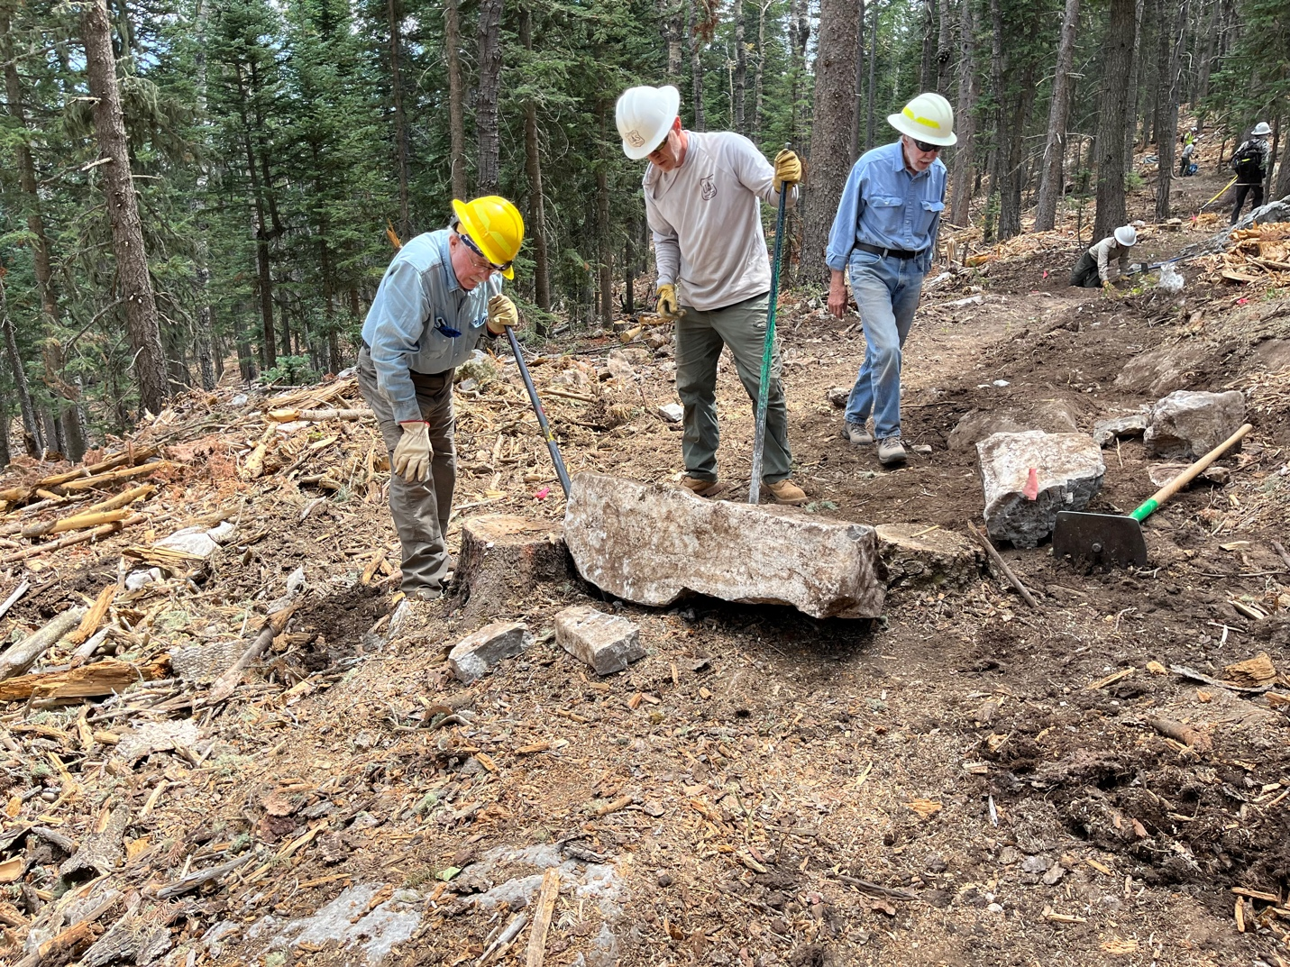

Now what do we do with it?

