Report of FOSM Project to Fabricate “Museum Open” and “Museum Closed” Signs
for the Tijeras Pueblo Archeological Site Sign on NM-337
in Front of the Ranger Station, Saturday, August 29, 2026

Jamey Browning and Sam Beard

On Saturday, August 29, new “Museum Open” and “Museum Closed” signs related to the Tijeras Pueblo Archeological Site Museum were installed on the roadside sign on NM-337 in front of the Ranger Station. Jamey Browning used his CNC (Computer Numerical Control) Machine to cut lettering in boards of Douglas Fir that holds its shape well and resists twisting or warping better than many other softwoods when moisture changes. Sam Beard painted the signs using the procedure shown in the photographs below. The following USFS colors were used in painting the signs: background, yellow-cream, Federal Standard Color Number 23695 and letters, light blue, Federal Standard Color Number 15187. The brown archeological sign is painted with Color Number 20059.

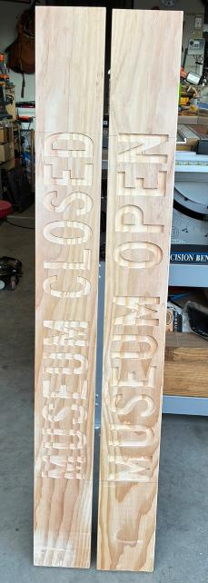
Sign letters cut in Douglas Fir boards. Photo by Jamey Browning
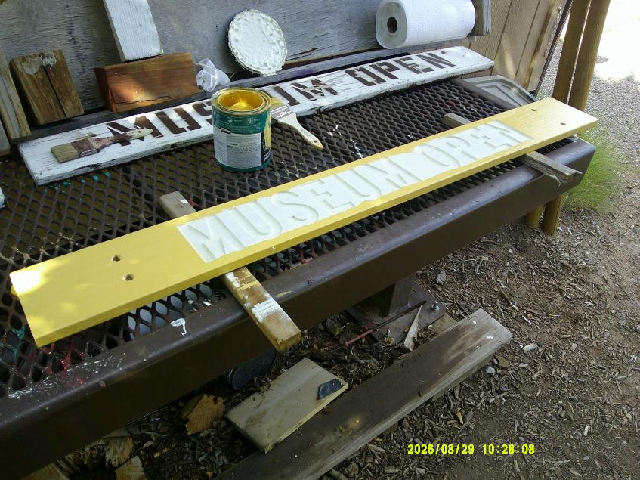
The ends of the signs and the edges were painted with the yellow-cream color. All photos by Sam Beard
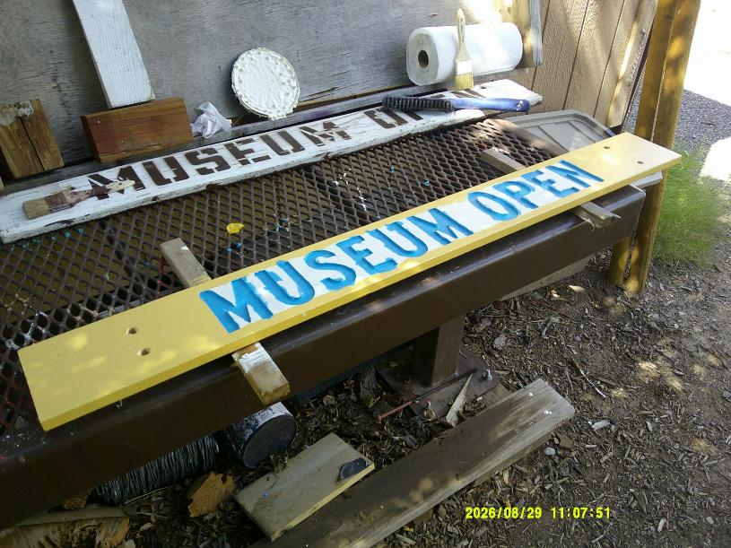
The cut areas of the letters were painted with the light blue color with an artist brush slightly narrower than the cut letters.
The blue paint on the surface of the sign was painted over with yellow-cream paint in the next step of the procedure.
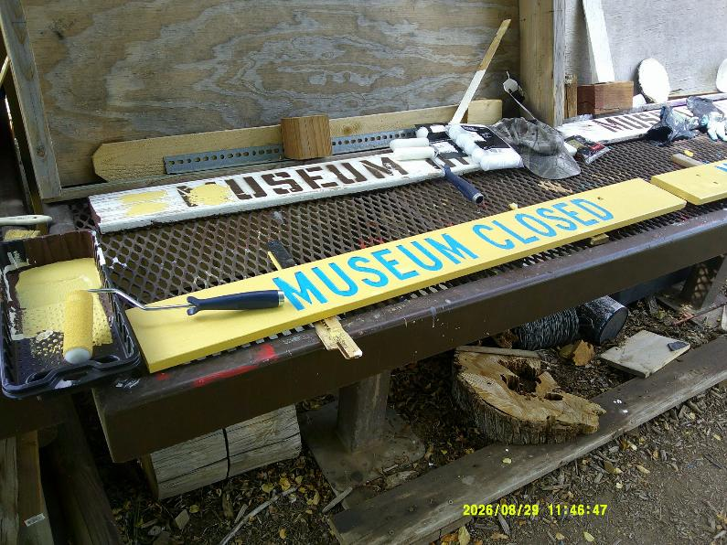
Yellow-cream paint was applied to the surface of the sign with a 4-inch-wide dense foam roller. Yellow-cream paint was accidently
applied on the blue letters in just a few very small places which were painted over with blue paint on a small artist brush.

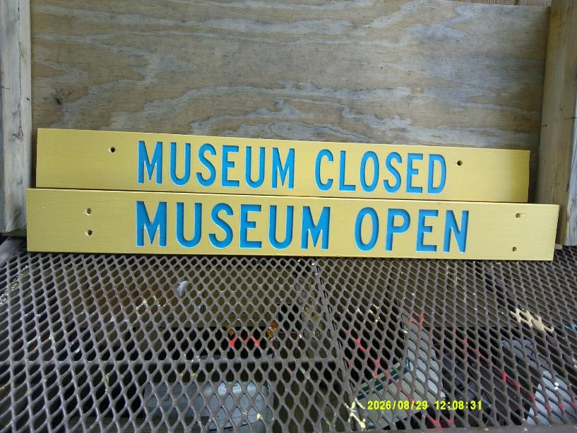
The completed museum signs on the work bench at the FOSM Guard Station.

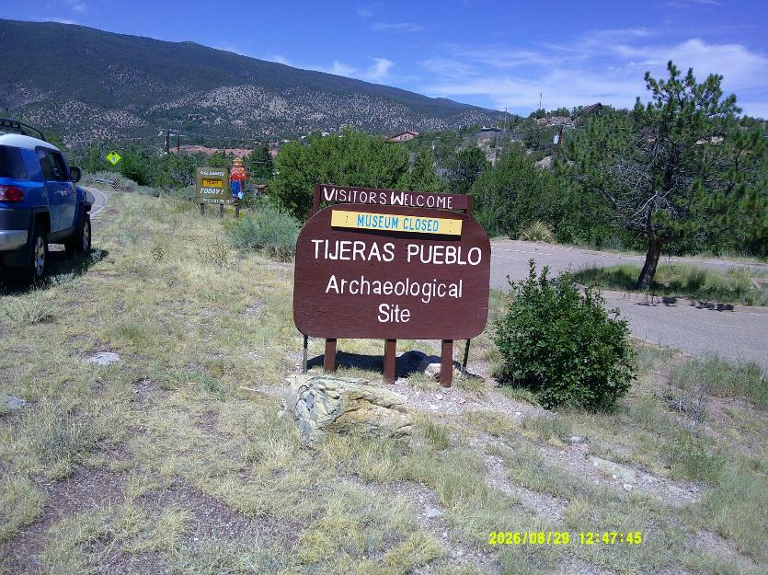
One museum sign was installed on the south side of the brown archaeological sign at the highway.
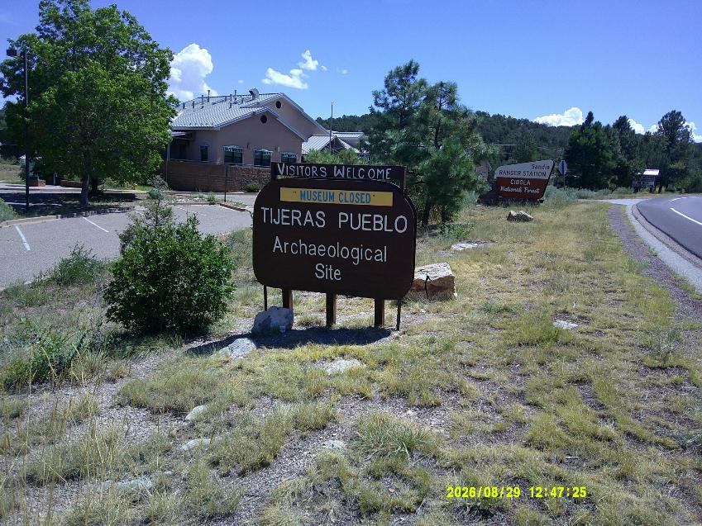
The other museum sign was installed on the north side of the archaeological sign.

