Thursday, 09/03/26- Switchback: Work continued on Switchback this week. With 12 volunteers and Chris and Isaiah (SRD) we were able to make some good progress. The plan is to continue on Switchback and then head up Buried Cable to the highest point of Switchback that needs finishing. Not sure how long this will take but having a large crew definitely helps move things alone. The demolition of the Crest House continues and the weather up top is really perfect these days.

Volunteers: Bill Perkins, Byron Garner, Kerry Jones, John McNett, Jim Houle,
Bruce Hansche, Claudia Bergsohn, Luis Cuadros, Eric Russell, Luck Anaya and Kit French (New Diggers!) and Laura Leon

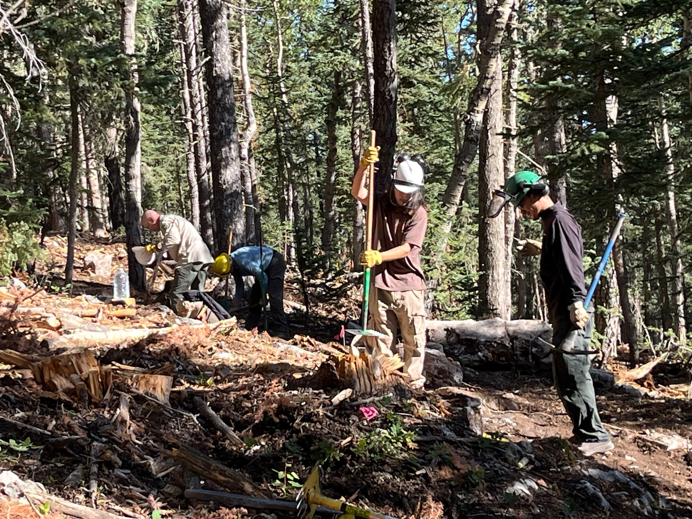
Photos: Laura Leon

Isaiah, Luck, Chris and Eric get ready to do some rock work.

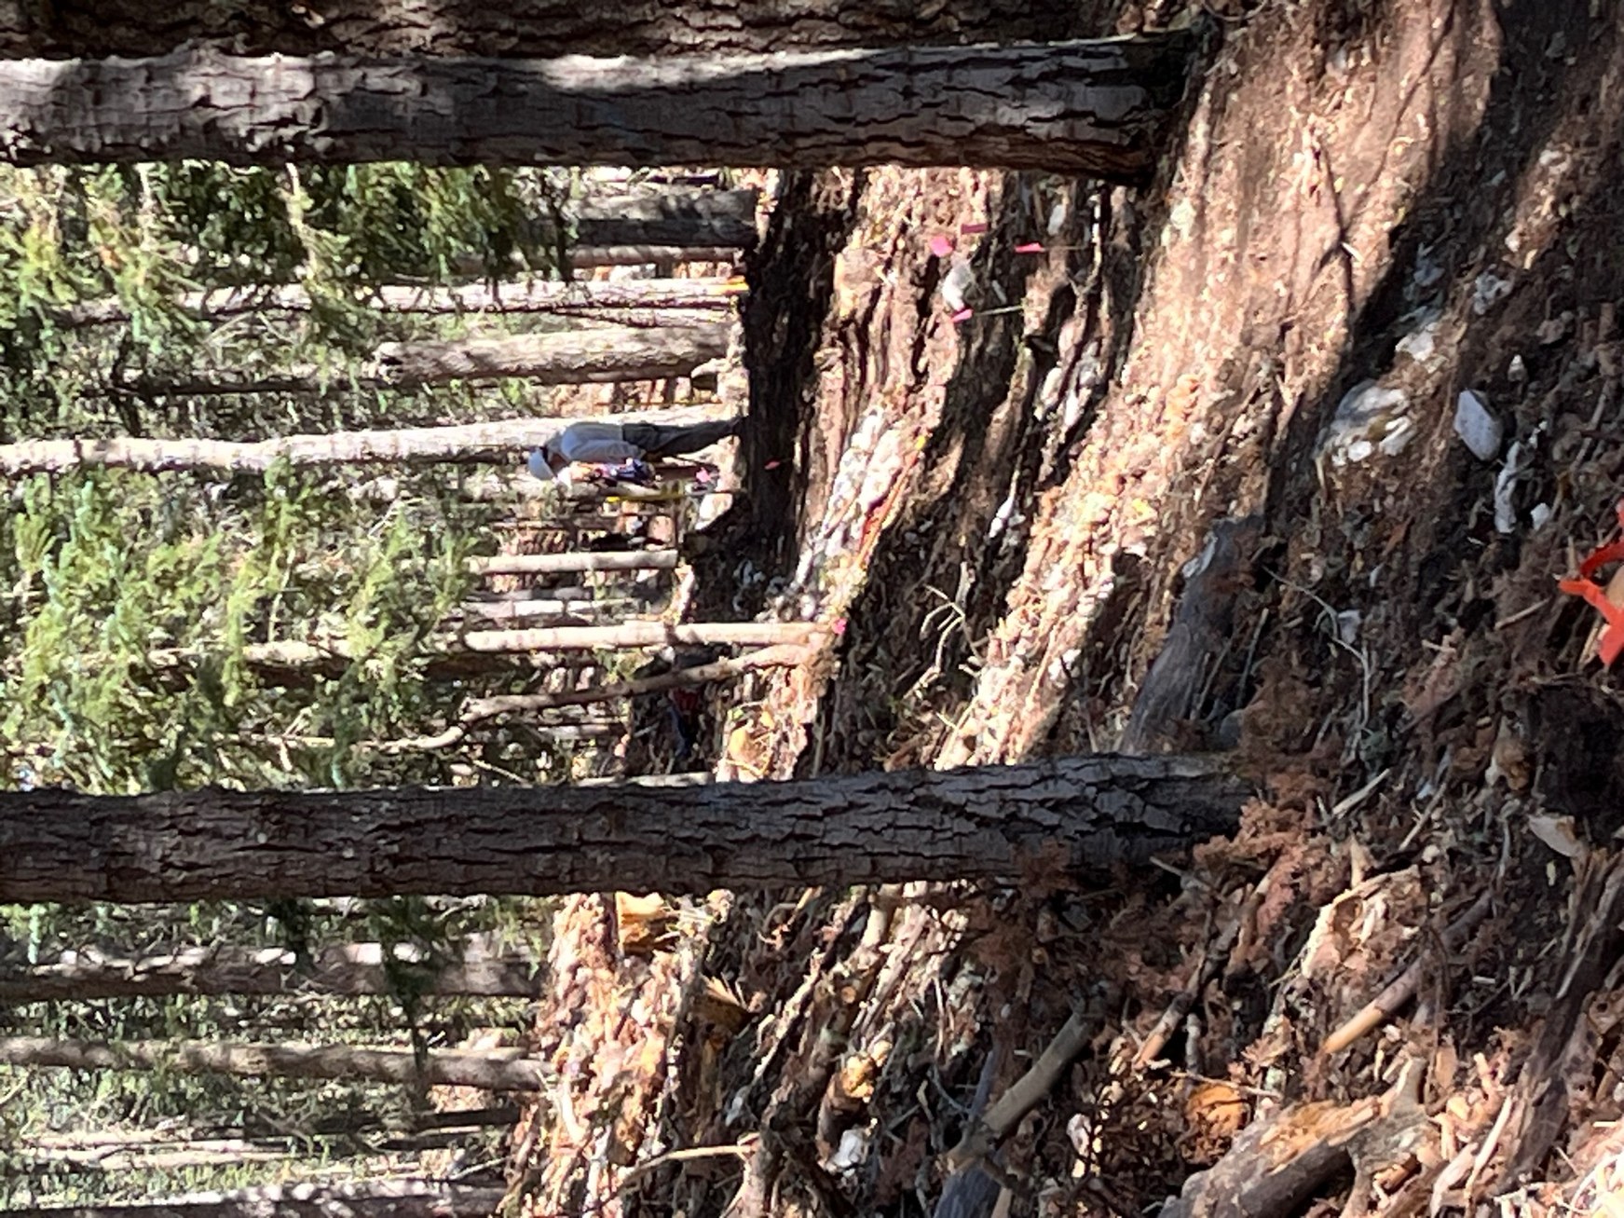

Bill reviews the work ahead.
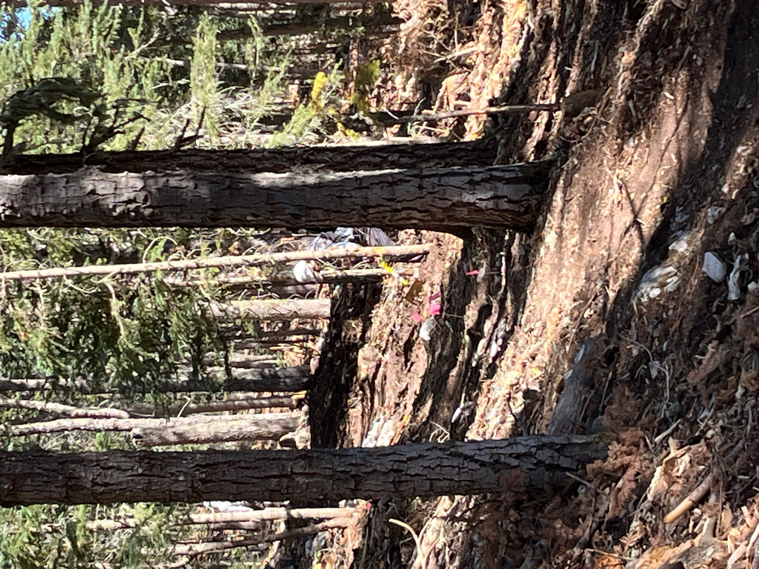

Bruce works through the duff.
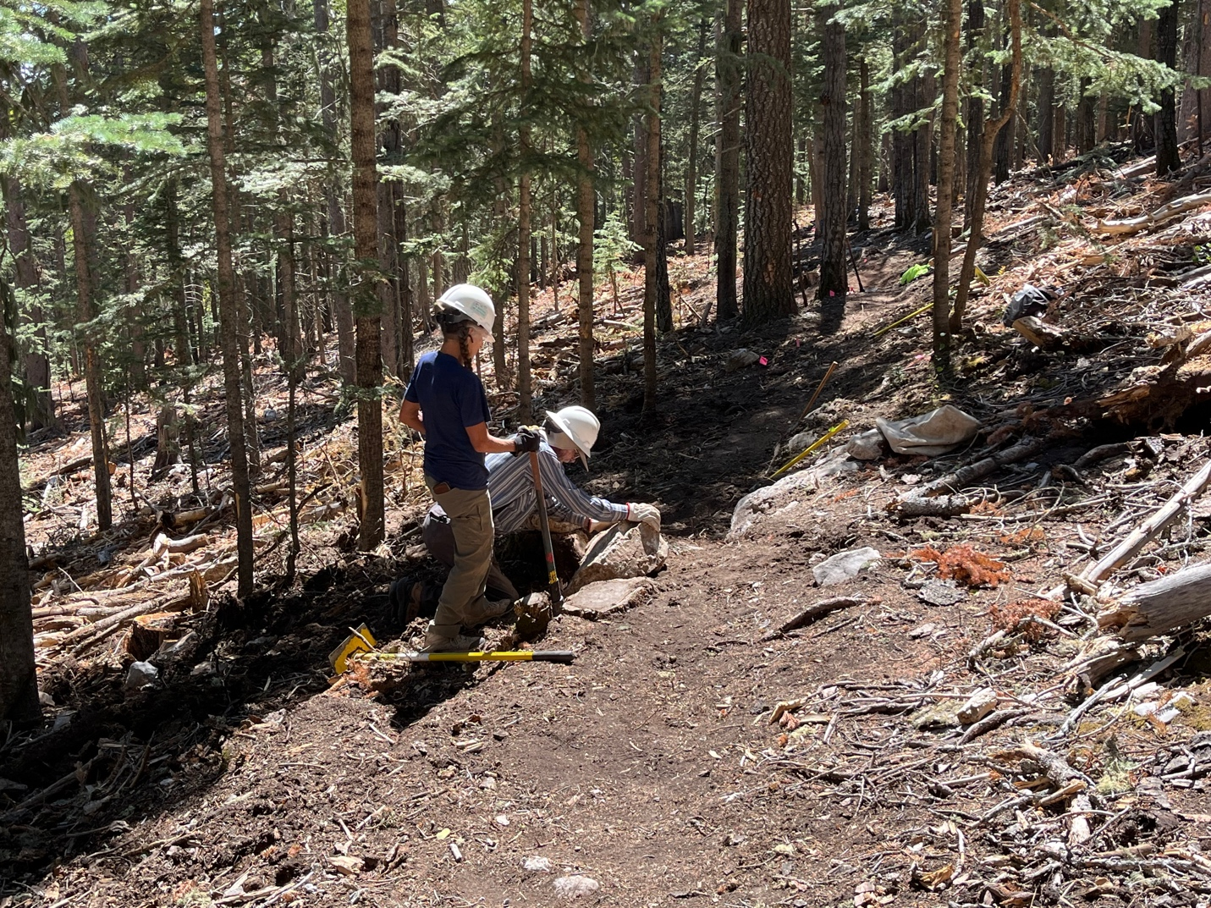

Claudia and Bruce play with rocks and holes.

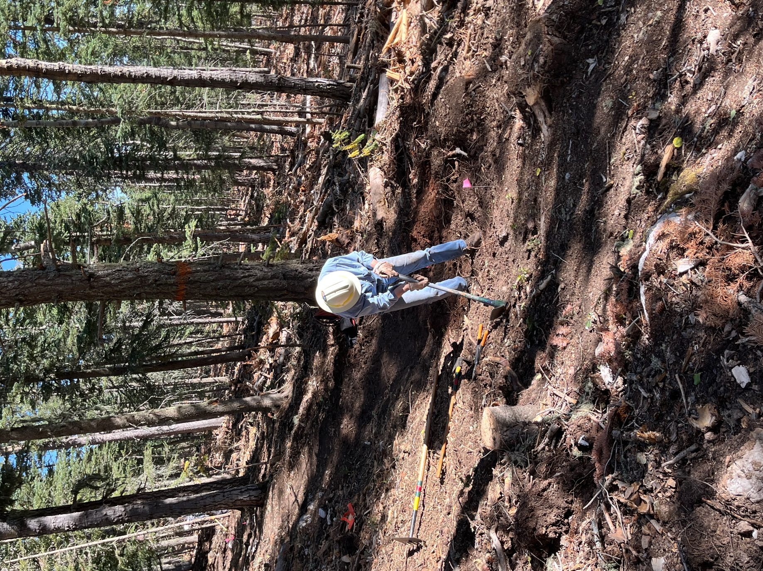

Byron digs through roots.
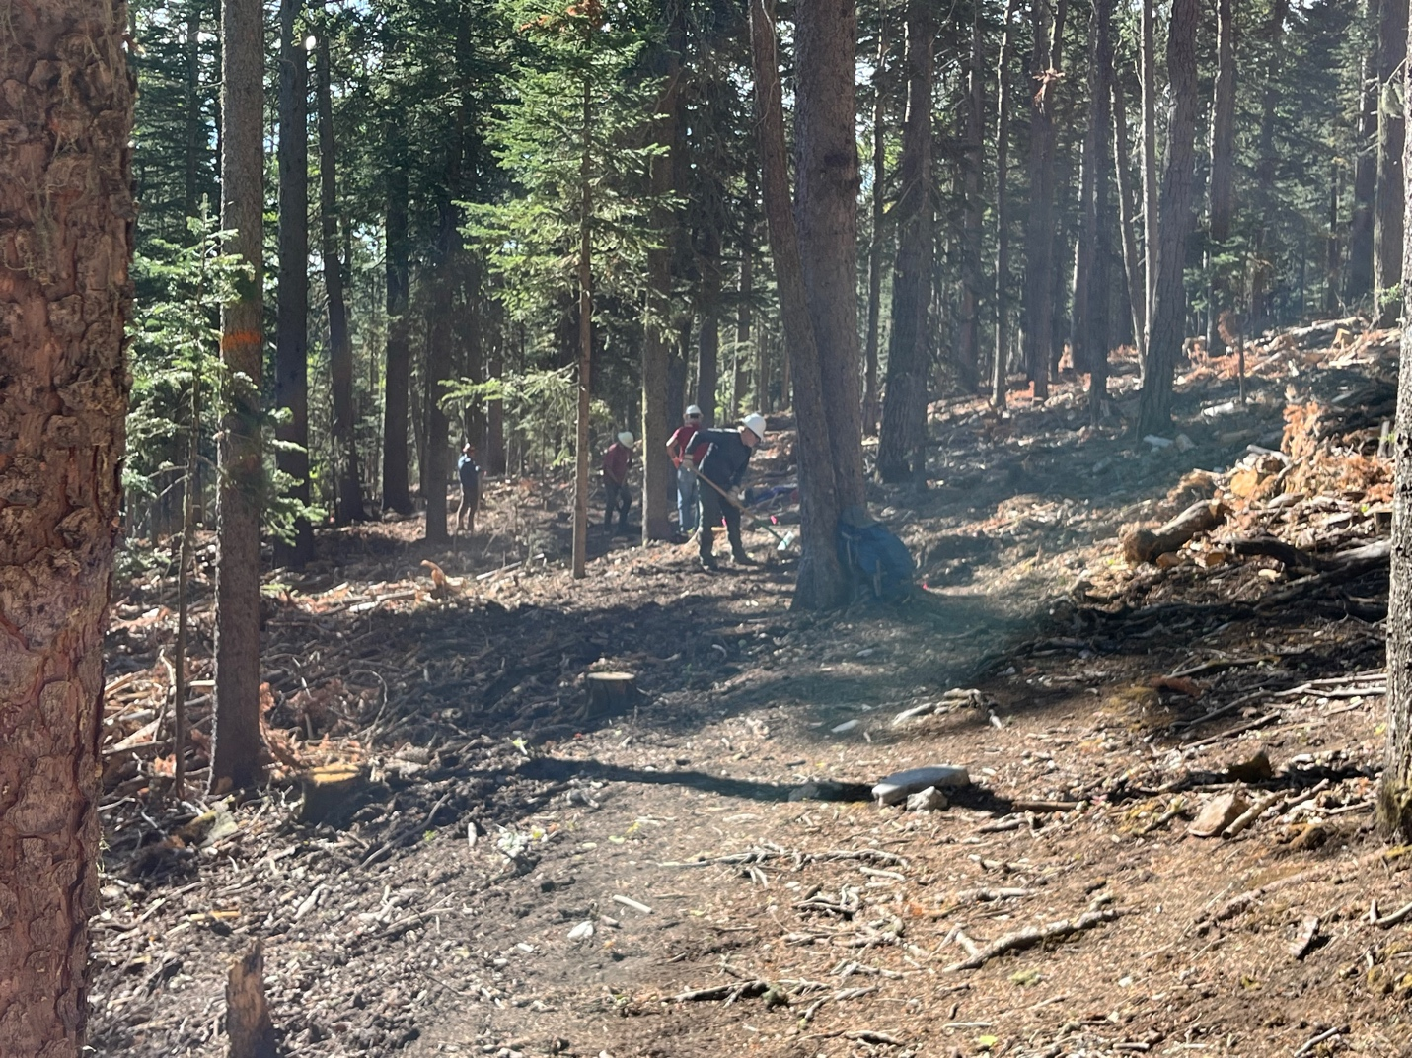

John, Kit, Jim and Kerry worked all day on this section. Because they are dedicated, cool dudes. And Kit said he would come back!

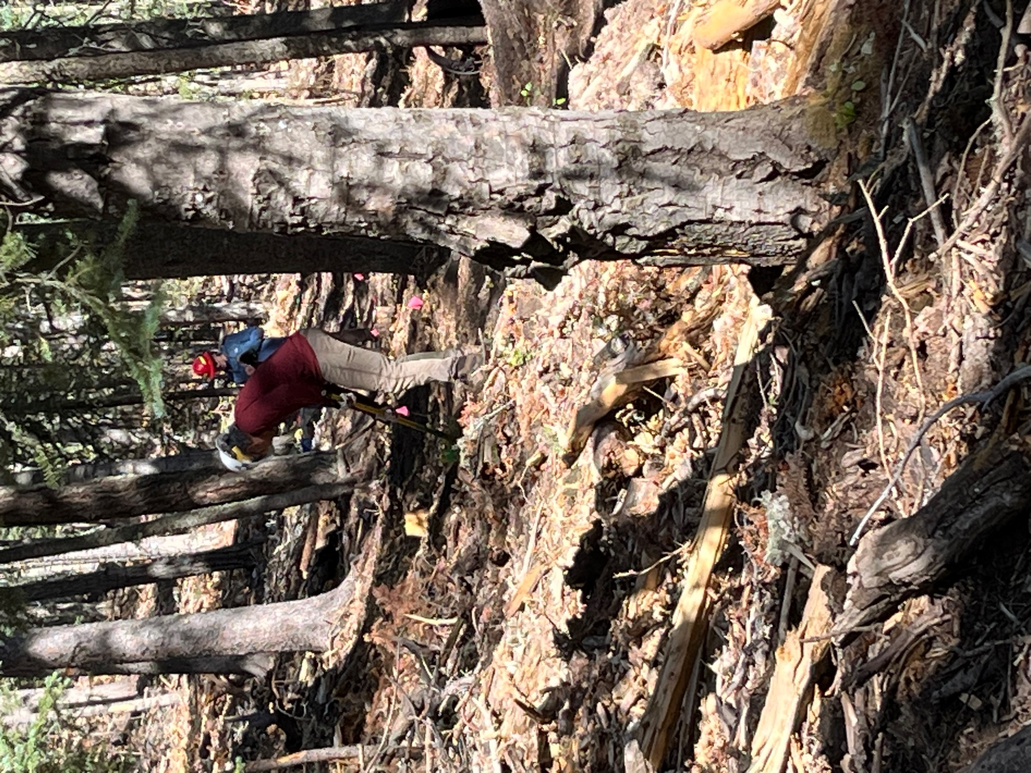

Luis and Kerry dig through the debris.

