Report of the FOSM Project to Replace Four Broken Fence Posts in the Upper Cienega
Canyon Picnic Area Parking Lot, Wednesday, September 2, 2026
Sam Beard
On Wednesday, September 2, seven FOSM volunteers replaced four rotten and broken posts with four pressure-treated posts that had been stored at Don Carnicom’s house near the picnic area. The most difficult task in the replacement of a broken post is digging out the remains of the rotten post in the ground. After the rotten debris is removed, a new post is placed in the hole and dirt and rocks are packed around it. A long twist bit or spade bit is then used to drill a 5/8-inch diameter hole through the pole and post. A Forstner bit is used to cut ½-inch deep counter sinks on the side of the pole and the back of the post so that the nut and threaded rod end do not protrude past the post where they could injure a visitor. One-half-inch diameter threaded rod is inserted in hole, washers are place on each end, and the nuts are tightened to secure the pole the post. The top of the post is then cut the height of adjacent posts.
The volunteers working on this project were Jerry Carroll, Kent Towler, Don Carnicom, Eric Russell, Dan Benton, Sam Benton, and Dan Benton.

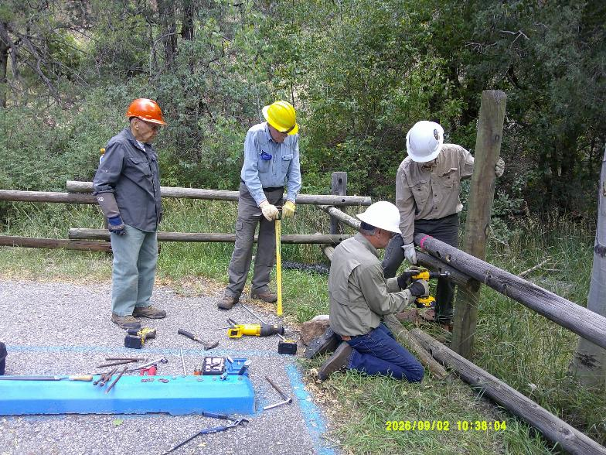
L to R: Don Carnicom, Eric Russell, Chuck Logan, and Kent Towler are attaching the second of four poles to the
new post. Chuck is using a battery-powered drill and Forstner bit to cut a 2-inch diameter hole about ½-inch
deep to form a counter sink so that the nut and threaded rod end are not protruding from the pole. All photos by Sam Beard
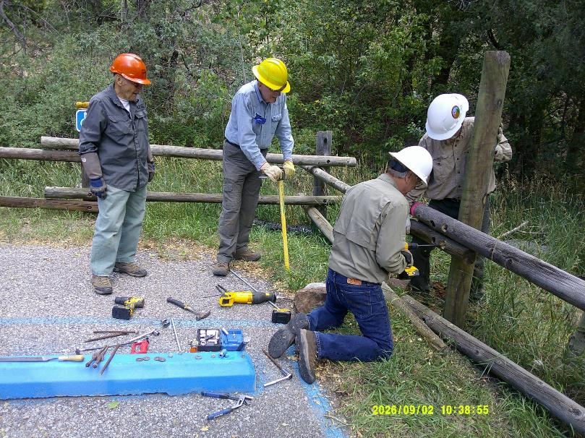
Chuck is now using a bit to drill a hole through the pole and post so that a long piece
of threaded rod and nuts will secure the pole to the post.
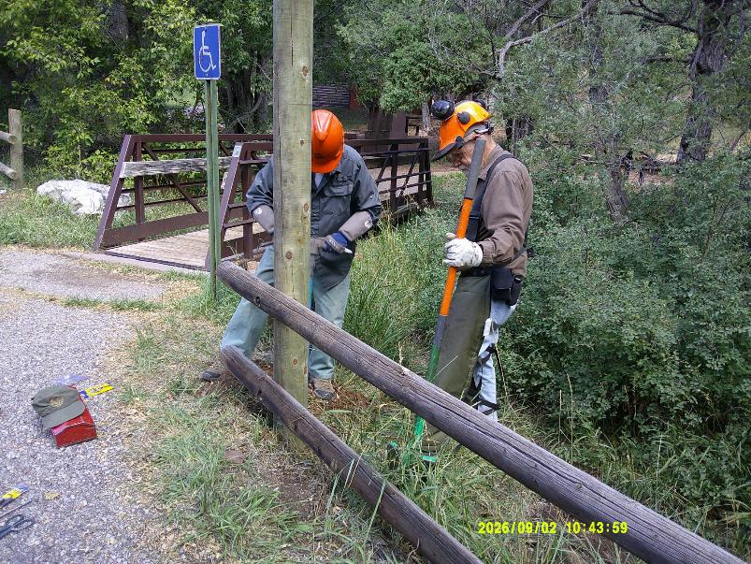
Don Carnicom is using the handle of a pick to pack dirt and rocks around the new post.
Jerry Carroll is holding a shovel that was used to put dirt in the hole around the post.
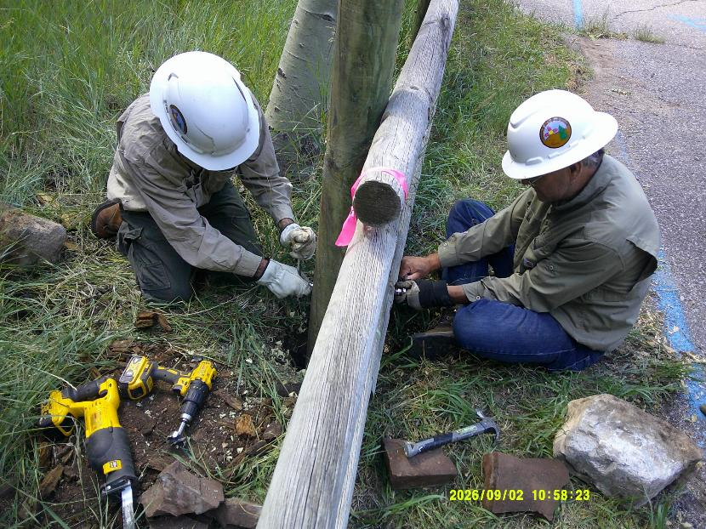
Kent and Chuck are tightening the nuts on the threaded rod to finish replacing the broken post.
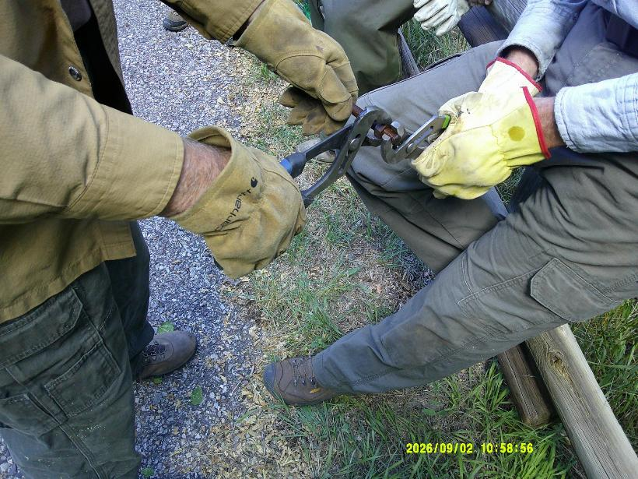
Two volunteers are using Channellock pliers to remove a nut from an old rusty piece of threaded rod.
Old rusty nuts, washers, and threaded rod are recycled to attach poles to the posts.
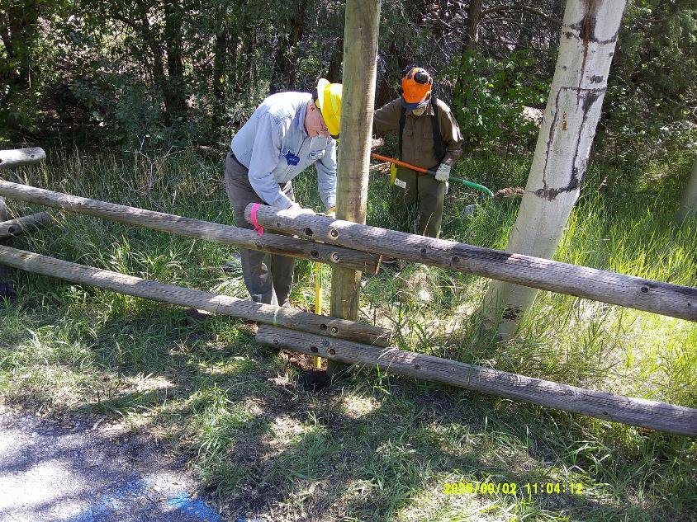
Jerry is bringing dirt to fill the hole around the post, and Eric is using a pick handle to pack the dirt.
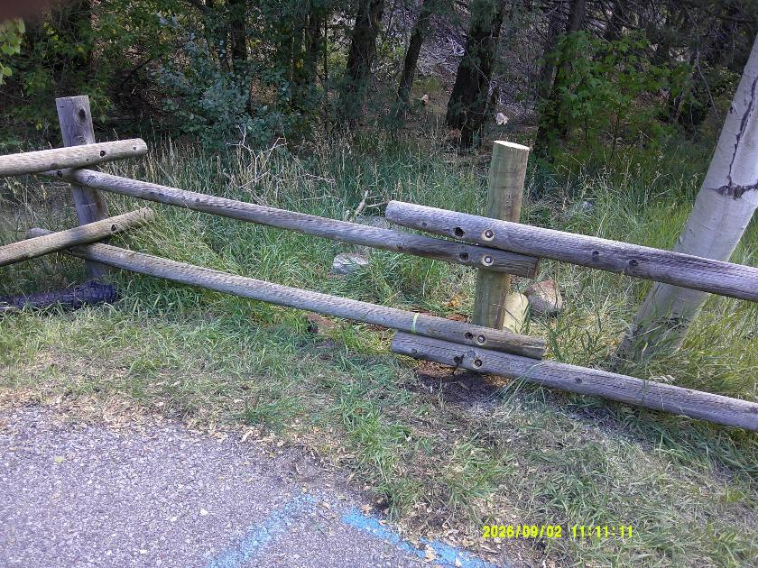
The completed installation of a new post in the fence on the right side of the entrance to the parking lot.
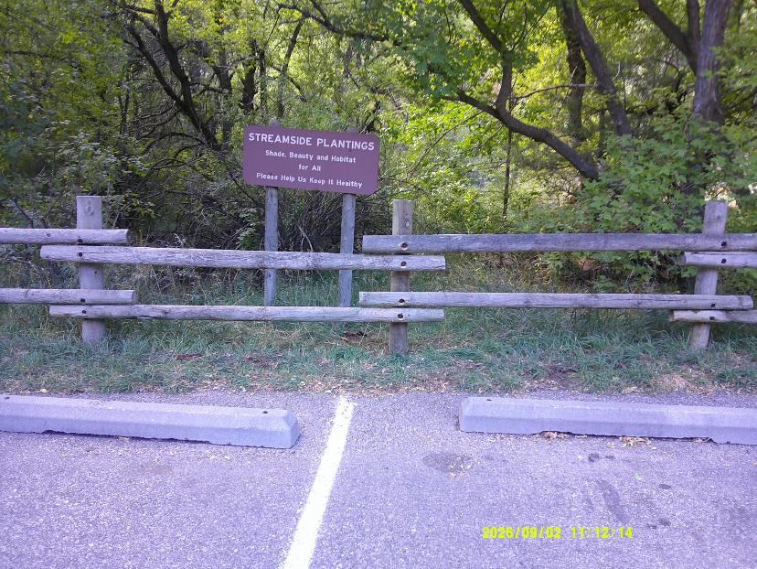
The center post near this vegetation sign was replaced on the side of the parking lot next to Cienega Creek.
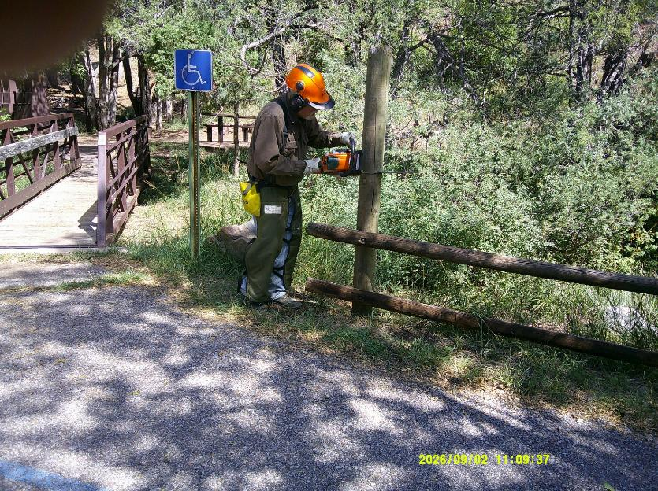
Jerry using his chain saw to cut the new post to the height of adjacent posts.
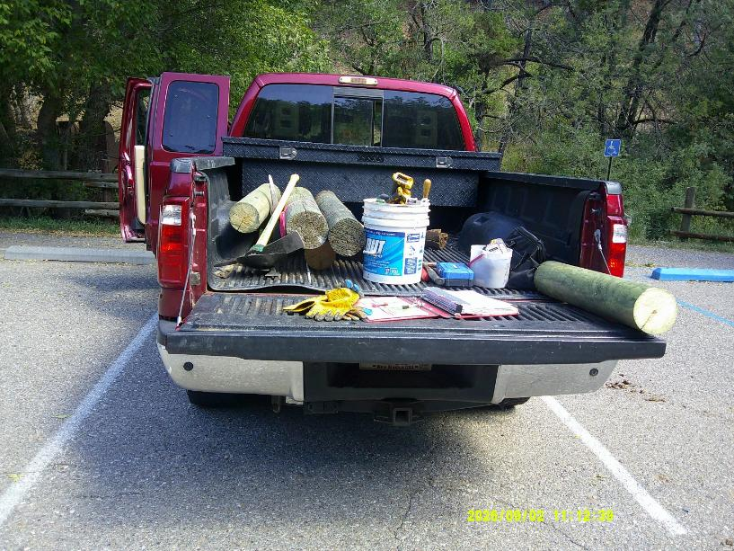
FOSM tools and supplies are hauled in Jerry’s pickup. The pieces of pressure-treated posts will be hauled to the Sandia Ranger District
trash pile and taken to the local transfer station. Pressure-treated wood should not be burned in fire places or stoves.

