Report of the FOSM Project to Work with Sandia Ranger District Personnel to Install a Three-Panel Kiosk
at the Pine Flat Picnic Area, Wednesday, September 9, 2026

Sam Beard
FOSM volunteers and Sandia Ranger District personnel began installing a large three-panel kiosk at Pine Flat Picnic Area on Wednesday, September 9. Attempting to dig four post holes to a depth of 30 inches was the most time-consuming part of the project.
The instructions for the installation of the kiosk were to dig the post holes to a depth of 30 inches with a diameter of 18 inches. The four holes for this kiosk were quickly dug to a depth of about 24 inches with the power auger on the skid steer. At this depth was a layer of a few inches of rock that the auger could not penetrate. An electric hammer and manual rock bar were then used to remove enough of the rocks in the two center holes for the auger to dig deeper. At the upper end of the kiosk, the plan was to remove six inches of the steel post, because it was not practical to remove all the rock so that the hole could be dug to 30 inches. The ground was sloping down enough to the west that it was not necessary to dig to a depth of 30 inches at the fourth hole.
The kiosk was sold by the Rockart Company, 3006 North Maple in Mesa, Arizona. In addition to digging the four post holes, the installation of the center panel included bolting two special temporary pieces of aluminum to the two posts. The posts were then in the correct orientation for the panel to be bolted to the posts after the concrete had cured. This procedure was designed to avoid attempting to place the posts in the required positions using the heavy center panel. The two outer panels will be installed later by the SRD personnel.
The FOSM volunteers were Sim Cook, Jerry Carroll, Chuck Logan and Sam Beard. The SRD personnel were Kenny Capps, Steven Woshee, and Isaiah Ramires.
Project photos are presented below.

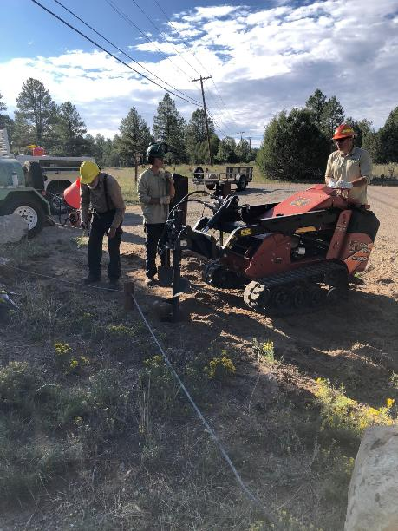
Digging the first hole with the skid steer auger. Photo by Sim Cook

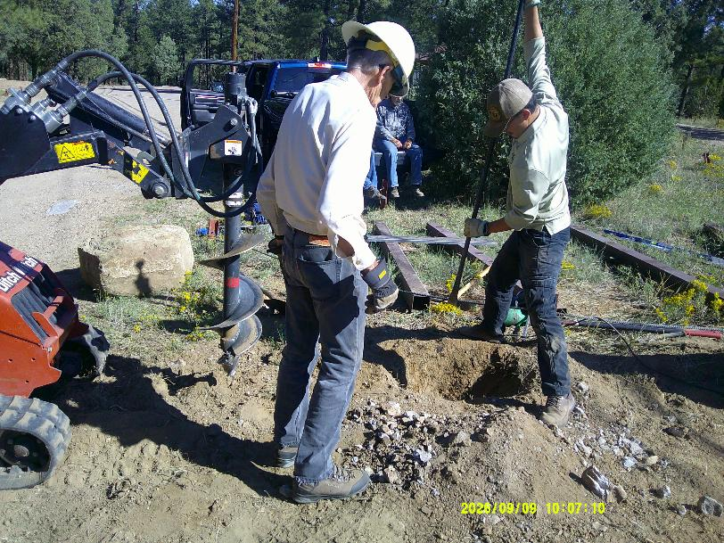
Steven Woshee is using a steel rock bar to remove some of the rock.
All photos by Sam Beard unless noted otherwise
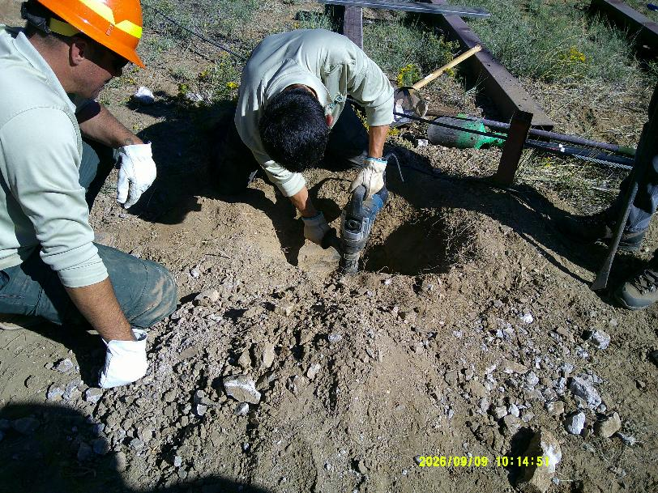
Isaiah Ramires is using an electric hammer to break the rock.

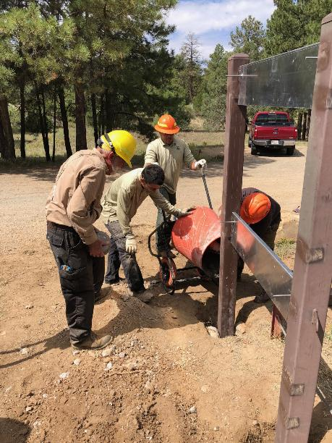
A small electric mixer was used to mix the concrete to pour around the posts.
L to R: Sam Beard, Isaiah Ramires, and Kenny Capps. Photo by Sim Cook
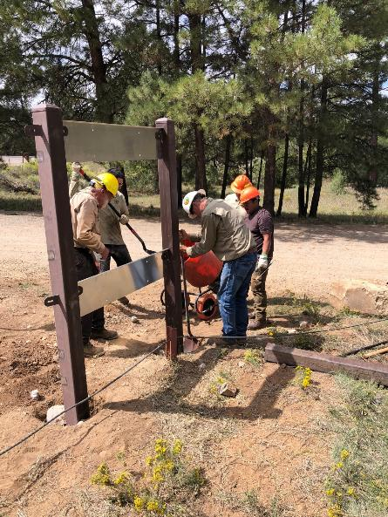
Pouring concrete around the first post. Aluminum panels from the kiosk company were bolted
between the steel posts and supported them in the correct location temporarily until the concrete
had cured enough that the heavy center panel could be installed with four bolts. Photo by Sim Cook
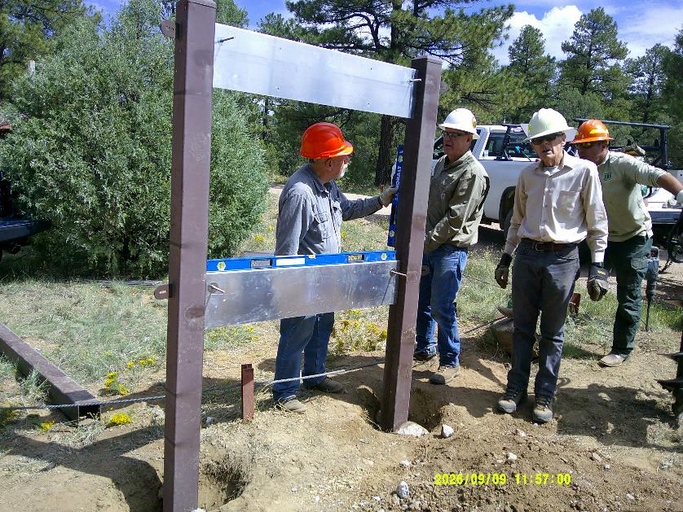
Jerry Carroll is using a level to verify that the post is vertical.
L to R: Jerry Carroll, Chuck Logan, Sim Cook, and Kenny Capps.
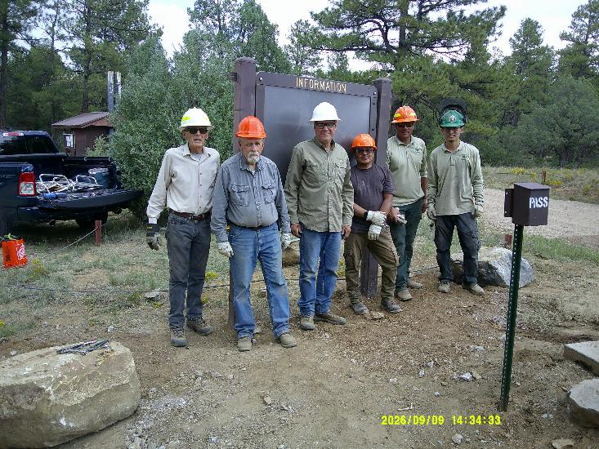
The heavy center panel has been installed. The two large stones are covering the two other holes that had been dug.
The SRD employees will complete the installation of the two other panels. L to R: Sim Cook, Jerry Carroll, Chuck Logan,
Steven Woshee, Kenny Capps, and Isaiah Ramires.

