Thursday, 09/10 26- Switchback: After 8 weeks of work on both Thursdays and some Tuesdays, the crew made it to the end of the first section of Switchback!
This week, 11 volunteers and Jen (SRD) made it to the end of the section- about 4000 feet of trail. There was a lot of debris removal along the way and thanks goes out to all the extra FS folks who came out periodically to help. It was a satisfying day which ended with an uphill climb with tools to Buried Cable where we will start work next week. Work on Switchback will continue once the mitigation people complete their work at the crest. By the way, the weather up at the crest is wonderful! If you are looking for a break from the city heat, try a 10K hike!

Volunteers: Bill Perkins, Byron Garner, John McNett, Bruce Hansche, Luis Cuadros,
Claudia Bergsohn, Kerry Jones, Jim Houle, Kit French, Cleve Sharp and Laura Leon

Pictures: Laura Leon Maps and numbers: Luis Cuadros

Switchback UPPER........4,065 ft
progress 9/10/2026.........3,907 ft
remaining ..........................158 ft

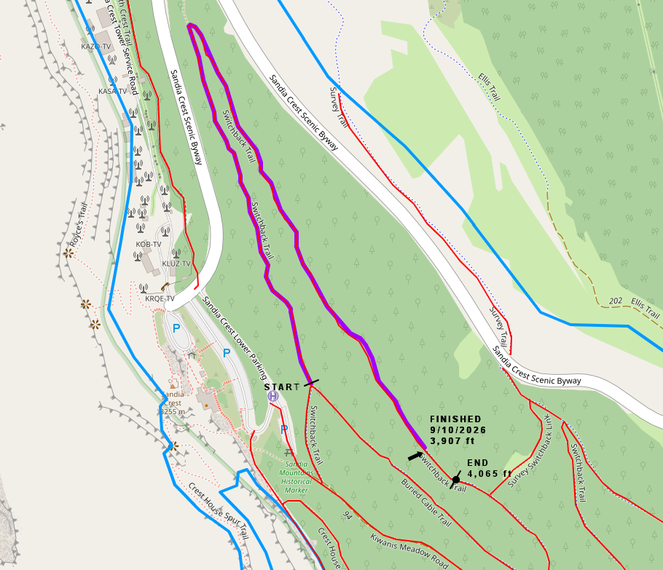

We will return to Switchback to do some finishing work next week but the debris has been moved and most of the tread is close to finished.

I walked the length of the finished tread to make sure we hadn’t left any tools of personal items along the way. It was a beautiful walk.
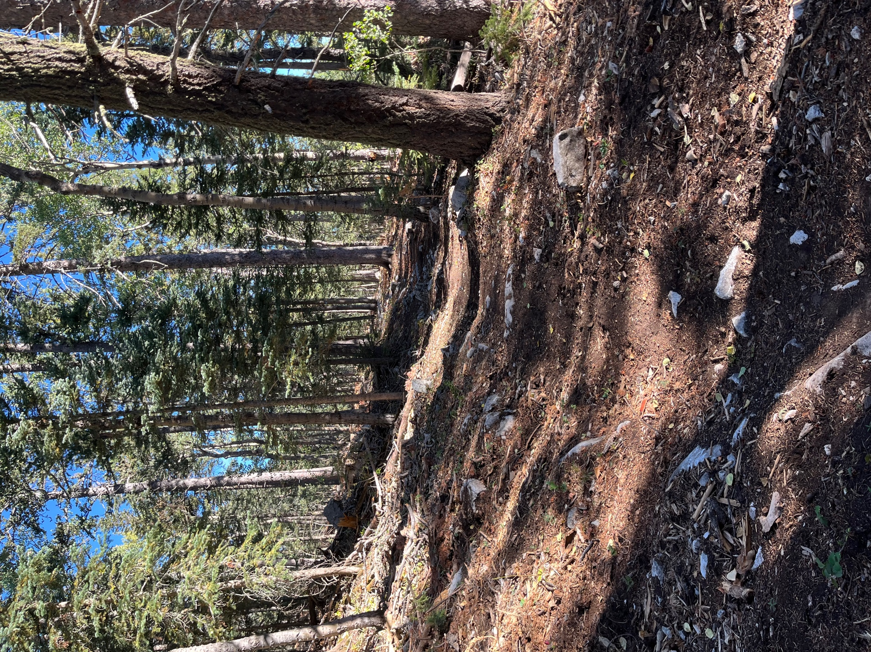

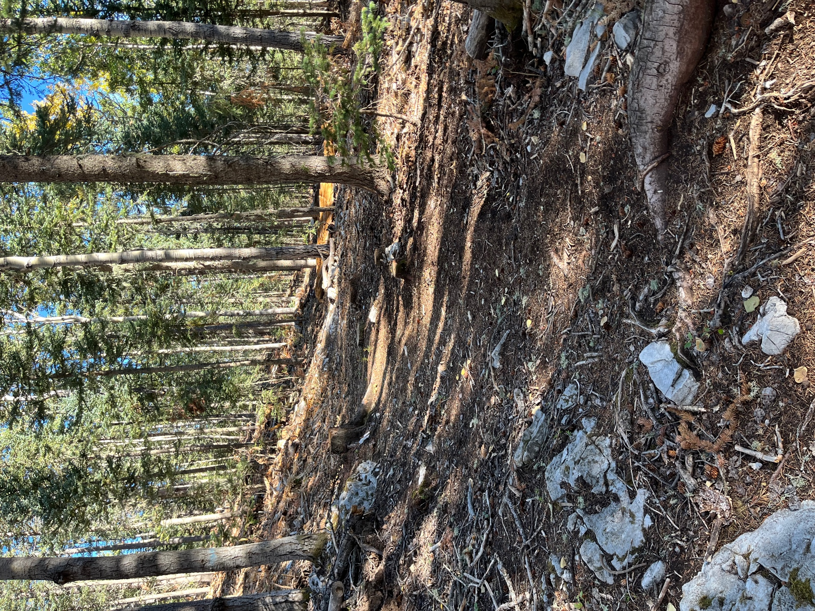

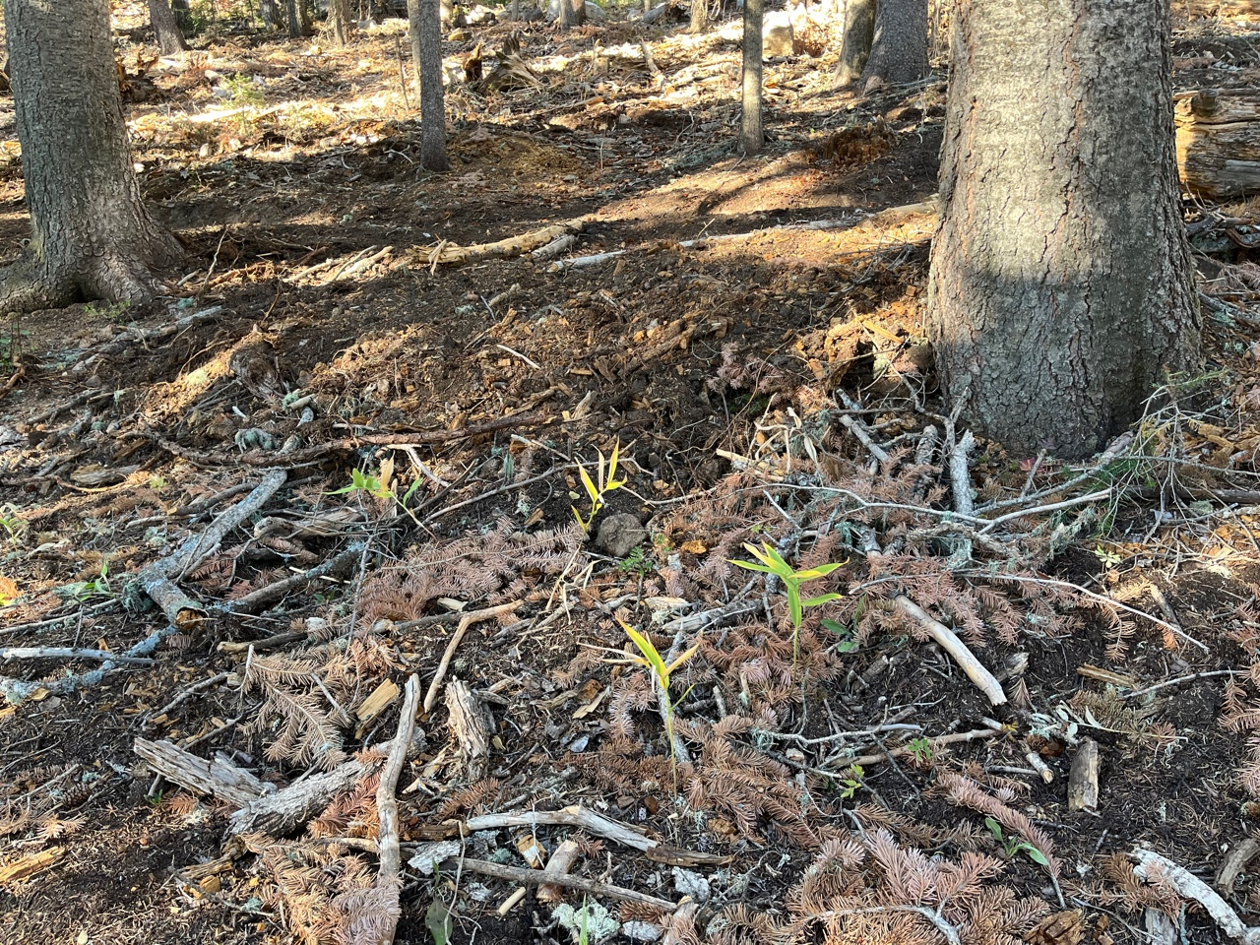

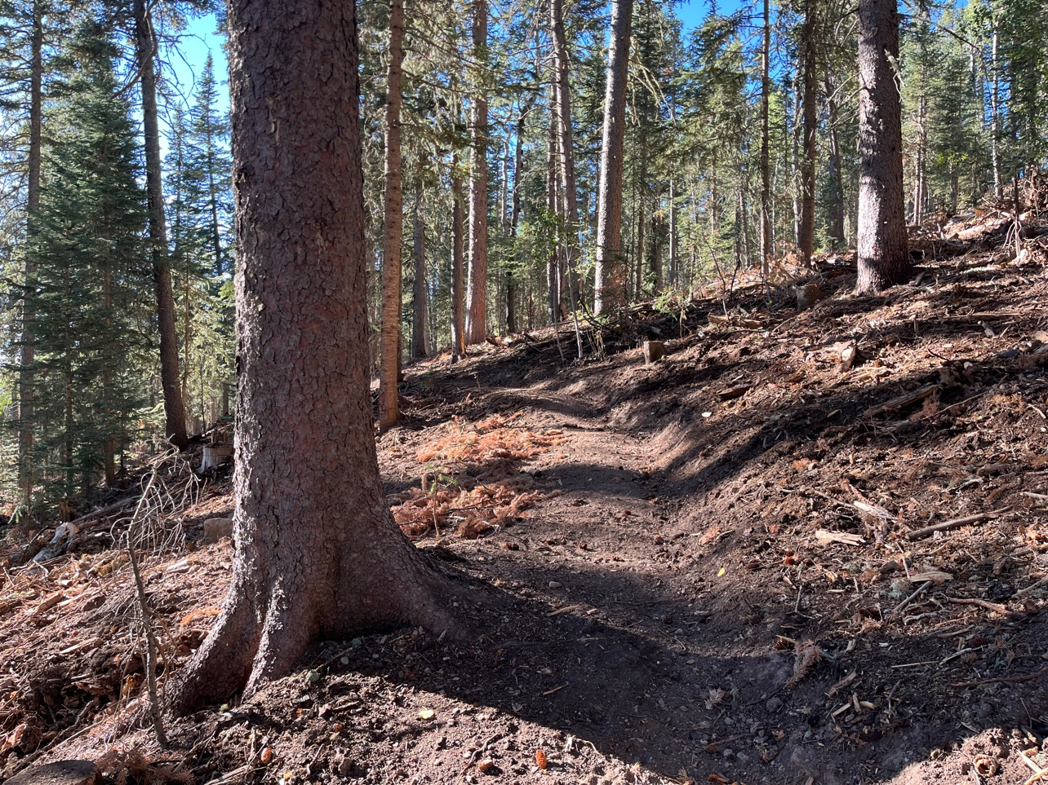
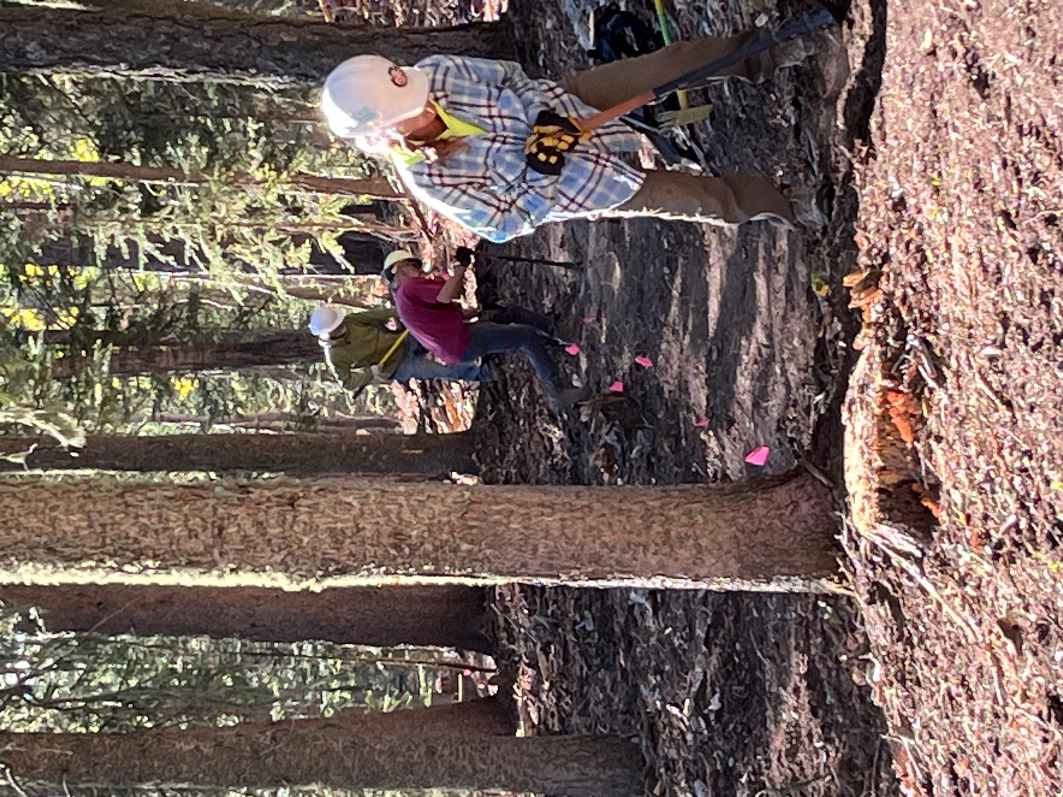

Claudia, Jim and Kit finish working tread from the previous week.
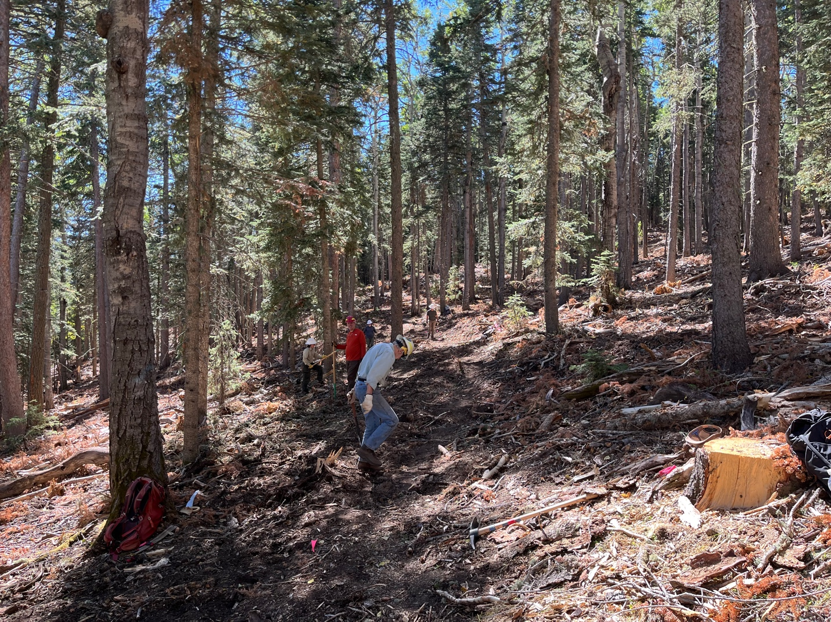

We’ve been really spread out as we worked and with a go size crew that makes for a long line of workers. Byron, Kerry, Jen, John and Luis all in a row.

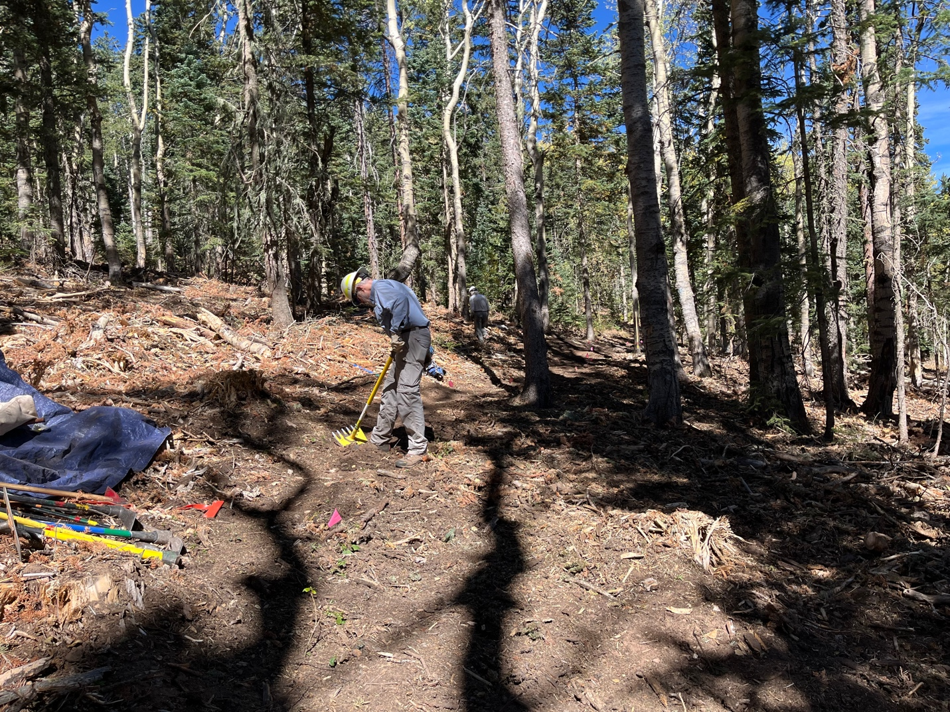

Cleve and Bill work away.
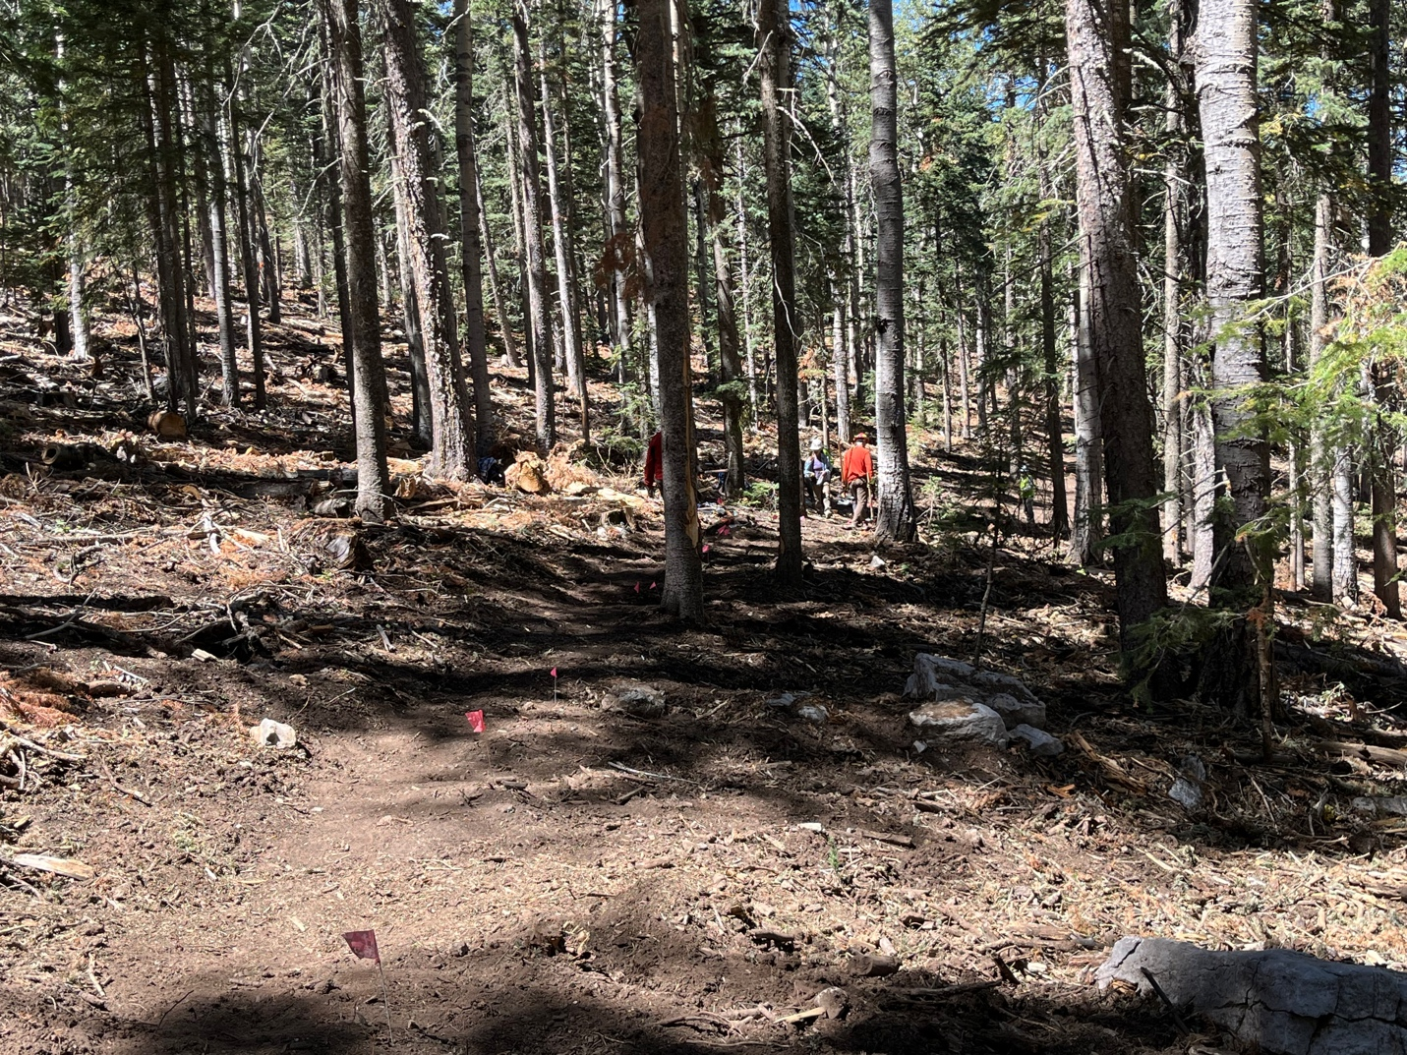

Calling it quits for the day. Just some finishing touches to do next week.
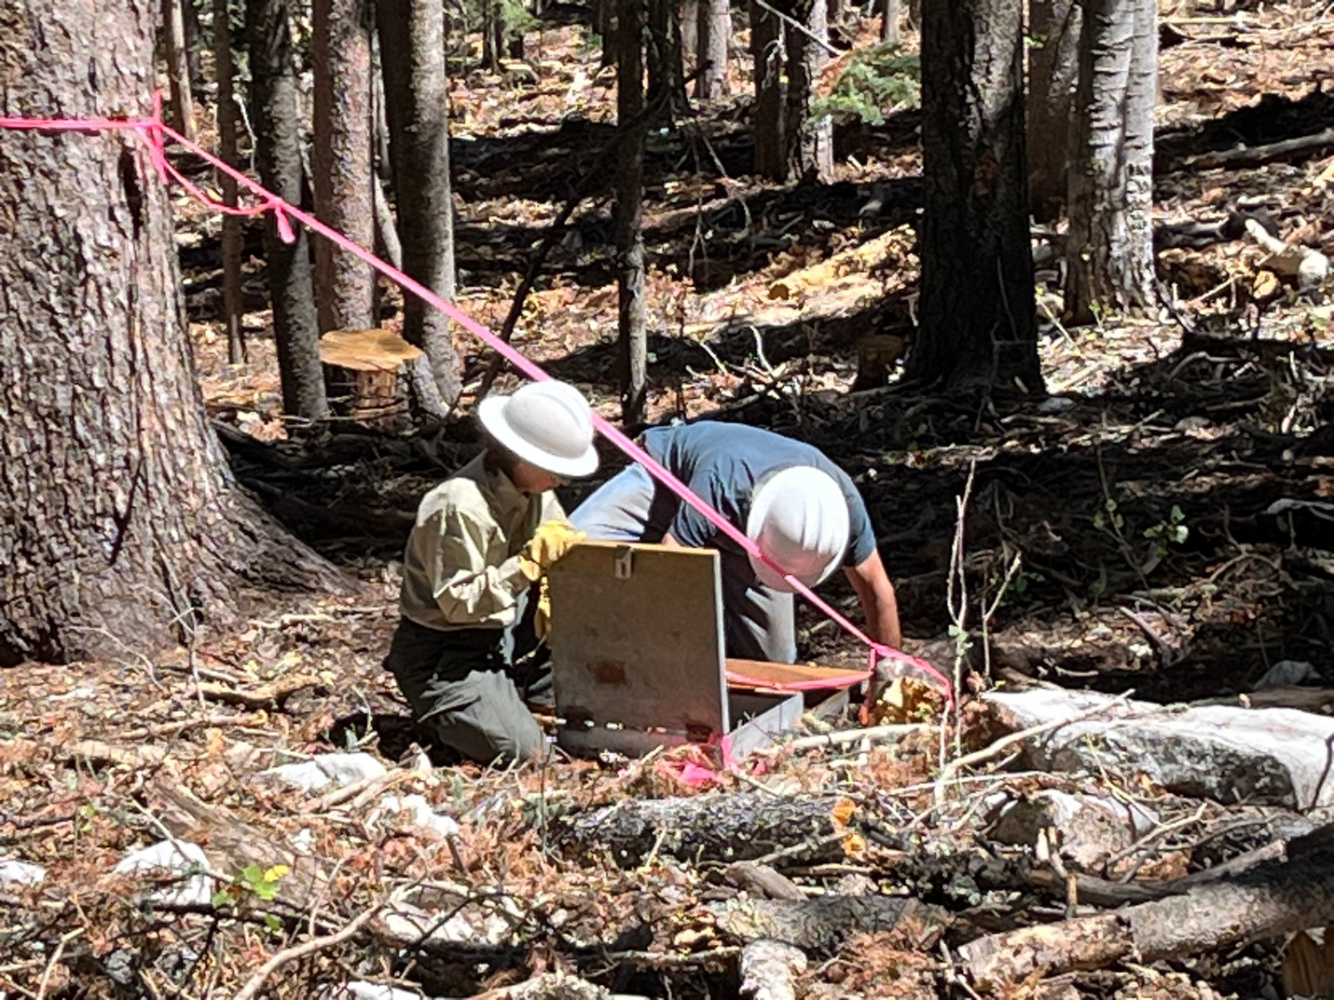

It’s the box. No one seems to know what it is. It has some water measuring tools in it?

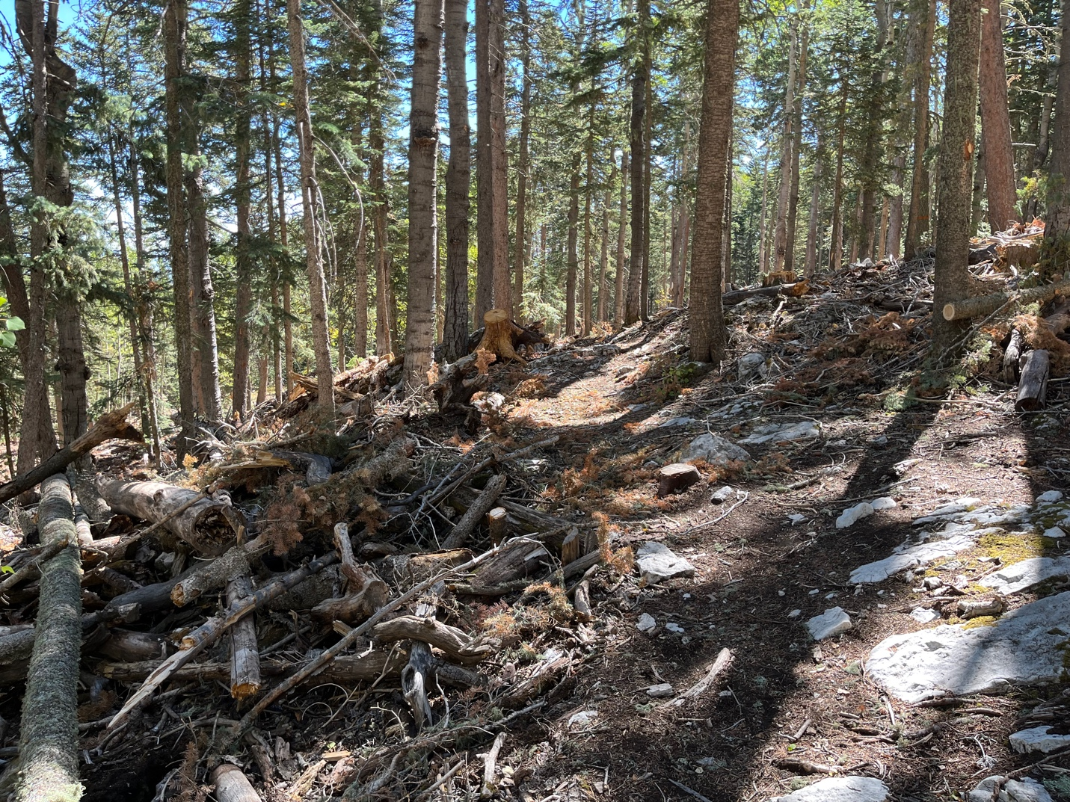

This is what awaits our return to Switchback once the mitigation crew finishes.

