FOSM Project to Repair a Hinge on a CCC Restroom Door
in La Cueva Picnic Area, Friday, September 11, 2026

Sam Beard and Chuck Logan
On September 11, Sam and Chuck repaired a hinge on a CCC (Civilian Conservation Corps) restroom door in the forest a short distance west of the modern restroom in La Cueva Picnic Area. The upper hinge on the heavy wooden door had separated from the door frame so that the door was leaning against the stone on the right side of the restroom entrance. The heavy door could not be safely opened, and the outer lower corner of the door had been in contact with the ground and was completely decayed away.
The following parts of the pintle and gudgeon hinge are presented in the second photograph below: the pintle pin attached to the door frame and the gudgeon on the left end of the black steel strap bolted to the wooden door. In this type of hinge, the pintle is the vertical pin on the door frame, and the gudgeon is the loop of steel into which the pintle is inserted. The dictionary definite of gudgeon is a socket for the pintle of a hinge.
In the second photo below, it can be seen that if the hinge on the door is rotated up to the pintle, the pintle would not be completed seated in the gudgeon. The pintle would have to be lowered to be inserted more completely in the gudgeon. In order to remove the pintle it was necessary to remove the steel frame door designed to prevent the use of the restroom. The vault of the restroom was not sealed so that waste would not be in contact with the ground; therefore, this historic old CCC restroom should not be used by the public. A few years ago, a steel frame door was installed in the entrance so the public could see the interior of this old restroom but visitors could not use the restroom. The steel door included a 5-inch-wide section on the right side that could be pressed against the door frame with a ratchet operated with an approximately 12-inch-long handle. After the ratchet had been operated enough to apply adequate pressure on the door frame that it could not be easily removed, the ratchet was locked with a USFS lock.
Some years ago, the wooden door frame had been reinforced with a strip of steel on each side of it. In order to lower the pintle, it was necessary to remove the steel strips and lower them so that the pintle bolt could be lowered about 1 inch. An 18-inch long ¾-inch ships auger was used in an attempt to drill a lower hole in the door frame that was approximately 6 inches deep. During this operation, the new lower hole merged with the old upper hole to form a vertical hole about 1-1/2 inch high. After this occurred, it was decided to reinstall the steel strip on each side of the door frame so that the pintle pin was supported by the steel strips. In order to rehang the door, the pintle was placed in the gudgeon and inserted in the holes in the steel strips. The nut on the inside of the door frame was tightened, and the door could be opened safely. The steel frame door was reinstalled, and the ratchet was tightened so that the steel could not be moved. The USFS lock was inserted in the ratchet base and locked. The repair of the hinge was complete.
Project photos are presented below.

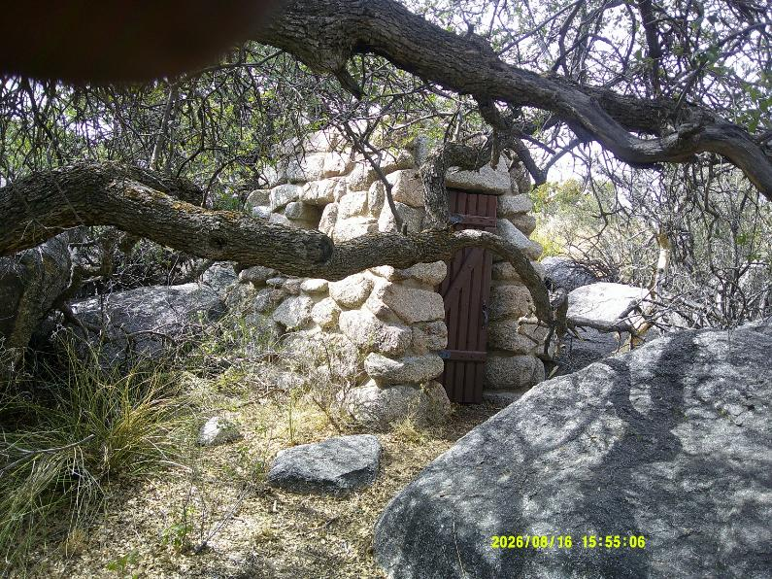
CCC stone and mortar restroom in La Cueva Picnic Area built in the 1930s. All photos by Sam Beard

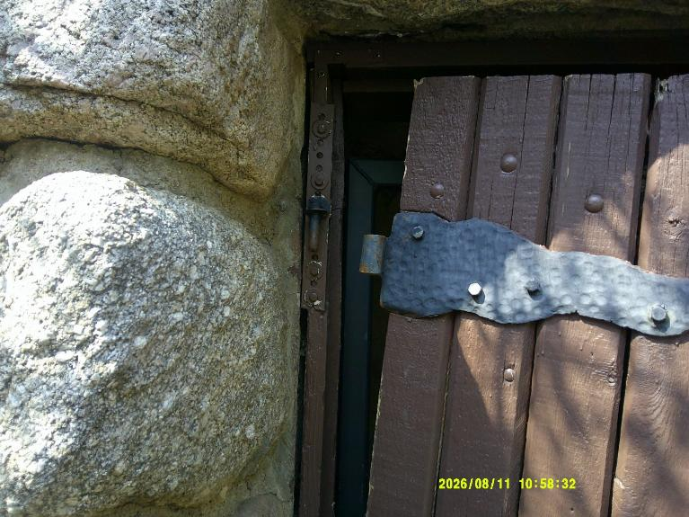
On this CCC restroom door, the gudgeon strap hinge is off the pintle that is attached to the door frame. On the lower pintle and
gudgeon hinge, the pintle or post is pointed up. All the weight of the door is on the lower pintle. The upper pintle
holds the door in the vertical position. Note the steel strap with holes that was installed in the past to strengthen
the old wooden door frame. A steel strap was also installed on the back side of the door frame.

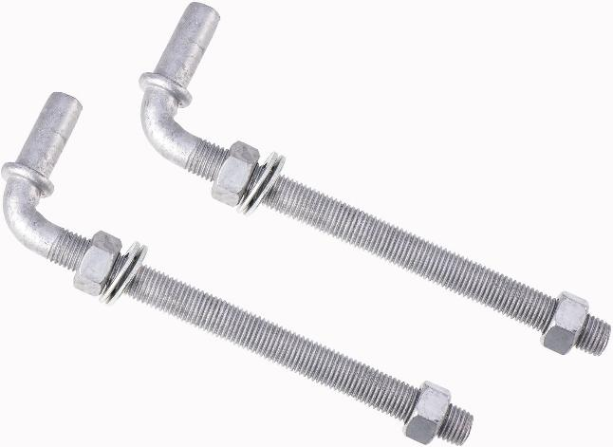
The pintle part of a pintle and gudgeon hinge. On the CCC restroom hinge, the diameter
of the pintle post and bolt part was 5/8 inch.
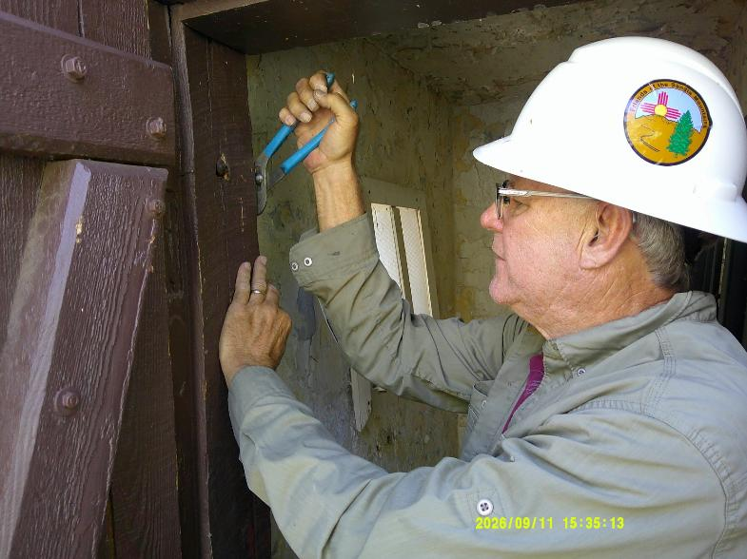
Chuck Logan is unscrewing the nut on the end of the pintle bolt that passes through the door frame so that
the pintle can be removed. The steel frame door that prevents entry to the CCC restroom was removed by
unlocking the USFS lock and rotating the ratchet securing the door to both sides of the door frame.
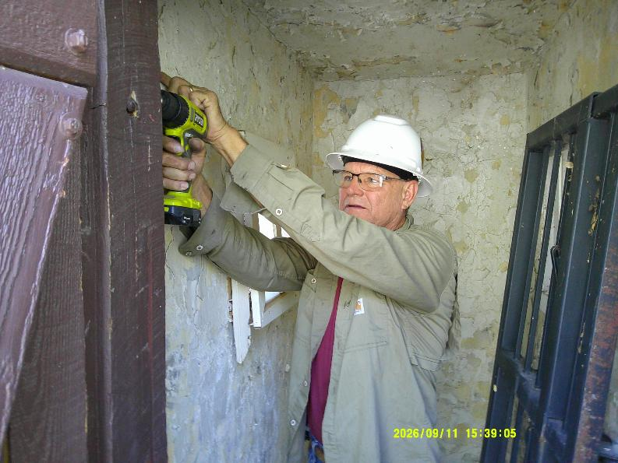
Chuck is drilling a 1/8-inch pilot hole in the wooden door frame so that the ¼-inch lag bolts securing the steel can be
reinstalled in the door frame after the pintle had been lowered by 1 inch so that the strap hinge would stay on the pintle.

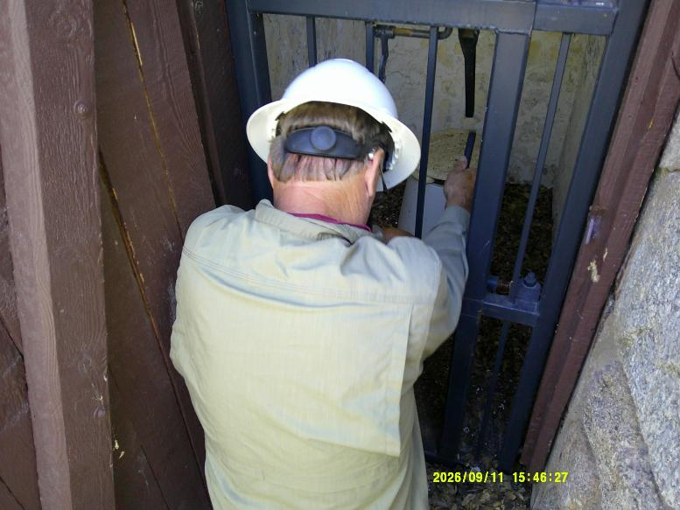
Chuck is turning the ratchet so that the 5-inch-wide movable right part of the steel door is putting pressure on the right wooden
door frame to secure the door to prevent entry into the CCC restroom. After the steel door was in the correct position, the
USFS lock was put on the ratchet so that the steel door cannot be opened.
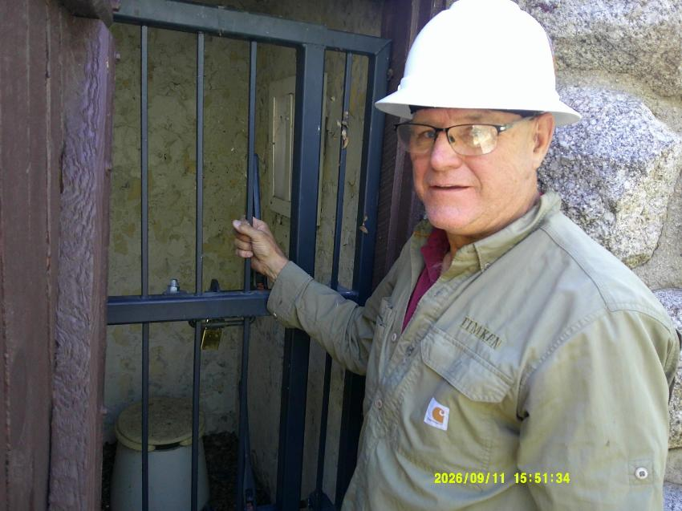
Chuck at the closed steel door with the brass USFS lock in the lower center part of the photograph.
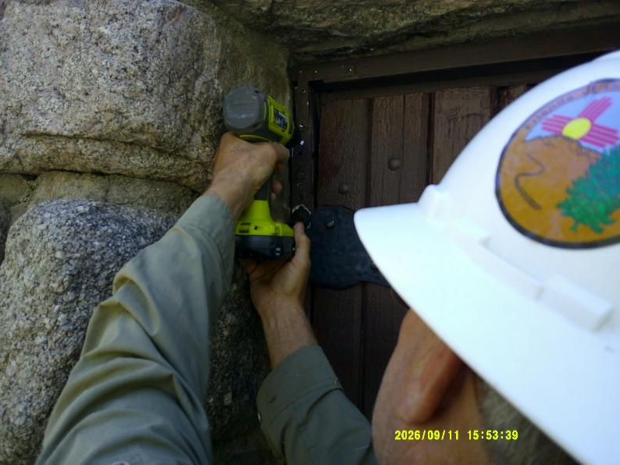
Chuck is tightening the ¼-inch lag screws securing the outer metal strip to the wooden door frame.

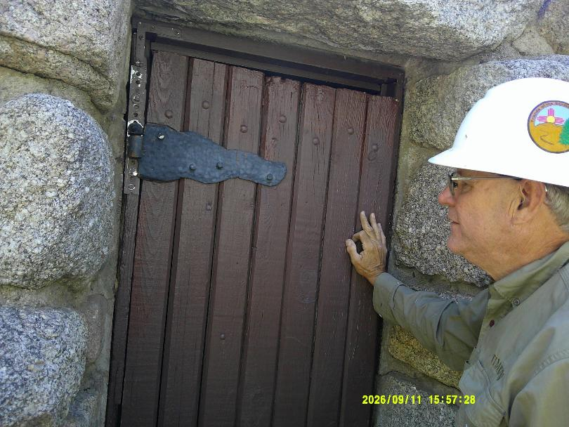
The upper pintle has been reinstalled and the steel strap gudgeon on the door has been reinstalled on the downward
pointing pintle post to secure the wooden door to the door fame.
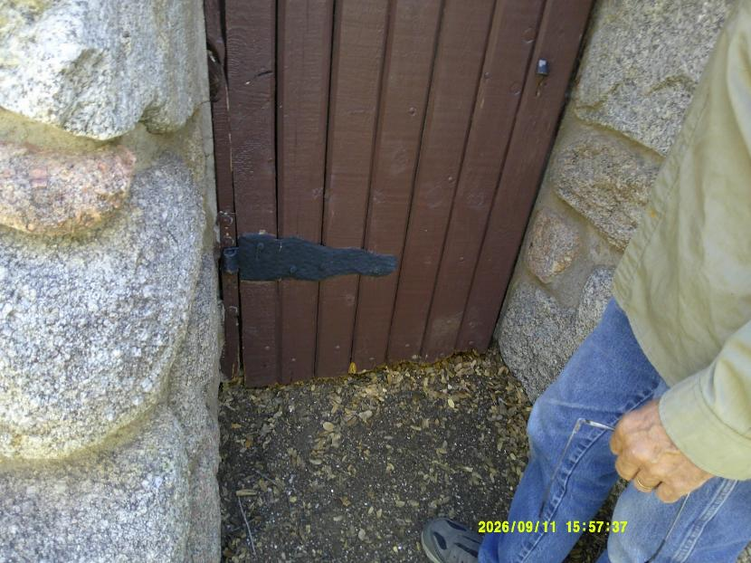
The lower pintle and gudgeon hinge supports the full weight of the heavy wooden door.

