Trail Maintenance Project: Monday, September 14, 2026
Byron Garner
After some adjustments to our start time to take advantage of the good but brief weather window, the Monday trail crew headed up Cienega to remove a " large tree" reported (in separate reports) by Betsy Kapiloff and Canyon Young. About half way to the Faulty Junction, we found this twenty two inch heavily limbed lunker of a ponderosa completely blocking and suspended over the trail. There was enough complexity here in terms of binds and support to give this project a lengthy, instructive and interesting discussion for the whole crew in terms of safety and outcome efficiency. Fortunately, Steve Roholt had previously limbed a very good duck-under which gave us a much easier start. After a good bit of limbing unsporting branches, debris removal and strategy review, we fired up the "crosscuts". Two cuts later, Cienega was back in bussiness.
We then hiked a ways up trail clearing a few "widow makers" and noting a good bit of recent ( after extensive previous brushing) trail edge over growth. With the increasing heat and humidity we elected to about face before the rain showers began.
The crew included Rene Archer, Phil Cromer, John Cooper, Dana Price, Larry Larrichio, Dave McCrerry and Byron Garner.

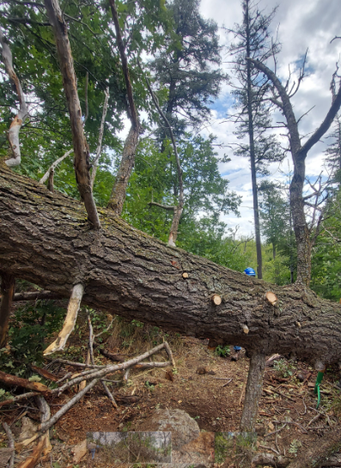Archer
The task ahead

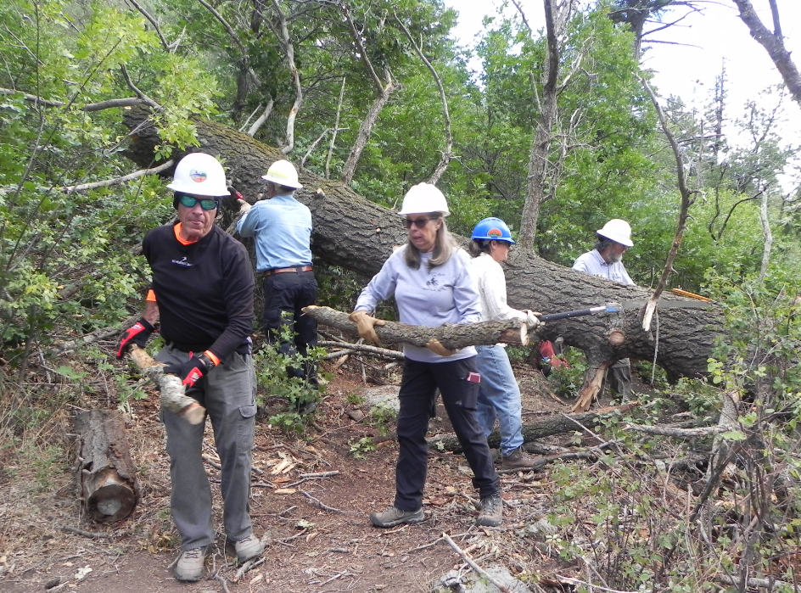
Larry, Dave, Rene Dana and Phil demonstrate teamwork

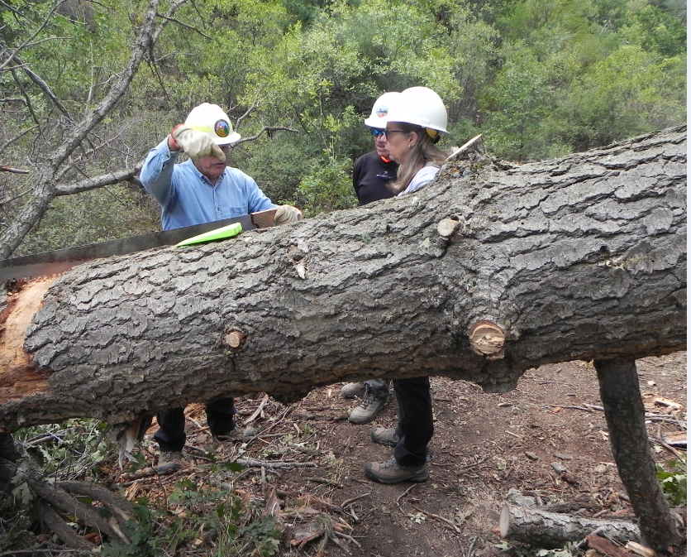
Dave explains compound cuts to Larry and Rene

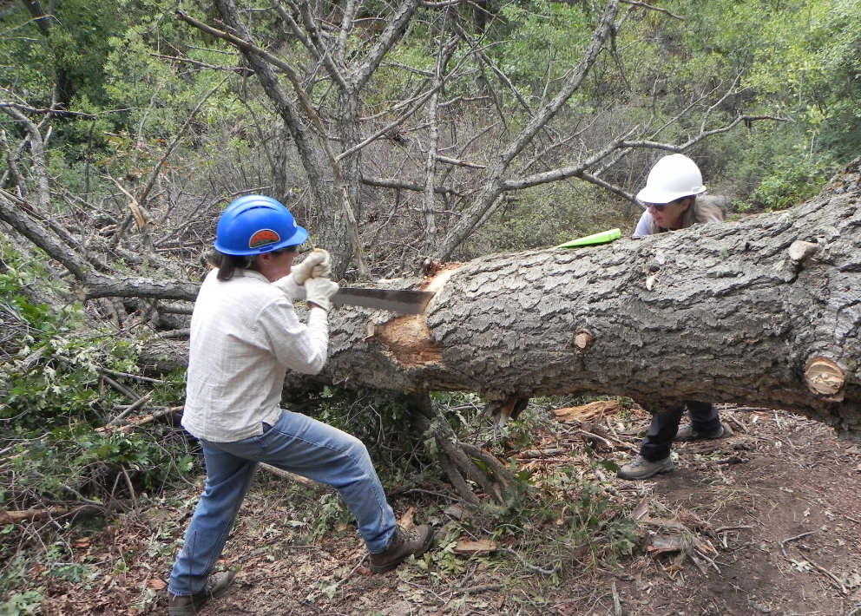
Dana and Rene make good time on the first cut

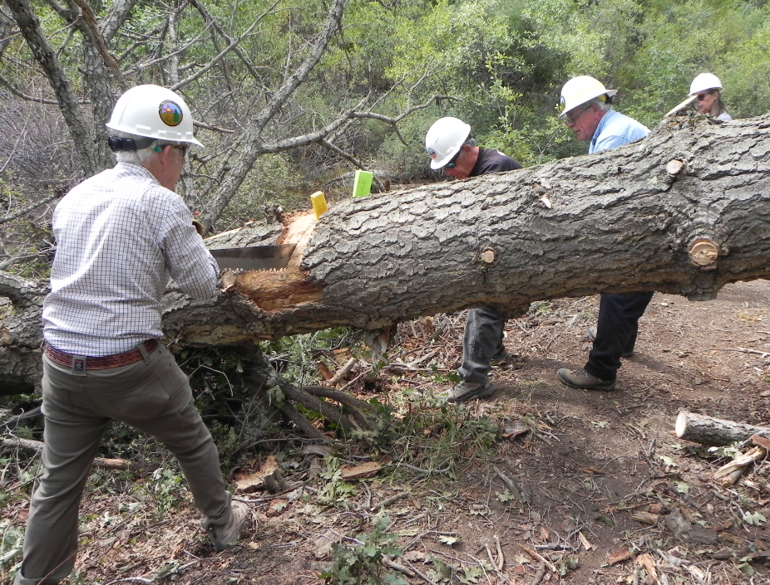
John and Larry work the second shift

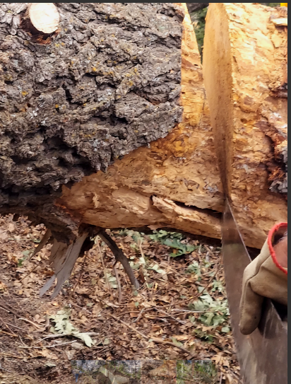Archer
Now what?

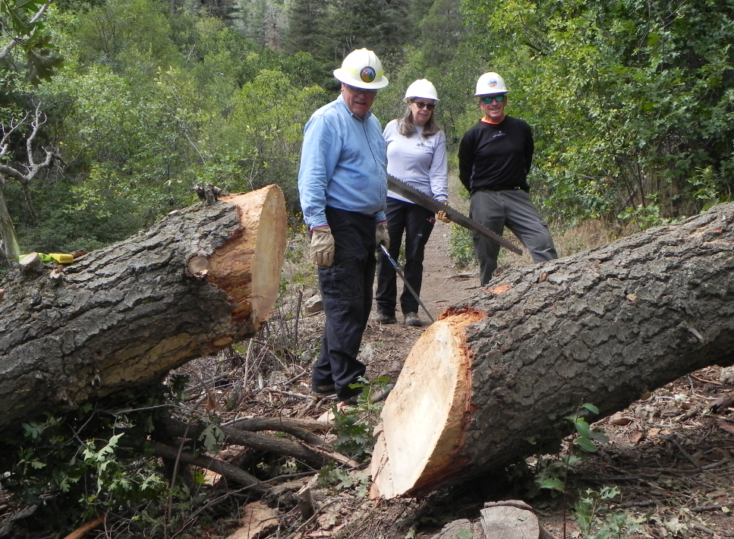
Half way home

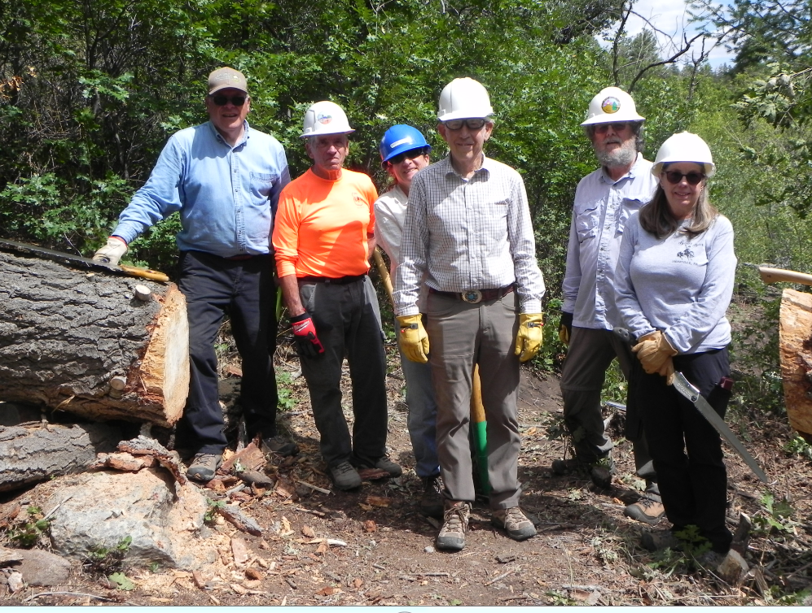
Dave, Larry, Dana, John, Phil and Rene

