Report of the FOSM Project with the Sandia National Laboratories ES&H Volunteer Activities Team to Collect Trash and Paint Wooden Kiosks in La Cueva and Juan Tabo Picnic Areas on Saturday, September 26, 2026
Joelle Hertel and Sam Beard
In celebration of National Public Lands Day on Saturday, September 26, Joelle Hertel and Sam Beard coordinated a FOSM project with the Sandia National Laboratories (SNL) ES&H Volunteer Activities Team. This group focuses on environmental, safety, and health work at SNL. Amber Mowery, SRD employee, helped lead the project and provided collection buckets and hand tools for picking up the trash. Twelve ES&H volunteers met the project leaders at the gravel parking lot on Forest Road 333 located at the cattle guard near Tramway Road. The plan for the day was to paint wooden kiosks at the La Cueva and Juan Tabo picnic areas and to pick up trash and trim branches at both sites. The group was split with Sam managing painting at three kiosks at La Cueva PA and one kiosk at Juan Tabo PA while Joelle and Amber walked the area looking for trash and doing trimming.
These two recreation areas have unique picnic tables, benches, remnants of a spring-fed water system and other structures (restrooms and shelters), all built in the 1930s under the direction of the CCC (Civilian Conservation Corps). The tables are dispersed over the area and hidden behind boulders and concealed by brush and oak trees. This was intentional in the original design to blend into nature and harmonize with the natural beauty of the area.
Because the tables are hidden and paths between tables are indistinct, Joelle led the group through the area to locate tables. At the lunch break in the La Cueva rock shelter, the history of the area was presented by Joelle, and reconstruction and restoration efforts were discussed. Following lunch, the group drove to Juan Tabo PA and again walked through the area visiting 14 of the 20 tables to pick up trash. A lot was accomplished by this group to help keep the area clean.
Project photographs are presented below.

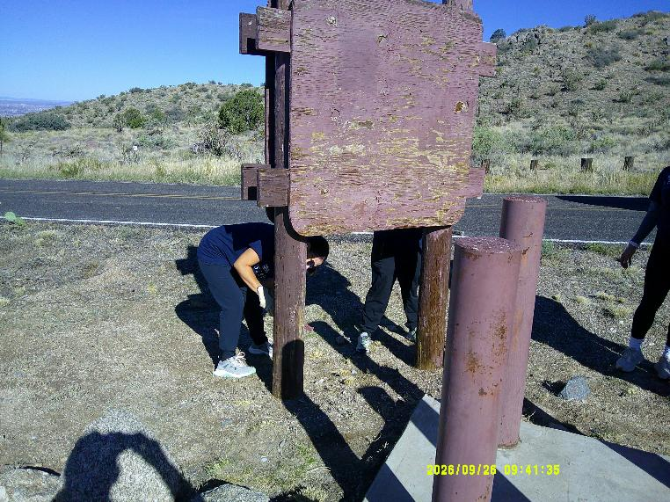
Three ES&H volunteers scraping off loose paint on the west kiosk at the gravel parking lot near the cattle guard on Forest Road 333
at the intersection of the La Cueva PA Road and the Juan Tabo PA Road. (All photos by Sam Beard)
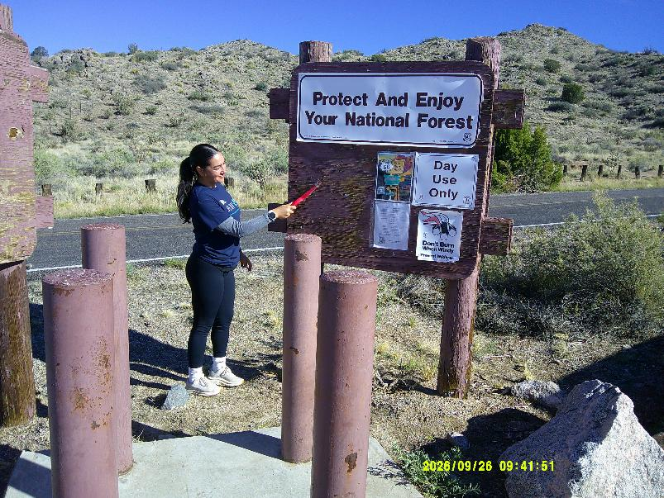
An ES&H volunteer removing loose paint from the second kiosk at the gravel parking lot.
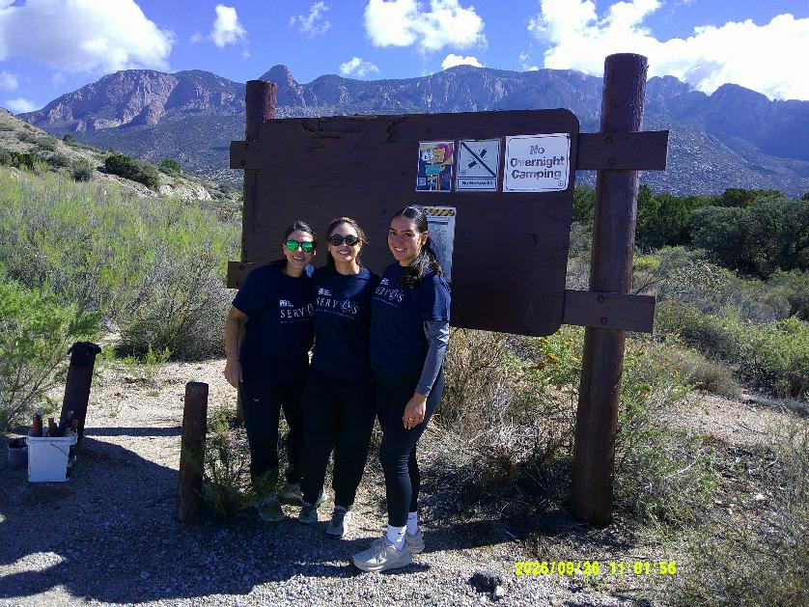
The three ES&H volunteers who have just painted this kiosk at the first intersection on FR-333.
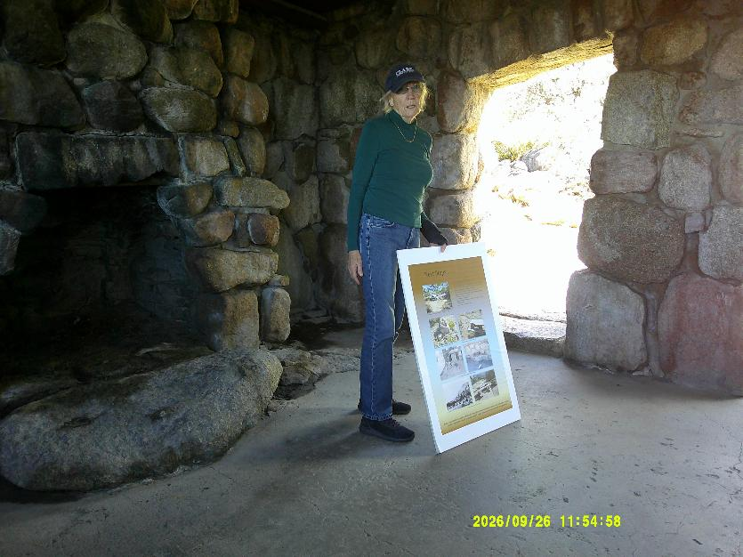
Joelle presenting the history of the construction of La Cueva and Juan Tabo Picnic Areas by the CCC in the 1930s.
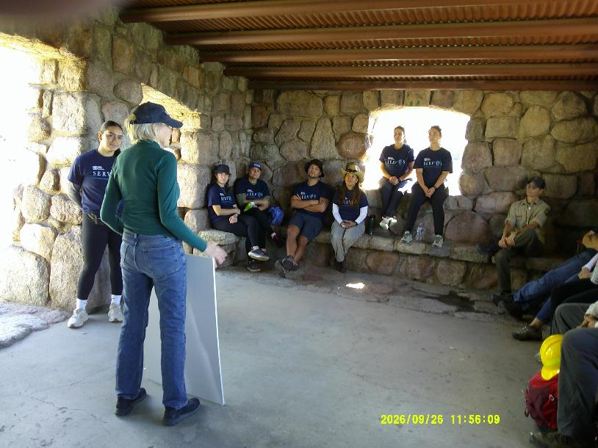
ES&H volunteers and SRD employee Amber Mowery in the La Cueva picnic shelter while Joelle
was presenting the picnic area histories.
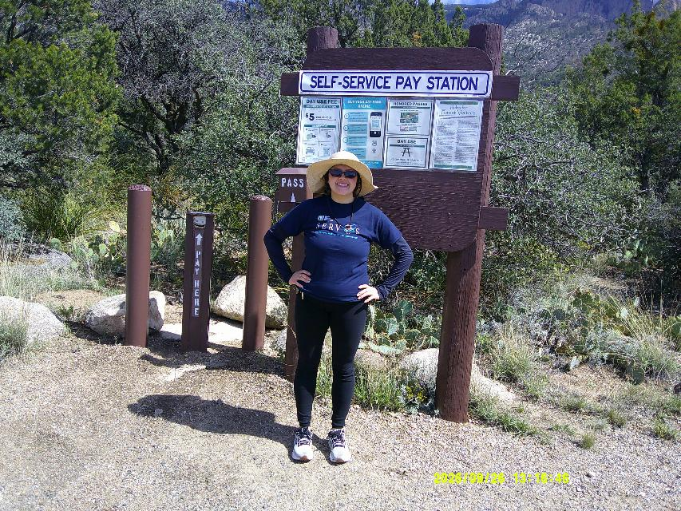
ES&H volunteer in front of the kiosk and steel posts that she helped paint in Juan Tabo Picnic Area.
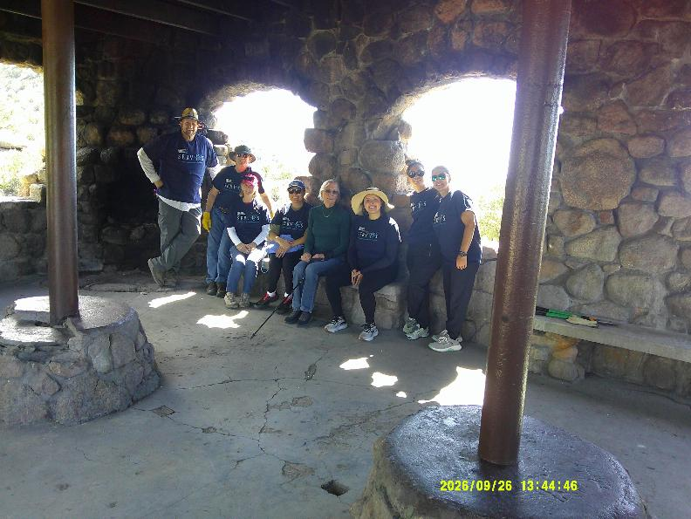
Joelle with ES&H volunteers in the CCC Juan Tabo Picnic Area Shelter.

