Report of the Removal of Graffiti Tags from Sites along the Upper Crest Highway
by FOSM Volunteers, Friday, October 2, 2026

Sam Beard
On Friday, October 2, Pauline Ho, Rick Buss, and Sam Beard removed numerous graffiti tags from the following four sites on the upper Crest Highway: 10K Trailhead area, Nine Mile Picnic Area, Capulin Snow Play Area, and Balsam Glade Picnic Area. Julie Padilla, SRD Recreation Staff Officer, was especially interested in having these tags removed before the Balloon Fiesta when many visitors go to the Sandia Mountains.

Project photographs are presented below.

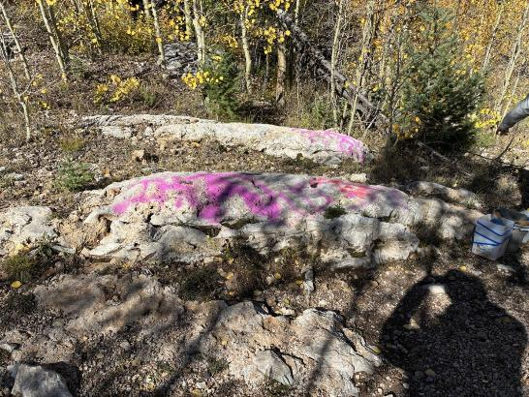
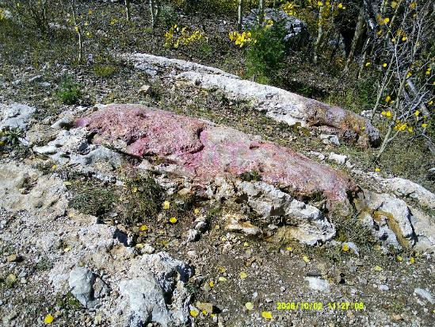
Top – Pink graffiti tag on rock beside the trail almost one-quarter mile north of 10K Trailhead.
Bottom – Much of the tag has been removed. It is difficult to remove
tags from such rough rocks with many small crevices. Photos by Cliff Giles and Sam Beard
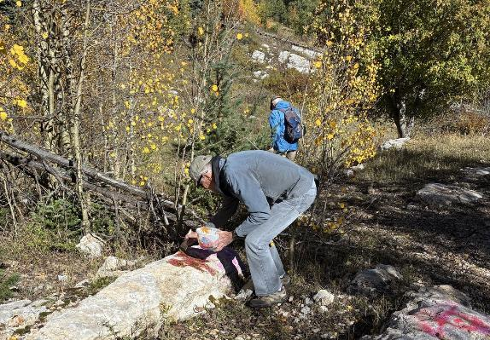
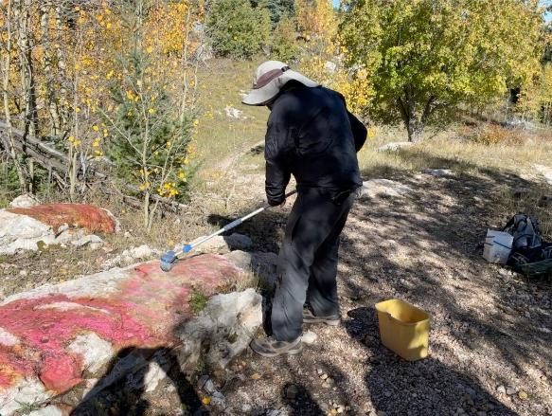
Top – Sim Cook applying tag removal chemical.
Bottom – Cliff Giles rinsing tag and chemical residue from nearby stone with water.

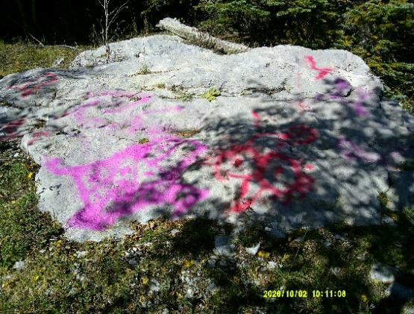
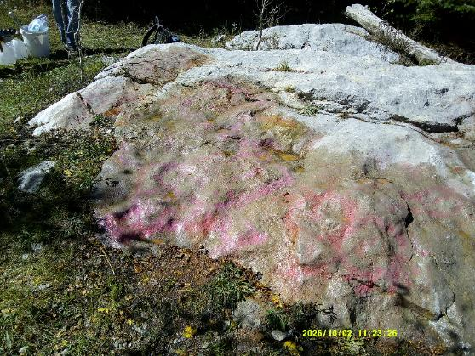
Top – Pink tag on a large rock. Bottom – Most of the tag has been removed.
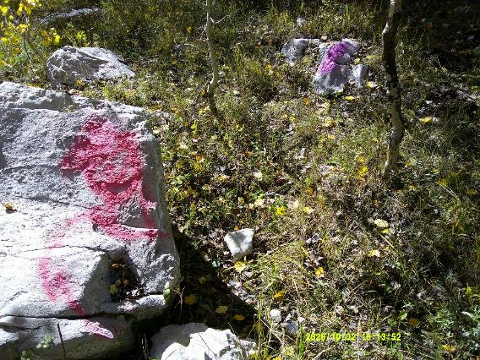
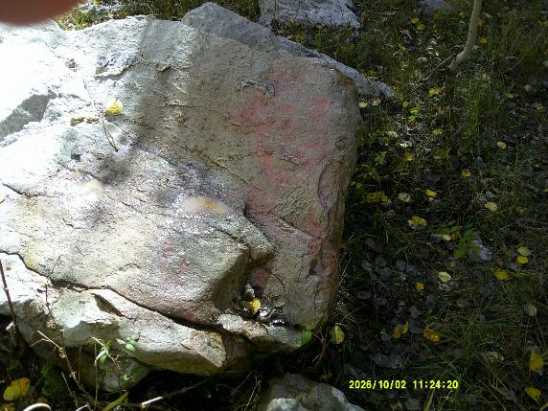
Top – Pink tag on large stone. Bottom – Most of the tag has been removed.
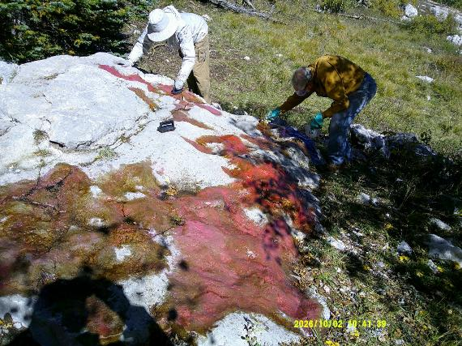
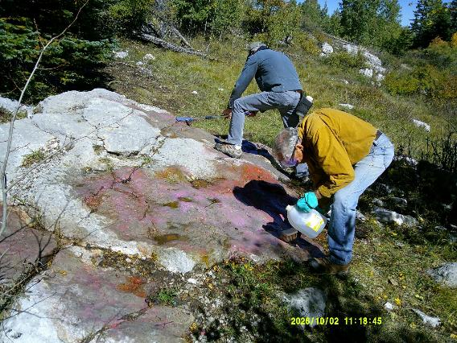
Top – Pauline Ho and Rick Buss removing tags from the large stone.
Bottom – Sim Cook and Rick Buss rinsing debris from the stone with water.

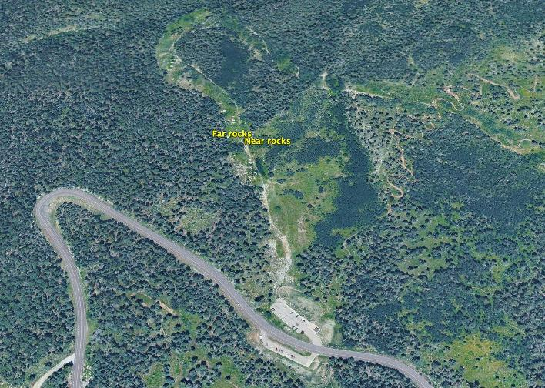
Graffiti tags were located about one-quarter mile north of the 10K Trailhead parking lot
along a trail in the old road clearing. Map by Cliff Giles

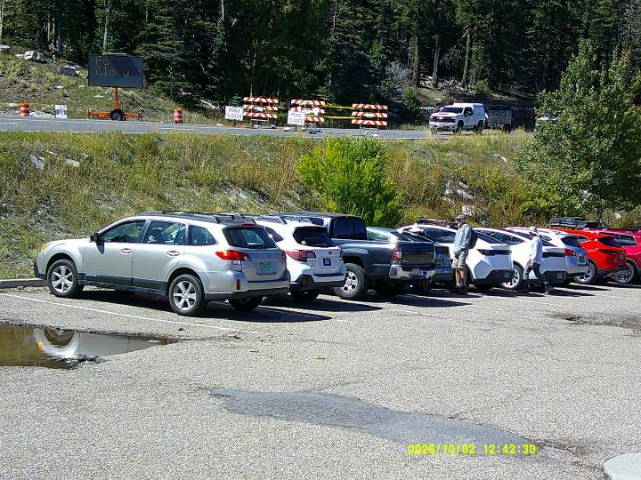
The Crest Highway was blocked by the U. S. Forest Service personnel at 10K Trailhead.

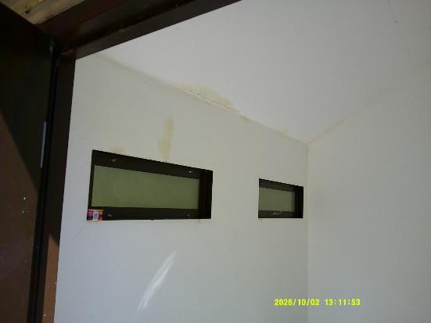
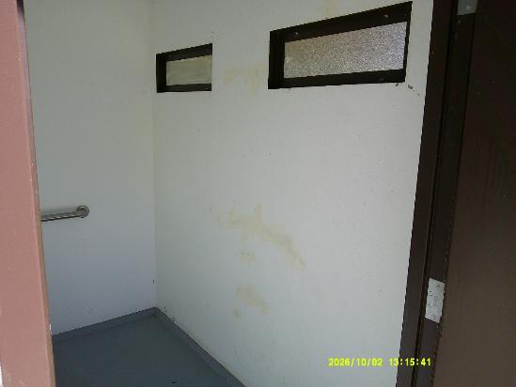
Top – Damage on the upper left wall was covered with white paint at Balsam Glade Picnic Area.
Bottom – Damage on the lower right wall was covered with white paint.

