Thursday, 10/01/26- Jaral Canyon area: A fabulous day to be out working after the rains of the previous days and weeks. 13 volunteers met Jen, Chris and Noah at the first pullout on FS 333. We broke into 3 groups and went about installing somewhere between 17 and 19 metal and wooden post signs. There were a few problem installations of one kind or another but we were successful on most.
Volunteers: Bill Perkins, Kent Towler, Steve Roholt, Rich Fagioli, Kit French, Byron Garner, John McNett, Bruce Hansche, Claudia Bergsohn, Eric Russell, Kerry Jones, Luis Cuadros and Laura Leon
Pics: Kerry Jones, Steve Roholt, Bruce Hansche, Rich Fagioli and Laura Leon

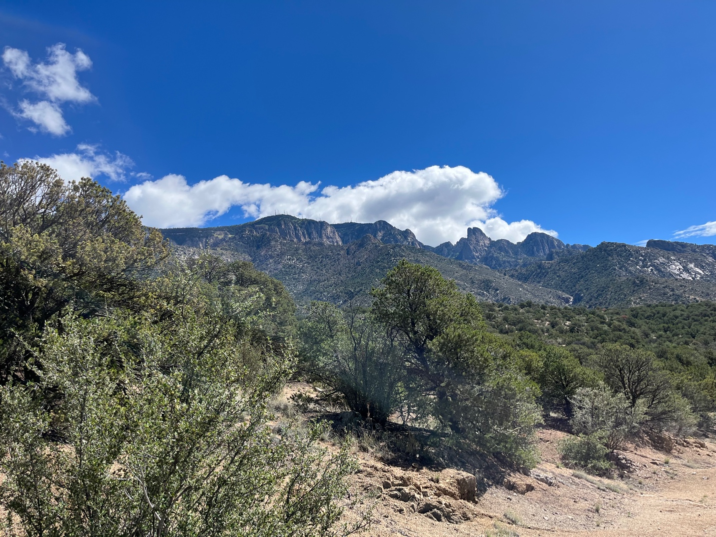

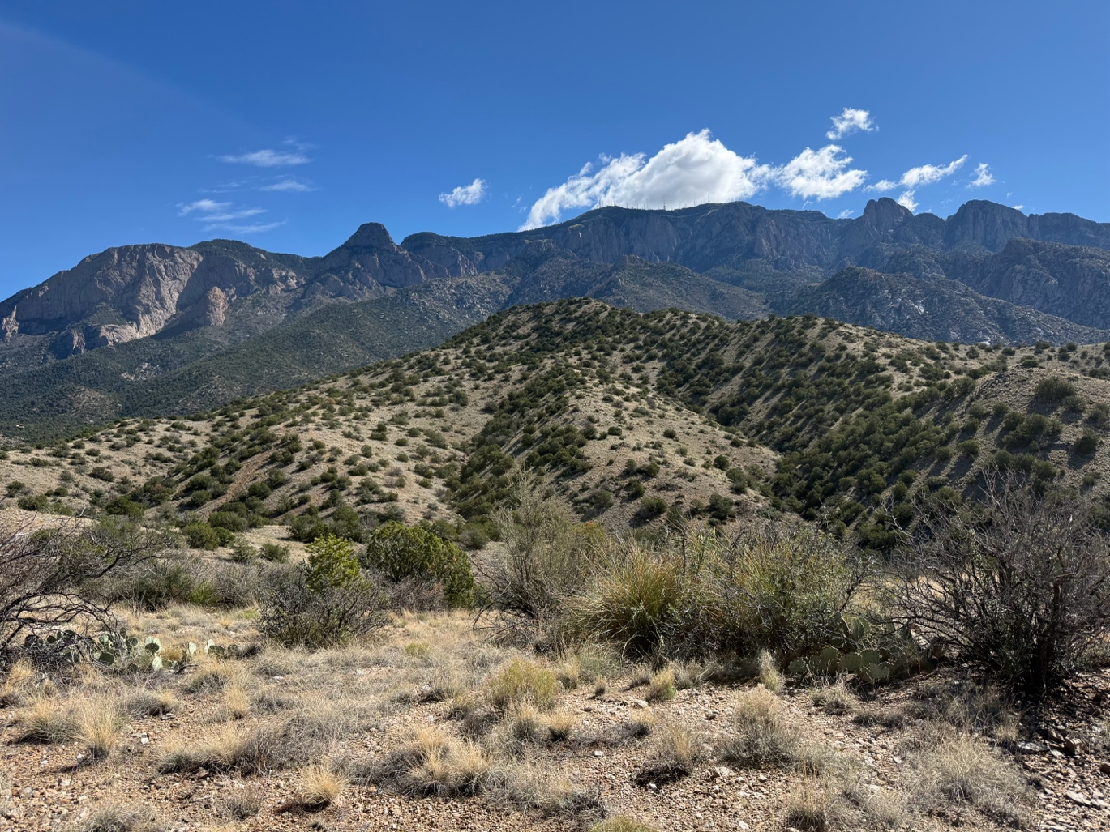
What a nice day! Getting started…
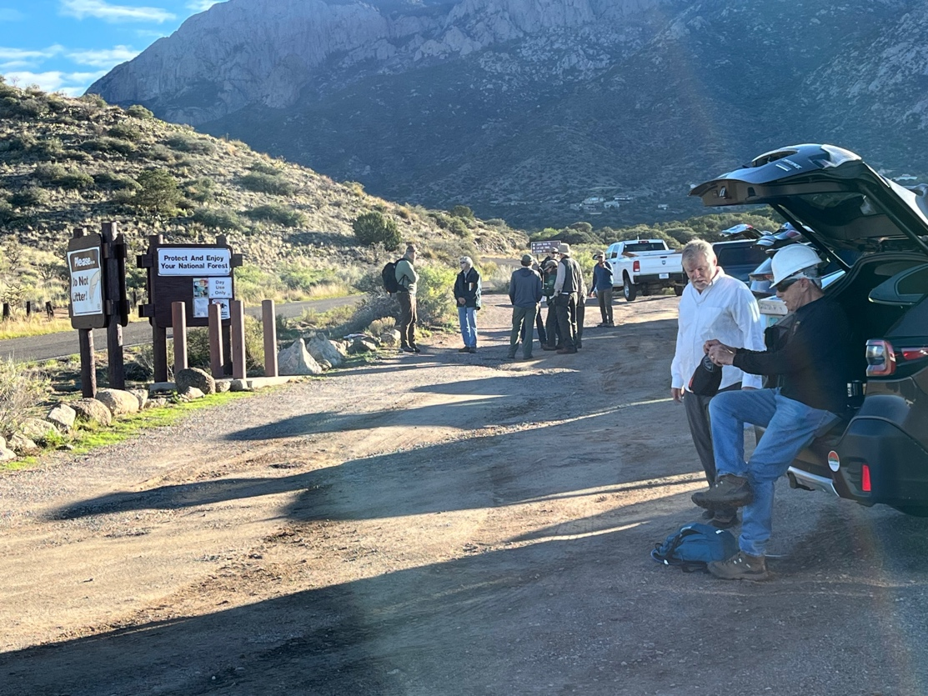
Group A- Eric, Bruce, Steve and Noah-set off along the road installing.
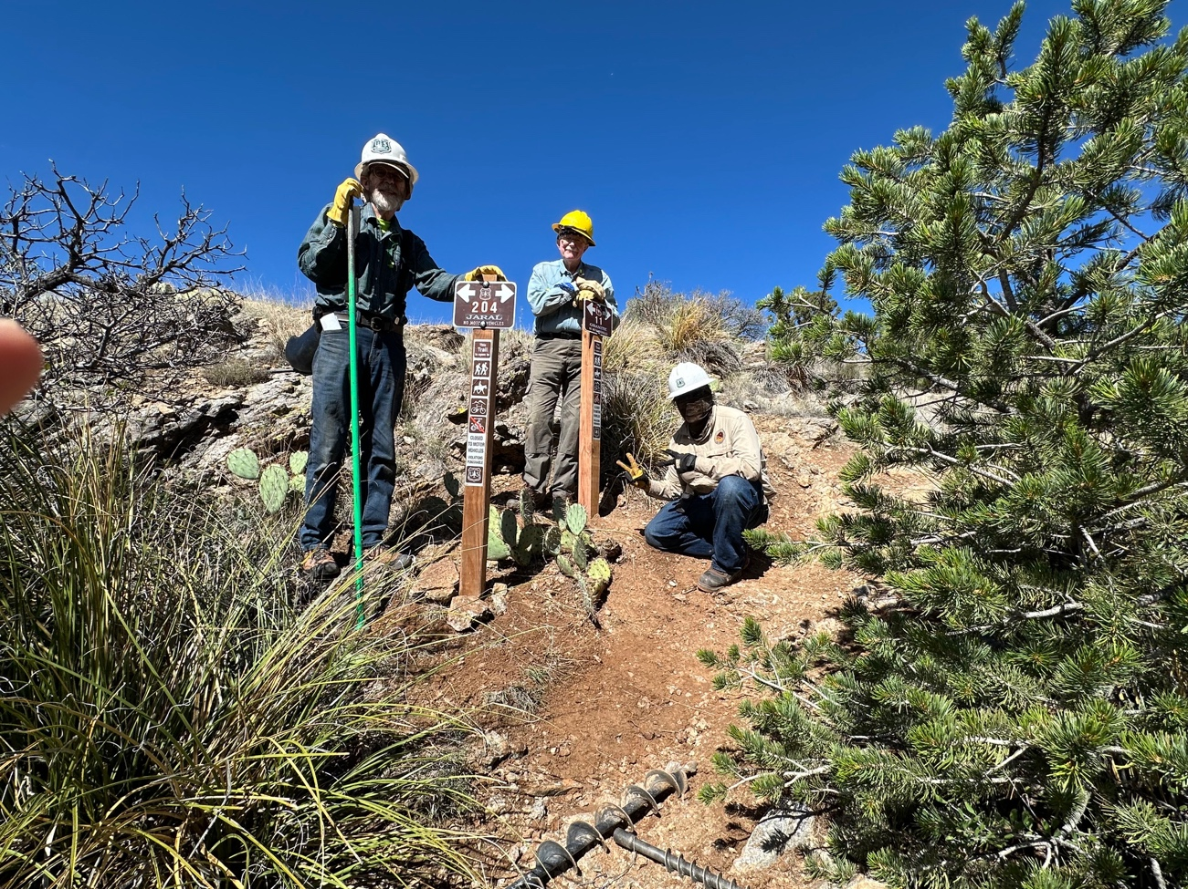
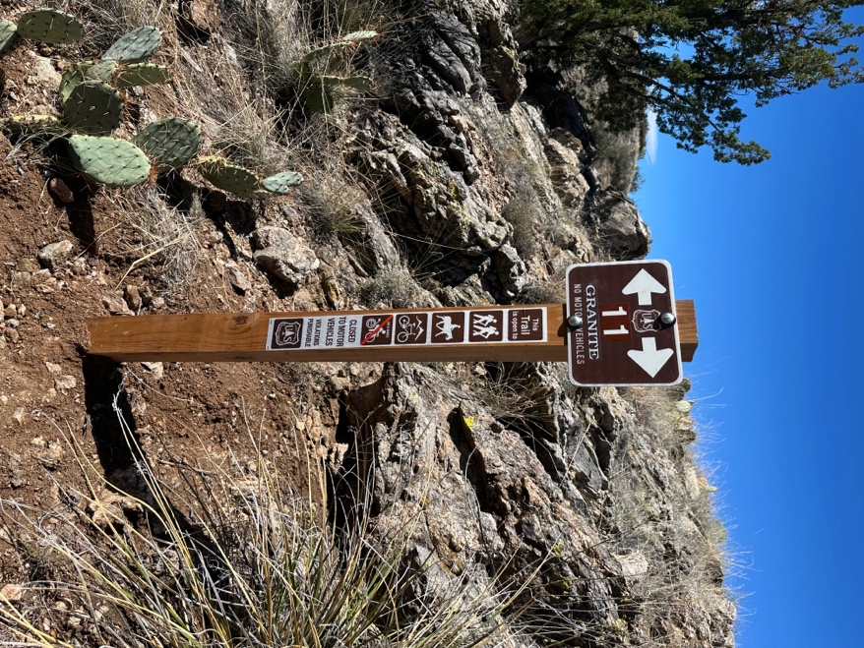
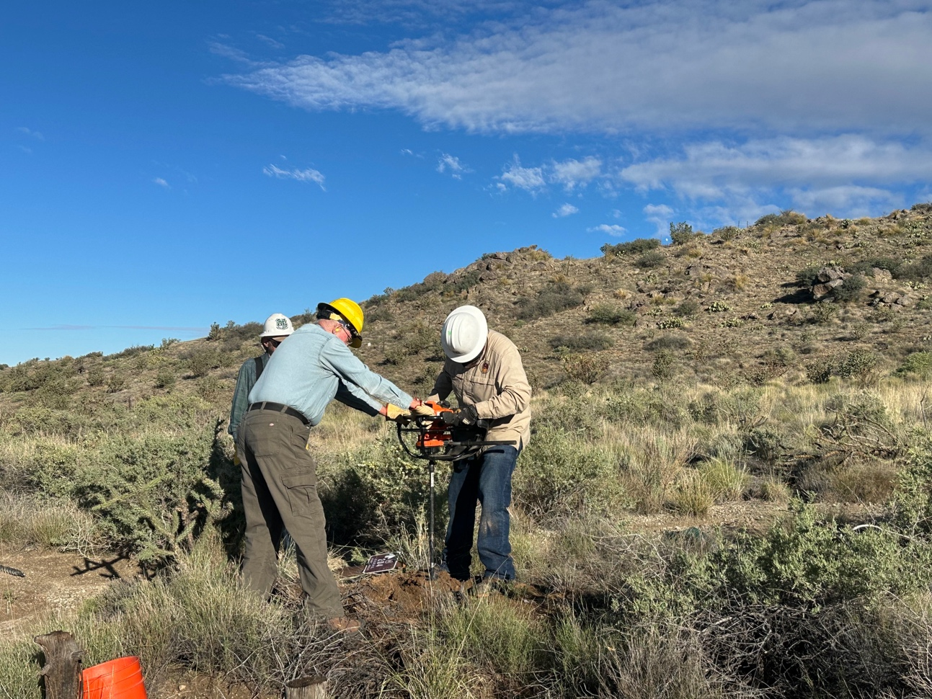

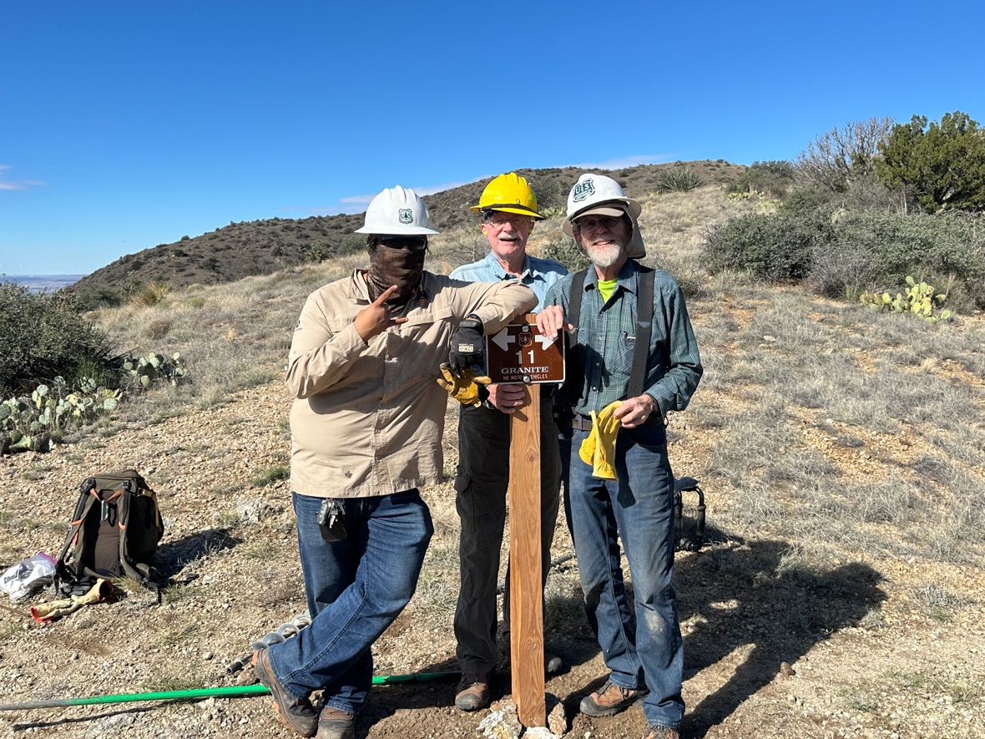

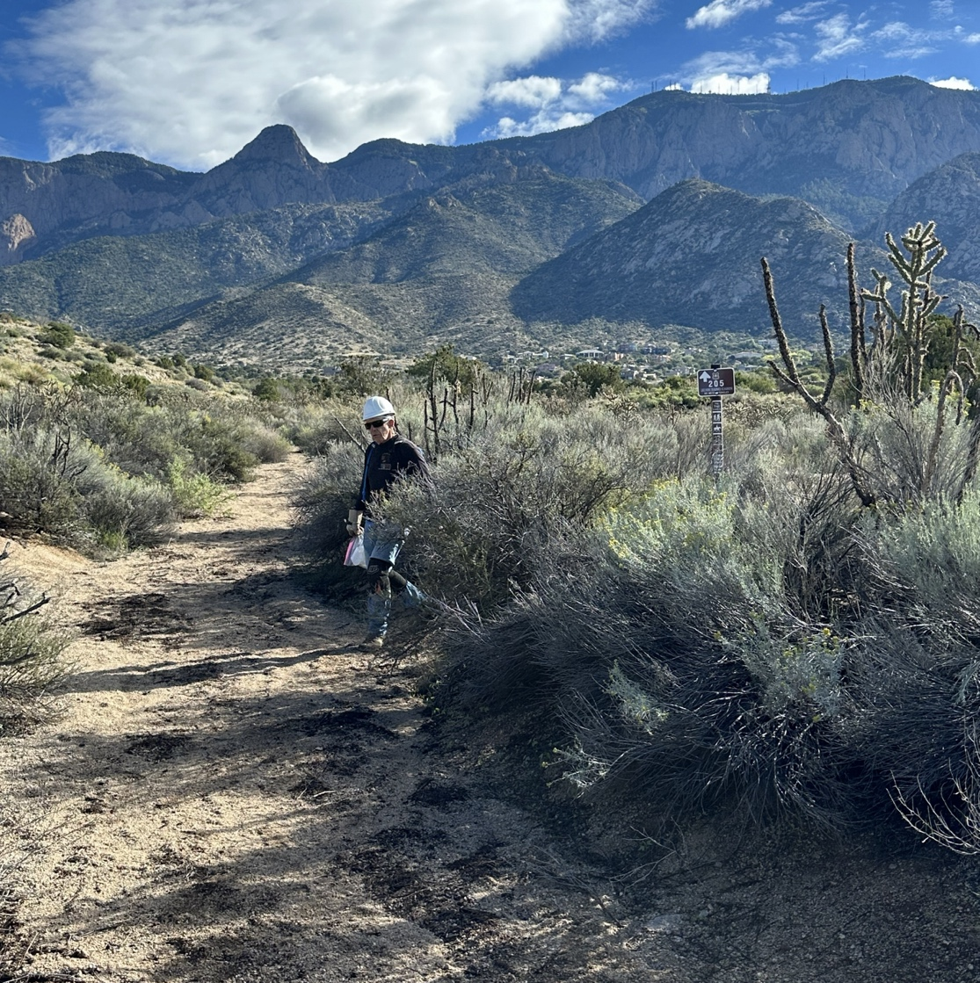
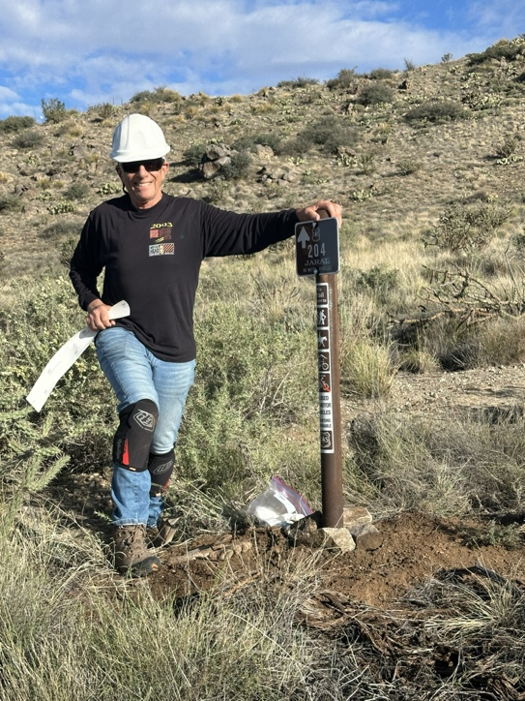

Group B: Laura, Luis, Kit, Rich and Bill wandered a bit more inland.
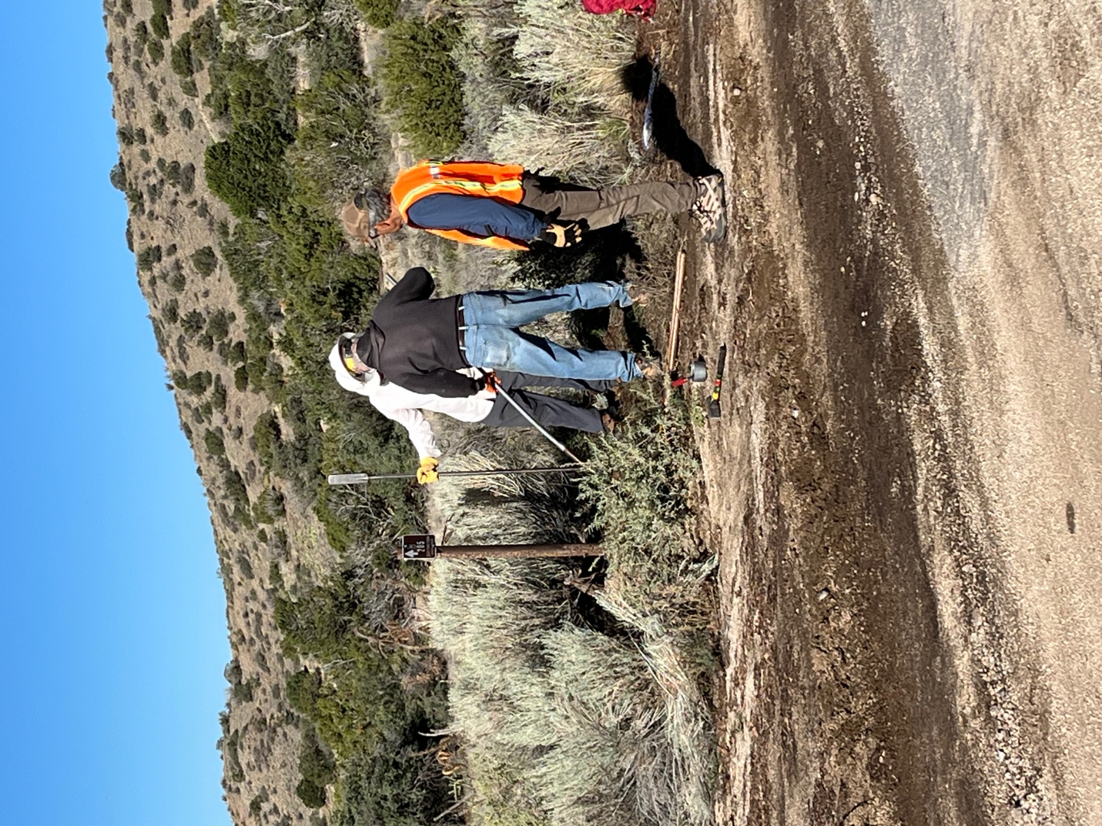

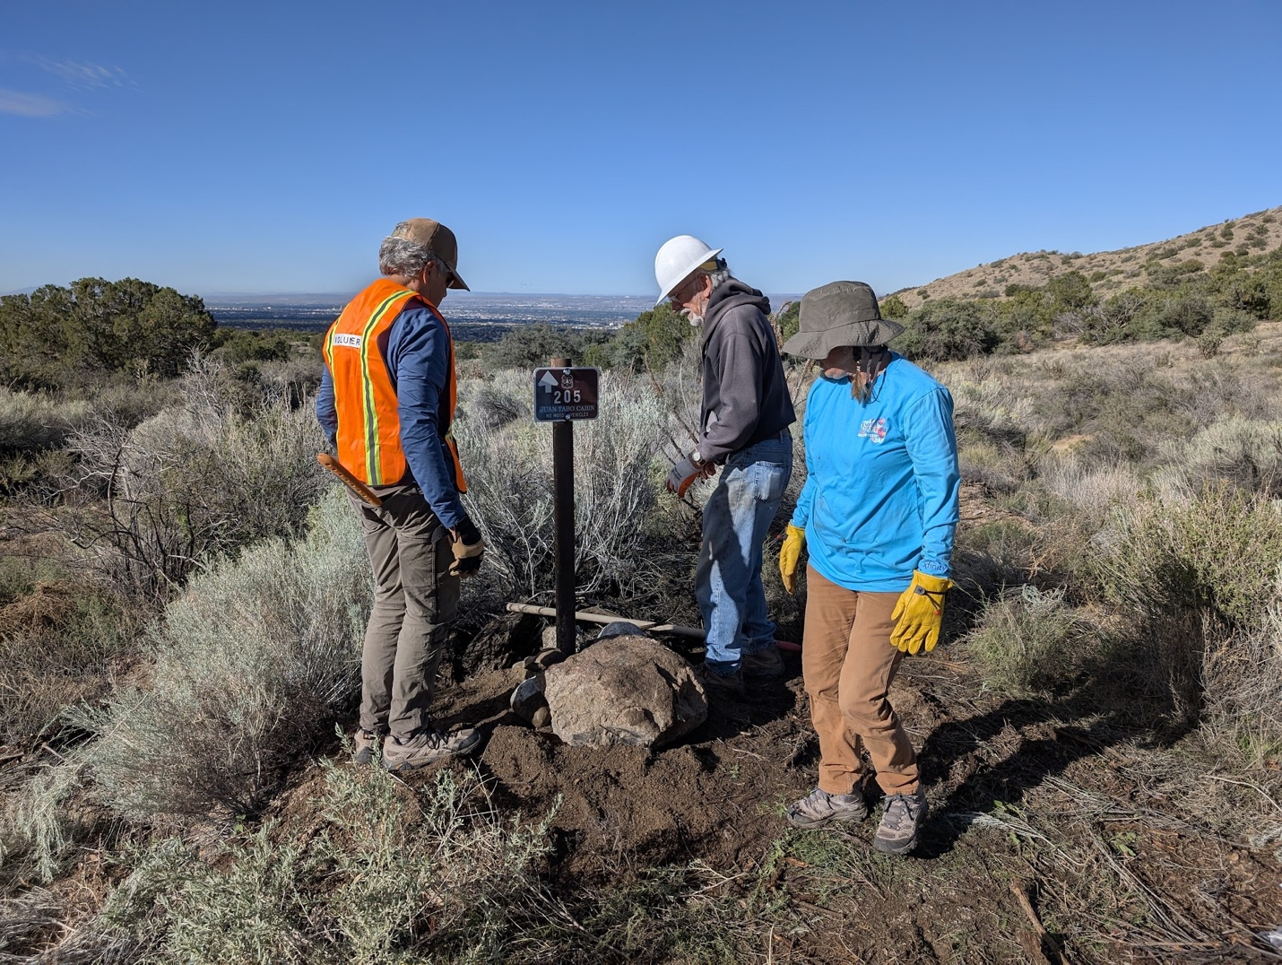

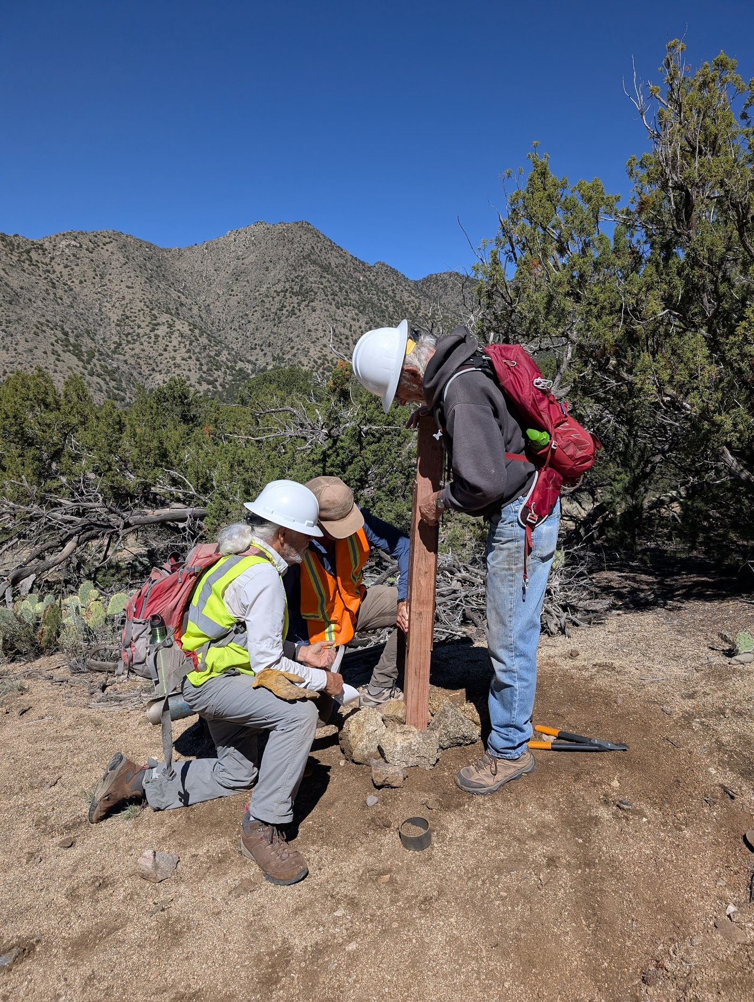
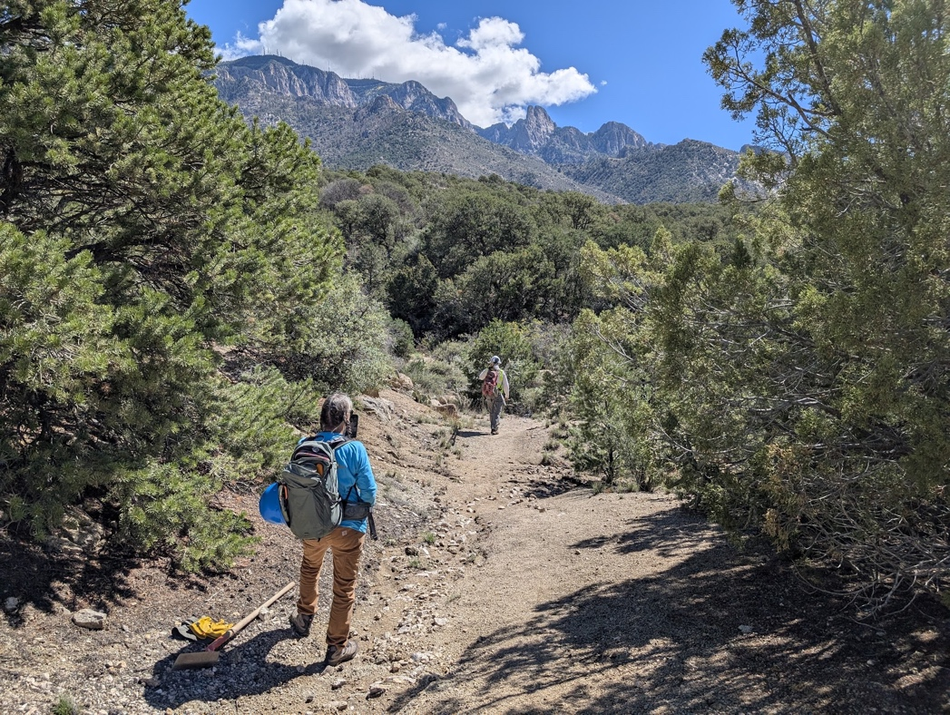

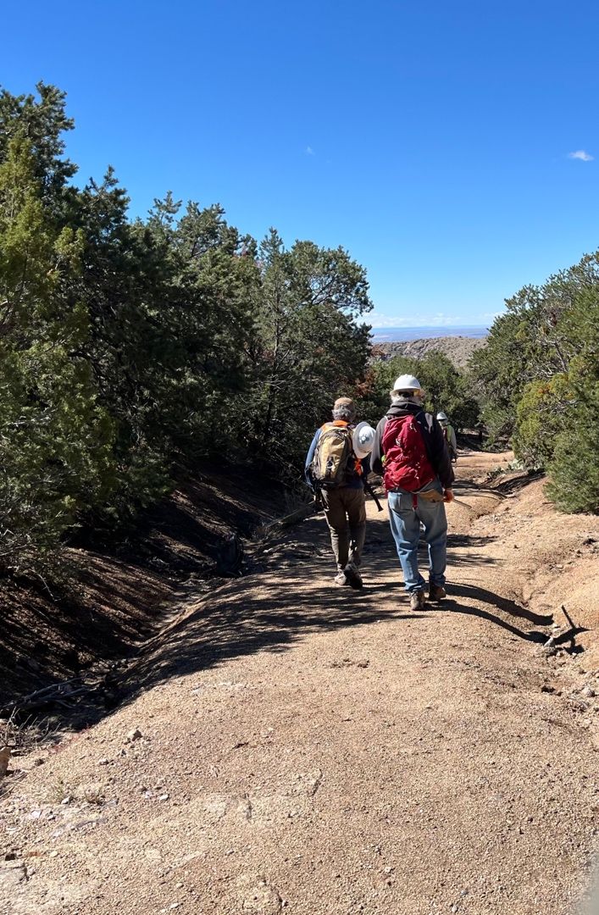
And Group C opted for the 2 mile hike out into the wilds.
