Thursday, 10/08/26- Buried Cable: We had 10 volunteers (unsupervised by FS peeps ) up on the crest this week. The road is barricaded at the 10K parking area again with a guard- at least right now. The mitigation crew is due to start up work on Monday, 10/23/26. Aspens are showing their colors and it was a wonderfully comfortable day for working. The recent rains left their mark in some of the debris areas but the trail work seems to have held up well. We worked on Buried Cable and made some good progress. We should be able to finish up the section available to us next week.
Volunteers: Luis Cuadros, Kit French, Kerry Jones, Chris Chatenka, Eric Russell, Byron Garner, Claudia Bergson, Rich Fagioli, Tony Pachelli and Laura Leon
Pictures: Laura Leon and Luis Cuadros

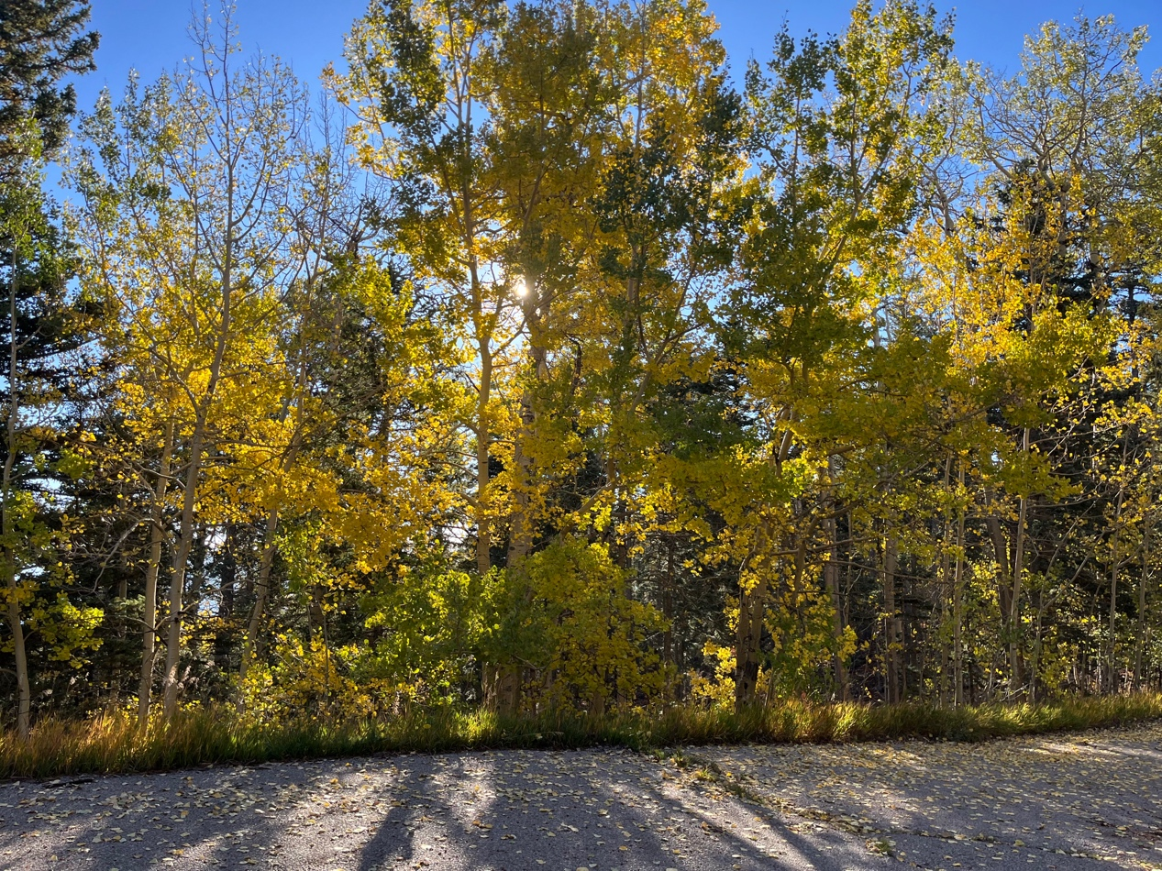
A nice start to the morning.
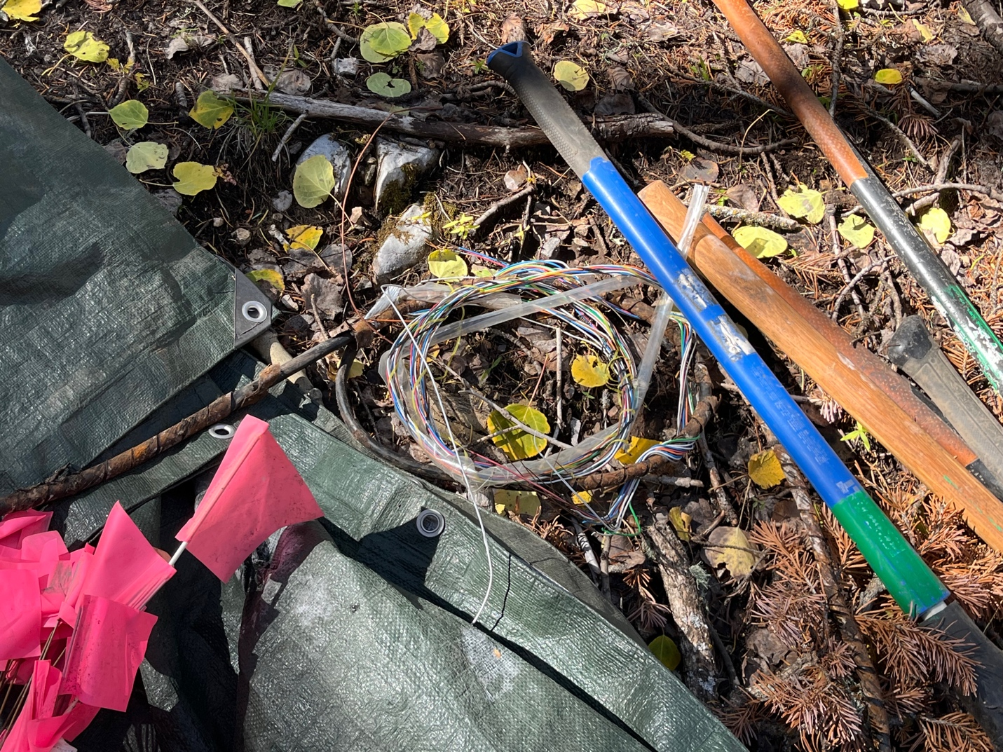
It’s called Buried Cable for a reason!
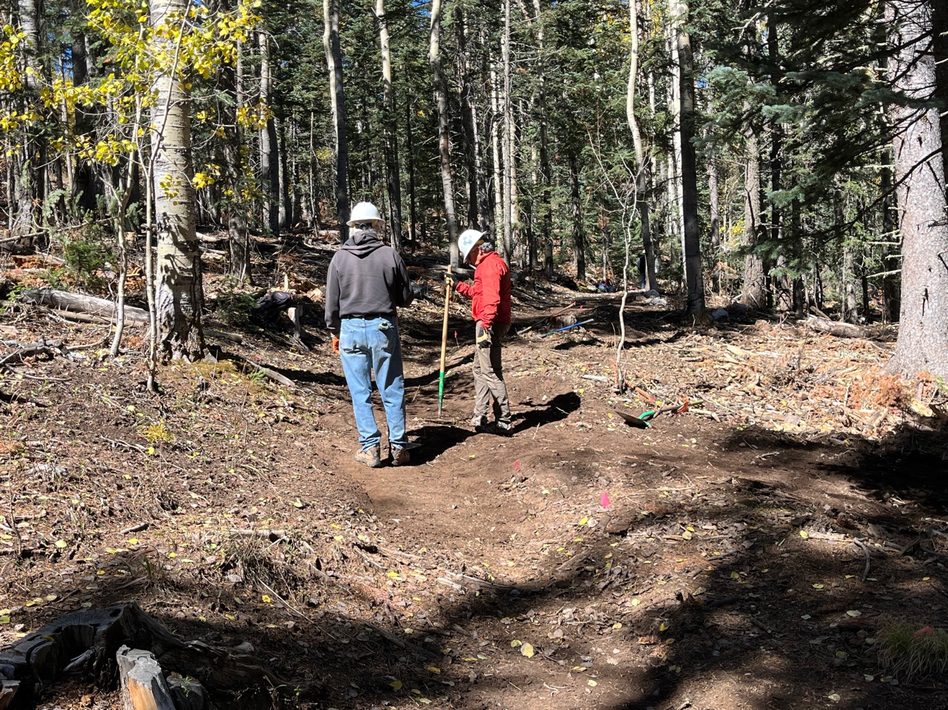
Luis and Kit look over the work.

Byron, Claudia, Rich and Chris at work- sorry Byron.
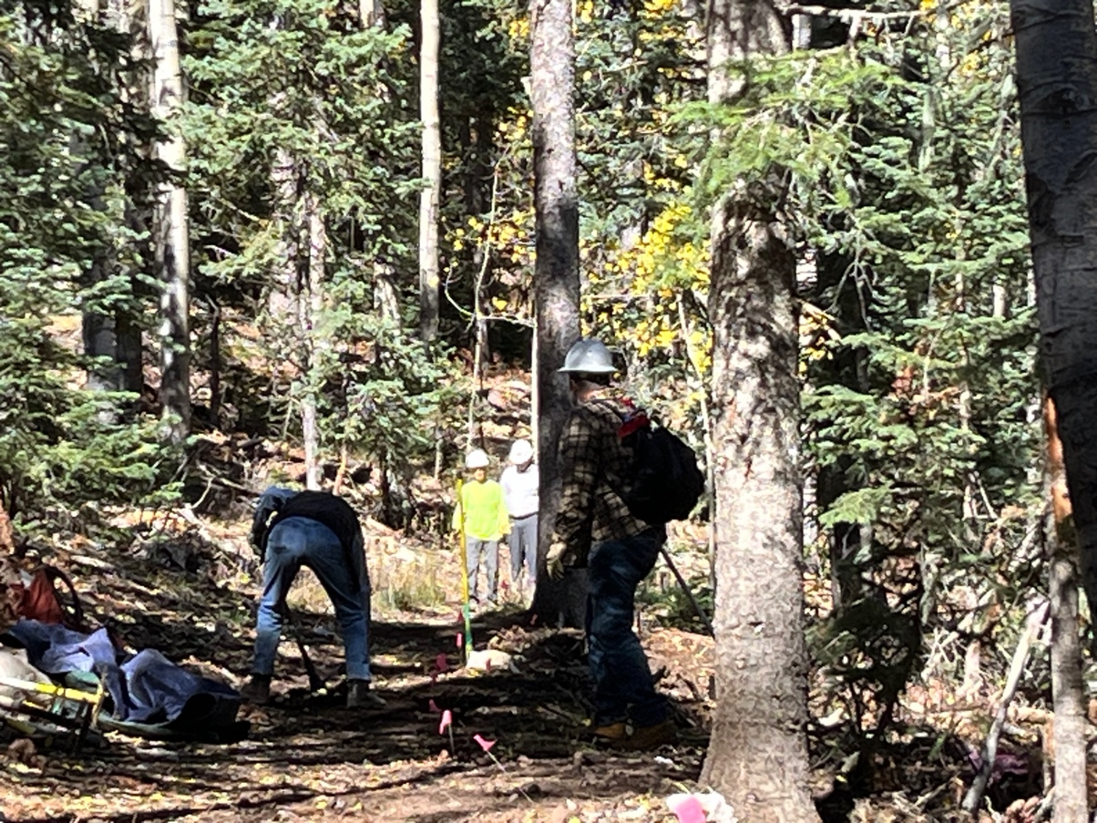
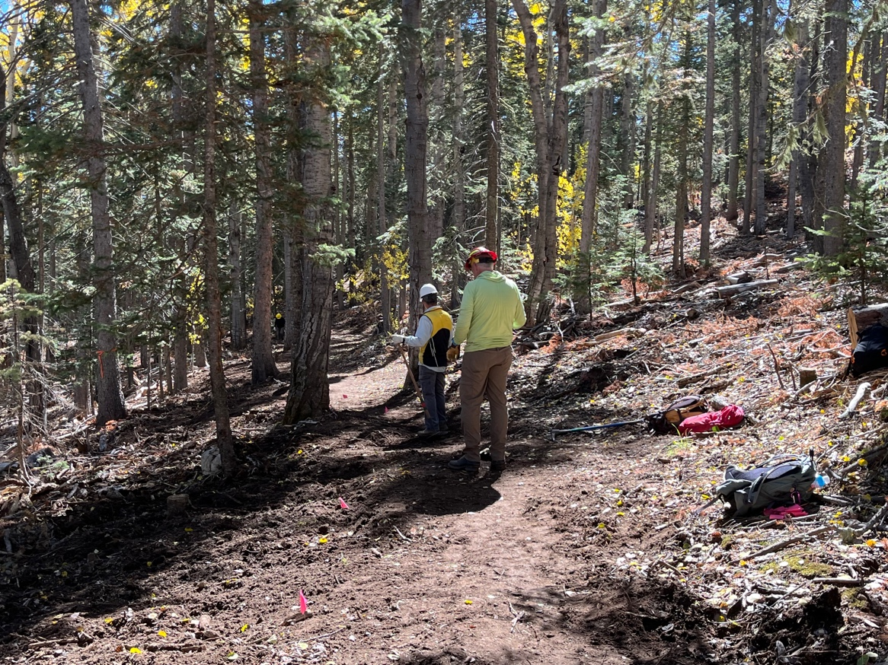
Tony and Kerry work on drainage.
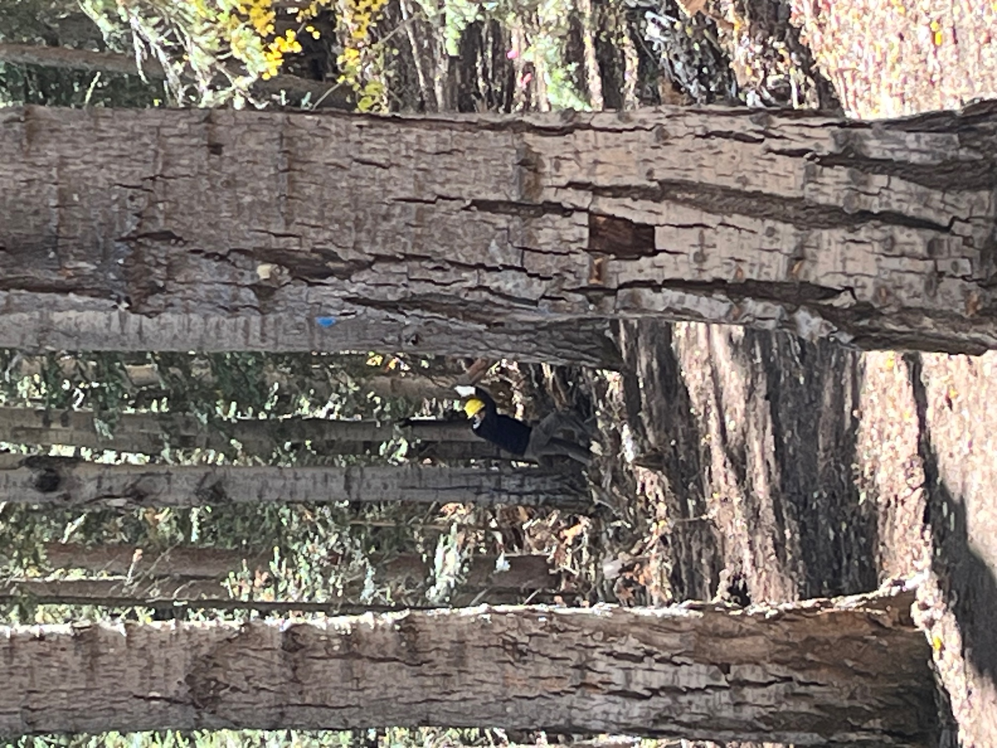
Eric moves mountains…
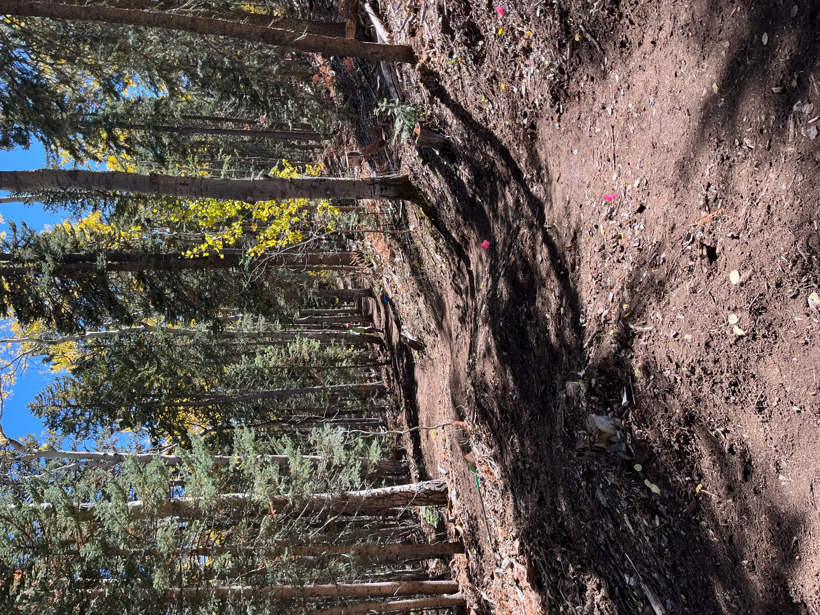
Kerry finishes up a trail section. It looks great!
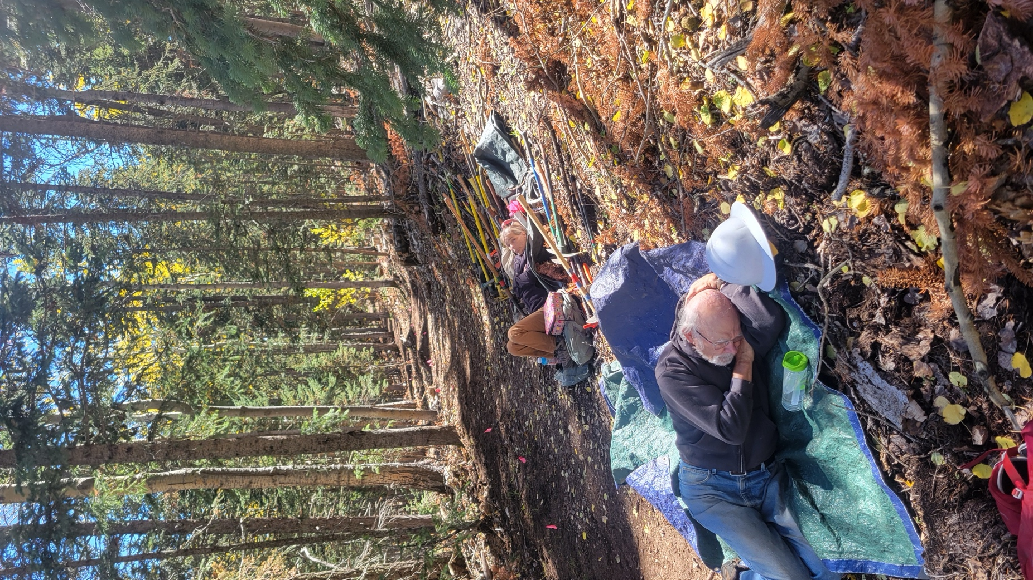
Lunch and cat naps- it’s very quiet, comfortable and peaceful up top.
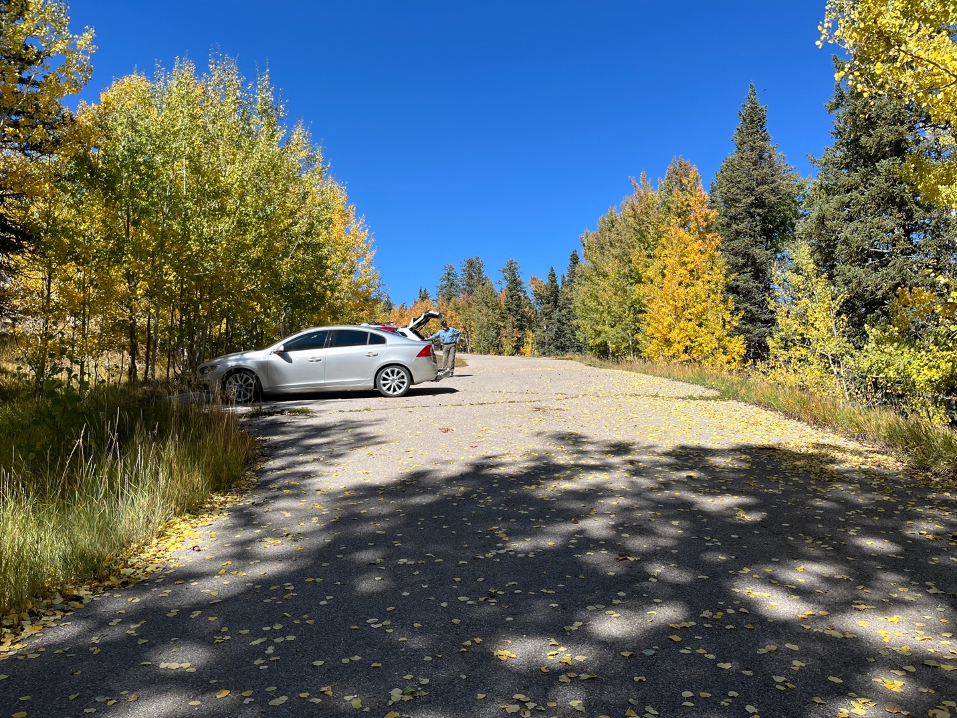

Eric was first back to the cars this week! Fall colors everywhere!

